**The Briefing – Number 62**

**22nd July 2021**

Dear Friends,

I hope that the recent move to Step 4 of the Government’s Covid-19 recovery plan has not caused you all undue worry. From my reading of the general situation we are all continuing to be careful, are continuing to socially distance and continue to wear face masks. Even though we can reopen our churches and do those activities both within and outside of worship that we have been yearning for since March 2020, I sense a level of caution that is humbling as well as setting an example to the communities in which we serve. I’m happy to reiterate the advice that the URC, both nationally and at Synod level is offering; that we do not rush into something which would put our churches, our members, our visitors and the communities we serve at risk. Therefore, to run the risk of repetition I urge you to consult the latest offering from the **URC Synod Moderators** here [**New Freedoms, Same Responsibilities: Synod Moderators' advice to congregations (urc.org.uk)**](https://urc.org.uk/church-information-guides/3870-new-freedoms-same-responsibilities.html). As the title suggests we have the new freedoms offered by the lifting of the restrictions we have been working under for the past 16 months, but our responsibilities are still the same and I hope that these are at the forefront of our collective minds as we move through the summer. The Moderators remind us to love God with our whole being and love our neighbour as we love ourselves. To do this we should still regularly review our Risk Assessments, remember those who remain clinically vulnerable or anxious. Furthermore the Moderators encourage everyone to continue the practice of washing or sanitising hands, to maintain a careful cleaning routine in our buildings and to show love to others through minimising risk to their health. I make no apologies either in drawing your attention to the latest release from the Moderators at [**https://urc.org.uk/latest-news/3873-urc-s-summary-of-government-s-guidance-for-places-of-worship-for-england**](https://urc.org.uk/latest-news/3873-urc-s-summary-of-government-s-guidance-for-places-of-worship-for-england)where Revd Steve Faber and the Moderators have summarised the changes that were brought about on 19th July and have contextualised some of the questions that are being asked.

The latest Government advice – updated 21st July – can be found here [Coronavirus: how to stay safe and help prevent the spread - GOV.UK (www.gov.uk)](https://www.gov.uk/guidance/covid-19-coronavirus-restrictions-what-you-can-and-cannot-do) and all the links therein are worth following to ascertain the extent of the changes that came into effect on 19th July. On writing those pages which impact most on the worship life of our churches [COVID-19: guidance for the safe use of places of worship - GOV.UK (www.gov.uk)](https://www.gov.uk/government/publications/covid-19-guidance-for-the-safe-use-of-places-of-worship-during-the-pandemic-from-4-july/covid-19-guidance-for-the-safe-use-of-places-of-worship-from-2-december), [Celebrating religious festivals during coronavirus (COVID-19) - GOV.UK (www.gov.uk)](https://www.gov.uk/government/publications/covid-19-guidance-for-the-safe-use-of-places-of-worship-during-the-pandemic-from-4-july/celebrating-religious-festivals-during-coronavirus-covid-19) and [COVID-19: suggested principles of safer singing - GOV.UK (www.gov.uk)](https://www.gov.uk/government/publications/covid-19-suggested-principles-of-safer-singing/covid-19-suggested-principles-of-safer-singing) have yet to be updated to incorporate the changes due to take place from 19th July. However, they may well have been updated by the time you read this.

From a Synod point of view, we appreciate that each of the churches within our remit will be working at different speeds. We know that some will want to return to full activities, others will be happy to follow a more circumspect path. Whatever a church decides Synod will support it in that decision. All that we advise is that you be responsible and that you respect the wishes of those who are not yet prepared to embrace the apparent freedoms Step 4 offers. Similarly, if churches do feel that they are not yet prepared to offer what is to be allowed from July 19th and need support then Synod is there for them. So in the meantime keep referring to the websites here [guidance on what you can and cannot do](https://www.gov.uk/guidance/covid-19-coronavirus-restrictions-what-you-can-and-cannot-do) and [Find out what the rules are](https://www.gov.uk/guidance/covid-19-coronavirus-restrictions-what-you-can-and-cannot-do?priority-taxon=774cee22-d896-44c1-a611-e3109cce8eae) and hopefully they will have been updated on the Government website.

**Church Links, Mission Activities and Synod Events**

**Lay Preachers Planning Group news**

Not only have the Lay Preaching planning group been working tirelessly this summer, they are also working to fill your autumn diaries as well. They have asked Lawrence Moore to lead an overview of **Luke’s Gospel** for worship leaders. The provisional dates are **2nd, 4th, 9th and & 11th November 2021** between 10.00am and 11.30am, with a repeat at 7.30pm on the dates mentioned. More details as we get closer here of the Briefing, on the website and on the Weekly Mailing (please sign up at [Yorkshire Synod (urcyorkshire.org.uk)](https://urcyorkshire.org.uk/)).

I know there are more things in the pipeline and news of these will be distributed in the usual ways.

And looking forward – into next year no less – Kath Lonsdale has asked that you keep the **22nd to 24th July 2022** clear if you are interested in a **lay preachers weekend at Wydale conference centre**. More details and a booking form nearer the time.

**Property News**

I have mentioned above that the change to Step 4 did happen on July 19th and as usual the Synod team is constantly keeping a close eye on any developments that may arise, especially as Covid-19 cases in the community continue to rise. Advice is always available from the team so don’t be backward at being forward in asking any questions of us. Synod is here to help, so if you have any questions drop a line to either me at [clerk@urcyorkshire.org.uk](mailto:clerk@urcyorkshire.org.uk) or to Jane at [property@urcyorkshire.org.uk](mailto:property@urcyorkshire.org.uk).

One thing to be particularly aware of is that, although many restrictions have been lifted, our advice is not to let up on maintaining the cleanliness routines which you have all been so good at. It means that as we all come out of lockdown your buildings are ready to welcome folk back. Advice is available at both Synod and National levels on both the Yorkshire [COVID-19 Advice and Support | URC Yorkshire Synod](https://urcyorkshire.org.uk/covid-19-advice-and-support/) and Denominational [Advice to churches about coronavirus from the United Reformed Church](https://urc.org.uk/coronavirus.html#resources-for-churches) websites.

**URC Buildings Forum Steering Group**

The URC Buildings Forum Steering Group is planning some more conferences in the wake of the successful Buildings Forum held back on April 19th and more recently on July 21st.

The third and final conference for 2021 is on 14th October 2021 from 7.00pm to 8.30pm and will focus on environmental issues for church buildings, including Eco-Church and Eco-Congregation. More details will be forthcoming when available via the [Yorkshire Synod (urcyorkshire.org.uk)](https://urcyorkshire.org.uk/) website.

**Children and Young Peoples News**

There is a great deal happening in the CYP part of the Synod, and I do urge you to pass news of these events on to those who are key to nurturing the younger end of your congregations. Why not have a look at the latest newsletter here <https://tinyurl.com/ssazwa4c> and sign up for it to be sent directly to your e-mail address. All the Synod activities will be uploaded to the Yorkshire Synod Website as well, which does have a link for you to sign up to the weekly update.

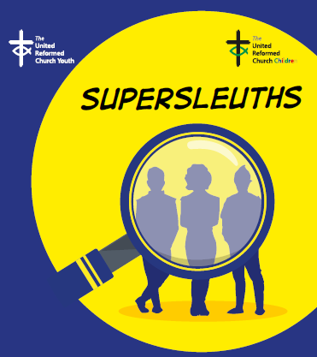For those who fancy themselves as budding Sherlocks or Morses (or even Inch High Private Eyes, for those with a long memory) why not try the **‘Super sleuths’ URC Holiday Club materials** – a FREE resource from the Children and Youth Team, with videos, activities, songs and ideas for groups that are pre-school, primary, secondary, vintage (‘older’) or intergenerational. There is also up to £100 available to help you put on your activity. The resource can be used for an activity day and there are additional materials to adapt it to use with under fives, for intergenerational groups and for a Vintage Holiday Club (for people in later life or with dementia). Visit <https://urc.org.uk/holiday-club> for full details and download instructions.

**SAVE THE DATE – Sat Sep 18th 2021. ‘The LITTLE Big Day Out’**

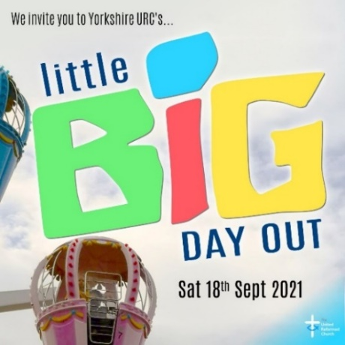

This a great opportunity for a day out especially for any families you are connected with through your churches and church activities. Tickets £12 per person (over 90cm tall) by contacting [wilderness@urcyorkshire.org.uk](mailto:wilderness@urcyorkshire.org.uk). For more information on the venue please visit (<https://www.gulliversvalleyresort.co.uk/>

Further financial support will be available and as the plans start to come together more information on this and other aspects of the day will be sent out and uploaded to the Children and Young Peoples’ section of the new look Yorkshire Synod Website [Children and Young People | URC Yorkshire Synod](https://urcyorkshire.org.uk/candy/).



Friday 1st October to Sunday 3rd October is the Wilderness Youth Weekend – a residential activity weekend at Kingswood Activity Centre, Dearne Valley. Designed for 11-17s the cost will be £25 per person. More details and booking information will be available soon on the synod website.

**Wilderness Faith Maps**

Finally – This simple weekly resource provides an easy way to engage with the Bible, prayer and the world around us. Linked to a Sunday Lectionary reading, it is suitable for all ages and faith experiences, as a starting point for a discussion or for personal reflection. You can find it each week here on [Facebook](https://www.facebook.com/wildernessfaithmaps), then like the page to be alerted when each weekly post arrives.

**URC Youth Assembly 2022**

It’s that time of year again! Youth Assembly 2022 is just round the corner! Are you or do you know a 14-26 years old? (Yes, we have increased the age for this year!). Experience worship and participate in discussions about faith and life with people your age! Not the chatty type? A silent disco could be right up your street! For more info click here:

[www.urc.org.uk/urc-youth-urc.html](http://www.urc.org.uk/urc-youth-urc.html?fbclid=IwAR3Senx_itMcZHxx_k7lGr4KpeoS8ryseA6NjArC11WB3m-pH0rumpPdzBY)

Book your place before 1 January 2022 at: [www.urc.org.uk/urcya](http://www.urc.org.uk/urcya?fbclid=IwAR3OdJQ1rN48SDpAxorbbP1kzQ4O6eztnWL_wL-1s1Bwon9nMJghZJJipbs)

**IT Group News**

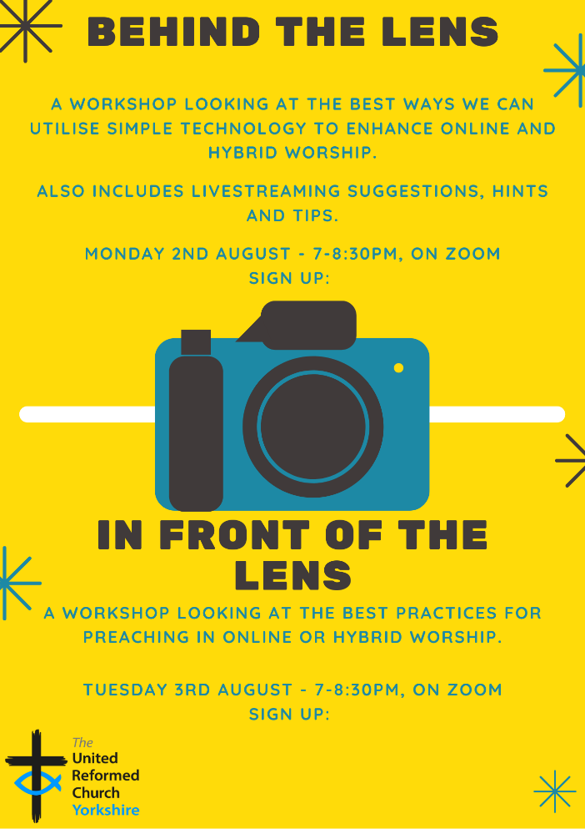

**Behind the lens** is a workshop looking at the best ways we can utilise simple technology to enhance online and hybrid worship including livestreaming suggestions, hints and tips.

**Monday 2nd August – 7-8:30pm on Zoom**

To sign p: [behindthelens1.eventbrite.co.uk](http://www.behindthelens1.eventbrite.co.uk/)

**In front of the lens:** A workshop looking at the best practices for preaching online or in hybrid worship.

**Tuesday 3rd August – 7-8:30pm on Zoom.**

To sign up: [infrontofthelens1.eventbrite.co.uk](http://www.infrontofthelens1.eventbrite.co.uk/)

FULL DETAILS AT [In front of/behind the lens! | URC Yorkshire Synod](https://urcyorkshire.org.uk/in-front-behind-the-lens/)

And don’t forget that Yorkshire Synod has launched its brand new **Weekly Mailing**! It's a great way of keeping informed about what's going on, in and around the synod. It contains latest news on events past, present and future, good news stories, announcements, and general updates. Anyone can sign up, so spread the word around your congregations and ask them to sign up. It's very easy to do, visit the synod website [www.urcyorkshire.org.uk](http://www.urcyorkshire.org.uk) and scroll down to the bottom of ANY page. You will see the sign up form on the right-hand side, fill it in, send it off and you'll be sent a confirmation email to confirm your subscription.

**We look forward to you hearing from us!**

**General Information and Resource Sharing**



Also here is information about a new series of online gatherings hosted by our Children’s and Youth Work specialists from around the synods. Entitled **“Talking about….”**, these monthly gatherings will provide all those engaging with children, families and young people, whether as volunteers or employed workers, to meet together, to build networks, and to talk through some of the issues common to many. The first session, on **29th July**, will be focused on opening up some of our children’s and youth groups post-lockdown – a topic which will be relevant to many as we ease out of restrictions and consider our next steps. To book your tickets visit <https://www.eventbrite.co.uk/e/opening-up-tickets-1618754243>

A while ago the good folk in North-Western Synod identified a need for training in Mail Chimp. North-Western are happy to extend that opportunity out to the Northerly Synods as Lawrence Moore is going to deliver that training. The date is now set – **29th July** – and if you follow this link you can easily sign up:

[Grow Your Mailing List Tickets, Thu 29 Jul 2021 at 19:00 | Eventbrite](https://www.eventbrite.co.uk/e/grow-your-mailing-list-tickets-164004099677?keep_tld=1)

The Summer 2021 edition of **In GEAR** is now on the GEAR's web-site. This latest edition plus numerous back copies can be found at: [http://www.gear.org.uk/publications/in-gear-magazine/](https://gear.us11.list-manage.com/track/click?u=2f0f3dc9a988ed172e04150ad&id=a3adbab85f&e=739c78e1e4)  
You can download the PDF version by clicking on the relevant front page view. If you wish to receive a paper copy (or multiple copies), please complete the form on the web page.

**Worshipping God Together : Apart**. The series of services from Rev Janine Atkinson are still on the website (even though she is taking a well-earned holiday). I’d like to take this opportunity to thank Janine for these resources. You can find it under the ‘What we do’ drop down heading if you fancy a Yorkshire Synod Website surf or more directly at <https://urcyorkshire.org.uk/worship/>

**Relay to COP26 Starts Soon**



This November, world leaders are meeting in Glasgow for important climate negotiations. It is a decade-defining opportunity to make a stand. The **Young Christian Climate Network** relay has begun; it started immediately after the G7 summit on 11th June and is making its way to Glasgow, passing through the full length of our Synod between 14th and 25th September including a sojourn in York between the 20th & 24th September.

If you click on this link [RELAY | YCCN](https://www.yccn.uk/) not only can you volunteer to get involved, but you can see where it goes.

**Time for God Volunteers**

Has your church considered hosting a Time For God volunteer? If it has then this is for you, if it hasn’t then this is also for you. Rather than come through the Synod Office, all information can be gleaned from [director@timeforgod.org](mailto:director@timeforgod.org). However if you would like the full size leaflets sent across, drop me a line at [clerk@urcyorkshire.org.uk](mailto:clerk@urcyorkshire.org.uk).

 

**Synod Mission Fund**

As you will know, the Synod runs a Mission Fund designed to resource the outward looking mission of churches and church groups. As you all start to move out of lockdown to resume your work in the communities we serve don’t forget that the Fund is available for you and that all you need is a good idea. If you need to have a chat about what may be suitable please get in touch with me at [clerk@urcyorkshire.org.uk](mailto:clerk@urcyorkshire.org.uk) and have a look at the [Grants and Funding | URC Yorkshire Synod](https://urcyorkshire.org.uk/grants-and-funding/) page and follow the links to the Synod Mission Fund forms.

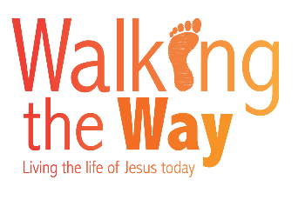A reminder that the fortnightly [United Reformed Church podcast](https://anchor.fm/theurcpodcast) from the **Walking the Way** team is available now. This series will look at what it means to be a disciple of Jesus across all aspects of our lives, as we respond to concerns, issues and topics we encounter.

In addition to a new episode every second Wednesday, for the next few weeks between podcast episodes being released, Simon Peters, the Project Manager will also be uploading some video conversations with various people across the URC in relation to discipleship. Please look out for these on the [URC’s YouTube channel](https://www.youtube.com/user/URCUK/videos).

If you or someone you know might be interested in featuring in either the podcast or video conversations, please let Simon know.

For those with local tastes I know that the **Sheffield team** have their services on their own website at <http://sheffieldurc.org.uk/> and on the Yorkshire site you can find help in preparing and participating in Online Worship at [COVID-19 Advice and Support | URC Yorkshire Synod](https://urcyorkshire.org.uk/covid-19-advice-and-support/).

St Andrew's URC Sheffield has a very gifted and committed organist who has put worship resources on every week since the beginning of the first lockdown. The music is an eclectic, rich and classical selection and the Reflection is read aloud with the words there on the screen for you to read yourself. The service from the previous week is immediately accessible below the new one, and earlier services are now archived and accessible too. [www.standrewsurcsheffield.org.uk/stop-press](http://www.standrewsurcsheffield.org.uk/stop-press)

As I keep mentioning the Yorkshire Synod has a dedicated **YouTube channel**. On it there are the **Moderators musings** and releases from **the LYCiG team, Children's and Youth, Mission** and more! The link is here: <https://bit.ly/urcyorkshireyoutube> and have a look at what has already been uploaded. If you have a google account, you will receive emails when a new video is posted. In addition, there is a great deal of information on the LYCIG page on the Synod website. Now is as good a time to have a look at [Leading Your Church Into Growth | URC Yorkshire Synod](https://urcyorkshire.org.uk/lycig/)

The latest edition of the URC’s **NewsUpdate** has just been published. A downloadable version of it, formatted for print and for churches to cut and paste into church newsletters, is available on the URC website. Download and print your copyhere[**URC News Update July/August 2021 (urc-news.org.uk)**](https://urc-news.org.uk/2JB1-1R7II-122F160E1908EEE459BX7G3A2531BF46D2BD62/cr.aspx)

**Please don’t hide these events in your inboxes. Please send this Briefing around your own church mailing lists as these events are for everyone, member or non-member, church-goer or non-church-goer. All these activities within and beyond Synod are designed to grow the Kingdom.**

**Plans are always happening to bring more activities and good news stories to your attention, so keep an eye open for the next Briefing. All you need to do is get in touch with me at** [**clerk@urcyorkshire.org.uk**](mailto:clerk@urcyorkshire.org.uk)**.**

If you know of anything you may find useful for our churches, please contact me at [clerk@urcyorkshire.org.uk](mailto:clerk@urcyorkshire.org.uk) and I’ll circulate it here and on the website. Similarly if you need any further help, be it to do with IT, finance, property or the like we are here to help.

National URC site: <https://urc.org.uk/> Yorkshire Synod: <https://urcyorkshire.org.uk/> Yorkshire Synod Twitter: <https://twitter.com/urcyorkshire> Yorkshire Synod Facebook: <https://www.facebook.com/urcyorkshire> Yorkshire Young People’s Facebook: <https://www.facebook.com/wildernessyorkshireurc/>

*Tim Crossley*

*Synod Clerk*