Worshipping Together : Apart
Sunday 18th July 2021 at 10.30am
Church; Physically Distanced but Spiritually United
Worship Prepared by Rev. Janine Atkinson
A Call to Worship God
God calls us to be sheep in the fold of his Son, so:
Will you follow the good shepherd and learn from him?
Will you be compassionate and look out for the lost?
Will you be faithful in prayer and joyful in praise?
Will you rest when you are weary and not be afraid to be still?
Will you share with others the good news of the gospel?
Approaching God in Prayer
We bring our tiredness and lay it down.
We bring our hurts and lay them down.
We bring our hopes and offer them up to you Jesus,
the good shepherd,
because you will restore, comfort, lead and guide us,
today and always.
We thank you that when we are excited and want to share,
you listen and encourage us;
when we are tired and exhausted, you offer us rest;
when we feel lost and afraid,
you embrace us with your presence.
And at all times you are with us, guiding us
by the rod of your compassion and the staff of your love.
Thank you, Lord, that you always had time for people.
Even when you were tired and needed a rest,
when the crowds gathered
your compassionate heart healed and restored all those who
came to you.
Thank you that you are kind and caring
and lavish your love upon us.
Your self-giving love has set us free
to be the people you have called us to be.
Thank you that you are present
in the big and small things of our lives,
in the ordinary and everyday times,
and in the extraordinary and special times.
You never leave us or forsake us.
Thank you, Lord, our Shepherd and King.
Amen
Hymn – R&S 679: MP 660
The Lord’s my Shepherd, I’ll not want; he makes me down to lie
in pastures green; he leadeth me the quiet waters by.

My soul he doth restore again; and me to walk doth make
within the paths of righteousness, ev’n for his own name’s sake.

Yea, though I walk in death’s dark vale, yet will I fear no ill;
for thou art with me; and thy rod and staff me comfort still.

My table thou hast furnished in presence of my foes;
my head thou dost with oil anoint, and my cup overflows.

Goodness and mercy all my life shall surely follow me;
and in God’s house forever more my dwelling-place shall be.
Psalm 23 Metrical version by William Whittingham (1524-79) T

The Rhythm of Rushing and Resting
Today we read how Jesus is in demand once again! News of his teachings and actions are spreading fast. He tries to find a quiet place, recognising its value for himself and the disciples, but the crowds still follow
Gospel Reading: Mark 6.30-34,53-56 - www.rootsontheweb altd.
30-34: The disciples returned from their journeys around the villages and gathered around Jesus to tell him all that they had done and taught.
He said to them, ‘Come away with me to a quiet place so that you can rest for a while.’ There were so many people coming and going around them that he and the apostles didn’t even have time to eat! So they went away in a boat to a deserted place all by themselves.
But many people saw them set off in the boat and they hurried from all the nearby towns to meet them when they landed. When Jesus went ashore, he saw a great crowd and he had compassion for them, because they were like sheep without a shepherd. So he began to teach them many things.
- The next 19 verses tell the story of the feeding of the 5,000!
53-56: Later Jesus and the disciples crossed over the lake in the boat and came to land at Gennesarat. Immediately as they got out of the boat and tied it up, people recognised Jesus, and rushed from all over the region, bringing sick people on mats to wherever he was. And no matter where Jesus went, into farms or villages or cities, people laid out the sick in the market places, and begged him that they might just touch the fringe of his cloak. And everyone who touched it was healed.

A Prayer of Confession and Assurance of Forgiveness
Gracious God, you always make time for us;
we are sorry that we don’t always make time for you.
When we are rushing around being busy,
sometimes even when we are doing your work,
we forget about you.
We are sorry when we make our lives so full
that there is no room left for you –
no room to get away, to be in a quiet place with you.
Forgive us, Lord, and help us not to hurry but to slow down,
to make space for you to dwell within us.
And in that dwelling place,
may we seek what you want us to do
and who you want us to spend time with.
Help us to get the right balance,
a right rhythm that is in tune with you.
Even though we have gone astray,
you are our Shepherd – the one who brings us back to the fold.
We are assured of your forgiveness,
and we are set free in the knowledge
that you always make room for us.
Amen
Reflection
We all feel tensions in some area or other of our lives, and Jesus is no different.
It seems impossible for Jesus to find quiet time and space – there’s always some one in need, something to be done and, not for the first time, Jesus has compassion for the crowds of people following him wherever he goes and the time to reflect and recuperate is cut short. Jesus is torn between the needs around him - the vital work of healing, peace and restoration - and the real need we all feel for times of peace and quiet; still waters that will refresh our souls.
Jesus knew that in order to find the strength to show the kind of care and compassion that he needed to give he needed to be quiet so as to draw on the inner strength required for the work that was necessary. He modelled for us that nurturing ourselves spiritually, setting aside time and space to ‘refuel’, gives us the balance we need between rushing and resting. He made time for his disciples to spend with him reflecting on their adventures out ‘in the field’ without Jesus present.
I wonder, how do you make time to be still? How do you find the energy to carry on and meet the challenges you face - whatever they are? How do you find time to reflect with Jesus on what you’re doing?
Look ahead at your day and see if you can find any moments in which you will be able to be still.
Remember that even in your busyness, God is with you – whether you are aware of it or not; whether you have forgotten about it or not, God does not forget you and is with you.
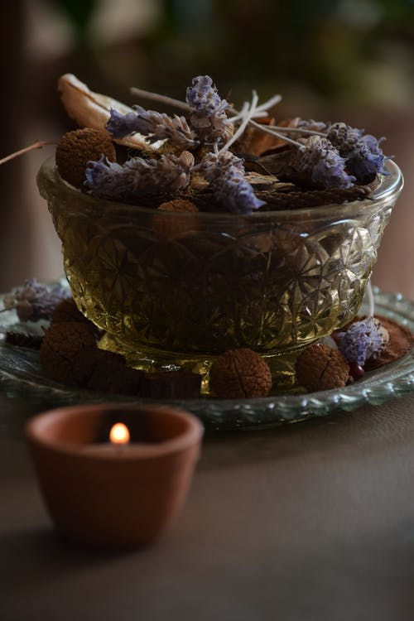
Song
Be still and know that I am God,
be still and know that I am God,
be still and know that I am God.
I am the Lord that healeth thee,
I am the Lord that healeth thee,
I am the Lord that healeth thee.
In thee, O Lord, I put my trust,
In thee, O Lord, I put my trust,
In thee, O Lord, I put my trust.
Anonymous
A Quiet Place
It’s said that John Wesley knew when his mother was having some time with God when she turned her apron up and over her head. Even with a busy family life, she managed to find her quiet space.
Why not set up a quiet corner (or a bit of wall and a shelf) in your home to make into your ‘holy ground’. You could gather some items to put in it to help focus your attention on God – a Bible, a cross, a candle, a shell a lovely stone or pebble, a feather, leaves – whatever helps you. If you haven’t got the space, you could use the inside of a cupboard door to put some picture or photos on to help you to be quiet, reflect and recharge your batteries and find the inner strength God can provide when we focus on him.
Hymn - R&S 492: MP 111: J.G. Whittier (1807-92)
Dear Lord and Father of mankind, forgive our foolish ways!
Reclothe us in our rightful mind; in purer lives thy service find,
in deeper reverence, praise.

In simple trust like theirs who heard beside the Syrian sea
the gracious calling of the Lord, let us, like them, without a word,
rise up and follow thee.

O Sabbath rest by Galilee! O calm of hills above,
where Jesus knelt to share with thee the silence of eternity
interpreted by love!

With that deep hush subduing all our words and works that drown
the tender whisper of thy call, as noiseless let thy blessing fall
as fell thy manna down.

Drop thy still dews of quietness, till all our strivings cease;
take from our souls the strain and stress,
and let our ordered lives confess the beauty of thy peace.

Breathe through the heats of our desire thy coolness and thy balm;
let sense be dumb, let flesh retire; speak through the earthquake, wind, and fire, O still, small voice of calm!
Holding the World in Prayer
Lord God, our shepherd,
we pray for your compassion and healing
in the villages of the world:
for small vibrant communities,
where people know each other and work together;
for places that are cut off, with few resources.
We pray for your compassion and healing
in the towns of the world:
for places that act as centres for wider rural areas;
for places that accommodate the dispossessed and landless.
We pray for your compassion and healing
in the cities of the world:
for buzzing, connected, multicultural centres of success;
for overcrowded slums with inadequate infrastructure.
We pray that no cry for help will go unheeded,
no need go unmet, no child go unloved,
and no tears go unnoticed.
We ask this in Jesus’ name, who taught us to pray
Our Father, who art in heaven, hallowed be thy name;
thy kingdom come; thy will be done; on earth as it is in heaven.
Give us this day our daily bread. And forgive us our trespasses,
as we forgive those who trespass against us.
And lead us not into temptation; but deliver us from evil.
For thine is the kingdom, the power and the glory,
for ever and ever. Amen.
Hymn – R&S 367: MP 302 C Simmonds, 1964*
I want to walk with Jesus Christ all the days I live of this life on earth,
to give to him complete control of body and of soul:

Follow him, follow him, yield, your life to him,
he has conquered death, he is King of kings.
Accept the joy which he gives to those
who yield their lives to him.

I want to learn to speak to him, to pray to him, confess my sin,
to open my life and let him in, for joy will then be mine:

I want to learn to read his word, for this is how I know the way,
to live my life as pleases him, in holiness and joy:

I want to learn to speak of him; my life must show that he lives in me,
my deeds, my thoughts, my words must speak of all his love for me:

O holy Spirit of the Lord, enter now into this heart of mine,
take full control of my selfish will and make me wholly thine:
Closing Words and Blessing
Walk with others when they are weary,
be still with those who need rest,
and be strong in the knowledge that you are cherished,
empowered and cared for by Jesus the good shepherd,
today and always.
May the grace of our Lord Jesus Christ,
the love of God and the fellowship of the Holy Spirit
be with us all, evermore. Amen

Resources from www.rootsontheweb have been used to produce this act of worship
Image: www.pexels.com
Hymn words reproduced under the CCLI Licence numbers of the SPACE Group of Churches: 181588 - Grove URC: 178113 - The URC Heckmondwike:
177949 - Longcauseway Church: 1236906 - Norristhorpe URC:
783508 - Ravensthorpe with Hopton URC

