**The Briefing – Number 64**

**5th August 2021**

Dear Friends,

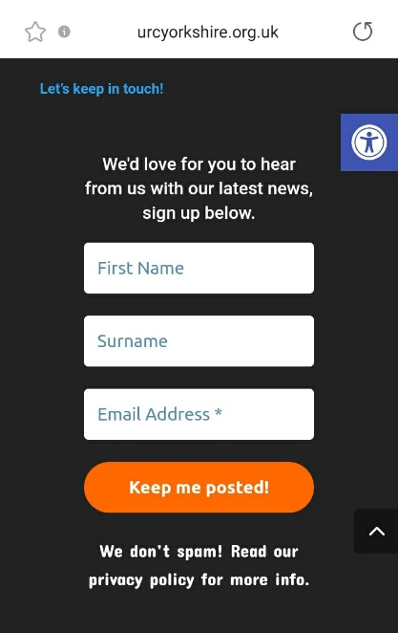August is now upon us and the activity level is lessening somewhat – primarily due to it being the holiday season. I have to admit that I am now counting down the days to my annual holiday, so next week’s issue will be the last regular Briefing of the month. After I get back in late August the plan is for the Briefing to go fortnightly as we hope that by then you will have signed up to the Website mailing which is distributed automatically each Friday. There are a couple of reasons for this change. First is the fact that as we seem to be moving out of a period of Covid-19 restriction as set out in law there does not appear to be the need for immediacy in keeping you all up to date. I’m sure that we all know what is expected of us, and as a reminder below are the key links to both the URC guidelines as well as to the Government websites. Secondly as we are slowly starting to return to a period where we can organise more events it would be folly not to put those items which require circulating on the Yorkshire Synod Website. Now I may have mentioned this before, but the website has a facility to automatically generate a mailing which is distributed without fail on a Friday afternoon. This mailing is designed for everybody; all you have to do is sign up in the box illustrated here, which you’ll find at the foot of the [**Yorkshire Synod (urcyorkshire.org.uk)**](https://urcyorkshire.org.uk/) home page and you become part of the Synod family. The mailing will highlight the new items that have been uploaded to the new Synod Website as well as showcasing the events which are to be planned by Synod in the future. These events are the kind of events that I have been advertising here in the Briefing, but through putting them on the website mailing they automatically become immediate events for your enjoyment.

Don’t keep this little snippet of information to yourself – tell your friends, your church members and your congregations as a whole. There’s a whole array of things to help, guide and inform you, not only about the URC but about how we can become a **Jesus centred people**.

So as we travel through August keep the doors open and the welcomes warm. Our responsibilities are still the same as they have been throughout the pandemic and I hope that these are at the forefront of our collective minds.

As a reminder of where we stand in response to the Covid-19 pandemic please consult both the URC advice, ably encapsulated in **URC Synod Moderators’** [**New Freedoms, Same Responsibilities: Synod Moderators' advice to congregations (urc.org.uk)**](https://urc.org.uk/church-information-guides/3870-new-freedoms-same-responsibilities.html) as well as the **URC’s main** [**Advice to churches about coronavirus from the United Reformed Church**](https://urc.org.uk/coronavirus.html)pages. Similarly please consult the Government sites at [**Coronavirus: how to stay safe and help prevent the spread - GOV.UK (www.gov.uk)**](https://www.gov.uk/guidance/covid-19-coronavirus-restrictions-what-you-can-and-cannot-do) and also at [**guidance on what you can and cannot do**](https://www.gov.uk/guidance/covid-19-coronavirus-restrictions-what-you-can-and-cannot-do) and [**Find out what the rules are**](https://www.gov.uk/guidance/covid-19-coronavirus-restrictions-what-you-can-and-cannot-do?priority-taxon=774cee22-d896-44c1-a611-e3109cce8eae)**.**

**Church Links, Mission Activities and Synod Events**

**Lay Preachers Planning Group news**

Not only have the Lay Preaching planning group been working tirelessly this summer, they are also working to fill your autumn diaries as well. They have asked Lawrence Moore to lead an overview of **Luke’s Gospel** for worship leaders. The provisional dates are **2nd, 4th, 9th and & 11th November 2021** between 10.00am and 11.30am, with a repeat at 7.30pm on the dates mentioned. More details as we get closer here of the Briefing, on the website and on the Weekly Mailing (please sign up at [Yorkshire Synod (urcyorkshire.org.uk)](https://urcyorkshire.org.uk/)).

I know there are more things in the pipeline and news of these will be distributed in the usual ways.

And looking forward – into next year no less – Kath Lonsdale has asked that you keep the **22nd to 24th July 2022** clear if you are interested in a **lay preachers weekend at Wydale conference centre**. More details and a booking form nearer the time.

**Property News**

The Synod team is constantly keeping a close eye on any developments that may arise, especially as Covid-19 cases in the community continue to fluctuate. Advice is always available from the team so don’t be backward at being forward in asking any questions of us. Synod is here to help, so if you have any questions drop a line to either me at [clerk@urcyorkshire.org.uk](mailto:clerk@urcyorkshire.org.uk) or to Jane at [property@urcyorkshire.org.uk](mailto:property@urcyorkshire.org.uk). The main thing that needs emphasising is that while there is no legal requirement to maintain records, we are being asked to continue with the QR code and the test and trace lists in terms of good practice. Full details are at the following site, last updated on 16th July:

[**https://www.gov.uk/guidance/covid-19-guidance-for-the-safe-use-of-places-of-worship**](https://www.gov.uk/guidance/covid-19-guidance-for-the-safe-use-of-places-of-worship).

One thing to be particularly aware of is that, although many restrictions have been lifted, our advice is not to let up on maintaining the cleanliness routines which you have all been so good at. Advice is available at both Synod and National levels on both the Yorkshire [**COVID-19 Advice and Support | URC Yorkshire Synod**](https://urcyorkshire.org.uk/covid-19-advice-and-support/) and Denominational [**Advice to churches about coronavirus from the United Reformed Church**](https://urc.org.uk/coronavirus.html#resources-for-churches) websites.

**URC Buildings Forum Steering Group**

The URC Buildings Forum Steering Group is planning some more conferences in the wake of the successful Buildings Forum held back on April 19th and more recently on July 21st.

The third and final conference for 2021 is on 14th October 2021 from 7.00pm to 8.30pm and will focus on environmental issues for church buildings, including Eco-Church and Eco-Congregation. More details will be forthcoming when available via [**Yorkshire Synod (urcyorkshire.org.uk)**](https://urcyorkshire.org.uk/).

**IT Group News**

And don’t forget that Yorkshire Synod has launched its brand new **Weekly Mailing**! I have a feeling I’ve mentioned it before, but it’s worth mentioning again. It's a great way of keeping informed about what's going on, in and around the synod. It contains latest news on events past, present and future, good news stories, announcements, and general updates. Anyone can sign up, so spread the word around your congregations and ask them to sign up. It's very easy to do, visit the synod website [**www.urcyorkshire.org.uk**](http://www.urcyorkshire.org.uk) and scroll down to the bottom of ANY page. You will see the sign up form on the right-hand side, fill it in, send it off and you'll be sent a confirmation email to confirm your subscription.

**We look forward to you hearing from us!**

**Children and Young Peoples News**

**BOOKINGS ARE NOW OPEN**

**Sat Sep 18th 2021. ‘The LITTLE Big Day Out’**

[](https://urcyorkshire.org.uk/wp-content/uploads/2021/07/Little-Big-Day-Out-Gullivers-Valley-1-scaled.jpg)‘Little Big Day Out’ is a chance for churches and families to have fun and spend time together after so many months of isolation and limits on our lives. We cannot offer a large organised programme due to ongoing restrictions but we can provide some ‘time out’. We hope you and your families will find it valuable to just be together.

Tickets for this event are already at a reduced price but further subsidy is available, so please get in touch to discuss your church or families’ circumstance. Tickets are needed for everyone over 90cm tall (however old you are).

Download a [**booking form here**](https://urcyorkshire.org.uk/wp-content/uploads/2021/07/2021-LBDO-Booking-form.pdf) or visit the website at [**Little Big Day Out | URC Yorkshire Synod**](https://urcyorkshire.org.uk/event/little-big-day-out/)**.** Bookings need to be received by Weds 1st Sep. Please [**contact us**](https://urcyorkshire.org.uk/event/little-big-day-out/wilderness@urcyorkshire.org.uk) if you have any questions.

We look forward to seeing you in September.

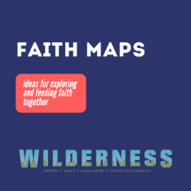**Wilderness Faith Maps**

This simple weekly resource provides an easy way to engage with the Bible, prayer and the world around us. Linked to a Sunday Lectionary reading, it is suitable for all ages and faith experiences, as a starting point for a discussion or for personal reflection. You can find it each week here on [Facebook](https://www.facebook.com/wildernessfaithmaps), then like the page to be alerted when each weekly post arrives.

**Yorkshire Synod Youth Weekend**

October 1 @ 5:00 pm - October 3 @ 2:00 pm

[](https://urcyorkshire.org.uk/wp-content/uploads/2021/07/Wilderness-Adventure-Weekend-Kingswood-2021.jpg)After all the restrictions of the past year we are really pleased to be able to bring you the synod Youth Weekend again 1st – 3rd Oct at [**Kingswood Activity Centre, Dearne Valley**](https://www.kingswood.co.uk/activity-centres/dearne-valley/). Last year was particularly hard on young people, so we are glad to be able to offer a residential weekend to socialise, have fun and join in all sorts of activities with friends.

There will also be time for young people to try praying and to look at the Bible together in a way that will be completely accessible if you don’t have any faith or church experience.

The cost of the weekend is only £25 per person. Leaders from URC groups will be welcome to come with any young people from their churches too. Please get in touch if you would like to join us.

So what are you waiting for? Please pass on the details and look out for the booking forms coming soon on this website. You can download the full poster from the website at [**Yorkshire Synod Youth Weekend | URC Yorkshire Synod**](https://urcyorkshire.org.uk/event/yorkshire-synod-youth-weekend/) to distribute and please do get in touch if you have any questions: [**wilderness@urcyorkshire.org.uk**](https://urcyorkshire.org.uk/event/yorkshire-synod-youth-weekend/wilderness@urcyorkshire.org.uk)

**URC Youth Assembly 2022**

It’s that time of year again! Youth Assembly 2022 is just round the corner! Are you or do you know a 14-26 years old? (Yes, we have increased the age for this year!). Experience worship and participate in discussions about faith and life with people your age! Not the chatty type? A silent disco could be right up your street! For more info click here:

[www.urc.org.uk/urc-youth-urc.html](http://www.urc.org.uk/urc-youth-urc.html?fbclid=IwAR3Senx_itMcZHxx_k7lGr4KpeoS8ryseA6NjArC11WB3m-pH0rumpPdzBY)

Book your place before 1 January 2022 at: [www.urc.org.uk/urcya](http://www.urc.org.uk/urcya?fbclid=IwAR3OdJQ1rN48SDpAxorbbP1kzQ4O6eztnWL_wL-1s1Bwon9nMJghZJJipbs)

There is a great deal happening in the CYP part of the Synod, and I do urge you to pass news of these events on to those who are key to nurturing the younger end of your congregations. Why not have a look at the latest newsletter here <https://tinyurl.com/ssazwa4c> and sign up for it to be sent directly to your e-mail address. All the Synod activities will be uploaded to the Yorkshire Synod Website as well, which does have a link for you to sign up to the weekly update.

**General Information and Resource Sharing**

**Safeguarding News**

**Trustee training**.

Matt Knowles, our Synod Safeguarding Adviser has managed to secure some more spaces in the training sessions being run by Farrer & Co regarding trustee responsibilities in respect of safeguarding. The training is free as it is funded by a successful application to the Synod Development fund managed by the Assembly Safeguarding Advisory Group. It is the same course that was successfully run last month, but this time it is being organised by SW Synod and Matt has been able to ensure that there will be spaces available for those who are Trustees within Yorkshire Synod unable to attend the training in July.

The training will be via Zoom and the dates are:

17th November 2.30pm -4.30pm, 23rd November 11am – 1pm, 30th November 11am – 1pm

and will include:

1. Why does safeguarding matter to the Church?
2. Duties as Trustees.
3. Case studies in breakout rooms regarding Serious Incidents.
4. Reporting Serious Incidents to the Charity Commission.
5. Fictional case study in break out rooms exploring roles and responsibilities.
6. How to ensure effective safeguarding arrangements are in place.
7. Conclusion
8. Q & A

If you wish to attend, or if you know of someone who needs to attend then please send details to [**secretary@urcsouthwest.org.uk**](mailto:secretary@urcsouthwest.org.uk).

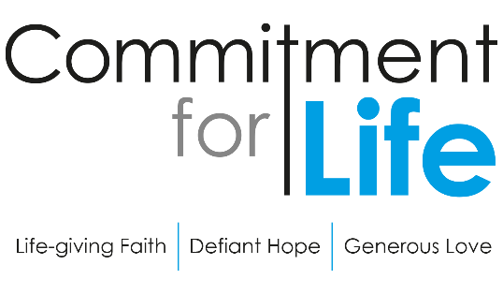**Harvest Service on Legacies**

Suzanne Pearson from Church House has got in touch to draw our attention to the **NEW** service that *Commitment for Life* has created in conjunction with Christian Aid on leaving a Legacy. The Harvest service including full text and a video of the service is downloadable from our website by following the link <https://urc.org.uk/commitment-for-life/worship-commitment-for-life.html>

As this Harvest Service is a pilot legacy partnership, it would really help Christian Aid and CFL if you could kindly provide us with some feedback. Please do let me know if your church uses these CFL Harvest resources and how well it was received by the congregation.

A simple ‘How to do it’ style flyer, is in the process of being prepared and will be added to the *Commitment For Life* website by the end of August [Commitment for life (urc.org.uk)](https://urc.org.uk/our-work/commitment-for-life.html) .

Finally, Christian Aid are organising training on ‘talking about legacies in your church’ on 23rd September. Church leaders can book their place by emailing Kathy directly via this link: <https://www.christianaid.org.uk/give/gifts-wills/remember-charity-week>.

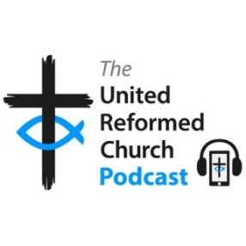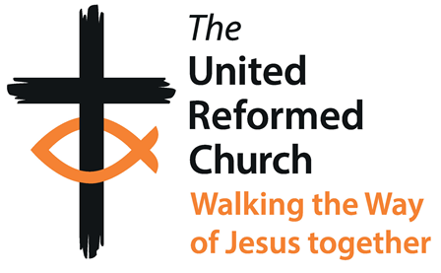

Simon Peters, the Walking the Way Project Manager, has been in touch to say that the latest episode of the URC Podcast, featuring Richard Lewney and Kevin Snyman of Commitment for Life, looking at how disciples of Jesus should approach the topic of money, is now available at <https://bit.ly/URCPodcast4>

****This has come through from Trinity Rawdon. For more information visit [www.trinityrawdon.org.uk](http://www.trinityrawdon.org.uk).

The Summer 2021 edition of **In GEAR** is now on the GEAR's web-site. This latest edition plus numerous back copies can be found at: [http://www.gear.org.uk/publications/in-gear-magazine/](https://gear.us11.list-manage.com/track/click?u=2f0f3dc9a988ed172e04150ad&id=a3adbab85f&e=739c78e1e4)  
You can download the PDF version by clicking on the relevant front page view. If you wish to receive a paper copy (or multiple copies), please complete the form on the web page.

**
  Towards Appreciating Neuro-diversity in the URC image
**On **Monday 27th September at 7.00pm** there will be the Initial gathering of neuro-diverse adults and young people associated with the URC to explore how we might celebrate neuro-diversity.

Curated by URC Children's & Youth Work team, there will be sharing of stories and experiences, hopes and dreams for how the URC might be more inclusive and support a celebration of neuro-diversity. This event will use mixed verbal, text, and image based communication.

For more information, and to book a free place, please visit: [**Towards Appreciating Neuro-diversity in the URC Tickets, Mon 27 Sep 2021 at 19:00 | Eventbrite**](https://www.eventbrite.co.uk/e/towards-appreciating-neuro-diversity-in-the-urc-tickets-164992177043)**.**

**Worshipping God Together : Apart**. Rev Janine Atkinson is back from her well-earned break and a new service for this coming weekend has been uploaded to the website where you will still find many of the services previously uploaded. As always a big thank you to Janine for these incredible resources. You can find it under the ‘What we do’ drop down heading if you fancy a Yorkshire Synod Website surf or more directly at <https://urcyorkshire.org.uk/worship/>

**Relay to COP26 Starts Soon**



This November, world leaders are meeting in Glasgow for important climate negotiations. It is a decade-defining opportunity to make a stand. The **Young Christian Climate Network** relay has begun; it started immediately after the G7 summit on 11th June and is making its way to Glasgow, passing through the full length of our Synod between 14th and 25th September including a sojourn in York between the 20th & 24th September.

If you click on this link [RELAY | YCCN](https://www.yccn.uk/) not only can you volunteer to get involved, but you can see where it goes.

**Time for God Volunteers**

Has your church considered hosting a Time For God volunteer? If it has then this is for you, if it hasn’t then this is also for you. Rather than come through the Synod Office, all information can be gleaned from [director@timeforgod.org](mailto:director@timeforgod.org). However if you would like the full size leaflets sent across, drop me a line at [clerk@urcyorkshire.org.uk](mailto:clerk@urcyorkshire.org.uk).

**Synod Mission Fund**

As you will know, the Synod runs a Mission Fund designed to resource the outward looking mission of churches and church groups. As you all start to move out of lockdown to resume your work in the communities we serve don’t forget that the Fund is available for you and that all you need is a good idea. If you need to have a chat about what may be suitable please get in touch with me at [clerk@urcyorkshire.org.uk](mailto:clerk@urcyorkshire.org.uk) and have a look at the [Grants and Funding | URC Yorkshire Synod](https://urcyorkshire.org.uk/grants-and-funding/) page and follow the links to the Synod Mission Fund forms.

For those with local tastes I know that the **Sheffield team** have their services on their own website at <http://sheffieldurc.org.uk/> and on the Yorkshire site you can find help in preparing and participating in Online Worship at [COVID-19 Advice and Support | URC Yorkshire Synod](https://urcyorkshire.org.uk/covid-19-advice-and-support/).

St Andrew's URC Sheffield has a very gifted and committed organist who has put worship resources on every week since the beginning of the first lockdown. The music is an eclectic, rich and classical selection and the Reflection is read aloud with the words there on the screen for you to read yourself. The service from the previous week is immediately accessible below the new one, and earlier services are now archived and accessible too. [www.standrewsurcsheffield.org.uk/stop-press](http://www.standrewsurcsheffield.org.uk/stop-press)

As I keep mentioning the Yorkshire Synod has a dedicated **YouTube channel**. On it there are the **Moderators musings** and releases from **the LYCiG team, Children's and Youth, Mission** and more! The link is here: <https://bit.ly/urcyorkshireyoutube> and have a look at what has already been uploaded. If you have a google account, you will receive emails when a new video is posted. In addition, there is a great deal of information on the LYCIG page on the Synod website. Now is as good a time to have a look at [Leading Your Church Into Growth | URC Yorkshire Synod](https://urcyorkshire.org.uk/lycig/)

The latest edition of the URC’s **NewsUpdate** has just been published. A downloadable version of it, formatted for print and for churches to cut and paste into church newsletters, is available on the URC website. Download and print your copyhere[**URC News Update July/August 2021 (urc-news.org.uk)**](https://urc-news.org.uk/2JB1-1R7II-122F160E1908EEE459BX7G3A2531BF46D2BD62/cr.aspx)

**Please don’t hide these events in your inboxes. Please send this Briefing around your own church mailing lists as these events are for everyone, member or non-member, church-goer or non-church-goer. All these activities within and beyond Synod are designed to grow the Kingdom.**

**Plans are always happening to bring more activities and good news stories to your attention, so keep an eye open for the next Briefing. All you need to do is get in touch with me at** [**clerk@urcyorkshire.org.uk**](mailto:clerk@urcyorkshire.org.uk)**.**

If you know of anything you may find useful for our churches, please contact me at [clerk@urcyorkshire.org.uk](mailto:clerk@urcyorkshire.org.uk) and I’ll circulate it here and on the website. Similarly if you need any further help, be it to do with IT, finance, property or the like we are here to help.

National URC site: <https://urc.org.uk/> Yorkshire Synod: <https://urcyorkshire.org.uk/> Yorkshire Synod Twitter: <https://twitter.com/urcyorkshire> Yorkshire Synod Facebook: <https://www.facebook.com/urcyorkshire> Yorkshire Young People’s Facebook: <https://www.facebook.com/wildernessyorkshireurc/>

*Tim Crossley*

*Synod Clerk*