The Briefing – Number 65
12th August 2021
Dear Friends,
Today sees me rushing around making sure that I have no loose threads dangling as I head off on holiday. This time it is two weeks away with the whole family and is one that I have been looking forward to since January when the accommodation was booked. There have been times when I had worried that we would not be able to make it; especially during the long winter lockdown and then when the move to Step Four was delayed by five weeks. Even now, the worry that the virus will return with renewed vigour worries me. Yesterday morning as I was slowly waking up to whatever was on Radio 4, I heard mention of the Parable of the Empty House (Matt 12 43-45 & Luke 11 24-26) used in this kind of context, with the evil spirit of the parable being represented by the virus, and the house being either us or the buildings we use. It is not a story that is particularly familiar to me – only two verses and quite dark in its telling - yet the lesson taught by Jesus and the way it has been used as a lesson now really strikes home. I worry that we are becoming a touch complacent in the way we are protecting ourselves, that we are not keeping up with the good practices we have learnt over the past 16 months, and that we are neglecting to be good neighbours. As this Briefing is probably the last of the regular weekly ones, I hope that this parable is one which stays with us and helps us to maintain the good work we have done since March last year. I make no apology again for highlighting the advice from the denomination as well as from the government so please do take note of the advice that is contained in these links:
The URC Synod Moderators’ New Freedoms, Same Responsibilities: Synod Moderators' advice to congregations (urc.org.uk)
The URC’s main Advice to churches about coronavirus from the United Reformed Church
Government sites at Coronavirus: how to stay safe and help prevent the spread - GOV.UK (www.gov.uk)
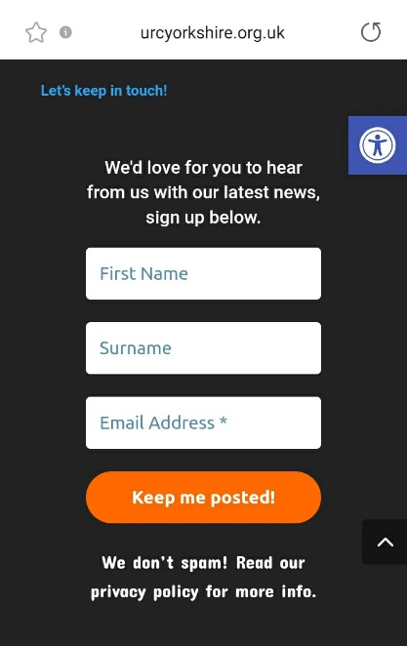
and guidance on what you can and cannot do and Find out what the rules are.

So after I get back in late August the plan is for the Briefing to go fortnightly. I mentioned the reasons for this last week, with the key reason being that we are looking to use the website as the primary means of communication. As we are able to upload details of events it means that they are effectively distributed, so long as you sign up to receive the newsletter. This facility to automatically generate a mailing which is distributed without fail on a Friday afternoon is designed for everybody; all you have to do is sign up in the box illustrated here, which you’ll find at the foot of the Yorkshire Synod (urcyorkshire.org.uk) home page and you become part of the Synod family. Don’t keep this little snippet of information to yourself – tell your friends, your church members and your congregations as a whole. There’s a whole array of things to help, guide and inform you, not only about the URC but also about how we can become a Jesus centred people.
Church Links, Mission Activities and Synod Events

Lay Preachers Planning Group news
Not only have the Lay Preaching planning group been working tirelessly this summer, they are also working to fill your autumn diaries as well. They have asked Lawrence Moore to lead an overview of Luke’s Gospel for worship leaders. The provisional dates are 2nd, 4th, 9th and & 11th November 2021 between 10.00am and 11.30am, with a repeat at 7.30pm on the dates mentioned. More details as we get closer here of the Briefing, on the website and on the Weekly Mailing (please sign up at Yorkshire Synod (urcyorkshire.org.uk)).
I know there are more things in the pipeline and news of these will be distributed in the usual ways.
And looking forward – into next year no less – Kath Lonsdale has asked that you keep the 22nd to 24th July 2022 clear if you are interested in a lay preachers weekend at Wydale conference centre. More details and a booking form nearer the time.

Property News
URC Buildings Forum Steering Group
The URC Buildings Forum Steering Group is planning some more conferences in the wake of the successful Buildings Forum held back on April 19th and more recently on July 21st.
The third and final conference for 2021 is on 14th October 2021 from 7.00pm to 8.30pm and will focus on environmental issues for church buildings, including Eco-Church and Eco-Congregation. More details will be forthcoming when available via Yorkshire Synod (urcyorkshire.org.uk).

IT Group News
Yorkshire Synod has launched its brand new Weekly Mailing! I have a feeling I have mentioned it before, but it’s worth mentioning again. It's a great way of keeping informed about what's going on, in and around the synod. It contains latest news on events past, present and future, good news stories, announcements, and general updates. Anyone can sign up, so spread the word around your congregations and ask them to sign up. It's very easy to do, visit the synod website www.urcyorkshire.org.uk and scroll down to the bottom of ANY page. You will see the sign up form on the right-hand side, fill it in, send it off and you'll be sent a confirmation email to confirm your subscription.
We look forward to you hearing from us!

A key thing to keep us informed is to supply the office with a simple A4 poster – including any pictures you can, so that we can upload it to the site. We’ll put it in the Latest News | URC Yorkshire Synod section and once done it will feature in the weekly newsletter (as well as being a fixture on the webpage. Simple, effective and visible to all.

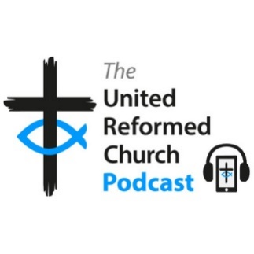
The latest episode of the URC podcast is now available at www.bit.ly/URCPodcast5 and on all major podcast platforms, looking at what it means to be a disciple of Jesus in the workplace.
Episode 5 - The Workplace by The United Reformed Church Podcast • A podcast on Anchor
Hosts Ann-Marie Nye and Simon Peters explore what it means to be a disciple of Jesus at work, talking with two people who work outside the Church, Pauline and David, about their experiences.
By the way – the previous issue is still available at https://bit.ly/URCPodcast4

Children and Young Peoples News
BOOKINGS ARE NOW OPEN
Sat Sep 18th 2021. ‘The LITTLE Big Day Out’
‘Little Big Day Out’ is a chance for churches and families to have fun and spend time together after so many months of isolation and limits on our lives. We cannot offer a large organised programme due to ongoing restrictions but we can provide some ‘time out’. We hope you and your families will find it valuable, if only to be together.
Tickets for this event are already at a reduced price but further subsidy is available, so please get in touch to discuss your church or families’ circumstance. Tickets are needed for everyone over 90cm tall (however old you are).
Download a booking form here or visit the website at Little Big Day Out | URC Yorkshire Synod. Bookings need to be received by Weds 1st Sep. Please contact us if you have any questions. If you can. Please get your numbers to us by 31st August and we look forward to seeing you in September.

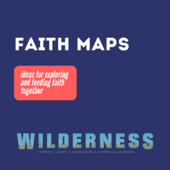
Wilderness Faith Maps
This simple weekly resource provides an easy way to engage with the Bible, prayer and the world around us. Linked to a Sunday Lectionary reading, it is suitable for all ages and faith experiences, as a starting point for a discussion or for personal reflection. You can find it each week here on Facebook, then like the page to be alerted when each weekly post arrives.

Yorkshire Synod Youth Weekend

October 1 @ 5:00 pm - October 3 @ 2:00 pm
After all the restrictions of the past year we are really pleased to be able to bring you the synod Youth Weekend again 1st – 3rd Oct at Kingswood Activity Centre, Dearne Valley. Last year was particularly hard on young people, so we are glad to be able to offer a residential weekend to socialise, have fun and join in all sorts of activities with friends.
There will also be time for young people to try praying and to look at the Bible together in a way that will be completely accessible if you don’t have any faith or church experience.
The cost of the weekend is only £25 per person. Leaders from URC groups will be welcome to come with any young people from their churches too. Please get in touch if you would like to join us.
So what are you waiting for? Please pass on the details and look out for the booking forms coming soon on this website. You can download the full poster from the website at Yorkshire Synod Youth Weekend | URC Yorkshire Synod to distribute and please do get in touch if you have any questions: wilderness@urcyorkshire.org.uk

URC Youth Assembly 2022
It’s that time of year again! Youth Assembly 2022 is just round the corner! Are you or do you know a 14-26 years old? (Yes, we have increased the age for this year!). Experience worship and participate in discussions about faith and life with people your age! Not the chatty type? A silent disco could be right up your street! For more info click here:
www.urc.org.uk/urc-youth-urc.html
Book your place before 1 January 2022 at www.urc.org.uk/urcya

There is a great deal happening in the CYP part of the Synod, and I do urge you to pass news of these events on to those who are key to nurturing the younger end of your congregations. Why not have a look at the latest newsletter here https://tinyurl.com/ssazwa4c and sign up for it to be sent directly to your e-mail address. All the Synod activities will be uploaded to the Yorkshire Synod Website as well, which does have a link for you to sign up to the weekly update.

General Information and Resource Sharing

Safeguarding News
Trustee training.
Matt Knowles, our Synod Safeguarding Adviser has managed to secure some more spaces in the training sessions being run by Farrer & Co regarding trustee responsibilities in respect of safeguarding. The training is free as it is funded by a successful application to the Synod Development fund managed by the Assembly Safeguarding Advisory Group. It is the same course that was successfully run last month, but this time it is being organised by SW Synod. Matt has been able to ensure that there will be spaces available for those who are Trustees within Yorkshire Synod able to attend the training in July.
The training will be via Zoom and the dates are:
17th November 2.30 p.m. -4.30 p.m, 23rd November 11 a.m. – 1 p.m, 30th November 11 a.m. – 1 p.m.

If you wish to attend, or if you know of someone who needs to attend then please send details to secretary@urcsouthwest.org.uk.

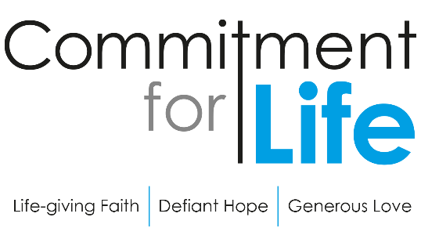
Harvest Service on Legacies
Commitment for Life has created a new service in conjunction with Christian Aid on leaving a Legacy. The Harvest service including full text and a video of the service is downloadable from our website by following the link https://urc.org.uk/commitment-for-life/worship-commitment-for-life.html
As this Harvest Service is a pilot legacy partnership, it would really help Christian Aid and CFL if you could kindly provide us with some feedback. Please do let CLF know if your church uses these CFL Harvest resources and how well it was received by the congregation.
A simple ‘How to do it’ style flyer, is in the process of being prepared and will be added to the Commitment For Life website by the end of August Commitment for life (urc.org.uk) .
Finally, Christian Aid are organising training on ‘talking about legacies in your church’ on 23rd September. Church leaders can book their place by emailing Kathy directly via this link: https://www.christianaid.org.uk/give/gifts-wills/remember-charity-week.

The Summer 2021 edition of In GEAR is now on the GEAR's web-site. This latest edition plus numerous back copies can be found at http://www.gear.org.uk/publications/in-gear-magazine/
You can download the PDF version by clicking on the relevant front page view. If you wish to receive a paper copy (or multiple copies), please complete the form on the web page.

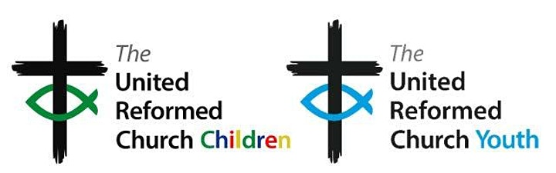
On Monday 27th September at 7.00pm there will be the Initial gathering of neuro-diverse adults and young people associated with the URC to explore how we might celebrate neuro-diversity.
Curated by URC Children's & Youth Work team, there will be sharing of stories and experiences, hopes and dreams for how the URC might be more inclusive and support a celebration of neuro-diversity. This event will use mixed verbal, text, and image based communication.
For more information, and to book a free place, please visit: Towards Appreciating Neuro-diversity in the URC Tickets, Mon 27 Sep 2021 at 19:00 | Eventbrite.

Worshipping God Together : Apart. Rev Janine Atkinson is back from her well-earned break and a new service for this coming weekend has been uploaded to the website where you will still find many of the services previously uploaded. As always a big thank you to Janine for these incredible resources. You can find it under the ‘What we do’ drop down heading if you fancy a Yorkshire Synod Website surf or more directly at https://urcyorkshire.org.uk/worship/

Time for God Volunteers
Has your church considered hosting a Time For God volunteer? If it has then this is for you, if it hasn’t then this is also for you. Rather than come through the Synod Office, all information can be gleaned from director@timeforgod.org. However if you would like the full size leaflets sent across, drop me a line at clerk@urcyorkshire.org.uk.

For those with local tastes I know that the Sheffield team have their services on their own website at http://sheffieldurc.org.uk/ and on the Yorkshire site you can find help in preparing and participating in Online Worship at COVID-19 Advice and Support | URC Yorkshire Synod.

St Andrew's URC Sheffield has a very gifted and committed organist who has put worship resources on every week since the beginning of the first lockdown. The music is an eclectic, rich and classical selection and the Reflection is read aloud with the words there on the screen for you to read yourself. The service from the previous week is immediately accessible below the new one, and earlier services are now archived and accessible too. www.standrewsurcsheffield.org.uk/stop-press

Please don’t hide these events in your inboxes. Please send this Briefing around your own church mailing lists as these events are for everyone, member or non-member, church-goer or non-church-goer. All these activities within and beyond Synod are designed to grow the Kingdom.
Plans are always happening to bring more activities and good news stories to your attention, so keep an eye open for the next Briefing. All you need to do is get in touch with me at clerk@urcyorkshire.org.uk.
If you know of anything you may find useful for our churches, please contact me at clerk@urcyorkshire.org.uk and I’ll circulate it here and on the website. Similarly if you need any further help, be it to do with IT, finance, property or the like we are here to help.
National URC site: https://urc.org.uk/ Yorkshire Synod: https://urcyorkshire.org.uk/ Yorkshire Synod Twitter: https://twitter.com/urcyorkshire Yorkshire Synod Facebook: https://www.facebook.com/urcyorkshire Yorkshire Young People’s Facebook: https://www.facebook.com/wildernessyorkshireurc/

Tim Crossley
Synod Clerk

