**Worshipping Together : Apart**

**Sunday 29th August 2021 at 10.30am**

**Church; Physically Distanced but Spiritually United**

Worship Prepared by Rev. Janine Atkinson

**A Call to Worship God**

I come, heart and mind, to worship you, Lord God, in this place.  
No matter whether I feel bruised, or triumphant, sad, or joyful,  
I lift my spirit to praise you, and acknowledge your worth.

**Hymn – R&S 586: MP 16:**

All my hope on God is founded;

he doth still my trust renew.

Me through change and chance he guideth,

only good and only true.

God unknown, he alone calls my heart to be his own.

Human pride and earthly glory,

sword and crown betray our trust;

what with care and toil is builded,

tower and temple, fall to dust.

But God’s power hour by hour is my temple and my tower.

God’s great goodness aye endureth,

deep his wisdom, passing thought;

splendour, light and life attend him,

beauty springeth out of naught.

Evermore from his store new-born worlds rise and adore.

Daily doth the almighty giver

bounteous gifts on us bestow;

his desire our soul delighteth

pleasure leads us where we go.

Love doth stand at his hand; joy doth wait on his command.

Still from earth to God eternal

sacrifice of praise be done,

high above all praises praising

for the gift of Christ his Son.

Christ doth call one and all; ye who follow shall not fall.

*Robert Bridges (1844-1930) altd.* based on Joachim Neander (1650-80)*

**Approaching God in Prayer and Saying Sorry**

Holy God, I am in awe of your power and your goodness.  
Your works are amazing; Your love is unrelenting.  
Your glory blazes through my life;

Your mercy surrounds me; Your grace astounds me.  
I worship and adore you.

Lord God, I am on a journey of faith *in* and *with* you.  
As we journey together towards a better way of living  
help me to find that I can support and encourage others as fellow travellers on the same journey,  
Lord God, make me wise and willing to hear from you today.

Help me to draw close to you Almighty God,  
so that I can focus on your voice,  
Help me to press **‘**pause’ on the noise and clamour of the world  
and the busyness of life.  
Help me to take time to slow my mind and open my heart,  
in preparation to receive what you want to give me today.  
Help me to be honest before you and with others.  
In Jesus’ name I come,   
and in his name, I pray.

Lord, I admit that sometimes my motives get murky.  
Forgive me when I ‘play-act’ my faith,  
not letting your word sink into me and dwell in me richly.  
Forgive me for the times when I just recite what sounds good  
without acknowledging the ugliness in my heart.  
Lord God,peel away the layers of my insincerity and hypocrisy,  
and bring me into the all-revealing light of your presence.  
Help me to live my life   
as a reflection of your grace and glory,  
so that when they meet me, people will find   
a genuine witness to your amazing gospel.  
In Jesus’ name I pray and as I say the prayer he taught us

Our Father, who art in heaven, hallowed be thy name.

Thy kingdom come, thy will be done on earth as it is in heaven.

Give us this day our daily bread.

And forgive us our trespasses,

as we forgive those who trespass against us.

And lead us not into temptation, but deliver us from evil.

For thine is the kingdom, the power and the glory, for ever and ever. Amen

**Gospel Reading: Mark 7: 1 – 9, 14 – 15, 21 – 23**

**(The Living Bible)**

One day some Jewish religious leaders - Pharisees and scribes - arrived from Jerusalem to investigate Jesus, 2and noticed that some of his disciples failed to follow the usual Jewish rituals before eating. 3(For the Jews, especially the Pharisees, will never eat until they have sprinkled their arms to the elbows, as required by their ancient traditions. 4So when they come home from the market, they must always sprinkle themselves in this way before touching any food.

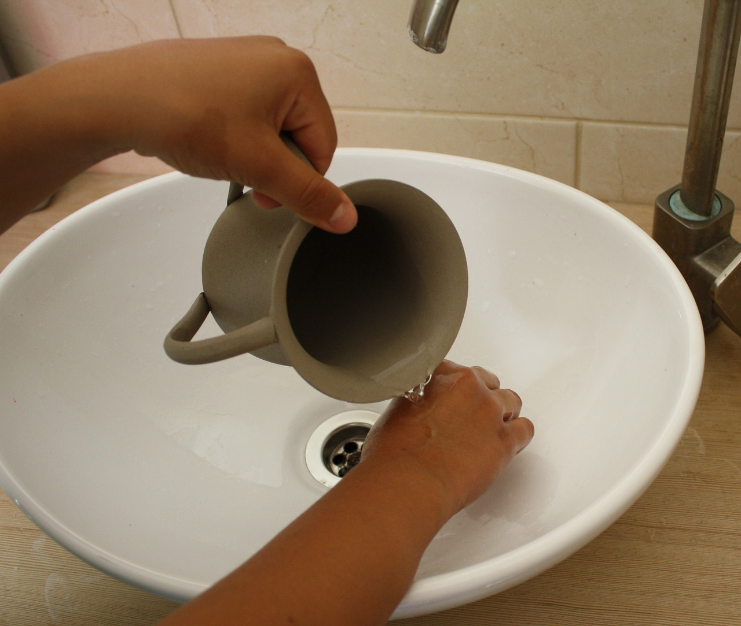

This is just one of many examples of laws and regulations they have clung to for centuries, and still follow, such as their ceremony of cleansing for pots, pans and dishes).

5So the religious leaders asked him, “Why don’t your disciples follow our age-old customs? For they eat without first performing the washing ceremony.”

6-7Jesus replied, “You bunch of hypocrites! Isaiah the prophet described you very well when he said, ‘These people speak very prettily about the Lord, but they have no love for him at all. Their worship is a farce, for they claim that God commands the people to obey their petty rules.’ How right Isaiah was! 8For you ignore God’s specific orders and substitute your own traditions.

9You are simply rejecting God’s laws and trampling them under your feet for the sake of tradition.

14Then Jesus called to the crowd to come and hear. “All of you listen,” he said, “and try to understand. 15-16Your souls aren’t harmed by what you eat, but by what you think and say!”

21For from within, out of people’s hearts, come evil thoughts of lust, theft, murder, adultery, 22wanting what belongs to others, wickedness, deceit, lewdness, envy, slander, pride, and all other folly. 23All these vile things come from within, they are what pollute you and make you unfit for God.”

**Setting the Scene**

Now the Pharisees were creating a distraction, they were trying to divert attention away from Jesus’ by bringing up fake news about the disciples not washing their hands – meanwhile, the real news was about Jesus bringing in God’s kingdom, but it was unwelcome news for the religious authorities of the day, because Jesus was upsetting the applecart of long devised and long held-to tradition.

These days we can tap into wall-to-wall news on the TV, radio and via social media. Some of it is true and, unfortunately, some of it is fake. So, we have work to do! Out of all the news and ideas we hear about, how do we tell real news from fake? How do we know what we should really be listening to and responding to and modelling our behaviour on?

Well, one way is to think about what seems to be the kindest, most generous, most welcoming and most loving way of behaving, because if anyone tells you that a mean, uncaring, heartless, and excluding way is the right way to behave then we won’t be behaving in the way Jesus wants us to.

There’s a handy way of reminding ourselves how to live out our faith when we act, speak or send messages. Before you speak, or write a message to someone, apply the ‘**THINK’** principle - Is what I am about to say **T**rue, **H**elpful, **I**nspiring, **N**ecessary and **K**ind?

If not, do something different, send a different message, change your thinking, so that what you say and write and do is good news for people, just as Jesus’ words were, so that what comes out of you in words and actions is good and true.

**Hymn – R&S 492: MP 111**

Dear Lord and Father of mankind, forgive our foolish ways!

Reclothe us in our rightful mind; in purer lives thy service find,

in deeper reverence, praise.

In simple trust like theirs who heard beside the Syrian sea

the gracious calling of the Lord, let us, like them, without a word,

rise up and follow thee.

O Sabbath rest by Galilee! O calm of hills above,

where Jesus knelt to share with thee the silence of eternity

interpreted by love!

With that deep hush subduing all our words and works that drown

the tender whisper of thy call, as noiseless let thy blessing fall

as fell thy manna down.

Drop thy still dews of quietness, till all our strivings cease;

take from our souls the strain and stress,

and let our ordered lives confess the beauty of thy peace.

Breathe through the heats of our desire thy coolness and thy balm;

let sense be dumb, let flesh retire; speak through the earthquake, wind, and fire, O still, small voice of calm!

*J.G. Whittier (1807-92)*

**New Testament Reading: James 1: 17 – 27 (NRSVA)**

**17**Every generous act of giving, with every perfect gift, is from above, coming down from the Father of lights, with whom there is no variation or shadow due to change. **18**In fulfilment of his own purpose he gave us birth by the word of truth, so that we would become a kind of first fruits of his creatures.

**Hearing and Doing the Word**

**19**You must understand this, my beloved: let everyone be quick to listen, slow to speak, slow to anger; **20**for your anger does not produce God’s righteousness. **21**Therefore rid yourselves of all sordidness and rank growth of wickedness, and welcome with meekness the implanted word that has the power to save your souls.

**22**But be doers of the word, and not merely hearers who deceive themselves. **23**For if any are hearers of the word and not doers, they are like those who look at themselves[[h](https://www.biblegateway.com/passage/?search=James%201&version=NRSVA#fen-NRSVA-30272h)] in a mirror; **24**for they look at themselves and, on going away, immediately forget what they were like. **25**But those who look into the perfect law, the law of liberty, and persevere, being not hearers who forget but doers who act — they will be blessed in their doing.

**26**If any think they are religious, and do not bridle their tongues but deceive their hearts, their religion is worthless. **27**Religion that is pure and undefiled before God, the Father, is this: to care for orphans and widows in their distress, and to keep oneself unstained by the world.

**Reflections**

It’s a few weeks since we were looking at Mark’s Gospel, but when we left Mark’s account of Jesus’ life and ministry, he was hectically busy, healing the sick by touching and being touched.

But this chapter begins with a story of hostile opposition, as the Pharisees complain that the disciples aren’t keeping their hands ritually clean. Presumably, and by implication, this complaint also extends to Jesus.

Mark manages to create an ironic contrast between the disciples getting their hands dirty in God’s work, and the Pharisees, focusing on keeping their hands clean but not involving themselves in caring for the sick in any way.

In his letter, James *(1.17)* tells us ‘Every generous act of giving, with every perfect gift, is from above, coming down from the Father of lights’. Jesus might have approved, if the washing advocated by the Pharisees had been an act of kindness for someone who needed help. But it wasn’t, it was merely obedience to pedantic, nit-picky rules.

The Pharisees believed that God’s will for his people was to be found in ritual and one of those rituals was being ritually pure by avoiding contact with anything unclean. This isn’t about dirt but about the ritual ‘uncleanness’ conveyed by contact with certain objects - principally anything dead. If someone came into contact with such a thing, they had to wash the ‘uncleanness’ off as soon as possible and certainly before eating anything. This was one of the ways they identified themselves as ‘different’ from other Jews, carefully following the traditions that they believed came originally from words spoken by Moses, words that were remembered, rather than those that had been written down.

Now, the gospels are consistently hostile to the Pharisees, who were the early Church’s major competitors for ‘converts’ by the time the gospels were written and Mark describes how Jesus responds to them by criticising their attitude to God. He quotes Isaiah whose words are part of the prophetic tradition that attacks those who worship God in ‘word’ but not in ‘action’.

Of course, in our churches we have rituals and rules! I wonder, what rituals and rules, written or unwritten, are important to us? Are they justified? What might ‘visitors’ think about them?

There’s a story told about a man, who started attending a church. He went for several weeks but no one spoke to him. One day he forgot to remove his hat. It wasn’t long before someone spoke to him then - to ask him to remove his hat!

What revealing stories could you tell, about ‘rules’ or ‘rituals’ that get in the way of welcome, and what stories might people tell us about their experiences of ‘rules’ and ‘rituals’ in church? What habits of ours get in the way of people encountering God? Will the last 18 months have created habits that will be questioned in 100 years? ‘Dad, why does the minister sanitise her hands before receiving the offertory plate?’

What defines our church communities?

Jesus contrasts (perhaps unfairly) an elitist and rather fussy group, who form a community based on outward adherence to ritual, with his disciples, whom he is forming into a community of inner disposition - what we might call grace.

It’s not always easy to see ourselves as others see us, but trying to imagine what others see when they look at us might be a useful way of discovering whether or not we are ‘grace-ful’ communities and how (if even at all) we bring life, nourishment and healing to others.

Jesus went on to tell the crowd a parable, and to offer the disciples an explanation, about the difference between what goes into someone’s mouth and what comes from the heart. In both Greek and Hebrew thinking, the heart is the seat of both thought and action; so what you put in your heart will determine what you will think is right and how you live in the light of it.

The list of sins that Mark lists is similar to those found elsewhere in the New Testament and in both Jewish and Gentile texts from that period.

Mark’s telling of this event stands alongside other accounts of Jesus’ teaching, for example in Matthew chapter 5, where he focuses on getting the heart right so that right action follows on.

Newly emerging Christian communities found themselves facing this issue very early on. In the book of Acts, Luke describes the vision that convinced Peter that nothing created by God was unclean, and Paul fought this same battle repeatedly.

Because of Jesus there is no need for this ‘ritual’ for Christians because, theologically speaking, Christians are made clean, once and for all, by the sacrifice of Christ.

Sociologically speaking, Jesus establishes a community open to anyone and everyone who puts their trust in him. This enables us to turn away from the use of any kind of ‘rule’ or ‘ritual’ that might cause us to maintain hierarchy, create power, exclude, or belittle *anyone*.

In undermining the Jewish food laws Jesus is saying that it’s the things that come out of a person that defiles them. Evil words and actions come from inside and it’s these that hurt and destroy others.

So, remember to apply the ‘**THINK’** principle; run your ideas through this filter - Is what I am about to say **T**rue, **H**elpful, **I**nspiring, **N**ecessary and **K**ind? If not, change your words and actions – for God’s sake.

**Hymn – R&S 294: MP 89**

Come down, O Love Divine, seek thou this soul of mine,

and visit it with thine own ardour glowing;

O Comforter, draw near, within my heart appear,

and kindle it, thy holy flame bestowing.

O let it freely burn, till earthly passions turn

to dust and ashes in its heat consuming;

and let thy glorious light shine ever on my sight,

and clothe me round, the while my path illuming.

Let holy charity mine outward vesture be,

and lowliness become mine inner clothing;

true lowliness of heart, which takes the humbler part,

and o’er its own shortcomings weeps with loathing-

And so the yearning strong with which the soul will long,

shall far outpass the power of human telling;

for none can guess its grace, till he become the place

wherein the Holy Spirit makes his dwelling.

*Bianco Da Siena (d. 1434) tr. R. F. Littledale (1833-90)*

**Holding the World in Prayer**

God of justice,  
we live in an unjust world.  
We are all too aware that shame stalks the corridors of power  
and that hypocrisy is second nature to many.

Lord God, in your mercy,  
remove the dinginess of disgrace and discrimination,  
to reveal truth and promote light,

and call the world to see you through your beloved Son.

Help me to be wise in how I conduct my life   
and in how I interact with others.  
Make a ‘doer’ of your word and a ‘bringer’ of peace.

Where there is nothing but cruelty,  
may I plant the seeds of kindness.  
Where life is full of the fake and the false,  
make me an advocate of truth.

May those in power not be trigger-happy with their retorts,   
but thoughtful and wise.  
Give us all discernment in how we respond  
to the myriad voices and the plethora of opinions  
that surround us in today’s world.

Help me to seek what is genuine and choose what is real.  
For Jesus’ sake. Amen

**Praying for yourself**

*Wash your hands with soap and water for at least the ‘recommended’ 20 seconds and as you do think about the things you*

*know are wrong in your life and silently say sorry to God*



* **and pray**

Lord God, I wash my hands,

but I know that it is clean hearts and minds that you desire.

Help me to be clean on the inside,

so that what comes out of me -

my words and actions - will be good and kind. Amen

**Hymn – to the tune for ‘Be thou my vision’**

Love is the touch of intangible joy;

love is the force that no fear can destroy;

love is the goodness we gladly applaud:

God is where love is, for love is of God.

Love is the lilt in a lingering voice;

love is the hope that can make us rejoice;

love is the cure for the frightened and flawed:

God is where love is, for love is of God.

Love is the light in the tunnel of pain;

love is the will to be whole once again;

love is the trust of a friend on the road:

God is where love is, for love is of God.

Love is the Maker and Spirit and Son;

love is the kingdom their will has begun;

love is the pathway the saints all have trod:

God is where love is, for love is of God.

*© Alison M. Robertson - 2005*

**Closing Words and Blessing**

With the Word of God in my heart,  
I pray that I will embody it in my life,  
and be a true witness to the great hope I have in Jesus.  
Help me, Holy Spirit, to keep in step with you  
and grow more like Jesus every day. Amen.

And may the grace of our Lord Jesus Christ,

the love of God and the fellowship of the Holy Spirit,

be with us all, evermore. Amen

*Hymn words reproduced under the CCLI Licence numbers of the SPACE Group of Churches: 181588 - Grove URC: 178113 - The URC Heckmondwike: 177949 - Longcauseway Church: 1236906 - Norristhorpe URC: 783508 - Ravensthorpe with Hopton URC*

*Images* [*www.pixabay.com*](http://www.pixabay.com) *and* [*www.unsplash.com*](http://www.unsplash.com) *Sean Horsburgh @seanhorsburgh*