The Briefing – Number 66
2nd September 2021
Dear Friends,
The beginning of September always seems, to me at least, to be the start of something new. It could be that it is the start of the academic year, and with three school-age children this time of the year always revolves around new shoes, new uniforms and new stationery. It could be that after a two-week holiday the mind and body are refreshed and ready for new challenges. It is also the time to start filling the freezer up with this year’s blackberries, ready for pies, crumbles and jam.
It comes as no surprise then that this issue of the Briefing marks something new and marks a bit of a departure from what I have been doing since March 2020. Rather than the Briefing being a weekly publication, I hope to be able to bring it to you twice a month – probably on the first Thursday and the third Thursday. There may be a need in the future to return to a weekly format, but with the weekly news update being sent automatically, and to which it is really easy to sign up at the foot of this page Yorkshire Synod (urcyorkshire.org.uk), the Briefing becomes bi-monthly. As we are able to upload details of events to the website it means that they are effectively distributed, so long as you sign up to receive the newsletter. This facility to automatically generate a mailing which is distributed without fail on a Friday afternoon is designed for everybody; all you have to do is sign up in the box illustrated here, which you’ll find at the foot of the Yorkshire Synod (urcyorkshire.org.uk) home page and you become part of the Synod family. Don’t keep this little snippet of information to yourself – tell your friends, your church members and your congregations as a whole. There’s a whole array of things to help, guide and inform you, not only about the URC but also about how we can become a Jesus centred people

Having said that we still need to be acutely aware of the Covid-19 situation and be careful in the way we continue to open up our church buildings to both regular attendees and to new friends. Let’s not forget or forego the good work we have done since March last year. So I make no apology again for highlighting the advice from the denomination as well as from the government so please do take note of the advice that is contained in these links:
The URC Synod Moderators’ New Freedoms, Same Responsibilities: Synod Moderators' advice to congregations (urc.org.uk)
The URC’s main Advice to churches about coronavirus from the United Reformed Church
Government sites at Coronavirus: how to stay safe and help prevent the spread - GOV.UK (www.gov.uk) and guidance on what you can and cannot do and Find out what the rules are.

Church Links, Mission Activities and Synod Events

Lay Preachers Planning Group news

Exploring the upcoming lectionary readings together
The next lay preacher preparation sessions will be on Tuesday 14th September on Zoom at 10am -11.30am and then repeated at 7.30pm -9pm that evening.
The session will be facilitated by Rod Morrison and they will be a time for participants to look together at the lectionary readings for 19th & 26th September, 3rd & 10th October in preparation for leading worship on those Sundays.

Also for your autumn diaries is Lawrence Moore’s series on Luke’s Gospel for worship leaders. The provisional dates are 2nd, 4th, 9th and & 11th November 2021 between 10.00am and 11.30am, with a repeat at 7.30pm on the dates mentioned. More details as we get closer here of the Briefing, on the website and on the Weekly Mailing (please sign up at Yorkshire Synod (urcyorkshire.org.uk)).
I know there are more things in the pipeline and news of these will be distributed in the usual ways.
And looking forward – into next year no less – Kath Lonsdale has asked that you keep the 22nd to 24th July 2022 clear if you are interested in a lay preachers weekend at Wydale conference centre. More details and a booking form nearer the time.

Property News
URC Buildings Forum Steering Group
The URC Buildings Forum Steering Group is planning some more conferences in the wake of the successful Buildings Forum held back on April 19th and more recently on July 21st.
The third and final conference for 2021 is on 14th October 2021 from 7.00pm to 8.30pm and will focus on environmental issues for church buildings, including Eco-Church and Eco-Congregation. More details will be forthcoming when available via Yorkshire Synod (urcyorkshire.org.uk).

IT Group News
Yorkshire Synod has launched its brand new Weekly Mailing! I have a feeling I have mentioned it before, but it’s worth mentioning again. It's a great way of keeping informed about what's going on, in and around the synod. It contains latest news on events past, present and future, good news stories, announcements, and general updates. Anyone can sign up, so spread the word around your congregations and ask them to sign up. It's very easy to do, visit the synod website www.urcyorkshire.org.uk and scroll down to the bottom of ANY page. You will see the sign up form on the right-hand side, fill it in, send it off and you'll be sent a confirmation email to confirm your subscription.
We look forward to you hearing from us!
A key thing to keep us informed is to supply the office with a simple A4 poster – including any pictures you can, so that we can upload it to the site. We’ll put it in the Latest News | URC Yorkshire Synod section and once done it will feature in the weekly newsletter (as well as being a fixture on the webpage. Simple, effective and visible to all.

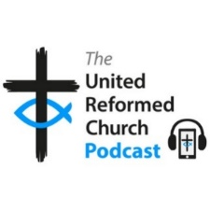
The regular URC podcasts can all be found at The United Reformed Church Podcast • A podcast on Anchor.
The latest episode on Antiracism is now available as are the previous issues including podcasts on The Workplace, Money and Climate Crisis. They are all well worth a listen.
Children and Young Peoples News
BOOKINGS ARE NOW OPEN
October 1st to October 3rd - ‘SYNOD YOUTH WEEKEND’
The Synod Youth Weekend is only a month away. It will take place at Kingswood residential activity centre near Doncaster and is open to anyone aged 11-17 connected to your church. This will be a great opportunity for young people to socialise again and do something different, with a wide range of activities available for only £25 for the weekend. We will also spend some time together finding out about prayer and the Bible in a way that will be easy for young people with no church experience to be part of. Further details and booking forms are available on the synod website: https://urcyorkshire.org.uk/event/yorkshire-synod-youth-weekend/
Leaders from URC groups will be welcome to come with any young people from their churches too. Please get in touch if you would like to join us. So what are you waiting for? Please pass on the details and look out for the booking forms on the website. You can download the full poster from the website at Yorkshire Synod Youth Weekend | URC Yorkshire Synod to distribute and contact wilderness@urcyorkshire.org.uk if you have any questions.

Please pass this information on to your congregations and connections. All young people who have a connection to your church or its members are welcome to join us, please get in touch if you have any questions.

Wilderness Faith Maps
This simple weekly resource is an easy way to engage with the Bible, prayer and the world around us. Linked to a Sunday Lectionary reading, it is suitable for all ages and faith experiences, as a starting point for a discussion or for personal reflection. You can find it each week here on Facebook, then like the page to be alerted when each weekly post arrives.

URC Youth Assembly 2022
It’s that time of year again! Youth Assembly 2022 is just round the corner! Are you or do you know a 14-26 years old? (Yes, we have increased the age for this year!). Experience worship and participate in discussions about faith and life with people your age! Not the chatty type? A silent disco could be right up your street! For more info click here: www.urc.org.uk/urc-youth-urc.html
To book your place click here www.urc.org.uk/urcya before 1st January 2022.
General Information and Resource Sharing

Safeguarding News
In advance of the publication of the CPIROS (Child Protection in Religious Organisations and Settings) investigation report on 2 September, support has been made available for those who require it.
The Independent Inquiry into Child Sexual Abuse's support service will be available, via phone, to witnesses and core participants of the CPIROS investigation in the lead up to publication, on the day of publication and for 4 to 6 weeks after publication. Core participants and witnesses can be allocated a support worker by contacting the support team at investigationsupport@iicsa.org.uk or on 0203 7892 206 (please leave a voicemail).

Training.
Following up from the Foundation (Basic) Safeguarding Training packages, the Intermediate Safeguarding Training Package is now up and running. This package follows on from the content of the foundation training based within Good Practice 5 and covers more in depth areas of safeguarding for use within the local church. It will last about 2 ½ hours with breaks to get drinks etc – as well as giving you time away from listening to Matt if needed!!
Initially, this training will be provided in an online format. However, as we move into 2022 it may be that it moves to a physical setting. Watch this space for updates!!
Everyone who attended basic training in the past three years invited to attend this intermediate training, so to bring those without that basic training some more sessions are being planned.
All courses are booked via the Synod office. Please contact Sally via email to confirm your places or to get more information at moderatorpa@urcyorkshire.org.uk.
The dates are as follows: Foundation (Basic) courses – 2 hours in duration
Wednesday 15th September 2021 – 1pm to 3pm
Tuesday 21st September 2021 – 10am to 12pm
Thursday 2nd December 2021 – 9.30am to 11.30am

Intermediate courses – 2 ½ hours in duration
Wednesday 13th October 2021 – 2pm to 4.30pm
Tuesday 19th October 2021 – 10am to 12.30pm
Thursday 28th October 2021 – 10am to 12.30pm
Wednesday 3rd November 2021 – 9.30am to 12pm
Saturday 13th November 2021 – 10am to 12.30pm
Wednesday 17th November 2021 – 9.30am to 12pm
Thursday 25th November 2021 – 1pm to 3.30pm

Matt has also managed to secure some more spaces in the Trustee Training safeguarding sessions being run by Farrer & Co. The training is free as it is funded by a successful application to the Synod Development fund managed by the Assembly Safeguarding Advisory Group. It is the same course that was successfully run in July, but this time it is being organised by SW Synod. Matt has been able to ensure that there will be spaces available for those who are Trustees within Yorkshire Synod able to attend the training in July. The training will be via Zoom and the dates are:
17th November 2.30pm -4.30pm, 23rd November 11am – 1pm, 30th November 11am – 1pm

If you wish to attend, or if you know of someone who needs to attend then please send details to secretary@urcsouthwest.org.uk.

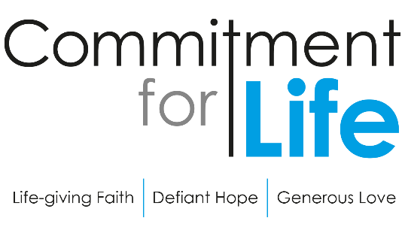
Harvest Service on Legacies
Commitment for Life has created a new service in conjunction with Christian Aid on leaving a Legacy. The Harvest service including full text and a video of the service is downloadable from our website by following the link https://urc.org.uk/commitment-for-life/worship-commitment-for-life.html
As this Harvest Service is a pilot legacy partnership, it would really help Christian Aid and CFL if you could kindly provide us with some feedback. Please do let CLF know if your church uses these CFL Harvest resources and how well it was received by the congregation. A simple ‘How to do it’ style flyer should now be available at Commitment for life (urc.org.uk).
Finally, Christian Aid are organising training on ‘talking about legacies in your church’ on 23rd September. Church leaders can book their place by emailing Kathy directly via this link: https://www.christianaid.org.uk/give/gifts-wills/remember-charity-week.

The Summer 2021 edition of In GEAR is now on the GEAR's web-site. This latest edition plus numerous back copies can be found at http://www.gear.org.uk/publications/in-gear-magazine/
You can download the PDF version by clicking on the relevant front page view. If you wish to receive a paper copy (or multiple copies), please complete the form on the web page.

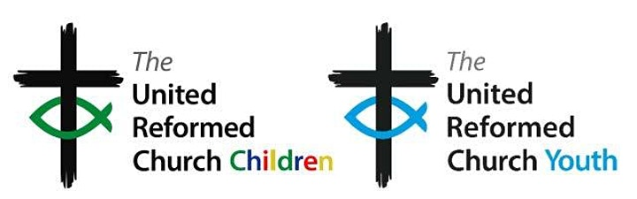
On Monday 27th September at 7.00pm sees the Initial gathering of neuro-diverse adults and young people associated with the URC to explore how we might celebrate neuro-diversity. Curated by URC Children's & Youth Work team, there will be sharing of stories and experiences, hopes and dreams for how the URC might be more inclusive and support a celebration of neuro-diversity. This event will use mixed verbal, text, and image based communication. For more information, and to book a free place, please visit: Towards Appreciating Neuro-diversity in the URC Tickets, Mon 27 Sep 2021 at 19:00 | Eventbrite.

Worshipping God Together : Apart. Rev Janine Atkinson is back and a new service for this coming weekend has been uploaded to the website where you will still find many of the services previously uploaded. As always a big thank you to Janine for these incredible resources. You can find it under the ‘What we do’ drop down heading if you fancy a Yorkshire Synod Website surf or more directly at https://urcyorkshire.org.uk/worship/
The latest issue of the URC News Update September 2021 (urc-news.org.uk) is now available. It has updates on the impending URC 50th Anniversary plans including how to get hold of resource packs, a General Assembly Round Up, how to contribute to the Haiti Emergency Appeal and the news that Shiregreen URC has become the first URC to receive the new Youth Friendly Scheme award First Children and Youth Friendly Church Scheme plaque presented.

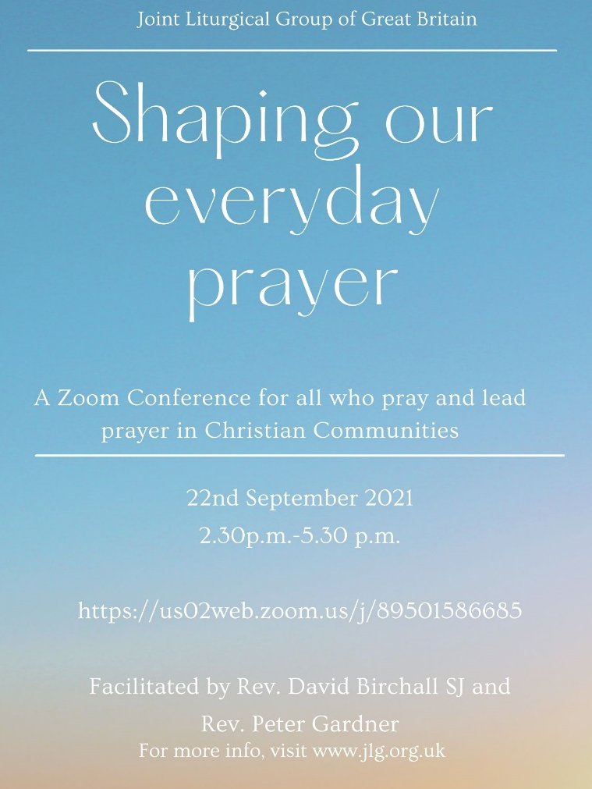
The Ecumenical & Interfaith Relations group are taking a hand in the organisation of this conference being held on 22nd September via Zoom. The zoom link is https://us02web.zoom.us//j/89501586685
For more details please visit www.jlg.org.uk

Time for God Volunteers
Has your church considered hosting a Time For God volunteer? If it has then this is for you, if it hasn’t then this is also for you. Rather than come through the Synod Office, all information can be gleaned from director@timeforgod.org. However if you would like the full size leaflets sent across, drop me a line at clerk@urcyorkshire.org.uk.

For those with local tastes I know that the Sheffield team have their services on their own website at http://sheffieldurc.org.uk/ and on the Yorkshire site you can find help in preparing and participating in Online Worship at COVID-19 Advice and Support | URC Yorkshire Synod.

St Andrew's URC Sheffield has a very gifted and committed organist who has put worship resources on every week since the beginning of the first lockdown. The music is an eclectic, rich and classical selection and the Reflection is read aloud with the words there on the screen for you to read yourself. The service from the previous week is immediately accessible below the new one, and earlier services are now archived and accessible too. www.standrewsurcsheffield.org.uk/stop-press

Please don’t hide these events in your inboxes. Please send this Briefing around your own church mailing lists as these events are for everyone, member or non-member, church-goer or non-church-goer. All these activities within and beyond Synod are designed to grow the Kingdom.
Plans are always happening to bring more activities and good news stories to your attention, so keep an eye open for the next Briefing. All you need to do is get in touch with me at clerk@urcyorkshire.org.uk.
If you know of anything you may find useful for our churches, please contact me at clerk@urcyorkshire.org.uk and I’ll circulate it here and on the website. Similarly if you need any further help, be it to do with IT, finance, property or the like we are here to help.
National URC site: https://urc.org.uk/ Yorkshire Synod: https://urcyorkshire.org.uk/ Yorkshire Synod Twitter: https://twitter.com/urcyorkshire Yorkshire Synod Facebook: https://www.facebook.com/urcyorkshire Yorkshire Young People’s Facebook: https://www.facebook.com/wildernessyorkshireurc/

Tim Crossley
Synod Clerk

