The Briefing – Number 68
30th September 2021

Dear Friends,

Now before you mention it, I know I said that the Briefing would be published on the 1st and 3rd Thursdays in the month. However as this month contains five Thursdays, I will refer you all to one of the URC’s favourite words “normally”. Normally I would have published the Briefing on the 1st and 3rd Thursdays, but this month we are blessed (or so it seems) with this fifth Thursday, and there are some things that need mentioning before the Synod meetings of Thursday 7th and Saturday 9th October.

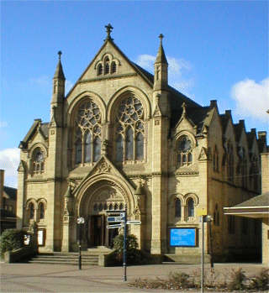
Although this is meant to be a mini-briefing, primarily to highlight the fact that the Autumn Synod meeting will be taking place next week, there are a few things that need to be mentioned before they happen. First of all this is a reminder that next week’s Yorkshire Synod meeting will be an opportunity to meet in body for the first time since October 2019. The Synod meeting will comprise two parts, the first on the “Zoom” digital platform will be held on the evening of Thursday 7th October, the second part on the morning of Saturday 9th October Synod will convene at Longcauseway Church, Dewsbury. After last times split meeting it was felt that to split this meeting meant that it opened it up to a greater number of people and we aim to live stream the proceedings from Dewsbury as well for those unable to attend in person. The log in details for the Thursday evening part of the meeting will soon be with your church synod representatives, church secretaries and ministers. Another way to get details of how to join us, please contact office@urcyorkshire.org.uk for details. The Saturday session will be live streamed on the Yorkshire Synod YouTube page. To access this all you need to do is click here https://bit.ly/urcyorkshireyoutube and it will take you there. I am reminded to ask you that once you do, please like the page and sign up for updates. As with all things new, we would like to hear your feedback as that will be taken into account when we begin planning the Spring 2022 meeting.

We still need to be acutely aware of the Covid-19 situation. Let’s continue to be careful in the way we open up our church buildings this autumn. Don’t forget or forego the good work we have done since March last year. Please do take note of the advice that is contained in these links:
The URC Synod Moderators’ New Freedoms, Same Responsibilities: Synod Moderators' advice to congregations (urc.org.uk)
The URC’s main Advice to churches about coronavirus from the United Reformed Church
Government sites at Coronavirus: how to stay safe and help prevent the spread - GOV.UK (www.gov.uk) and guidance on what you can and cannot do and Find out what the rules are.

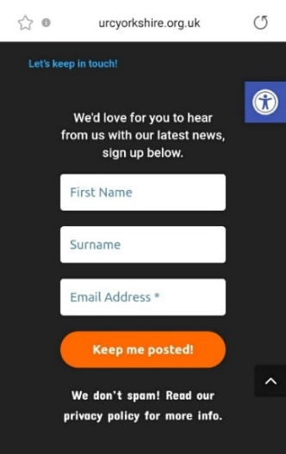
As I mentioned last week I had hoped to be able to bring the Briefing twice a month – probably on the first Thursday and the third Thursday – but today is a bit of an exception. I still would like to hear from you so that I can get your news out to a wide audience. Not only does it end up in the Briefing, but also we can put it on the website in the News section Latest News | URC Yorkshire Synod. It doesn’t matter if it is a small event or an earth shattering announcement, send it in and then sign up to the weekly news update which is sent out automatically each Friday. It is really easy to sign up; look at the foot of the Yorkshire Synod (urcyorkshire.org.uk) page, find the bit that looks like this image and simply fill it in. It’s not a secret so please tell your friends, your church members and your congregations as a whole. There is a whole array of things to help, guide and inform you, not only about the URC but also about how we can become a Jesus centred people

Church Links, Mission Activities and Synod Events

Lay Preachers Planning Group news

After good feedback on last year’s overview on Mark we have planned
‘An overview of Luke led by Lawrence Heath-Moore’
2nd, 4th, 9th & 11th November
10.00am-11.30am repeated at 7.30pm-9.00pm
Lawrence Heath-Moore will lead a series of sessions via the Zoom platform on the gospel of Luke (the upcoming 'Year' in the revised common lectionary). The sessions will be interactive, informal, and set you up well for a year of preaching on Luke! Whether you are a seasoned preacher, minister, lay preacher, worship leader, elder, Bible study leader or just interested please book your place with the Synod office
office@urcyorkshire.org.uk 0113 289 8490.

More details as we get closer here on the Briefing, on the website and on the Weekly Mailing (please sign up at Yorkshire Synod (urcyorkshire.org.uk)).

I know there are more things in the pipeline and news of these will be distributed in the usual ways.
And looking forward – into next year no less – Kath Lonsdale has asked that you keep the 22nd to 24th July 2022 clear if you are interested in a lay preachers weekend at Wydale conference centre. More details and a booking form nearer the time.

Property News
Faith New Deal Pilot Fund: new grant opportunity
Time is now very, very tight if you want to explore this potential grant funding opportunity as the closing date is 7th October. The Faith New Deal Pilot Fund is a new, competitive grant programme to help support faith-based organisations use their resources effectively within their community and to build trust between national & local government and faith groups. To find out more the details are on the government website: https://www.gov.uk/government/publications/faith-new-deal-pilot-fund/faith-new-deal-pilot-fund-prospectus#how-to-apply--the-application-and-assessment-process
and the application form can be downloaded here https://assets.publishing.service.gov.uk/government/uploads/system/uploads/attachment_data/file/1015500/Faith_New_Deal_Pilot_Fund_application_form.odt
URC Buildings Forum Steering Group
The URC Buildings Forum Steering Group is planning some more conferences in the wake of the successful Buildings Forum held back on April 19th and more recently on July 21st.
The third and final conference for 2021 is on 14th October 2021 from 7.00pm to 8.30pm and will focus on environmental issues for church buildings, including Eco-Church and Eco-Congregation. More details will be forthcoming when available via Yorkshire Synod (urcyorkshire.org.uk).

Children and Young Peoples News

Wilderness Faith Maps
This simple weekly resource is an easy way to engage with the Bible, prayer and the world around us. Linked to a Sunday Lectionary reading, it is suitable for all ages and faith experiences, as a starting point for a discussion or for personal reflection. You can find it each week here on Facebook, then like the page to be alerted when each weekly post arrives.

URC Youth Assembly 2022
It’s that time of year again! Youth Assembly 2022 is just round the corner! Are you or do you know a 14-26 years old? (Yes, we have increased the age for this year!). Experience worship and participate in discussions about faith and life with people your age! Not the chatty type? A silent disco could be right up your street! For more info click here: www.urc.org.uk/urc-youth-urc.html
To book your place click here www.urc.org.uk/urcya before 1st January 2022.

General Information and Resource Sharing

Safeguarding News
Training.
Following up from the Foundation (Basic) Safeguarding Training packages, the Intermediate Safeguarding Training Package is now up and running and filling up very fast. As of earlier this week, the list of available courses and dates is as follows:

Foundation (Basic) courses all now fully booked, more planned in 2022
Intermediate courses Saturday 13th November 2021 – 10am to 12.30pm
Wednesday 17th November 2021 – 9.30am to 12pm
Thursday 25th November 2021 – 1pm to 3.30pm
All courses are booked via the Synod office. Please contact Sally via email to confirm your places or to get more information at moderatorpa@urcyorkshire.org.uk.
Please be aware that these dates are filling up very quickly. Having said that I am reliably informed that more dates will be available in the New Year.
Matt has also managed to secure some more spaces in the Trustee Training safeguarding sessions. The training is free as it is funded by a successful application to the Synod Development fund. It is the same course that was successfully run in July, but this time it is being organised by SW Synod. Matt has been able to ensure that there will be spaces available for those who are Trustees within Yorkshire Synod unable to attend the training in July. The training will be via Zoom and the dates are:
17th November 2.30 p.m. -4.30 p.m, 23rd November 11 a.m. – 1 p.m, 30th November 11 a.m. – 1 p.m.
If you wish to attend, or if you know of someone who needs to attend then please send details to secretary@urcsouthwest.org.uk.

IT NEWS
News from the Mersey Synod: They are throwing open their Copyright Clinic to the wider Church fellowship. Like the Copyright Clinic of earlier in the year that Yorkshire hosted this Copyright Clinic will be on Zoom and will highlight best practice as well as answering any of your questions.
It will take place on Wednesday 13 October 1.30pm.
Please contact synodadmin@urcmerseysynod.org.uk if you would like to sign up and a code will be sent out. The sessions will include:

- principles of copyright
- can I use YouTube videos?
- copyright advice for hybrid/online worship
- what licences do I need?
- best practice for church services
- finding copyright free media (photos, videos, images)
- top tips.

Worshipping God Together : Apart. Rev Janine Atkinson’s regular services and reflections are still being uploaded to the website. As always a big thank you to Janine for these incredible resources. You can find it under the ‘What we do’ drop down heading if you fancy a Yorkshire Synod Website surf or more directly at https://urcyorkshire.org.uk/worship/

The latest issue of the URC News Update October 2021 (urc-news.org.uk)is now available. It has updates on the impending URC 50th Anniversary plans, how to get hold of resource packs, plans for the upcoming COP26 conference in Glasgow, Discipleship grants, and how to contribute to the Haiti Emergency Appeal. Not only that but there is a link to the new look URC shop The United Reformed Church Bookshop (urcshop.co.uk) which I’m told is full of all those things that you didn’t know you needed, as well as The 2021 Advent Box for churches to give out to families. This year it is called Come & See and is now available to pre-order. Ann-Marie, who edits the URC News Update (like me) is always on the hunt for stories to tell. Don’t leave it to the deadline, drop her a line at ann-marie.nye@urc.org.uk and get your good news out there.

ECO News
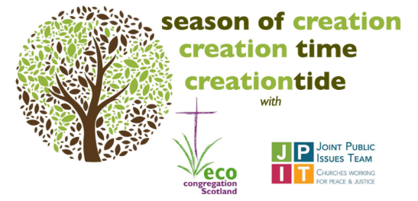
For anyone still looking for material for Harvest or Creation Time worship, this is as good a place as any to look.
https://www.ecocongregationscotland.org/creation-time/. It will also link into imminent COP26 conference and the work JPIT is doing in relation to the climate emergency.

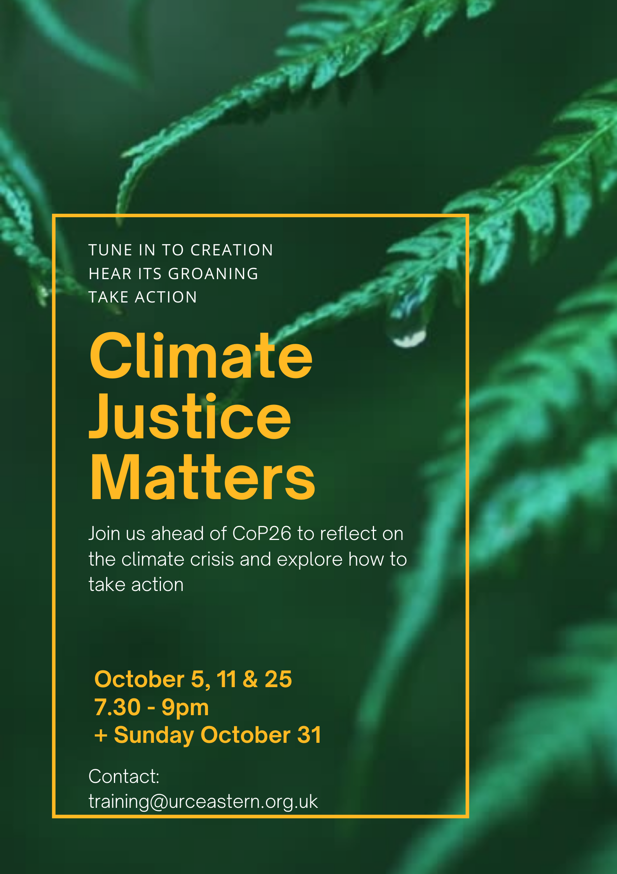
And In the run up to COP26, the Eastern Synod is running a series of sessions on climate justice to which we have been invited. For details please contact Lindsay Brown, Eastern’s Mission and Training Officer, at training@urceastern.org.uk.

For those with local tastes I know that the Sheffield team have their services on their own website at http://sheffieldurc.org.uk/ and on the Yorkshire site you can find help in preparing and participating in Online Worship at COVID-19 Advice and Support | URC Yorkshire Synod.

St Andrew's URC Sheffield has a very gifted and committed organist who has put worship resources on every week since the beginning of the first lockdown. The music is an eclectic, rich and classical selection and the Reflection is read aloud with the words there on the screen for you to read yourself. The service from the previous week is immediately accessible below the new one, and earlier services are now archived and accessible too. www.standrewsurcsheffield.org.uk/stop-press

Situations Vacant
Please feel free to share the link https://urc.org.uk/vacancies.html within your circle for the following URC posts that are currently being recruited.
- Training and Development Coordinator for Safeguarding
- Director of Ministry Formation, Westminster College
- Designated Safeguarding Lead
- Minister for Digital Worship
Full details are on the website, if you have any questions please direct them in that direction.

Please don’t hide these events in your inboxes. Please send this Briefing around your own church mailing lists as these events are for everyone, member or non-member, church-goer or non-church-goer. All these activities within and beyond Synod are designed to grow the Kingdom.
Plans are always happening to bring more activities and good news stories to your attention, so keep an eye open for the next Briefing. All you need to do is get in touch with me at clerk@urcyorkshire.org.uk.
If you know of anything you may find useful for our churches, please contact me at clerk@urcyorkshire.org.uk and I’ll circulate it here and on the website. Similarly if you need any further help, be it to do with IT, finance, property or the like we are here to help.
National URC site: https://urc.org.uk/ Yorkshire Synod: https://urcyorkshire.org.uk/ Yorkshire Synod Twitter: https://twitter.com/urcyorkshire Yorkshire Synod Facebook: https://www.facebook.com/urcyorkshire Yorkshire Young People’s Facebook: https://www.facebook.com/wildernessyorkshireurc/

Tim Crossley
Synod Clerk

