**The Briefing – Number 69**

**7thth October 2021**

Dear Friends,

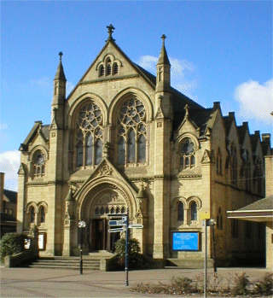We are back to where we are meant to be, and welcome to the first Thursday in October. This week sees the meeting of Synod, in another new format. Tonight sees a session of Zoom and on Saturday 9th October sees the first physical meeting of the whole body of Synod since October 2019 when we all met at Herringthorpe. The log in details for the tonight’s part of the meeting are with your church synod representatives, church secretaries and ministers. On Saturday we are spending the morning with Longcauseway Church in Dewsbury. I would like to take this opportunity to say thank you on behalf of Synod for the gracious way in which the good folk at Longcauseway have invited us in. I hope that this split meeting will open up the proceedings to a greater number than would normally attend, especially as the Saturday session will be live streamed on the Yorkshire URC YouTube channel at [**https://bit.ly/urcyorkshireyoutube**](https://bit.ly/urcyorkshireyoutube). I am reminded to ask you that once you do, please like the page and sign up for updates. As with all things new, we would like to hear your feedback as that will be taken into account when we begin planning the Spring 2022 meeting. There is still a great deal going on and in the weeks after our Synod meeting I hope to be able to bring you a resume of the decisions that were made.

One thing not to forget about is that we still need to be acutely aware of the Covid-19 situation. From personal experience I know that it is still running through our communities, especially schools so let’s continue to be careful in the way we open up our church buildings this autumn. Don’t forget the good work we have done since March last year. So please take note of the advice these links contain:

**The URC Synod Moderators’** [**New Freedoms, Same Responsibilities: Synod Moderators' advice to congregations (urc.org.uk)**](https://urc.org.uk/church-information-guides/3870-new-freedoms-same-responsibilities.html)

**The URC’s main** [**Advice to churches about coronavirus from the United Reformed Church**](https://urc.org.uk/coronavirus.html)

**Government sites** at [**Coronavirus: how to stay safe and help prevent the spread - GOV.UK (www.gov.uk)**](https://www.gov.uk/guidance/covid-19-coronavirus-restrictions-what-you-can-and-cannot-do) and [**guidance on what you can and cannot do**](https://www.gov.uk/guidance/covid-19-coronavirus-restrictions-what-you-can-and-cannot-do) and [**Find out what the rules are**](https://www.gov.uk/guidance/covid-19-coronavirus-restrictions-what-you-can-and-cannot-do?priority-taxon=774cee22-d896-44c1-a611-e3109cce8eae)**.**



I still would like to hear from you so that I can get your news out to a wide audience. We can out it in both the Briefing and in the News Section of Synod website [**Latest News | URC Yorkshire Synod**](https://urcyorkshire.org.uk/latest-news/). It doesn’t matter if it is a small or a large event. Send it in and then sign up to the weekly news update which is sent out automatically each Friday. Look at the foot of the [**Yorkshire Synod (urcyorkshire.org.uk)**](https://urcyorkshire.org.uk/)page, find the bit that looks like this image and simply fill it in. It’s not a secret so please tell your friends, your church members and your congregations as a whole. There is a whole array of things to help, guide and inform you, not only about the URC but also about how we can become a Jesus centred people.

**Church Links, Mission Activities and Synod Events**

**Lay Preachers Planning Group news**

**‘An overview of Luke led by Lawrence Heath-Moore’**

2nd, 4th, 9th & 11th November, 10.00am-11.30am repeated at 7.30pm-9.00pm

Lawrence Heath-Moore will lead a series of sessions via the Zoom platform on the gospel of Luke (the upcoming 'Year' in the revised common lectionary). The sessions will be interactive, informal, and set you up well for a year of preaching on Luke! Whether you are a seasoned preacher, minister, lay preacher, worship leader, elder, Bible study leader or just interested please book your place with the Synod office at [office@urcyorkshire.org.uk](mailto:office@urcyorkshire.org.uk) or leave a message at 0113 289 8490.

More details as we get closer here on the Briefing, on the website and on the Weekly Mailing (please sign up at [**Yorkshire Synod (urcyorkshire.org.uk)**](https://urcyorkshire.org.uk/)).

I know there are more things in the pipeline and news of these will be distributed in the usual ways.

And looking forward – into next year no less – Kath Lonsdale has asked that you keep the **22nd to 24th July 2022** clear if you are interested in a **lay preachers weekend at Wydale conference centre**. More details and a booking form nearer the time.

**Property News**

**URC Buildings Forum Steering Group**

The URC Buildings Forum Steering Group is planning some more conferences in the wake of the successful Buildings Forum held back on April 19th and more recently on July 21st.

The third and final conference for 2021 is on 14th October 2021 from 7.00pm to 8.30pm and will focus on environmental issues for church buildings, including Eco-Church and Eco-Congregation.

If you have not already done so, please email [mission@urc.org.uk](mailto:mission@urc.org.uk) to sign up for this event.

**Children and Young Peoples News**

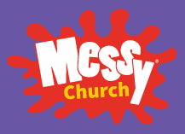Do you run a **Messy Church**? Would you like to meet up on zoom with others from across the 5 Northerly Synods and share ideas for Advent and Christmas? COMING SOON: **Monday 18th October**, 7.30-9.00pm, in your own living room/study/kitchen etc. Come and join us, share what you're up to and get some ideas. Get in touch for the zoom details at either <https://urcyorkshire.org.uk/cyp> or

[wilderness@urcyorkshire.org.uk](mailto:wilderness@urcyorkshire.org.uk)



**Wilderness Faith Maps**

This simple weekly resource is an easy way to engage with the Bible, prayer and the world around us. Linked to a Sunday Lectionary reading, it is suitable for all ages and faith experiences, as a starting point for a discussion or for personal reflection. You can find it each week here on [**Facebook**](https://www.facebook.com/wildernessfaithmaps), then like the page to be alerted when each weekly post arrives.

**URC Youth Assembly 2022**

Youth Assembly 2022 is getting closer and closer! Are you or do you know a 14-26 years old? (Yes, we have increased the age for this year!). Experience worship and participate in discussions about faith and life with people your age! Not the chatty type? A silent disco could be right up your street! For more info click here: [**www.urc.org.uk/urc-youth-urc.html**](http://www.urc.org.uk/urc-youth-urc.html?fbclid=IwAR3Senx_itMcZHxx_k7lGr4KpeoS8ryseA6NjArC11WB3m-pH0rumpPdzBY)

To book your place click here [**www.urc.org.uk/urcya**](http://www.urc.org.uk/urcya) before 1st January 2022.

**General Information and Resource Sharing**

**I.T. News**

News from the Mersey Synod: They are throwing open their Copyright Clinic to the wider Church fellowship. Like the Copyright Clinic of earlier in the year this Copyright Clinic om **Wednesday 13th October at 1.30pm** will be on Zoom and will highlight best practice as well as answering any of your questions.

Please contact [synodadmin@urcmerseysynod.org.uk](mailto:synodadmin@urcmerseysynod.org.uk) if you would like to sign up and a code will be sent out. The sessions will include:

•

principles of copyright

• can I use YouTube videos?

• copyright advice

• what licences do I need?

• best practice for church services

• finding copyright free media (photos, videos, images)

• top tips.

**Safeguarding News**

I mentioned in the last few editions that the **Intermediate Safeguarding Training Package** and the **Foundation (Basic) Safeguarding** were filling up very fast. Well they have filled up and a big thank you for all of you who appreciate the importance of ensuring that your churches are safe places for not only our youth, but for our whole communities.

Matt has also managed to secure some more spaces in the **Trustee Training** safeguarding sessions. The training is free as it is funded by a successful application to the Synod Development fund. It is the same course that was successfully run in July, but this time it is being organised by SW Synod. Matt has been able to ensure that there will be spaces available for those who are Trustees within Yorkshire Synod unable to attend the training in July. The training will be via Zoom and the dates are:

17th November 2.30pm - 4.30pm, 23rd November 11am – 1pm, 30th November 11am – 1pm.

If you wish to attend, or if you know of someone who needs to attend then please send details to [**secretary@urcsouthwest.org.uk**](mailto:secretary@urcsouthwest.org.uk).

Philippa Linton, the Administrator to Education & Learning at Church House has sent the following poster over drawing our attention to this 8 week course for church group leaders. It is being run by Westminster College from Wednesday 13th October through to Wednesday 1st December. People can attend in person, but there is an online facility as well.

Topics being covered include What is Christian Education? What does it mean to be a disciple and an educator? Liberative Education, Transformative Christian Education and Black Theology Education, Mission and Ecclesiology and Planning and Structuring courses and sessions. Primarily led by Dr Alison Gray and Revd Dr Paul Dominiak, other speakers have been booked to appear as well.

Please contact the Westminster College Tutorial Office for more information on 01223 330632 or at [admin@westminster.cam.ac](mailto:admin@westminster.cam.ac).

The latest issue of the [**URC News Update October 2021 (urc-news.org.uk)**](https://urc-news.org.uk/2JB1-1SFF1-122F160E1908EEE459BX7G3A2531BF46D2BD62/cr.aspx)is now available. It has updates on the impending URC 50th Anniversary plans, how to get hold of resource packs, plans for the upcoming COP26 conference in Glasgow, Discipleship grants, and how to contribute to the Haiti Emergency Appeal. Not only that but there is a link to the new look URC shop [**The United Reformed Church Bookshop (urcshop.co.uk)**](https://urcshop.co.uk/?dm_i=2JB1%2C1SFF1%2C59BX7G%2C667YB%2C1)which I’m told is full of all those things that you didn’t know you needed, as well as The 2021 Advent Box for churches to give out to families. This year it is called Come & See and is now available to pre-order. Ann-Marie, who edits the URC News Update (like me) is always on the hunt for stories to tell. Don’t leave it to the deadline, drop her a line at [ann-marie.nye@urc.org.uk](mailto:ann-marie.nye@urc.org.uk) and get your good news out there.

**Worshipping God Together : Apart.**

Rev Janine Atkinson’s regular services and reflections are still being uploaded to the website. As always a big thank you to Janine for these incredible resources which can be found under the ‘What we do’ drop down heading if you fancy a Yorkshire Synod Website surf or more directly at [**https://urcyorkshire.org.uk/worship/**](https://urcyorkshire.org.uk/worship/)

|  |
| --- |
|  |

**ECO News**

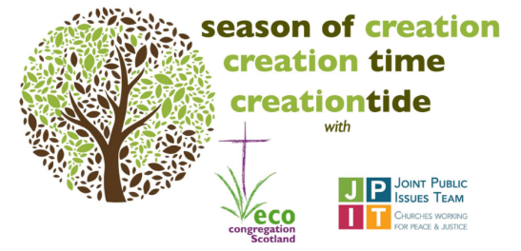For anyone still looking for material for Harvest or Creation Time worship, this is as good a place as any to look.

<https://www.ecocongregationscotland.org/creation-time/>. It will also link into imminent COP26 conference and the work JPIT is doing in relation to the climate emergency.

And in the run up to COP26, the Eastern Synod is running a series of sessions on climate justice to which we have been invited. The first one took place this past Tuesday, but there are still sessions on Monday 11th and Monday 25th October. For details please contact Lindsay Brown, Eastern’s Mission and Training Officer, at [training@urceastern.org.uk](mailto:training@urceastern.org.uk).

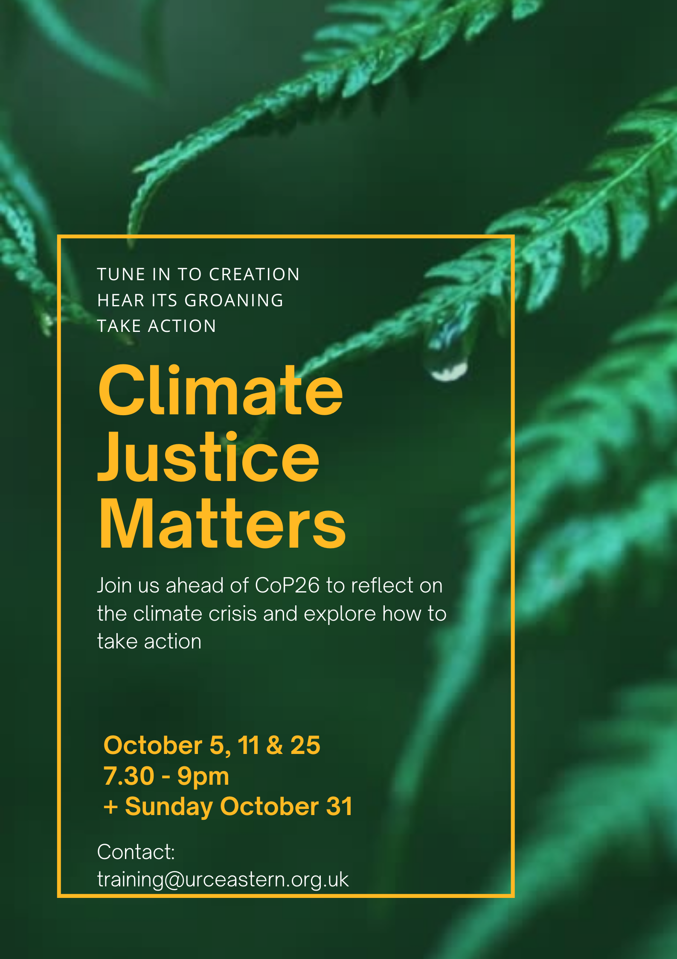

For those with local tastes I know that the **Sheffield team** have their services on their own website at <http://sheffieldurc.org.uk/> and on the Yorkshire site you can find help in preparing and participating in Online Worship at [COVID-19 Advice and Support | URC Yorkshire Synod](https://urcyorkshire.org.uk/covid-19-advice-and-support/).

Now that **St Andrew’s Sheffield** are worshipping in person on Sundays at 10.45am their website services have been discontinued. However, all the services that were uploaded to their website have been archived and can still be accessed at [www.standrewsurcsheffield.org.uk/stop-press](http://www.standrewsurcsheffield.org.uk/stop-press).

They include some very thoughtful Reflections by a variety of ministers and other preachers as well as an eclectic, rich and classical selection of music to complement these acts of worship.

**Situations Vacant**

Please feel free to share the link [**https://urc.org.uk/vacancies.html**](https://urc.org.uk/vacancies.html)within your circle for the following URC posts that are currently being recruited.

1. Training and Development Coordinator for Safeguarding
2. Director of Ministry Formation, Westminster College
3. Designated Safeguarding Lead
4. Minister for Digital Worship

Full details are on the website, if you have any questions please direct them in that direction.

**Please don’t hide these events in your inboxes. Please send this Briefing around your own church mailing lists as these events are for everyone, member or non-member, church-goer or non-church-goer. All these activities within and beyond Synod are designed to grow the Kingdom.**

**Plans are always happening to bring more activities and good news stories to your attention, so keep an eye open for the next Briefing. All you need to do is get in touch with me at** [**clerk@urcyorkshire.org.uk**](mailto:clerk@urcyorkshire.org.uk)**.**

If you know of anything you may find useful for our churches, please contact me at [clerk@urcyorkshire.org.uk](mailto:clerk@urcyorkshire.org.uk) and I’ll circulate it here and on the website. Similarly if you need any further help, be it to do with IT, finance, property or the like we are here to help.

National URC site: <https://urc.org.uk/> Yorkshire Synod: <https://urcyorkshire.org.uk/> Yorkshire Synod Twitter: <https://twitter.com/urcyorkshire> Yorkshire Synod Facebook: <https://www.facebook.com/urcyorkshire> Yorkshire Young People’s Facebook: <https://www.facebook.com/wildernessyorkshireurc/>

*Tim Crossley*

*Synod Clerk*