The Briefing – Number 70
21st October 2021
Dear Friends,
For those of you who attended the October meetings of Yorkshire Synod may I take this opportunity to say thank you very much for coping with the dual nature of it and for attending in both digital format and in person. A big thank you to the good people of Longcauseway church who hosted the Saturday meeting and also a big thank you to all those folk behind the scenes who were instrumental in getting the Thursday meeting online and the Saturday meeting streamed. Some of you may have spotted my absence on Saturday and that the notes were being taken by our Property Officer, Jane Bunyan-Murray. Thank you Jane for standing in at short notice. I was “pinged” on the Thursday lunchtime prior to the meetings and took advice as to whether to attend Synod in person or not. The advice was that I should attend remotely. It was the correct decision as the PCR test I took on the Friday proved positive and from Sunday 10th through to Tuesday 19th I had to self-isolate. I feel blessed in that the vaccine seemed to have worked with neither my seven-year old son, wife nor myself having had to seek further treatment.
Working in self-isolation was much the same as working from home. However, the added imperative not to leave the house was hard. Fortunately, I’m now free to carry on as before, but I have learnt a salutary lesson in being careful; we haven’t rid ourselves of this virus, we still need to be as vigilant as we ever have been and our first duty as Christians is to ensure that the welfare of our neighbours is paramount. So please do not to forget about being careful in the way we open up our church buildings this autumn and please be prepared to return to the more restrictive practices we endured earlier in the year in the light of the rising cases that are being reported in the media.
The current advice is still to be found via these links, but if matters do take a turn for the worse we will be advising churches accordingly.
The URC Synod Moderators’ New Freedoms, Same Responsibilities: Synod Moderators' advice to congregations (urc.org.uk)
The URC’s main Advice to churches about coronavirus from the United Reformed Church
Government sites at Coronavirus: how to stay safe and help prevent the spread - GOV.UK (www.gov.uk) and guidance on what you can and cannot do and Find out what the rules are.

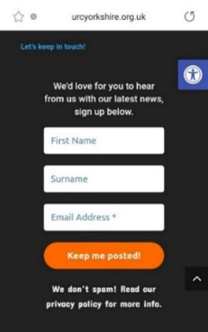
This issue is a little shorter than usual but I know that there are lots of things in preparation for later in the year and for 2022. The website is as good a place to keep up with what is happening, but we need you to let us know what you are doing. Please send in your news so that we can send it out to wide audience. We can put it in both the Briefing and in the News Section of Synod website Latest News | URC Yorkshire Synod. It doesn’t matter if it is a small or a large event. Send it in and then sign up to the weekly news update which is sent out each Friday. Look at the foot of every Yorkshire Synod (urcyorkshire.org.uk) page, find the bit that looks like this image and simply fill it in. It’s not a secret so please tell your friends, your church members and your congregations as a whole. There is a whole array of things to help, guide and inform you, not only about the URC but also about how we can become a Jesus centred people.
Church Links, Mission Activities and Synod Events

Lay Preachers Planning Group news

‘An overview of Luke led by Lawrence Heath-Moore’
2nd, 4th, 9th & 11th November, 10.00am-11.30am repeated at 7.30pm-9.00pm
Lawrence Heath-Moore will lead a series of sessions via the Zoom platform on the gospel of Luke (the upcoming 'Year' in the revised common lectionary). The sessions will be interactive, informal, and set you up well for a year of preaching on Luke! Whether you are a seasoned preacher, minister, lay preacher, worship leader, elder, Bible study leader or just interested please book your place with the Synod office at office@urcyorkshire.org.uk or leave a message at 0113 289 8490.
Time is running short, so why not sign up now.

More details as we get closer here of the Briefing, on the website and on the Weekly Mailing (please sign up at Yorkshire Synod (urcyorkshire.org.uk)).

I know there are more things in the pipeline and news of these will be distributed in the usual ways.
And looking forward – into next year no less – Kath Lonsdale has asked that you keep the 22nd to 24th July 2022 clear if you are interested in a lay preachers weekend at Wydale conference centre. More details and a booking form nearer the time.

Children and Young Peoples News

Wilderness Faith Maps
This simple weekly resource is an easy way to engage with the Bible, prayer and the world around us. Linked to a Sunday Lectionary reading, it is suitable for all ages and faith experiences, as a starting point for a discussion or for personal reflection. You can find it each week here on Facebook, then like the page to be alerted when each weekly post arrives.

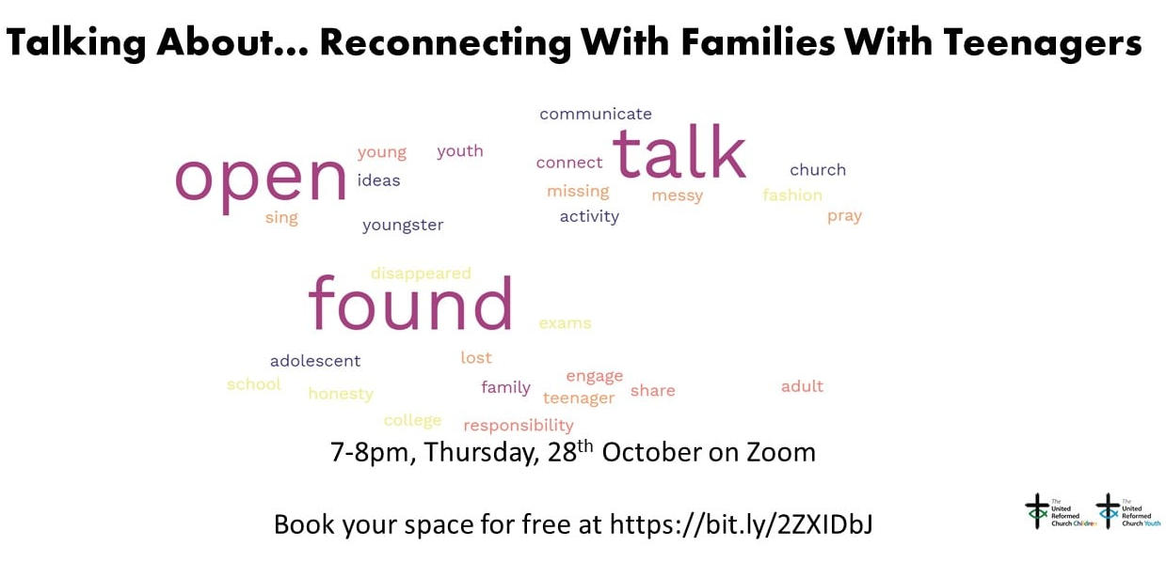
Talking About… Reconnecting With Families With Teenagers
Thursday 28th October is a very important date for your diary. If ministry with teenagers is something that you want to encourage in your Church, come along to this event to hear more. Book your space for free at https://bit.ly/2ZXIDbJ

Come & See Advent Box - additional free resources
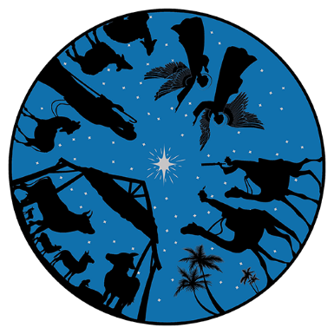
The Come & See the Advent Box for 2021 offers a range of fun, creative and reflective activities for all ages organised into four weeks to cover Advent. These additional free resources, including a church guide, are available for you to download.
- Church guide with suggestions for how to make the most of the boxes and link with your worship and groups – download PDF (1.13 mb)
- Stained glass window images to decorate – download PDF (305 kb)
- Bunting kit to make at home – download PDF (93 kb)
- Invitation card – resource coming soon!
- Come and See circular logo – download JPG (3.3 mb) download PNG (180 kb)

Buy the Advent Box online
You can buy the full Come & See Advent Box online from the URC Shop.

URC Youth Assembly 2022
Youth Assembly 2022 is getting closer and closer! Are you or do you know a 14-26 years old? (Yes, we have increased the age for this year!). Experience worship and participate in discussions about faith and life with people your age! Not the chatty type? A silent disco could be right up your street! For more info click here: www.urc.org.uk/urc-youth-urc.html
To book your place click here www.urc.org.uk/urcya before 1st January 2022.

General Information and Resource Sharing

Safeguarding News
I mentioned in the last few editions that the Intermediate Safeguarding Training Package and the Foundation (Basic) Safeguarding were filling up very fast. Well they have filled up and a big thank you for all of your who appreciate the importance of ensuring that your churches are safe places for not only our youth, but for our whole communities.

Matt has also managed to secure some more spaces in the Trustee Training safeguarding sessions. The training is free as it is funded by a successful application to the Synod Development fund. It is the same course that was successfully run in July, but this time it is being organised by SW Synod. Matt has been able to ensure that there will be spaces available for those who are Trustees within Yorkshire Synod unable to attend the training in July. The training will be via Zoom and the dates are:
17th November 2.30pm-4.30pm, 23rd November 11am–1pm, 30th November 11am–1pm.
If you wish to attend, or if you know of someone who needs to attend then please send details to secretary@urcsouthwest.org.uk.

ECO News
Eco Church Open Evening
6:30 – 9:30pm Tuesday 2 November
This open evening hosted by St Andrews Psalter Lane Church and Sheffield Methodist District is for churches of any denomination interested in considering, getting started, or already involved in the Eco Church movement.
An opportunity to ask questions, hosted by a local church holding an Eco Church Silver Award. What difference does being an Eco Church make in practice? How to get started? How to overcome common challenges? How can we better support and encourage each other?
Further details and booking at https://211102-ecochurch.eventbrite.co.uk

Sustaining the World Module by Rev Dr Rosalind Selby
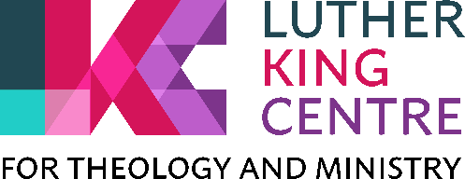
An 8-session course which looks at: science (introductory), Western Christianity’s role/responsibility/ task, mission, bible, theology, ethics in amongst church responses. To make the most of the course, there will be pre-reading/thinking/exercises which I anticipate take 1-2 hours each. All the pre-tasks will be available before the course starts so you could get ahead with them at any point after you have registered.
This course is running by Zoom on Monday evenings: 29 Nov, 6 Dec, 10 Jan, 17 Jan, 24 Jan, 31 Jan, 7 Feb and 28 Feb, from 7.00-8.30pm.
If you want more content details, please contact Rosalind Selby
If you want registration details, please contact Paul Barrett, the assistant registrar: paul.barrett@lutherking.ac.uk – the course number is TMM 2237.

The latest issue of the URC News Update October 2021 (urc-news.org.uk) is now available. It has updates on the impending URC 50th Anniversary plans, how to get hold of resource packs, plans for the upcoming COP26 conference in Glasgow, Discipleship grants, and how to contribute to the Haiti Emergency Appeal. Not only that but there is a link to the new look URC shop The United Reformed Church Bookshop (urcshop.co.uk) which I’m told is full of all those things that you didn’t know you needed, as well as The 2021 Advent Box for churches to give out to families. This year it is called Come & See and is now available to pre-order. Ann-Marie, who edits the URC News Update (like me) is always on the hunt for stories to tell. Don’t leave it to the deadline, drop her a line at ann-marie.nye@urc.org.uk and get your good news out there.

Worshipping God Together : Apart.
Rev Janine Atkinson’s regular services and reflections are still being uploaded to the website. As always a big thank you to Janine for these incredible resources which can be found under the ‘What we do’ drop down heading if you fancy a Yorkshire Synod Website surf or more directly at https://urcyorkshire.org.uk/worship/

For those with local tastes I know that the Sheffield team have their services on their own website at http://sheffieldurc.org.uk/ and on the Yorkshire site you can find help in preparing and participating in Online Worship at COVID-19 Advice and Support | URC Yorkshire Synod.

Now that St Andrew’s Sheffield are worshipping in person on Sundays at 10.45am their website services have been discontinued. However, all the services that were uploaded to their website have been archived and can still be accessed at www.standrewsurcsheffield.org.uk/stop-press.
They include some very thoughtful Reflections by a variety of ministers and other preachers as well as an eclectic, rich and classical selection of music to complement these acts of worship.

Situations Vacant
Please feel free to share the link https://urc.org.uk/vacancies.html within your circle for the following URC posts that are currently being recruited.
- Training and Development Coordinator for Safeguarding
- Director of Ministry Formation, Westminster College
- Designated Safeguarding Lead
- Minister for Digital Worship
Full details are on the website, if you have any questions please direct them in that direction.

Please don’t hide these events in your inboxes. Please send this Briefing around your own church mailing lists as these events are for everyone, member or non-member, church-goer or non-church-goer. All these activities within and beyond Synod are designed to grow the Kingdom.
Plans are always happening to bring more activities and good news stories to your attention, so keep an eye open for the next Briefing. All you need to do is get in touch with me at clerk@urcyorkshire.org.uk.
If you know of anything you may find useful for our churches, please contact me at clerk@urcyorkshire.org.uk and I’ll circulate it here and on the website. Similarly if you need any further help, be it to do with IT, finance, property or the like we are here to help.
National URC site: https://urc.org.uk/ Yorkshire Synod: https://urcyorkshire.org.uk/ Yorkshire Synod Twitter: https://twitter.com/urcyorkshire Yorkshire Synod Facebook: https://www.facebook.com/urcyorkshire Yorkshire Young People’s Facebook: https://www.facebook.com/wildernessyorkshireurc/

Tim Crossley
Synod Clerk

