**The Briefing – Number 71**

**4th November 2021**

Dear Friends,

Where I come from in Airedale, the evening of the 4th November is known as “Mischief Night”.

I remember as a child in the 1970’s playing practical (and looking back rather malicious) pranks on friends, neighbours and those who lived in the small village I grew up in between Keighley and Bingley. Quite often our “gang” went out with string to tie doors to bins in order that the knock and run game was played to a suitably discordant tune. Similarly, the application of syrup to handles added to this the sense of fun. All this is behind me now, but the idea of things that will stick to us is at the forefront of the things being highlighted in this issue of the Briefing.

There are two strands of support being offered in this issue – the spiritual and the practical. On the spiritual side the **Overview of Luke** has started this week and just around the corner we will be celebrating Advent which will be more than enhanced by the resources on offer from the URC shop. On a more practical note, the IT team has published their winter timetable, starting with **How to Grow Your Mailing List** on 22nd November. In response to the huge demand, Matt Knowles is offering more dates for both basic and intermediate Safeguarding training, and in the grid in the Safeguarding section you’ll find a ready visual guide as to which training you are well advised to get. As well as the home-grown resources there are plenty of activities to join in at a national level, from URC Youth Assembly in January 2022 to participating in and engaging with 2022’s URC Jubilee.

Be aware though of the continuing threat to our collective health by the **Covid-19 virus**. When the idea of having a Briefing arose back in March 2020 it was designed to keep you abreast of the rules, regulations and restrictions that were imposed and changed almost on a weekly basis. I make no apologies for keeping this on the front page and hopefully at the forefront of your minds. This thing hasn’t gone away and I continue to urge churches to be as vigilant as we ever have been. Our first duty as Christians is to ensure that the welfare of our neighbours is paramount. So please do not to forget about being careful in the way we open up our church buildings and please be prepared to return to the more restrictive practices we endured earlier in the year in the light of the rising cases that are being reported.

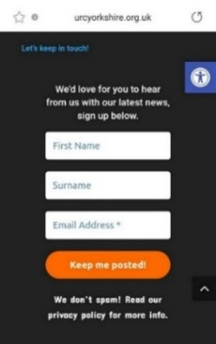The current advice is still to be found via these links, but if matters do take a turn for the worse we will be advising churches accordingly. **The URC Synod Moderators’** [**New Freedoms, Same Responsibilities: Synod Moderators' advice to congregations (urc.org.uk)**](https://urc.org.uk/church-information-guides/3870-new-freedoms-same-responsibilities.html). **The URC’s main** [**Advice to churches about coronavirus from the United Reformed Church**](https://urc.org.uk/coronavirus.html)**. Government sites** at [**Coronavirus: how to stay safe and help prevent the spread - GOV.UK (www.gov.uk)**](https://www.gov.uk/guidance/covid-19-coronavirus-restrictions-what-you-can-and-cannot-do) and [**guidance on what you can and cannot do**](https://www.gov.uk/guidance/covid-19-coronavirus-restrictions-what-you-can-and-cannot-do) and [**Find out what the rules are**](https://www.gov.uk/guidance/covid-19-coronavirus-restrictions-what-you-can-and-cannot-do?priority-taxon=774cee22-d896-44c1-a611-e3109cce8eae)**.**

And finally another reminder that there is the opportunity still to sign up for the weekly website based newsletter. Head to any page on [**Yorkshire Synod (urcyorkshire.org.uk)**](https://urcyorkshire.org.uk/), scroll to the foot and follow the instructions on the area that looks like this image. It can’t be any simpler than that.

There is a whole array of things to help, guide and inform you, not only about the URC but also about how we can become a Jesus centred people.

**Church Links, Mission Activities and Synod Events**

**Lay Preachers Planning Group news**

**‘An overview of Luke led by Lawrence Heath-Moore’**

2nd, 4th, 9th & 11th November, 10.00am-11.30am repeated at 7.30pm-9.00pm

Lawrence Heath-Moore has begun to lead a series of sessions via the Zoom platform on the gospel of Luke (the upcoming 'Year' in the revised common lectionary). The sessions are interactive, informal, and set you up well for a year of preaching on Luke! Whether you are a seasoned preacher, minister, lay preacher, worship leader, elder, Bible study leader or just interested please book your place with the Synod office at [office@urcyorkshire.org.uk](mailto:office@urcyorkshire.org.uk) or leave a message at 0113 289 8490.

**Time is running short, so why not sign up now.**

More details as we get closer here of the Briefing, on the website and on the Weekly Mailing (please sign up at [**Yorkshire Synod (urcyorkshire.org.uk)**](https://urcyorkshire.org.uk/)).

I know there are more things in the pipeline and news of these will be distributed in the usual ways.

And looking forward – into next year no less – Kath Lonsdale has asked that you keep the **22nd to 24th July 2022** clear if you are interested in a **lay preachers weekend at Wydale conference centre**. More details and a booking form nearer the time.

**Children and Young Peoples News**

**Come & See Advent Box - additional free resources**

The [Come & See the Advent Box](https://urcshop.co.uk/come-see-advent-kit/) for 2021 offers a range of fun, creative and reflective activities for all ages organised into four weeks to cover Advent. These additional free resources, including a church guide, are available for you to download.

**[](https://urc.org.uk/images/AdventComeSee/Advent-Logo-RGB.png)Church guide** with suggestions for how to make the most of the boxes and link with your worship and groups – [download PDF](https://urc.org.uk/images/AdventComeSee/Church-Guide-v2.pdf) (1.13 mb)

**Stained glass window images** to decorate – [download PDF](https://urc.org.uk/images/AdventComeSee/Stain-Glass-Windows.pdf) (305 kb)

**Bunting kit** to make at home – [download PDF](https://urc.org.uk/images/AdventComeSee/COME_AND_SEE_bunting.pdf) (93 kb)

**Invitation card** – resource coming soon!

***Come and See****circular logo* – [download JPG](https://urc.org.uk/images/AdventComeSee/Advent-Logo-CMYK.jpg) (3.3 mb) [download PNG](https://urc.org.uk/images/AdventComeSee/Advent-Logo-RGB.png) (180 kb)

**Buy the Advent Box online:** You can buy the full [**Come & See Advent Box**](https://urcshop.co.uk/come-see-advent-kit/) online from the URC Shop.

**Wilderness Faith Maps**

This simple weekly resource is an easy way to engage with the Bible, prayer and the world around us. Linked to a Sunday Lectionary reading, it is suitable for all ages and faith experiences, as a starting point for a discussion or for personal reflection. You can find it each week here on [**Facebook**](https://www.facebook.com/wildernessfaithmaps), then like the page to be alerted when each weekly post arrives.

**Engaging Young Adults**

Staying connected with our young adults is a challenge. We've had them colouring-in and singing 'If I Were A Butterfly' since they were toddlers, as they got older we 'encouraged' them by putting them in charge of the audio-visual equipment, but now, well, now they're as big as us, they're at University, or they've got jobs, they might even have a partner and children of their own - how do we stay connected?

This session will look at exactly that and there are two guest speakers to help start the conversation:

[Reuben Watt](https://www.facebook.com/reuben.watt.9?__cft__%5b0%5d=AZXhTbN7g5WzCxKzxgvr7VGyhP_vfNY3aUUSYb1N8QES7dwktn3-sYQgOoMI8QOWZOaIMqJEjsaRfPlgqzZZVOLtO9P-cPa6yAmqvuPkrBl1u51ua-oBrN6zC_ujxi2ny-ulrbOYwywmUe0MawSzW5sl3AKnB31pS_w-5l_qOCWPww&__tn__=-%5dK-y-R) is the Moderator of the United Reformed Church Youth Assembly and [Mike Walsh](https://www.facebook.com/revd.walsh?__cft__%5b0%5d=AZXhTbN7g5WzCxKzxgvr7VGyhP_vfNY3aUUSYb1N8QES7dwktn3-sYQgOoMI8QOWZOaIMqJEjsaRfPlgqzZZVOLtO9P-cPa6yAmqvuPkrBl1u51ua-oBrN6zC_ujxi2ny-ulrbOYwywmUe0MawSzW5sl3AKnB31pS_w-5l_qOCWPww&__tn__=-%5dK-y-R) is a Pioneer Minister in Chorlton, Manchester.

Come and listen, come and ask questions, come and share. Register for your free place at [https://bit.ly/3jyVBDR](https://bit.ly/3jyVBDR?fbclid=IwAR1A4svca1coZ24tTBXxqrR8M2W2xGIRfHwdxDcUrpfk4jRJC5g0SMO1wmc) 7pm on Thursday, 25th November on Zoom.



**parenting for faith**

Sharing your faith with your children can feel like a HUGE responsibility. Join us for some of Rachel Turner's brilliantly simple and practical guidance.

The sessions, under the banner of the **Northerly Synods** group, will be fortnightly on zoom, beginning next Monday Nov 8th (7-8.30pm). If you would like to join us, please book using this link:

****[https://www.eventbrite.co.uk/.../parenting-for-faith...](https://www.eventbrite.co.uk/e/parenting-for-faith-tickets-170164002111?fbclid=IwAR1SIcjq646gFGzIGw2LqQefqz9zOsqxi2UjcAvNDAuIXLQjwRqx51gpRAg)

**URC Youth Assembly 2022**

Youth Assembly 2022 is getting closer and closer! Are you or do you know a 14-26 years old? (Yes, we have increased the age for this year!). Experience worship and participate in discussions about faith and life with people your age! Not the chatty type? A silent disco could be right up your street! For more info click here: [**www.urc.org.uk/urc-youth-urc.html**](http://www.urc.org.uk/urc-youth-urc.html?fbclid=IwAR3Senx_itMcZHxx_k7lGr4KpeoS8ryseA6NjArC11WB3m-pH0rumpPdzBY)

To book your place click here [**www.urc.org.uk/urcya**](http://www.urc.org.uk/urcya) before 1st January 2022.

**General Information and Resource Sharing**

**Lent Resource Packs**

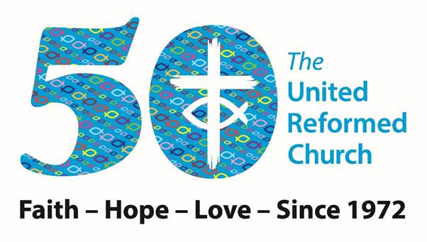This request has come through from Revd Jenny Mills, the Secretary for Education and Learning regarding **Lent materials for the 50th Anniversary of the United Reformed Church.**

﻿

Education and Learning request your help. As you’ll recall, earlier this year we offered people the opportunity to buy Lent Resource Packs. We would like to do the same again. This time we are aiming for 50 stories and we need your help!  
The brief that has been developed by Sam Richards, Simon Peters and Andy Jackson is below so see if you can help. It may be that you can offer a story but not the accompanying resources or vice versa, either way let us know what you would be willing to do. Maybe you can gather a local church/synod community together and create one of the stories and resources? It would be great to have offerings from different people, people serving the church in different ways and those with stories to tell who don’t get the opportunity to share more widely.   
All in all 50 inspirational stories of people from the URC overcoming challenges/issues, living out faith, hope and love are required based on a brief of approximately 700 words and if possible with an all-age and intergenerational content.

* An interesting or thought-provoking story of someone associated with the URC  – link to faith, hope or love – **200 words**
* a short Bible passage or verse – **100 words**
* a prayer to say – I would suggest one that includes space for the person using the resource to personalise it by including (….) within the prayer (and explaining that in the introduction) – **100 words**
* a prayer/reflective activity - **100 words**
* discussion starter/ wondering question - **10-25 words**
* a way to engage with the theme/issues in everyday life (could be a weblink, a JPIT/WtW/C4L project or action etc) - **50 words**
* something fun or creative to do – very simple (think all ages) – could be a link to a video/song/craft/game to play etc – **up to 150 words**

Also can people supply photos of anything that might need demonstrating – basically try it out themselves and photograph the result or the stages involved.

Please get permission from the person (if living) to use their story – you could interview them - a photo of them if possible, or an image that links to their story.



**Revd Jenny Mills**

Secretary for Education and Learning

Email [Philippa.linton@urc.org.uk](mailto:Philippa.linton@urc.org.uk) and copy me in please [jenny.mills@urc.org.uk](mailto:jenny.mills@urc.org.uk) with your submissions

**I.T. News**

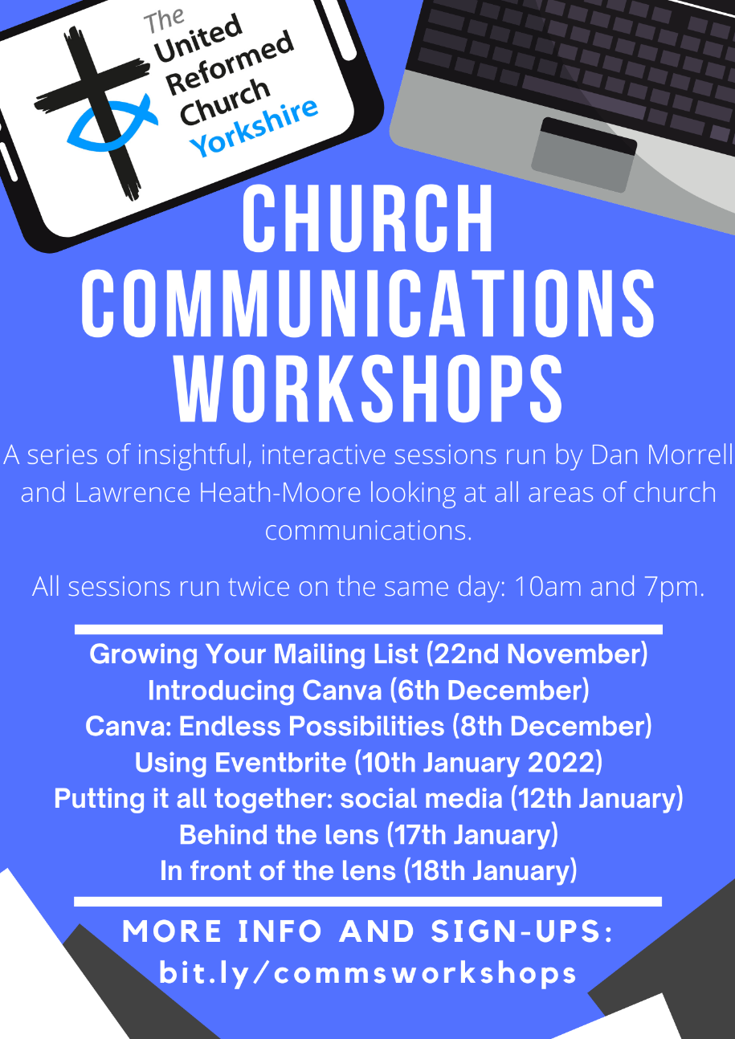**Church Communications Workshops**

In this next series of workshops led by Dan Morrell and Lawrence Heath-Moore, different areas of church communications will be explored as well as finding how you can tap into some powerful resources to make your life easier, yet make your communication more effective at the same time!

Each of the sessions will be interactive and there will be space at the end to ask questions. Some of the sessions are linked, some may be irrelevant to you/your church, so come to some, come to none, come to all!

All the sessions will be recorded and may often have handouts to go with them.

On each of the dates stated, the workshops are repeated at 10am & 7pm so there should be a time to suit everyone.

***Growing Your Mailing List***

*Monday 22nd November 2021*

Traditional emails can often look so boring, people are after a lot more! How about a tool that helps with design of your emails, suggests content, and manages your email lists for free! This session will look primarily at **Mailchimp** as a tool for hassle free e-mail management.

***Introducing Canva***

*Monday 6th December 2021*

Tired of using Publisher? We are! Canva is an incredibly powerful tool that is free, which does a lot of the hard work for you including design suggestions and helps you with sizing your publicity too. This workshop will take you through the basics of how to use Canva and the varying ways you could utilise it in your church.

***Canva: Endless Possibilities***

*Wednesday 8th December 2021*

Thought you’d mastered Canva? Thing again! (we don’t mean this in a bad way!) We just have so many exciting things to tell you about Canva that we have to spread it across 2 sessions!

***Using Eventbrite*,** *Monday 10th January 2022*

***Putting it all together: social media,*** *Wednesday 12th January 2022*

***Behind the lens,*** *Monday 17th January 2022*

***In front of the lens,*** *Tuesday 18th January 2022*

Details of these January courses in a later Briefing – so keep an eye out for the December issues.

**To sign up for any of these events*, please fill in the following Google Form (preferred) or email website@urcyorkshire.org.uk:** [**https://forms.gle/vTnBh8YbgRybrT8B6**](https://forms.gle/vTnBh8YbgRybrT8B6)

*We are **not** running strict attendance; this is just to gain an idea of numbers! The Zoom link for all the sessions will be the same so once you receive the Zoom link you will be able to attend any/all.

**Safeguarding News**

**DBS Training, 10th November 2021**

Matt Knowles, our Safeguarding Adviser, has arranged some training to be provided on the Disclosure and Barring Service (DBS). This is completely separate to any training you may have attended provided by DDC (the company that oversees the checks on behalf of the URC) and is led by Sue Davison, the Regional Outreach Advisor for the DBS. It complements nicely the training that is being provided for safer recruitment within the Intermediate Safeguarding Training sessions.

Sue will be will discuss various points including –

• Understanding more clearly the role of DBS and the benefits of working together

• To get a greater understanding of what ‘regulated activity’ means to our churches

• Understand different types of harm

• To have an understand of how barring works in relation to DBS checks

• Have a clear understanding of consequences of various actions whilst in the workplace

There will also be a question and answer session after the presentation.

The training is being held online via Zoom on **Wednesday 10th November** between 7pm and 8.30pm. To reserve a place please contact Matt via [**matt.safeguarding@urcyorkshire.org.uk**](mailto:matt.safeguarding@urcyorkshire.org.uk)

Matt has also managed to secure some more spaces in the **Trustee Training** safeguarding sessions. The training is free as it is funded by a successful application to the Synod Development fund. It is the same course that was successfully run in July and this time it is being organised by SW Synod. Matt has been able to ensure that there will be spaces available for those who are Trustees within Yorkshire Synod unable to attend the training in July. The training will be via Zoom and the dates are:

17th November 2.30pm -4.30pm, 23rd November 11am – 1pm, 30th November 11am – 1pm.

If you wish to attend, or if you know of someone who needs to attend then please send details to [**secretary@urcsouthwest.org.uk**](mailto:secretary@urcsouthwest.org.uk).

**Foundation and Intermediate Training**

Due to increased demand and the need for people to be trained due to the adoption by General Assembly of Paper T5 we are releasing some further dates for online safeguarding training. [Paper T5 - SAG - Safeguarding Training Framework (urc.org.uk)](https://urc.org.uk/images/General-Assemblies/Assembly2021/Paper_T5_-_SAG_-_Safeguarding_Training_Framework_FINAL.pdf) lists the roles within the church to which training courses are required. Although **EVERYONE** is invited to **ALL** training please note that certain roles attract a mandatory level of training. Below is a grid outlining the details.

There are courses for both Foundation (Basic) level and Intermediate level, but please be aware that you will have had to have attended a Foundation course within the last 3 years before you can book on an Intermediate course.

All courses will be online and via Zoom and bookings can be made by contacting Sally at [moderatorpa@urcyorkshire.org.uk](mailto:moderatorpa@urcyorkshire.org.uk).

**Foundation (Basic) Training**

Thursday 20th Jan 2022 – 10am to 12pm

Tuesday 1st Feb 2022 – 10am to 12pm

Wednesday 16th Feb 2022 – 7pm to 9pm

**Intermediate Training**

Wednesday 8th Dec 2021 – 1pm to 3.30pm

Wednesday 5th Jan 2022 – 1pm to 3.30pm

Monday 24th Jan 2022 - 1pm to 3.30pm

Saturday 12th Feb 2022 – 10am to 12.30pm

Thursday 24th Feb– 10am to 12.30pm

|  |  |  |  |
| --- | --- | --- | --- |
| **Roles requiring mandatory training** | **Foundation (Basic)** | **Intermediate** | **Advanced** |
| Church safeguarding coordinators | X | X |  |
| Deputy church safeguarding coordinators | X | X |  |
| Members of Synod Safeguarding Committees | X |  |  |
| Active Ministers and CRCWs (including retired ministers who meet the requirements of active ministry) | X | X |  |
| Youth and Children Workers including volunteer leaders | X | X | X |
| Youth and Children’s Workers (volunteer helpers) ** | X | X |  |
| Adult Workers including volunteer leaders | X | X |  |
| Adult Workers (volunteer helpers) ** | X | X |  |
| Pastoral Workers / Visitors | X | X |  |
| Worship Leaders and Assembly Accredited Lay Preachers | X | X |  |
| URC Trustees and Synod Trustees | X |  |  |
| Elders as local church trustees | X |  |  |

** those helping at a holiday club, assisting occasionally with Sunday school, running a craft activity at Messy Church, running the tuck shop at a youth group, helpers at a craft club / lunch / trip, etc, where it is clear these people are in ‘helper’ roles are always working in the presence of, and under the supervision of, a ‘leader’.

**ECO News**

**Sustaining the World Module by Rev Dr Rosalind Selby**

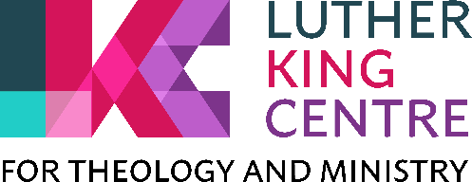An 8-session course which looks at: science (introductory), Western Christianity’s role/responsibility/ task, mission, bible, theology, ethics in amongst church responses. To make the most of the course, there will be pre-reading/thinking/exercises which I anticipate take 1-2 hours each. All the pre-tasks will be available before the course starts so you could get ahead with them at any point after you have registered.   
This course is running by Zoom on Monday evenings: 29 Nov, 6 Dec, 10 Jan, 17 Jan, 24 Jan, 31 Jan, 7 Feb and 28 Feb, from 7.00-8.30pm.   
If you want more content details, please contact Rosalind Selby   
If you want registration details, please contact Paul Barrett, the assistant registrar: paul.barrett@lutherking.ac.uk – the course number is TMM 2237.

**Worshipping God Together : Apart.**

Rev Janine Atkinson’s regular services and reflections are still being uploaded to the website. As always a big thank you to Janine for these incredible resources which can be found under the ‘What we do’ drop down heading if you fancy a Yorkshire Synod Website surf or more directly at [**https://urcyorkshire.org.uk/worship/**](https://urcyorkshire.org.uk/worship/)

The latest issue of the [**URC News Update November 2021 (urc-news.org.uk)**](https://urc-news.org.uk/2JB1-1SZ7Q-122F160E1908EEE459BX7G3A2531BF46D2BD62/cr.aspx) is now available. It has updates on the COP 26 conference, the Climate Crisis, the URC 50th Anniversary plans, and the great news that Herringthorpe’s **Rev Matt Stone** has been named the new Chair of Group for Evangelism and Renewal (GEAR) within the URC. Not only that but there is a link to the new look URC shop [**The United Reformed Church Bookshop (urcshop.co.uk)**](https://urcshop.co.uk/?dm_i=2JB1%2C1SFF1%2C59BX7G%2C667YB%2C1)which I’m told is full of all those things that you didn’t know you needed, as well as The 2021 Advent Box for churches to give out to families. This year it is called Come & See and is now available to pre-order. Ann-Marie, who edits the URC News Update (like me) is always on the hunt for stories to tell. Don’t leave it to the deadline, drop her a line at [ann-marie.nye@urc.org.uk](mailto:ann-marie.nye@urc.org.uk) and get your good news out there.

|  |
| --- |
|  |

For those with local tastes I know that the **Sheffield team** have their services on their own website at <http://sheffieldurc.org.uk/> and on the Yorkshire site you can find help in preparing and participating in Online Worship at [COVID-19 Advice and Support | URC Yorkshire Synod](https://urcyorkshire.org.uk/covid-19-advice-and-support/).

Now that **St Andrew’s Sheffield** are worshipping in person on Sundays at 10.45am their website services have been discontinued. However, all the services that were uploaded to their website have been archived and can still be accessed at [www.standrewsurcsheffield.org.uk/stop-press](http://www.standrewsurcsheffield.org.uk/stop-press).

They include some very thoughtful Reflections by a variety of ministers and other preachers as well as an eclectic, rich and classical selection of music to complement these acts of worship.

**Please don’t hide these events in your inboxes. Please send this Briefing around your own church mailing lists as these events are for everyone, member or non-member, church-goer or non-church-goer. All these activities within and beyond Synod are designed to grow the Kingdom.**

**Plans are always happening to bring more activities and good news stories to your attention, so keep an eye open for the next Briefing. All you need to do is get in touch with me at** [**clerk@urcyorkshire.org.uk**](mailto:clerk@urcyorkshire.org.uk)**.**

If you know of anything you may find useful for our churches, please contact me at [clerk@urcyorkshire.org.uk](mailto:clerk@urcyorkshire.org.uk) and I’ll circulate it here and on the website. Similarly if you need any further help, be it to do with IT, finance, property or the like we are here to help.

National URC site: <https://urc.org.uk/> Yorkshire Synod: <https://urcyorkshire.org.uk/> Yorkshire Synod Twitter: <https://twitter.com/urcyorkshire> Yorkshire Synod Facebook: <https://www.facebook.com/urcyorkshire> Yorkshire Young People’s Facebook: <https://www.facebook.com/wildernessyorkshireurc/>

*Tim Crossley*

*Synod Clerk*