Worshipping God Together : Apart
Sunday 7th November 2021 at 10.30am
Church; Physically Distanced but Spiritually United
Worship Prepared by Rev. Janine Atkinson

A Call to Worship God
Meet God, in your need:
Meet God in your lack: Meet God with your gifts:
Meet God with your hopes: Meet God with all that you are:

So, I come to worship you Lord God.
Hymn – R&S 74: MP 564
Praise to the Lord, the Almighty, the King of creation!
O my soul, praise him, for he is thy health and salvation:
come ye who hear, brothers and sister, draw near,
praise him in glad adoration!
Praise to the Lord, who o’er all things so wondrously reigneth,
bears thee on eagle’s wings, and through all troubles sustaineth:
hast thou not seen all that is needful hath been
granted in what he ordaineth?
Praise to the Lord, who doth prosper thy work and defend thee!
Surely his goodness and mercy here daily attend thee:
ponder anew all the Almighty can do,
who with his love doth befriend thee.
Praise to the Lord! O let all that is in me adore him!
All that hath life and breath come now with praises before him!
Let the amen sound from his people again:
gladly for aye we adore him!

Joachim Neander (1650-80) tr. Catherine Winkworth (1827-78) and others
Psalm 146
Praise the Lord. Praise the Lord, my soul.
² I will praise the Lord all my life;
I will sing praise to my God as long as I live.
³ Do not put your trust in princes, in human beings, who cannot save.
⁴ When their spirit departs, they return to the ground;
on that very day their plans come to nothing.
⁵ Blessed are those whose help is the God of Jacob,
whose hope is in the Lord their God.
⁶ He is the Maker of heaven and earth,
the sea, and everything in them – he remains faithful for ever.
⁷ He upholds the cause of the oppressed and gives food to the hungry.
The Lord sets prisoners free,
⁸ the Lord gives sight to the blind,
the Lord lifts up those who are bowed down,
the Lord loves the righteous.
⁹ The Lord watches over the foreigner
and sustains the fatherless and the widow,
but he frustrates the ways of the wicked.
¹⁰ The Lord reigns for ever, your God, O Zion, for all generations.
Praise the Lord.
Approaching God in Prayer
Lord God, I do not come to you to become powerful and wealthy,
but to become a person of peace.
I do not come to you to climb lofty branches,
but to plant a small seed in the ground.
I do not come to you to savour the feast of kings,
but to ferment yeast into bread.
I come, not to flaunt precious jewels,
but to find the hidden treasure within you.
I come, not to trade in the things of this world,
but to find what is precious.
I come, for it is Christ the itinerant storyteller,
the valuer of the small things, who meets me.
So, I cannot pray for the poor, if I’d choose to walk by on the other side.
I cannot pray for the sick, if I remain unmoved.
I cannot pray for the hungry, and continue to waste food.
I cannot pray for the exploited,
and continue to buy the products that enslave them.
I cannot pray for the victims of war,
and continue to wage war, at home as I argue,
in my community as I turn my nose up at some and not at others.
I cannot pray for the persecuted, if I support the bully.
I cannot pray for the unemployed and the low waged,
and continue to value only the lowest price.
God of forgiveness, in this world of sin,
we, ourselves, are ensnared in sin.
So, forgive me - forgive us, because however we try,
we cannot live lives without sin
we cannot escape the systems of death
and we cannot change the world.
Forgive us.
Hear our prayers, and change us
so that we become part of the solution – even a small part –
not part of the problem.
In the name of the one who shows us the way, and taught us to pray
Our Father, who art in heaven, hallowed be thy name…
Today’s Old Testament reading (if you choose to read it – and whyever not?!) is
1 Kings 17: 8-16
Gospel Reading – Mark 12: 38 - 44

Warning against the teachers of the law
³⁸ As Jesus taught, he said, ‘Watch out for the teachers of the law. They like to walk around in flowing robes and be greeted with respect in the market-places, ³⁹ and have the most important seats in the synagogues and the places of honour at banquets. ⁴⁰ They devour widows’ houses and for a show make lengthy prayers.
These men will be punished most severely.’

The widow’s offering
⁴¹ Jesus sat down opposite the place where the offerings were put and watched the crowd putting their money into the temple treasury. Many rich people threw in large amounts.
⁴² But a poor widow came and put in two very small copper coins, worth only a few pence.
⁴³ Calling his disciples to him, Jesus said, ‘Truly I tell you, this poor widow has put more into the treasury than all the others. ⁴⁴ They all gave out of their wealth; but she, out of her poverty, put in everything – all she had to live on.’

Setting the Scene - Prayer
My mum sometimes said ‘You’re making a right show of yourself’! What she meant was that I was drawing attention to myself in some way or other – and, more than likely, not in a good way!
It’s easy to imagine that in prayer we need to ‘put on a show’ – make sure that God is listening, as if God only understands ‘churchy’ language. We think we need to say the ‘right’ words in the ‘right’ way – more to satisfy ourselves than God, I fear. So, we can end up making a bit of a show of ourselves – and not always in a good way
Yet, within ‘public worship’ of any sort, prayer will more than likely have ‘churchy’ words and form of some sort, even it it’s an open invitation for people to offer their own prayers into the worship time and space, or to ‘sum up’ or ‘round off’. And that’s OK.
But otherwise, our prayers are personal, so they may be short… wordless… a muddle… angry… uttered through tears… or smiles of relief and joy.
Fabulously though, God doesn’t wait for our words, God puts his ear to our hearts and listens for us there. God listens in our silence and muddle – and somehow makes sense of whatever we offer in good faith.
Our prayers can sometimes best be expressed in this image…
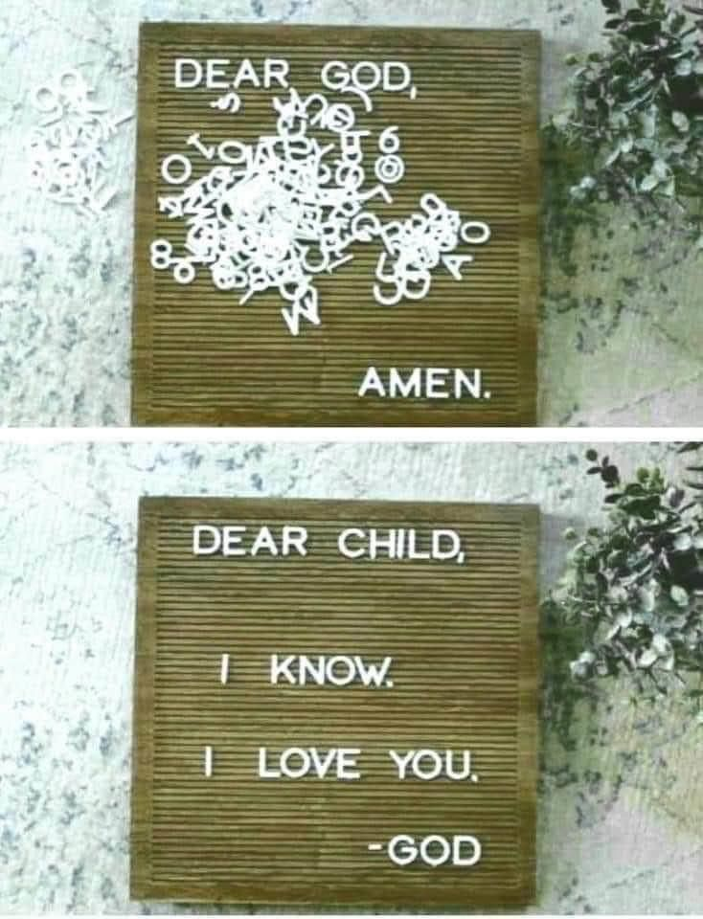
And that’s OK!
A Reflective Prayer
God of the small things,
we look out at the vastness of space – spiralling galaxies,
shape-shifting clouds of coloured gases,
unimaginable distances
measured in starlight,
and we wonder at the magnitude of your creation.
God of the small things,
we look at the structure of a cell wall through a microscope,
we hear the flicker of life in a barely perceivable heartbeat,
we see the fragile beauty of each distinct snowflake,
and the miracle of spiralling DNA, the blueprint of life.
God of the small things,
you are more vast than we can imagine,
you are more intricate and tiny than we can imagine,
you are wonder and mystery itself,
yet you notice a widow putting two pennies in a plate,
yet you stoop to hold a grieving mother who has laid her son to rest,
yet you call each one of us by name.
Wow! Amen
Hymn – R&S 495: MP 132 Love Maria Willis (1824-1908) and others
Father, hear the prayer we offer; not for ease that prayer shall be,
but for strength that we may ever live our lives courageously.
Not for ever in green pastures do we ask our way to be;
but the steep and rugged pathway may we tread rejoicingly.
Not for ever by still waters would we idly rest and stay;
but would smite the living fountains from the rocks along our way.
Be our strength in hours of weakness, in our wanderings be our guide;
through endeavour, failure, danger, Father, be thou at our side.
Reflection
The widow Jesus saw putting her two coins into, let’s say, the ‘offertory’ (though it was a tax not a voluntary contribution, so something had to be put in there) put in out of her poverty, all she had to live on. Everything, not just a small amount of money from the small amount she had to live on, she put in everything. I sometimes wonder what became of her.

Jesus contrasts the rich people who can afford to give plenty to the Temple treasury, and make sure others see that they are doing it with the poor widow who has given, literally, her whole life – two copper coins which were worth just pennies, but all she had to live on, at least for that day. There would probably have been an announcement from the ‘cashier’ stating how much each person had given with no appreciation for the real cost of that offering – ‘From Mr Smith 10,000 copper coins!’ smiles all round, and the audience cheers. ‘From Mrs Jones 2 copper coins!’ No smiles, no cheers, instead grimaces from the cashier and humiliation for Mrs Jones because of her poverty.

Her sacrifice, though small, was total. One might have thought she was ‘merely’ putting in 2 copper coins, in fact she was putting in everything she had.
Throughout the second part of Mark’s Gospel Jesus is heard speaking about his death and the sacrifice he will make.
One might have thought the Messiah was ‘merely’ David’s son – a human king amongst other human kings. But, in fact, in the Messiah, Israel’s God has given himself totally – all that he had and all that he was.
In her poverty the widow gave the greatest gift – everything she had. God in his love for us, gave us his only Son – an even greater gift, ‘for God so loved the world that he gave his one and only Son, that whoever believes in him shall not perish but have eternal life. For God did not send his Son into the world to condemn the world, but to save the world through him. (John 3: 16)
Hymn – R&S 371: MP 624 Frances Ridley Havergal (1836-79)
Take my life, and let it be consecrated, Lord, to thee;
take my moments and my days, let them flow in ceaseless praise.
Take my hands, and let them move at the impulse of thy love;
take my feet, and let them be swift and beautiful for thee.
Take my voice, and let me sing always, only, for my King;
take my lips, and let them be filled with messages from thee.
Take my silver and my gold, not a mite would I withhold;
take my intellect, and use every power as thou shalt choose.
Take my will, and make it thine; it shall be no longer mine;
take my heart, it is thine own; it shall be thy royal throne.
Take my love, my Lord, I pour at thy feet its treasure-store;
take myself, and I will be ever, only, all for thee.
Holding the World in Prayer
Lord God,
the world dictates that everything must be bigger, better, faster,
yet walking and cycling are healthier for us and for the environment.

Consuming less means there is more to share with others, and shopping locally helps strengthen our community.

Holy Lord, teach me to see the greatness of the small.

God of the poor and defender of the weak,
whose laws protected the widow and the orphan,
I pray for those who have little,
and all who struggle to make ends meet.
I give thanks for those who work to help relieve poverty,
for those who provide food for the hungry
and facilitate development among the disadvantaged.
I pray for all who work to bring an end to injustice
through lobbying, awareness raising and education.
I pray for provision and assurance for them
so that people will know their value, how much they have to give
and the difference they can make,
so that no one feels small and useless,
but affirmed as precious children of God.

Help me, as an individual and ‘us’ as church,
to be prepared to walk on the margins of life,
to befriend the outcasts, to notice the invisible
and to share what I have with others -
whether they are known to me or not.

Lord, teach me to see the greatness of the small, even my small part through what I do, and say, and give. Amen.

Hymn – MP 181: Carol Owens ©1972 Bud John Songs
God forgave my sin in Jesus’ name; I’ve been born again in Jesus’ name
and in Jesus name I come to you to share his love as he told me to.
He said: ‘Freely, freely you have received, freely, freely give;
Go in my name and because you believe,
others will know that I live.
All power is given in Jesus’ name; in earth and heaven in Jesus’ name; and in Jesus’ name I come to you to share his power as he told me to.
He said: ‘Freely, freely you have received…
Closing Words and Blessing
Generous God, make your Church and all its people generous.
Make us generous in joy, and generous in love.
Remind us, every day, that we need to share our love for you with others,
that we need to give and live generously – for you are a generous God.
Remind me Lord that you are with me and all whom I love,
this week and always. Amen
Hymn words reproduced under the CCLI Licence numbers of the SPACE Group of Churches: 181588 - Grove URC: 178113 - The URC Heckmondwike: 177949 - Longcauseway Church: 1236906 - Norristhorpe URC: 783508 - Ravensthorpe with Hopton URC
Image: Dear God – pinterest: Angie Miller

