Worshipping God Together : Apart
Sunday 14th November 2020 at 10.45am
Church; Physically Distanced but Spiritually United
Worship Prepared by Rev. Janine Atkinson

A Service of Prayer and Reflection

for Remembrance Sunday
Call to Worship God
God invites us to meet him in worship.
So come close to God.
Come in your need; come in your well-being.
Come in your lack; come with your skills.
Come with your hopes; come with your fears.
Come to remember; come to forget.
Come to be touched by God.
Lord God, I come with all that I am; and all that I am not, in worship
asking that the grace and peace of my Lord Jesus Christ
will be with me: and with all who strive for peace and justice.
Prayer of Praise and Confession
Lord, you deserve all of my praise.
You guide me; you love me.
You call me into a deeper relationship with you.
You hear the cry of the weak;
and you value each one of us - whatever our circumstances.
I praise you for your astonishing grace
and, flawed though my attempts are,
I give thanks that I am called
to reflect your grace and love in my own life.
So Lord,
I ask for your forgiveness for the times
when I have only thought of myself and my own needs;
for the times I have preferred to tread the easy path,
rather than the one that leads to you;
for the times I have failed to see your image in my neighbours.
In your mercy, free me from my wrongdoing
and move my heart to praise you
in every moment and every act.
Lord, accept my penitence and my praise
and equip me to respond to your calling.
I ask all my prayers in the name of Jesus,
your Son, my Lord. Amen.

Bible Reading: Isaiah 49: 13 – 19
¹³ Sing for joy, O heavens, and exult, O earth;
break forth, O mountains, into singing!
For the Lord has comforted his people,
and will have compassion on his suffering ones.
¹⁴ But Zion said, ‘The Lord has forsaken me,
my Lord has forgotten me.’
¹⁵ Can a woman forget her nursing-child,
or show no compassion for the child of her womb?
Even these may forget,
yet I will not forget you.
¹⁶ See, I have inscribed you on the palms of my hands;
your walls are continually before me.
¹⁷ Your builders outdo your destroyers,
and those who laid you waste go away from you.
¹⁸ Lift up your eyes all around and see;
they all gather, they come to you.
As I live, says the Lord,
you shall put all of them on like an ornament,
and like a bride you shall bind them on.
¹⁹ Surely your waste and your desolate places
and your devastated land —
surely now you will be too crowded for your inhabitants,
and those who swallowed you up will be far away.
In Flanders' fields
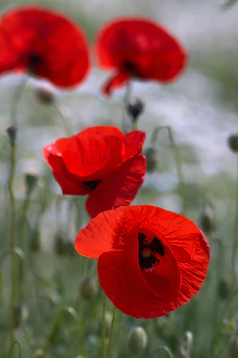
In Flanders' fields the poppies blow between the crosses, row on row
that mark our place;
and in the sky the larks, still bravely singing,
fly scarce heard amid the guns below.
We are the Dead.
Short days ago we lived, felt dawn,
saw sunset glow,
loved, and were loved and now we lie in Flanders' fields.
Take up our quarrel with the foe:
To you from failing hands we throw the torch; be yours to hold it high.
If ye break faith with us who die we shall not sleep, though poppies grow in Flanders' fields.
John McCrae
Inspired by this moving poem, poppies became a poignant reminder, particularly of the First World War, but today, as much as a way of remembering all those who’ve lost their lives, or health in wars that still rob the world of its people today.
Poppies became a reminder of war, they could be made and sold to raise money to support those wounded in war.
As well as serving as a reminder of the horror of war, they also became a sign of hope for young soldiers, a symbol that God had not forgotten them, because, even in this most hostile of environments, something of beauty could survive.
And so, poppies became a sign that peace would come.
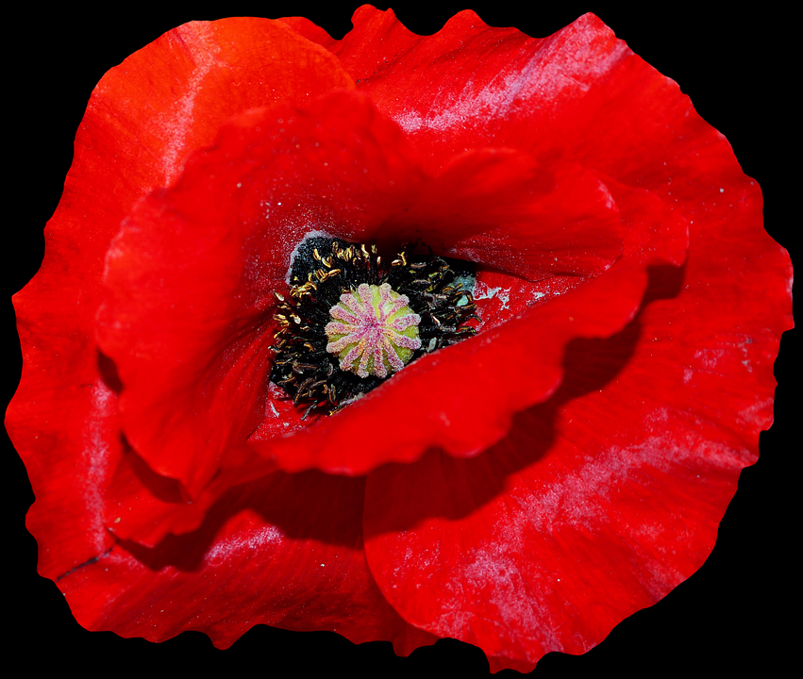
Prayerfully reflect on the poppy as you remember the war in your own way. Perhaps there is someone you want to remember specifically - a family member killed or injured whilst at war; someone who’s life has been affected by war; or perhaps the people of a country who suffer because of war today.
And continue in prayer...
God our creator,
here and now I remember all those
who have given their lives in times of war and conflict
for their sisters' and brothers' freedom.
I pray for all who have lost their lives in conflict - then and now.
I thank you for their selfless example
in laying down their lives for my freedom.
I lift to you in prayer those who mourn the loss of their loved ones:
those who’ve been widowed, or orphaned
those whose loss still troubles and pains them.
May the generosity of all who have laid down their lives
inspire us all to work tirelessly
for harmony and peace amongst all peoples.
May we honour the sacrifices made for our peace
by challenging attitudes that threaten to divide
whenever they present themselves. Amen.

The weight of a snowflake
“Tell me the weight of a snowflake,” a Robin asked a Wild Dove.
“Nothing more than nothing,” was the answer.
“In that case I must tell you a marvellous story,” the Robin said.
I sat on the branch of a fir, close to its trunk, when it began to snow, not heavily, not in a raging blizzard: no, just like in a dream, without a sound and without any violence. Since I did not have anything better to do, I counted the snowflakes settling on the twigs and needles of my branch. Their number was exactly 3,741,952. When the 3,741,953rd dropped onto the branch - nothing more than nothing, as you say - the branch broke off”.
Having said that, the Robin flew away.
The Dove, since Noah’s time and authority on the matter, thought about the story for a while, and finally said to herself: “Perhaps there is only one person’s voice lacking for peace to come to the world”.
From ‘New Fables, Thus spoke the Marabou’ By Kurt Kauter.
Keep a time of quiet for reflection.....
As followers of Jesus Way of living, we do not need to ask whether or not it is our voice that is necessary to make the difference, but to ask God for the courage to use the voice we have with Christian integrity.
Hymn – R&S 629: MP 456:
Make me a channel of your peace.
Where there is hatred, let me bring your love;
where there is injury, your pardon, Lord;
and where there’s doubt, true faith in you:
O, Master, grant that I may never seek
so much to be consoled as to console;
to be understood as to understand;
to be loved as to love with all my soul.
Make me a channel of your peace.
Where there’s despair in life let me bring hope;
where there is darkness, let me bring your light;
and where there’s sadness, bring your joy:
Make me a channel of your peace;
for when we give we will ourselves receive.
It is in pardoning that we are pardoned,
and in dying that we gain eternal life.
From a prayer sometimes attributed to St Francis (1182-1226)
arr. Sebastian Temple. (1928 - )*
The Dove
One olive tree above the flood
and one branch is the sign of solid land again.
You bring hope, messenger of peace.
What olive leaves do we discover in the world’s flood of pain?
The fall of a dictator, a pact between old enemies,
a government halving its spending on arms,
a family embracing different cultures,
a doctor’s care in a war-torn land,
and children with uncorrupted eyes.
Jesus of the olive grove you knew the agony of doubt.
Shall we be saved?
Yes, in the garden dawn; yes in the upper room
and yes, where the tree of life
bears leaves to heal the nations Bernard Thorogood
To follow Jesus’ way is to follow the path of a peacemaker. It won’t be an easy path, or an easy peace, but a peace born out of love and compassion for all - neighbour and enemy alike, those afflicted by power, prejudice and injustice - into this we must speak of peace which is shaped by God’s grace and our self-control rather than our self-interest.
Join with the nation in the Act of Remembrance at 11am
Keep two minutes silence
in which to remember with thanksgiving and sadness
those whose lives were given by God
and taken away by wars - past and present;
there and then - here and now
Remember with gratitude
those who, in the cause of peace
and the service of their fellow men,
died for their country in times of war.
The Last Post
Two minutes silence is kept........
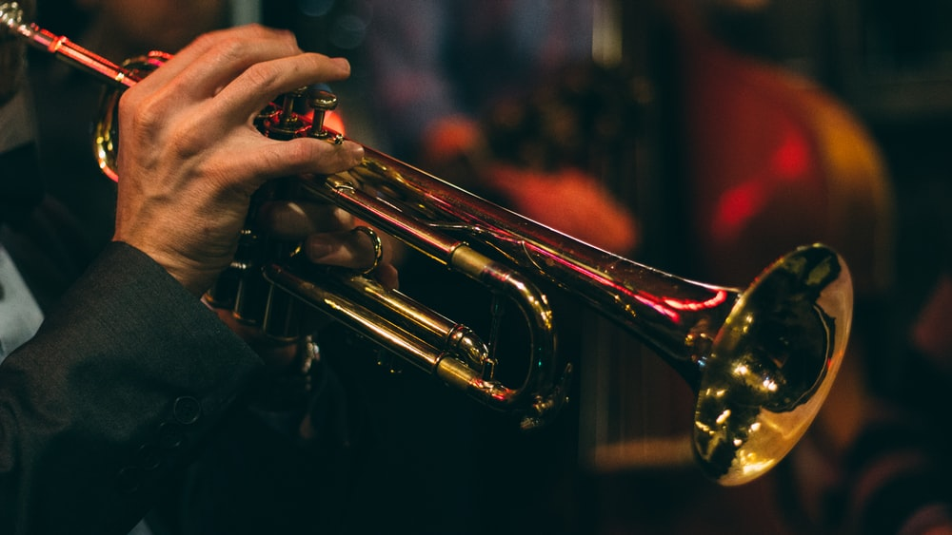
‘The Reveille’ is traditionally played to end the silence. The word derives from the French word ‘réveiller’ meaning ‘wake up’. This is the call that awakens soldiers at dawn.
They shall grow not old, as we that are left grow old.
Age shall not weary them, nor the years condemn.
At the going down of the sun, and in the morning,
we will remember them.
We will remember them.
When you go home, tell them of us and say,
for their tomorrow we gave our today
The Kohima Epitaph - John Maxwell Edmonds (1875–1958) written c. 1916
Lord God, we give thanks for those who have given their lives
for the sake of freedom and peace
Help us to use that freedom wisely, to persistently keep that peace,
so that their sacrifice will not have been in vain.
Empower our peace-making with your Spirit, in Jesus name. Amen
Hymn – R&S 705: MP 489:
Our God, our help in ages past, our hope for years to come,
our shelter from the stormy blast, and our eternal home:
under the shadow of thy throne thy saints have dwelt secure;
sufficient is thine arm alone, and our defence is sure.
Before the hills in order stood, or earth received her frame;
from everlasting thou art God, to endless years the same.
A thousand ages in thy sight are like an evening gone;
short as the watch that ends the night before the rising sun.
Time, like an ever-rolling stream, bears all our years away;
they fly forgotten, as a dream dies at the opening day.
Our God, our help in ages past, our hope for years to come,
be thou our guard while troubles last, and our eternal home.
Isaac Watts (1674-1748) altd. based on Psalm 90:1-6
Reflections
Isaiah’s words express so much fear and anxiety “The Lord has abandoned us! He has forgotten us” the people cry and of course, their cry echoes across thousands of years, there and then - here and now.
The upbeat message of the first verse sounds like ‘optimistic’ political spin on a desperate situation. But it’s rebuked by a wail of despair from the people, against the reality of their predicament as they rail against God.
Through Isaiah the Lord God articulates his reply, words of promise and comfort to a suffering people.
This chapter relates to a time when the people of Judah, God’s chosen people, were in exile in Babylon, they were captive and crushed, a people without hope.
But, Isaiah spoke his prophetic word into this predicament. God’s people are about to be released from their exile! They will go back to Jerusalem, their home. And there, the remnant of the people will be able to reassemble and build a new life - there will be an opportunity for a ‘new normal’.
Isaiah’s words are God’s Word. Through Isaiah’s voice we hear God’s beautiful responses that still comfort us today, because this reading deals with themes that still resonate with us here and now.
The Lord comforts his suffering people. Now, the word comfort originally meant to “give strength to”, the word ‘fortè’ meaning ‘strength’.
God is able to strengthen us, encourage us (give us courage) and in doing so, to move us from one state of ‘being’ to a better one.
So God intends to change people from despair to hope. God’s ‘comfort’ isn’t intended just to soothe and make people feel better, God’s intention is to draw us beyond our current situation, and that demands that we change the way we look at things. Life throws things at us that can make us feel ‘stuck’ and bogged down. God’s message of comfort is intended to draw us out of despair and into a future of promise, vision, and hope.
And God still wants to comfort us and offer us a way out of our ‘stuckness’.
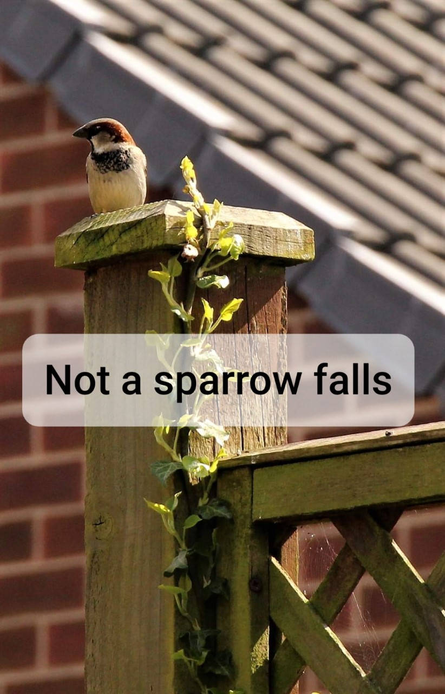
Luke tells us that Jesus says, ‘Aren't five sparrows sold for two pennies? Yet not one sparrow is forgotten by God. Even the hairs of your head have all been counted. So, do not be afraid; you are worth much more than many sparrows!
And the Gospel writer Matthew reminds us that Jesus said ‘Look at the birds of the air; they do not sow or reap or store away in barns, and yet your heavenly Father feeds them. Are you not much more valuable than they?’
Both Isaiah and Jesus tell us that God knows each of us individually and intimately with a love stronger than death. In fact, he loves us to death… on a cross.
We are of so much more value than the sparrows - and Jesus tells us that even the sparrows cannot be forgotten by God.
Unlikely then, that God could ever forget us, as Jesus’ words ring out the truth, that we are precious in God’s sight. Even like a mother knows her own children, unable ever to forget them; God has written each of our names on the palm of His hands - like the tattoos some wear, with the name of their children, imprinted forever.
Take a moment to imagine a mother waiting for news from the battlefront of her beloved child… the body her body bore… So, God cannot forget us. From age-to-age God reassures us, through the remembered words of a prophet “I can never forget you! I have written your name on the palms of my hands”.
Perhaps Isaiah’s and Jesus words remind us of the love of the women and men left at home, waiting, writing letters, aching, anxious for news, and praying that their sons would be safe.
Meanwhile, those who went to war were soon mired in mud, cold and wet, baking in beating hot sun, no place for proper rest in the endless violence and vigil of battle.
And those who refused to fight were vilified; white feathers were given to those who didn’t join the army; those who ran away were shot for cowardice… and the world was never the same again.
Isaiah’s words remind us that the world has suffered from wars for thousands of years. Yet, in November 1918 people dared to hope, and prayed and believed that this was the war to end all wars. The human cost had been immense. Now, surely the world had to study the ways of peace instead of war.
But we’re only too aware that this is not the case, because today we remember also those whose lives are transformed and taken from them in wars that have raged since then, and still rage today.
In remembering, we long for peace, a longing shared by those who reassembled and returned from war, those coming home, so as to build homes safely, and raise children in security, in communities where every human life is valued equally.
Our task, especially as we remember and still witness the terrible events of war, is to engage in the difficult work of building a world of peace, where all have a share of the world’s resources, where people care for one another as much as God cares even for the sparrows, and where the kingdom comes. Because love triumphs where we share with God in the loving comfort that strengthens us, en-courages us and moves us out of our ‘stuckness’ and into new hope.
Hymn – R&S 635: Fred Kaan (1929- )
Put peace into each other’s hands and like a treasure hold it,
protect it like a candle-flame, with tenderness enfold it.
Put peace into each other’s hands with loving expectation;
be gentle in your words and ways, in touch with God's creation.
Put peace into each other’s hands like bread we break for sharing;
look people warmly in the eye: our life is meant for caring.
As at communion, shape your hands into a waiting cradle;
the gift of Christ receive, revere, united round the table.
Put Christ into each other’s hands, he is love’s deepest measure;
in love make peace, give peace a chance, and share it like a treasure.

Prayers for the World... Prayers for Peace
Jesus said
“Peace I leave with you; my peace I give to you.
I do not give to you as the world gives.
Do not let your hearts be troubled, and do not let them be afraid”.
John 14:27

As I remember those who have died in past wars,
so I pray too for those still dying today...
and for those who grieve...
God of the past, be our future peace.
I remember those living in countries
where civil war is destroying communities
and making enemies of neighbours,
where fear and violence dominate every aspect of daily living...
God of today, be our future peace.
I remember those who have been injured and traumatised
by the brutality of war,
especially those robbed of their childhood
by what they have seen or been forced to do ...
God of tomorrow, be our future peace.
I remember those who are peacemakers,
those who negotiate,
those who speak out at great cost to themselves and their families...
God of the future, be our eternal peace.
Help us all, Lord God, to be people who plant seeds of peace wherever our journey takes us
Help us to bless others as we have been blessed.
Help us to speak no words that will wound others.
Help us to withhold nothing that can be shared
and help us to pray always for peace.
Accept all our prayers in the name of Jesus...
the source of our strength, and our inspiration
The one who taught us to pray -
Our Father, who art in heaven, hallowed be thy name
thy kingdom come; thy will be done; on earth as it is in heaven.
Give us this day our daily bread.
And forgive us our trespasses,
as we forgive those who trespass against us.
And lead us not into temptation, but deliver us from evil.
For thine is the kingdom, the power, and the glory,
for ever and ever. Amen.
Hymn – R&S 90: Patrick Appleford (1925 - ) alt.
O Lord, all the world belongs to you
and you are always making all things new.
What is wrong you forgive,
and the new life you give
is what’s turning the world upside down.
The world’s only loving to its friends,
but your way of loving never ends,
loving enemies too;
and this loving with you
is what’s turning the world upside down.
The world lives divided and apart,
you draw us together and we start
in our friendship to see
that in harmony we
can be turning the world upside down.
The world wants the wealth to live in state,
but you show a new way to be great:
like a servant you came,
and if we do the same,
we’ll be turning the world upside down.
O Lord, all the world belongs to you
and you are always making all things new.
What is wrong you forgive,
and the new life you give
is what’s turning the world upside down.
Closing Words and Blessing
We are the Church, the body of Christ,
called to be a living sign of all that God has done,
and all that God will do.
So be ready to proclaim the good news
of God’s freedom, justice, grace and peace, to all humankind. Amen
And may the grace of our Lord Jesus Christ,
the love of God, and the fellowship of the Holy Spirit,
be with us all evermore. Amen

Images:-
Poppies in Field: www.unsplash.com @wolfgang_hasselmann (free image)
Single Poppy: www.pixabay.com (free image) Bugle: www.unsplash.com @chrisbair (free image) Sparrow: Photo by Carol Marsh (Longcauseway Church)

Hymn words reproduced under the CCLI Licence numbers of the SPACE Group of Churches: 181588 - Grove URC: 178113 - The URC Heckmondwike:
177949 - Longcauseway Church: 1236906 - Norristhorpe URC:
783508 - Ravensthorpe with Hopton URC

