**The Briefing – Number 73**

**2nd December 2021**

Dear Friends,

A fortnight ago I was bemoaning the fact that the week prior to issue 72 being released had become very busy. Well, looking back it seems that what was seemingly busy then has nothing on the last week of November and the first week of December. Not only is the diary bulging at the seams but we are entering the season of Advent. It is this season that heralds the coming of the Messiah, not only in Jesus Christ in Bethlehem over 2000 years ago but also again in our hearts and minds as we look to God to lead us in our day to day lives.

The past few days have even seen a return to the scouring of the Government website to try to make sense of the last weekend’s announcement regarding face coverings, where they are mandatory and the advice being given to church organisations. As you will have gathered, the increase in the new Omicron Covid variant has precipitated a change in the law regarding the wearing of face coverings in retail establishments and on public transport. At first glance it does not appear to change any of the regulations associated with places of public worship or places of hospitality and the latest link seems to back this up [**Coronavirus (COVID-19): guidance and support - GOV.UK (www.gov.uk)**](https://www.gov.uk/coronavirus)**.** As ever though the advice from us here at Synod and from the URC as a whole is to abide by the regulations and perhaps even to take it a little further to ensure that those visiting your churches are confident that we have their welfare at heart. Jane, our erstwhile Property Officer, has also asked that this link is brought to your attention as it deals specifically with volunteers, so click here [**Enabling safe and effective volunteering during coronavirus (COVID-19) - GOV.UK (www.gov.uk)**](https://www.gov.uk/guidance/enabling-safe-and-effective-volunteering-during-coronavirus-covid-19)and keep yourselves up to date.

Much of what is in this issue is to do with events now in the New Year. 2022 seems such a long way off, but it is only just over four weeks away and 2022 will mark the 50th Anniversary of the formation of the United Reformed Church. There will be many activities happening at Synod and National level and I hope that you as individual churches will be able to mark this Jubilee with us as well. Our Missional Synod initiative is at the heart of Yorkshire’s response and I hope to be able to bring you details of how we draw on our collective past to create a bright future for our churches. Keep an eye on the [**Yorkshire Synod (urcyorkshire.org.uk)**](https://urcyorkshire.org.uk/) website as well as the [**United Reformed Church 50th Anniversary**](https://urc.org.uk/50th)page.

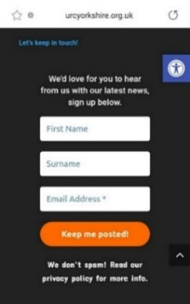

And finally, you can still sign up for the weekly website based newsletter. Head to any page on [**Yorkshire Synod (urcyorkshire.org.uk)**](https://urcyorkshire.org.uk/), scroll to the foot and follow the instructions on the area that looks like this image. It can’t be any simpler than that.

**Church Links, Mission Activities and Synod Events**

**Children and Young Peoples News**

This is the link to the latest Wilderness newsletter put together by the Yorkshire Synod Children and Young Peoples group <https://mailchi.mp/3b3b91b5465d/advent-is-here?e=fb33124ced>.

Please don’t pass it by and as a taster here’s a big question for you all

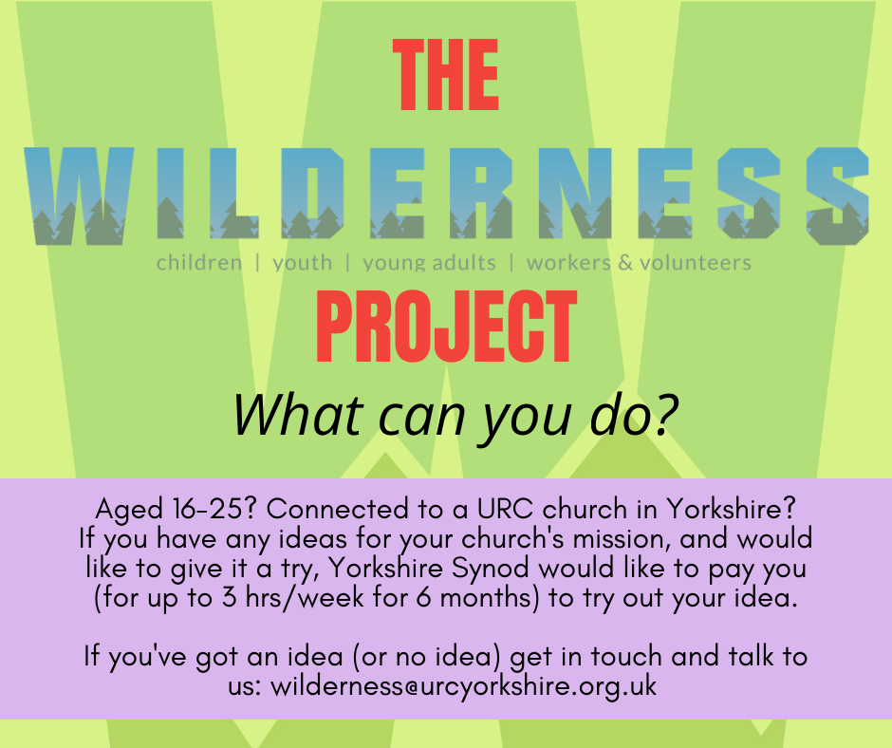

**The WILDERNESS Project is back for 2022.  
*Here at the Yorkshire Synod we want to see young people participating in the mission of God in their church. More than that, we want to PAY YOUNG PEOPLE to participate in the mission of God in their church.*  
We know that it can be a struggle to keep young people engaged in church life, especially when so many other things are happening in their world. Often young people around the age of 16 take part time jobs, which means we see them less. The WILDERNESS Project hopes to encourage, enable and equip young people with the support and the resource to turn a passion into a project to enrich the life of their church.   
Please contact Megan**[here](mailto:wilderness@urcyorkshire.org.uk?subject=The%20WILDERNESS%20Project)**for more information.**

To subscribe to the Wilderness newsletter you can either find the link through the newsletter itself or even better click here [URC Yorkshire Synod (list-manage.com)](https://urcyorkshire.us18.list-manage.com/subscribe?u=6386cd1d52e213399865e28c0&id=911b09bcc9)

**URC Youth Assembly 2022**

Youth Assembly 2022 is getting closer and closer! Are you or do you know a 14-26 years old? (Yes, we have increased the age for this year!). Experience worship and participate in discussions about faith and life with people your age! Not the chatty type? A silent disco could be right up your street! For more info click here: [**www.urc.org.uk/urc-youth-urc.html**](http://www.urc.org.uk/urc-youth-urc.html?fbclid=IwAR3Senx_itMcZHxx_k7lGr4KpeoS8ryseA6NjArC11WB3m-pH0rumpPdzBY)

To book your place click here [**www.urc.org.uk/urcya**](http://www.urc.org.uk/urcya) before 1st January 2022.

**Wilderness Faith Maps**

This simple weekly resource is an easy way to engage with the Bible, prayer and the world around us. Linked to a Sunday Lectionary reading, it is suitable for all ages and faith experiences, as a starting point for a discussion or for personal reflection. You can find it each week here on [**Facebook**](https://www.facebook.com/wildernessfaithmaps), then like the page to be alerted when each weekly post arrives.

**Lay Preachers Planning Group news**

The things in the pipeline are now emerging, with the forst being the latest exploration of the lectionary readings. The next session is on **Thursday 13th January 2022 10am – 11.30am  repeated 7.30pm - 9pm**. It will be facilitated by Rod Morrison and will be a time for participants to look together at the lectionary readings for 23rd and 30th January, 6th and 13th February in preparation for leading worship on those Sundays.

The link will come to all lay preachers nearer the date and more information can be had from Kath Lonsdale via the Synod Office.

And looking forward – into next year no less – Kath Lonsdale has asked that you keep the **22nd to 24th July 2022** clear if you are interested in a **lay preachers weekend at Wydale conference centre**. More details and a booking form nearer the time.

**Worshipping God Together : Apart.**

Rev Janine Atkinson’s regular services and reflections are still being uploaded to the website. As always a big thank you to Janine for these incredible resources which can be found under the ‘What we do’ drop down heading if you fancy a Yorkshire Synod Website surf or more directly at [**https://urcyorkshire.org.uk/worship/**](https://urcyorkshire.org.uk/worship/)

**General Information and Resource Sharing**

**Lent Resource Packs**

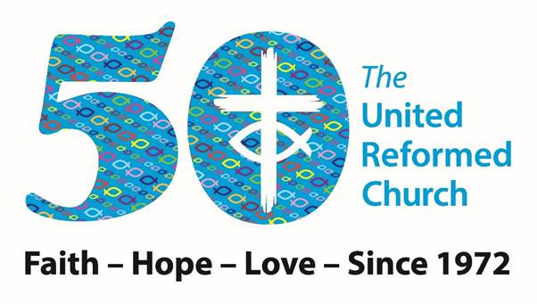This request has come through from Revd Jenny Mills, the Secretary for Education and Learning regarding **Lent materials for the 50th Anniversary of the United Reformed Church.**

﻿

Education and Learning request your help. As you’ll recall, earlier this year we offered people the opportunity to buy Lent Resource Packs. We would like to do the same again. This time we are aiming for 50 stories and we need your help!  
The brief that has been developed by Sam Richards, Simon Peters and Andy Jackson is below so see if you can help. It may be that you can offer a story but not the accompanying resources or vice versa, either way let us know what you would be willing to do. Maybe you can gather a local church/synod community together and create one of the stories and resources? It would be great to have offerings from different people, people serving the church in different ways and those with stories to tell who don’t get the opportunity to share more widely.   
All in all 50 inspirational stories of people from the URC overcoming challenges/issues, living out faith, hope and love are required based on a brief of approximately 700 words and if possible with an all-age and intergenerational content.

* An interesting or thought-provoking story of someone associated with the URC  – link to faith, hope or love – **200 words**
* a short Bible passage or verse – **100 words**
* a prayer to say – I would suggest one that includes space for the person using the resource to personalise it by including (….) within the prayer (and explaining that in the introduction) – **100 words**
* a prayer/reflective activity - **100 words**
* discussion starter/ wondering question - **10-25 words**
* a way to engage with the theme/issues in everyday life (could be a weblink, a JPIT/WtW/C4L project or action etc) - **50 words**
* something fun or creative to do – very simple (think all ages) – could be a link to a video/song/craft/game to play etc – **upto 150 words**

Also can people supply photos of anything that might need demonstrating – basically try it out themselves and photograph the result or the stages involved.

Please get permission from the person (if living) to use their story – you could interview them - a photo of them if possible, or an image that links to their story.



**Revd Jenny Mills**

Secretary for Education and Learning

Email [Philippa.linton@urc.org.uk](mailto:Philippa.linton@urc.org.uk) and copy me in please [jenny.mills@urc.org.uk](mailto:jenny.mills@urc.org.uk) with your submissions

**I.T. News**

**Church Communications Workshops**

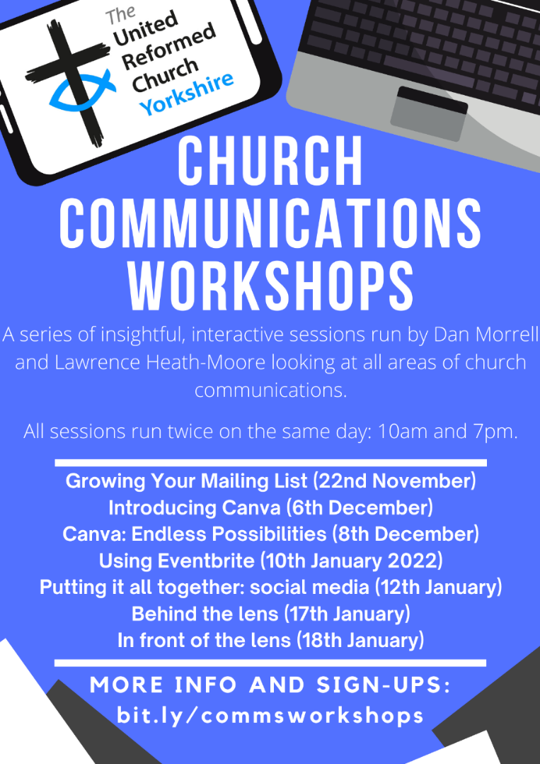In this next series of workshops led by Dan Morrell and Lawrence Heath-Moore, different areas of church communications will be explored as well as finding how you can tap into some powerful resources to make your life easier, yet make your communication more effective at the same time!

Each of the sessions will be interactive and there will be space at the end to ask questions. Some of the sessions are linked, some may be irrelevant to you/your church, so come to some, come to none, come to all!

All the sessions will be recorded and may often have handouts to go with them and the workshops run twice on the dates stated at 10am & 7pm. There should be a time to suit you.

***Growing Your Mailing List***

Thank you very much to those of you who attended our first workshop on Growing your mailing list. The recording of this workshop can be found here: <https://youtu.be/pJBx6WBc1Fg>

The next workshop is **Introducing Canva** on **6th December** (again, 10am and 7pm). Canva is an incredibly powerful, simple-to-use tool that will take your publicity to the next level and beyond! Gone are the days of Microsoft Word or Publisher, ClipArt, WordArt and the like. Canva will transform how you do it!

Following on from that, our ‘next level’ session on **Canva** will be on **8th December** (10am and 7pm). Basically, Canva is so cool that we couldn’t possibly cram it all into 1 session! Please only attend this session if you’ve used Canva before (or, indeed, gone to 6th December one and feel comfortable), as we’ll be making these sorts of assumptions.

***Into next year:***

***Using Eventbrite*,** *Monday 10th January 2022*

***Putting it all together: social media,*** *Wednesday 12th January 2022*

***Behind the lens,*** *Monday 17th January 2022*

***In front of the lens,*** *Tuesday 18th January 2022*

Details of these January courses in a later Briefing – so keep an eye out for the December issues.

**To sign up for any of these events*, please fill in the following Google Form (preferred) or email website@urcyorkshire.org.uk:** [**https://forms.gle/vTnBh8YbgRybrT8B6**](https://forms.gle/vTnBh8YbgRybrT8B6)

*We are **not** running strict attendance; this is just to gain an idea of numbers! The Zoom link for all the sessions will be the same so once you receive the Zoom link you will be able to attend any/all.

**Annual Church Returns**

***Annual Church Returns (ACR) - an important change to note for* Church Secretaries**

This year, the URC plans to introduce online Annual Church Returns. Churches will be able to submit their statistics and updated information by entering this directly onto the user-friendly URC Church Update portal – this will be open to receive updated ACR data from churches during January and February 2022. The information supplied will be sent electronically to Church House and this will be shared with the Synod. We will be contacting you again with further information about the portal and you will receive your individual login and password in due course. Please do contact us with any questions.

***Annual Safeguarding Returns (ASR) - an important change to note for Church Safeguarding Co-ordinators***

This year, the URC plans to introduce online Annual Safeguarding Returns. Churches will be able to submit their updated information by entering this directly onto the user-friendly URC Church Update portal – this will be open to receive updated ASR data from churches during January and February 2022. The information supplied will be shared with the Synod Safeguarding Officer/Adviser. We will be contacting you again with further information about the portal and you will receive your individual login and password in due course. Please do contact us with any questions.

We at Synod Office are also getting to grips with this change, so if you do have any questions I’m told you can send them to the database team at Church House at [ministries.dbs@urc.org.uk](mailto:ministries.dbs@urc.org.uk) and copy them into us at [office@urcyorkshire.org.uk](mailto:office@urcyorkshire.org.uk) so that we know who may need supporting on a more local level.

**Safeguarding News**

**Foundation and Intermediate Training**

Due to increased demand and the need for people to be trained due to the adoption by General Assembly of [Paper T5 - SAG - Safeguarding Training Framework (urc.org.uk)](https://urc.org.uk/images/General-Assemblies/Assembly2021/Paper_T5_-_SAG_-_Safeguarding_Training_Framework_FINAL.pdf) there are some new dates for online safeguarding training. Although **EVERYONE** is invited to **ALL** training please note that certain roles attract a mandatory level of training. To find out which level of training you are expected to go one please follow the link and in the paper it identifies role with the level of training required. If you struggle, let me know at [clerk@urcyorkshire.org.uk](mailto:clerk@urcyorkshire.org.uk) and I’ll send across the details.

Fresh courses have been planned in December, January and February with courses for both Foundation (Basic) level and Intermediate level planned. However, please be aware that you will have had to have attended a Foundation course within the last 3 years before you can book on an Intermediate course.

All courses will be online and via Zoom and bookings can be made by contacting Sally at [moderatorpa@urcyorkshire.org.uk](mailto:moderatorpa@urcyorkshire.org.uk).

**Foundation (Basic) Training**

Thursday 20th Jan 2022 – 10am to 12pm

Tuesday 1st Feb 2022 – 10am to 12pm

Wednesday 16th Feb 2022 – 7pm to 9pm

**Intermediate Training**

Wednesday 8th Dec 2021 – 1pm to 3.30pm

Wednesday 5th Jan 2022 – 1pm to 3.30pm

Monday 24th Jan 2022 - 1pm to 3.30pm

Saturday 12th Feb 2022 – 10am to 12.30pm

Thursday 24th Feb – 10am to 12.30pm

**ECO News**

**Sustaining the World Module by Rev Dr Rosalind Selby**

An 8-session course which looks at: science (introductory), Western Christianity’s role/responsibility/ task, mission, bible, theology, ethics in amongst church responses. To make the most of the course, there will be pre-reading/thinking/exercises which I anticipate take 1-2 hours each. All the pre-tasks will be available before the course starts so you could get ahead with them at any point after you have registered.   
This course is running by Zoom on Monday evenings: 29 Nov, 6 Dec, 10 Jan, 17 Jan, 24 Jan, 31 Jan, 7 Feb and 28 Feb, from 7.00-8.30pm.   
If you want more content details, please contact Rosalind Selby   
If you want registration details, please contact Paul Barrett, the assistant registrar: paul.barrett@lutherking.ac.uk – the course number is TMM 2237.

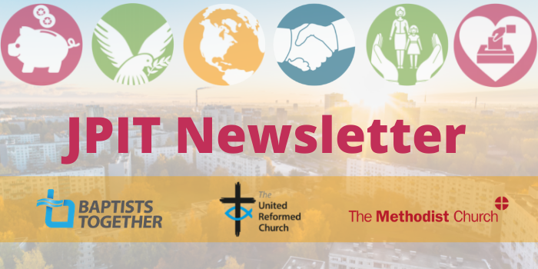

The latest issue of the Joint Public Issues Team Newsletter has just dropped into my in box. As you’ll see it’s been a busy month for them, and it doesn’t seem to be getting any less busy either. JPIT are continuing to focus on the Nationality and Borders Bill, and this month there are new resources available for use. To catch up on this and other news click on this link [**Joint Public Issues Newsletter (jointpublicissues-news.org.uk)**](https://jointpublicissues-news.org.uk/1MV9-7MFUR-6E9EAA3AA92A0FE8MT4T0M0F13CC561F04A3A8/cr.aspx)

The latest issue of the [**URC News Update November 2021 (urc-news.org.uk)**](https://urc-news.org.uk/2JB1-1SZ7Q-122F160E1908EEE459BX7G3A2531BF46D2BD62/cr.aspx) is still available. It has updates on the COP 26 conference, the Climate Crisis, the URC 50th Anniversary plans, and the great news that Herringthorpe’s **Rev Matt Stone** has been named the new Chair of Group for Evangelism and Renewal (GEAR) within the URC. Not only that but there is a link to the new look URC shop [**The United Reformed Church Bookshop (urcshop.co.uk)**](https://urcshop.co.uk/?dm_i=2JB1%2C1SFF1%2C59BX7G%2C667YB%2C1)which I’m told is full of all those things that you didn’t know you needed. Ann-Marie, who edits the URC News Update (like me) is always on the hunt for stories to tell. Don’t leave it to the deadline, drop her a line at [ann-marie.nye@urc.org.uk](mailto:ann-marie.nye@urc.org.uk) and get your good news out there.

|  |
| --- |
|  |

For those with local tastes I know that the **Sheffield team** have their services on their own website at <http://sheffieldurc.org.uk/> and on the Yorkshire site you can find help in preparing and participating in Online Worship at [COVID-19 Advice and Support | URC Yorkshire Synod](https://urcyorkshire.org.uk/covid-19-advice-and-support/).

Now that **St Andrew’s Sheffield** are worshipping in person on Sundays at 10.45am their website services have been discontinued. However, all the services that were uploaded to their website have been archived and can still be accessed at [www.standrewsurcsheffield.org.uk/stop-press](http://www.standrewsurcsheffield.org.uk/stop-press).

They include some very thoughtful Reflections by a variety of ministers and other preachers as well as an eclectic, rich and classical selection of music to complement these acts of worship.

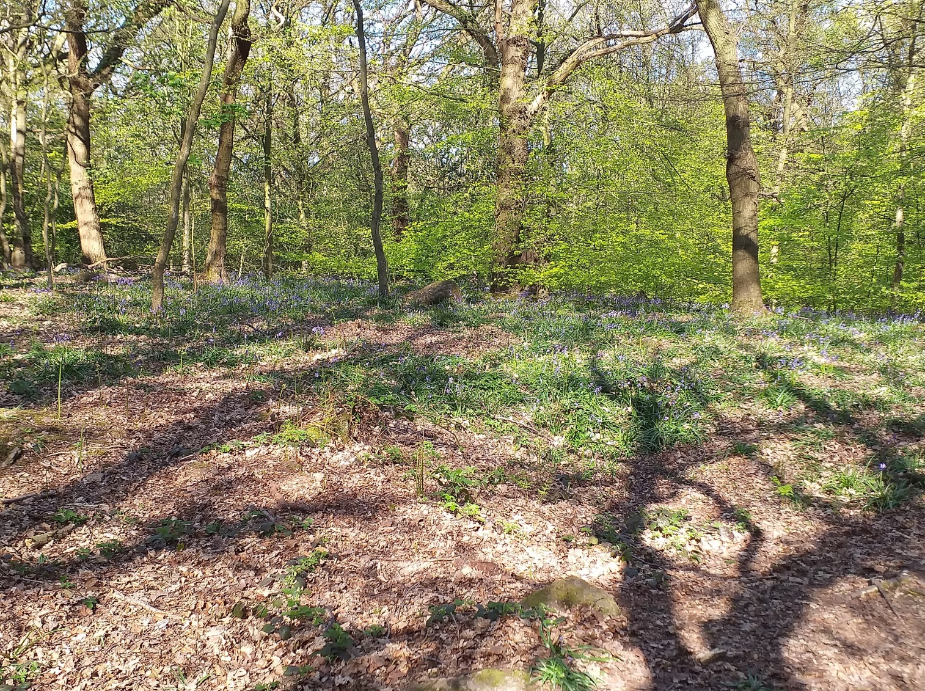

**Please don’t hide these events and resources in your inboxes or within the trees hiding your own churches’ woods. Please send this Briefing around your own church mailing lists as these events are for everyone, member or non-member, church-goer or non-church-goer. All these activities within and beyond Synod are designed to grow the Kingdom.**

**Plans are always happening to bring more activities and good news stories to your attention, so keep an eye open for the next Briefing. All you need to do is get in touch with me at** [**clerk@urcyorkshire.org.uk**](mailto:clerk@urcyorkshire.org.uk)**.**

Don’t forget that up to date Covid-19 (of any variant) advice can be found at any of the following links:

**The URC Synod Moderators’** [**New Freedoms, Same Responsibilities: Synod Moderators' advice to congregations (urc.org.uk)**](https://urc.org.uk/church-information-guides/3870-new-freedoms-same-responsibilities.html). **The URC’s main** [**Advice to churches about coronavirus from the United Reformed Church**](https://urc.org.uk/coronavirus.html)**. Government sites** at [**Coronavirus: how to stay safe and help prevent the spread - GOV.UK (www.gov.uk)**](https://www.gov.uk/guidance/covid-19-coronavirus-restrictions-what-you-can-and-cannot-do) and [**guidance on what you can and cannot do**](https://www.gov.uk/guidance/covid-19-coronavirus-restrictions-what-you-can-and-cannot-do) and [**Find out what the rules are**](https://www.gov.uk/guidance/covid-19-coronavirus-restrictions-what-you-can-and-cannot-do?priority-taxon=774cee22-d896-44c1-a611-e3109cce8eae)**.**

If you know of anything you may find useful for our churches, please contact me at [clerk@urcyorkshire.org.uk](mailto:clerk@urcyorkshire.org.uk) and I’ll circulate it here and on the website. Similarly if you need any further help, be it to do with IT, finance, property or the like we are here to help.

National URC site: <https://urc.org.uk/> Yorkshire Synod: <https://urcyorkshire.org.uk/> Yorkshire Synod Twitter: <https://twitter.com/urcyorkshire> Yorkshire Synod Facebook: <https://www.facebook.com/urcyorkshire> Yorkshire Young People’s Facebook: <https://www.facebook.com/wildernessyorkshireurc/>

*Tim Crossley*

*Synod Clerk*