Worshipping Together : Apart
Sunday 19th December 2021 at 10.30am
Church; Physically Distanced but Spiritually United
Worship Prepared by Rev. Janine Atkinson
A Call to Worship God
I worship the God of the great and of the lowly.
I bring all I have within me to be blessed.
I lift up my voice and rejoice.
I share with you, Lord God, my hopes and my fears,
because you are with me
Lighting the Advent Candle
If you have one, light a candle – or the 4th in your Advent Wreath (if you have one)
As I light this candle, may its flame be a symbol of hope;
its warmth be a symbol of God’s love for me and all those I love.
May it inspire us to find joy
in all our journeying and gathering this Christmas,
and God’s presence in our midst.
In the name of Jesus, the Light of the World. Amen.
Hymn – R&S 137: MP 210: Philip Doddridge (1702-51) altd.*
Hark, the glad sound! The Saviour comes, the Saviour promised long:
let every heart prepare a throne, and every voice a song.
He comes, the prisoners to release in Satan’s bondage held;
the gates of brass before him burst, the iron fetters yield.
He comes, from ignorance and doubt to clear the inward sight;
and on the darkness of the blind to pour celestial light.
He comes, the broken heart to bind, the wounded soul to cure,
and with the treasures of his grace to enrich the humble poor.
Our glad hosannas, Prince of Peace, thy welcome shall proclaim;
and heaven’s eternal arches ring with thy beloved name.

Gospel Reading – Luke 1: 39 – 55
Mary Visits Elizabeth
³⁹ At that time Mary got ready and hurried to a town in the hill country of Judea, ⁴⁰ where she entered Zechariah’s home and greeted Elizabeth. ⁴¹ When Elizabeth heard Mary’s greeting, the baby leaped in her womb, and Elizabeth was filled with the Holy Spirit. ⁴² In a loud voice she exclaimed: ‘Blessed are you among women, and blessed is the child you will bear! ⁴³ But why am I so favoured, that the mother of my Lord should come to me? ⁴⁴ As soon as the sound of your greeting reached my ears, the baby in my womb leaped for joy. ⁴⁵ Blessed is she who has believed that the Lord would fulfil his promises to her!’
Mary’s Song

⁴⁶ And Mary said: ‘My soul glorifies the Lord
⁴⁷ and my spirit rejoices in God my Saviour,
⁴⁸ for he has been mindful of the humble state of his servant.
From now on all generations will call me blessed,
⁴⁹ for the Mighty One has done great things for me –
holy is his name.
⁵⁰ His mercy extends to those who fear him,
from generation to generation.
⁵¹ He has performed mighty deeds with his arm;
he has scattered those who are proud in their inmost thoughts.
⁵² He has brought down rulers from their thrones
but has lifted up the humble.
⁵³ He has filled the hungry with good things
but has sent the rich away empty.
⁵⁴ He has helped his servant Israel, remembering to be merciful
⁵⁵ to Abraham and his descendants for ever,
just as he promised our ancestors.’
A Prayer of Adoration
Lord God, you are light in our darkness:
What a blessing you are!
You are purpose in our wandering:
What a blessing you are!
You are revealed in the angel’s greeting:
What a blessing you are!
You are known in the acceptance of Mary:
What a blessing you are!
You are felt in the care of Joseph:
What a blessing you are!
You are received in the following of the shepherds:
What a blessing you are!
You are given in the gifts of the magi:
What a blessing you are!
You, Lord God, are a blessing today. Amen
Approaching God in Prayer
All-knowing and all-loving God, thank you for calling me just as I am,
and thank you that in your kingdom:
we do not have to be clever to be wise;
we do not have to be wealthy to be rich;
we do not have to be high-ranking to be your chosen witness.
For you are a God of humility as well as of glory,
So I say thank you.
Lord, bring to birth the gifts that you have been nurturing within me:
where I am afraid, give me courage,
where I am unsure, give me clarity,
where I am hesitant, give me determination,
and help me to recognise and release the gifts in others,
so that my life may reflect your glory in the little things I do
and in the ordinariness of who I am.
Forgive me, Lord:
when I have thought more about being famous than faithful;
when I have looked down on those you have raised up;
when I have missed your blessing
in my rush to find blessings of my own.
Forgive me, Lord, and lead me to the child in the manger,
the girl at his side,
and the carpenter watching over them both.
I pray in Jesus’ name. Amen.
Mary Speaks: I couldn't believe my ears
Mary looks back, reflecting on the moment that the angel told her she would bear God's son.
I couldn't believe my ears. Of course, I knew about angels, everyone did. We had heard so many stories about them from Scripture. But angels appeared to other folk, important people like Abraham, or Jacob, or Gideon, or Tobias but not to girls like me. And yet I did encounter one – at the well. The family had run out of water and I was asked to fetch some more. It was late morning and the well was deserted. Usually there was someone around and it was a good place to exchange news and gossip as we filled up our jars, but on this occasion, there was no one, or so I thought.
I'd just started to lift my water pot when I felt a presence. I can't begin to describe him, but I was conscious of a radiance and a beauty that glowed with... well… heaven. Then the voice: clear, musical, yet awesome. I nearly dropped my jar in terror. 'Do not be afraid, Mary, the Lord is with you.' He knew my name; no, more than this, he knew me. Nothing was hidden from him, my fears, my dreams, my inmost longings. Not only this but he also bore a message for me that both thrilled and appalled me. 'Greetings! You who enjoy God's favour.' It was as if I was more important than him, a mere slip of a girl on the brink of womanhood, more important than the archangel himself.
Yet there was nothing special about me, coming as I did from a poor family, in a poverty-stricken hilltop village, where most folks lived in caves rather than in ‘proper’ houses. Nonetheless, he greeted me as if I was royalty.
I was awestruck, dumbfounded, perplexed, thrilled, and yet deeply troubled. But more was to come. 'You have been chosen by God to bear a son, whom you will name Jesus. He is the expected one, Son of the Most High, greater than David, because his reign will never end.'
'But I am still a virgin,' I stuttered, 'How can I bear a child?' 'The Spirit of God will quicken your womb,' came the calm reply, 'you will be mother to God's own son.' It was then that I felt a surge of power and love shoot through my entire body. 'Believe in the God of miracles as your cousin Elizabeth is now six months pregnant.'
Elizabeth? Elizabeth! Who had longed and prayed for a child for years, without avail. At that time an older woman, devoted to God, but hurting inside because her childlessness left her feeling unfulfilled. She was with child. It was a miracle indeed! So, if God could cause that to happen, perhaps it could happen for me too? I would leave the explanations, and the implications to him.
With a fearful joy I said 'Yes, let it be.' Let God have his way, I would be his servant. I didn't understand what it would mean then, the pain, the shame, the tears and the joy, but I am so grateful to have been chosen, so glad to have said, 'yes'. (Adapted from Roots on the Web 2003)
Hymn – R&S 740: MP 631Timothy Dudley-Smith. (1926- ) based on Luke 1:46-55
Tell out, my soul, the greatness of the Lord!
Unnumbered blessings give my spirit voice;
tender to me the promise of his word;
in God my Saviour shall my heart rejoice.
Tell out, my soul, the greatness of his name!
Make known His might, the deeds his arm has done;
his mercy sure, from age to age the same;
his holy name — the Lord, the mighty One.
Tell out, my soul, the greatness of his might!
Powers and dominions lay their glory by;
proud hearts and stubborn wills are put to flight,
the hungry fed, the humble lifted high.
Tell out, my soul, the glories of his word!
Firm is his promise, and his mercy sure.
Tell out, my soul, the greatness of the Lord
to children’s children and forever more!
Reflection
I discovered that I was pregnant on my 40th birthday! It was a bit of a surprise! I too had thought I couldn’t have children, and age wasn’t on my side, so I have some empathy with Elizabeth.
To be honest, I was frightened of giving birth and, like Mary, I needed to meet others who were also expecting a baby. So, Mike and I joined the local NCT Group (National Childbirth Trust).
I was, by some years, the oldest expectant mother there, but within that all age community a bond grew. I learned from women and men much younger than me – some of them young enough to be my daughters and sons - and they learned from Mike and I. Through openness and honesty, we learned from each other.
One particular expectant mum became a great friend. She is 14 years younger than me. Like me, she was ‘unexpectedly’ pregnant.
The NCT Group brought people together from different walks of life and backgrounds. In most cases our paths would never have crossed except for our common bond of impending parenthood. We were on a journey together, a rollercoaster of emotions, but held together -whatever life’s journey had been up to that point - by the blessing of impending parenthood and the new journey we were on - together.
Throughout our pregnancies as expectant mums and dads we learned together, we shared hopes and fears, dreams and nightmares – that was before our babies were born, all within 5 weeks of each other (it should have been within 3 weeks of each other, but one came early and one was 10 days late, naming no names!) So, I learned from the experience of those younger than me – and for that I am grateful. For me it may have saved my life – a friend had become severely ill a week or so after giving birth, so I was able to spot the signs of an infection (from which some die) before I became too ill.
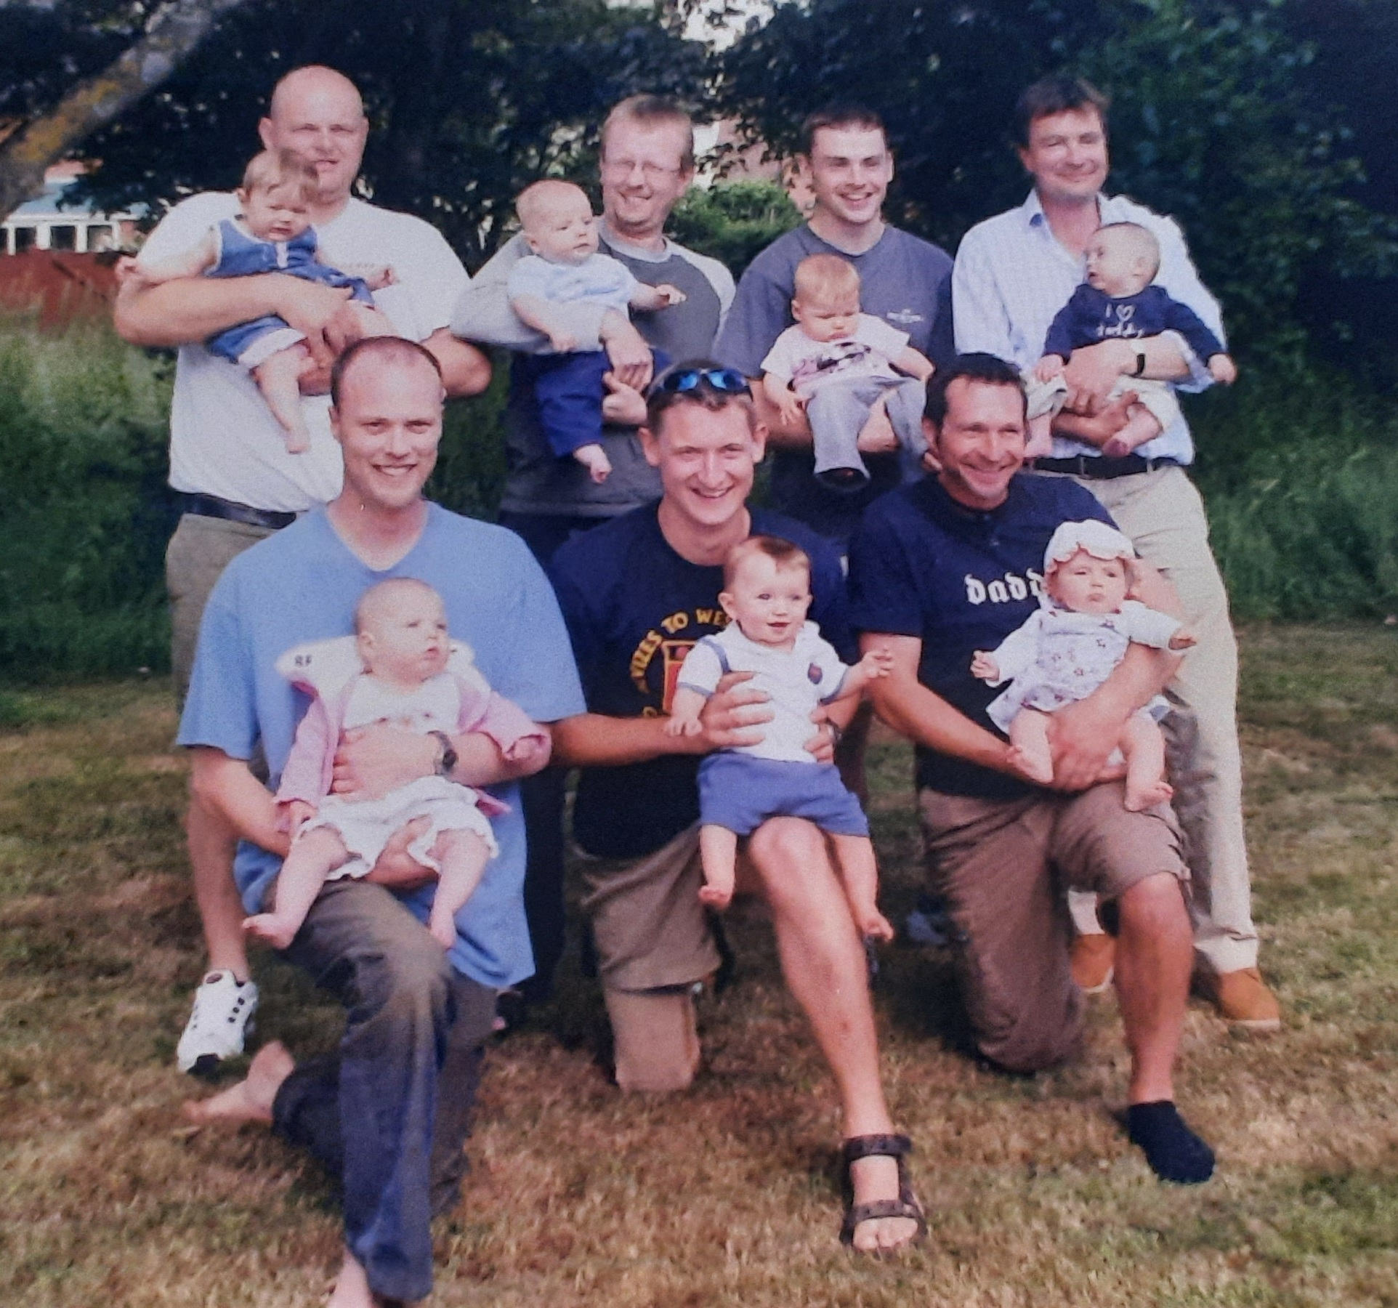
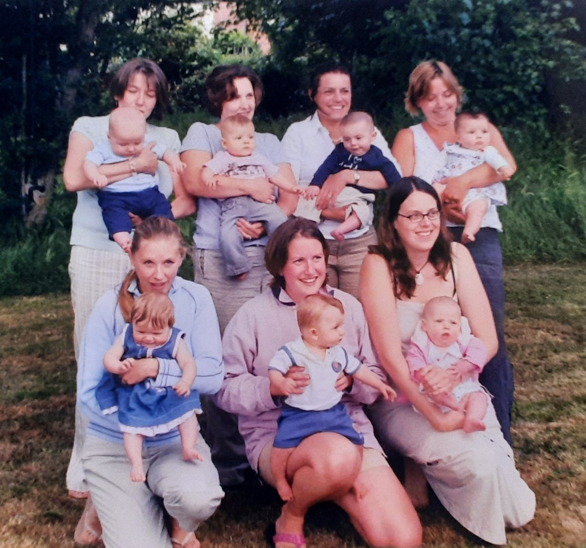
Pregnancy and childbirth are great ‘levellers’. They are no respecters of where you come from, or where you live, what your status is in life, or where you are going in life. Both pregnancy and childbirth are a heady mixture of joy and pain, hope and fear - no matter what. One way or another that baby has to both grow and come out.
And yet, still, some have more to fear than others, because despite the leveller that pregnancy and childbirth are, some people’s experience of it is far worse than others.
If you live in a country where there is little or no healthcare support, there is much more to fear than to hope for. If you have to pay for your care, you may not be able to afford what you need in your particular circumstances.
In some parts of the world, women give birth on a roadside, whilst others will give birth in private wards in safe clean hospitals. For some their precious baby will be born too soon, or asleep. For some the process will be traumatic. We are not all in the same boat.
The visit and greeting of someone who knows and understands is special. Whatever the circumstances, when we receive news that surprises or shocks us; saddens or delights us, we need to connect with others. And that desire is strong and compelling – Mary’s trip to meet her cousin Elizabeth was a long one, wearying for a young woman in the early stages of her pregnancy.
We have experienced separations in times of both joy and crisis these last 21 months, times when we have been desperate to connect with others. We have not been able to meet or welcome people into our homes or greet others with a warm smile and a hug, no matter how we ached to do so. The need to meet and greet and support each other is strong - God did not make us to be alone - so these have been challenging times in ways we could never have imagined as we’ve been separated from others in so many ways, unable to gather, face-to-face, with family and friends to share life’s ups and downs in the way we normally do.
Although we are not all in the same boat Jesus is in the boat with us, waiting for us to notice him. So, as the day approaches for us to celebrate Jesus’ birth, we have an opportunity to notice Jesus, to ask him to be born, or reborn, in our hearts to help us steer the boat we are in, however strong or weak that ‘boat’ is.
Just as there are benefits to sharing our experiences of any fearful thing, we need others to share in the journey of faith with us too. We need the experience of others, younger and older than ourselves, who have found a welcome for Jesus in their heart. We need people prepared to speak from their experience, to share their faith and their doubt, their insights and their questions, with others. We are all at different points along the journey, and that journey will never end, that leads Jesus to be indwelling and incarnate in us – God with us – shaping within us a Christ-like character, and forming and reforming our inner being, bringing a brand new person to birth as Jesus takes shape and moves within us, making our hearts leap with joy as God is increasingly able to communicate his amazing grace – that undeserved and unconditional love that is ours, because we are God’s children, people brought fully alive through all that Jesus has already done - and still does as ‘God imparts to human hearts the blessings of his heaven’.
Amen
Hymn – R&S 145: MP 503: Phillips Brooks (1835-93)
O little town of Bethlehem, how still we see thee lie!
Above thy deep and dreamless sleep the silent stars go by:
yet in thy dark streets shineth the everlasting Light;
the hopes and fears of all the years are met in thee tonight.
O morning stars, together proclaim the holy birth,
and praises sing to God the King, goodwill and peace on earth.
For Christ is born of Mary; and gathered all above,
while mortals sleep, the angels keep their watch of wondering love.
How silently, how silently, the wondrous gift is given!
So God imparts to human hearts the blessings of his heaven:
no ear may hear his coming; but in this world of sin,
where meek souls will receive him, still the dear Christ enters in.
O Holy Child of Bethlehem, descend to us, we pray;
cast out our sin, and enter in, be born in us today.
We hear the Christmas angels the great glad tidings tell:
O come to us, abide with us, our Lord, Immanuel.
Holding the World in Prayer
In the early days of her pregnancy Mary made the long journey to visit Elizabeth. And in the late stages of her pregnancy, she travelled 70 miles from Nazareth to Bethlehem.

So we remember today, those who are on a journey:
from the old to the new; familiarity to insecurity;
tyranny to democracy; war to peace; danger to safety,
despair to hope, exploitation to freedom,
fear to tranquillity, homelessness to sanctuary.

And we remember those who wait:
for an end; for good news; for love; for hope; for new birth.
We remember today those who hear the news
that there is new life on the way:
those who will receive the news with joy; and those who will be afraid;
those who rejoice, and give support; for those who turn their backs;
those who make expensive preparations;
and those who wonder how they will feed another mouth;
those who had given up hope; and those who are still waiting;
those who see a perfect image;
and those who are told something is not right;
those who deliver with ease, and for those for whom it is a struggle;
those who will deliver in comfort, and those who will deliver in makeshift homes of tarpaulin and poor sanitation, or by a roadside.

Creator God, may they and may I, know you to be cradling us - mothering us into peace and hope and joy in your love.

Father God, creative and inventive within us enable us to give birth to solutions that will level the playing field for all humankind,
created out of your love and in your image.

Lord Jesus, enter our hearts and be born in us today. Amen.
Hymn – R&S 90: Patrick Appleford (1925 - ) alt.
O Lord, all the world belongs to you
and you are always making all things new.
What is wrong you forgive, and the new life you give
is what’s turning the world upside down.

The world’s only loving to its friends,
but your way of loving never ends,
loving enemies too; and this loving with you
is what’s turning the world upside down.

The world lives divided and apart,
you draw us together and we start
in our friendship to see that in harmony we
can be turning the world upside down.

The world wants the wealth to live in state,
but you show a new way to be great:
like a servant you came, and if we do the same,
we’ll be turning the world upside down.

O Lord, all the world belongs to you
and you are always making all things new.
What is wrong you forgive, and the new life you give
is what’s turning the world upside down.
Closing Words and Blessing

The Word made flesh lives in you, and speaks through you.
So, trust in his riches, not in your poverty;
trust in his power, not in your weakness;
and rejoice that God has called all of us, young and old,
to be his children, his witnesses, his people.
Follow in the footsteps of Mary, make your way to the stable
and rejoice that Christ, born in Bethlehem,
is, and always will be, your friend, your companion and your Saviour.
May the Lord bless you and keep you;
may the Lord make his face to shine upon you, and be gracious to you,
the Lord lift up his countenance upon you, and give you peace. Amen

Hymn words reproduced under the CCLI Licence numbers of the SPACE Group of Churches: 181588 - Grove URC: 178113 - The URC Heckmondwike: 177949 - Longcauseway Church: 1236906 - Norristhorpe URC: 783508 - Ravensthorpe with Hopton URC
Photos: NCT Mummies and Babies: NCT Daddies and Babies - June 2004 Photos taken by Mike and Janine Atkinson

