The Briefing – Number 75
6th January 2022
Dear Friends,
A very Happy New Year to you all. I hope and pray that 2022 brings you health and happiness, growth and peace under the watchful and loving eye of our Lord and Saviour Jesus Christ.

I had hoped that I could be as positive and optimistic about the start of the New Year as possible, but I must admit there is a bit of the “same old, same old” about where we are. I’m referring to the Covid-19 state of affairs and the uncertainty over where the Omicron variation is going to take us and whether any previous or subsequent variations are going to have an effect on the way in which we conduct our lives.

I write this after the latest Prime Ministerial announcement on the evening of 4th January. Yes, there have been some developments regarding schools and their response to the latest Covid-19 figures and the rise of the Omicron variation, but for us as churches there is no change. That guidance is online in the government’s own website and in the excellent guidance offered by the Synod Moderators, which was updated before Christmas Covid Plan B: Synod Moderators' updated guidance - United Reformed Church. As you look at this, also look at the other resources the URC are offering. The Coronavirus advice - United Reformed Church page has all the latest updates, worship aid and resources, all designed for you and your churches. Please don’t forget though to keep a close eye on the official government websites, where there are links to help with negotiating the revised regulations. The key link is this Coronavirus (COVID-19): guidance and support - GOV.UK (www.gov.uk) website. Indeed, the advice from us here at Synod and from the URC as a whole is to abide by the regulations and perhaps even to take it a little further to ensure that those visiting your churches are confident that we have their welfare at heart.

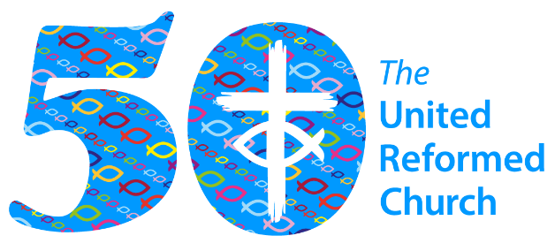
So here we are in JUBILEE YEAR 2022. As I mentioned last year, 2022 marks the 50th Anniversary of the formation of the United Reformed Church. There will be many activities happening at Synod and National level and I hope that you as individual churches will be able to mark this Jubilee with us as well. Our Missional Synod initiative is at the heart of Yorkshire’s response and I hope to be able to bring you details of how we draw on our collective past to create a bright future for our churches. Keep an eye on the Yorkshire Synod (urcyorkshire.org.uk) website as well as the Our 50th Anniversary - United Reformed Church page.

Lay Preachers Planning Group news

The things in the pipeline are definitely now emerging, the first being the latest exploration of the lectionary readings. This session is on Thursday 13th January 2022 10am – 11.30am repeated 7.30pm - 9pm. It will be facilitated by Rod Morrison and will be a time for participants to look together at the lectionary readings for 23rd and 30th January, 6th and 13th February in preparation for leading worship on those Sundays.
The link will come to all lay preachers nearer the date and more information can be had from Kath Lonsdale via the Synod Office.

And looking forward – into the summer no less – Kath Lonsdale has asked that you keep the 22nd to 24th July 2022 clear if you are interested in a lay preachers weekend at Wydale conference centre. More details and a booking form nearer the time.

URC Website
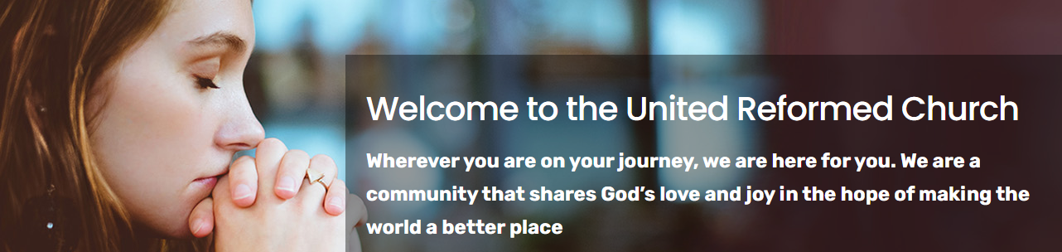

Over the weekend of 11th & 12th December, the URC website, www.urc.org.uk, had a transformation. It has been updated and is the product of many months’ work by the team at Church House. It seems to be working and I haven’t come across anything amiss with it.
The old website will be available for a time at www.urc.org.uk/archive for older content that you need to access. Some pages on the new website are a work in progress and these will be finished in the next few weeks. Please get in touch with the Communications Team at Church House via urc@urc.org.uk if there is an urgent page missing, broken link or item not working.
Please remember that websites always evolve and are never finished. This new website puts visitors first, not the church structures, and some sections have changed or been reordered, in collaboration with the teams responsible for that content. Many pages that weren’t being looked at have not come across.
And, unlike the old website, this one has a search engine that works! 😊

URC News Update
The latest issue of the URC News Update Dec 2021 - Jan 2022 (urc-news.org.uk) is now available. In it there is an opportunity to obtain free tickets to next year’s Jubilee Service on 1st October at Westminster Central Hall as well as updates on the recent Assembly Executive, the URC’s response to Conversion Therapy, and its response to Omicron. Not only that but there is a link to the new look URC shop The United Reformed Church Bookshop (urcshop.co.uk) which I’m told is full of all those things that you didn’t know you needed. Ann-Marie, who edits the URC News Update (like me) is always on the hunt for stories to tell. Don’t leave it to the deadline, drop her a line at ann-marie.nye@urc.org.uk and get your good news out there.
Children and Young Peoples News

This is the link to the latest Wilderness newsletter put together by the Yorkshire Synod Children and Young Peoples group https://mailchi.mp/3b3b91b5465d/advent-is-here?e=fb33124ced.
Please don’t pass it by and as a taster here’s a big question for you all
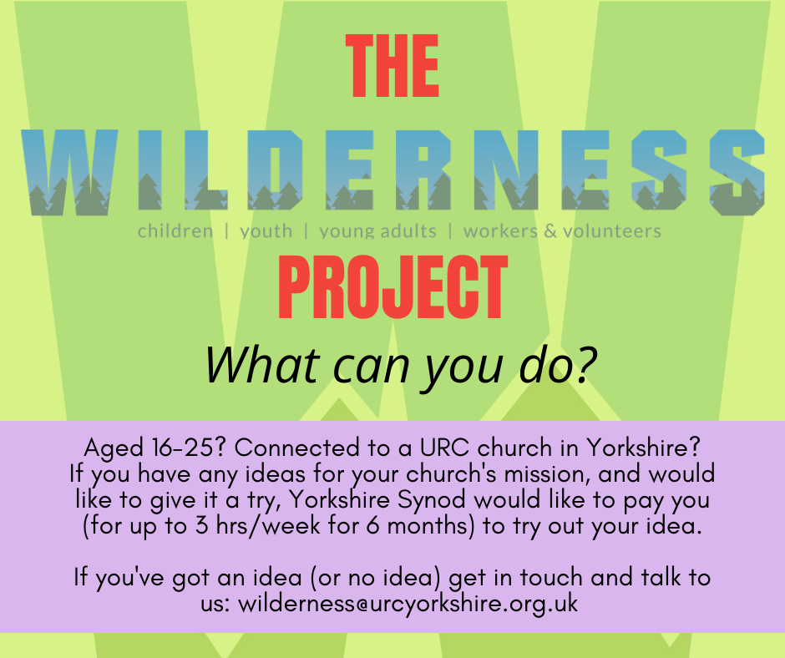

The WILDERNESS Project is back for 2022.
Here at the Yorkshire Synod we want to see young people participating in the mission of God in their church. More than that, we want to PAY YOUNG PEOPLE to participate in the mission of God in their church.
We know that it can be a struggle to keep young people engaged in church life, especially when so many other things are happening in their world. Often young people around the age of 16 take part time jobs, which means we see them less. The WILDERNESS Project hopes to encourage, enable and equip young people with the support and the resource to turn a passion into a project to enrich the life of their church.
Please contact Megan here for more information.

To subscribe to the Wilderness newsletter you can either find the link through the newsletter itself or even better click here URC Yorkshire Synod (list-manage.com)

Wilderness Faith Maps
This simple weekly resource is an easy way to engage with the Bible, prayer and the world around us. Linked to a Sunday Lectionary reading, it is suitable for all ages and faith experiences, as a starting point for a discussion or for personal reflection. You can find it each week here on Facebook, then like the page to be alerted when each weekly post arrives.

I.T. News
Church Communications Workshops
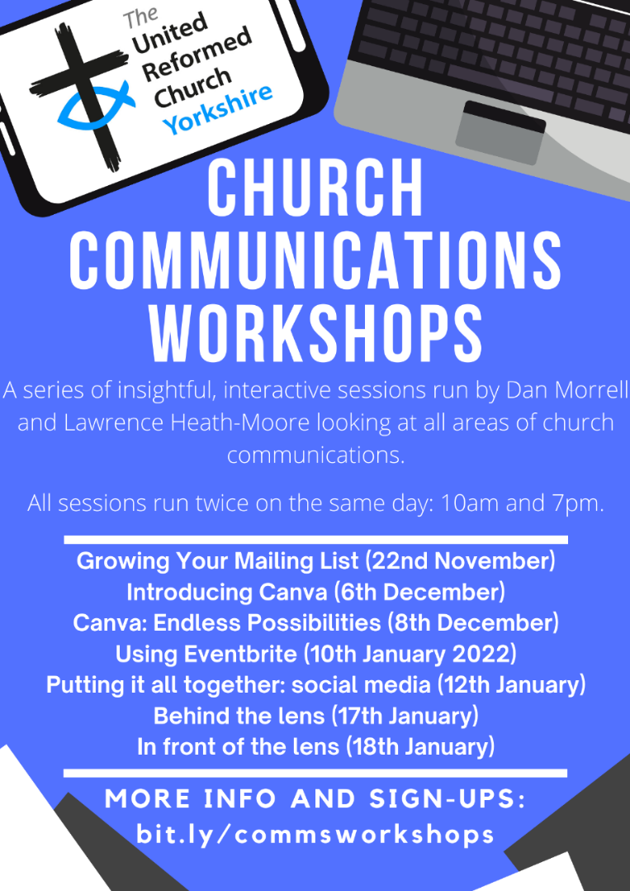
These workshops led by Dan Morrell and Lawrence Heath-Moore, see different areas of church communications being explored as well as finding how you can tap into some powerful resources to make your life easier, yet make your communication more effective at the same time!
Each of the sessions will be interactive and there will be space at the end to ask questions. Some of the sessions are linked, some may be irrelevant to you/your church, so come to some, come to none, come to all!
All the sessions will be recorded and may often have handouts to go with them and the workshops run twice on the dates stated at 10am & 7pm. There should be a time to suit you.

Using Eventbrite, Monday 10th January 2022,
Putting it all together: social media, Wednesday 12th January 2022
Behind the lens, Monday 17th January 2022,
In front of the lens, Tuesday 18th January 2022

To sign up for any of these events*, please fill in the following Google Form (preferred) or email website@urcyorkshire.org.uk: https://forms.gle/vTnBh8YbgRybrT8B6
*We are not running strict attendance; this is just to gain an idea of numbers! The Zoom link for all the sessions will be the same so once you receive the Zoom link you will be able to attend any/all.

Worshipping God Together : Apart.
Rev Janine Atkinson’s regular services and reflections are still being uploaded to the website. As always a big thank you to Janine for these incredible resources which can be found under the ‘What we do’ drop down heading if you fancy a Yorkshire Synod Website surf or more directly at https://urcyorkshire.org.uk/worship/

Annual Church Returns
Annual Church Returns (ACR) - an important change to note for Church Secretaries
This year, the URC plans to introduce online Annual Church Returns. Churches will be able to submit their statistics and updated information by entering this directly onto the user-friendly URC Church Update portal – this will be open to receive updated ACR data from churches during January and February 2022. The information supplied will be sent electronically to Church House and this will be shared with the Synod. We will be contacting you again with further information about the portal and you will receive your individual login and password in due course. Please do contact us with any questions.

Safeguarding News
Annual Safeguarding Returns (ASR) - an important change to note for Church Safeguarding Co-ordinators
In 2022 the URC plans to introduce online Annual Safeguarding Returns. Churches will be able to submit their updated information by entering this directly onto the user-friendly URC Church Update portal during January and February 2022. The information supplied will be shared with the Synod Safeguarding Officer/Adviser. We will be contacting you again with further information about the portal and you will receive your individual login and password in due course. Please do contact us with any questions.
As we at Synod Office are also getting to grips with this change if you have any questions please send them to the database team at Church House at ministries.dbs@urc.org.uk and copy them into us at office@urcyorkshire.org.uk so that we know who may need supporting on a more local level.

Foundation and Intermediate Training
Due to increased demand and the need for people to be trained due to the adoption by General Assembly of Paper T5 - SAG - Safeguarding Training Framework (urc.org.uk) there are some new dates for online safeguarding training. Although EVERYONE is invited to ALL training please note that certain roles attract a mandatory level of training. To find out which level of training you are expected to go one please follow the link and in the paper it identifies role with the level of training required. If you struggle, let me know at clerk@urcyorkshire.org.uk and I’ll send across the details.
Fresh courses have been planned in January and February with courses for both Foundation (Basic) level and Intermediate level planned. However, please be aware that you will have had to have attended a Foundation course within the last 3 years before you can book on an Intermediate course. All courses will be online and via Zoom and bookings can be made by contacting Sally at moderatorpa@urcyorkshire.org.uk.
THERE ARE A FEW PLACES LEFT ON THE FOLLOWING DATES SO PLEASE GET IN TOUCH SOON BEFORE THEY ALL GO

Foundation (Basic) Training
Thursday 20th Jan 2022 – 10am to 12pm
Tuesday 1st Feb 2022 – 10am to 12pm
Wednesday 16th Feb 2022 – 7pm to 9pm
Intermediate Training
Saturday 12th Feb 2022 – 10am to 12.30pm
Thursday 24th Feb – 10am to 12.30pm

Now that St Andrew’s Sheffield are worshipping in person on Sundays at 10.45am their website services have been discontinued. However, all the services that were uploaded to their website have been archived and can still be accessed at www.standrewsurcsheffield.org.uk/stop-press.
They include some very thoughtful Reflections by a variety of ministers and other preachers as well as an eclectic, rich and classical selection of music to complement these acts of worship.

ECO News
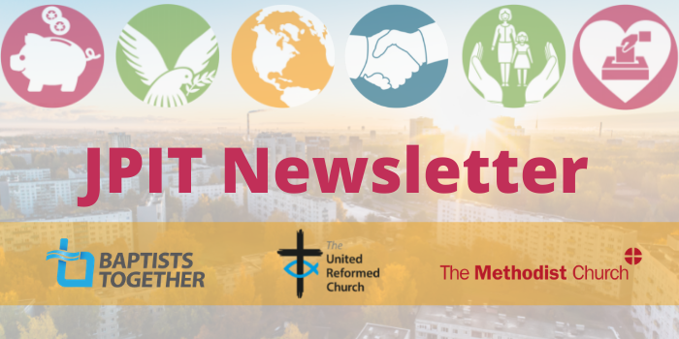
The latest issue of the Joint Public Issues Team Newsletter is out. As you’ll see it’s been a busy month for them, and it doesn’t seem to be getting any less busy either. JPIT are continuing to focus on the Nationality and Borders Bill, and this month there are new resources available for use. To catch up on this and other news click on this link Joint Public Issues Newsletter (jointpublicissues-news.org.uk)

Talking of all things ECO, we are still looking for more Synod Green Apostles. If you have a desire to help Yorkshire become an Eco Synod and a torch-bearer for a greener environment please get in touch. Alex Jowitt at greenapostle@urcyorkshire.org.uk or me at clerk@urcyorkshire.org.uk would love to hear from you.

Please don’t hide these events and resources in your inboxes or within the trees hiding your own churches’ woods. Please send this Briefing around your own church mailing lists as these events are for everyone, member or non-member, church-goer or non-church-goer. All these activities within and beyond Synod are designed to grow the Kingdom.
Plans are always happening to bring more activities and good news stories to your attention, so keep an eye open for the next Briefing. All you need to do is get in touch with me at clerk@urcyorkshire.org.uk.

Don’t forget that up to date Covid-19 (of any variant) advice can be found at any of the following links:
The URC Synod Moderators’ New Freedoms, Same Responsibilities: Synod Moderators' advice to congregations (urc.org.uk). The URC’s main Advice to churches about coronavirus from the United Reformed Church. Government sites at Coronavirus: how to stay safe and help prevent the spread - GOV.UK (www.gov.uk) and guidance on what you can and cannot do and Find out what the rules are.

If you know of anything you may find useful for our churches, please contact me at clerk@urcyorkshire.org.uk and I’ll circulate it here and on the website. Similarly if you need any further help, be it to do with IT, finance, property or the like we are here to help.
National URC site: https://urc.org.uk/ Yorkshire Synod: https://urcyorkshire.org.uk/ Yorkshire Synod Twitter: https://twitter.com/urcyorkshire Yorkshire Synod Facebook: https://www.facebook.com/urcyorkshire Yorkshire Young People’s Facebook: https://www.facebook.com/wildernessyorkshireurc/

Tim Crossley
Synod Clerk

