**The Briefing – Number 78**

**17th February 2022**

Dear Friends,

Welcome to you bumper mid-February edition of the Briefing. The stops really have been pulled out this issue and there is such a lot going on. This is great, for you for Synod and for the work of the Lord in Yorkshire. We have the work of our new Mission Advocate gaining momentum so all, you churches who haven’t had a call from Jon, expect one soon. We have more IT resources being offered at the beginning of March, there is more information on the national site about the events surrounding the 50th Anniversary of the URC and the Yorkshire Website is offering more than just snippets of news and events, but opportunities to really explore our faith. February traditionally heralds the start of the spring series of meetings, both in local churches and within the synod. So it gives me great pleasure to let you all know again that the Spring meeting of Synod, on Saturday 12th March, will be at St Andrew’s Church, Skipton. Hopefully the papers will be sent out soon to your Synod Representatives so that they can participate in as full a way as possible. This time we aim to offer the Synod representatives who join online the same opportunities to contribute and vote as those who attend in person. It is a huge step forward and one that the URC as a whole is embracing. Similarly, the Synod appreciates that Yorkshire is a different place to what it was two years ago with churches developing different and new priorities. So keep an eye open for the papers and pray for a successful meeting on the 12th March.

 I’ll continue to mention that as part of Yorkshire’s response to Jubilee 2022 our **Missional Synod** initiative is at the heart of what we aim to offer this year. In this issue, Jon Steel brings details of how we can create a bright future for our churches. Keep an eye on the [**Yorkshire Synod (urcyorkshire.org.uk)**](https://urcyorkshire.org.uk/) website as well as the [**Our 50th Anniversary - United Reformed Church**](https://urc.org.uk/who-we-are/our-50th-anniversary/)page. As part of this initiative to raise the profile of mission in the synod, our new **Mission Advocate**, Jon Steel, has begun to upload short articles onto the synod website and Facebook page each week, as well as hosting monthly Zoom get-togethers to as the question “What is Mission?” They get-togethers planned for the last Tuesday in the month using this regular Zoom link:

[**https://zoom.us/j/92778926887?pwd=dUJKckNDZ1NNL1BMRncvMzBFd2Q1UT09**](https://zoom.us/j/92778926887?pwd=dUJKckNDZ1NNL1BMRncvMzBFd2Q1UT09). More information can be had from Jon via his new e-mail [**missionadvocate@urcyorkshire.org.uk**](mailto:missionadvocate@urcyorkshire.org.uk)**.** If you have signed up to the weekly update from website (which I would encourage you to do), you will receive a copy of it each Friday and with it the link to articles and as a taster here’s the direct link to the first one [**https://urcyorkshire.org.uk/a-biblical-jubilee-for-the-synod/**](https://urcyorkshire.org.uk/a-biblical-jubilee-for-the-synod/).

I hope you will find the stories useful and interesting week by week as we celebrate the last 50 years and look forward to what might come next in the synod. Please do get in touch with Jon if you have any feedback or ideas, or you would like to find out more about exploring mission for yourself or your church.

**Mission Advocate**

Jon Steel, our Mission Advocate has the following message:

*I hope you don’t mind this quick update from me? In case you haven’t had a chance to see them, there have been some weekly blogs on the synod website, beginning our conversation about mission this year:*

[***https://urcyorkshire.org.uk/so-whats-the-plan/***](https://urcyorkshire.org.uk/so-whats-the-plan/) *explains a little bit about where we are starting this year (with prayer).*

[***https://urcyorkshire.org.uk/whatismission1/***](https://urcyorkshire.org.uk/whatismission1/) *Ashley Evans gives a brief overview of his understanding of mission (look out for other people sharing their thoughts each month).*

[***https://urcyorkshire.org.uk/what-are-we-here-for/***](https://urcyorkshire.org.uk/what-are-we-here-for/)*encourages us to start at the very beginning and think about what our churches are actually here to for*

*There will also be monthly real-life examples from churches of what their mission looks like (starting next week). Please could you point them out to your members in case they are interested?*

*There will also be the second f our ‘****What is Mission?****’ online groups on* ***Tuesday February 22nd****. Everyone is welcome to join in at any point, please watch the website and get in touch for the zoom details.*

*Over the next couple of months I will also be following up the Moderator’s letter about mission and contacting every Church Secretary. If this makes me sound like the ‘mission police’ that really isn’t the idea. I am hoping to get a picture of what your church understands mission to be, and whether you feel it is something you do, or can engage with, or not. I hope it doesn’t sound off-putting – it would be a cup of tea and a chat if I could meet you in person (which I would also be glad to do).*

*I hope the lengthening days are bringing you a sense of more light and possibility.*

*Many thanks,*

*Jon*

[**missionadvocate@urcyorkshire.org.uk**](mailto:missionadvocate@urcyorkshire.org.uk)

07522 220214

**Disciple Development Fund**

***Yorkshire URC Synod Discipleship Development Fund***

This fund is available to encourage and support individuals within the United Reformed Church engage with a journey of developing personal discipleship. It is available for any URC member or regular URC attender of any age who is not a Minister of Word and Sacraments or Church Related Community Worker.

Yorkshire Synod Ministries Committee are pleased to share with you that grants of up to £200 are now available.

**Individuals** can apply for help with the cost of attending an approved discipleship course, activities or retreats offered by others.

**Congregations** can apply for help with the cost of buying in a speaker or other resources to facilitate in-house schemes.

Please contact Kath Lonsdale, Convenor of Yorkshire Ministries, [kathlonsdale@talktalk.net](mailto:kathlonsdale@talktalk.net) or 01274 315203 to apply for this grant.

**Lay Preachers Planning Group news**

**Exploring the upcoming lectionary readings together**

On **Tuesday 8th February 2022 between 10am and 11.30am**, and repeated between **7.30pm and 9pm**, Jill Fletcher will facilitate these sessions which will be a time for participants to look together at the lectionary readings for 20th & 27thth February, 6th & 13th March in preparation for leading worship on those Sundays. The link will come to all lay preachers nearer the date and all are welcome to share in this resource. For more information, contact Kath Lonsdale via the Synod Office.

**Lay preachers and Worship Leaders weekend**

And looking forward – into the summer no less – Kath Lonsdale has asked that you keep the **22nd to 24th July 2022** (Friday teatime to Sunday lunch) clear if you are interested in a **Lay preachers and Worship Leaders weekend at Wydale conference centre**. The planning group are pleased to share that this weekend will be paid for by grants successfully applied for so you will only need to cover your travel costs. **There are 30 places available** and you are now invited to register your interest for this weekend with the office at [**office@urcyorkshire.org.uk**](mailto:office@urcyorkshire.org.uk) or 0113 289 8490.

**I.T. News**

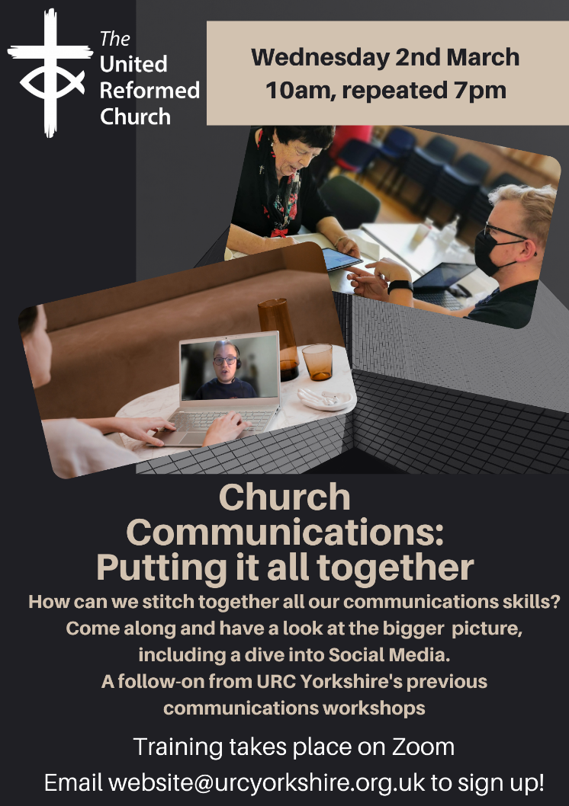The final Communications Workshop will be taking place on **Wednesday 2nd March!**

**Putting It All Together**

Picture this: You’ve used Canva to design your flyer for your event, you’ve published it on Eventbrite and have sign-ups through there, you’ve told you congregation about it through your Mailchimp mailing. Now you need to tell everyone else!

Social Media is the buzz phrase of the century, different media is used by different generations, so don’t just assume “Facebook is the one”, not always!

In this session we’ll be talking about taking a holistic approach to your publicity.

We would highly recommend watching these videos by Oli Deeks from Camberley Youth for Christ, who ran 3 sessions for the URC a few months ago. He takes you through the basics of social media (as well as picking up on some Canva stuff too!):

[**https://youtu.be/UvCwEXrOeGs**](https://youtu.be/UvCwEXrOeGs)

[**https://youtu.be/l5u6U5N2lNo**](https://youtu.be/l5u6U5N2lNo)

[**https://youtu.be/OPvNuMEXIsc**](https://youtu.be/OPvNuMEXIsc)

It will be taking place on Zoom, at our usual time of 10am, repeated at 7pm and the link is here:

[**https://us02web.zoom.us/j/87559170655?pwd=elpVZS96a0t6MlgwaVYwNmZVR09vZz09**](https://us02web.zoom.us/j/87559170655?pwd=elpVZS96a0t6MlgwaVYwNmZVR09vZz09)

**Meeting ID: 875 5917 0655**

**Passcode: 494619**

As always, please do share this around your networks/circles, we’d love for as many people to benefit as possible!

**Yorkshire Reflections**

Just to let you know that the weekly ‘Reflections from around the Synod’ have begun to appear on the Synod Website. Rev Ashley Evans, Synod Evangelist, brought us the first one on February 6th, and Rev Philip Bee brought us last weeks. Keep an eye out for who will premiere on Sunday morning on the Synod website at:  [**https://urcyorkshire.org.uk/worship/**](https://urcyorkshire.org.uk/worship/)

**Legacies of Slavery Consultation**

Warm greetings from Global & Intercultural Ministries.

The Legacies of Slavery task group would like to thank you for your support regarding the URC's Legacies of Slavery consultation.  We are mindful, however, that the timing of our previous communication was not brilliant, so we are asking if you would kindly circulate the materials again to your churches and church groups, with an encouragement to engage with the consultation.  We genuinely want to hear from the breadth of the URC, irrespective of the particular responses which may be shared.

We also recognise that the timeframe given for responses was very tight and that a short deadline would enable focus and prevent the consultation being put off and forgotten.  We are now proposing to extend the cut off date for responses to the [**global.intercultural@urc.org.uk**](mailto:global.intercultural@urc.org.uk)e-mail address to **31st March 2022**.  We hope this will enable much wider engagement.  We would also like to encourage churches, groups and individuals to keep engaging with the materials, and with the LoS/Anti-Racist Church journey in general, beyond the consultation period.  Whilst responses received by the end of March will contribute to the written documents which go to General Assembly in July, we will welcome reflections and responses after this date, and will seek to incorporate them into our verbal presentation to General Assembly.

Please find here the consultation documents for easy reference and downloading:

[**https://urc.org.uk/who-we-are/what-we-do/legacies-of-slavery/**](https://urc.org.uk/who-we-are/what-we-do/legacies-of-slavery/)

Thank you to those who have invited us to engage with your Synods more directly - we look forward to seeing you.  And thanks again to all for your support.

With all good wishes,

**Karen Campbell,** Secretary for Global & Intercultural Ministries (Mission)

**URC News Update**

The latest issue of the [**URC News Update February 2022 (urc-news.org.uk)**](https://urc-news.org.uk/2JB1-1TUKU-122F160E1908EEE459BX7G3A2531BF46D2BD62/cr.aspx)is now available. There are lots of links to this year’s Jubilee, including a special all-age book to help celebrate the URC’s 50th anniversary. ***Celebrate Together*** is a lively, colourful picture book designed for families to share together, and is being made available free of charge for all members of, and those connected to, the URC. Order your free copies through the [**URC Bookshop**](https://urc-news.org.uk/2JB1-1TUKU-59BX7G-17M4Q9-1/c.aspx).

There is also the chance to win one of three awards in the Community Project Awards 2022. The Awards are an initiative run by the URC in collaboration with Congregational Insurance. These awards have recognised innovative community projects that have a positive effect on local communities. The winning projects can receive up to £2,000. The closing date for entries is 26 February. [**Read more**](https://urc-news.org.uk/2JB1-1TUKU-59BX7G-17M76G-1/c.aspx) by clicking this link.

Ann-Marie, who edits the URC News Update (like me) is always on the hunt for stories to tell. Drop her a line at [**ann-marie.nye@urc.org.uk**](mailto:ann-marie.nye@urc.org.uk) and get your good news out there.

**Moderator of General Assembly Nominations**

Nominations for the election of the Moderator of the General Assembly 2023-2024 are due to the General Secretary following the spring meetings of Synods – which in Yorkshire’s case will be on Saturday March 12th at Skipton. More details about the procedure can be found in section 3 of C: Rules of Procedure for the Conduct of the United Reformed Church from the Manual. [**https://urc.org.uk/wp-content/uploads/1638/72/C_Rules_of_Procedure.pdf**](https://urc.org.uk/wp-content/uploads/1638/72/C_Rules_of_Procedure.pdf)

If you do feel called to nominate anyone please contact the Clerk at [**clerk@urcyorkshire.org**](mailto:clerk@urcyorkshire.org) and he will run through what happens. In essence an election will take place at the meeting of General Assembly this July for a successor to the Revd Fiona Bennett who will serve from the close of that meeting until the close of the 2023 meeting. It is hoped that with the role GA Moderator becoming a one year role, it will widen the number and diversity of folk who might feel that they could consider a call to this very particular piece of ministry. Last year that proved so with a sweep of very good nominations, and two absolutely excellent candidates willing to test that call with the Assembly.

Many thanks in advance for any names and don’t hesitate to be in touch if you have any queries about this process.

**Children and Young Peoples News**

**The WILDERNESS Project is back for 2022.  
*Here at the Yorkshire Synod we want to see young people participating in the mission of God in their church. More than that, we want to PAY YOUNG PEOPLE to participate in the mission of God in their church.*  
We know that it can be a struggle to keep young people engaged in church life, especially when so many other things are happening in their world. Often young people around the age of 16 take part time jobs, which means we see them less. The WILDERNESS Project hopes to encourage, enable and equip young people with the support and the resource to turn a passion into a project to enrich the life of their church.   
Please contact Megan**[here](mailto:wilderness@urcyorkshire.org.uk?subject=The%20WILDERNESS%20Project)**for more information.**

To subscribe to the Wilderness newsletter you can either find the link through the newsletter itself or even better click here [**URC Yorkshire Synod (list-manage.com)**](https://urcyorkshire.us18.list-manage.com/subscribe?u=6386cd1d52e213399865e28c0&id=911b09bcc9)



It’s back and ticket sales are already open and won’t close until Friday 09th September. Please contact the synod office to book your tickets ([office@urcyorkshire.org.uk](mailto:office@urcyorkshire.org.uk) / 0113 289 8490). **Include your church/group, group leader (and contact email), the number of paid tickets and how many free under 3 tickets and look out for the special coach funding offer**.

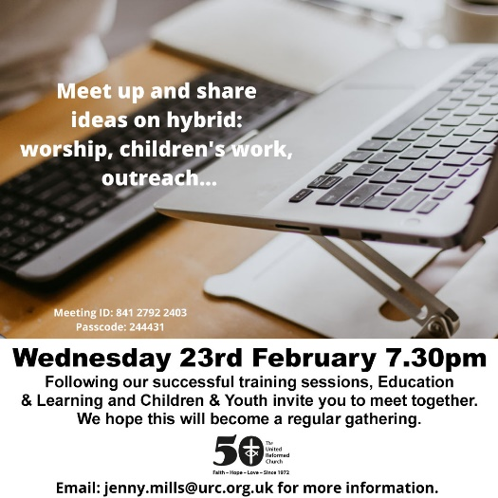**Hybrid Ideas Sessions**

The national Education & Learning and Children & Youth Committees have come together again to offer this open get-together to look at ideas on hybrid worship, children’s work and outreach. It will be happening on Wednesday 23rd February at 7.30pm and all are welcome from any age group who are looking to bring the virtual and the real together in their churches. The Zoom Meeting ID is 841 2792 2403 with the Passcode being 244431. For more information, please contact [**jenny.mills@urc.org.uk**](mailto:jenny.mills@urc.org.uk) for more information.



**To help you out, these are the links to the four websites listed in the poster:**

[**COURSES | time-space4children (timeandspaceforchildren.co.uk)**](https://www.timeandspaceforchildren.co.uk/contact)

[**Let Us Play - Cliff College**](https://cliffcollege.ac.uk/courses/short-courses-weekend/let-us-play)

[**The SPACE | time-space4children (timeandspaceforchildren.co.uk)**](https://www.timeandspaceforchildren.co.uk/the-space)

[**Joined Up – Joined Up Conference (wordpress.com)**](https://joinedupconferencecom.wordpress.com/)

If you need any further details please contact the good folk at Cliff College via their website.

**Worshipping God Together : Apart.**

Rev Janine Atkinson’s regular services and reflections are still being uploaded to the website. As always a big thank you to Janine for these incredible resources which can be found under the ‘What we do’ drop down heading if you fancy a Yorkshire Synod Website surf or more directly at [**https://urcyorkshire.org.uk/worship/**](https://urcyorkshire.org.uk/worship/)

**Property and Listed Building News**

Jane, our Property Officer has asked that this bit of news regarding the Listed Places of Worship Grant Scheme from the HRBA be passed on.

**LISTED PLACES OF WORSHIP GRANT SCHEME**  
Some **very good news** - we heard last month that the government's Listed Places of Worship Grant Scheme has been extended for another three years until 31 March 2025 (this is the scheme that gives a grant to cover the cost of VAT on repairs etc to listed places of worship). In today's financial climate is very, very welcome. For more information on how this works and the responsibilities of caring for churches which are listed, please drop Jane a line at [**property@urcyorkshire.org.uk**](mailto:property@urcyorkshire.org.uk).

And talking of listed buildings, Andrew Lonsdale, the Convenor of the Listed Buildings Advisory Group sends this message:

**LISTED BUILDINGS ADVISORY COMMITTEE**

Managing our church buildings is one of the most difficult tasks we have. However, it does not have to be so and particularly for those churches which have Listed Buildings help and advice is always available. It is important to note that when a church is listed, all internal fixtures and fittings are included and any other buildings within the curtilage of the listed building.

The Synod Listed Buildings Advisory Committees are there to help individual churches in their areas to work through their plans and visions to understand what changes and alterations they can make. So if your church is listed and contemplating large repairs or alterations the first step should be to contact the secretary of the Listed Building Advisory Committee (LBAC) for informal discussion and advice on how to take the necessary next steps, which can have the option of an informal visit, and the dates when an application must be put in. This helps the committee to better understand the proposals and the church understand the timetable and what is possible.

The LBAC is an advisory committee and following an application will recommend their decision to the Synod Property Committee.

We can meet the challenge of our buildings together.

Andrew Lonsdale – Convenor [**andrewlondale@talktalk.net**](mailto:andrewlondale@talktalk.net)

Jane Bunyan-Murray – Secretary [**Property@urcyorkshire.org.uk**](mailto:Property@urcyorkshire.org.uk)

**URC Vacancies**

The URC nationally has some vacancies that it needs filling. They include an **Administrative Assistant (Safeguarding)**, a **Digital Content Officer (Digital Worship)** and a **Programme Assistant, Children’s & Youth Work**. All the details are on the URC’s website so please feel free to share this link within your circle <https://urc.org.uk/jobs/> and circulate any other vacancies that are listed to those you feel may benefit from them.

**ECO News**

The Synod is still looking for more **Synod Green Apostles**. If you have a desire to help Yorkshire become an Eco Synod and a torch-bearer for a greener environment please get in touch. Alex Jowitt at [**greenapostle@urcyorkshire.org.uk**](mailto:greenapostle@urcyorkshire.org.uk) or me at [**clerk@urcyorkshire.org.uk**](mailto:clerk@urcyorkshire.org.uk) would love to hear from you.

**Joint Public Issues Team News**

[](http://www.jointpublicissues.org.uk/conference/)**Joint Public Issues Team Conference** on **11th June 2022** in London or online at [**www.jointpublicissues.org.uk/conference**](www.jointpublicissues.org.uk/conference)

The conference will focus on the increasing significance of the ‘local’ in action for change. During the pandemic, the local has taken on a renewed importance, and the needs, characteristics and opportunities in our communities have been seen in different ways. The local is playing a new role in the political landscape too, with the ‘levelling up’ agenda and regional and national identities assuming prominence, and grassroots community organising bringing new power to campaigning.

Keynote speakers at the conference will include Emma Revie, CEO of The Trussell Trust, Marsha De Cordova MP and Bishop Mike Royal, incoming General Secretary of Churches Together in England.

Attendees will have the opportunity to hear from these keynote speakers, learn and ask questions in workshops and engage with other participants.

The conference is open to anyone who is inspired about working for change, from those already active to those who don’t know where to begin.

We hope to make the conference as accessible as possible, which is why we are offering free tickets for those who have low incomes and for anyone aged under 25. These tickets are supported by the opportunity for other attendees to ‘donate a ticket’ when they purchase their own. Tickets can be booked at bit.ly/JPIT2022

We’d love it if you were able to join us for this day of creative exploration, and also encourage others from your churches to attend, in particular

* Someone who wouldn’t otherwise be able to afford it
* Someone they have identified as a lay leader in the community
* Someone aged between 16-25
* Someone who can carry ideas back to a wider team

The conference will be an opportunity for us to come together, to be re-energised to speak, pray and act boldly as Christians committed to seeing transformation in our communities and beyond.

More publicity will be circulated shortly

If you have any questions or suggestions, please do not hesitate to get in touch with

**Simeon Mitchell, Team Leader, Joint Public Issues Team**

**Secretary for Church and Society, United Reformed Church**

86 Tavistock Place, London, WC1H 9RT

020 7916 8633 | 07584 053432 | [simeon.mitchell@urc.org.uk](mailto:simeon.mitchell@urc.org.uk)

Now that **St Andrew’s Sheffield** are worshipping in person on Sundays at 10.45am their website services have been discontinued. However, all the services that were uploaded to their website have been archived and can still be accessed at [www.standrewsurcsheffield.org.uk/stop-press](http://www.standrewsurcsheffield.org.uk/stop-press).

They include some very thoughtful Reflections by a variety of ministers and other preachers as well as an eclectic, rich and classical selection of music to complement these acts of worship.

**Annual Church Returns**

***Annual Church Returns (ACR) - another very important note for Church Secretaries***

As many of you will be aware on 31st January 2022 (or not long afterwards) you should have received log in details with instructions so that you can access the site to complete your church update and Annual Church Return figures. We have had several enquiries regarding the dual nature of this year’s return so can you please read the following which hopefully explains the situation.

The Annual Church Returns are in three sections this year:-

**Section 1 Church Information**

Please use the NEW URC Church Update portal to access and amend information where necessary.

A welcome email with log in details has already been sent to you, please check your Junk / Spam folders for this email if you haven’t seen it.

**Section 2  Annual Church Return (Statistics)**

Please use the NEW URC Church Update portal to enter this information.

A welcome email with log in details has already been sent to you, please check your Junk / Spam folders for this email if you haven’t seen it, this is the same email as mentioned above.

NOTE: There will be only one welcome email and log in for both Section 1 and Section 2.  Thank you to those who have already logged on.

**Section 3  People information**

Due to circumstances beyond our control relating to GDPR and issues with Microsoft access we have been unable to launch this section using the portal at this time. For this reason, we have produced a paper document to enable you to check your people and their contacts. This will be sent to you by post from your Synods.  Please make any changes on the paper document and return it to the Synod Office by 31 March 2022.

We had hoped that you would find it seamless, but sadly it isn’t. So if you have and further queries, please do get in touch with the Synod Office.

**Safeguarding News**

**Church Activities in Private Dwellings**

We have a request from the denomination’s Safeguarding Advisory Group and the Children and Youth Committee with some guidance our Safeguarding Officer, Matt Knowles and the new Denominational lead, Sharon Barr is producing. It is in relation to URC local church activities in private dwellings and can be found here: [Guidance for URC local church activities in private dwellings - United Reformed Church](https://urc.org.uk/safeguarding/guidance-for-urc-local-church-activities-in-private-dwellings/).

It has been normal practice in many churches for some organised church activities to take place in private dwellings (the homes of church people). This guidance is to remind churches of the risks to be aware of and take into account, for the safety of the people who live in the dwelling and for those visiting.  Although a manse is normally considered a place of work, for the purposes of this guidance and to ensure good practice, it shall be considered a dwelling.

If you have any queries, please contact Matt Knowles, the Synod Safeguarding officer at [matt.safeguarding@urcyorkshire.org.uk](mailto:matt.safeguarding@urcyorkshire.org.uk).

***Annual Safeguarding Returns (ASR) – a very important to note for Church Safeguarding Co-ordinators***

On **31 January 2022** or not long afterwards) you should have received log in details with instructions so that you can access the site to complete your church Safeguarding Return (ASR) figures.

We are aware that there has been a slight delay in launching the new online system so for that reason the site will be live until **31 March 2022**. If you are unable to complete the ASR in that time, or feel you need a blank paper copy, you can either print it directly from the portal or contact Synod Office to send you a blank copy of the form.

This is a new but much awaited departure for the Church in relation to gathering and recording church information.   We hope that you find it seamless and if you have queries, please do get in touch with Synod Office or Synod Safeguarding Officer.

**Covid-19 and Current Regulations**

The government’s “Plan B measures” were lifted on 27th January and we are now under the guidance of “Plan A”, as we were at the back end of 2021. The current regulations can be found here [**Coronavirus (COVID-19): guidance and support - GOV.UK (www.gov.uk)**](https://www.gov.uk/coronavirus) with the recommendations of the URC to be found at the [**Coronavirus advice - United Reformed Church**](https://urc.org.uk/our-news-stories/coronavirus-advice/) page. This also has links to the latest updates, worship aid and resources, all designed for you and your churches. I would like to draw your attention to two articles from our Moderators, who wisely advise us to be careful as the government restrictions ease; [**New Freedoms, Same Responsibilities: Synod Moderators' advice to congregations - United Reformed Church**](https://urc.org.uk/new-freedoms-same-responsibilities-synod-moderators-advice-to-congregations/)was updated in December whilst the [**Covid Plan B: Synod Moderators' updated guidance - United Reformed Church**](https://urc.org.uk/covid-plan-b-synod-moderators-updated-guidance/) is as valid now as when it was written just before Christmas.

Our key responsibility and duty of care to our congregations, members and friends. Infection rates are still high and although they appear to be dropping, it would be unwise to think it is all over. So please follow the guidance that is still available and if you need any help from us here at Synod, please get in touch.

**Please don’t hide these events and resources in your inboxes or within the trees hiding your own churches’ woods. Please send this Briefing around your own church mailing lists as these events are for everyone, member or non-member, church-goer or non-church-goer. All these activities within and beyond Synod are designed to grow the Kingdom.**

**Plans are always happening to bring more activities and good news stories to your attention, so keep an eye open for the next Briefing. All you need to do is get in touch with me at** [**clerk@urcyorkshire.org.uk**](mailto:clerk@urcyorkshire.org.uk)**.**

If you know of anything you may find useful for our churches, please contact me at [**clerk@urcyorkshire.org.uk**](mailto:clerk@urcyorkshire.org.uk) and I’ll circulate it here and on the website. Similarly, if you need any further help, be it to do with IT, finance, property or the like we are here to help.

National URC site: [**https://urc.org.uk/**](https://urc.org.uk/)Yorkshire Synod: [**https://urcyorkshire.org.uk/**](https://urcyorkshire.org.uk/) Yorkshire Synod Twitter: [**https://twitter.com/urcyorkshire**](https://twitter.com/urcyorkshire) Yorkshire Synod Facebook: [**https://www.facebook.com/urcyorkshire**](https://www.facebook.com/urcyorkshire) Yorkshire Young People’s Facebook: [**https://www.facebook.com/wildernessyorkshireurc/**](https://www.facebook.com/wildernessyorkshireurc/)

*Tim Crossley*

*Synod Clerk*