Worshipping God Together : Apart
Sunday 6th February 2022 at 10.30am
Church; Physically Distanced but Spiritually United
Worship Prepared by Rev. Janine Atkinson
A Call to Worship God
The good news has been proclaimed to me,
I have received it,
and through it I am being saved.
So, I thank and worship you Lord God,
Father, Son and Holy Spirit
Hymn – R&S 29: MP 139: Terry Coelho. (1952- )
Father, we adore you,
lay our lives before you,
how we love You.
Jesus, we adore you,
lay our lives before you,
how we love You.
Spirit, we adore you,
lay our lives before you,
how we love you.
Approaching God in Prayer
I come to meet you, living Lord.
I hold you in my heart and behold you in my mind’s eye,
thankful for the testimony of those who witnessed the reality of Jesus’ life, death and resurrection.
Come, Lord Jesus, help my unbelief,
so that I may behold the truth.
I offer my thanks for those who evoke the sense of wonder in me.
I offer my thanks for those who witness to wonder in the world.
I meet you as the day declares new hope
as the night nurses us in healing.
as the sky surprises us with rainbows.
as the earth empties itself for us in food.
as the neighbour nestles us into love.
as the stranger speaks to us of strange tales.
as the cross confronts us with innocent pain.
as the tomb testifies to us your sacrifice.
So let our days and nights
fill the sky and earth with love for neighbour and stranger,
And by the cross and tomb may our sins be forgiven,
our brokenness healed, and our lives be restored.
Meet me, Lord God, as I come to you in prayer with the words Jesus taught
Our Father, who art in heaven…
Old Testament Reading – Isaiah 6: 1 – 8 Isaiah’s commission
6 In the year that King Uzziah died, I saw the Lord, high and exalted, seated on a throne; and the train of his robe filled the temple. ² Above him were seraphim, each with six wings: with two wings they covered their faces, with two they covered their feet, and with two they were flying. ³ And they were calling to one another:
‘Holy, holy, holy is the Lord Almighty;
the whole earth is full of his glory.’
⁴ At the sound of their voices the doorposts and thresholds shook and the temple was filled with smoke.
⁵ ‘Woe to me!’ I cried. ‘I am ruined! For I am a man of unclean lips, and I live among a people of unclean lips, and my eyes have seen the King, the Lord Almighty.’
⁶ Then one of the seraphim flew to me with a live coal in his hand, which he had taken with tongs from the altar. ⁷ With it he touched my mouth and said, ‘See, this has touched your lips; your guilt is taken away and your sin atoned for.’
⁸ Then I heard the voice of the Lord saying, ‘Whom shall I send? And who will go for us?’
And I said, ‘Here am I. Send me!’
Gospel Reading – Luke 5: 1 – 11 Jesus calls his first disciples
5 One day as Jesus was standing by the Lake of Gennesaret, the people were crowding round him and listening to the word of God. ² He saw at the water’s edge two boats, left there by the fishermen, who were washing their nets. ³ He got into one of the boats, the one belonging to Simon, and asked him to put out a little from the shore. Then he sat down and taught the people from the boat.
⁴ When he had finished speaking, he said to Simon, ‘Put out into deep water, and let down the nets for a catch.’
⁵ Simon answered, ‘Master, we’ve worked hard all night and haven’t caught anything. But because you say so, I will let down the nets.’
⁶ When they had done so, they caught such a large number of fish that their nets began to break. ⁷ So they signalled to their partners in the other boat to come and help them, and they came and filled both boats so full that they began to sink.
⁸ When Simon Peter saw this, he fell at Jesus’ knees and said, ‘Go away from me, Lord; I am a sinful man!’ ⁹ For he and all his companions were astonished at the catch of fish they had taken, ¹⁰ and so were James and John, the sons of Zebedee, Simon’s partners.
Then Jesus said to Simon, ‘Don’t be afraid; from now on you will fish for people.’ ¹¹ So they pulled their boats up on shore, left everything and followed him.
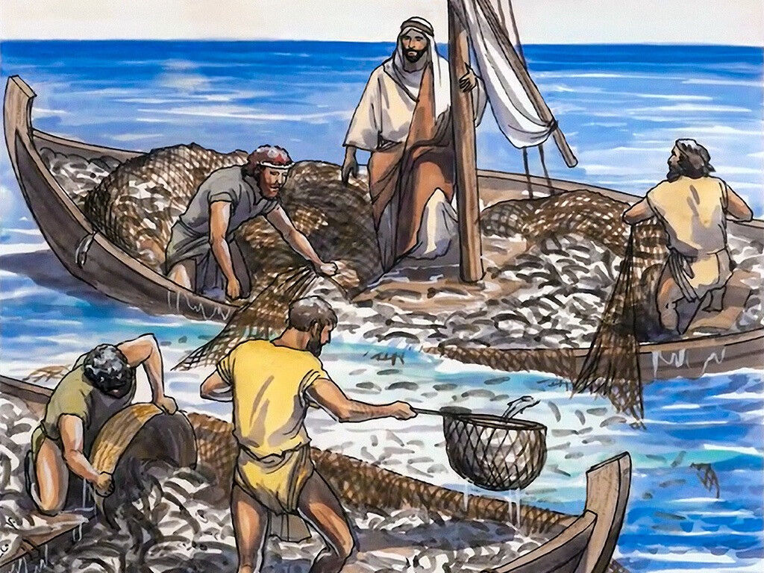

Image: www.freebibleimages.org
The Shallow End
The former Archbishop of Canterbury, Robert Runcie once said, “The Church is like a swimming pool: All the noise is at the shallow end”.
When I am safe in the shallow end
with my feet firmly on the floor,
when I am surrounded by the familiar
and content with what I think I know,
may I hear afresh your gracious invitation
to wade out into deeper waters,
to make new discoveries
and be open to new possibilities.
When I am in deep waters
and feel out of my depth,
when I am beyond my comfort zone
and see and understand myself all too clearly,
when I look with longing
for the safety of the shallow end again
may I hear your voice saying ‘Don’t be afraid.’
(Adapted from the URC Prayer Handbook 2019 p.13 Wayne Hawkins)
A Prayer of Confession
Lord, I confess that, in common with others,
I fear getting in too deep with you.
When we feel you drawing us to you,
calling us to leave the safe confines of life as we know it
and plunge into the depths of life with you, we are afraid.
What will you ask of us, Lord?
For we are ordinary people;
we have no tongues to talk in clever parables,
we have no miracles to perform.
And, the fact is, we’re quite content as we are;
we’re happy to serve you from the wings,
we don’t want the spotlight.
Yet you have drawn us into your story,
and you call us to be all that we can be.
We confess that we are afraid of our potential;
afraid to unleash your power within us.
Forgive us, and grant us the courage to overcome our fears
and follow you. Amen.
Setting the Scene.
What would you do if someone from a different trade or profession told you how to do your job?
I don’t suppose you’d be too impressed.
What a cheek for a carpenter to tell fishermen how to do their job.
But the fishermen, Simon, James and John (asked first of all if Jesus can borrow their boat) not only allow him to use their boat as a platform for his message, they go on to take instructions in the practice of their own trade.
All their experience and skill had not produced a catch at the right time for fishing, yet these seasoned fishermen go along with a carpenter's contrary directions.
That really says something about Jesus' presence, his charisma.
But Jesus doesn’t stop at telling the fishermen how to do their job. When the results of Jesus’ intervention say something about his extraordinary power, he invites them to learn a new trade.
But Jesus’ invitation is not an invitation to learn some new tricks of the fishing trade, rathe, it’s a new purpose in life. Jesus will take them onto his team and change them, transform their lives, completely and utterly.
Hymn – R&S 371: MP 624: Frances Ridley Havergal (1836-79)
Take my life, and let it be consecrated, Lord, to thee;
take my moments and my days, let them flow in ceaseless praise.
Take my hands, and let them move at the impulse of thy love;
take my feet, and let them be swift and beautiful for thee.
Take my voice, and let me sing always, only, for my King;
take my lips, and let them be filled with messages from thee.
Take my silver and my gold, not a mite would I withhold;
take my intellect, and use every power as thou shalt choose.
Take my will, and make it thine; it shall be no longer mine;
take my heart, it is thine own; it shall be thy royal throne.
Take my love, my Lord, I pour at thy feet its treasure-store;
take myself, and I will be ever, only, all for thee.
Reflections
Both our readings today have to do with ‘call’.
Dietrich Bonhoeffer said, “When Christ calls a person, he tells them to come and die”. Bonhoeffer of course did exactly that, he was hanged by the Nazis for resistance to Hitler.
But when Simon Peter first met Jesus, he didn’t realise this. If he could have gazed into a crystal ball and seen what would happen to him in the next couple of years, he might have persisted in asking Jesus to leave him in peace! But that’s not how Jesus worked, and it’s not how God works.
Peter clearly had a sense that life was never going to be the same again, that he was going to face new demands and challenges, but he couldn’t help being swept off his feet by what had happened – that miraculous catch of fish seems to have got him.
It had started with a bit of resourcefulness on Jesus’ part, he’d begun to teach a group of people by the shore, but the crowd got bigger and bigger and there simply wasn’t room – so he improvised!
Along the shore of Lake Galilee – or Gennesaret as it’s sometimes called, as it is here – close to Capernaum, there’s a sequence of steep inlets, a zig-zagging shoreline with each inlet forming a natural amphitheatre. Apparently, even now, if you get in a boat and push out a little from the shore, you can talk in quite a natural voice and anyone on the slopes of the inlet can hear you clearly, more clearly than if you were right there with them on the shore. So, Jesus was exploiting the geography of the area and the timely availability of a boat.
Having commandeered the boat and with the fishermen listening to his every word, he puts them on the spot. It’s daytime, and fish are more likely to be caught after dark in this lake, and on this occasion the men had worked all night for nothing. The last thing they would normally do would be to start again in daylight. But Jesus told them to – so they did!
Jesus made that sort of impression on people, even hard-working, no-nonsense fishermen.
In Luke’s account of the calling of the fishermen, Simon, James and John have already witnessed Jesus’ power, Simon’s mother-in-law has already been healed, starting a sequence of healings (chapter 4: 38-41) so they are already aware that Jesus has presence and power.
There’s a huge catch of fish! Messages are sent for another boat to come and help with the catch and there’s a struggle to get the boats and the fish back to land before they all go under with the weight!
And then there’s the moment of truth. Simon finds himself right out of his league as Jesus promises that the same sort of thing will happen again, only now it will be people, not fish that will be gathered in. And the fishermen become followers, the first to fall for Jesus, hook, line and sinker. They go off with Jesus into a new life with only the sketchiest of ideas about where it will take them.
This is the kind of story it helps to get inside of. Become Simon for a few moments – pause and ponder what you normally do, day after day and then imagine Jesus suddenly appearing, asking for your help with his own work and then telling you to do something in your own line of work which seems like a pointless waste of time and energy. You do it, grumbling (perhaps under your breath) and suddenly everything clicks into place, everything succeeds on a scale you’d never dreamed of.
What’s going on? How did it happen? Feel the sense of awe, perhaps even terror, as you come to terms with the power of this man Jesus.
Then feel that sense of terror increase, as he turns to you, with what looks like a question in his eyes, though it proves to be a command “You and I are going to be working together from now on” he says. And you realise that you have no choice. If this man isn’t worth following, then nobody is. And that’s God’s call.
Or maybe you’re not at that stage yet. Maybe you’re somewhere back in the crowd by the shore. You’ve heard something of what Jesus has been saying. You know those fishermen, everybody knows them, they’re hardworking men. You see them coming back from a night’s work just when you’re getting up. They are big, strong men with hands like shovels.
From the shore you watch as Jesus talks to them. You see them shrug their shoulders, put the boat out into the deeper water and let down their nets. You hear the shouting, you see the flurry of activity. Then you see Simon, a strapping man, kneeling down in front of Jesus. And then they all go off together.
What goes through your mind? You’ve not quite grasped all of what’s been going on, but you know something’s going on.
Many people are in that position in relation to God’s kingdom today. They’ve heard enough to know that something’s going on. Perhaps they see other people suddenly changed, their lives turned around. Maybe they’re a bit jealous, but also a bit relieved that the spotlight hasn’t been turned on them!
But the spotlight shines in order to show the way to life. Even though it shows things up we’d rather keep hidden – remember, Simon’s instant reaction was to see himself in the light of God’s holiness and to draw the necessary conclusions that he was a sinful man.
Jesus doesn’t want to leave anybody out. His call to Simon and the others, that they should now help him in catching people, was precisely in order that the Good News would go out wider and wider, reaching as many as possible.
Ultimately, there are no bystanders in the kingdom of God, Jesus has called us all to be witnesses to his power, his presence and to kingdom ways. The reason we can read Luke’s Gospel today is because, despite Simon Peter’s initial reluctance and subsequent failures, he and the other disciples spread the Good News.
When Jesus calls, he certainly does demand everything. But only because he has already given everything himself and has plans in store for us and for the world. Plans we would never have dreamed of. When we respond to God’s call as Isaiah and Simon Peter did, a whole world of adventure opens up.
For the church, fishing becomes a metaphor for its mission and ministry and 'leaving everything and following Jesus' in faith – because Jesus says to do so, even if it seems foolish – becomes our model of obedient discipleship.
(With thanks to Tom Wright’s book - Luke for Everyone (altd))
Hymn – R&S 367: MP 302: C Simmonds, 1964* Copyright © C. Simmonds
I want to walk with Jesus Christ all the days I live of this life on earth,
to give to him complete control of body and of soul:
Follow him, follow him, yield, your life to him,
he has conquered death, he is King of kings.
Accept the joy which he gives to those
who yield their lives to him.
I want to learn to speak to him, to pray to him, confess my sin,
to open my life and let him in, for joy will then be mine:
I want to learn to read his word, for this is how I know the way,
to live my life as pleases him, in holiness and joy:
I want to learn to speak of him; my life must show that he lives in me,
my deeds, my thoughts, my words must speak of all his love for me:
O holy Spirit of the Lord, enter now into this heart of mine,
take full control of my selfish will and make me wholly thine:
Holding the World in Prayer
Father God,
I pray for all who are going through difficulties that make belief hard:
for those who are suffering physical and mental illness,
that they may feel the comfort of your healing touch;
for the bereaved, that they may know your presence
as they walk the valley of the shadow;
for those who have been hurt, abused or betrayed
by people they loved and trusted,
that they will come to believe in the One who rose above all human fallibility and did not sin.
Ease open all hurting eyes and hearts, Lord – including my own.
Push aside all barriers to belief.
Shine your light in our darkness, so that faith may flourish even in the midst of sorrow. Amen.
Hymn – R&S 34: MP 237: Reginald Heber. (1783-1826)
Holy, holy, holy, Lord God Almighty,
early in the morning our song shall rise to thee;
Holy, holy, holy! merciful and mighty,
God in three Persons, blessed Trinity!
Holy, holy, holy! All the saints adore thee,
casting down their golden crowns around the glassy sea;
cherubim and seraphim falling down before thee,
who wast, and art, and ever more shalt be.
Holy, holy, holy! Though the darkness hide thee,
though the sinful human eye thy glory may not see,
only thou art holy, there is none beside thee,
perfect in power, in love and purity.
Holy, holy, holy, Lord God Almighty,
all thy works shall praise thy name, in earth, and sky, and sea;
Holy, holy, holy, merciful and mighty,
God in three Persons, blessed Trinity!
Closing Words and Blessing
The prophets pointed the way to God. Who will do it now?
Here I am, Lord. Send me.
Jesus called Simon to point the way to God. Who will do it now?
Here I am, Lord. Send me.
Christians down the ages have pointed the way to God.
Who will do it now?
Here I am, Lord. Send me.
Help me to point the way to you, Lord God. Amen
May the grace of our Lord Jesus Christ,
the love of God,
and the fellowship of the Holy Spirit,
be with us all evermore. Amen

Hymn words reproduced under the CCLI Licence numbers of the SPACE Group of Churches: 178113 – Heckmondwike URC: 177949 - Longcauseway Church: 1236906 - Norristhorpe URC: 783508 - Ravensthorpe with Hopton URC

