**The Briefing – Number 81**

**7th April 2022**

Dear Friends,

As I listen to the April showers hitting the windows, and as I watched the snow melt on the afternoon of the 31st March I knew we were in Spring. March Synod is behind me, and thank you to the good folk of Skipton who hosted us and thank you for all who attended in person and online. The Spring programme of events is building up a head of steam and I sense that there is an impetus in our Christian life as we travel further into the URC’s Jubilee Year.

It hardly seems three weeks since I last wrote an introduction to The Briefing, but it is and I am encouraged by the amount of activity that is being brought to our attention here at Synod. Keep letting us know your good news as it is the thing that keeps this august journal going. When we started this just over two years ago it was designed to bring together all the changes to the regulations being enacted in response to the burgeoning Covid-19 threat. As I type, those regulations are as good as gone, but the disease has not. We are acutely aware at Synod that the infection levels are still high and that we must not drop out guard. So, if churches do feel that they want to bring in their own mitigations, we are here to support, guide and enable that choice.

Many churches in the Synod have also been acutely aware of the crisis in Ukraine. Prayer vigils and events have been held already and I imagine there will be more of these happening over the next weeks and months. If you feel you want to advertise your events and appeals more widely, let me know in the usual ways. For those who are looking to use spare accommodation for refugees the official guidance is rather mixed and confused. Our intensions are not however, and we have been able to get preliminary advice from our insurers which is below. As soon as we get a clearer grasp of what individuals and churches can do I’ll circulate that information. What we can do is Pray and join with our partner charities and with the [Ukraine Humanitarian Appeal | Disasters Emergency Committee (dec.org.uk)](https://www.dec.org.uk/appeal/ukraine-humanitarian-appeal).

The Jubilee challenges we are setting ourselves are starting to be met. Many of our churches will already have been contacted by our Mission Advocate, Jon Steel, and I hope that we can take this Jubilee moment to reset our Christian lives and work to bring the Kingdom’s good news to everyone. As Portholme Selby and Moldgreen Huddersfield have done, please let me know what you are up to. We need to get the good news of your good news stories out and about. It doesn’t matter how you do that Jubilee work, what matters is that the Good News of Jesus is carried far and wide.

Synod is offering the means to resource that missional work, financially through the Discipleship Development Fund and spiritually through Leading Your Church into Growth. We have all this at our fingertips – all it takes is that extra stretch to grab hold of it.

Finally, let me take this opportunity to wish you all a Spirit filled Easter; an Easter which will mark the start of a new Christian journey for all of us.



**Stop-press news from Moldgreen URC; they are pleased to have achieved a Silver Eco Church award from A Rocha.**



Moldgreen URC in Huddersfield have recently been awarded Silver Eco Church status by the [**A Rocha UK – Caring for God's Earth**](https://arocha.org.uk/)organisation. This is an incredible achievement and below is how they were able to achieve it.

The Church had a headstart with elder Kevan Shuttleworth, a vegan cyclist, nature lover and champion of all things eco. Kevan led Moldgreen’s first eco worship session and a series of workshops to help the church recognise and understand the need for change. He became Moldgreen’s ‘eco warrior’ encouraging all in our fellowship and recording our progress with A Rocha.

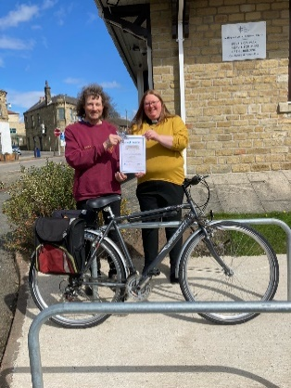Moldgreen URC are also indebted to the hard-working Worship Group, who work with the Minister, Reverend Sarah Fitton, for their efforts in achieving the Worship and Teaching aspects of the Eco Church requirements; including special services, guest speakers and the like.

The Maintenance Team put in lots of hard and innovative work for the Buildings category, installing water butts, cycle racks, low-energy lighting, extra insulation, new windows and so on. The church is again grateful to One Community, All Churches Fund and Yorkshire Synod Mission Fund who awarded grants towards the costs of these projects.

In the Land category, the church owes much to our Church Related Community Work minister Rosie Buxton, who has worked with local schools to turn our church garden into a truly community-centred green space, very much fulfilling the Eco Church ethos.

The Lifestyle category required input and commitment from the whole church congregation, in their personal lives as much as their church lives. Fairtrade, carbon footprint, ethical investment were some of the areas explored.

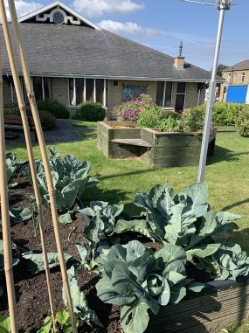The Community and Global Engagement category is possibly the most challenging for the church, and the one where there is still lots to do as the church looks towards working for a Gold award. In this area as well as all the others, the Church Secretary Christine Hall has been a driving and organisational force pushing our achievement of the Silver Award.

None of the above was done in isolation. Displays were put up and invitations were sent to all the users of our building to become involved raising funds for toilet twinning, switching off lights for ‘Earth Hour’ each Spring and taking part in the RSPB birdwatch.

It has been fun, the church has learnt a lot and has worked hard. More importantly there has been a shift in the thinking of Moldgreen URC and opportunities to engage with the users of our building and the wider community to demonstrate how we, as Christians, can play a role in the care of God’s creation.

**Disciple Development Fund**

***Yorkshire URC Synod Discipleship Development Fund***

This fund is available to encourage and support individuals within the United Reformed Church engage with a journey of developing personal discipleship. It is available for any URC member or regular URC attender of any age who is not a Minister of Word and Sacraments or Church Related Community Worker.

Yorkshire Synod Ministries Committee are pleased to share with you that grants of up to £200 are now available.

**Individuals** can apply for help with the cost of attending an approved discipleship course, activities or retreats offered by others.

**Congregations** can apply for help with the cost of buying in a speaker or other resources to facilitate in-house schemes.

Please contact Kath Lonsdale, Convenor of Yorkshire Ministries, [kathlonsdale@talktalk.net](mailto:kathlonsdale@talktalk.net) or 01274 315203 to apply for this grant.

**Also available is the following video, which was shown at the March Synod meeting, which gives an overview of what is on offer** [**https://drive.google.com/drive/folders/1bsPMiSjEbtqiTXSXuXJKOY0DCpDPm-_J**](https://drive.google.com/drive/folders/1bsPMiSjEbtqiTXSXuXJKOY0DCpDPm-_J)

**Lay Preachers Planning Group news**

**Lay preachers and Worship Leaders weekend**

We are looking forward to the Lay Preachers and Worship Leaders weekend at Wydale conference centre 22nd to 24th July 2022 (Friday teatime to Sunday lunch) . Thankyou to all those who have already registered. We look forward to sharing this weekend together.

 We need to confirm numbers with Wydale by 6th May and there are **still 5 places** left to fill of the 30 places we provisionally booked.

Have you thought about this but not registered yet?

If you are coming is there anyone else you can encourage to come?

If you are not coming is there anyone in your church who you could share this opportunity with and encourage them to register?

The cost of this weekend will be paid for by grants successfully applied for so you or the person you encourage will only need to cover travel costs.

Please register by 1st May at [office@urcyorkshire.org.uk](mailto:office@urcyorkshire.org.uk) or 0113 289 8490.

Yours in Christ’s service

Kath

Kath Lonsdale ( on behalf of the lay preachers planning group )

[kathlonsdale@talktalk.net](mailto:kathlonsdale@talktalk.net)

01274 315203

07759525936

**GEAR**

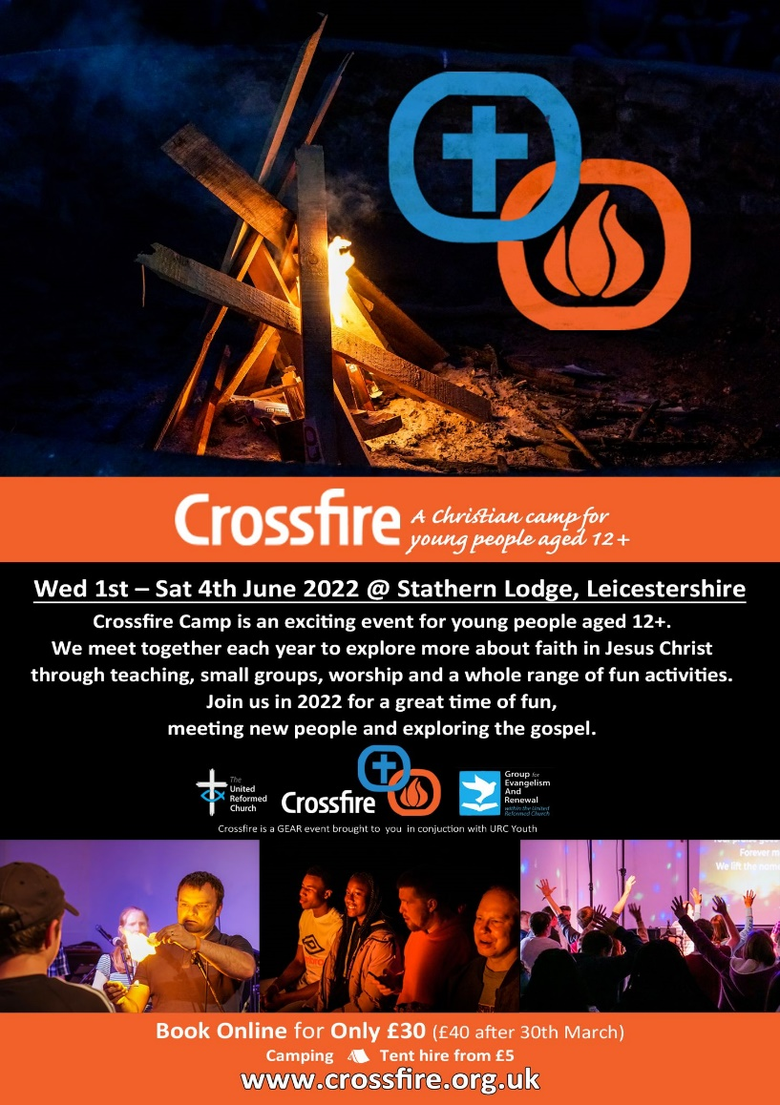Rev Matt Stone has also asked me to draw your attention to CROSSFIRE, A Christian camp for young people ages 12+. It is organised by GEAR and is happening from 1st to 4th June (Platinum Jubilee Weekend).

All details and booking information is via [**www.crossfire.org.uk**](http://www.crossfire.org.uk)



GEAR (the Group for Evangelism and Renewal in the URC) has been hosting a Lent series that is open to any individuals and churches who wish to join us.

Each week there has been worship, Bible Study, discussion and prayer as the aims of GEAR were unpacked. Although the March sessions have now passed the recordings are available on the GEAR YouTube channel for personal or church use at [**https://www.youtube.com/channel/UCdbMiDGYKBHCwgf4bxkkQ0w**](https://www.youtube.com/channel/UCdbMiDGYKBHCwgf4bxkkQ0w)

**For more information contact** [**matt@hurc.co.uk**](mailto:matt@hurc.co.uk))

**Children and Young Peoples News**

**The WILDERNESS Project is back for 2022.  
*Here at the Yorkshire Synod we want to see young people participating in the mission of God in their church. More than that, we want to PAY YOUNG PEOPLE to participate in the mission of God in their church.*  
We know that it can be a struggle to keep young people engaged in church life, especially when so many other things are happening in their world. Often young people around the age of 16 take part time jobs, which means we see them less. The WILDERNESS Project hopes to encourage, enable and equip young people with the support and the resource to turn a passion into a project to enrich the life of their church.   
Please contact Megan**[**here**](mailto:wilderness@urcyorkshire.org.uk?subject=The%20WILDERNESS%20Project)**for more information.**

****It’s back and ticket sales for

**THE BIG DAY OUT**

has already opened and won’t close until Friday 09th September.

Please contact the synod office to book your tickets [**office@urcyorkshire.org.uk**](mailto:office@urcyorkshire.org.uk)

**0113 289 8490**

**Include your church/group, group leader (and contact email), the number of paid tickets and how many free under 3 tickets and look out for the special coach funding offer**.

To subscribe to the Wilderness newsletter you can find either the link through the newsletter itself or even better click here [**URC Yorkshire Synod (list-manage.com)**](https://urcyorkshire.us18.list-manage.com/subscribe?u=6386cd1d52e213399865e28c0&id=911b09bcc9)

**Yorkshire Reflections**

**Since the beginning of February we have been uploading in to the ‘Worship’ section of the Synod website, a weekly reflection on a Sunday.  Thank you to all who have either already contributed or have offered a date – it is much appreciated.  If you would like to take a look, you can find the latest reflection here:** [**https://urcyorkshire.org.uk/worship/**](https://urcyorkshire.org.uk/worship/)

**If you are willing and able to have a go, do get in touch with me and we can discuss a date and what is required and how to send it. I look forward to hearing from you.**

**With thanks and best wishes**

***Sally Duxbury, PA to the Moderator - Revd Jamie Kissack***

[**office@urcyorkshire.org.uk**](mailto:office@urcyorkshire.org.uk)

**Worshipping God Together : Apart.**

Rev Janine Atkinson’s regular services and reflections are still being uploaded to the website. As always a big thank you to Janine for these incredible resources which can be found under the ‘What we do’ drop down heading if you fancy a Yorkshire Synod Website surf or more directly at [**https://urcyorkshire.org.uk/worship/**](https://urcyorkshire.org.uk/worship/)

|  |
| --- |
| **Prayers for Ukraine** |
|  |

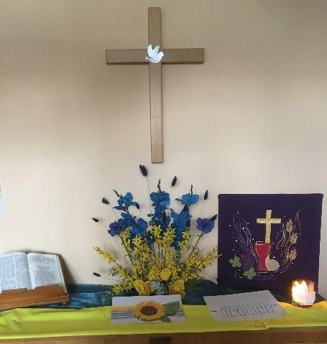**Christ Church Halton's effort for Ukraine**

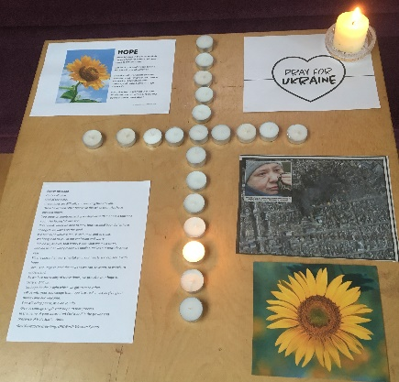On Saturday, 2nd April, Christ Church Halton in Leeds opened up the church for members of the local community to pray and light a candle for Ukraine, as well as holding an afternoon tea in aid of the DEC's appeal.  The afternoon tea was the idea of Sheila Staveley, who has spearheaded similar events for other appeals in the past but this was the most successful to date, with over £1000 being raised so far and donations still coming in.  Sheila was the mastermind behind the tea but had a dedicated team, who worked all day to provide what was described by a couple of guests as the best afternoon tea they had ever had!

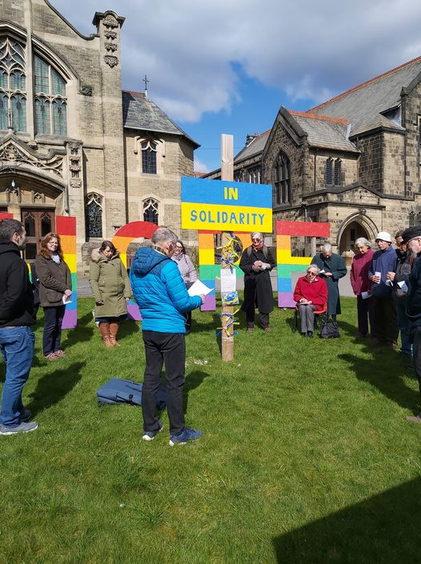Those coming for the tea were able to light a candle for Ukraine and pray at a number of prayer stations in the church, as well as watching an extremely moving video of the Prayer for Ukraine by Oneness.  The church was also open in the morning when the regular coffee morning took place and the prayer stations remained until after the morning service on Sunday.

**Prayer Vigil at Skipton**

St Andrew’s Skipton held a prayer vigil outside their buildings on the afternoon of Sunday 3rd April and it is hoped to be able to continue this for so long as peace is yearned for in Ukraine and beyond.

As I mentioned on page one, we have received some advice from our insurers regarding offering temporary accommodation to refugees:

**Ministers taking Ukrainian refugees into their own homes**

* All refugees are in the UK legally
* This must be done as part of the Government scheme so all vetting/checks done by them
* Safeguarding measures must be in place to protect the Minister, their family and the refugees
* This is a temporary arrangement
* Premises are suitable for this arrangement
* All risk assessed and appropriate Health & Safety assessments carried out
* The Minister should advise his/her contents Insurers.

**Use of Unoccupied manses**

* Refugees must be in the UK legally
* Again this must only be on a temporary basis
* Must be part of the Government scheme so all vetting/checks done by them
* Properties must be suitable/fit for purpose – up to date gas/electric etc
* Appropriate risk management assessments done as per any other letting of the property

**Other points to note**

* We must be made aware of any arrangements made
* Insurers would prefer family units rather than groups of unrelated people

To assist the situation, Insurers do not propose to charge any additional premiums/extra terms. However, we would kindly ask you to refer all arrangements to ourselves in the first instance at [**trust@urcyorkshire.org.uk**](mailto:trust@urcyorkshire.org.uk) or [**clerk@urcyorkshire.org.uk**](mailto:clerk@urcyorkshire.org.uk).

**ECO News**

The Synod is still looking for more **Synod Green Apostles**. After Alex Jowitt’s excellent overview of what is happening in both Synod and our Churches to help us meet the Eco challenge we have set ourselves there is a need for more Synod Green Apostles. You will have read above of the great work being done at Moldgreen, so if you want to help encourage more of our churches to follow in their footsteps and if you have a desire to help Yorkshire become an Eco Synod and a torchbearer for a greener environment, please contact [**greenapostle@urcyorkshire.org.uk**](mailto:greenapostle@urcyorkshire.org.uk) or [**clerk@urcyorkshire.org.uk**](mailto:clerk@urcyorkshire.org.uk)**.**

**Joint Public Issues Team News**

[](http://www.jointpublicissues.org.uk/conference/)**Joint Public Issues Team Conference** on **11th June 2022** in London or online at **www.jointpublicissues.org.uk/conference**

The conference will focus on the increasing significance of the ‘local’ in action for change.  Full details and how to book can be found at the [**JPIT Conference 2022 | Joint Public Issues Team**](https://www.jointpublicissues.org.uk/conference/) website

We’d love it if you were able to join us for this day of creative exploration, and also encourage others from your churches to attend, in particular

* Someone who wouldn’t otherwise be able to afford it
* Someone they have identified as a lay leader in the community
* Someone aged between 16-25
* Someone who can carry ideas back to a wider team

The conference will be an opportunity for us to come together, to be re-energised to speak, pray and act boldly as Christians committed to seeing transformation in our communities and beyond.

If you have any questions or suggestions, please do not hesitate to get in touch with

**Simeon Mitchell, Team Leader, Joint Public Issues Team**

**Secretary for Church and Society, United Reformed Church**

020 7916 8633 | 07584 053432 | [**simeon.mitchell@urc.org.uk**](mailto:simeon.mitchell@urc.org.uk)

**Church Events**

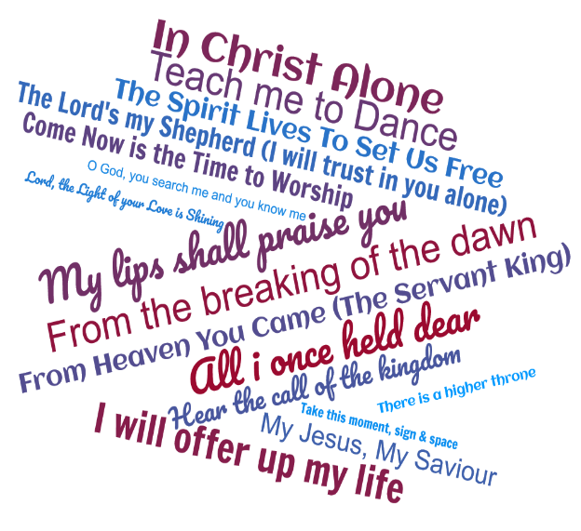**Portholme Selby Raises the Roof**

On 7th May Portholme Selby are holding a “Raise the Roof” event comprising an evening of song and fellowship. It’s an evening of modern hymns to celebrate three anniversaries: the Queen’s Platinum Jubilee, the United Reformed Church’s 50th Anniversary and also Portholme Church’s own 10th birthday. Not only that it marks the completion of their roof replacement programme. All the hymns will be ones that have been written since Queen Elizabeth II ascended the throne in 1952. It should be a really good evening of singing modern worship songs.  The musical line-up is not finalised yet but the organ will definitely remain silent! So Portholme extends a very warm welcome to everyone from other URC churches in Yorkshire (or anywhere, come to that!)

The best place to get further information is on the [**Portholme Church - Methodist / URC LEP**](https://portholmechurch.org.uk/) website or on their Facebook page which can be found here [**https://www.facebook.com/selbyportholmechurch**](https://www.facebook.com/selbyportholmechurch)

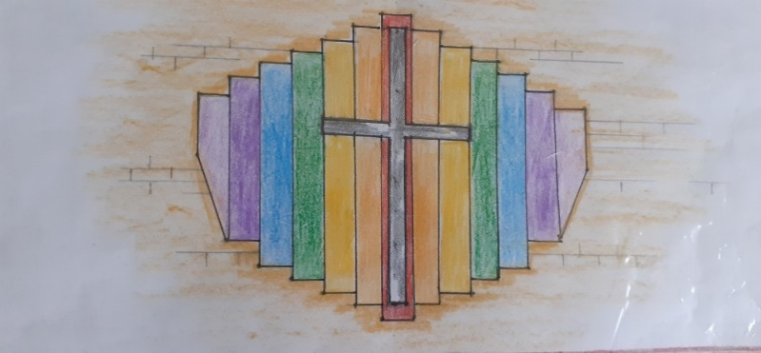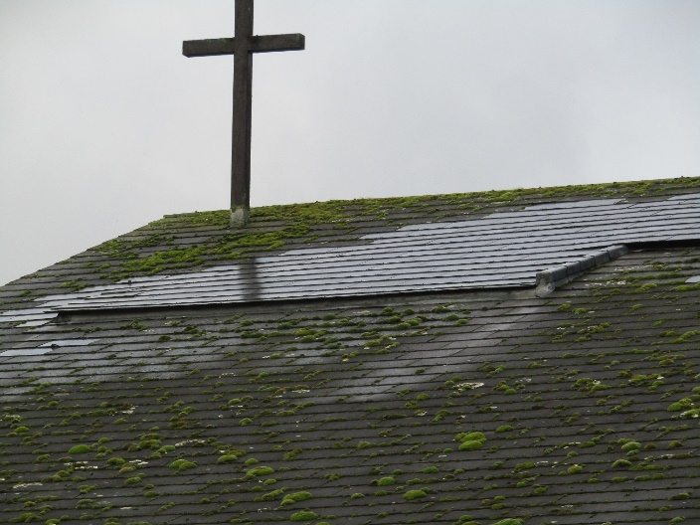As well as this, they hope to be able to reposition the old cross that was on their old roof line to a more prominent position on the front of the church. They are using some spare timber from the construction of the new roof to create a rainbow background which will attract the attention of passers-by.  One of the problems with such a modern building is that people don’t often realise that it’s a church, so Portholme are hoping that the cross with the rainbow artwork behind it will help to clarify the main purpose of the building with the message that “all are welcome”.  Solar-powered lamps will illuminate the cross at night. If you would like to help Portholme achieve this goal, please contact them through their website [**Portholme Church - Methodist / URC LEP**](https://portholmechurch.org.uk/).

**Holiday Forum**

|  |
| --- |
| Logo**All your Holiday Forum 2022 news**  **HOLIDAY FORUM IN A DAY - Saturday 30th April, Zoom**  After the success of last year’s one day online Forum taster, we’re bringing you another jam packed day to whet your appetite for the summer conference.  https://dim.mcusercontent.com/cs/0e34254ac99bc7636021341f1/images/8328f2ae-a4cf-b686-08b7-dc7cbf00ac95.png?w=351&dpr=2Meet our theme leader, [**Tessa Henry Robinson**](http://www.urcholidayforum.org.uk/wpsite/2022-theme/), and experience worship with [**Dan Morrell**](http://www.urcholidayforum.org.uk/wpsite/2022-theme/). Both will give us a glimpse into what we can expect from this summer’s Holiday Forum.  You can also expect a lot of fun: we’ll be running a virtual **labyrinth** with **Daleen Ten Cate**, an online **tour of Abi Howl’s working farm** (both great for all ages) and of course an **evening quiz and social time** to catch up with friends.  HF in a Day will run throughout the day, so drop in as you like [using this link](https://us06web.zoom.us/j/88537406794)  [**https://us06web.zoom.us/j/88537406794**](https://us06web.zoom.us/j/88537406794)- Meeting ID: 885 3740 6794  See you online! |
|  |



**Lifting of Covid-19 Restrictions**

As you will know, the government has lifted the restrictions surrounding the wearing of masks and the compulsory self-isolation regulations if one contracts Covid-19. There was even a change in the regulations on 1st April which reduced the minimum number of days of self-isolation. This doesn’t mean that the pandemic is over by any means. There are still many people contracting the virus and it appears it is on the increase. In fact, the advice that is being offered is that you still need to remain vigilant and that if you feel as though it is the right thing to do you may retain the measures you have had in place over the past months. Certain things will no longer be happening, such as the use of the QR posters and the track and trace scheme we had all got used to. However if you or your church feel it is right to maintain the restrictions we have used for the care and protection of your community, we at Synod will support you.

The current regulations can be found here [**Coronavirus (COVID-19): guidance and support - GOV.UK (www.gov.uk)**](https://www.gov.uk/coronavirus) with the recommendations of the URC to be found at the [**Coronavirus advice - United Reformed Church**](https://urc.org.uk/our-news-stories/coronavirus-advice/) page. This also has links to the latest updates, worship aid and resources, all designed for you and your churches as well as the links to the guidance I’ve previously highlighted from the Synod Moderators.

Our key responsibility and duty of care to our congregations, members and friends. So if you feel as a church that you wish to continue in asking that masks be worn, that hand gel be used and that social distancing is maintained, we at Synod will support you in that choice.

**Please don’t hide these events and resources in your inboxes or within the trees hiding your own churches’ woods. Why not send the Briefing around your own church mailing lists as these events are for everyone, member or non-member, church-goer or non-church-goer. All these activities within and beyond Synod are designed to grow the Kingdom.**

**Plans are always happening to bring more activities and good news stories to your attention, so keep an eye open for the next Briefing due on 28th April (as I am on holiday during the week after Easter). All you need to do is get in touch with me at** [**clerk@urcyorkshire.org.uk**](mailto:clerk@urcyorkshire.org.uk)**.**

If you need any further help, be it to do with IT, finance, property or the like we are here to help.

National URC site: [**https://urc.org.uk/**](https://urc.org.uk/)Yorkshire Synod: [**https://urcyorkshire.org.uk/**](https://urcyorkshire.org.uk/) Yorkshire Synod Twitter: [**https://twitter.com/urcyorkshire**](https://twitter.com/urcyorkshire) Yorkshire Synod Facebook: [**https://www.facebook.com/urcyorkshire**](https://www.facebook.com/urcyorkshire) Yorkshire Young People’s Facebook: [**https://www.facebook.com/wildernessyorkshireurc/**](https://www.facebook.com/wildernessyorkshireurc/)

*Tim Crossley*

*Synod Clerk*