**The Briefing – Number 82**

**28th April 2022**

Dear Friends,

I hope that you all had a happy and fulfilling Easter. Mine was an all too brief holiday, sadly spent helping my 7 year old son navigate the nasty dose of Chicken Pox that sneaked through his defences as the school term ended. As I write, he is on the mend and we hope that he is able to return to school later this week. Where he picked up the virus we don’t know and this is a salutary warning that the Covid virus is similarly still out there and running its way through the population. We all know that the restrictions have been lifted, but please be careful, remain vigilant and make sure that you keep your churches as safe as you can as we open up for worship and fellowship.

This issue is a week later than normal – mainly as I have been on leave. This means that there is a great deal to pack in. The activity during Spring warrants this, and I really have had a job to keep this issue to 10 pages. It really is great to see the amount of activity in and around the Synod. All this activity is for you, so please help those who are helping you to come closer to Christ. Keep letting me know your good news as it is the thing that keeps this august journal going.

The Briefing also gives me the opportunity to ask questions of you and I have a couple of big question to ask today.

Firstly are you willing to represent your Synod at the General Assembly of the URC this summer?

This is not just normal General Assembly, this is **Jubilee General Assembly.**

As you may know, General Assembly meetings are now being held on an annual basis and the next one is to be held at *The Hayes* in Swanwick, Derbyshire from Friday 8th July 2022 to Monday 11 July. Each Synod is asked to provide sixteen representatives, of which a minimum of six should be ordained Ministers of Word & Sacraments or CRCWs and a minimum of six should be lay. Currently I have a shortage of volunteers (especially ordained as I have only three so far), so I am asking would you would be willing to be one of Yorkshire’s representatives at General Assembly this summer? I am being asked for names by the end of this month, which I know doesn’t give much time for you to think over this request, but I hope sufficient time for you to give me an indication of what you are able to offer to Synod. So if you are willing to be a Yorkshire representative please drop me a line as soon as you can so that I can let those organizing it at Church House your details.

The second question is whether you are willing to sit on one of the several Synod Committees which help guide the Synod in its work for you and for the churches in Yorkshire. In particular we have vacancies on the Property Committee and on the Financial Resources Committee, and I’m still looking for more Green Apostles. If you feel the call to serve please drop me a line at [**clerk@urcyorkshire.org.uk**](mailto:clerk@urcyorkshire.org.uk), hopefully sooner than later. The roles may appear to be restricted to those with specific skills, but as the ethos of the Synod is mission, we need folk who can help churches use their resources to ensure that the Gospel of Jesus Christ still rings out loud and clear from our places of worship.

**Disciple Development Fund**

***Yorkshire URC Synod Discipleship Development Fund***

This fund is available to encourage and support individuals within the United Reformed Church engage with a journey of developing personal discipleship. It is available for any URC member or regular URC attender of any age who is not a Minister of Word and Sacraments or Church Related Community Worker.

Yorkshire Synod Ministries Committee are pleased to share with you that grants of up to £200 are now available.

**Individuals** can apply for help with the cost of attending an approved discipleship course, activities or retreats offered by others.

**Congregations** can apply for help with the cost of buying in a speaker or other resources to facilitate in-house schemes.

Please contact Kath Lonsdale, Convenor of Yorkshire Ministries, [kathlonsdale@talktalk.net](mailto:kathlonsdale@talktalk.net) or 01274 315203 to apply for this grant.

**Also available is the following video, which was shown at the March Synod meeting, which gives an overview of what is on offer** [**https://drive.google.com/drive/folders/1bsPMiSjEbtqiTXSXuXJKOY0DCpDPm-_J**](https://drive.google.com/drive/folders/1bsPMiSjEbtqiTXSXuXJKOY0DCpDPm-_J)

**Lay Preachers Planning Group news**

**Lay preachers and Worship Leaders weekend**

We are looking forward to the Lay preachers and Worship Leaders weekend at Wydale conference centre 22nd to 24th July 2022 (Friday teatime to Sunday lunch) . Thankyou to all those who have already registered. We look forward to sharing this weekend together.

 We need to confirm numbers with Wydale by 6th May and there is **still a place or two** left to fill of the 30 places we provisionally booked.

Have you thought about this but not registered yet ?

If you are coming is there anyone else you can encourage to come?

If you are not coming is there anyone in your church who you could share this opportunity with and encourage them to register?

The cost of this weekend will be paid for by grants successfully applied for so you or the person you encourage will only need to cover travel costs.

Please register by 1st May at [office@urcyorkshire.org.uk](mailto:office@urcyorkshire.org.uk) or 0113 289 8490.

Yours in Christ’s service

Kath

Kath Lonsdale ( on behalf of the lay preachers planning group )

[kathlonsdale@talktalk.net](mailto:kathlonsdale@talktalk.net)

01274 315203

07759525936



Please contact [**ministries@urc.org.uk**](mailto:ministries@urc.org.uk)for further details.

**Children and Young Peoples News**

**The WILDERNESS Project is back for 2022.  
*Here at the Yorkshire Synod we want to see young people participating in the mission of God in their church. More than that, we want to PAY YOUNG PEOPLE to participate in the mission of God in their church.*  
We know that it can be a struggle to keep young people engaged in church life, especially when so many other things are happening in their world. Often young people around the age of 16 take part time jobs, which means we see them less. The WILDERNESS Project hopes to encourage, enable and equip young people with the support and the resource to turn a passion into a project to enrich the life of their church.   
Please contact Megan**[**here**](mailto:wilderness@urcyorkshire.org.uk?subject=The%20WILDERNESS%20Project)**for more information.**

****It’s back and ticket sales for

**THE BIG DAY OUT**

have already opened and won’t close until Friday 09th September.

Please contact the synod office to book your tickets [**office@urcyorkshire.org.uk**](mailto:office@urcyorkshire.org.uk)

**0113 289 8490**

**Include your church/group, group leader (and contact email), the number of paid tickets and how many free under 3 tickets and look out for the special coach funding offer**.

****The Wilderness team is also organising a couple of major events later on in the year. In July there is the Young Adults weekend for 17 to 25 year olds at the Peak Centre in Edale. For more information and to book onto this Young Adults Retreat:[**https://forms.gle/MsoWGcmThbtudaE46**](https://forms.gle/MsoWGcmThbtudaE46).

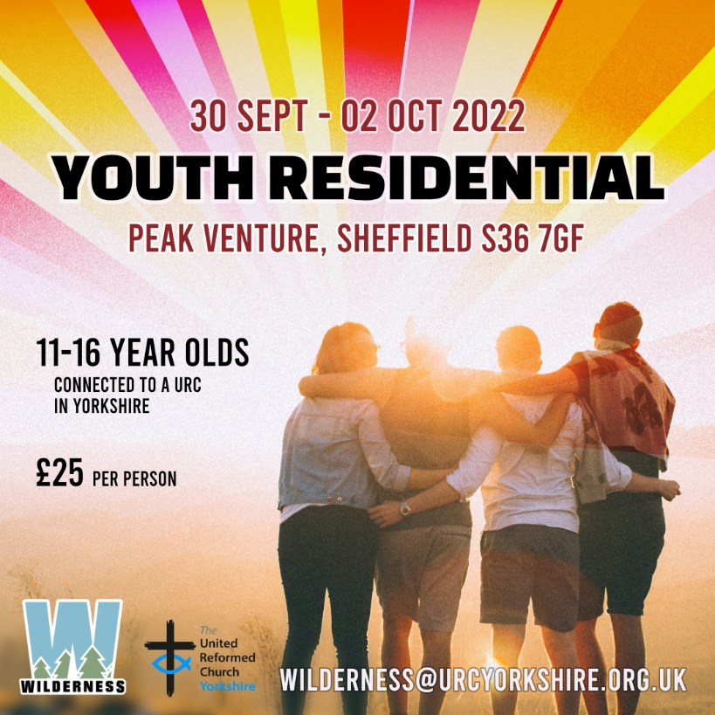

And at the end of September there will be the Youth Residential for 11 to 16 year olds at Peak Venture in Sheffield.To book onto the Youth Residential click here [**https://forms.gle/xp1oYgrzG5nTHgBp9**](https://forms.gle/xp1oYgrzG5nTHgBp9)

To subscribe to the Wilderness newsletter you can find either the link through the newsletter itself or even better click here [**URC Yorkshire Synod (list-manage.com)**](https://urcyorkshire.us18.list-manage.com/subscribe?u=6386cd1d52e213399865e28c0&id=911b09bcc9)

**GEAR**



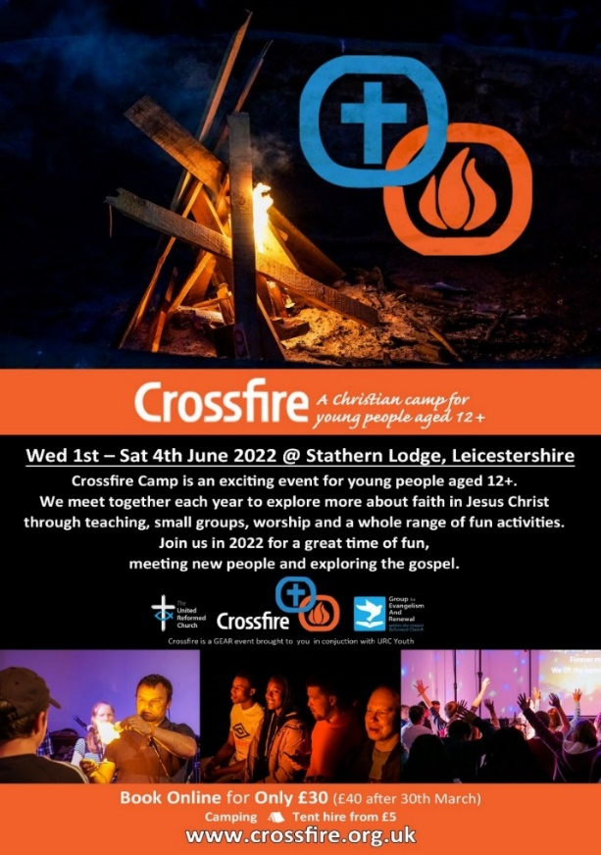Rev Matt Stone has asked me to draw your attention to CROSSFIRE, A Christian camp for young people ages 12+. It is organised by GEAR and is happening from 1st to 4th June (Platinum Jubilee Weekend).

All details and booking information is via [**www.crossfire.org.uk**](http://www.crossfire.org.uk)

**Yorkshire Reflections**

**Since the beginning of February we have been uploading in to the ‘Worship’ section of the Synod website, a weekly reflection on a Sunday.  Thank you to all who have either already contributed or have offered a date – it is much appreciated.  If you would like to take a look, you can find the latest reflection here:** [**https://urcyorkshire.org.uk/worship/**](https://urcyorkshire.org.uk/worship/)

**If you are willing and able to have a go, do get in touch with me and we can discuss a date. We have availability and details of what is required and how to send it can be found below on the original email. I look forward to hearing from you.**

**With thanks and best wishes**

***Sally Duxbury, PA to the Moderator - Revd Jamie Kissack***

[**office@urcyorkshire.org.uk**](mailto:office@urcyorkshire.org.uk)

**Property News**

News from the Walking the Way team in that there is to be a URC Buildings Forum Online Event: **Living the life of Jesus through our buildings**

**Wednesday 25 May from 7:30pm to 9pm**

Join Simon Peters, project manager for Walking the Way: living the life of Jesus today, as we explore differing examples of how buildings can be used to support people in recognising God in everyday life, not just in worship on a Sunday.

To register for this event please contact [mission@urc.org.uk](mailto:mission@urc.org.uk).

**Joint Public Issues Team News**

[](http://www.jointpublicissues.org.uk/conference/)**Joint Public Issues Team Conference** on **11th June 2022** in London or online at **www.jointpublicissues.org.uk/conference**

The conference will focus on the increasing significance of the ‘local’ in action for change.  Full details and how to book can be found at the [**JPIT Conference 2022 | Joint Public Issues Team**](https://www.jointpublicissues.org.uk/conference/) website

We’d love it if you were able to join us for this day of creative exploration, and also encourage others from your churches to attend, in particular

* Someone who wouldn’t otherwise be able to afford it
* Someone they have identified as a lay leader in the community
* Someone aged between 16-25
* Someone who can carry ideas back to a wider team

The conference will be an opportunity for us to come together, to be re-energised to speak, pray and act boldly as Christians committed to seeing transformation in our communities and beyond.

If you have any questions or suggestions, please do not hesitate to get in touch with

**Simeon Mitchell, Team Leader, Joint Public Issues Team**

**Secretary for Church and Society, United Reformed Church**

020 7916 8633 | 07584 053432 | [**simeon.mitchell@urc.org.uk**](mailto:simeon.mitchell@urc.org.uk)

|  |
| --- |
| **Prayers for Ukraine** |
|  |

As I mentioned in last time’s edition, we have received some advice from our insurers regarding offering temporary accommodation to refugees:

**Ministers taking Ukrainian refugees into their own homes**

* All refugees are in the UK legally
* This must be done as part of the Government scheme so all vetting/checks done by them
* Safeguarding measures must be in place to protect the Minister, their family and the refugees
* This is a temporary arrangement
* Premises are suitable for this arrangement
* All risk assessed and appropriate Health & Safety assessments carried out
* The Minister should advise his/her contents Insurers.

**Use of Unoccupied manses**

* Refugees must be in the UK legally
* Again this must only be on a temporary basis
* Must be part of the Government scheme so all vetting/checks done by them
* Properties must be suitable/fit for purpose – up to date gas/electric etc.
* Appropriate risk management assessments done as per any other letting of the property

**Other points to note**

* We must be made aware of any arrangements made
* Insurers would prefer family units rather than groups of unrelated people

To assist the situation, Insurers do not propose to charge any additional premiums/extra terms. However, we would kindly ask you to refer all arrangements to ourselves in the first instance at [**trust@urcyorkshire.org.uk**](mailto:trust@urcyorkshire.org.uk) or [**clerk@urcyorkshire.org.uk**](mailto:clerk@urcyorkshire.org.uk).

**Safeguarding Training**

**For the attention of Church Safeguarding Co-ordinators, Serving Ministers and Church Secretaries**

Please note if anyone from your church needs a place on either of the Safeguarding training courses, Foundation or Intermediate, (you will need to have completed the Foundation course before the Intermediate) there are spaces on the following dates:

**Foundation Safeguarding course**

Monday 16th May 2022 – 10am to 12pm – now fully booked

**Intermediate Safeguarding courses**

Thursday 5th May 2022 – 1pm to 3.30pm, Thursday 12th May 2022 – 10am to 12.30pm

Tuesday 24th May 2022 – 1pm to 3.30pm

The places for these courses are very much at a premium, so please check availability.

Please do get in touch to book at [**moderatorpa@urcyorkshire.org.uk**](mailto:moderatorpa@urcyorkshire.org.uk)

**Worshipping God Together : Apart.**

Rev Janine Atkinson’s regular services and reflections are still being uploaded to the website. As always a big thank you to Janine for these incredible resources which can be found under the ‘What we do’ drop down heading if you fancy a Yorkshire Synod Website surf or more directly at [**https://urcyorkshire.org.uk/worship/**](https://urcyorkshire.org.uk/worship/)

**Church Events**

**New doors officially opened on Easter Morning!**

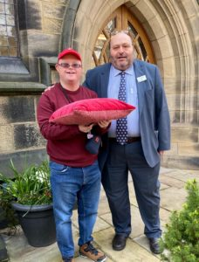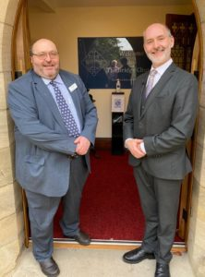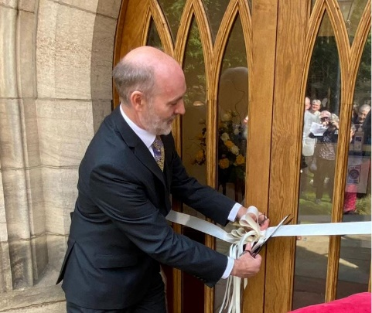The Bridge Church in Otley was pleased that Rev Jamie Kissack, Moderator of the Yorkshire Synod of the United Reformed Church officially opened their new bi-centenary doors prior to leading their Easter morning worship. The Bridge Church had celebrated their 200th anniversary during 2021.

Jamie was welcomed on behalf of the church by their Secretary, John Eveleigh and was handed the official scissors by one of the Bridge Church members, Andrew Jackson.

**Bilton Grange URC** in Harrogate is delighted to announce that they are hosting a Walk Through the Bible - Old Testament. As it says here it is providing the Old Testament in a nutshell.

It is being held at the church on the evening of 6th May and the morning of Saturday 7th May. To book please contact either [www.Bible.org.uk](http://www.Bible.org.uk) or Bilton Grange’s minister Rev Alan Crump at [alan.g.crump139@gmail.com](mailto:alan.g.crump139@gmail.com).

I’m told that it's a great way to hear and engage with the story of the Old Testament so please book a place as soon as you can.

**Portholme Selby Raises the Roof**

Following on from the announcement in last time’s Briefing, Portholme Church invites everyone to join them to **“Raise the Roof”** in celebration of the Queen’s Platinum Jubilee (as well as their own 10th birthday) They shall be singing the “top ten” from over 50 nominations of worship hymns that have been written in the last 70 years. They have received lots of votes and wish to thank everyone who has taken part. The winners will remain a closely guarded secret until the evening itself, so make sure you come along on Saturday 7 May for a great evening of modern worship followed by light refreshments.

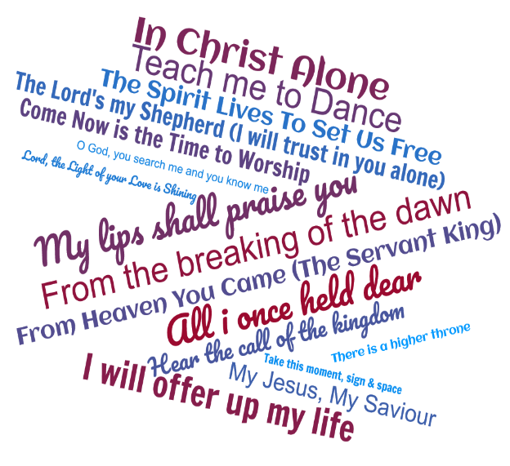There are no tickets and there will be no charge on the door (but we shall ask for voluntary donations to our roof fund).

**“Raise the Roof” – Portholme Church, Selby YO8 4QH - 7.30pm, Saturday 7 May**

The best place to get further information about the event as well as the work that they have done on their roof and the repositioning of their iconic cross is on the [**Portholme Church - Methodist / URC LEP**](https://portholmechurch.org.uk/) website or on their Facebook page which can be found here [**https://www.facebook.com/selbyportholmechurch**](https://www.facebook.com/selbyportholmechurch)



**Holiday Forum**

|  |
| --- |
| Logo**All your Holiday Forum 2022 news**  **HOLIDAY FORUM IN A DAY - Saturday 30th April, Zoom**  https://dim.mcusercontent.com/cs/0e34254ac99bc7636021341f1/images/8328f2ae-a4cf-b686-08b7-dc7cbf00ac95.png?w=351&dpr=2After the success of last year’s one-day online Forum taster, we’re bringing you another jam-packed day to whet your appetite for the summer conference. Meet our theme leader, [**Tessa Henry Robinson**](http://www.urcholidayforum.org.uk/wpsite/2022-theme/), and experience worship with [**Dan Morrell**](http://www.urcholidayforum.org.uk/wpsite/2022-theme/). Both will give us a glimpse into what we can expect from this summer’s Holiday Forum.  You can also expect a lot of fun: we’ll be running a virtual **labyrinth** with **Daleen Ten Cate**, an online **tour of Abi Howl’s working farm** (both great for all ages) and of course an **evening quiz and social time** to catch up with friends.  HF in a Day will run throughout the day, so drop in as you like [using this link](https://us06web.zoom.us/j/88537406794) [**https://us06web.zoom.us/j/88537406794**](https://us06web.zoom.us/j/88537406794)- Meeting ID: 885 3740 6794 See you online! |
|  |

**Please don’t hide these events and resources in your inboxes or within the trees hiding your own churches’ woods. Why not send the Briefing around your own church mailing lists as these events are for everyone, member or non-member, church-goer or non-church-goer. All these activities within and beyond Synod are designed to grow the Kingdom.**

**Plans are always happening to bring more activities and good news stories to your attention, so keep an eye open for the next Briefing due on 28th April (as I am on holiday during the week after Easter). All you need to do is get in touch with me at** [**clerk@urcyorkshire.org.uk**](mailto:clerk@urcyorkshire.org.uk)**.**

If you need any further help, be it to do with IT, finance, property or the like we are here to help.

National URC site: [**https://urc.org.uk/**](https://urc.org.uk/)Yorkshire Synod: [**https://urcyorkshire.org.uk/**](https://urcyorkshire.org.uk/) Yorkshire Synod Twitter: [**https://twitter.com/urcyorkshire**](https://twitter.com/urcyorkshire) Yorkshire Synod Facebook: [**https://www.facebook.com/urcyorkshire**](https://www.facebook.com/urcyorkshire) Yorkshire Young People’s Facebook: [**https://www.facebook.com/wildernessyorkshireurc/**](https://www.facebook.com/wildernessyorkshireurc/)

*Tim Crossley*

*Synod Clerk*