**Reflections for Good Friday 2022 - Together : Apart**

**Opening Words**

Create in me, Lord, eyes within my eyes,

so that, with *new* eyes

I may contemplate your divine sacrifice.

Create in me a pure heart,

so that, through the power of your Spirit,

I may inhaleyour salvation.

*(Joseph the Visionary - a Syrian Father of eighth-century Iraq. altd.)*

**Hymn: My song is love unknown**

1. My song is love unknown,

my Saviour’s love to me:

love to the loveless shown,

that they might lovely be.

O who am I, that for my sake

my Lord should take frail flesh and die?

1. He came from his blessed throne,

salvation to bestow;

but men made strange, and none

the longed-for Christ would know.

But O, my Friend, my Friend indeed,

who at my need his life did spend.

**A Prayer in Praise of God’s Grace**

Lord, I realise that what I see of your love

is only the beginning.

One drop from the whole ocean.

And like the sea, moving, surging.

All-embracing.

Seeking to surround me, not to overwhelm, to drown,

but to hold me, buoy me up.

A love with room to spare.

No rejections.

No high-tide mark of rubbish, pushed up and thrown aside.

I wish Judas could have known that.

I wish that somehow, in his own agony in the garden,

so different, Lord, from yours, so like to mine,

he could have reached out from the depths of his despair

and felt your hand.

There’s nothing I can do about that.

I leave it with you Lord, as I leave so much.

You’ve got strong hands.

*(Eddie Askew.* *From ‘The Book of a Thousand Prayers’. Angela Ashwin. p.337)*

**The Betrayal and Arrest of Jesus - Mark 14: 43 - 51**

**43**Immediately, while he was still speaking, Judas, one of the twelve, arrived; and with him there was a crowd with swords and clubs, from the chief priests, the scribes, and the elders.

**44**Now the betrayer had given them a sign, saying, ‘The one I will kiss is the man; arrest him and lead him away under guard.’ **45**So when he came, he went up to him at once and said, ‘Rabbi!’ and kissed him. **46**Then they laid hands on him and arrested him.

**47**But one of those who stood near drew his sword and struck the slave of the high priest, cutting off his ear.

**48**Then Jesus said to them, ‘Have you come out with swords and clubs to arrest me as though I were a bandit? **49**Day after day I was with you in the temple teaching, and you did not arrest me. But let the scriptures be fulfilled.’

**50**All of them deserted him and fled.

**51**A certain young man was following him, wearing nothing but a linen cloth. They caught hold of him, **52**but he left the linen cloth and ran off naked. *(I wonder - was this the Gospel writer, Mark?)*

**A Prayer of Confession**

Lord Jesus, forgive us for failing you.

Through thoughtlessness we betray you, as Judas did;

through fear we run away from you, along with all the disciples;

through cowardice we deny you, as Peter did,

not wanting people to know that we are your followers.

Have mercy on us, as you had mercy on Peter and the others,

And when the cock crows in our hearts and we realise what we have

done, help us to bear your gaze of love. Amen

*(From ‘The Book of a Thousand Prayers’. Angela Ashwin. p.341 altd.)*

**Hymn: My song is love unknown**

1. Why, what hath my Lord done?

What makes this rage and spite?

He made the lame to run,

he gave the blind their sight.

Sweet injuries! Yet they at these

themselves displease and ‘gainst him rise.

**A Priest Speaks**

This young man from Galilee, he has no idea about the tricky situation with Rome. There’s just so much at stake.

I daresay he’s a fine chap, but what can he possibly know?

You see it’s a very difficult balance. There’s the matter of worship. That’s vital!

We’ve done a lot of delicate negotiations with the Romans about that.

They wanted a graven image of Caesar in the Holy of Holies

Well of course that’s unthinkable, ‘No graven images’ one of the Ten Commandments Moses gave us from God himself**.**

You know, we’re always living on a knife edge here.

The important thing is to keep the worship going,

make all the right sacrifices in the right way

and dispense God’s forgiveness responsibly and properly.

That lunatic from Galilee is spoiling everything, undermining everything we’ve fought to save.

He just doesn’t understand or appreciate everything that’s at stake here.

He’s either not aware of, or he just doesn’t care about, allour careful dealings with Rome,all the work that’s gone in to keep everything as it must be.

It’s *sad*, of *course***,** but he’s undermining everything we’ve worked so hard to protect, we just have to get rid of him before he brings the whole thing down around our heads.

I always said we could trust God to find a way to get us out of this mess, so thank God for Judas Iscariot, he was a real godsend.

Thanks to him we can get it allover and done with quickly, no fuss.

*(Ian Cowie - Eggs and Ashes p.192. altd.)*

**Jesus before Pilate**

*‘Listen’ for the accusations in Jesus’ trial, the injustice and Pilate’s own view about Jesus and consider Jesus’ demeanour.*

**Reading –** **Mark 14: 53 to 15: 15**

**Jesus before the Council**

**53**They took Jesus to the high priest; and all the chief priests, the elders, and the scribes were assembled.

**54**Peter had followed him at a distance, right into the courtyard of the high priest; and he was sitting with the guards, warming himself at the fire.

**55**Now the chief priests and the whole council were looking for testimony against Jesus to put him to death; but they found none. **56**For many gave false testimony against him, and their testimony did not agree. **57**Some stood up and gave false testimony against him, saying, **58**‘We heard him say, “I will destroy this temple that is made with hands, and in three days I will build another, not made with hands.”’ **59**But even on this point their testimony did not agree.

**60**Then the high priest stood up before them and asked Jesus, ‘Have you no answer? What is it that they testify against you?’ **61**But he was silent and did not answer. Again the high priest asked him, ‘Are you the Messiah, the Son of the Blessed One?’

**62**Jesus said, ‘I am; and

“you will see the Son of Man seated at the right hand of the Power”,  
and “coming with the clouds of heaven.”’

**63**Then the high priest tore his clothes and said, ‘Why do we still need witnesses? **64**You have heard his blasphemy! What is your decision?’

All of them condemned him as deserving death. **65**Some began to spit on him, to blindfold him, and to strike him, saying to him, ‘Prophesy!’

The guards also took him over and beat him.

**Peter Denies Jesus**

**66**While Peter was below in the courtyard, one of the servant-girls of the high priest came by.

**67**When she saw Peter warming himself, she stared at him and said, ‘You also were with Jesus, the man from Nazareth.’

**68**But he denied it, saying, ‘I do not know or understand what you are talking about.’ And he went out into the forecourt.

Then the cock crowed.

**69**And the servant-girl, on seeing him, began again to say to the bystanders, ‘This man is one of them.’ **70**But again he denied it.

Then after a little while the bystanders again said to Peter, ‘Certainly you are one of them; for you are a Galilean.’

**71**But he began to curse, and he swore an oath, ‘I do not know this man you are talking about.’

**72**At that moment the cock crowed for the second time.

Then Peter remembered that Jesus had said to him, ‘Before the cock crows twice, you will deny me three times.’

And he broke down and wept.

**Jesus before Pilate**

**15**As soon as it was morning, the chief priests held a consultation with the elders and scribes and the whole council.

They bound Jesus, led him away, and handed him over to Pilate.

**2**Pilate asked him, ‘Are you the King of the Jews?’ He answered him, ‘You say so.’

**3**Then the chief priests accused him of many things.

**4**Pilate asked him again, ‘Have you no answer? See how many charges they bring against you.’

**5**But Jesus made no further reply, so that Pilate was amazed.

**Pilate Hands Jesus over to Be Crucified**

**6**Now at the festival he used to release a prisoner for them, anyone for whom they asked.

**7**Now a man called Barabbas was in prison with the rebels who had committed murder during the insurrection.

**8**So the crowd came and began to ask Pilate to do for them according to his custom.

**9**Then he answered them, ‘Do you want me to release for you the King of the Jews?’ **10**For he realized that it was out of jealousy that the chief priests had handed him over.

**11**But the chief priests stirred up the crowd to have him release Barabbas for them instead.

**12**Pilate spoke to them again, ‘Then what do you wish me to do with the man you call the King of the Jews?’ **13**They shouted back, ‘Crucify him!’ **14**Pilate asked them, ‘Why, what evil has he done?’ But they shouted all the more, ‘Crucify him!’

**15**So Pilate, wishing to satisfy the crowd, released Barabbas for them; and after flogging Jesus, he handed him over to be crucified.

***Keep a silence....................***

From the companionship of a meal with his closest friends, Jesus now stood alone, a solitary figure, in his hour of greatest need.

All the disciples had deserted him, Judas had betrayed him and Peter had denied even knowing him.

Would you have been courageous enough to speak up for Jesus?

***Keep a silence....................***

**Hymn: My song is love unknown**

5. They rise and needs will have

my dear Lord made away;

a murderer they save,

the Prince of Life they slay,

yet cheerful he to suffering goes,

that he his foes from thence might free.

**Hymn: When I survey the wondrous cross**

1. When I survey the wondrous Cross,

on which the Prince of glory died,

my richest gain I count but loss,

and pour contempt on all my pride.

1. Forbid it, Lord, that I should boast,

save in the death of Christ my God;

all the vain things that charm me most,

I sacrifice them to his blood.

1. See from his head, his hands, his feet,

sorrow and love flow mingled down;

did e’er such love and sorrow meet,

or thorns compose so rich a crown?

1. His dying crimson, like a robe,

spreads o’er his body on the tree;

then am I dead to all the globe,

and all the globe is dead to me.

Meanwhile, standing near the cross of Jesus were his mother, and his mother’s sister, Mary the wife of Clopas, and Mary Magdalene. When Jesus saw his mother and the disciple whom he loved standing beside her, he said to his mother, ‘Woman, here is your son.’ Then he said to the disciple, ‘Here is your mother.’ And from that hour the disciple took her into his own home.

**Mary Speaks**

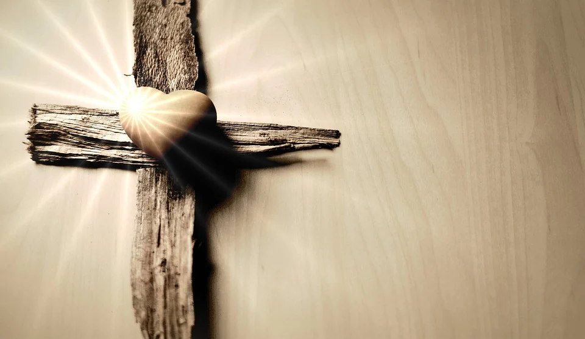

Jesus, my dear, dear son.

What have they done to you?

After all the people you’ve healed!

After all the good you’ve done!

How could they?

Why? *Why?*

Why didn’t you just come home when we camefor you?

Your brothers, your sisters and I.

We allsaw that trouble was brewing.

If only Joseph had still been here,

he would have made sure you came home,

and then this wouldn’t have happened.

But, yes son, I’ll take care of John,

although nobody can ever take your place, not even John.

For your sake, I will be his mother and he will be my son.

*(Ian Cowie - Eggs and Ashes p.196 altd.)*

*“Father forgive them; for they do not know what they are doing”*

**The Roman Centurion on Duty Speaks**

Who the hell does he mean?

I know full well what I’m doing. Obeying orders**,** that’s me.

“You’re not paid to think! You just obey, and do it quickly!”

You join the army and that’s it.

So, if they say “Crucify that man” you just crucify him, no questions.

Well, you’re saving a lotof lives they say.

After all, these so-called Messiah’s stir up a lotof trouble,

and then, when the rabble is roused,

we have to kill hundreds to show them who’s boss.

So, crucifying one will maybe save a lot more.

Seeing what we do to people claiming to be Messiah

will maybe teach them a sharplesson.

You’ve got to be brutalwith these people.

It’s the only language they understand, but I don’t like it all the same.

*Jesus said “I thirst”.*

*A jar stood there, full of sour wine, so they soaked a sponge, fixed it on a branch of hyssop and held it to his lips*

What’s that? You’re thirsty?

Here chum, have a drink on me - Go on, sup up.

Wow! You’ve got guts!

I’ve crucified quite a few in my time, but you’re the daddy of ‘em all.

I know I took the mickey out of you, along with the others,

it’s the way you deal with it.

But now I wish I hadn’t.

I’d have liked to have a drink with you

before that shower of priests got their hands on you.

You seem kind of understanding, even now you’re stuck up there!

I thought you were just another criminal to begin with,

but now I’m not so sure.

Why, for heaven’s sake did they want to crucify you?....

You’ve not far to go now.

Death’s your best friend when you’re on a cross.

You’re not far away now.

For what it’s worth, you’ve another friend here,

but there’s not a thing I can do to help you!

It’s a shame so it is.

You’re the Son of God alright... sure you are!

*(Ian Cowie - Eggs and Ashes p.192 + 195 (altd.)*

*My God, My God...*

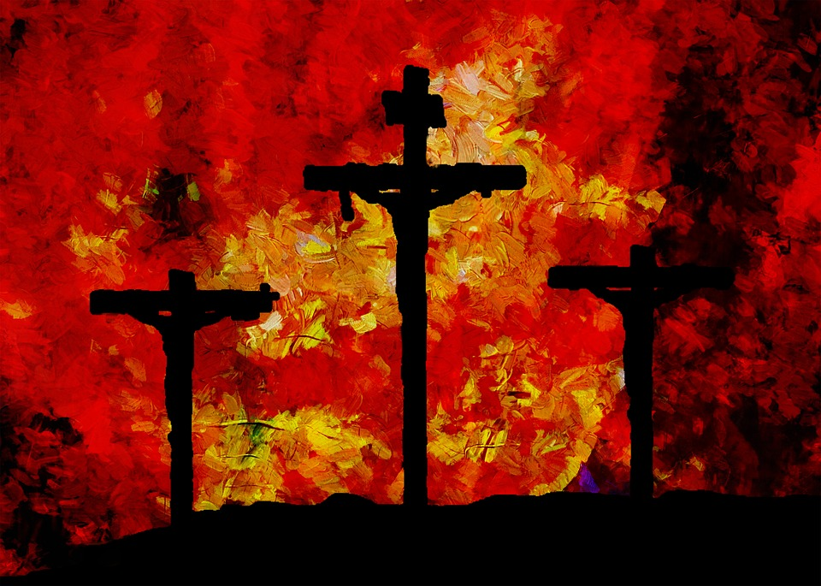

*Why have you forsaken me?*

*(Mark 15: 34a)*

**The Pharisee Speaks**

It was atrocious the way that Galilean broke all the rules of the Law.

But we go by The Book - The Word of God.

Every rule and regulation must be observed carefully,

only that will save us.

Yet our supposed Messiah was playing fast and loose with the Law.

Do you know that on several occasions he actually said:

“The Law of God says such and such a thing.... But *I* say to you...”

It’s a wonder God didn’t strike him dead on the spot.

Arrogance like that provokes God’s wrath.

Then he wonders why God’s forsaken him, what a nerve, we could tell him why.

He was a threat to Israel, undermining God’s people,

so he had to go.

*Then Jesus shouted, “Father, I entrust my spirit into your hands!” And with those words he breathed his last.*

And there he goes right now. And good riddance, now we can get on with proper religion. Praise the Lord!

*(Ian Cowie - Eggs and Ashes p.193 altd.)*

**Prayer**

O Lord, Holy Father,

show me what kind of man it is who is hanging for our sakes

on the cross, whose suffering causes the rocks themselves

to crack and crumble with compassion,

whose death brings the dead back to life.

Let my heart crack and crumble at the sight of him.

Let my soul break apart with compassion for his suffering.

Let it be shattered with grief at my sins for which he dies.

And finally let it be softened with devoted love for him. Amen

*(Prayer from the thirteenth-century Franciscan, Bonaventure)*

**Jesus in the tomb**

After these things, Joseph of Arimathea, who was a disciple of Jesus, though a secret one because of his fear of the Jews, asked Pilate to let him take away the body of Jesus. Pilate gave him permission; so he came and removed his body.

Nicodemus, who had at first come to Jesus by night, also came, bringing a mixture of myrrh and aloes, weighing about a hundred pounds.

They took the body of Jesus and wrapped it with the spices in a clean linen cloth, according to the burial custom of the Jews and Joseph laid it in his own new tomb, which had been carved out of the rock. Then he rolled a great stone across the entrance and left.  Both Mary Magdalene and the other Mary were sitting across from the tomb watching.

The next day, on the Sabbath, the leading priests and Pharisees went to see Pilate. They told him, “Sir, we remember what that deceiver once said while he was still alive:

‘After three days I will rise from the dead.’

So we request that you seal the tomb until the third day. This will prevent his disciples from coming and stealing his body and then telling everyone he was raised from the dead! If that happens, we’ll be worse off than we were at first.”

Pilate replied, “Take guards and secure it the best you can.”

So they sealed the tomb and posted guards to protect it.

*(Adapted from Matthew’s and John’s Gospel accounts – New Living Translation)*

**Hymn: My song is love unknown**

6. In life no house, no home

my Lord on earth might have;

in death, no friendly tomb,

but what a stranger gave.

What may I say? Heaven was his home;

and mine the tomb wherein he lay.

7. Here might I stay and sing,

no story so divine;

never was love, dear King,

never was grief like thine.

This is my friend, in whose sweet praise

I all my days could gladly spend.

Today he who hung the earth upon the waters

is hung upon the Cross.

He who is King of the angels is arrayed in a crown of thorns.

He who wraps the heaven in clouds

is wrapped in the purple of mockery.

He who in Jordan set Adam free

receives blows upon his face.

The Bridegroom of the Church is transfixed with nails.

The Son of the Mary is pierced with a spear.

We worship you, Lord Jesus.

Draw us to yourself with bands of love.

Show us the glory of your Resurrection.

*(Adaptation of Hymns of Good Friday, Orthodox Tradition)*

**Hymn: When I survey the wondrous cross**

1. Were the whole realm of nature mine,

that were an offering far too small;

love so amazing, so divine,

demands my soul, my life, my all.

**Blessing**

Look at your hands.  
It was hands like yours that were nailed to the cross.

Look at your feet.  
It was feet like yours that stumbled their way to Calvary.

Look into the eyes of your neighbours.  
It was for ones like these, that Jesus was crucified.

Look at yourself. It was for you that Jesus died.

*Images:* [*www.pixabay.com*](http://www.pixabay.com) *Free Images*



*All Bible readings are from the NRSVA Translation*

*Prepared by Rev. Janine Atkinson (April 2022)*

*Minister of the SPACE Group of Churches, West Yorkshire*

*Hymn words reproduced under the CCLI Licence numbers of the SPACE Group of Churches: 178113 – Heckmondwike URC: 177949 - Longcauseway Church: 1236906 - Norristhorpe URC: 783508 - Ravensthorpe with Hopton URC*

*My song is love unknown - R&S 207: Samuel Crossman (1624-84)*

*When I survey the wondrous cross - R&S 217: Isaac Watts (1674-1748)*