Reflections for Maundy Thursday at Home
Prepare a meal with bread and wine (or juice) and eat it - reserving the bread and wine for later - then:-
Stop and pause a while…
Come into the presence of God…
Come with your faith…
and come with your questions…
Keep a Silence ……………………
Lord Christ,
whose feet were caressed with perfume,
you humbly took a basin and towel
and washed the feet of your friends.
Wash us also in your tenderness
as we receive from you.
Embrace us, so that we may be free in your name.
Loving God,
you whose concern is holiness,
we thank you for gifting us with a pattern of kneeling down
and pouring out compassion, and care, and love for each other.
Through Jesus, our brother and friend you,
gracious God, have poured out life and love for us.
Lead us to empty ourselves
for the sake of others,
so that in the overflow of love
the world may recognise the power of your love.
As walkers of the Jesus way
may our practice of loving feed our spirits, refresh our bodies
and bring courage to our hearts.
In the name of the one who showed us that your table-space
is a place of grace for all.
(Prayer Handbook 2016. p.34. Michael Jagessar. altd.)
Keep a Silence……………………
Jesus and his disciples gathered in an upper room, filled with the smells of cooking to share the Passover meal.
We give thanks for them and all those who have kept the light of the Gospel burning down the centuries, remembering those who have passed the light on to us
- If you have one, light a candle to represent Christ,
light of the world
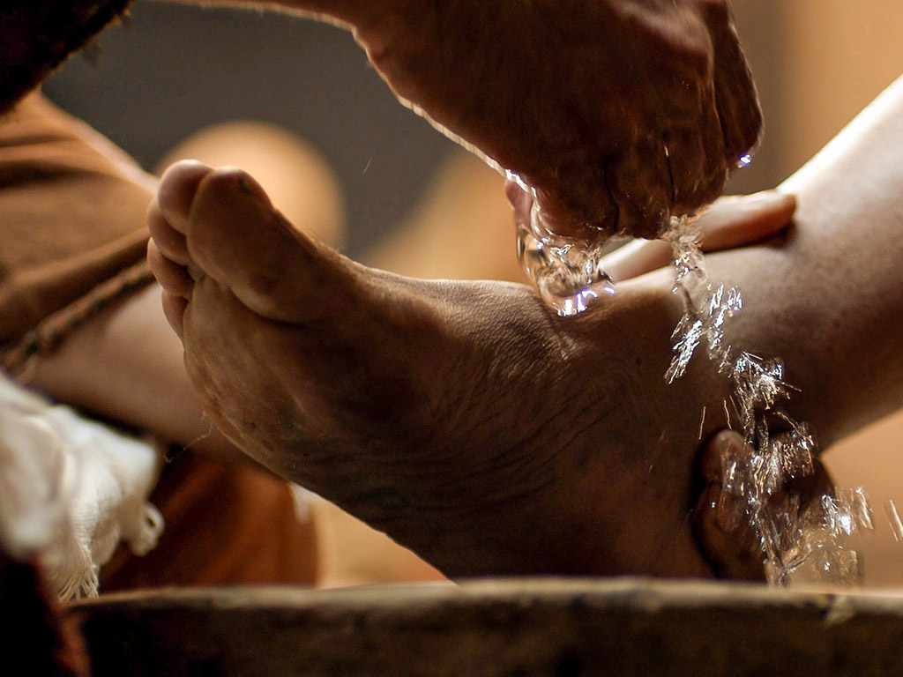

The Gospel writer John tells us that, during the meal Jesus got up, he ‘tied a towel around himself. Then he poured water into a basin and began to wash the disciples’ feet and to wipe them with the towel that was tied around him’ (John 13: 4-5)
Jesus said ‘If I, your Lord and Teacher, have washed your feet, you also ought to wash one another’s feet. For I have set you an example that you also should do as I have done for you.
If you know these things, blessed are you if you do them’. (John 13:14-15, 17)
Wash and dry your hands as a symbol of service -
Why not turn your everyday hand washing into an opportunity for prayer for the world God loves so much that he sent Jesus
On this night, our Lord Jesus Christ said to his disciples:
“Peace I leave with you: my peace I give to you.”
The peace of the Lord is always with you.
Suffering Servant
Lord Jesus Christ; suffering servant,
stretch your arms wide over all who feel the bitter pain of betrayal.
Lord Jesus Christ; suffering servant,
stretch your arms wide
over all who lack courage to stand up for truth
Lord Jesus Christ; suffering servant,
stretch your arms wide over all who endure torment and torture.
Lord Jesus Christ; suffering servant,
stretch your arms wide over all who are alone and terrified.
Lord Jesus Christ; suffering servant,
stretch your arms wide
over all who are powerless in the face of violence.
Lord Jesus Christ; suffering servant,
stretch your arms wide over all who are in sorrow and mourning.
Lord Jesus Christ; suffering servant,
stretch your arms wide over all who need forgiveness and wholeness.
Lord Jesus Christ; suffering servant,
stretch your arms wide and hold your world in love
(Prayer Handbook 2016. p.35. Frances Brienen. altd.)
- Make ready your bread and wine (or juice) to eat and drink as Jesus invites you to:-

The Institution of the Lord’s Supper – Matthew 26: 26 - 30
²⁶ While they were eating, Jesus took a loaf of bread, and after blessing it he broke it, gave it to the disciples, and said, ‘Take, eat; this is my body.’
Eat the Bread and Keep a Silence……………………
²⁷ Then he took a cup, and after giving thanks he gave it to them, saying, ‘Drink from it, all of you; ²⁸ for this is my blood of the covenant, which is poured out for many for the forgiveness of sins. ²⁹ I tell you, I will never again drink of this fruit of the vine until that day when I drink it new with you in my Father’s kingdom.’.
Drink the Wine and Keep a Silence……………………
³⁰ When they had sung the hymn, they went out to the Mount of Olives.
- Think of a hymn you know and sing it if you like.

Jesus said to them “all of you will run away and leave me, for the scripture says “God will kill the shepherd and the sheep of the flock will be scattered” (Matthew 26: 31)
Then Jesus went with them to a place called Gethsemane; and he said to his disciples ‘Sit here while I go over there and pray... (Matthew 26: 36)
- So we wait and we pray:
Lord God, keep us watchful so that we might be ready.
May you not catch us napping.
May you find us waiting, eagerly, to follow Christ’s leading
Amen

Images: www.clipart-library.com: www.freeibleimages.org
Prepared by Rev. Janine Atkinson (April 2022)
Minister of the SPACE Group of Churches, West Yorkshire

