**The Briefing – Number 84**

**19th May 2022**

Dear Friends,

It’s that time in the month when the Briefing arrives and the last two weeks have seen a steady increase in the number of events which are needing to be advertised and items to be brought to your attention. There seems to be an increasing momentum in the things that churches, Synods and denominations are doing to equip us for our missional work. Our emerging from the pandemic lockdown carries on apace – as you’ll see from the Sits Vacs I’ve highlighted this time - whilst many churches are looking to celebrate both Jubilees this year. I know that we will be overwhelmed by the Platinum Jubilee celebrations over the next two or three weeks, but don’t forget that the URC celebrates its own Golden Jubilee this year and the Church itself celebrates its birthday over the bank holiday weekend as it is PENTECOST on 5th June. With this in mind there’s no excuse not to head to this link [**https://www.thykingdomcome.global/**](https://www.thykingdomcome.global/)that has been kindly supplied by our Synod Evangelist, Rev Ashley Evans. Within the site you can find free resources from Thy Kingdom Come; from prayer journals to a reflection on 1 Peter by Justin Welby; from booklets for children to the means by which churches can focus on prayer and invitation between Ascension and Pentecost.

This issue is back in its regular slot, but due to a holiday this half-term, the Briefing will be available on about 8th June. This means you can send in all your good news stories of what you all did over the bank holiday weekend, how you celebrated Pentecost and maybe even the odd picture of a Platinum Jubilee garden party. However, I hope that what you are able to share is you sharing the Gospel, no matter how big or how small, your sharing brings more people to God.

Finally, and perhaps emphasising my comments in last time’s issue, the Briefing also keeps giving me the opportunity to ask questions of you. Currently we have immediate vacancies on both the Property Committee and on the Financial Resources Committee. These two vital committees exist to underpin the missional work of the Synod. Without them the Synod wouldn’t have any form of effective resourcing. As well as these vacancies, I know there are places available across the life of Synod. If you are called to serve in any way, please let either Jamie, the Synod Moderator, or myself know: give us a ring, drop us an e-mail and we will able to explore that calling with you. Synod is here to equip and support Yorkshire’s churches with the tools from and through which our missional work is done. Without these resources churches would not be able to proclaim a presence in their communities or quietly serve those who are in need. Can you offer a few hours a month, a meeting a quarter, playing a part in the mission of the URC in Yorkshire? If you feel the call to serve please drop me a line at [**clerk@urcyorkshire.org.uk**](mailto:clerk@urcyorkshire.org.uk). The roles I have mentioned here may appear to be restricted to those with specific skills, but as the ethos of the Synod is mission, we need folk who can help churches use their resources to ensure that the Gospel of Jesus Christ still rings out loud and clear from our places of worship.

**Disciple Development Fund**

***Yorkshire URC Synod Discipleship Development Fund***

This fund is available to encourage and support individuals within the United Reformed Church engage with a journey of developing personal discipleship. It is available for any URC member or regular URC attender of any age who is not a Minister of Word and Sacraments or Church Related Community Worker.

Yorkshire Synod Ministries Committee are pleased to share with you that grants of up to £200 are now available.

**Individuals** can apply for help with the cost of attending an approved discipleship course, activities or retreats offered by others.

**Congregations** can apply for help with the cost of buying in a speaker or other resources to facilitate in-house schemes.

Please contact Kath Lonsdale, Convenor of Yorkshire Ministries, [kathlonsdale@talktalk.net](mailto:kathlonsdale@talktalk.net) or 01274 315203 to apply for this grant.

**Also available is the following video, which was shown at the March Synod meeting, which gives an overview of what is on offer** [**https://drive.google.com/drive/folders/1bsPMiSjEbtqiTXSXuXJKOY0DCpDPm-_J**](https://drive.google.com/drive/folders/1bsPMiSjEbtqiTXSXuXJKOY0DCpDPm-_J)

**Church Leadership Programme**

I have been sent a reminder by Philippa Linton, the URC’s Education and Learning Administrator that the final deadline for registering for the **Church Leadership Programme** is rapidly approaching. I’m told that there are already a number of potential applicants for the 2022-23 programme but there is room for more, but the deadline for registrations is **Tuesday 31 May**.

For more details, please head to the URC website at [**The Church Leadership Programme - United Reformed Church**](https://urc.org.uk/education-learning/the-church-leadership-programme/) an if you have any other questions, it’s best to contact Philippa directly at either

[**philippa.linton@urc.org.uk**](mailto:philippa.linton@urc.org.uk), 020 7916 8635 or 07801993222

**Northern College Taster Weekend**

**Northern College** (as you might have seen in Reform) are holding a very very heavily subsidised weekend (literally, a whole weekend for £50 which is refundable if anyone takes a course in the future) which might allow people to consider candidating, or taking a course for interest, or finding out more about assembly accredited lay preachers.

It is taking place from **5.30pm on Friday 22nd July, to 2.30pm on Sunday 24th July 2022**.

Here’s a link to a video which you might find interesting and which we’d be grateful if you’d pass on as you think appropriate. [**https://northerncollege.co.uk/taster-weekend/**](https://northerncollege.co.uk/taster-weekend/)

 If anyone wants to know more, please contact Rosalind Selby, the Principal of the College at [**Rosalind.selby@lutherking.ac.uk**](mailto:Rosalind.selby@lutherking.ac.uk).

**Lay Training news**

**Revd Jenny Mills**, the Secretary for Education and Learning has been in touch to highlight the news that The United Reformed Church is launching the **Newbigin Pioneering Hub** to offer a space for Pioneers to connect and learn.

This lay training course will begin in September 2022 and will be run by Seedbeds and the Church Mission Society (CMS) who have a history of offering training for Pioneering ministry. The Hub will be cited in a current and active Pioneering project at Lodge Road URC/Community Church, Birmingham. The Hub will also seek to connect current pioneers to offer and receive support and networking opportunities.

We are offering a ‘taster day’ for everyone to find out more on **Saturday 21 May** from **11-3pm.**    This is an opportunity to connect and find out more about the ‘Community of Pioneers’ and the ‘Certificate in Pioneer Mission’ course that will be run by the ‘Newbigin Pioneering Hub’.  This interactive day will be led by Newbigin Pioneering Hub leader Revd Dr Ash Barker and Jonny Baker of CMS with local ‘Stories of Hope’ in Winson Green.   Click here to book a place: <https://bit.ly/3KJjNit>

‘The Church in each place is to be the sign, instrument and foretaste of the reign of God present in Christ for that place; a sign, planted in the midst of the present realities of the place but pointing beyond them to the future which God has promised; an instrument available for God’s use in the doing of his will for that place; a foretaste – manifesting and enjoying already in the midst of the messianic tribulations a genuine foretaste of the peace and joy of God’s reign.’ – Lesslie Newbigin

On **Saturday 2July** there will be the Newbigin Public Lecture given by Cathy Ross, leader of the Pioneer Mission Leadership Training Centre of CMS.  At that event we will also offer thanks and celebrate that we are establishing a Pioneering Hub in our 50th anniversary year, and focus on the possibilities, joys and dreams we have around developing lay pioneering, training and support in the URC.  This event will run from **1-4pm** at Lodge Road, URC/Community Church, Birmingham.  Register here to secure your place:  <https://www.eventbrite.co.uk/e/newbigin-annual-public-lecture-celebration-of-newbigin-pioneering-hub-tickets-333560056107>

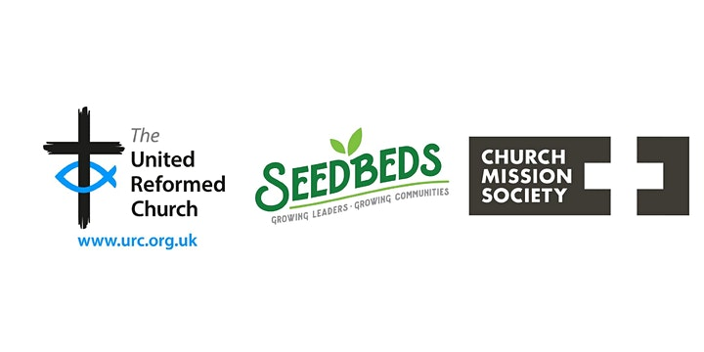

If you are unable to attend either of these events but are interested in finding out more, please email [info@seedbeds.org](mailto:info@seedbeds.org) or contact [ministries@urc.org.uk](mailto:ministries@urc.org.uk)

**LYCiG**

The **Leading Your Church into Growth Northerly Synods’ Conference** will be taking place between 7th and 9th November at Hinsley Hall, Leeds. Each of the 5 Northerly Synods has been allocated a set number of places, but there may be more places available than first thought as one or two of the synods may not be able to fill their allocation. Keep an eye on all good URC websites and Briefing news sheets for further updates.

Looking further ahead, the URC LYCiG team are looking at doing a national LYCiG conference for the whole of the denomination. Keep June 2023 clear in your diaries…………..

And as a reminder of what the Clerk wrote on page one of the Briefing

**Free resources from Thy Kingdom Come are available, from prayer journals to a reflection on 1 Peter by Justin Welby to a booklet for children, to focus churches on prayer and invitation between Accession and Pentecost.**

[**https://www.thykingdomcome.global/**](https://www.thykingdomcome.global/)

**Children and Young Peoples News**

**The WILDERNESS Project is back for 2022.  
*Here at the Yorkshire Synod we want to see young people participating in the mission of God in their church. More than that, we want to PAY YOUNG PEOPLE to participate in the mission of God in their church.*  
We know that it can be a struggle to keep young people engaged in church life, especially when so many other things are happening in their world. Often young people around the age of 16 take part time jobs, which means we see them less. The WILDERNESS Project hopes to encourage, enable and equip young people with the support and the resource to turn a passion into a project to enrich the life of their church.   
Please contact Megan**[**here**](mailto:wilderness@urcyorkshire.org.uk?subject=The%20WILDERNESS%20Project)**for more information.**

****It’s back and ticket sales for

**THE BIG DAY OUT**

Is open and won’t close until Friday 9th September.

Please contact the synod office to book your tickets [**office@urcyorkshire.org.uk**](mailto:office@urcyorkshire.org.uk)

**0113 289 8490**

**Include your church/group, group leader (and contact email), the number of paid tickets and how many free under 3 tickets and look out for the special coach funding offer**.

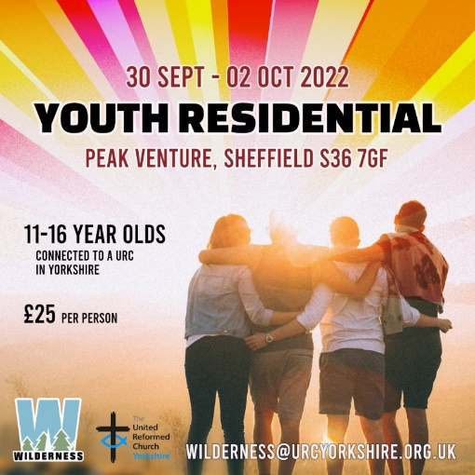

****The Wilderness team is also organising a couple of major events later on in the year. In July there is the Young Adults weekend for 17 to 25 year olds at the Peak Centre in Edale and at the end of September there is the Youth Residential at Peak Venture in Sheffield.

For more information on the Young Adults click here:[**https://forms.gle/MsoWGcmThbtudaE46**](https://forms.gle/MsoWGcmThbtudaE46)

For the Youth residential click here: [**https://forms.gle/xp1oYgrzG5nTHgBp9**](https://forms.gle/xp1oYgrzG5nTHgBp9)

To subscribe to the Wilderness newsletter click here [**URC Yorkshire Synod (list-manage.com)**](https://urcyorkshire.us18.list-manage.com/subscribe?u=6386cd1d52e213399865e28c0&id=911b09bcc9)

**Yorkshire Reflections**

**Since the beginning of February we have been uploading in to the ‘Worship’ section of the Synod website, a weekly reflection on a Sunday.  Thank you to all who have either already contributed or have offered a date – it is much appreciated.  If you would like to take a look, you can find the latest reflection here:** [**https://urcyorkshire.org.uk/worship/**](https://urcyorkshire.org.uk/worship/)

**If you are willing and able to have a go, do get in touch with me and we can discuss a date. We have availability and details of what is required and how to send it can be found below on the original email. I look forward to hearing from you.**

**With thanks and best wishes**

***Sally Duxbury, PA to the Moderator - Revd Jamie Kissack***

[**office@urcyorkshire.org.uk**](mailto:office@urcyorkshire.org.uk)

**Property News**

News from the Walking the Way team in that there is to be a URC Buildings Forum Online Event: **Living the life of Jesus through our buildings**

**Wednesday 25 May from 7:30pm to 9pm**

If God is present in every aspect of our lives, calling us to engage in God’s Mission, what role should our buildings play in our discipleship? Join Simon Peters, project manager for *Walking the Way: living the life of Jesus today*, as we explore differing examples of how buildings can be used to support people in recognising God in everyday life, not just in worship on a Sunday.

To register for this event please contact [**mission@urc.org.uk**](mailto:mission@urc.org.uk).

**Joint Public Issues Team News**

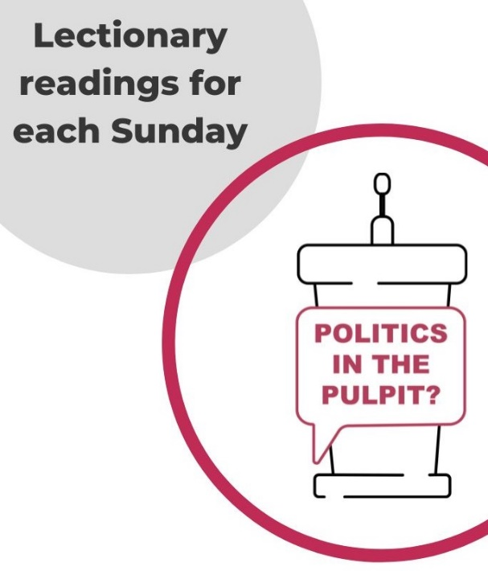**Revd Jenny Mills,** the Secretary for Education and Learning writes this as the current (new, and first URC) host for **JPIT Politics in the Pulpit podcast.** It is a weekly podcast shared through the Joint Public Issues Team (the Baptist, Methodist and United Reformed Churches working together to live out the gospel of Christ in church and society). The podcast looks at the Lectionary readings for the coming week with someone regularly engaged with preaching and who has a heart for peace and justice, also reflecting on the issues in the world and news. **JPIT can be found on Facebook- The Joint Public Issues Team or on Twitter @publicissues and online at** [**Politics in the Pulpit? | Joint Public Issues Team**](https://www.jointpublicissues.org.uk/politicsinthepulpit/)**. You can even watch Jenny hosting on YouTube** [**https://youtu.be/B2YFDAkWs2U**](https://youtu.be/B2YFDAkWs2U)

**Politics in the Pulpit** can be found on **Twitter @pulpit_politics** and the podcast can be found on Spotify, Apple Podcasts, Acast, Podbean, SoundCloud, Google Podcasts, Amazon Music/Audible, Youtube. Search ‘Politics in the Pulpit’ on your platform of choice.

Any questions, please contact Jenny at [**jenny.mills@btinternet.com**](mailto:jenny.mills@btinternet.com)

**Digital Worship Resources**

Andy Braunston, the URC’s Minister for Digital Worship is pleased to announce that the URC has a new resource for Elderships, lay preachers, and ministers as they prepare worship.  Starting from **Pentecost,** Sunday 5th June, we will have a set of notes that will help with planning worship.  The notes will contain all the prayers needed, some thoughts on the readings which could be built into a sermon, and suggestions for hymns taken from the main hymnbooks our congregations use.  Each month there will be at least one Holy Communion prayer and an Affirmation of Faith.    
  
These notes are designed to help everyone who plans worship and will be found on the URC website here [**www.urc.org.uk/worship-notes**](http://www.urc.org.uk/worship-notes)**.**  They in digital format and can be easily downloaded. They will help those who need to plan worship in a hurry, they will give refreshment to hard pressed lay preachers and ministers, and they can either be used as they are or adapted for local use.  Worship leaders might want to use some but not all of the resources. We suggest you think of them as a smorgasbord from which you can choose.    
Our first crop of writers, for services in June, include the Rev Ruth Whitehead, Moderator of the South Western Synod, the Rev Dr Susan Durber, Moderator of the Faith and Order Committee of the World Council of Churches, and the Rev Sarah Moore, Transition Champion in the Synod of Scotland.    
The notes are planned to be released at least a month before the Sundays to which they relate so as to facilitate good planning and put them on the URC website so you can always find them at short notice!  
I do hope you find them useful; we will remind people each month that they are available when we send out the PowerPoint files as well as the audio and printed versions of services.  [**You can sign up for these emails here**](http://eepurl.com/gWJ8vn)**.**

**Safeguarding Training**

**Foundation Training**

Matt Knowles, the Synod Safeguarding Officer is providing **Foundation Safeguarding** training face to face training on five occasions in five different locations over the coming months.

Below are the churches, addresses and times of the training, so if you want to, or if you know of someone who needs to attend, please contact Sally at [office@urcyorkshire.org.uk](mailto:office@urcyorkshire.org.uk) or our new Synod Safeguarding Support Officer, Paula Kitson at [Safeguardingsupport@urcyorkshirenorthern.org.uk](mailto:Safeguardingsupport@urcyorkshirenorthern.org.uk).

|  |  |  |
| --- | --- | --- |
| West Melton, 192 Melton High Street, Rotherham S63 6RG | 25th May 2022, 12 noon |  |
| Bingley, Dryden Street, Bingley, BD16 2LU | 27th May 2022, 10.30am |  |
| Bolton Villas, Livingstone Road, Bradford, BD2 1PZ | 30th May 2022, 1.00pm |  |
| St Andrews Scarborough, Ramshill Road, Scarborough, YO112LN | 15th June 2022, 10.30am |  |
| St Andrews Roundhay, Shaftsbury Avenue, Leeds, LS8 1DS | 6th July 2022, 10.30am |  |

**Safeguarding for Elders**

After a lot of hard work done by many people there is now a **Safeguarding for Elders** package which is being launched by Carrie Kaunda, (who is for those who may not know the safeguarding training and development co-ordinator for the denomination.)

It has been agreed that this will be launched via a webinar and at the moment there are two available dates: Tuesday 14th June 2022 at 7.30pm and Thursday 21st July 2022 at 2pm.

Each webinar lasts between 60 and 90 minutes so we would ask people to give 90 minutes to allow for questions at the end.

To book please contact Carrie direct at [**Carrie.kaunda@urc.org.uk**](mailto:Carrie.kaunda@urc.org.uk)

**Verifier Training**

Also available centrally is some Verifier Training. Carrie Kaunda, the URC’s Safeguarding Training and Development officer, has organised some new 1 hour training dates for verifiers for DBS checks. She will also provide an hour long training session after this input by DDC in relation to safer recruitment training to assist local churches in this area of safeguarding. The following dates and times are available:

16th May 10.00am

12th Jul 7.00pm

10th September 10.00am

10th October 2.00pm

15th November 7.00pm

Again, please contact Carrie direct to book at [**carrie.kaunda@urc.org.uk**](mailto:carrie.kaunda@urc.org.uk)

**Worshipping God Together : Apart.**

Rev Janine Atkinson’s regular services and reflections are still being uploaded to the website. As always a big thank you to Janine for these incredible resources which can be found under the ‘What we do’ drop down heading if you fancy a Yorkshire Synod Website surf or more directly at [**https://urcyorkshire.org.uk/worship/**](https://urcyorkshire.org.uk/worship/)

**Church Events**

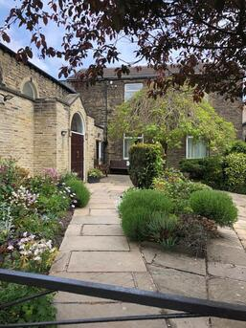Rev Sue Pegg of **Kirkheaton United Church** has been in touch with news of their work as we come out of the pandemic.

*“Let the children come to me and don’t stop them because the Kingdom of Heaven belongs to such as these” (Matthew 19:14)*

The right Christian attitude to children and the Kingdom seems be clear as Jesus rebukes his disciples who try to turn them away.

Traditionally, since the formation of its early Sunday Schools both the URC and the Methodist Church have been front runners in nurturing children in the faith. Although numbers attending on Sundays have been steadily in decline the Messy Church movement seemed to give it a welcome boost .

But then came the pandemic, or rather the post pandemic when we began to realise that after two years the babies who once came to tots group were now going to nursery and many young teens felt they’d outgrown the groups they once attended.

Online indicatives were welcomed, but for the churches I work with there still seemed to be a large hole left in the work we’d previously done.

It was the word “come” that spoke to us in the verse from scripture at the **United Church Kirkheaton** and we prayerfully asked ourselves “but where were the children Jesus wanted us to invite?” It seemed the right way forward was to make schools work a priority, but rather than going into the schools instead invite them to ‘come’ to us and make sure they felt welcome.

Much to our surprise inviting school groups for a church visit was as popular as inviting children to a party – no one turned down our invitations. And so it was that Kirkheaton Primary School decided that the whole school (in groups of 60 at a time) would love to visit The United Church. Fun times followed, we sung, did craft work, games, told Bible stories and got through an amazing amount of chocolate biscuits.

We began our schools initiative in early March and by Easter some 295 children in age appropriate ways had heard the Easter story and I suggest few will ever forget that we roll eggs because the stone rolled away on the first Easter morning.

Kirklees Council have recognised the church as a place of welcome and have awarded The United Church a **‘Schools are Welcome Certificate’** which we now proudly display on our notice board. Already we have ‘bookings’ for future visits and we look forward immensely to extending the invitation from Jesus himself to the children to ‘come, all of you are welcome’.

**Portholme Selby** really did **“Raise the Roof”** in celebration of the Queen’s Platinum Jubilee a couple of Saturdays ago. Roger Pipe tells us that the evening went really well and everyone thoroughly enjoyed the event.  As Church Treasurer he is also very pleased with the amount raised towards paying for our new roof – over £700 so far!

The event celebrated Elizabeth II’s Platinum Jubilee by singing the whole “Top Ten” of the 63 modern hymns that were nominated. They were all written over the last 70 years and the breadth of choices illustrated very clearly that not all the great hymn writers are dead! Rev Philip Macdonald introduced each of the hymns with a brief background to both the writer and the subject of the hymn.  So here are the top ten hymns (as voted by the good folk at Portholme, Selby) from 1952 to 2022:

|  |  |  |  |  |
| --- | --- | --- | --- | --- |
| **1** | **The Lord’s my Shepherd (I will trust in you alone)** |  | **1996** | **14.3%** |
| **2** | **In Christ Alone** |  | **2001** | **11.5%** |
| **3** | **Lord, the Light of your Love is Shining** |  | **1987** | **7.0%** |
| **4** | **From heaven You came (The Servant King)** |  | **1983** | **5.6%** |
| **5** | **Let us build a house where love can dwell** |  | **1994** | **5.2%** |
| **6** | **Hear the call of the kingdom** |  | **2006** | **4.5%** |
| **7** | **Give to me Lord a thankful heart** |  | **1975** | **3.1%** |
| **8** | **O God, you search me and you know me** |  | **1992** | **2.8%** |
| **9** | **Ten thousand reasons (Bless the Lord)** |  | **2011** | **2.8%** |
| **10** | **All I once held dear** |  | **1993** | **2.4%** |

Incredibly, the top ten collectively took almost 60% of the entire vote.  Despite this, there were some very popular hymns that “failed to chart” and we’ve been asked to arrange another evening to sing the “best of the rest”. If you would like to see the full chart, drop me a line at Synod Office and I’ll forward it on.

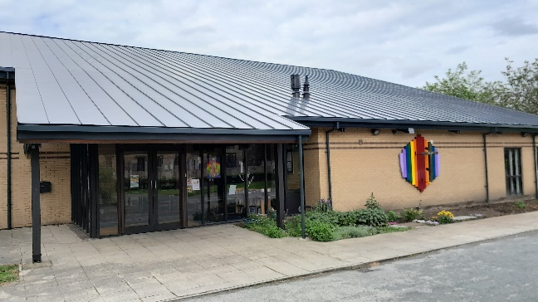Portholme are also very pleased say that the Rainbow Cross was completed just in time for Raise the Roof.  The photos show the new artwork in daylight and at dusk. Selby artist, Stephen Walker, has taken the old cross and given it a new lease of life as a brand-new artwork with pride of place on the front wall of Portholme Church. The cross now has a unique double-rainbow background and is illuminated at night by a solar powered battery pack. The rainbow symbolises both God’s promise as told in the story of Noah’s ark and that all are welcome to share in the love of Jesus.  The original roof cross itself remains unrestored; after surviving the worst of all weathers for 40 years, it symbolises the permanence and unchanging nature of God’s love.

Being a modern building, many of the people who walk past it every day have failed to recognise it as a church – I think the Rainbow Cross will go a long way to showing that Portholme Church is a place of welcome.

The best place to get further information about the event as well as the work that they have done on their roof and the repositioning of their iconic cross is on the [**Portholme Church - Methodist / URC LEP**](https://portholmechurch.org.uk/) website or on their Facebook page which can be found here [**https://www.facebook.com/selbyportholmechurch**](https://www.facebook.com/selbyportholmechurch)

**Situations Vacant**

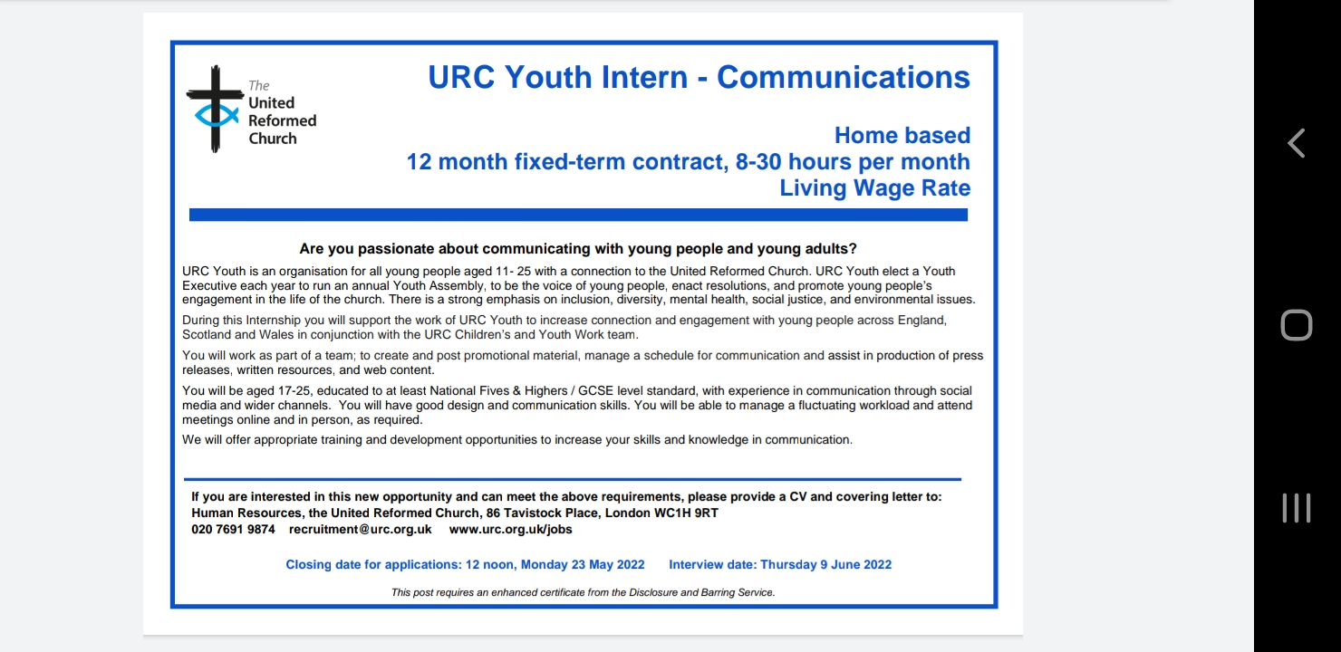We have received news of a couple of URC National vacancies, one from Mersey Synod and one from our friends in the West Yorkshire Methodist District. If you know of anyone who may be interested, please forward the details on.

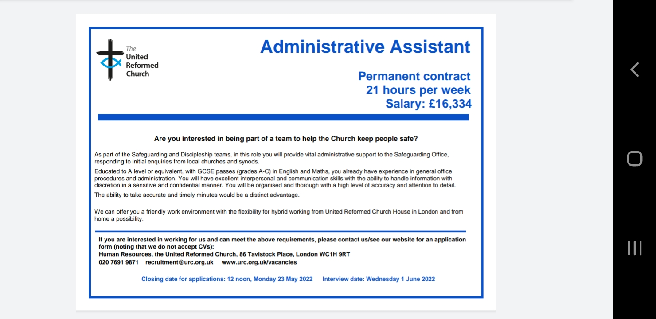You can find the job details here for the Youth Intern <https://urc.org.uk/jobs/urc-youth-intern-communications/>

And here for the Administrative Assistant (Safeguarding). <https://urc.org.uk/jobs/administrative-assistant/>

Training and Development Officer

Mersey Synod United Reformed Church

37.5 hours pw. Office based.

Salary: £37,000

Lay appointment or URC Ministers Stipend

Are you passionate about facilitating and developing the gifts and competencies of the whole people of God?

We are looking for a committed Training and Development Officer who will proactively consult, guide, advise and provide training in order to assist the development and delivery of the Mersey Synod training and development strategy.

You will also, from time to time, work with colleagues as appropriate to support the provision and delivery of training across the Northerly Synods and wider United Reformed Church.

Success in the role will require a change-orientated, creative, enthusiastic training and development practitioner. You will be able not only to deliver training but to help ministers, local churches and key post holders across the synod determine the training they need and identify the appropriate resources to meet those needs. You will also be involved in working ecumenically.

Applications are invited from lay or ordained candidates who feel that they can meet this challenging brief.

The role is based in Liverpool but regular travel around the Synod is an essential requirement.

For further information, including arranging an informal conversation with the Moderator please contact the Synod Office on 0151 722 6590.

An application pack can be accessed via the synod website [www.urcmerseysynod.org.uk](http://www.urcmerseysynod.org.uk) or by telephoning the Synod office 0151 722 6590 (noting that we do not accept CV’s) and should be returned to the Synod Clerk [synodclerk@urcmerseysynod.org.uk](mailto:synodclerk@urcmerseysynod.org.uk)

Closing date for applications: **Wednesday 1 June 2022 12 noon. Interviews on Wednesday 22 June 2022.**

**In accordance with the Equalities Act 2010 Part 1; Schedule 9, there is a genuine occupational requirement that the post holder be a Christian.**

**The post requires an enhanced DBS certificate from the Disclosure and Barring Service**

|  |
| --- |
| Are you a Leader of an Inter Faith Group -Does your Inter Faith Group face challenges?  On Saturday 11th June, the **Blackley Centre** are holding a networking morning. This will be facilitated by our **Director for Inter Faith Relations - Andy Williams** and hosted on Zoom to allow easy attendance.  This is your chance to discuss issues that matter to your group, to find solutions to problems and to meet up with friends both old and new.  To attend all you have to do is contact Peter in the office and book a space.  You can contact him on [**01422 646803**](callto:01422%20646803)or email[**admin@blackleycentre.co.uk**](mailto:admin@blackleycentre.co.uk)**. The event is free and we'll send you the zoom link in the week running up to the event** |



**The Yorkshire West Methodist District is looking to appoint an**

**Admin Assistant**

**from 3rd August 2022**

**Part time appointment, 25 hours per week**

We are seeking a part time Admin Assistant to work as part of the District Team.

This is a new post and the person appointed will be required to:

* Work under the direction of the District Administrator, dealing with office correspondence, telephone enquiries, e-mail, photocopying, collating, filing etc.
* Maintain data in line with the latest GDPR requirements.
* Take minutes at meetings, some of which may take place in an evening.
* Assist in the production and circulation of District resources.

The post will be for 25 hours per week, worked 9:30 am to 2:30 pm, Monday to Friday, based at the District Office, 4 Easby Road, Bradford, BD7 1QX

and may include occasional evening and weekend work.

The rate of pay will be £11.23 per hour,

with enrolment in the District’s NEST workplace pension scheme.

For more information and an application pack please contact the District Administrator: [admin@ywmethodist.org.uk](mailto:admin@ywmethodist.org.uk) or 01274 392628

Closing Date: Tuesday, 7th June 2022 at 10 am Interviews will take place on Monday, 20th June 2022.

................................................................................................................................................................

The Yorkshire West Methodist District came into being on 1st September 2017 and was formed from a joining together of the former West Yorkshire District and part of the previous Leeds District.

The geographical area covered by the District stretches approximately 80 miles from Ingleton in the north to Penistone in the south, and 50 miles from Todmorden in the west to Knottingley in the east.

The District is made up of a range of communities and settings, including extensive rural areas, large cities and urban towns, and smaller market towns and villages. Throughout this diverse area there are local Methodist churches of people gathering together as disciples of Jesus Christ to worship God and serve their local communities.

**Yorkshire West Methodist District** 4 Easby Road, Bradford, BD7 1QX 01274 392628

[admin@ywmethodist.org.uk](mailto:admin@ywmethodist.org.uk)

<https://www.yorkshirewestmethodist.org.uk/>

**Parish Nursing**

Following on from the presentation at March Synod, here is an opportunity to explore more of what Parish Nursing is about. Further details and booking info can be accessed via the synod website at:[**https://urcyorkshire.org.uk/event/parish-nursing-ministries-uk-introduction-online/**](https://urcyorkshire.org.uk/event/parish-nursing-ministries-uk-introduction-online/). They look forward to seeing you there.

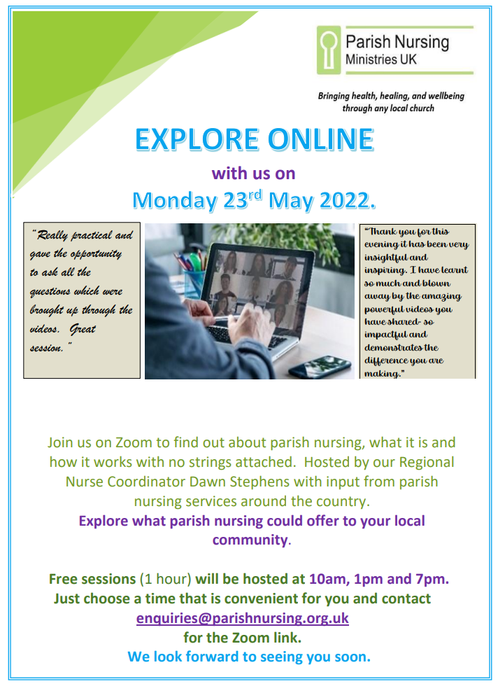

You may also be interested to read an article on our website, the first of a new series on mission, which this week is all about the Parish Nurse at Heath URC:

[**https://urcyorkshire.org.uk/our-mission-is/**](https://urcyorkshire.org.uk/our-mission-is/)



**Please don’t hide these events and resources in your inboxes or within the trees hiding your own churches’ woods. Why not send the Briefing around your own church mailing lists as these events are for everyone, member or non-member, church-goer or non-church-goer. All these activities within and beyond Synod are designed to grow the Kingdom.**

**Plans are always happening to bring more activities and good news stories to your attention, so keep an eye open for the next Briefing due on 8th June. All you need to do is get in touch with me at** [**clerk@urcyorkshire.org.uk**](mailto:clerk@urcyorkshire.org.uk)**.**

If you need any further help, be it to do with IT, finance, property or the like we are here to help.

National URC site: [**https://urc.org.uk/**](https://urc.org.uk/)Yorkshire Synod: [**https://urcyorkshire.org.uk/**](https://urcyorkshire.org.uk/) Yorkshire Synod Twitter: [**https://twitter.com/urcyorkshire**](https://twitter.com/urcyorkshire) Yorkshire Synod Facebook: [**https://www.facebook.com/urcyorkshire**](https://www.facebook.com/urcyorkshire) Yorkshire Young People’s Facebook: [**https://www.facebook.com/wildernessyorkshireurc/**](https://www.facebook.com/wildernessyorkshireurc/)

*Tim Crossley*

*Synod Clerk*