**The Briefing – Number 85**

**9th June 2022**

Dear Friends,

My apologies for confusing you this week. I know I have said that I was hoping to publish the Briefing on the first and third Thursdays in each month, but the way in which my diary has developed this Spring, I have had to change the publication dates. So, for this inaugural issue on the second Thursday I bring you lots and lots of stuff. Some has gone on the Synod website already, whilst some has more of a national emphasis and can be found on the main URC website. Nevertheless, all these events and news items are here for you, they are here to inspire, to inform and to show that the life and work of the URC in Yorkshire and beyond is bringing the Good News of Jesus Christ to everyone.

I had hoped to bring you some Pentecost/Jubilee news, but I think the deadline may have been tight so the request goes out again – Let us know what is happening where you are so that you can inspire and inform others. The next issue I hope will be going out on 23rd June so please share with us how you are sharing the Gospel, no matter how big or how small, your sharing brings more people to God.

**Disciple Development Fund**

***Yorkshire URC Synod Discipleship Development Fund***

This fund is available to encourage and support individuals within the United Reformed Church engage with a journey of developing personal discipleship. It is available for any URC member or regular URC attender of any age who is not a Minister of Word and Sacraments or Church Related Community Worker.

Yorkshire Synod Ministries Committee are pleased to share with you that grants of up to £200 are now available.

**Individuals** can apply for help with the cost of attending an approved discipleship course, activities or retreats offered by others.

**Congregations** can apply for help with the cost of buying in a speaker or other resources to facilitate in-house schemes.

Please contact Kath Lonsdale, Convenor of Yorkshire Ministries, [kathlonsdale@talktalk.net](mailto:kathlonsdale@talktalk.net) or 01274 315203 to apply for this grant.

**Also available is the following video, which was shown at the March Synod meeting, which gives an overview of what is on offer** [**https://drive.google.com/drive/folders/1bsPMiSjEbtqiTXSXuXJKOY0DCpDPm-_J**](https://drive.google.com/drive/folders/1bsPMiSjEbtqiTXSXuXJKOY0DCpDPm-_J)

**Church at the Edge**

**Thursday 9th June 1.30pm**

This is a very last minute notice if you are a busy activist, a passionate disciple, a minister, and/or engaged in community ministry. If you need a space to meet with others, to be inspired and to be open and honest about current difficulties, and to seek support from each other in living through these challenging times, then please sign up for the third series of monthly Zoom sessions, brought to you by Church Action on Poverty and the URC's 'New Reality Same Mission' group (CRCW, Church & Society, Children’s & Youth, Walking the Way).

Thursday’s session at 1.30pm will be led by **Eunice Attwood**, Church at the Margins Coordinator for the Methodist Church in conversation with an inspiring local leader, exploring what it means to be a Church at the Margins in practice.

**Sign up to receive further information and reminders for each session here** [**https://forms.gle/9kdPpVtQgy1PRqiu9**](https://forms.gle/9kdPpVtQgy1PRqiu9)

Eunice brings over twenty years’ experience of ordained diaconal ministry from a variety of contexts, including city- and town-centred ministry amongst marginalised and vulnerable communities, where she helped start and grow many fresh expressions of church. She is also one of the launch team leaders for New Inclusive Church Birmingham, a church plant started out of a deep commitment to living out the love of Jesus in practical, unexpected, and transforming ways.

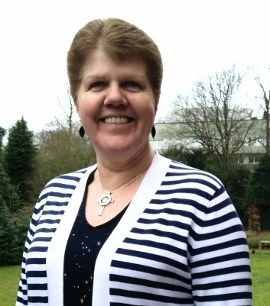**The final session of this series will be on 14th July: Poverty Truth Commission - Lucy Zwolinska**  
Lucy will reflect on her two years as facilitator of the Gateshead Poverty Truth Commission, which recently had it’s final 'celebration event'.

With best wishes,

cid:image003.png@01D86E9E.E18138A0

**Samara Andrews | Administrator (Church Related Community Work & Special Category Ministry)**

**Northern College Taster Weekend**

**Northern College** (as you might have seen in Reform) are holding a very very heavily subsidised weekend (literally, a whole weekend for £50 which is refundable if anyone takes a course in the future) which might allow people to consider candidating, or taking a course for interest, or finding out more about assembly accredited lay preachers.

It is taking place from **5.30pm on Friday 22nd July, to 2.30pm on Sunday 24th July 2022**.

Here’s a link to a video which you might find interesting and which we’d be grateful if you’d pass on as you think appropriate. [**https://northerncollege.co.uk/taster-weekend/**](https://northerncollege.co.uk/taster-weekend/)

If anyone wants to know more, please contact Rosalind Selby, the Principal of the College at [**Rosalind.selby@lutherking.ac.uk**](mailto:Rosalind.selby@lutherking.ac.uk).

**Lay Training news**

**Revd Jenny Mills**, the Secretary for Education and Learning has been in touch to highlight the news that The United Reformed Church is launching the **Newbigin Pioneering Hub** to offer a space for Pioneers to connect and learn.

This lay training course will begin in September 2022 and will be run by Seedbeds and the Church Mission Society (CMS) who have a history of offering training for Pioneering ministry. The Hub will be cited in a current and active Pioneering project at Lodge Road URC/Community Church, Birmingham. The Hub will also seek to connect current pioneers to offer and receive support and networking opportunities.

Following on from the ‘taster day’ that was held a couple of Saturdays ago, the **Newbigin Public Lecture** will be given by Cathy Ross, leader of the Pioneer Mission Leadershio Training Centre of the CMS on **Saturday 2July**. At that event we will also offer thanks and celebrate that we are establishing a Pioneering Hub in our 50th anniversary year, and focus on the possibilities, joys and dreams we have around developing lay pioneering, training and support in the URC.  This event will run from **1-4pm** at Lodge Road, URC/Community Church, Birmingham.  Register here to secure your place:  <https://www.eventbrite.co.uk/e/newbigin-annual-public-lecture-celebration-of-newbigin-pioneering-hub-tickets-333560056107>

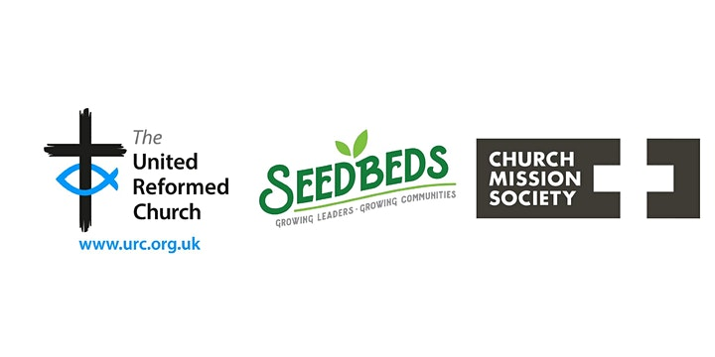

If you are interested in finding out more, please email [info@seedbeds.org](mailto:info@seedbeds.org) or contact [ministries@urc.org.uk](mailto:ministries@urc.org.uk)

**LYCiG**

The **Leading Your Church into Growth Northerly Synods’ Conference** will be taking place between 7th and 9th November at Hinsley Hall, Leeds. Each of the 5 Northerly Synods has been allocated a set number of places, but there may be more places available than first thought as one or two of the synods may not be able to fill their allocation. Keep an eye on all good URC websites and Briefing news sheets for further updates.

Looking further ahead, the URC LYCiG team are looking at doing a national LYCiG conference for the whole of the denomination. Keep June 2023 clear in your diaries…………..

And as a reminder of what the Clerk wrote on page one of the Briefing

**Free resources from Thy Kingdom Come are available, from prayer journals to a reflection on 1 Peter by Justin Welby to a booklet for children, to focus churches on prayer and invitation between Accession and Pentecost.**

[**https://www.thykingdomcome.global/**](https://www.thykingdomcome.global/)

**Children and Young Peoples News**

**Amelia Platt has become the third young person in the Yorkshire Synod to win the Lundie Memorial Award.**

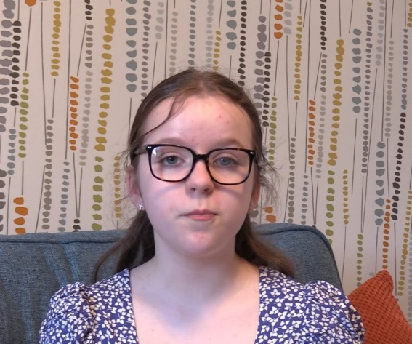Amelia, aged 11, is a committed young Christian who plays a full part in the life and mission of her church, St Andrews in Skipton. She is a talented musician and often plays her flute during Sunday worship and also takes part in readings, prayers and drama.

When the COVID pandemic started and churches were instructed to close their doors and cease all ministry happening out of their buildings, the small group of the fellowship at St Andrews began to record short daily reflections which were broadcast on the church Facebook page and YouTube channel. To see Amelia’s latest reflection click [**Morning Reflection from Amelia Platt 18th 2022 - YouTube**](https://www.youtube.com/watch?v=yj92kiQEv7g) and to have a look at all from Skipton click [**St Andrew's Church Skipton – Our Church (standrewsskipton.org.uk)**](http://standrewsskipton.org.uk/word2/), scroll down and take your pick. These reflections were shared to give hope and encouragement, to allow the church to still remain connected to one another and to share the love of God. Rev. Andrew Webb, the minister at St Andrews praised Amelia for her commitment and contribution to this team, ‘Amelia is a really valued member of the team. She was keen to volunteer and is the youngest by many years, but always has something relevant and thought provoking to share. Amelia is able to share her faith with others in a refreshing and contemporary way and her messages are really well received and appreciated.’

As a winner of The Lundie Memorial Award, Amelia will be presented with a certificate, a medal (edible!) and St Andrews will receive a £100 gift which Amelia will decide how to spend on the mission of the church in Skipton.

*If you know anyone who you would like to nominate for the Lundie Memorial Award, to recognise and celebrate the good work that children and young people are doing in their churches and communities, please click*[***here***](https://urc.org.uk/your-church/church-local-and-global/lundie-memorial-awards/)*.*

**URC Children**

July 2022 will see the launch of URC Children – the umbrella that encompasses all children and children’s groups and activities associated with the United Reformed Church.

We would like to invite you to pray for us throughout the month of July, especially on 9 July when we hope to take a group of children to General Assembly for the launch.

***Pray Like Hannah*** is a schedule of prayer prompts that can be used through July to help shape your prayers, not only for URC Children but for all children and those who support and nurture them. This is available on our website and will be shared daily through our social media.

Also on the website are the intergenerational posters we are sending out in our all-church mailing this month. One encourages your prayers for the holiday clubs which might be taking place in your church or in a nearby church over the coming months. The other encourages the beginnings of an intergenerational conversation, a prompt that your church members of all ages might use to engage in dialogue with someone from a different generation. Bridging those intergenerational gaps through conversation starters is a good way to build solid relationships and enable everybody to have their voice heard on an equal footing.

We are also offering an invitation to our online event in July “Let’s Celebrate: Children and Young People in the URC”. We would love to ‘see’ you there. Sign up at bit.ly/CYWfringe by 15 July.

Finally, if you are thinking of running a holiday club in your own church this year or working ecumenically with others to run something similar, whether for children or intergenerationally, you may be interested to look at our second book of holiday club materials which is now available on our website or by request as a digital copy. ***Timetravellers*** takes children and adults on a whirlwind journey through time to talk with children from Bible times and bring back what we learn to help us in our walk with Jesus today and in the future. It comes with video dramas, original music and a range of appendices to help you adapt for different settings. You can find it on <https://urc.org.uk/your-faith/children-young-people/children-youth-work/time-travellers/>

**The WILDERNESS Project is back for 2022.  
*Here at the Yorkshire Synod we want to see young people participating in the mission of God in their church. More than that, we want to PAY YOUNG PEOPLE to participate in the mission of God in their church.*  
We know that it can be a struggle to keep young people engaged in church life, especially when so many other things are happening in their world. Often young people around the age of 16 take part time jobs, which means we see them less. The WILDERNESS Project hopes to encourage, enable and equip young people with the support and the resource to turn a passion into a project to enrich the life of their church.   
Please contact Megan**[**here**](mailto:wilderness@urcyorkshire.org.uk?subject=The%20WILDERNESS%20Project)**for more information.**

****It’s back and ticket sales for

**THE BIG DAY OUT**

Is open and won’t close until Friday 9th September.

Please contact the synod office to book your tickets [**office@urcyorkshire.org.uk**](mailto:office@urcyorkshire.org.uk)

**0113 289 8490**

**Include your church/group, group leader (and contact email), the number of paid tickets and how many free under 3 tickets and look out for the special coach funding offer**.

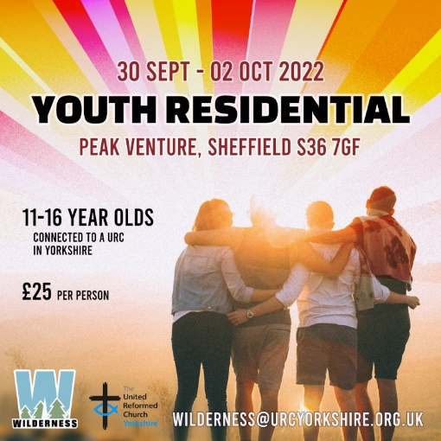The Wilderness team is also organising a couple of major events later on in the year. In July there is the Young Adults weekend for 17 to 25 year olds at the Peak Centre in Edale and at the end of September there is the Youth Residential at Peak Venture in Sheffield.

For more information on the Young Adults click here:[**https://forms.gle/MsoWGcmThbtudaE46**](https://forms.gle/MsoWGcmThbtudaE46)

For the Youth residential click here: [**https://forms.gle/xp1oYgrzG5nTHgBp9**](https://forms.gle/xp1oYgrzG5nTHgBp9)

To subscribe to the Wilderness newsletter click here [**URC Yorkshire Synod (list-manage.com)**](https://urcyorkshire.us18.list-manage.com/subscribe?u=6386cd1d52e213399865e28c0&id=911b09bcc9)

**Yorkshire Reflections**

**Since the beginning of February we have been uploading in to the ‘Worship’ section of the Synod website, a weekly reflection on a Sunday.  Thank you to all who have either already contributed or have offered a date – it is much appreciated.  If you would like to take a look, you can find the latest reflection here:** [**https://urcyorkshire.org.uk/worship/**](https://urcyorkshire.org.uk/worship/)

**If you are willing and able to have a go, do get in touch with me and we can discuss a date. We have availability and details of what is required and how to send it can be found below on the original email. I look forward to hearing from you.**

**With thanks and best wishes**

***Sally Duxbury, PA to the Moderator - Revd Jamie Kissack***

[**office@urcyorkshire.org.uk**](mailto:office@urcyorkshire.org.uk)

**Joint Public Issues Team News**

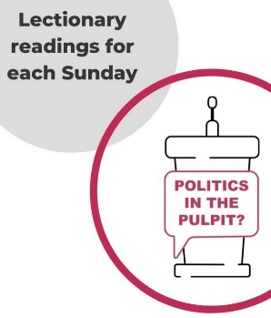**Revd Jenny Mills,** the Secretary for Education and Learning writes this as the current (new, and first URC) host for **JPIT Politics in the Pulpit podcast.** It is a weekly podcast shared through the Joint Public Issues Team (the Baptist, Methodist and United Reformed Churches working together to live out the gospel of Christ in church and society). The podcast looks at the Lectionary readings for the coming week with someone regularly engaged with preaching and who has a heart for peace and justice, also reflecting on the issues in the world and news. **JPIT can be found on Facebook- The Joint Public Issues Team or on Twitter @publicissues and online at** [**Politics in the Pulpit? | Joint Public Issues Team**](https://www.jointpublicissues.org.uk/politicsinthepulpit/)**. You can even watch Jenny hosting on YouTube** [**https://youtu.be/B2YFDAkWs2U**](https://youtu.be/B2YFDAkWs2U)

**Politics in the Pulpit** can be found on **Twitter @pulpit_politics** and the podcast can be found on Spotify, Apple Podcasts, Acast, Podbean, SoundCloud, Google Podcasts, Amazon Music/Audible, Youtube. Search ‘Politics in the Pulpit’ on your platform of choice.

Any questions, please contact Jenny at [**jenny.mills@btinternet.com**](mailto:jenny.mills@btinternet.com)

**Digital Worship Resources**

Andy Braunston, the URC’s Minister for Digital Worship is pleased to announce that the URC has a new resource for Elderships, lay preachers, and ministers as they prepare worship.  Starting from **Pentecost,** Sunday 5th June, we will have a set of notes that will help with planning worship.  The notes will contain all the prayers needed, some thoughts on the readings which could be built into a sermon, and suggestions for hymns taken from the main hymnbooks our congregations use.  Each month there will be at least one Holy Communion prayer and an Affirmation of Faith.    
  
These notes are designed to help everyone who plans worship and will be found on the URC website here [**www.urc.org.uk/worship-notes**](http://www.urc.org.uk/worship-notes)**.**  They in digital format and can be easily downloaded. They will help those who need to plan worship in a hurry, they will give refreshment to hard pressed lay preachers and ministers, and they can either be used as they are or adapted for local use.  Worship leaders might want to use some but not all of the resources. We suggest you think of them as a smorgasbord from which you can choose.    
Our first crop of writers, for services in June, include the Rev Ruth Whitehead, Moderator of the South Western Synod, the Rev Dr Susan Durber, Moderator of the Faith and Order Committee of the World Council of Churches, and the Rev Sarah Moore, Transition Champion in the Synod of Scotland.    
The notes are planned to be released at least a month before the Sundays to which they relate so as to facilitate good planning and put them on the URC website so you can always find them at short notice!  
I do hope you find them useful; we will remind people each month that they are available when we send out the PowerPoint files as well as the audio and printed versions of services.  [**You can sign up for these emails here**](http://eepurl.com/gWJ8vn)**.**

**Safeguarding Training**

**Safeguarding for Elders**

After a lot of hard work done by many people there is now a **Safeguarding for Elders** package which is being launched by Carrie Kaunda, (who is for those who may not know the safeguarding training and development co-ordinator for the denomination.)

It has been agreed that this will be launched via a webinar and at the moment there are two available dates: Tuesday 14th June 2022 at 7.30pm and Thursday 21st July 2022 at 2pm.

Each webinar lasts between 60 and 90 minutes so we would ask people to give 90 minutes to allow for questions at the end.

To book please contact Carrie direct at [**Carrie.kaunda@urc.org.uk**](mailto:Carrie.kaunda@urc.org.uk)

**Verifier Training**

Also available centrally is some Verifier Training. Carrie Kaunda, the URC’s Safeguarding Training and Development officer, has organised some new 1 hour training dates for verifiers for DBS checks. She will also provide an hour long training session after this input by DDC in relation to safer recruitment training to assist local churches in this area of safeguarding. The following dates and times are available:

12th Jul 7.00pm

10th September 10.00am

10th October 2.00pm

15th November 7.00pm

Again, please contact Carrie direct to book at [**carrie.kaunda@urc.org.uk**](mailto:carrie.kaunda@urc.org.uk)

**Church Events**

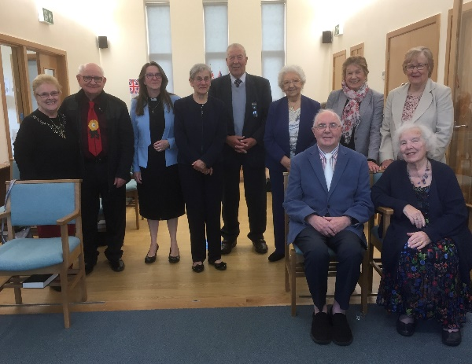On Sunday 29th May **Upper Chapel, Idle** received nine members of our church family into formal membership. They had previously worshipped at Wrose Methodist Church which unfortunately closed last year. We are delighted they have chosen Upper Chapel as their new home. Following the service we received expressions of interest in membership from two other members of the congregation. Earlier this year we also welcomed two former members of Eccleshill URC.

**KELD RESOURCE CENTRE**

**IN PARTNERSHIP WITH LOW ROW WITH KELD URC**

**NEW FOR 2022 : STUDY DAYS**

****As a new venture this year, we are offering a series of three study days. They are as follows

**Thursday July 7th**

**Revd John Proctor, Christian Witness in a Confused and Connected World (Acts 19-20)**

**Saturday August 6th**

**Revd David Wood, Seek the Ancient Paths : Old Testament Spirituality for Today**

**Thursday September 1st**

**Revd Trevor Pitt, Looking at Green Theology**

Each day will follow a similar programme

10.30 : Arrivals and Coffee

11.00 : Session One

12.30 : Lunch

13.30 : Session Two

15.00 : Refreshments and Departure

All participants are invited to bring a packed lunch and the cost for each day will be £10 per person. To book your place on any or all of the days, please contact Revd David Wood

Email address: [**david.wood4@btinternet.com**](mailto:david.wood4@btinternet.com)

We hope you will find these days stimulating and rewarding

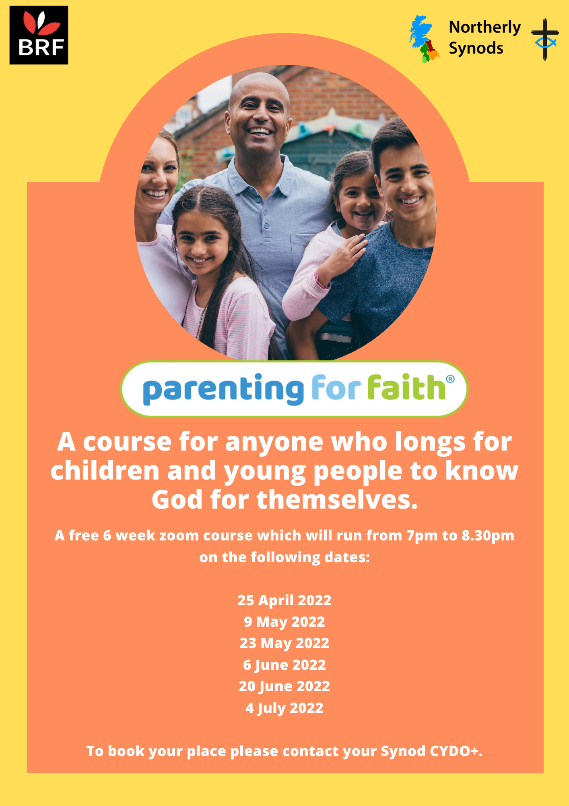

**Worshipping God Together : Apart.**

Rev Janine Atkinson’s regular services and reflections are still being uploaded to the website. As always a big thank you to Janine for these incredible resources which can be found under the ‘What we do’ drop down heading if you fancy a Yorkshire Synod Website surf or more directly at [**https://urcyorkshire.org.uk/worship/**](https://urcyorkshire.org.uk/worship/)

Finally, and perhaps emphasising my comments in pervious issues, the Briefing also keeps giving me the opportunity to ask questions of you. Currently Synod is in need of volunteers to fill vacancies on both the Property Committee and on the Financial Resources Committee. These two vital committees exist to underpin the missional work of the Synod. Without them the Synod wouldn’t have any form of effective resourcing. If you are called to serve in any way, please let either Jamie, the Synod Moderator, or myself know: give us a ring, drop us an e-mail and we will able to explore that calling with you. Synod is here to equip and support Yorkshire’s churches with the tools from and through which our missional work is done. Without these resources churches would not be able to proclaim a presence in their communities or quietly serve those who are in need. Can you offer a few hours a month, a meeting a quarter, playing a part in the mission of the URC in Yorkshire? If you feel the call to serve please drop me a line at [**clerk@urcyorkshire.org.uk**](mailto:clerk@urcyorkshire.org.uk). The roles I have mentioned here may appear to be restricted to those with specific skills, but as the ethos of the Synod is mission, we need folk who can help churches use their resources to ensure that the Gospel of Jesus Christ still rings out loud and clear from our places of worship.

**Please don’t hide these events and resources in your inboxes or within the trees hiding your own churches’ woods. Why not send the Briefing around your own church mailing lists as these events are for everyone, member or non-member, church-goer or non-church-goer. All these activities within and beyond Synod are designed to grow the Kingdom.**

**Plans are always happening to bring more activities and good news stories to your attention, so keep an eye open for the next Briefing due on 23rd June. All you need to do is get in touch with me at** [**clerk@urcyorkshire.org.uk**](mailto:clerk@urcyorkshire.org.uk)**.**

If you need any further help, be it to do with IT, finance, property or the like we are here to help.

National URC site: [**https://urc.org.uk/**](https://urc.org.uk/)Yorkshire Synod: [**https://urcyorkshire.org.uk/**](https://urcyorkshire.org.uk/) Yorkshire Synod Twitter: [**https://twitter.com/urcyorkshire**](https://twitter.com/urcyorkshire) Yorkshire Synod Facebook: [**https://www.facebook.com/urcyorkshire**](https://www.facebook.com/urcyorkshire) Yorkshire Young People’s Facebook: [**https://www.facebook.com/wildernessyorkshireurc/**](https://www.facebook.com/wildernessyorkshireurc/)

*Tim Crossley*

*Synod Clerk*