**The Briefing – Number 86**

**23rd June 2022**

|  |
| --- |
| **Month-long prayer initiative to launch for children across the URC** |

|  |
| --- |
|  |

|  |
| --- |
| Coverage BriefingURC Children, a new umbrella for children aged 0 to 12-years-old connected with the United Reformed Church (URC), is being launched in July through a new prayer initiative.  All local congregations are invited to ‘Pray like Hannah’ across the month of July for children.  Only 21% of those worshipping in local URCs are children, with more than double that number involved in other activities and groups. Children have always been important to the life of the URC, and as we celebrate our 50th anniversary, it seems timely to renew this commitment formally.  URC Children will seek to provide the support, resourcing, participation, and voice for children within the URC, and those who work with them, that URC Youth provides for young people aged 11-25.  It will do this in different, age-appropriate ways, and seeks to help the Church be more child-led in all areas. The Children’s and Youth Work team will be developing tools, training and resources to support local churches in their engagement with children.  Dr Sam Richards, Head of Children’s and Youth, said: “We want to help the whole Church to hear the voice and receive the blessing of children. URC Children will give a clear focus and identity for our youngest disciples.”  The story of Hannah is found in 1 Samuel. Hannah is the wife of Elkanah who is unable to bear a child. In her culture, this was a terrible thing – a curse, and seen to be the judgement of God. Children were vital to secure the future of the family, the tribe and the nation. It is desperation that drives Hannah to prayer. Her prayer is so passionate that Eli thinks she is drunk! Hannah prayed with devotion, fervour, intensity.  So, the first invitation is to pray passionately for children to know they are part of God’s family. It’s as simple as that. It is borne out of a deep longing and love for children and a sense of loss that they are absent from our midst.  Coverage BriefingThe URC General Assembly, meeting 8-11 July, will be asked to mark the launch of URC Children by resolving afresh to ensure that all structures and councils of the church (local church meeting, Synod and General Assembly) are consistently mindful of the voice of children and of the impact of their decisions on children and future generations.  More about Pray like Hannah can be found [**here**](https://urc.org.uk/pray-like-hannah). |

|  |
| --- |
|  |

Briefly, ***Pray Like Hannah*** is a schedule of prayer prompts that can be used through July to help shape your prayers, not only for URC Children but for all children and those who support and nurture them. This is available on our website and will be shared daily through our social media.

Also on the website are the intergenerational posters we are sending out in an all-church mailing this month. One encourages your prayers for the holiday clubs, which might be taking place in your church or in a nearby church over the coming months. The other encourages the beginnings of an intergenerational conversation, a prompt that your church members of all ages might use to engage in dialogue with someone from a different generation. Bridging those intergenerational gaps through conversation starters is a good way to build solid relationships and enable everybody to have their voice heard on an equal footing.

**LET’S CELEBRATE**

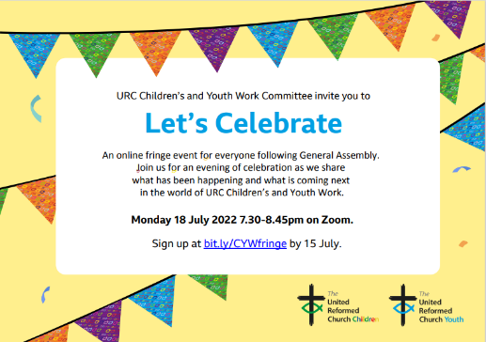We are also offering an invitation to our online event in July “Let’s Celebrate: Children and Young People in the URC”. We would love to ‘see’ you there. Sign up at bit.ly/CYWfringe by 15 July.

Finally, if you are thinking of running a holiday club in your own church this year or working ecumenically with others to run something similar, whether for children or intergenerationally, you may be interested to look at our second book of holiday club materials which is now available on our website or by request as a digital copy. ***Timetravellers*** takes children and adults on a whirlwind journey through time to talk with children from Bible times and bring back what we learn to help us in our walk with Jesus today and in the future. It comes with video dramas, original music and a range of appendices to help you adapt for different settings. You can find it on <https://urc.org.uk/your-faith/children-young-people/children-youth-work/time-travellers/>

**Children and Young Peoples News**

**The WILDERNESS Project is back for 2022.  
*Here at the Yorkshire Synod we want to see young people participating in the mission of God in their church. More than that, we want to PAY YOUNG PEOPLE to participate in the mission of God in their church.*  
We know that it can be a struggle to keep young people engaged in church life, especially when so many other things are happening in their world. Often young people around the age of 16 take part time jobs, which means we see them less. The WILDERNESS Project hopes to encourage, enable and equip young people with the support and the resource to turn a passion into a project to enrich the life of their church.   
Please contact Megan**[**here**](mailto:wilderness@urcyorkshire.org.uk?subject=The%20WILDERNESS%20Project)**for more information.**

****It’s back and ticket sales for

**THE BIG DAY OUT**

Is open and won’t close until Friday 9th September.

Please contact the synod office to book your tickets [**office@urcyorkshire.org.uk**](mailto:office@urcyorkshire.org.uk)

**0113 289 8490**

**Include your church/group, group leader (and contact email), the number of paid tickets and how many free under 4 tickets and look out for the special coach funding offer**.

**Here’s a quick reminder of what is on offer** [**https://youtu.be/Ec4zHtt0BW0**](https://youtu.be/Ec4zHtt0BW0)

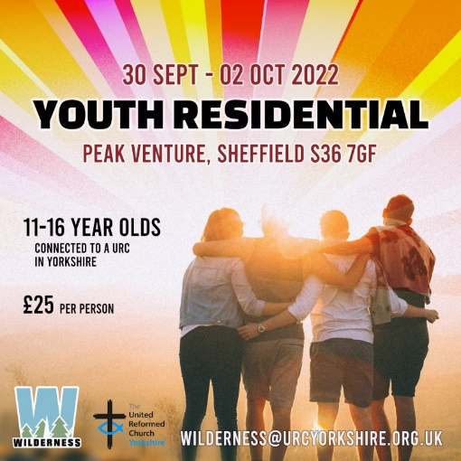The Wilderness team is also organising a couple of major events later on in the year. In July there is the Young Adults weekend for 17 to 25 year olds at the Peak Centre in Edale and at the end of September there is the Youth Residential at Peak Venture in Sheffield.

For more information on the Young Adults click here:[**https://forms.gle/MsoWGcmThbtudaE46**](https://forms.gle/MsoWGcmThbtudaE46)

For the Youth residential click here: [**https://forms.gle/xp1oYgrzG5nTHgBp9**](https://forms.gle/xp1oYgrzG5nTHgBp9)

To subscribe to the Wilderness newsletter click here [**URC Yorkshire Synod (list-manage.com)**](https://urcyorkshire.us18.list-manage.com/subscribe?u=6386cd1d52e213399865e28c0&id=911b09bcc9)

**LYCiG**

The **Leading Your Church into Growth Northerly Synods’ Conference** will be taking place between 7th and 9th November at Hinsley Hall, Leeds. Each of the 5 Northerly Synods has been allocated a set number of places, but there may be more places available than first thought as one or two of the synods may not be able to fill their allocation. Keep an eye on all good URC websites and Briefing newssheets for further updates.

Looking further ahead, the URC LYCiG team are looking at doing a national LYCiG conference for the whole of the denomination. Keep June 2023 clear in your diaries…………..

**Free resources from Thy Kingdom Come are available, from prayer journals to a reflection on 1 Peter by Justin Welby to a booklet for children, to focus churches on prayer and invitation between Accession and Pentecost.**

[**https://www.thykingdomcome.global/**](https://www.thykingdomcome.global/)

**Appreciative Conversations**

We all know it’s good to talk but it’s even better when we feel listened to and heard.

This **free one-dayworkshop** is about how, in all our conversations - in church, at work or with family, friends or neighbours - we can ensure all parties **know** they’ve been heard.



*Drawing provided by Siggy Parratt-Halbert* [*www.stinkingweasel.co.uk*](http://www.stinkingweasel.co.uk)

Come and join us

if you want to make your conversations more effective and enjoyable oryou just want to be re-energised and resourced!

**Saturday 16th July 2022 - 10am - 4 pm at Yorkshire Synod Office**

Led by Emmanuelle Bastide-Wilson & Jenny Poulter

*Refreshments & lunch will be provided and travel expenses can be claimed*

For more info or to book please contact Emmanuelle:

[**embastide@icloud.com**](mailto:embastide@icloud.com) or 07941 923 420



<https://urcyorkshire.org.uk/what-is-a-fresh-expression-or-pioneer-mission/>

**Lay Training news**

**Revd Jenny Mills**, the Secretary for Education and Learning has been in touch to highlight the news that The United Reformed Church is launching the **Newbigin Pioneering Hub** to offer a space for Pioneers to connect and learn.

This lay training course will begin in September 2022 and will be run by Seedbeds and the Church Mission Society (CMS) who have a history of offering training for Pioneering ministry. The Hub will be cited in a current and active Pioneering project at Lodge Road URC/Community Church, Birmingham. The Hub will also seek to connect current pioneers to offer and receive support and networking opportunities.

Following on from the ‘taster day’ that was held a couple of Saturdays ago, the **Newbigin Public Lecture** will be given by Cathy Ross, leader of the Pioneer Mission Leadershio Training Centre of the CMS on **Saturday 2July**. At that event we will also offer thanks and celebrate that we are establishing a Pioneering Hub in our 50th anniversary year, and focus on the possibilities, joys and dreams we have around developing lay pioneering, training and support in the URC.  This event will run from **1-4pm** at Lodge Road, URC/Community Church, Birmingham.  Register here to secure your place:  <https://www.eventbrite.co.uk/e/newbigin-annual-public-lecture-celebration-of-newbigin-pioneering-hub-tickets-333560056107>

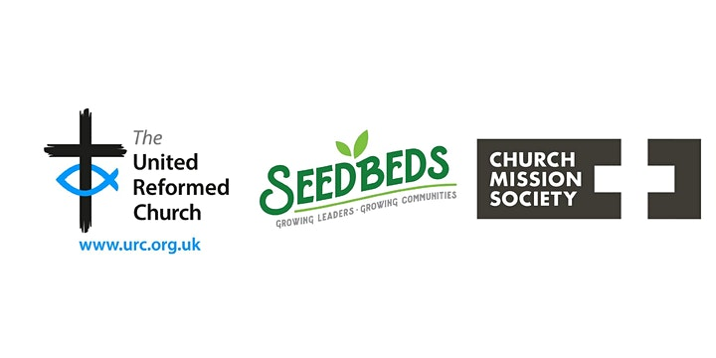

If you are interested in finding out more, please email [info@seedbeds.org](mailto:info@seedbeds.org) or contact [ministries@urc.org.uk](mailto:ministries@urc.org.uk)

**Disciple Development Fund**

***Yorkshire URC Synod Discipleship Development Fund***

This fund is available to encourage and support individuals within the United Reformed Church engage with a journey of developing personal discipleship. It is available for any URC member or regular URC attender of any age who is not a Minister of Word and Sacraments or Church Related Community Worker.

Yorkshire Synod Ministries Committee are pleased to share with you that grants of up to £200 are now available.

**Individuals** can apply for help with the cost of attending an approved discipleship course, activities or retreats offered by others.

**Congregations** can apply for help with the cost of buying in a speaker or other resources to facilitate in-house schemes.

Please contact Kath Lonsdale, Convenor of Yorkshire Ministries, [kathlonsdale@talktalk.net](mailto:kathlonsdale@talktalk.net) or 01274 315203 to apply for this grant.

**Still available is the following video, which was shown at the March Synod meeting, which gives an overview of what is on offer** [**https://drive.google.com/drive/folders/1bsPMiSjEbtqiTXSXuXJKOY0DCpDPm-_J**](https://drive.google.com/drive/folders/1bsPMiSjEbtqiTXSXuXJKOY0DCpDPm-_J)

However, the Large Grants window is about to close

Deadline for Discipleship Development Fund Large Grant Award applications

Dear Synod Moderators, Synod Clerks and RCL Principals

Please get the word out that the deadline for submitting applications for the Discipleship Development Fund Large Grant Award (up to £5,000) is 30 June.

Grants can be put towards any purpose that will contribute to the Discipleship Development of lay people in or connected with the URC including personnel costs, facilities, travel, courses etc.  
[**https://urc.org.uk/education-learning/discipleship-development/discipleship-development-fund/**](https://urc.org.uk/education-learning/discipleship-development/discipleship-development-fund/)

**Northern College Taster Weekend**

**Northern College** (as you might have seen in Reform) are holding a very heavily subsidised weekend (literally, a whole weekend for £50 which is refundable if anyone takes a course in the future) which might allow people to consider candidating, or taking a course for interest, or finding out more about assembly accredited lay preachers.

It is taking place from **5.30pm on Friday 22nd July, to 2.30pm on Sunday 24th July 2022**.

Here’s a link to a video which you might find interesting and which we’d be grateful if you’d pass on as you think appropriate. [**https://northerncollege.co.uk/taster-weekend/**](https://northerncollege.co.uk/taster-weekend/)

 If anyone wants to know more, please contact Rosalind Selby, the Principal of the College at [**Rosalind.selby@lutherking.ac.uk**](mailto:Rosalind.selby@lutherking.ac.uk).

**Joint Public Issues Team News**

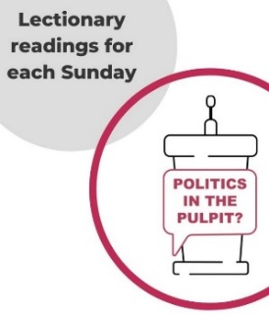**Revd Jenny Mills,** the Secretary for Education and Learning writes this as the current (new, and first URC) host for **JPIT Politics in the Pulpit podcast.** It is a weekly podcast shared through the Joint Public Issues Team (the Baptist, Methodist and United Reformed Churches working together to live out the gospel of Christ in church and society). The podcast looks at the Lectionary readings for the coming week with someone regularly engaged with preaching and who has a heart for peace and justice, also reflecting on the issues in the world and news. **JPIT can be found on Facebook- The Joint Public Issues Team or on Twitter @publicissues & @pulpit_politics** **and online at** [**Politics in the Pulpit? | Joint Public Issues Team**](https://www.jointpublicissues.org.uk/politicsinthepulpit/)**. You can even watch Jenny hosting on YouTube** [**https://youtu.be/B2YFDAkWs2U**](https://youtu.be/B2YFDAkWs2U)**.**

Any questions, please contact Jenny at [**jenny.mills@btinternet.com**](mailto:jenny.mills@btinternet.com)

**Worship Resources**

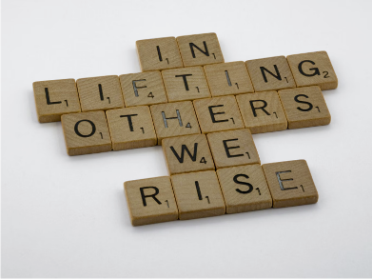The URC’s new **Worship Notes** initiative is now up and running. They are designed to help everyone who plans worship and will be found on the URC website here [**www.urc.org.uk/worship-notes**](http://www.urc.org.uk/worship-notes)**.**  They are in digital format and can be easily downloaded. They will help those who need to plan worship in a hurry, they will give refreshment to hard pressed Elders, Lay preachers and Ministers, and they can either be used as they are or adapted for local use.

The notes are planned to be released at least a month before the Sundays to which they relate so as to facilitate good planning and put them on the URC website so you can always find them at short notice!  
To find out more visit [**www.urc.org.uk/worship-notes**](http://www.urc.org.uk/worship-notes) and to get reminders each month [**You can sign up for these emails here**](http://eepurl.com/gWJ8vn)**.**

**Mission Committee**

The Synod is on the hunt for a volunteer to take on the role of Yorkshire Synod’s representative on the national Mission Committee. Usually the call for a volunteer to take on this role coincides with our bi-annual Synod meetings. However, our current representative is heading to pastures new over the summer and the next meeting is to be a 24-hour residential meeting (lunch to lunch) on 22-23 September at the Focolare Centre, Welwyn Garden City.

The areas the committee deals with is wide ranging. They are interested in mission, evangelism, missional discipleship, global and intercultural ministries (including commitment for life), church and society, ecumenical and interfaith relations, fresh expressions and pioneering. While they would welcome people with an interest in all of it, they realise this is too ambitious, so if anyone would have a particular interest in one of these areas that would be fine too. Currently, the area the least represented in our members is probably that of *ecumenical and interfaith relations*. The main thing, however, is that the people who sit on the committee are willing to be liaisons between the synod. Finally, in terms of balance on the committee, women, Black and minority ethnic people and younger people are definitely underrepresented.

I hope this helps in creating a spark within you to take on this role, or to identifying someone who would be willing to take this on and I look forward to hearing from you soon at [clerk@urcyorkshire.org.uk](mailto:clerk@urcyorkshire.org.uk).

**Safeguarding Training**

**Safeguarding for Elders**

After a lot of hard work done by many people there is now a **Safeguarding for Elders** package which is being launched by Carrie Kaunda, (who is for those who may not know the safeguarding training and development co-ordinator for the denomination.)

It has been agreed that this will be launched via a webinar which will be approximately 90 minutes long, and at the moment there now only one available date: Thursday 21st July 2022 at 2pm.

To book please contact Carrie direct at [**Carrie.kaunda@urc.org.uk**](mailto:Carrie.kaunda@urc.org.uk)

**Verifier Training**

Also available centrally is some Verifier Training. Carrie Kaunda, the URC’s Safeguarding Training and Development officer, has organised some new 1 hour training dates for verifiers for DBS checks. The following dates and times are available:

12th Jul 7.00pm

10th September 10.00am

10th October 2.00pm

15th November 7.00pm

Again, please contact Carrie direct to book at [**carrie.kaunda@urc.org.uk**](mailto:carrie.kaunda@urc.org.uk)

**Church Events**

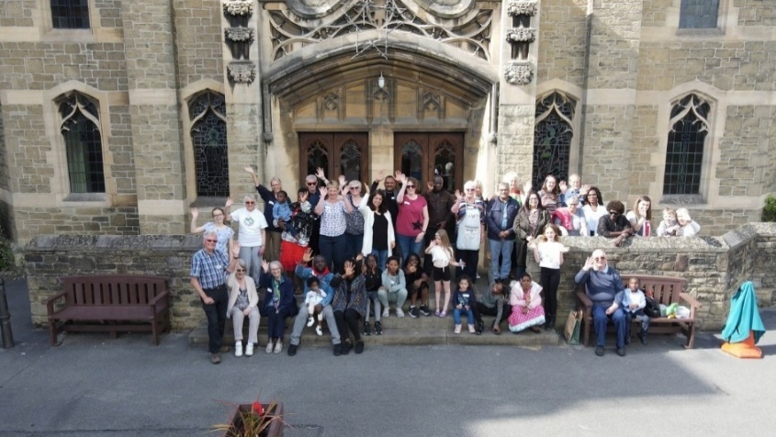**Lancashire’s DARE (Darwen Asylum seekers and Refugee Enterprise) visit St Andrew’s, Skipton, at the start of Refugee Week.**

On Sunday 19th June 2022, **St Andrew’s Skipton** in conjunction with the Skipton Refugee Support Group hosted a visit of members of DARE (Darwen Asylum seekers and Refugee Enterprise) led by North-Western Synod Mission Enabler, Rev Daleen ten Cate and Lay Leader, John East. Daleen and John led the morning worship and the whole group then had lunch at St Andrew’s, wandered around the town and then joined in with the regulars at St Andrew’s Messy Church event during the afternoon.

Negin, one of the refugees who attended the day wrote the following:

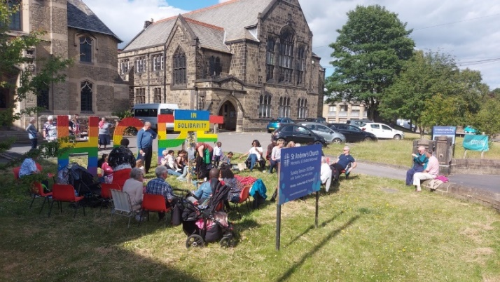“*We had a great time during our visit to St. Andrew’s Church in Skipton. From the minute we were picked up from our doorstep to the moment we were dropped off, every effort was made to make us feel valued. We were welcomed warmly by the people at St Andrew’s and I was amazed by their kindness and hospitality. We had the opportunity to represent the refugees, enjoy a nice meal and have a lovely walk in the woods. The children had a wonderful time at the messy church and the picnic in the end of our visit was great! I want to thank all the people at DARE.  We appreciate all that you do for us. I pray that one day we could do what you’re doing for us for other asylum seekers and refugees.*”

During Refugee week the group will be heading to Broadrake, near Ingleton, for a short holiday, this time being looked after by the Yorkshire Dales Millennium Trust, whose Project Officer, Judy Rogers is a member at St Andrew’s. More information on the trip to the dales is here [Refugee Week brings healing across the Dales (ydmt.org)](https://www.ydmt.org/news/refugee-week-2022) whilst the service at St Andrews is here <https://www.youtube.com/watch?v=xaI5gMzzjjo>.

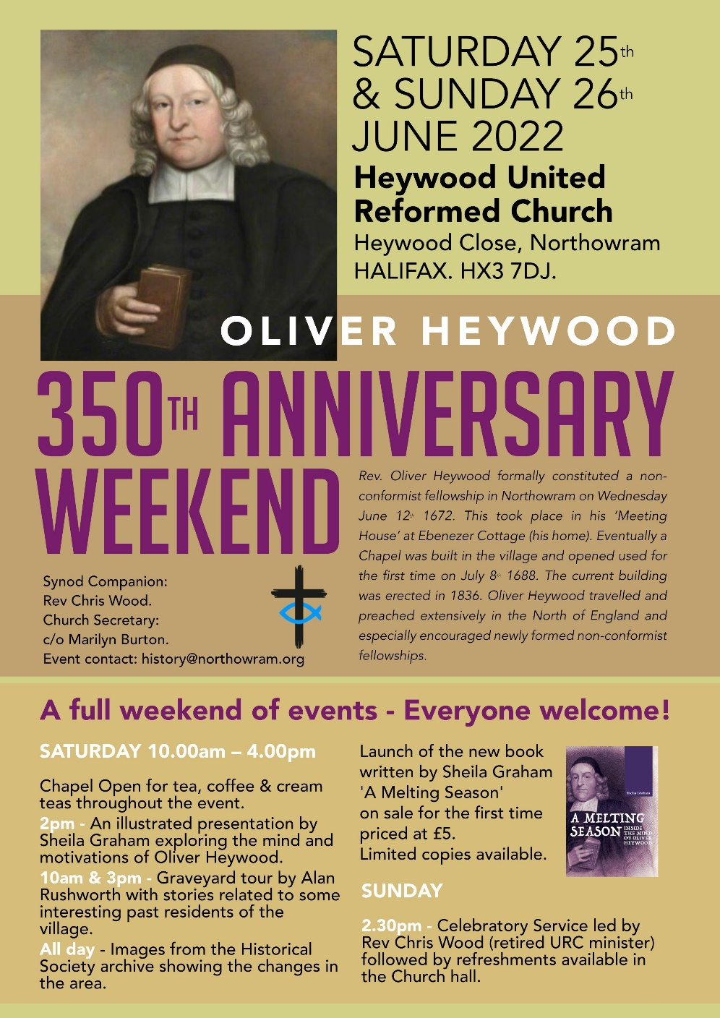**Heywood URC, Northowram**, is celebrating the 350th Anniversary of the founding of a non-conformist fellowship in Northowram this month. It was established by Rev Oliver Heywood following his ejection from the nearby Coley Church for refusing to use the Common Book of Prayer. During the 1660's he was persecuted by the authorities, forbidden from holding services (this didn't stop him!) and spent some time in prison at York for his stance. It was after the relaxing of certain Laws that he first established his fellowship in his own home, later building a Chapel. The pulpit he had built in those early years, which was constructed in a way that it would fit underneath the staircase in case the authorities came calling, is one of the many artifacts that are within the current building, although repaired and slightly altered over the years.

The weekend of **25th and 26th June** has been earmarked for various events, including an Open Day on Saturday and a celebratory service on Sunday afternoon.

A book has also been produced and published by the Northowram Historic Society. The author will speak over the weekend, and her book will be available to purchase. Also a summary of his life and mission is available either via me at Synod Office through Rev Chris Wood, the Heywood URC Synod Companion.

Oliver Heywood made a significant contribution to fledgling congregations in the North over his lifetime, travelling 1,000 plus miles each year on horseback to support and encourage the development of non-conformist fellowships, many of whom had suffered for their beliefs. He was definitely a Pioneer Minister very much into 'Missional Outreach so take the time to get to know this founding father of local non-conformity and join in with Heywood URC, Northowram’s own jubilee celebrations.

**KELD RESOURCE CENTRE**

**IN PARTNERSHIP WITH LOW ROW WITH KELD URC**

**NEW FOR 2022 : STUDY DAYS**

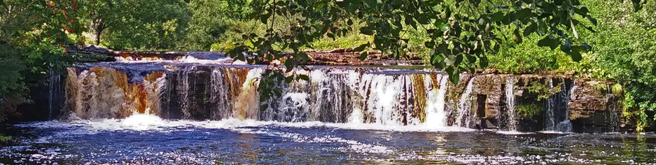As a new venture this year, we are offering a series of three study days. They are as follows

**Thursday July 7th: Revd John Proctor, Christian Witness in a Confused and Connected World (Acts 19-20)**

**Saturday August 6th: Revd David Wood, Seek the Ancient Paths : Old Testament Spirituality for Today**

**Thursday September 1st: Revd Trevor Pitt, Looking at Green Theology**

Each day will follow a similar programme

10.30 : Arrivals and Coffee

11.00 : Session One

12.30 : Lunch

13.30 : Session Two

15.00 : Refreshments and Departure

All participants are invited to bring a packed lunch and the cost for each day will be £10 per person. To book your place on any or all of the days, please contact Revd David Wood

Email address: [**david.wood4@btinternet.com**](mailto:david.wood4@btinternet.com)

We hope you will find these days stimulating and rewarding

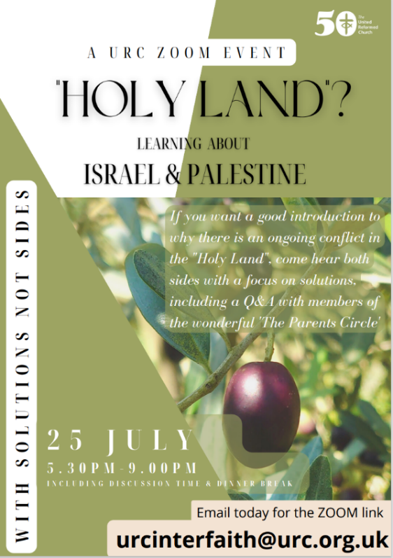If you know someone who is maybe at the start of their journey to understanding the situation in Israel and Palestine or could be interested in a wider perspective, **please invite them to this webinar**.

Working together with [Solutions Not Sides](https://solutionsnotsides.co.uk/), the Church House Mission Team is offering this introductory webinar for anyone who wishes to be better informed and have a deeper understanding of the issues in the Holy Land.

It would be great if you could offer specific, personal invitations as well as emailing to your networks – we want to encourage as many people as possible to benefit from a better understanding of these complex issues.

If you have any queries please do not hesitate to contact Carole Sired of the Mission and Ecumenical & Interfaith Relations team on 020 7916 2020 or by e-mail at [ecumenical@urc.org.uk](mailto:ecumenical@urc.org.uk).

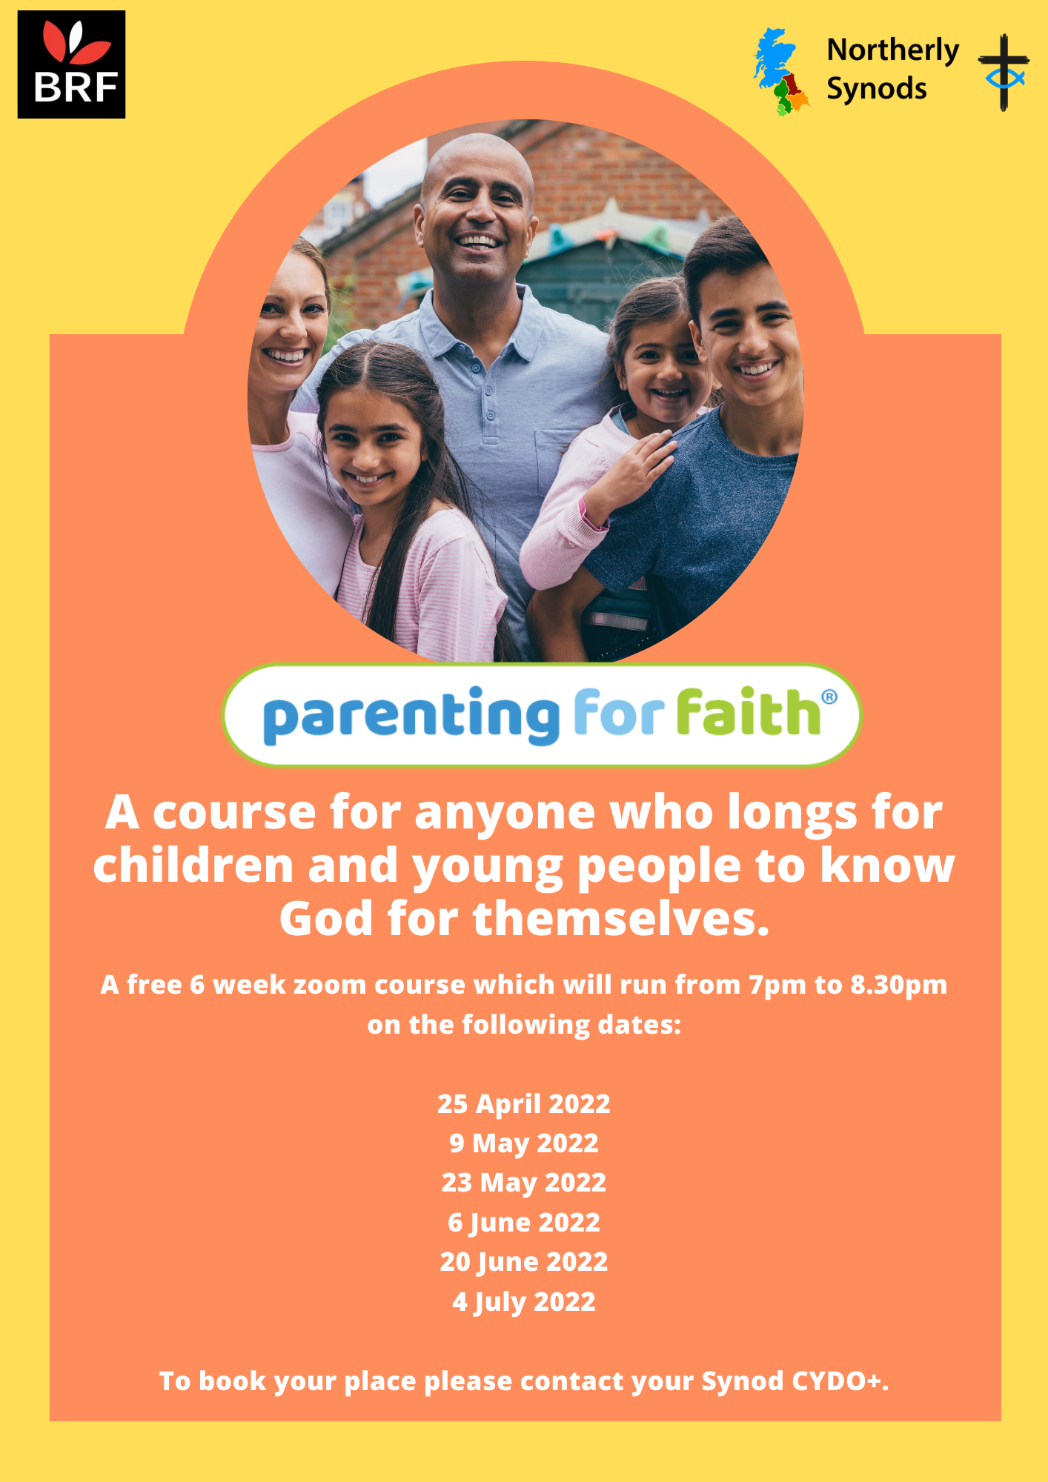

Dear Friends,

I make no apologies for changing things around this issue, My words are coming at the end as I want you concentrate on the words of prayer and praise, of hope and teaching, of listening and learning which are being offered throughout Yorkshire Synod. The Briefing begun in the Spring of 2020 as a means of getting news regarding the ever-changing regulations of the Covid-19 pandemic. As we move from that time into a new period in the Church’s life, the focus of the Briefing has changed. It has gone fortnightly, has become a general noticeboard for the Synod and I hope a pointer to what we all can do as disciples of Jesus.

However, the times, they are a changing (as someone once sung…..). To develop this resource further I would like to gather feedback as to how you would like to receive local and national information, how you use The Briefing, whether it is distributed to all of your congregations, or if it is of no use to you at all. There are other sources of Synod news – the website at [**Home - URC Yorkshire Synod**](https://urcyorkshire.org.uk/), the facebook pages at [**United Reformed Church in Yorkshire - Home | Facebook**](https://www.facebook.com/urcyorkshire) and [**Wilderness URC Yorkshire - Home | Facebook**](https://www.facebook.com/wildernessyorkshireurc/), the YouTube page at [**URC Yorkshire - YouTube**](https://www.youtube.com/channel/UCSAly5eC6tBlmY52dLxrylg) and the Twitter page at [**URC in Yorkshire (@URCYorkshire) / Twitter**](https://twitter.com/URCYorkshire). Each of these resources are used in a different way and it would be great to see whether you use these in conjunction with The Briefing or rely on only one resource centre. I look forward to hearing from you all via [**clerk@urcyorkshire.org.uk**](mailto:clerk@urcyorkshire.org.uk).

Finally, and in addition to my request above for a new Synod representative to the national Missions Committee the Synod is in desperate need of volunteers to fill vacancies on some key Committees, especially Property and Financial Resources. These two vital committees exist to underpin the missional work of the Synod. Without them the Synod wouldn’t have any form of effective resourcing to proclaim a presence in their communities or quietly serve those who are in need. If you are called to serve in any way, please let either Jamie, the Synod Moderator, or myself know: give us a ring, drop us an e-mail and we will able to explore that calling with you. Synod is here to equip and support Yorkshire’s churches with the tools from and through which our missional work is done. Can you offer a few hours a month, a meeting a quarter, playing a part in the mission of the URC in Yorkshire? If so please drop me a line at [**clerk@urcyorkshire.org.uk**](mailto:clerk@urcyorkshire.org.uk). The roles I have mentioned here may appear to be restricted to those with specific skills, but as the ethos of the Synod is mission, we need folk who can help churches use their resources to ensure that the Gospel of Jesus Christ still rings out loud and clear from our places of worship.

**Please don’t hide these events and resources in your inboxes or within the trees hiding your own churches’ woods. Why not send the Briefing around your own church mailing lists as these events are for everyone, member or non-member, church-goer or non-church-goer. All these activities within and beyond Synod are designed to grow the Kingdom.**

**Plans are always happening to bring more activities and good news stories to your attention, so keep an eye open for the next Briefing due on 7th July. All you need to do is get in touch with me at** [**clerk@urcyorkshire.org.uk**](mailto:clerk@urcyorkshire.org.uk)**.**

*Tim Crossley*

*Synod Clerk*