**The Briefing – Number 88**

**21st July 2022**

|  |
| --- |
| I am extremely grateful to Helen Owen of West Melton URC for sending in this picture. It is a sunflower she grew in her garden from one of the seeds that were given out at the Synod meeting last March in Skipton. I hope that Helen’s endeavours were equalled around the Synod, and you may even be in for a treat as even the Synod Clerk has managed to get one of the seeds to grow. Watch this space….  Watch this space as well for other things that you have been doing through the summer. This time of the year seems many churches hosting Holiday Clubs, Youth Events and Outdoor Services. Please drop me a line and a picture so that we can celebrate with you, and maybe even borrow some of your ideas.  **Clerk’s Comments**  I’m happy to say that I survived General Assembly. Moreover I enjoyed it and I think that it fair to say that all sixteen of us who went there representing you found it a fulfilling, prayerful, inclusive and enjoyable experience. There is a great deal to bring back to you all from General Assembly and we are working on a plan as to how best to ensure that you don’t miss out on the many opportunities to share in what the URC is doing at a national, Synod and church level. The overall proceedings can be found at the dedicated [**General Assembly papers - United Reformed Church**](https://urc.org.uk/general-assembly-assembly-executive-assembly-committees/general-assembly/general-assembly-papers/) and in particular via the Assembly Business Digest [**Assembly-Business-Digest-2022.docx (live.com)**](https://view.officeapps.live.com/op/view.aspx?src=https%3A%2F%2Furc.org.uk%2Fwp-content%2Fuploads%2F2022%2F07%2FAssembly-Business-Digest-2022.docx&wdOrigin=BROWSELINK) & [**Assembly-Business-Digest-2022.pdf (urc.org.uk)**](https://urc.org.uk/wp-content/uploads/2022/07/Assembly-Business-Digest-2022.pdf).  It was good to hear the URC affirming their support for Local Ecumenical Partnerships, especially for us in Yorkshire, as nearly a quarter of our churches are LEP’s. As important is the URC’s affirmative action towards being an Anti-Racist Church and the heartfelt confession and apology for the role of its antecedents in transatlantic slavery and its continuing complicity in the legacies of the trade today. Actioning this statement will be hard, but it will have a positive impact on us all. It proclaims Jubilee, and we need to take this, the URC’s and the Bible’s Jubilee stories out to our churches and beyond. The launch of URC Children will be at the forefront of Yorkshire’s own Children and Youth provision in the coming months. New resources are to be made available and to have 5 of the 16 representatives under the age of 26 shows that we are committed to the future.  Space is at a premium here, but as the summer progresses I hope to be able to bring you more on the Lay Pioneer initiative and the [**Newbigin Pioneering Hub - United Reformed Church**](https://urc.org.uk/your-faith/more-about-ministry/newbigin-pioneering-hub/). As well as this there will be more on the Church Life Review, Mental Health First Aid Training and the denomination’s Environmental policy. All these things are being done to help churches grow, to help churches be part of their communities and to help all of us be more missional in our life.  **Church Events and News**  Now you will all know that I am not biased in any way, shape or form to a certain church in the town that calls itself “the Gateway to the Dales”, but…………..  **St Andrew’s Church, Skipton** has won one of the three Community Project Awards, sponsored by Congregational Insurance for its Wellbeing Café that offers support to people with mental health conditions and was set up after a local mental health group lost their funding. It was great to see Rachel Coombes and Judith Duxbury receive the award from Margaret Slater of Congregational Insurance on behalf of the Wellbeing Café and St Andrew’s and I think they enjoyed the day trip to The Hayes at Swanwick as well. A video was made explaining what the café is all about and you can see it here [**https://youtu.be/C_dPBSwJUEM**](https://youtu.be/C_dPBSwJUEM)**.**  The second winner was the Community Uniform Swap Shop, at St Columba’s URC, Wolverhampton that allows parents and students at 58 schools to exchange second-hand uniforms and keeps records of the environmental savings made. The third winner was Roker Life, at Roker United Reformed Church who through working with local partners offers activities, such as cookery training, for refugee family and isolated adults in the area. Two other projects were highly commended and invited to apply for the award again in the future. They were the WestCan Show Choir, at Westfield and Cannington URCs, Bridgwater , and the Dulwich Grove Community Lunch, at Dulwich Grove URC.  To look at all the projects, follow this link [**Community Project Awards - United Reformed Church**](https://urc.org.uk/your-church/church-local-and-global/community-project-awards/#:~:text=The%20Community%20Project%20Awards%20is%20an%20initiative%20run,The%20winning%20project%20can%20receive%20up%20to%20%C2%A32%2C000.)  You can enter your church-based community project for the 2023 Awards from November. If you are interested please get in touch with me at [**clerk@urcyorkshire.org.uk**](mailto:clerk@urcyorkshire.org.uk)or keep an eye on the URC and the Congregational Insurance websites.  **Lay Training news**  As mentioned at General Assemblythe **Newbigin Pioneering Hub** is up and running with to offer a space for Pioneers to connect and learn. The first of these lay training courses will begin in September 2022 and will be run by Seedbeds and the Church Mission Society (CMS). The Hub will be cited in a current and active Pioneering project at Lodge Road URC/Community Church, Birmingham.  Taster Day: Newbigin Pioneering Hub, Birmingham image  If you are interested in finding out more, please email [info@seedbeds.org](mailto:info@seedbeds.org) or contact [ministries@urc.org.uk](mailto:ministries@urc.org.uk)  **Children and Young Peoples News**  **Month-long prayer initiative to launch for children across the URC** |

|  |
| --- |
|  |

|  |
| --- |
| Coverage BriefingAs many of you will now have heard, URC Children, a new umbrella for children aged 0 to 12-years-old connected with the United Reformed Church (URC), has been launched this month through a new prayer initiative.  Coverage BriefingAll local congregations are invited to ‘Pray like Hannah’ across the month of July for children. Children have always been important to the life of the URC, and as we celebrate our 50th anniversary, it seems timely to renew this commitment formally.  The URC General Assembly on 10th July marked the launch of URC Children by resolving to ensure that all structures and councils of the church (local church meeting, Synod and General Assembly) are consistently mindful of the voice of children and of the impact of their decisions on children and future generations.  More about Pray like Hannah can be found [**here**](https://urc.org.uk/pray-like-hannah). |

|  |
| --- |
|  |

Finally, if you are thinking of running a holiday club in your own church this year or working ecumenically with others to run something similar, whether for children or intergenerationally, you may be interested to look at our second book of holiday club materials which is now available on our website or by request as a digital copy. ***Timetravellers*** takes children and adults on a whirlwind journey through time to talk with children from Bible times and bring back what we learn to help us in our walk with Jesus today and in the future. It comes with video dramas, original music and a range of appendices to help you adapt for different settings. You can find it on <https://urc.org.uk/your-faith/children-young-people/children-youth-work/time-travellers/>

**THE BIG DAY OUT**

Ticket sales are open and will not close until Friday 9th September.

Please contact the synod office to book your tickets [**office@urcyorkshire.org.uk**](mailto:office@urcyorkshire.org.uk)

**0113 289 8490**

**Include your church/group, group leader (and contact email), the number of paid tickets and how many free under 4 tickets and look out for the special coach funding offer**.

**Here’s a quick reminder of what is on offer** [**https://youtu.be/Ec4zHtt0BW0**](https://youtu.be/Ec4zHtt0BW0)

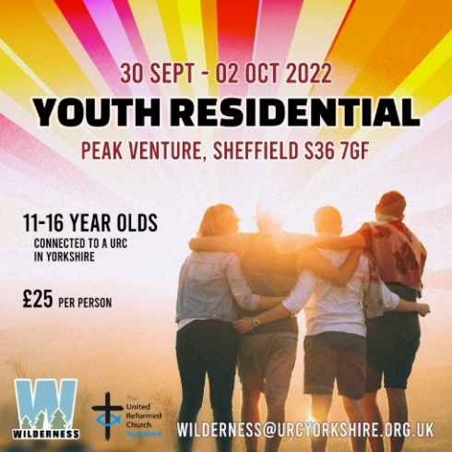

The Wilderness team is organising a YOUTH RESIDENTIAL at the end of September. This will be at Peak Venture in Sheffield and details of how to book can be found here: [**https://forms.gle/xp1oYgrzG5nTHgBp9**](https://forms.gle/xp1oYgrzG5nTHgBp9)

To subscribe to the Wilderness newsletter click here [**URC Yorkshire Synod (list-manage.com)**](https://urcyorkshire.us18.list-manage.com/subscribe?u=6386cd1d52e213399865e28c0&id=911b09bcc9)

**LYCiG**

The **Leading Your Church into Growth Northerly Synods’ Conference** will be taking place between 7th and 9th November at Hinsley Hall, Leeds. Each of the 5 Northerly Synods has been allocated a set number of places, but there may be more places available than first thought as one or two of the synods may not be able to fill their allocation. Keep an eye on all good URC websites and Briefing newssheets for further updates.

Looking further ahead, the URC LYCiG team are looking at doing a national LYCiG conference for the whole of the denomination. Keep June 2023 clear in your diaries…………..

**National News**

**Come to church at Greenbelt**

The URC turns 50 this year and we’re having a special service at Greenbelt to celebrate! Come to church at Greenbelt on **Sunday 28 August**, which will begin with one of the largest and most memorable communion services you’ve ever been part of, listen to superb music from Guvna B and Martyn Joseph, and join us for a special 50th birthday party that reflects the rich diversity of the URC.

Throughout the bank holiday weekend, there is a full programme running in the new café which challenges and inspires, equips, and entertains.

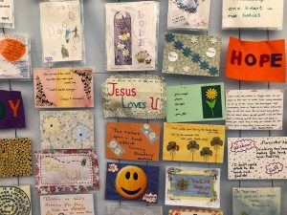Worship, discussion, music, bedtime stories and superb crafts on our theme of ‘Revolting Christians’ combine with great coffee and tea, delicious treats and affordable meals. All this plus the adventurous and epic Greenbelt programme means that this will be an unforgettable time for everyone who comes. For more information, head over to our URC@Greenbelt page: [**https://urc.org.uk/greenbelt/**](https://urc.org.uk/greenbelt/)

**Calling all Black and Ethnic Minority Members (& Friends) of the United Reformed Church…**

**Weaving the Tapestry**

As part of the URC’s Jubilee celebrations, we want to showcase the rich and vibrant contributions of Black and ethnic minority people to the tapestry that is our Church story.

We are putting together a publication to share our reflections, our prayers, our poems, our pictures (photos and artwork) - in short, our contributions to 50 years of the United Reformed Church. However, we need your input…

Do you have a story to share about how you come to be part of the United Reformed Church… the role(s) you have played to make your local or wider church a more diverse and welcoming fellowship… reflections on the URC’s journey towards being a more inclusive body? Have you written (or will you write) a prayer or poem, or song - either inspired in some way by being part of the URC, or which might be offered as a resource to be used by the URC?

Do you have Black and ethnic minority children and young people in your local congregation… and could they share an image – in words or pictures - of the church of which they dream?

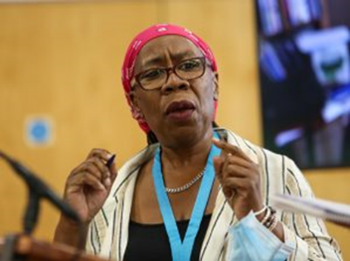Revd George Kalu and Karen Campbell (pictured) would love to hear from you (…or maybe you can think of someone else who needs a little nudge to get them to contribute!)

**We need all contributions by Monday 1st August**.

We may not be able to include everything, but we will read/consider all submissions and let you know by the end of August which contributions we are able to use.

Submissions should be sent to: [**publishing@urc.org.uk**](mailto:publishing@urc.org.uk) including your name (or the name of the author/artist) and your Synod.

Get your creative hats on, and let’s start weaving.

**The UK Shared Prosperity Fund (UK)**

The Department for Levelling Up, Housing & Communities has launched the £2.6 billion [UK Shared Prosperity Fund](https://www.gov.uk/government/publications/uk-shared-prosperity-fund-prospectus), which aims to level up all parts of the United Kingdom. All areas of the UK will be receiving an allocation from the Fund The spending of the Fund at a local level will be planned and delivered by councils and mayoral authorities.

The Fund will support the UK government’s wider commitment to level up all parts of the UK by delivering on each of the levelling up objectives, most significantly for churches these include:

1. Restore a sense of community, local pride and belonging, especially in those places where they have been lost
2. Empower local leaders and communities, especially in those places lacking local agency

Timeline: The first payments expected to lead local authorities will be from October 2022 so it is likely that applications from grassroots organisations will be open from Autumn this year.

The Funding period will last until March 2025.

**From our colleagues and friends in Citizens UK:**

We're excited to tell you about a new opportunity to join us at [**Still Small Voice**](https://click.actionnetwork.org/ss/c/Mqag7sW8TIW-nixyBdulQvSb3LYnVYVmFM9VpF1JPEnjurDccxByiPIuMOu3FpfR2jholEPYzJBEXq29KfWAYSlOrCAXIqdLX9SDFSOZDPhiAGQJAuZJyRm2DvDyR-aHWRhHTDlxH1JSJwNuzE9xUthas6gnoDKe6fssRsdssEDOz8zgKuJxO0NJvBftI8qhhWsF1aj7AbGBQI7CZuuoKTwS8LZHsbfRBaLN3an2TxD_Y5l1DXbuycYkptsf59GjsP4CpWFgI29leQdYDJ3VJbp1Mlcn9ayuVlGzEdRxAUfev2SXCIU8DuOkTP7nRiRKeitCvT0-80Qg28al1BJ-4VJq1RyctbkPYj1yHQ9C5sOThcYsMOId-ctVd8ufdHrW1fzcG_Me6KaxYu2hgVBVUg/3n1/H-p4NQaMSbOYIxX2aQGmDw/h1/qqWfY9IAA04BqZgL7-_Y5nnoAegDFXM-y0Po5lmFG4k), a residential 5-day retreat at Ripon College, Cuddesdon, taking place from Monday 12th to Friday 16th September 2022.

This retreat is aimed at a range of participants: those in ministry and ministerial training, lay and ordained; from those relatively new to Community Organising through to veterans of the craft.

During this retreat you will explore that ground, with a particular focus on contemplation and action; mysticism and resistance. How do we balance these in our own spiritual/organising lives, and how can we enable our faith communities to be renewed and re-energised by embracing that balance too?

We will bring to that exploration a spirit of ‘co-creation’ – everyone will participate by taking some kind of leadership role – learning and growing together. If you have any further questions, please email the learning team at [**learning@citizensuk.org**](mailto:learning@citizensuk.org)

**Safeguarding News**

Sometime soon the national Safeguarding team will be publishing a quarterly newsletter. It will be sent around to all church safeguarding leads and will be available to download from the URC Website’s Safeguarding page at [**Safeguarding - United Reformed Church**](https://urc.org.uk/safeguarding/)**.** If you struggle to download let Paula know via [**safeguardingsupport@urcyorkshirenorthern.org.uk**](mailto:safeguardingsupport@urcyorkshirenorthern.org.uk) and we’ll get the latest issue across to you.

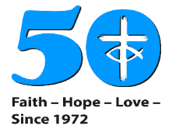

SAFEGUARDING

NEWSLETTER

In the meantime however please be aware of new legislation surrounding an amendment to the Sexual Offences Act 2033 which now includes an offences for a person in a position of trust within a religious setting. More details here [**https://urc.org.uk/new-law-includes-religious-settings-in-positions-of-trust/**](https://urc.org.uk/new-law-includes-religious-settings-in-positions-of-trust/) or from Paula Kitson at [**safeguardingsupport@urcyorkshirenorthern.org.uk**](mailto:safeguardingsupport@urcyorkshirenorthern.org.uk).

**Worship Resources**

The URC’s new **Worship Notes** initiative is now up and running. They are designed to help everyone who plans worship and will be found on the URC website here [**www.urc.org.uk/worship-notes**](http://www.urc.org.uk/worship-notes)**.**  They are in digital format and can be easily downloaded. They will help those who need to plan worship in a hurry, they will give refreshment to hard pressed Elders, Lay preachers and Ministers, and they can either be used as they are or adapted for local use.

The notes are planned to be released at least a month before the Sundays to which they relate so as to facilitate good planning and put them on the URC website so you can always find them at short notice!  
To find out more visit [**www.urc.org.uk/worship-notes**](http://www.urc.org.uk/worship-notes) and to get reminders each month [**You can sign up for these emails here**](http://eepurl.com/gWJ8vn)**.**

**Heritage Open Days**

The Yorkshire Historic Churches Trust has been in touch inviting churches to get involved in an exciting new initiative - **Yorkshire Churches Day (YCD**).

Their vision for Yorkshire Churches Day is to have one day a year when all places of worship in the region open up and showcase the history and heritage found inside their buildings. It is a wonderful opportunity to show off the value of the many historic religious buildings in Yorkshire both as places of worship and important centres for the local community.

The aim of the day is to encourage everyone to visit their local church even if they have never stepped foot inside a church before. It will be a day for those who are curious about the history and heritage of their local surroundings and to find out how our church buildings are still active places of worship.

This year Yorkshire Churches Day is being run in partnership with the Heritage Open Days (HOD) initiative on **Saturday 10th September**. Heritage Open Days is England's largest festival of history and culture, when thousands of people come together to celebrate their heritage, community and history.

To take part, a church needs to register on the HOD website [**Homepage | Heritage Open Days**](https://www.heritageopendays.org.uk/) by 31st July, open up on 10th September and explore missional and fundraising events to hold on the day. Full details of the signing up process and help and ideas about publicity can be found at [**https://www.yhct.org.uk/yorkshire-churches-day/**](https://www.yhct.org.uk/yorkshire-churches-day/%20)

For more details please contact Yorkshire Historic Churches Trust through Tom Ramsden the YHCT Chairman at [generalenquiries@yhct.org.uk](mailto:generalenquiries@yhct.org.uk) or through their website <https://www.yhct.org.uk/>.

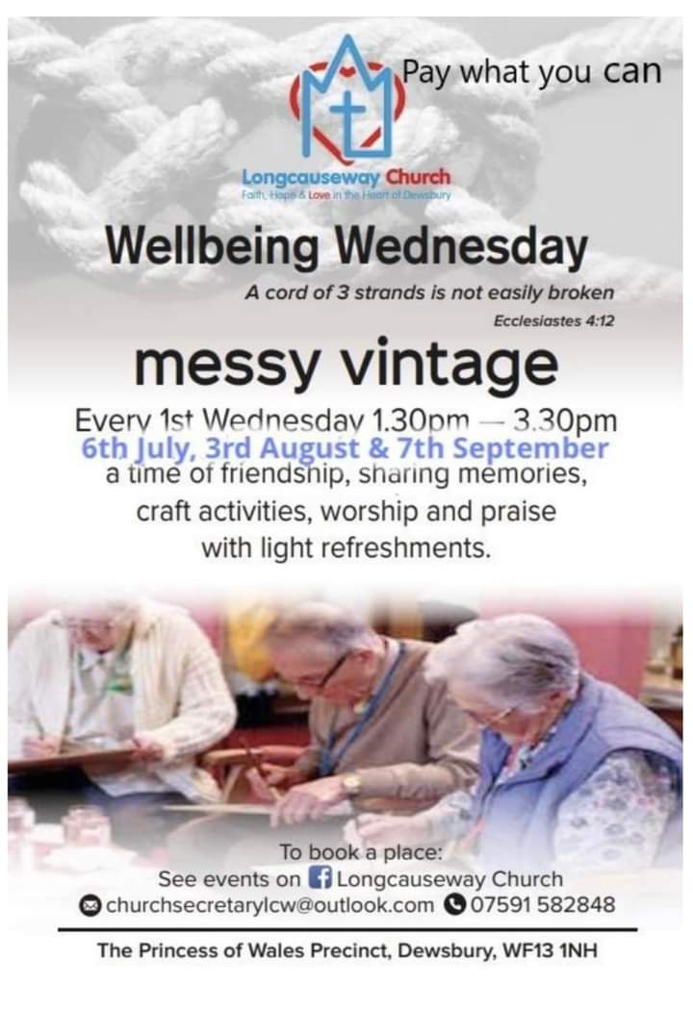

**KELD RESOURCE CENTRE**

**IN PARTNERSHIP WITH LOW ROW WITH KELD URC**

**2022 STUDY DAYS**

****There are now just two Study Days left this summer at the Keld Resource Centre. The next one is on **Saturday August 6th with Revd David Wood leading on “Seeking the Ancient Paths: Old Testament Spirituality for Today”**

**The programme for the day is:**

**10-30 – 11.00 : Arrivals and refreshments**

**11.00 - 12.30 : Session One : The Good Life**

**12.30 - 13.30 : Lunch**

**13.30 - 15.00 : Session Two : All Change**

**15.00 - 15.30 : Refreshments and departure.**

**You are invited to bring a Bible and a picnic. We will provide the drinks! The cost of the day is £10. We would love to see you!**

**If you are interested in attending, please contact David Wood at** [**david.wood4@btinternet.com**](mailto:david.wood4@btinternet.com)

The final Study Day is on **Thursday September 1st with Revd Trevor Pitt: Looking at Green Theology**

Don’t forget to keep an eye on all our social media platforms for news; on the website at [**Home - URC Yorkshire Synod**](https://urcyorkshire.org.uk/), the facebook pages at [**United Reformed Church in Yorkshire - Home | Facebook**](https://www.facebook.com/urcyorkshire) and [**Wilderness URC Yorkshire - Home | Facebook**](https://www.facebook.com/wildernessyorkshireurc/), the YouTube page at [**URC Yorkshire - YouTube**](https://www.youtube.com/channel/UCSAly5eC6tBlmY52dLxrylg) and the Twitter page at [**URC in Yorkshire (@URCYorkshire) / Twitter**](https://twitter.com/URCYorkshire). Each of these resources are used in a different way and it would be great to see whether you use these in conjunction with The Briefing or rely on only one resource centre. I look forward to hearing from you all via [**clerk@urcyorkshire.org.uk**](mailto:clerk@urcyorkshire.org.uk).

**Please don’t hide these events and resources in your inboxes or within the trees hiding your own churches’ woods. Why not send the Briefing around your own church mailing lists as these events are for everyone, member or non-member, church-goer or non-church-goer. All these activities within and beyond Synod are designed to grow the Kingdom.**

**Plans are always happening to bring more activities and good news stories to your attention, so keep an eye open for the next Briefing due on 7th July. All you need to do is get in touch with me at** [**clerk@urcyorkshire.org.uk**](mailto:clerk@urcyorkshire.org.uk)**.**

*Tim Crossley*

*Synod Clerk*