**The Briefing – Number 91**

**8th September 2022**

|  |  |
| --- | --- |
| **THE BIG DAY OUT**  Ticket sales are open and will not close until **tomorrow** - Friday 9th September.  Please contact the synod office to book your tickets [**office@urcyorkshire.org.uk**](mailto:office@urcyorkshire.org.uk)  **0113 289 8490**  **Include your church/group, group leader (and contact email), the number of paid tickets and how many free under 4 tickets and look out for the special coach funding offer**.  **Here’s a quick reminder of what is on offer** [**https://youtu.be/Ec4zHtt0BW0**](https://youtu.be/Ec4zHtt0BW0)  **Yorkshire Churches Day**  Helping Yorkshire's Historic Churches & ChapelsThis coming weekend sees some of our United Reformed and partner Churches taking part in the annual Yorkshire Historic Churches Trust **Yorkshire Churches Day.** Those taking part including The Bridge Church in Otley, Trinity URC in Sheffield, Toll Gavel in Beverley and Cornerstone at Great Horton in Bradford. Cornerstone have even supplied us with a flyer for you to download.  As with all the churches taking part on 10th September you can visit them between 10am and 3pm and you will be welcomed with open arms.  To find out more about Yorkshire Churches Day and to see if there is a church near you opening their doors, please visit [**Yorkshire Churches Day – Helping Yorkshire’s Historic Churches & Chapels (yhct.org.uk)**](https://www.yhct.org.uk/yorkshire-churches-day/)**.**  **JUBILEE**  As planning continues for the URC’s 50th Jubilee events on Saturday 1 October, the good folk who are organising the Jubilee weekend are asking for your help in promoting the three events on offer, and recruiting stewards to help ensure the smooth and safe running of the day. More information at [**Our 50th Anniversary - United Reformed Church**](https://urc.org.uk/who-we-are/our-50th-anniversary/)  Methodist Central HallWith regards to stewarding, help is needed at Open Church House to welcome visitors, guide them around the building and help manage safety and security. Support is also needed at the Worship Service, especially with serving Communion, which will, in many cases, involve carrying trays of bread and wine up flights of stairs. **If these are things you, or anyone you know, might be able to help with, please email** [**50@urc.org.uk**](mailto:50@urc.org.uk) **as soon as possible.**  In terms of promotion, the Service of Worship at Central Hall, Westminster, the Open Church House event and Walk to Westminster now each have their own tab on the events page, giving information about each event in a more accessible way. These can be linked to directly in emails and social media posts as follows:    Service: [**https://urc.org.uk/who-we-are/our-50th-anniversary/50th-anniversary-tickets/#service-of-thanksgiving-and-celebration**](https://urc.org.uk/who-we-are/our-50th-anniversary/50th-anniversary-tickets/#service-of-thanksgiving-and-celebration)  Open Church House: [**https://urc.org.uk/who-we-are/our-50th-anniversary/50th-anniversary-tickets/#open-church-house**](https://urc.org.uk/who-we-are/our-50th-anniversary/50th-anniversary-tickets/#open-church-house)  Walk to Westminster: [**https://urc.org.uk/who-we-are/our-50th-anniversary/50th-anniversary-tickets/#walk-to-westminster**](https://urc.org.uk/who-we-are/our-50th-anniversary/50th-anniversary-tickets/#walk-to-westminster)    If you have any questions, or would like to discuss anything further, please contact  **Andy Jackson, Head of Communications, The United Reformed Church,** 020 7916 2020 [50@urc.org.uk](mailto:50@urc.org.uk) [www.urc.org.uk](http://www.urc.org.uk/)  **LYCiG**  The **Leading Your Church into Growth Northerly Synods’ Conference** will be taking place between 7th and 9th November at Hinsley Hall, Leeds. Each of the 5 Northerly Synods has been allocated a set number of places, but there may be more places available than first thought as one or two of the synods may not be able to fill their allocation. Keep an eye on all good URC websites and Briefing newssheets for further updates.  Looking further ahead, the URC LYCiG team are looking at doing a national LYCiG conference for the whole of the denomination. Keep June 2023 clear in your diaries…………..  **Church Events and News**  **Induction & Ordination of Rev Nicola Robinson.**  For those who were unable to be at Christchurch, Halton on Saturday 3rd September for Nicola’s ordination and induction the service is still available on the Yorkshire Synod YouTube channel. All you need to do is click this link:  [**Ordination and Induction of Nicola Robinson - Saturday 3rd September 2022 - YouTube**](https://www.youtube.com/watch?v=cWWF7IVssqQ)  **Yorkshire Synod Autumn Meetings**  It’s that time of the year again when the thoughts of the Clerk turn to where and when we next meet together. So I’m happy to say that this autumn the Synod meeting will be spread over two days in order that we can continue our Jubilee challenge to be more missional and to receive our usual business papers. On **Saturday 8th October** from 9.30am we will meet at a new venue, Bilton Grange URC in Harrogate. As far as I know it will be the first time this century that we will have met in the Harrogate area. This part of the meeting will focus on Mission and Worship and is open not only to our church’s Synod representatives but to our wider worshipping community. Hopefully returning is a book stall run by Christian Books Huddersfield, and organised by Barry Simmons of Brackenhall URC. Please bring along a bob or two and remember that Bookshops like these need as much support as we can give. More details for the bookshop can be found here [Christian Books Huddersfield | Facebook](https://www.facebook.com/ChristianBooksHuddersfield).  Part two of the meeting will be held interactively online on **Thursday 13th October** at 6.30pm. A link and the documentation for the whole event will be sent out for this in due course so keep an eye on your in boxes and in the news section of the website.  **Saltaire URC**  As many of you will know, the church at Saltaire suffered severe damage in the two storms of February 2020. Since then work has been ongoing to the point that it is nearly finished. Happily this coincides with the annual [**Music & Arts Festival In Bradford | Saltaire Festival**](https://saltairefestival.co.uk/) when it is hoped that the doors of the church will be open visitors during the 2 weekends Saltaire Festival takes place. Tidying up and cleaning is well under way and it is hoped that a small display will be up in the church highlighting the collapse of the ceiling and subsequent repairs that are being carried out. The aim is to open church on the Saturdays and Sundays of both this weekend 10th & 11th September and the following weekend 17th & 18th September between 1pm and 4pm.  Please pray for Saltaire URC, its members and friends as they seek to welcome visitors for the first time since 2019!  **Lay Training news**  **Yorkshire Synod Discipleship Development small grant fund 2022**  We have been pleased to give out £500 of the £2000 Yorkshire were allocated for this year from the national small grant Discipleship Development fund but it would be good if we could have more applications to use the rest of this money before the end of the year. So far money has been agreed for new bible study resources and for sending a young helper on a messy church course.  If anyone wants to discuss an application before submitting it please pass on my contact details. Remember this is for any age to apply so please discuss with your young people as well as adults.  Every blessing  Kath Lonsdale, Convenor of Yorkshire Ministries, [**kathlonsdale@talktalk.net**](mailto:kathlonsdale@talktalk.net)  **Lay preachers and worship leaders conference**  You know how every now and then I get advance notice of events, well this is one such advance notice. Thanks to our ever efficient and attentive Ministries Committee Convenor Kath Lonsdale who has let me know that the next Lay preachers and worship leaders conference will be at Wydale from 7th to 9th July 2023 - look out for more information in the new year.  **Children and Young Peoples News**   |  | | --- | | **Morning Coffee Together**    This Saturday (10th September), Megan & Samantha will be at Costa Coffee in The Broadway in Bradford to catch up with the Young Adults of the synod. If you are age 17+ and fancy coming to have a warm drink, good conversation and to meet others, we'd love to see you there. 10.30am - 12noon.  Also keep an eye out for them at Synod at Bilton Grange URC as well as in Huddersfield in November and York in December.  **Youth Residential**  The Wilderness team is organising a YOUTH RESIDENTIAL at Peak Venture in Sheffield from 30th September through to 2nd October.  Details of how to book can be found here: [**https://forms.gle/xp1oYgrzG5nTHgBp9**](https://forms.gle/xp1oYgrzG5nTHgBp9)  To subscribe to the Wilderness newsletter click here [**URC Yorkshire Synod (list-manage.com)**](https://urcyorkshire.us18.list-manage.com/subscribe?u=6386cd1d52e213399865e28c0&id=911b09bcc9) | |

|  |
| --- |
|  |

**National News**

**From our colleagues and friends in Citizens UK**

We're excited to tell you about a new opportunity to join us at [**Still Small Voice**](https://click.actionnetwork.org/ss/c/Mqag7sW8TIW-nixyBdulQvSb3LYnVYVmFM9VpF1JPEnjurDccxByiPIuMOu3FpfR2jholEPYzJBEXq29KfWAYSlOrCAXIqdLX9SDFSOZDPhiAGQJAuZJyRm2DvDyR-aHWRhHTDlxH1JSJwNuzE9xUthas6gnoDKe6fssRsdssEDOz8zgKuJxO0NJvBftI8qhhWsF1aj7AbGBQI7CZuuoKTwS8LZHsbfRBaLN3an2TxD_Y5l1DXbuycYkptsf59GjsP4CpWFgI29leQdYDJ3VJbp1Mlcn9ayuVlGzEdRxAUfev2SXCIU8DuOkTP7nRiRKeitCvT0-80Qg28al1BJ-4VJq1RyctbkPYj1yHQ9C5sOThcYsMOId-ctVd8ufdHrW1fzcG_Me6KaxYu2hgVBVUg/3n1/H-p4NQaMSbOYIxX2aQGmDw/h1/qqWfY9IAA04BqZgL7-_Y5nnoAegDFXM-y0Po5lmFG4k), a residential 5-day retreat at Ripon College, Cuddesdon, taking place from Monday 12th to Friday 16th September 2022.

This retreat is aimed at a range of participants: those in ministry and ministerial training, lay and ordained; from those relatively new to Community Organising through to veterans of the craft.

During this retreat you will explore that ground, with a particular focus on contemplation and action; mysticism and resistance. How do we balance these in our own spiritual/organising lives, and how can we enable our faith communities to be renewed and re-energised by embracing that balance too?

We will bring to that exploration a spirit of ‘co-creation’ – everyone will participate by taking some kind of leadership role – learning and growing together. If you have any further questions, please email the learning team at [**learning@citizensuk.org**](mailto:learning@citizensuk.org)

**Church Life Review**

As we celebrate our Jubilee, the Church Life Review Group would like to hear your perceptions by discussing the questions below.  You may do so at any convenient gathering, and we encourage you to think about reflecting on the questions during worship on the 30th October. Supporting worship material will be available via the Daily Devotions and Worship Notes at [**www.urc.org.uk**](https://eur03.safelinks.protection.outlook.com/?url=http%3A%2F%2Fwww.urc.org.uk%2F&data=05%7C01%7CGordon.Woods%40defra.gov.uk%7Cc9359c569c954977bc3808da5300cff6%7C770a245002274c6290c74e38537f1102%7C0%7C0%7C637913560225810709%7CUnknown%7CTWFpbGZsb3d8eyJWIjoiMC4wLjAwMDAiLCJQIjoiV2luMzIiLCJBTiI6Ik1haWwiLCJXVCI6Mn0%3D%7C3000%7C%7C%7C&sdata=WlEwrBd3J5I0M8APRmBX92sFdNaxBadC7DvdGtt8%2BkM%3D&reserved=0)

*1. The Jubilee year was a time of great joy. Reflect quietly on a time when you have felt most joyful in your church life.*

*2.  The Jubilee year was a time of celebration. What would you like to celebrate about the United Reformed Church?*

*3.  The Jubilee year was a time of liberation. Are there any church burdens that, if freed of, would liberate you to flourish?*

*4.  The Jubilee year was a time of economic transformation and big dreams. If money was no object, what would you invest in to make your local church more effective?*

Responses are requested by Monday 28th November. Please upload your response to [**https://tinyurl.com/URCJubilee**](https://tinyurl.com/URCJubilee)or email [**churchlifereview@urc.org.uk**](mailto:churchlifereview@urc.org.uk) or send by post to Church Life Review, 21 Crawfurd Gardens, Rutherglen. G73 4JP.

It would be lovely if you felt you could share information about the consultation, the questions (and the link) in any communications, at any events, courses or other gatherings you might be planning to hold between now and November. If you would like more cards though, Andy Jackson has heaps!

**Safeguarding News**

**Update in relation to Safeguarding Foundation Training**

In line with other denominations, the foundation training package in relation to safeguarding is now available to be completed online via an e-learning package.

Full details were published in the last issue of the Briefing, but in a nutshell it means that for local churches everyone can access the training wherever and whenever they want.  You don’t have to make yourself available for a specific time and date, you don’t even have to complete it in one go.  The package allows **you** to take as much or as little time as **you** need and allows **you** to learn at your own speed.

The training has been completed by URC training and development officers including Matt Knowles, the Synod’s Safeguarding Officer. The package is easy to follow and understand and at the end of the training you are given the option of obtaining a certificate as well as ensuring you won’t need to attend any other URC foundation training for a further three years.

All that is required is to copy and paste [**https://www.urclearninghub.org.uk/**](https://www.urclearninghub.org.uk/) into a device of your choice and follow the instructions. It’s as easy as that.

We appreciate this is a new way of learning, but please embrace it and make best use of the resources available to you. If you have any queries please contact Paula Kitson, the new Synod Safeguarding Support Officer at [**safeguardingsupport@urcyorkshirenorthern.org.uk**](mailto:safeguardingsupport@urcyorkshirenorthern.org.uk).

Intermediate and other training will continue to be delivered utilising the same methods as we have done over the past 3 years, delivered directly by the synod safeguarding officer. Watch this space as more courses are planned soon.



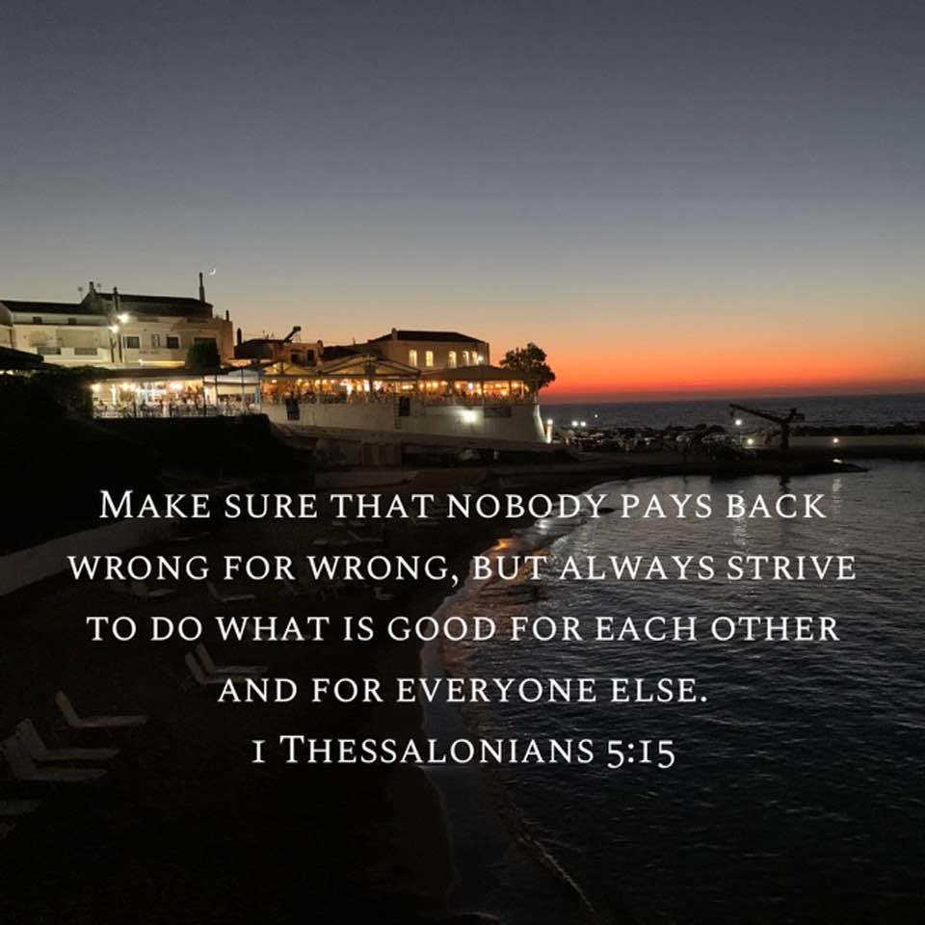

Thanks again to Ashley Evans, our Synod Evangelist for this image, which was uploaded to the Synod’s facebook page. You can keep an eye on all our social media platforms for news; on the website at [**Home - URC Yorkshire Synod**](https://urcyorkshire.org.uk/), the facebook pages at [**United Reformed Church in Yorkshire - Home | Facebook**](https://www.facebook.com/urcyorkshire) and [**Wilderness URC Yorkshire - Home | Facebook**](https://www.facebook.com/wildernessyorkshireurc/), the YouTube page at [**URC Yorkshire - YouTube**](https://www.youtube.com/channel/UCSAly5eC6tBlmY52dLxrylg) and the Twitter page at [**URC in Yorkshire (@URCYorkshire) / Twitter**](https://twitter.com/URCYorkshire).

**Please don’t hide these events and resources in your inboxes. Why not send the Briefing around your own church mailing lists as these events are for everyone, member or non-member, church-goer or non-church-goer. All these activities within and beyond Synod are designed to grow the Kingdom.**

**Plans are always happening to bring more activities and good news stories to your attention, so keep an eye open for the next Briefing due on 22nd September. All you need to do is get in touch with me at** [**clerk@urcyorkshire.org.uk**](mailto:clerk@urcyorkshire.org.uk)**.**

*Tim Crossley*

*Synod Clerk*