**The Briefing – Number 95 23rd November 2022**

|  |
| --- |
|  |

**Church Events and News**

**Man sleeps in Stocksbridge graveyard**

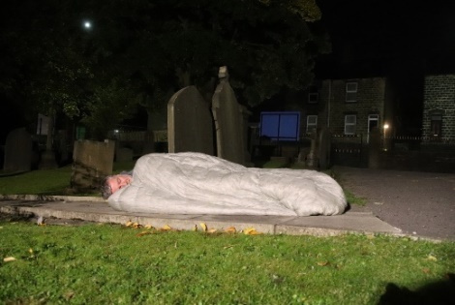A week last Monday, 24th October, a man slept in the graveyard at Christ Church Stocksbridge. His name is Tim Renshaw and he is the head of the Archer Project under the Cathedral in Sheffield [Supporting Sheffields homeless and vulnerable | Cathedral Archer Project](https://www.archerproject.org.uk/) .

He has been sleeping out in 16 churchyards across Sheffield, through October, sometimes with homeless friends, to raise awareness of the problem of homelessness.

Photo by Rebecca Aitken

He met with people from across Stocksbridge, to tell stories of homelessness, discuss the issues around it and a lively discussion was had over a Chinese takeaway.

Rev Ian Lucraft, minister at Christ Church, Stocksbridge, said; “The people who shared this event went away very moved by the stories of Tim’s friends and colleagues. We are fearful that homelessness may increase in coming months, and it is important that we support those who work among homeless people and speak up for the needs of people who are affected.”

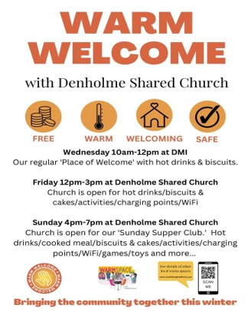**Warm Welcomes in Denholme**

Denholme Shared Church has been successful in obtaining a grant from the DWP through Bradford Council towards opening the church in Denholme on times outside their normal service hours.

They are starting this Friday afternoon with one session, and then on Sunday 13th November for the Sunday sessions. Although they are unsure what the take up will be like with this unseasonable weather, they will be going for it!!!

They already do a session in the local Mechanics Institute on Wednesdays which was called Place of Welcome (Well Springs Initiative from CofE) and this will continue as well.

For more information visit [Denholme Shared Church (denholmechurch.org.uk)](https://www.denholmechurch.org.uk/)

If your church is planning something similar, please let us know at Synod office.

**Winter Warmer Initiative grants from the Yorkshire Synod Mission Fund**

**The Yorkshire Synod is acutely aware of the challenges facing many people in our communities with the prospect of huge increases in energy bills this winter, and beyond.**

**We are pleased that some congregations are already responding (and intend to respond) with initiatives to offer warm spaces for their communities and Synod would like to help with this.**

**We would encourage congregations (and groups of churches, including ecumenical partners) who are planning such initiatives to apply to the small grants stream of the Synod Mission Fund for help (grants up to £2,500)**

To ease the burden and speed of administration the Synod Mission Fund Panel are relaxing our normal procedures for applications as follows:

1. Applications can be made at any time directly to the Synod Clerk, Tim Crossley at [clerk@urcyorkshire.org.uk](mailto:clerk@urcyorkshire.org.uk). The applications will then be dealt with between SMF Panel meetings as soon as possible.
2. Use and attach the small grants form found at [Forms - URC Yorkshire Synod](https://urcyorkshire.org.uk/forms/) ideally this one <https://urcyorkshire.org.uk/wp-content/uploads/2021/03/181121-Synod-Mission-Fund-SMALLER-grant-application-form.docx>
3. Please insert the title "Winter Warmer Initiative" followed by the Church (or lead Church) name into the Mission Project Name field on page 1 of the form AND in the e-mail subject field so we can pick up applications quickly.
4. Please be very brief in question 1 (Your Project). Some description of what you are doing will be helpful but there is no need for too much detail describing the purpose of your project and how it helps the mission of your church.
5. Churches can still apply for an additional grant towards Winter Warmer initiatives even if they already have applications for other projects in train, submitted recently, or planned for the near future.
6. Churches can apply if your Winter Warmer initiative has already started.
7. We would still like to see indications of offers of match funding plus your latest accounts. Some indication of how your own energy bills are being affected will also be helpful. Insert this in the form at question 3 (How much of this can your church contribute?). Costs of the project for which you request funding must relate directly to the initiative. This includes anticipated additional energy costs but not normal energy costs.
8. Applications towards Winter Warmer initiatives can be submitted up to 31st March 2023

We look forward to receiving your applications. Please come back to either Tim Crossley or the Synod Treasurer, Rev Simon Copley via the office with any questions you may have

You will be pleased to know that the Yorkshire Synod budget for 2023 includes £100,000 set aside to help churches in Yorkshire with the challenges of their own normal energy costs. This is in addition to £2 million that is being set aside by the URC centrally to help churches in all Synods.

The detailed criteria for distributing these central funds is yet to be decided but further updates and other useful information will follow as soon as we have more details.

With all good wishes

Simon Copley

Synod Treasurer

**Lay Training news**

**Yorkshire Synod Discipleship Development small grant fund 2022**

We have been pleased to give out £500 of the £2000 Yorkshire were allocated for this year from the national small grant Discipleship Development fund but it would be good if we could have more applications to use the rest of this money before the end of the year. So far money has been agreed for new bible study resources and for sending a young helper on a messy church course.

If anyone wants to discuss an application before submitting it please pass on my contact details. Remember this is for any age to apply so please discuss with your young people as well as adults.

Every blessing

Kath Lonsdale, Convenor of Yorkshire Ministries, [**kathlonsdale@talktalk.net**](mailto:kathlonsdale@talktalk.net)

**Making Sense of the Minor Prophets**

On **Saturday 11th February**, between 10.00am and midday Dr Alison Gray, one of the Old Testament lecturers from Westminister college, will lead a zoom session for us on this day entitled

“Making Sense of the Minor Prophets: An overview and a deep dive into preaching on Jonah”

This is a date for the diary for anyone interested in joining this session. Whether you are a minister, lay preacher, worship leader or just interested in this topic please consider keeping this date free. Keep an eye open on the website for more details nearer the time.

**Lay preachers and worship leaders conference**

You know how every now and then I get advance notice of events, well this is one such advance notice. Thanks to our ever efficient and attentive Ministries Committee Convenor Kath Lonsdale who has let me know that the next Lay preachers and worship leaders conference will be at Wydale from **7th to 9th July 2023** - look out for more information in the new year.

**Children and Young Peoples News**

**Morning Coffee Together**

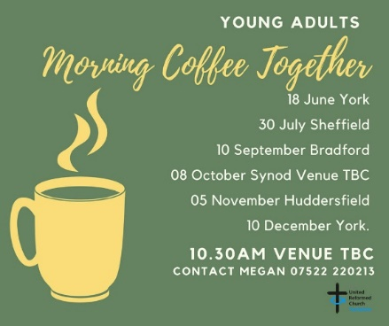

Throughout the autumn the Morning Coffee Together sessions for Young Adults will be wending its way around the Synod, with the next one due at the **Costa on New Street in Huddersfield** on 5th November. If you are age 17+ and fancy coming to have a warm drink, good conversation and to meet others, we'd love to see you there from 10.30am through to 12 noon.

Also keep an eye out for them in York on 10th December at the Bar Convent on Blossom Street in York [The Bar Convent Living Heritage Centre (bar-convent.org.uk)](https://www.bar-convent.org.uk/index.htm).

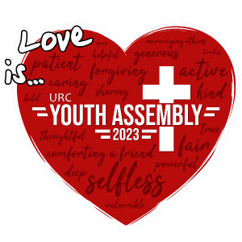**Online Bookings for the 2023 Youth Assembly are now open**

Each year the URC Youth Assembly brings together a diverse group of under-25s from across Scotland, England and Wales for a weekend of business and fun combined, exploring issues and topics relevant to Church, society and life through workshops, seminars, discussions and creative activities. Next year it is being held again at Whitemoor Lakes near Lichfield between 27th and 29th January.

The cost is £119 if the booking is received on or before 11 November 2022; £149 if booking received on or after 12 November 2022. To book visit [URC Youth Assembly - United Reformed Church](https://urc.org.uk/your-faith/children-young-people/urc-youth/urc-youth-assembly/) and if money is an issue, please contact us on 020 7916 8683 or email [children.youth@urc.org.uk](mailto:children.youth@urc.org.uk)

as financial support is available.

|  |  |  |
| --- | --- | --- |
| |  |  | | --- | --- | | |  | | --- | | **Calling All Messy Church Workers!** Monday 21st November 7 - 8.30 pm  The Five Northerly Synods have arranged another messy zoom gathering. We have listened to your suggestions and understand that the times in between special celebrations can be a challenge.  Fear not, we offer you this event in November, along with plenty of time to chat and share with volunteers just like you.  This offers a great chance to gather, listen, share, and support each other. A warm welcome awaits you all.  For further information please email [Hannah Middleton](mailto:hannah.middleton@urc-northernsynod.org), Northern Synod Children’s Work Advisor. | | |

**LYCiG**

The **Leading Your Church into Growth Northerly Synods’ Conference** will be taking place between 7th and 9th November at Hinsley Hall, Leeds. Each of the five Northerly Synods has been allocated a set number of places, but there may be more places available than first thought as one or two of the synods may not be able to fill their allocation. Keep an eye on all good URC websites and Briefing newssheets for further updates.

Looking further ahead, the URC LYCiG team are looking at doing a national LYCiG conference for the whole of the denomination. Keep June 2023 clear in your diaries…………..

**URC Buildings Forum Online Event: two Synod Moderators’ experiences of church development!**

If you want to hear more about this, please look out for further details of the next **URC Buildings Forum Conference** which is to take place on **Tuesday 15th November 2022 from 7.30pm until 9.00pm.** There will be an opportunity to hear about the experiences of developing a church building, its life and its mission, and learn of some of the joys and pitfalls of following that path, with the Revd. Ruth Whitehead and the Revd. Steve Faber as guest contributors.  There will also be time during the conference for a conversation about the Environmental Policy agreed at General Assembly.

To register, please email [**mission@urc.org.uk**](mailto:mission@urc.org.uk) with ‘Forum Online Event’ in the subject heading by 31st October 2022, along with your name, email address, and details of which church or organisation you are representing. Login details will be sent a few days before the meeting.

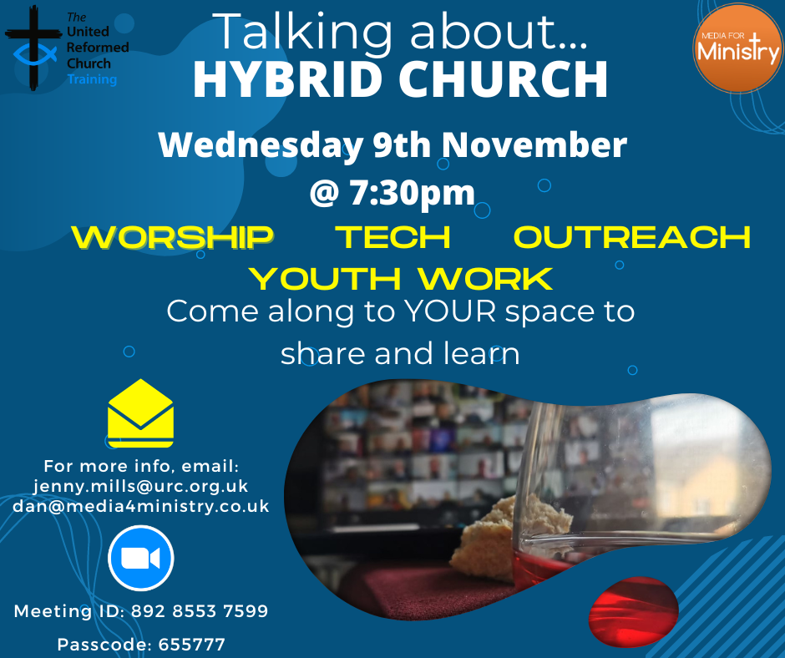

**For news about what the URC is doing around the country, head here** [**URC News Update November 2022 (urc-news.org.uk)**](https://urc-news.org.uk/2JB1-1X0H4-122F160E1908EEE459BX7G3A2531BF46D2BD62/cr.aspx) **and sign up for their monthly updates.**

|  |  |  |  |  |  |  |  |  |  |  |  |  |  |  |  |
| --- | --- | --- | --- | --- | --- | --- | --- | --- | --- | --- | --- | --- | --- | --- | --- |
| |  |  |  |  |  |  |  |  |  |  |  |  |  |  |  | | --- | --- | --- | --- | --- | --- | --- | --- | --- | --- | --- | --- | --- | --- | --- | | |  | | --- | |  | | |  |  | | --- | --- | | |  | | --- | | https://mcusercontent.com/2f0f3dc9a988ed172e04150ad/images/456e5f62-6363-4ed5-8a9c-afe14430401e.jpg | | | | |  |  |  | | --- | --- | --- | | |  |  | | --- | --- | | |  | | --- | | **New Edition of In GEAR available.**  The Autumn 2022 edition of In GEAR is now available on GEAR's web-site. This latest edition plus numerous back copies can be found at: [**http://www.gear.org.uk/publications/in-gear-magazine/**](https://gear.us11.list-manage.com/track/click?u=2f0f3dc9a988ed172e04150ad&id=3a355878b5&e=739c78e1e4) You can download the PDF version by clicking on the relevant front page view. If you wish to receive a paper copy (or multiple copies), please complete the form on the web page. Thanking you in anticipation Sheila Coop, GEAR Secretary | | | | | |  |  | | --- | --- | | |  | | --- | |  | | | |  |  | | --- | --- | | |  | | --- | | *Copyright © 2022 GEAR, All rights reserved.* **Our mailing address is:**  GEAR  219 Chamber Road  Oldham, Greater Manchester OL8 4DJ  United Kingdom | | | | | |

**Warm Welcomes in Herringthorpe**

|  |
| --- |
| https://i.emlfiles4.com/cmpimg/3/3/3/8/1/1/files/imagecache/3219880/w660_1894226_herringthorpeurccreditrotherhamadvertiser.jpgHerringthorpe URC will be offering free drinks, activities and a warm space to people struggling with paying their fuel bills. The Revd Matt Stone, the church's Minister, said Herringthorpe will be open between 1-4pm on Tuesday afternoons in November for people to "use the church's heating instead of their own" to help people who are worried sick about heating their home during winter. "We’re aware that people are anxious about energy bills — particularly elderly people who may be on low incomes — and also those who perhaps are at home a lot, so their energy bills are already high."  Image: Rotherham Advertiser |

**Safeguarding News**

**Training Update**

The URC’s Safeguarding Foundation training can now be accessed online via an e-learning package.  All you need is a device and a connection to the internet which doesn’t need to be at home – you can do this training at someone else’s home, in a church, in a library, in a coffee shop or even on a bus!!!  The training also doesn’t have to be done in one sitting – you can do it in bite sized chunks, when and where it suits you! At the end of the training there is a short quiz and then you are asked to enter you details. That’s it!!  You then send a message off to Church House via the press of a button and you will then receive your very own certificate and the records updated that you have completed your training. It is really easy to do, and the full instructions were given in previous Briefings. However as a reminder here are the links for your relevant devices:

Foundation Course for a Laptop or Desktop Computer [Safeguarding Foundation E-Course (canva.com)](https://www.canva.com/design/DAE4ntKmqAQ/nK-i-zdaZ80WYxl2y5JUCQ/view) or for a phone or tablet [Safeguarding Foundation E-Course for phone and tablet (canva.com)](https://www.canva.com/design/DAFHxbhLYuA/DHQmlcO-kpW06bWAK1R8tg/view). The narrated version of the Foundation Course with a voice over each slide [Safeguarding Foundation E-Course narrated version (canva.com)](https://www.canva.com/design/DAFJrcSwEnc/QGIcR50Axq32Hgk6KLSWKw/view)

However, if you have any questions, concerns, issues or queries relating to the e-learning package, please contact our synod safeguarding support officer Paula Kitson at [safeguardingsupport@urcyorkshirenorthern.org.uk](mailto:safeguardingsupport@urcyorkshirenorthern.org.uk).

We are mindful that this option may not be suitable for everyone.  Therefore a Foundation Course will be led by Matt Knowles via Zoom on Thursday 10th November 2022, between 10am and 12.00pm.  To book a place on this course please contact Paula on the above email.

**Intermediate Training**

Finally, for those that require Intermediate Training the final course of the year will be led by Matt Knowles on Monday 5th December 2022 – 10am to 12.30pm, so please contact Paula to book a place.

**Church Life Review**

As we celebrate our Jubilee, the Church Life Review Group would like to hear your perceptions by discussing the questions below.  You may do so at any convenient gathering, and we encourage you to think about reflecting on the questions during worship on the 30th October. Supporting worship material will be available via the Daily Devotions and Worship Notes at [**www.urc.org.uk**](https://eur03.safelinks.protection.outlook.com/?url=http%3A%2F%2Fwww.urc.org.uk%2F&data=05%7C01%7CGordon.Woods%40defra.gov.uk%7Cc9359c569c954977bc3808da5300cff6%7C770a245002274c6290c74e38537f1102%7C0%7C0%7C637913560225810709%7CUnknown%7CTWFpbGZsb3d8eyJWIjoiMC4wLjAwMDAiLCJQIjoiV2luMzIiLCJBTiI6Ik1haWwiLCJXVCI6Mn0%3D%7C3000%7C%7C%7C&sdata=WlEwrBd3J5I0M8APRmBX92sFdNaxBadC7DvdGtt8%2BkM%3D&reserved=0)

*1. The Jubilee year was a time of great joy. Reflect quietly on a time when you have felt most joyful in your church life.*

*2.  The Jubilee year was a time of celebration. What would you like to celebrate about the United Reformed Church?*

*3.  The Jubilee year was a time of liberation. Are there any church burdens that, if freed of, would liberate you to flourish?*

*4.  The Jubilee year was a time of economic transformation and big dreams. If money was no object, what would you invest in to make your local church more effective?*

Responses are requested by Monday 28th November. Please upload your response to [**https://tinyurl.com/URCJubilee**](https://tinyurl.com/URCJubilee)or email [**churchlifereview@urc.org.uk**](mailto:churchlifereview@urc.org.uk) or send by post to Church Life Review, 21 Crawfurd Gardens, Rutherglen. G73 4JP.

It would be lovely if you felt you could share information about the consultation, the questions (and the link) in any communications, at any events, courses or other gatherings you might be planning to hold between now and November. If you would like more cards though, Andy Jackson has heaps!

**Faith and Science in the Local Church**

For those among us who take an interest in Faith, Medicine and Science, the following workshop being run by the Faraday Institute in Cambridge may be of interest. All this information can be found on the Faraday Institute website, including registration details: <https://www.faraday.cam.ac.uk/>

**Faith and Science in the Local Church – A Workshop for Christian Leaders**

January 13 – 14, 2023, Cambridge and online

Full details to be had from Dr Zoe Binns, Events Manager, The Faraday Institute, Woolf Building, Madingley Road, Cambridge, CB3 0UB, UK. Tel: 01223-748-888, [zcl21@faraday.cam.ac.uk](mailto:zcl21@faraday.cam.ac.uk),

[www.faraday.cam.ac.uk](http://www.faraday.cam.ac.uk)

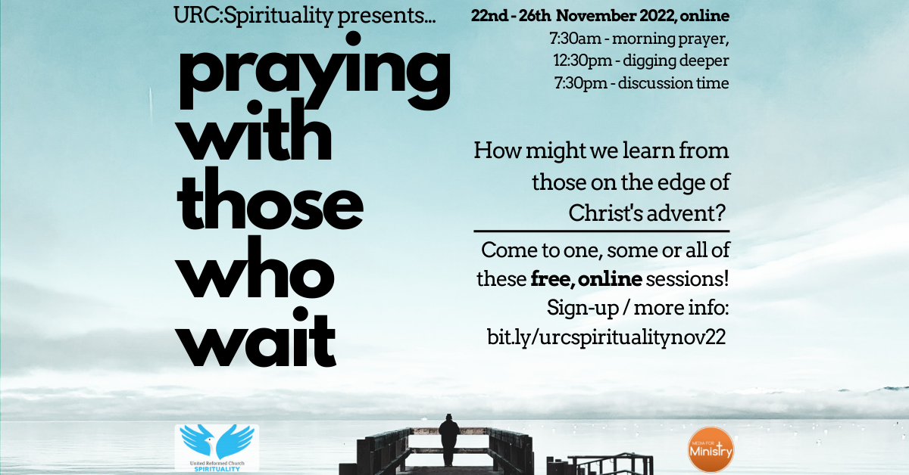**URC Spirituality**

Some of you may recall, or will have attended, the last URC:Spirituality online event that took place in June (an online quiet day) or the last series of events in January.

Now URC:Spirituality are pleased to be publicising its upcoming online week of events: **“Praying With Those Who Wait”.** This week of free sessions will look at the, perhaps, more unheard areas of Christ’s Advent. This will take place in 3 sessions each day, from Tuesday 22nd  to Saturday 26th November 2022. Each session is independent so feel free to attend one, some or all of them on Zoom.

A week of online sessions exploring characters and scenarios on the edge of Christ's advent. Hosted by URC:Spirituality. The sessions are independent so feel free to come to one, some or all of them!

Each morning there will be a short morning prayer time to start the day. This is a perfect way to begin your day in a contemplative way, giving whatever you may be up to that day, over to God.

At lunchtime we will have a series of sessions run by various people from the URC:Spriituality core group and beyond. Exploring largely unseen characters, or picking up on largely unexplored themes.

In the evenings we welcome guest speakers from across the breadth of spirituality as we continue to explore these characters and themes. These will be largely discussion-based and will finish with a short time of prayer to close the day.

The sessions will be held on Zoom, hosted by Media for Ministry. Media for Ministry has had a longstanding friendship with URC:Spirituality. Since first supporting "Streams in the Wilderness" back in May 2021, their expertise and sensitivity makes them a perfect fit with URC:Spirituality. Some of the M4M team have even led sessions at past events!

The sign up link is here: <https://prayingwiththosewhowait.eventbrite.co.uk> or you can distribute a shorter link: <https://bit.ly/urcspiritualitynov22>

**Dignity of Women - Scriptural Reflections Exhibition**

|  |  |  |  |
| --- | --- | --- | --- |
| |  |  |  | | --- | --- | --- | | |  |  | | --- | --- | | |  | | --- | | https://mcusercontent.com/09d0797dfb6f5d560848b19c2/images/9cba5ed3-3f84-498e-68b5-0cb06d45c078.jpgThe Blackley Centre in Elland is delighted to be working in partnership with the UK Women of Faith Network of Religions for Peace for Inter Faith Week. The Centre is hosting their excellent Dignity of Women - Scriptural Reflections Exhibition on 15th November from 11am to 8pm.  This special exhibition highlights the positive references on the status of women in the Sacred Scriptures of the Baha'i, Buddhist, Christian, Hindu, Jain, Jewish, Muslim, Sikh and Zoroastrian religions.  'The Dignity of Women - Scriptural Reflections' ExhibitionThe invitation is to women of all faiths and beliefs to come and explore the exhibition. If you would like to, there will then be an opportunity to informally chat/dialogue with other visitors and/or the facilitators. Men who are willing to act as advocates for women in their own faith tradition are also welcome to come and explore the exhibition. | | | |
| |  |  |  | | --- | --- | --- | | |  |  | | --- | --- | | |  | | --- | | To register for a free visit please go to <http://www.eventbrite.co.uk/e/the-dignity-of-women-scriptural-relections-exhibition-tickets-427954462317> For more information please contact: [women.coordinator@rfpuk.org](mailto:women.coordinator@rfpuk.org)  The Blackley Centre, Prospect View, Blackley, Elland, West Yorkshire, HX5 0TD. Tel. 01422 646803 | | | |

Since 1975 the Waldensian Church has been united with the Methodist Church in Italy. Each denomination has its own churches but ministers of both denominations move between the two in their ministry. Some, like the churches in Turin and Milan, also have English-speaking congregations and the Methodists have their own church in Rome near Castello Sant’Angelo. These congregations are by no means limited to English and American worshippers.

For this event we are joined by people who have experience of some of these churches which they will share with us. There will also be time for questions and answers.

[*https://us02web.zoom.us/j/84476125567?pwd=MFFTR3F5c0REU2lOYkVLa2x1cU5qdz09*](https://us02web.zoom.us/j/84476125567?pwd=MFFTR3F5c0REU2lOYkVLa2x1c)

*Meeting ID: 844 7612 5567*

*Passcode: 326951*

**Situations Vacant**



**The Yorkshire West Methodist District is looking to appoint an**

**Admin Assistant**

**to start as soon as possible**

**Part time appointment, 20 hours per week**

We are seeking a part time Admin Assistant to work as part of the District Team.

The person appointed will be required to:

* Work under the direction of the District Administrator, dealing with office correspondence, telephone enquiries, e-mail, photocopying, collating, filing etc.
* Maintain data in line with the latest GDPR requirements.
* Take minutes at meetings, some of which may take place in an evening.
* Assist in the production and circulation of District resources.

The post will be for 20 hours per week,

worked 9:30 am to 2:30 pm, Monday to Thursday **or** 10:00 am to 2:00 pm, Monday to Friday, based at the District Office, 4 Easby Road, Bradford, BD7 1QX

and may include occasional evening and weekend work.

A flexible term-time plus three weeks working pattern may be considered.

The rate of pay will be £11.23 per hour,

with enrolment in the District’s NEST workplace pension scheme.

For more information and an application pack please contact the PA to the Chair of District: [pa@ywmethodist.org.uk](mailto:pa@ywmethodist.org.uk) or 01274 442670

Closing Date: Friday, 11th November 2022 at 12 noon Interviews will take place on Tuesday, 22nd November 2022.

................................................................................................................................................................

The Yorkshire West Methodist District came into being on 1st September 2017 and was formed from a joining together of the former West Yorkshire District and part of the previous Leeds District.

The geographical area covered by the District stretches approximately 80 miles from Ingleton in the north to Penistone in the south, and 50 miles from Todmorden in the west to Knottingley in the east.

The District is made up of a range of communities and settings, including extensive rural areas, large cities and urban towns, and smaller market towns and villages. Throughout this diverse area there are local Methodist churches of people gathering together as disciples of Jesus Christ to worship God and serve their local communities.

**Yorkshire West Methodist District**

4 Easby Road, Bradford, BD7 1QX

01274 442670

[admin@ywmethodist.org.uk](mailto:admin@ywmethodist.org.uk)

https[://w](http://www.yorkshirewestmethodist.org.uk/)ww[.york](http://www.yorkshirewestmethodist.org.uk/)s[hirewestmethodist.org.uk](http://www.yorkshirewestmethodist.org.uk/)

Assistant District Safeguarding Officer

for the Yorkshire West and Yorkshire North & East Methodist Districts

## The Methodist Church is committed to ensuring its churches are safe spaces for all. We work hard to ensure compliance with legal requirements, develop good practice, provide effective training and give professional advice on individual cases. We have an exciting opportunity to join our team to work alongside the District Safeguarding Officers (DSOs) across the Yorkshire West and Yorkshire North & East Methodist Districts.

* Do you have a knowledge of safeguarding?
* Do you have Training and Quality Assurance skills and experience?
* Are you able to work flexibly and independently?
* Are you open to working in the faith sector?

# If so, this post may be for you.

## Amongst other things, you will be supporting our Safeguarding standards and DSOs by:

* Helping to deliver high quality safeguarding training
* Managing District DBS applications and the District Database
* Supporting Circuit and Church Safeguarding Officers
* Being committed to your own personal development

## The terms of employment will include:

* Salary £16,640 (£16 per hour), with enrolment in the Yorkshire West Methodist District’s NEST

Workplace Pension Scheme

* 20 hours per week, with flexibility including evenings, and occasional Saturdays (This includes core hours of 9 am to 3 pm on one day per week (to be agreed), which will be dedicated to the work in Yorkshire West District and another day per week (to be agreed), which will be dedicated to the work in Yorkshire North & East District. The remaining hours can be worked flexibly across the rest of the week in agreement with your Line Manager.)
* Home based
* Travel required across the Yorkshire West and Yorkshire North & East Districts.

The geographical area covered by the Yorkshire West District stretches approximately 80 miles from Ingleton in the north to Penistone in the south, and 50 miles from Todmorden in the west to Knottingley in the east. The District is made up of a range of communities and settings, including extensive rural areas, large cities and urban towns, and smaller market towns and villages. Throughout this diverse area there are local Methodist churches of people gathering together as disciples of Jesus Christ to worship God and serve their local communities.

The Yorkshire North and East District includes around 200 churches stretching over nearly 80 miles of the East Yorkshire coast, and across much of North Yorkshire, from Northallerton to Wetherby. The District embraces the cities of York, Hull and Ripon, and includes many rural settings as well as coastal and market towns and suburbs. The District seeks the flourishing of all its members and churches, responding faithfully to God’s call in our many and varied contexts.

**Full details and an application pack are available on request from** [admin@ywmethodist.org.uk](mailto:admin@ywmethodist.org.uk) Closing date for applications: **Friday, 18th November 2022** at **12 noon**

Interviews will be held on **Thursday, 1st December 2022** at

# Yorkshire West Methodist District Office, Touchstone, 4 Easby Road, Bradford, BD7 1QX

*Appointment will be subject to receipt of satisfactory references and an enhanced DBS disclosure.*

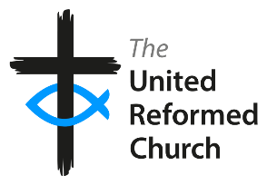

The East Midlands Synod of the United Reformed Church is seeking to appoint a **Children’s and Youth Development Officer** (Ref CYDO)

This is a full-time post for 37.5 hours/week

(including evening and weekends) on a permanent contract.

Salary: £32,796 to £33,624 depending on experience and qualifications

This post is subject to an Enhanced DBS Disclosure

This post offers a challenging opportunity for an experienced and professionally qualified Children’s and Youth Worker with training and development skills. We are looking for an enthusiastic and committed Christian to develop our strategy, serve the churches of the Synod in offering advice, training, and support to those working with children and young people and to work with the wider United Reformed Church. The Officer appointed will be a member of a collaborative Synod team and therefore good team working skills are essential.

If you share our passion for children and young people playing their part in the mission of God, please contact:

Mrs Chris Willis

East Midlands Synod Office

1 Edwards Lane, Sherwood

Nottingham, NG5 3AA

Tel: 0115 9609241

E-mail: admin@urc5.org.uk

**Closing date for applications: 30th November 2022**

**Interviews to be held : w/c 12th December 2022**

*In accordance with the Equality Act 2010: Part 1, Schedule 9, there is an occupational*

*requirement for the post holder to be a practising Christian*

We are committed to diversity and equality of opportunity. We especially welcome applications from women and Black and Minority Ethnic Groups who are currently under-represented in this area of work in the Church.

You can keep an eye on all our social media platforms for news; on the website at [**Home - URC Yorkshire Synod**](https://urcyorkshire.org.uk/), the facebook pages at [**United Reformed Church in Yorkshire - Home | Facebook**](https://www.facebook.com/urcyorkshire) and [**Wilderness URC Yorkshire - Home | Facebook**](https://www.facebook.com/wildernessyorkshireurc/), the YouTube page at [**URC Yorkshire - YouTube**](https://www.youtube.com/channel/UCSAly5eC6tBlmY52dLxrylg) and the Twitter page at [**URC in Yorkshire (@URCYorkshire) / Twitter**](https://twitter.com/URCYorkshire).

**Please don’t hide these events and resources in your inboxes. Why not send the Briefing around your own church mailing lists as these events are for everyone, member or non-member, church-goer or non-church-goer. All these activities within and beyond Synod are designed to grow the Kingdom.**

**Plans are always happening to bring more activities and good news stories to your attention, so keep an eye open for the next Briefing due on 17th November. All you need to do is get in touch with me at** [**clerk@urcyorkshire.org.uk**](mailto:clerk@urcyorkshire.org.uk)**.**

*Tim Crossley*

*Synod Clerk*