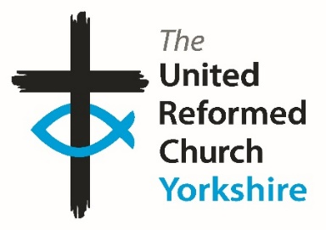
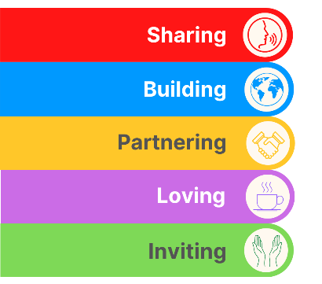
Yorkshire Synod Briefing
Number 106

20th April 2023

SYNOD FORUM – At a Church near you
Although this has been the place where the Synod Clerk traditionally had pointed his readers to various events and resources that are available, this time I am giving space to our Moderator, Rev Jamie Kissack. The reason is simple – Synod Forum is here.
'In these challenging times it is more important than ever to support each other, and to do so with the bible at the heart of our conversation.
Only a few of us have opportunity to gather in our twice-yearly Synod meetings so we are creating a new opportunity to meet for fellowship and good conversation between the churches of the Synod. We are calling it ‘Synod Forum’. We have chosen four dates and venues to make the conversation as accessible as possible. You are free to chose the date and venue that is best for you, listed on the next page and all will run from 10.30am – 2.30pm.
The conversation will be based around Paul’s first letter to the Corinthians. It will be mostly in small group discussions so you get chance to share with people from other churches. We hope that this will also be a chance for those with Synod roles to hear from the local church about your opportunities and challenges so that together we can find the best ways to support and encourage each other. The Synod Forum is your place to have your voice heard, and to help shape the priorities of the Synod.'

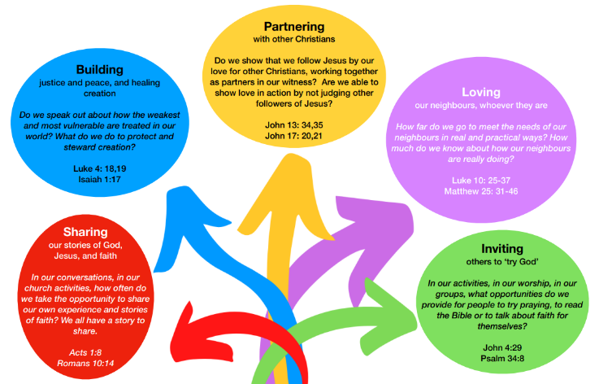
Finally, please let me have details of what YOUR church did or is planning to do over the next two Bank Holiday weekends – especially as one will involve a Coronation.
The next Briefing goes out on Thursday 4th May so please help me get your message out there, either via the Briefing or on the website at Latest News - URC Yorkshire Synod
All you need to do is get in touch with me at clerk@urcyorkshire.org.uk.

Tim Crossley

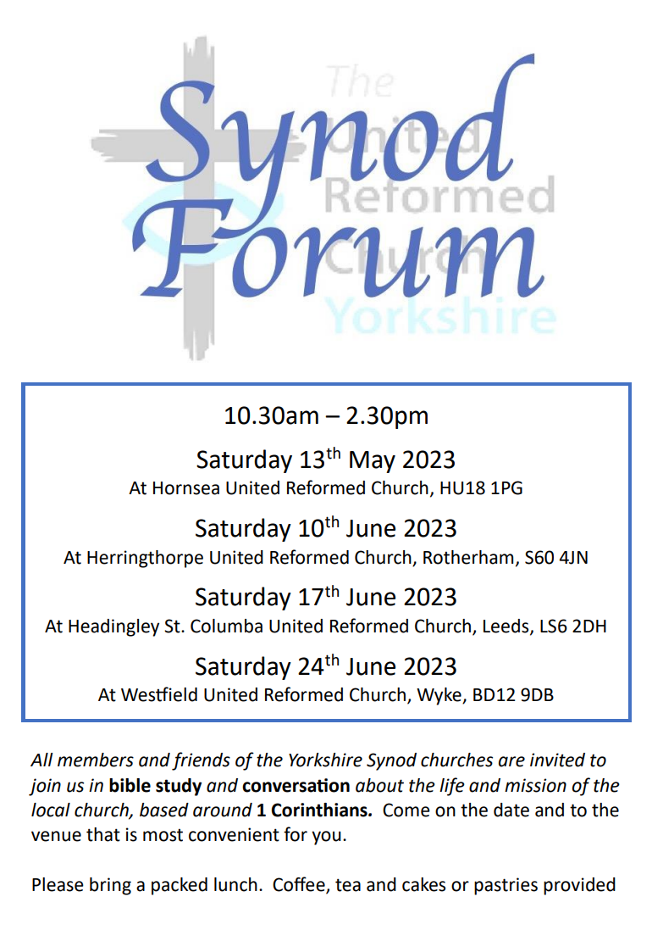
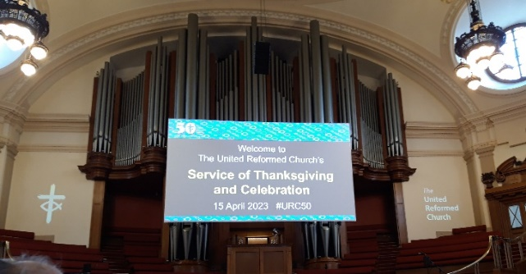
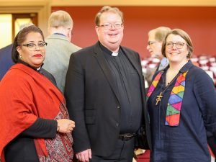
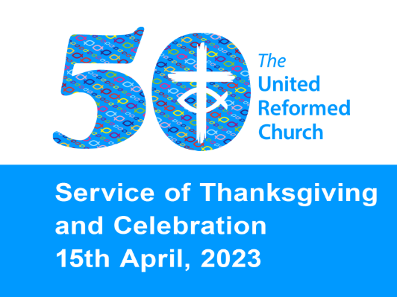
I hope that you will all know that the United Reformed Church held its Service of Thanksgiving and Celebration on Saturday 15 April 2023 at Methodist Central Hall in Westminster. It was a wonderful experience with the service celebrating all that the United Reformed Church is about. Around 1200 people attended and as well as enjoying the fellowship they were able to enjoy the diversity which is part and parcel of URC life. The service was led by the Revd John Bradbury, General Secretary of the URC, and the Moderator and Moderator-Elect of the URC General Assembly, the Revds Fiona Bennett and Revd Dr Tessa Henry-Robinson and it reflected the denomination’s past, present and future, as well as its place in the world Church.
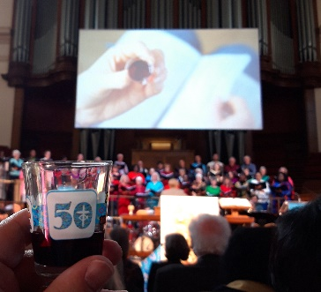
Former General Secretary the Revd Dr David Cornick, URC and Council for World Mission (CWM) scholar Victoria Turner, and the Revd Professor Jooseop Keum, CWM’s General Secretary, each delivered a sermon, and a specially formed Jubilee Choir sang ‘Always trust the star that guides us on the way’, Neil Thorogood’s winning poem in the 50th Anniversary Worship Resources Competition, in a setting by Scott Stroman. Other music in the service also included Colin Thompson’s competition-winning hymn, ‘God of the Pilgrim Way’. The climax of the service was the uplifting celebration of Holy Communion using special glasses donated by our partner church in Germany, the Evangelische Kirche der Pfalz. It can be viewed at Service of Thanksgiving - United Reformed Church and the order of service can be downloaded here Order-of-service-2023-web.pdf (urc.org.uk).
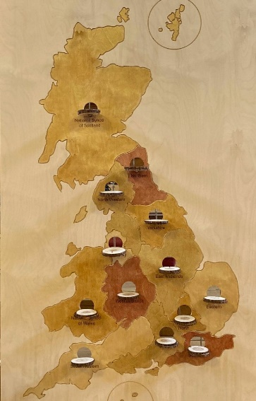
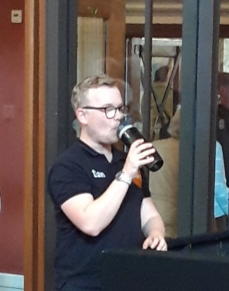
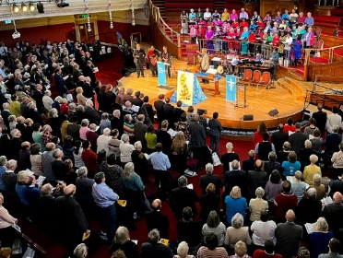
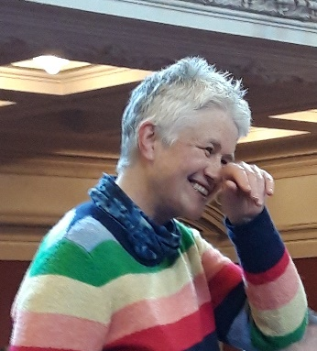
For those with eagle eyes watching the video may well spot a certain Yorkshire Synod Clerk with his long suffering daughter in the gathered congregation and he tells me that it was an extremely fulfilling experience to be there (and much louder than the YouTube video at https://youtu.be/34bymAfzws0 implies). Some of the pictures he took were rather shaky, but at least one of the Yorkshire contingent was having a good time whilst behind the scenes it was thirsty work for those who were part of the team that put this incredible day together.

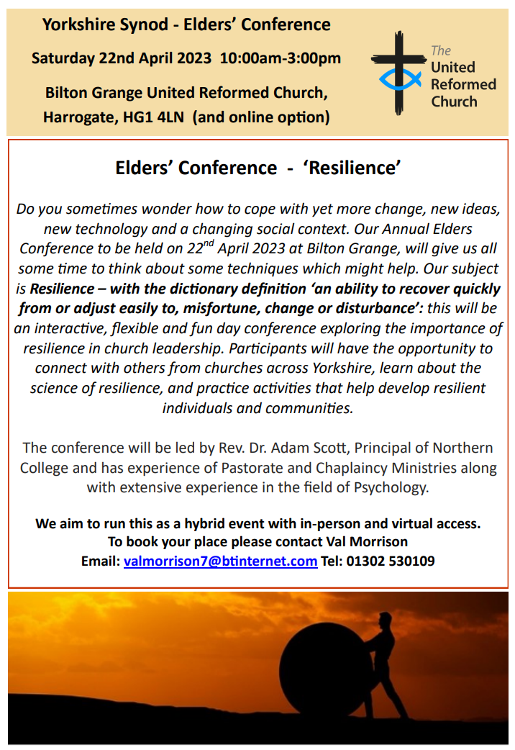
18-25 Project
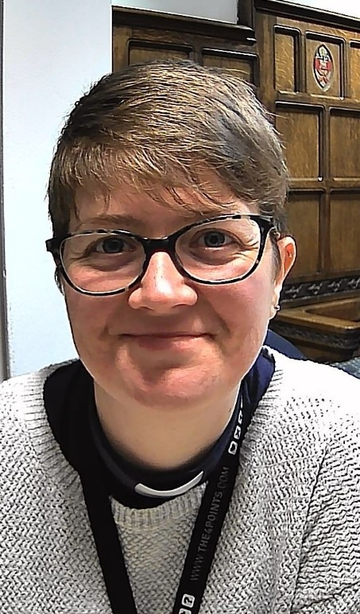
Friends, you might remember me, but let me reintroduce myself. I’m Samantha Sheehan and I am a Special Category Minister tasked with exploring how congregations can engage with 18-25 year olds and Young Adults. I live in Leeds and spend part of my time with the Ecumenical Chaplaincy team serving four of the Universities in Leeds. I also work with Megan in supporting the Young Adults (18-25ish year olds) in Synod (know of any, we would love to meet them at our monthly coffee meet up’s) and the rest of my time is spent exploring how as church we can minister to and engage with young adults and hopefully talk with you lovely people sharing stories and working together to see what all this might mean for you!
Back in Oct 2020, I offered a presentation at Synod Together, as an introduction to the project and to start the conversation.
Well friends, the good news is I am still here, still happy to share in that conversation, to come and meet you where you are, listen to your stories, and help to explore how you might be able to reach out and engage with young adults in your area.
A good place to start, to help take stock, is to have a look at the 20-40 Task Group Report (pg 22-32) which was presented at General Assembly in 2018. There are a number of questions in the appendix to help.
You can get in touch with me at rev.s.sheehan@gmail.com or phone 07484 791 049, always leave a message and I will get back to you.

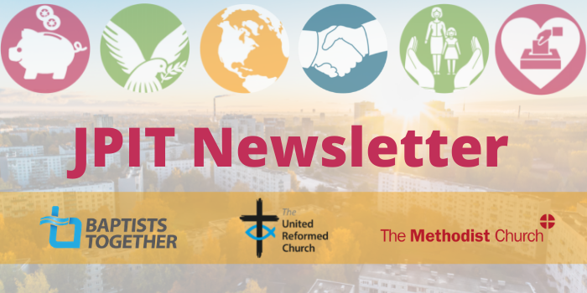
The latest issue of the JPIT Newsletter is now out. Click here to read it Joint Public Issues Newsletter (jointpublicissues-news.org.uk) and follow the link to subsribe to it as well.
Lay Training news

Lay preachers and Worship Leaders Weekend
‘Preaching Trauma and Resilience – Bible and World’
at the Wydale Conference Centre, Brompton by Sawdon near Scarbrough
https://www.wydale.org

We are pleased to say that registration for our second Lay preachers and Worship Leaders weekend at Wydale Conference Centre is NOW OPEN. This will be 7th – 9th July 2023 (Friday teatime to Sunday lunch).
We are excited that Dr Megan Warner, Old Testament lecturer from Northern College, will be our main speaker at the conference, and that once again we will be joined by our Moderator, Rev Jamie Kissack.
This weekend will again be paid for by grants successfully applied for, so you will only need to cover your travel costs. There are 30 places available and you are now invited to register with the office at office@urcyorkshire.org.uk or 0113 289 8490.

Yours in Christ’s service
Kath Lonsdale, Anne Dale, Jill Fletcher, Rod Morrison,
Lay Preachers and Worship Leaders Planning Group
For any queries, please contact Kath at kathlonsdale@talktalk.net 01274 315203 07759525936

The second edition of the Education and Learning Newsletter has just been distributed and it follows on from the success of their first Newsletter issued last month. This issue focuses on all things Education and Learning and in it are a number of links to follow for more information including Church Leadership Programme, Assembly Accredited Lay Preacher courses, Exploring Eldership, Stepwise and training offered by Northern and Westminster Colleges.
Also on offer are the Exploring Easter Resources offered by the Stepwise Faith-Filled Community group in North Western Synod. To find out more contact Daleen Ten Cate, Missional Discipleship Mentor for North Western Synod, at: Daleen.TenCate@nwsynod.org.uk

Please have a look at it here E&L News April 23 (urc-news.org.uk) and share this as you are able. Education & Learning we would love to hear from you with any comments, questions, or contributions on learninghub@urc.org.uk and this is the e-mail through which you can sign up to receive it regularly.
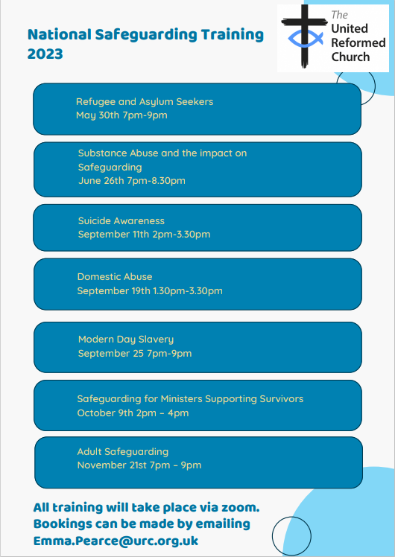
Safeguarding news
Our Safeguarding team are urging all who are in positions of trust within all our churches to enrol onto one of the Safeguarding courses that the Denomination and the Synod are offering. The national courses are being run through emma.pearce@urc.org.uk and seven have already been scheduled and are listed in the advert on the previous page.
The two key Synod courses are the Foundation Course which is accessed online and the Intermediate Course which can be offered both online video course, or if there are sufficient numbers, in person.
Safeguarding Intermediate Training
25th April 2023 – 6.45pm to 9.15pm – in person training at Herringthorpe URC, Wickersley Road, Rotherham, S60 4JN. Places are limited on this course so please book early.

4th May 2023 – 10am-12.30pm via zoom
16th May 2023 – 1pm-3.30pm via zoom

If you would like to book a place on any of the above courses please do so soon as the spaces are running out quickly. Also if you need more information on these and other courses, or for other related Safeguarding matters, please contact Paula Kitson, our Safeguarding Support Officer at
safeguardingsupport@urcyorkshirenorthern.org.uk

Yorkshire Synod Discipleship Development small grant fund 2023
During 2022 the Ministries Committee were pleased to authorise 8 different applications to the national small grant Discipleship Development fund which used up the whole of the £2000 Yorkshire Synod was allocated. Happily Synod has had confirmation that the same amount will be available during 2023. If anyone wants to discuss an application before submitting it please contact the Convenor of the Yorkshire Ministries Committee, Kath Lonsdale at kathlonsdale@talktalk.net.
Remember this is for any age to apply so please discuss with your young people as well as adults.

Gift Aid claims on digital donations
Churches and chapels that have installed card-readers to take casual donations by visitors should note the following: HMRC has issued new guidance which states: “Donations made using digital platforms, credit card or debit card may incur an administration fee which reduces the actual amount received by the charity. Subject to the normal qualifying conditions, the gross donation paid is eligible for Gift Aid, regardless of any processing fees incurred by the charity. The charity may treat these administrative fees as charitable expenditure. Where the charity is unable to demonstrate a clear audit trail of administration fees incurred Gift Aid should only be claimed on the net donation received” [our emphasis].
This might be an opportunity to claim more Gift Aid.

Saltaire Celebrates World Heritage Day

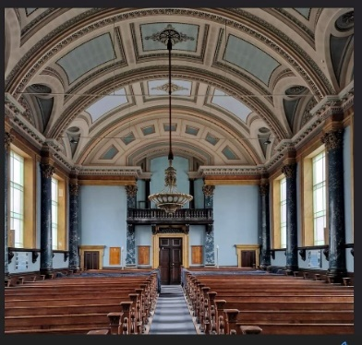
With the village of Saltaire, Saltaire United Reformed Church is celebrating World Heritage Day on Saturday 22 April 2023. Most of the activities are being held in Roberts Park and throughout the village from 10am to 10pm and this family event will include guided walks, Heritage stalls, rides, live music and entertainment at the bandstand. The event will end with a spectacular lantern parade.

Saltaire URC will be opening its doors to visitors on both Saturday 22nd and Sunday 23rd April from 1pm to 4pm.
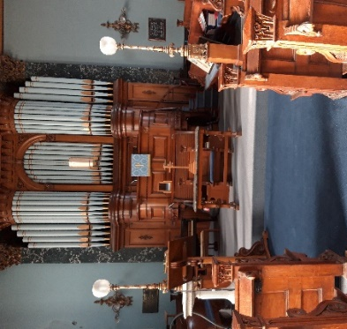
Here is an opportunity to visit the church there to marvel at the skill of the craftsmen who have recently completed repair of the part of the ceiling which collapsed in February 2020.
In the church you will be able to browse through their albums containing photographs of events over many years, including the ever popular weddings album. You will also find information about the history of the church and be able to see some of their archived memorabilia.
There will also be opportunity to listen to the organ being played at various intervals during the afternoons.
Saltaire URC looks forward to welcoming you to this Grade 1 Listed church. Yes, there is still major work to be done, but we still think it’s worth a visit!

General Assembly 2023
The General Assembly of the United Reformed Church will take place between 30th June and 3rd July at The Hayes Conference Centre in Swanwick, Derbyshire. Each Synod is able to send 16 representatives, comprising ministers and lay peoplincluding 2 ‘under-25s’. We are particularly looking for any lay people who would like to be involved this year as it affords an opportunity to be involved in discussions about the current and future work of the church, and to listen to varied speakers and conversations. If you are interested in learning more about General Assembly, you can look at the links on the URC website here General Assembly, Assembly Executive & Assembly committees - United Reformed Church. If you would be interested in attending this year, could you please contact the Synod Clerk at clerk@urcyorkshire.org.uk.
YOU’RE WELCOME COURSES
The Education and Learning part of the URC is again running its “You’re Welcome” courses again. This year there are two versions of the course, which brings in elements of courses that have run in the past, in particular “Ethos and History” and “What is the URC?”

1) The Zoom sessions which take place from Friday 9 – Saturday 10 June 2023. These sessions are for accepted candidates entering EM1, and are in fact mandatory for them. Over the last 2 years, however, we have extended the invitation to new Church House and Synod admin staff, and also Assembly Accredited Lay Preachers.

2) The residential course at Westminster College, Cambridge, which runs from lunch on Monday 2 October through to mid-morning on Wednesday 4 October 2023. This course has always been for ordained ministers of other denominations working in Local Ecumenical Partnerships and also for those on Certificates of Eligibility. In recent years we have also invited Assembly Accredited Lay Preachers, AALP trainees and new Synod field staff e.g. Training Officers and CYDOs. The sessions are led by staff and resource persons from the URC and Westminster College. Please note there is a fee for this course (£150 last year and the year before) and this fee, plus the delegates’ travel expenses, should be covered by their URC synod.

Both versions of the course include sessions on the history of the URC, what it means to be part of the URC and its mission today, and how to be intergenerational and intercultural.
For more details and further information please contact Philippa Linton, the Administrator to Education and Learning at philippa.linton@urc.org.uk.

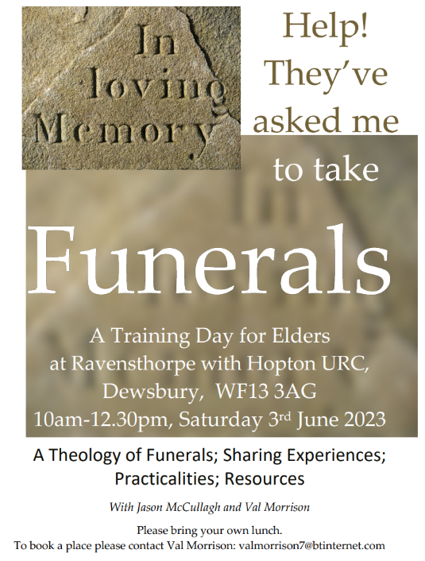
Funeral Training
Increasingly Elders are being asked to conduct funerals and we have been asked to repeat the session we ran a little while ago to help them in that task.
The session will be led by Rev Jason McCullagh and Mrs Val Morrison and will be informal, sharing experiences together with some input from our own experience.

Details are included on the attached flier. To book please contact Val at
valmorrison7@btinternet.com

Hot off the press is this month’s URC News Update April 2023 (urc-news.org.uk) Click on it to get the latest news from around the denomination.

#planting #revitalising #reimagining

We're recruiting a new Administrator

THE YBA is looking to appoint a part-time Administrator to our Admin Team based in Leeds city centre. This role has arisen as a result of the upcoming retirement of the current post holder.
With excellent administrative and organisational skills, the successful candidate will be highly organised and have a strong track record of multi-tasking. As a member of a team of three, good communication, collaboration and flexibility are essential as together we support our Regional Team and member churches.
An application form is available upon request from Debbie Gamble by email at debbie.gamble@yba.org.uk
For full details of the role - click here.
Interested applicants are invited to email Debbie to arrange an informal conversation.The closing date for applications is Friday, 21st April, 2023.

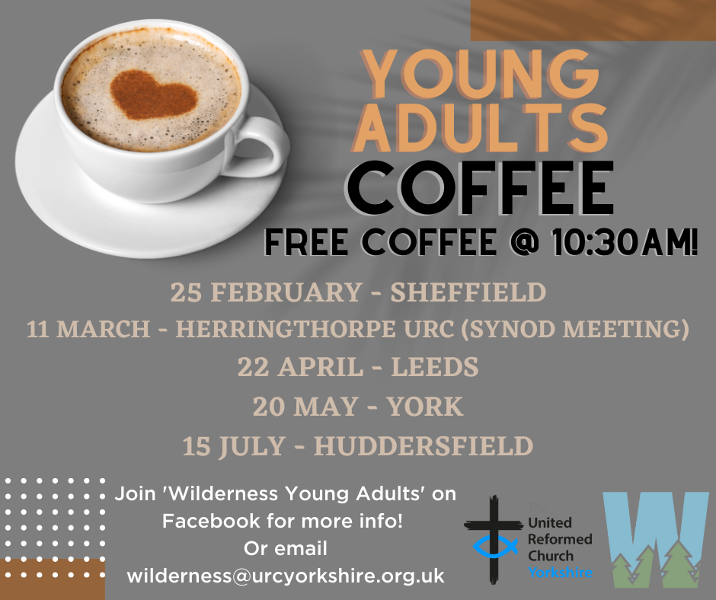
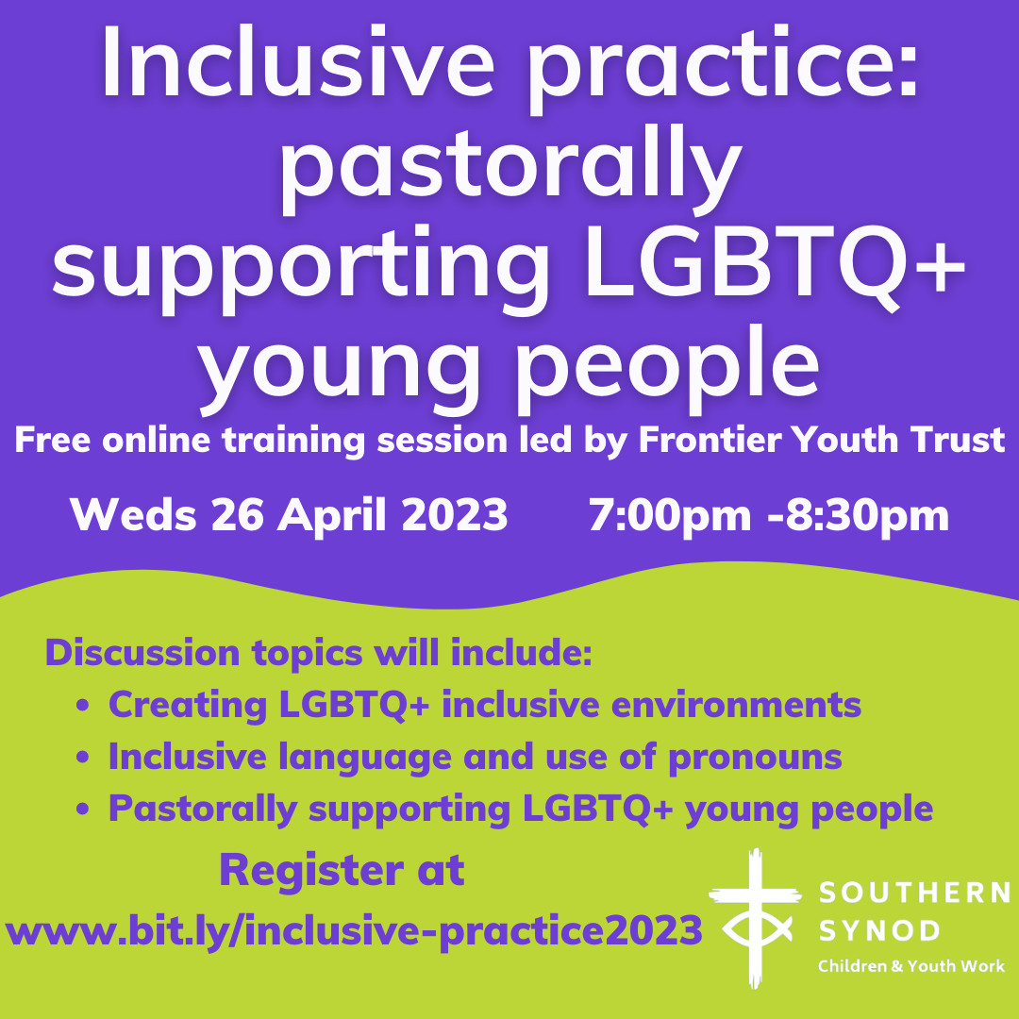

Dan will also be performing at Knaresborough URC on 29th April and will be taking part in the service at Bilton Grange on the morning of 30th April. For more information visit https://www.knaresboroughurc.org/ and Bilton Grange Urc | Facebook

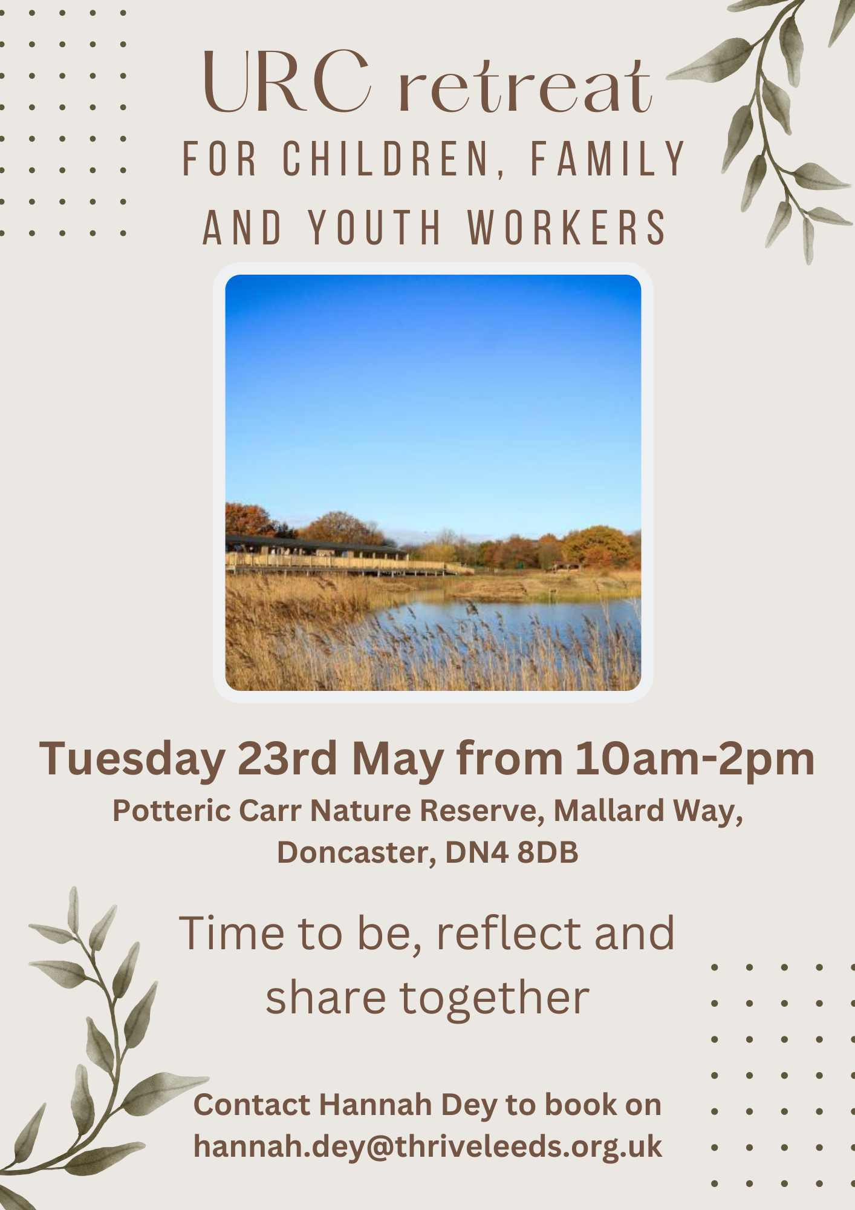
You can also keep an eye on all our social media platforms for news; on the website at Home - URC Yorkshire Synod, the Facebook pages at United Reformed Church in Yorkshire - Home | Facebook and Wilderness URC Yorkshire - Home | Facebook, the YouTube page at URC Yorkshire - YouTube and the Twitter page at URC in Yorkshire (@URCYorkshire) / Twitter.

