Musings from the Manse
Each year the church gifts to their ministers time away together at ‘Summer School’ to reflect and learn, have fellowship and fun and to simply be. In June I joined with 15 other Yorkshire Synod ministers and church leaders at Wydale Hall near Scarborough for 4 days of blessing.

On the first evening I led worship as we sat outside watching the
sunset and stopping in the moment to ‘be still my soul’. Worship continued taking in the beauty of God’s Cathedral of Nature, listening to ‘The day Thou Gavest Lord is Ended’, with the sound of sheep and birds adding to the life giving experience. | 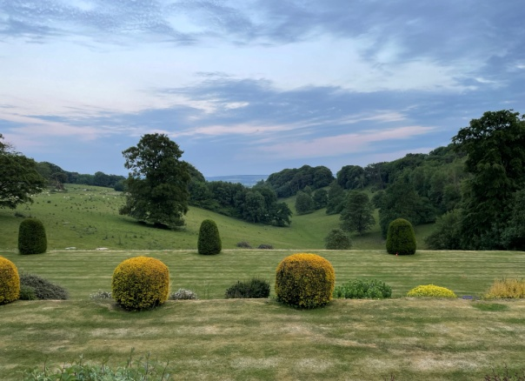
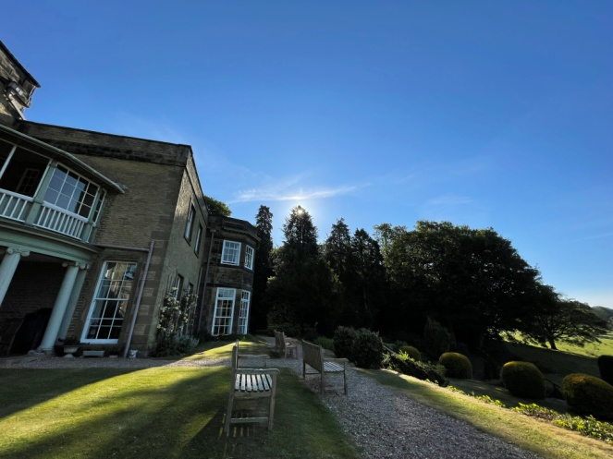 |  | ‘The sun comes up it’s a new day dawning’ sprang to mind as I sat alone outside with a coffee before breakfast on our first morning taking in the beauty of the moment in the amazing presence of God.
Hearing John Bradbury, the United Reformed Church’s General Secretary, share some reflections on the church over key periods in our history over 2000 years and how we are shaped today by those events made me reflect even more on how the church has been at worship over all this period because to put it simply yet profoundly, we love God and this is our natural response.

In the book we continue to use in both churches to encourage us, ‘Sleeping Giant – A call to the Church to Awake and Arise!’ Rev Tommy MacNeil states;
‘The truth about worship is that it doesn’t matter how it is expressed as long as it comes from the heart. The how of worship is never as important as the who of worship.’

Those words rang so true as I worshiped God at Summer School inside and outside, on the beach, in the fish and chip shop, in the chapel, in the heat of the day and in the stillness of the late evening. In each time of worship I felt able to give my full attention to God and praise him with all my heart. | 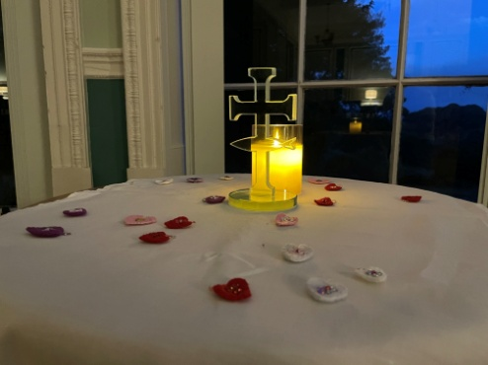
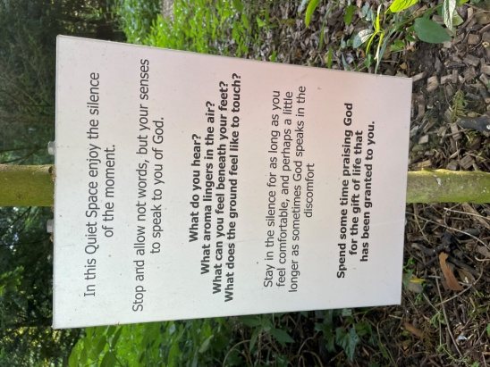 | In the beautiful gardens there is a Quiet Space for contemplation and worship and this sign sums up a place where I found God with me in such a tangible and breathtaking way.  A wonderful opportunity in a few days to ‘praise God for the gift of life’ and to do so at times on my own and at other times in fellowship and
conversation with my colleagues. God gives many gifts to us in which we are reminded of his love for us and our love for him and I hope this encourages you to find your times and places each day where you feel compelled to offer him your worship and delight in the privilege we share of those times we come together to worship.

Your friend and servant

Alan

