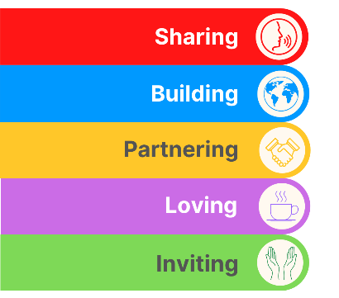
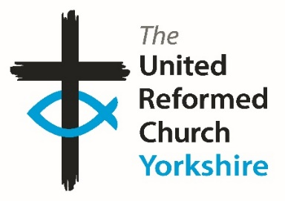
Yorkshire Synod Briefing
Number 113

24th August 2023

Are You Called?
I think I may have mentioned this in the past, but I always feel that this time of the year, and in particular the beginning of September, is a time of renewal, a time for fresh beginnings and a time to plan ahead for the future. Some of this comes from being refreshed after a summer holiday, some of it comes from still having school aged children whose new academic year begins in a couple of weeks, and dare I say having grown up in a Methodist/URC LEP, some of it comes from being attuned to the Methodist year’s cycle as well. This autumn sees plenty of opportunities to take up something fresh in our Christian lives. Courses on discipleship, eldership and safeguarding are all available, and invitations are offered to visit our historic churches or to attend key workshops on matters of justice and peace.
Now hidden away, at the bottom of last time’s Briefing was this appeal by me, and I’m bringing it to the front page as I feel that this time of the year is such a great time for new things. I am asking again to see whether you feel a call to help us out at Synod or whether you know of someone whose talents can be used to further the Kingdom through Synod.
Many of you who read this will have worked with the Synod team and may know that the functions of Synod are quite often left in the hands of the excellent staff based in and around the Synod office in Morley. However behind this team, supporting them and guiding the way in which Synod looks to support all the churches in its care, are another group of people without whom the basis of what we do would falter. These are the people who sit on the various committees which are at the beating heart of Synod life. They prayerfully consider the way in which the Synod moves; through offering pastoral care to giving financial advice, from offering a broad range of theological training to giving technical or compliance support.
This group of people is sadly diminishing so this call goes out to see whether you can fill any of the key roles Synod needs for it to function. At present there is a need for those with a financial acumen or interest to join the Financial Resources Committee as it plans how to best resource the Synod’s support for its churches. Similarly those whose expertise in bricks and mortar are gladly welcomed on to the Property Committee which supports churches in how best to utilise their buildings. Not forgetting those who have a call to help the pastoral and missional side of our many churches. We welcome anyone who can offer their wisdom and if you do feel called, please get in touch with me at clerk@urcyorkshire.org.uk or call on 07936 362673.

Thank you and God Bless,
Tim Crossley
Synod Clerk

Heritage Open Days
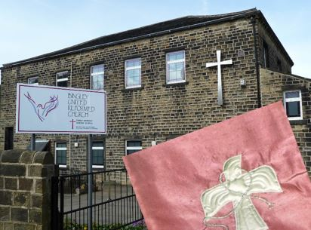
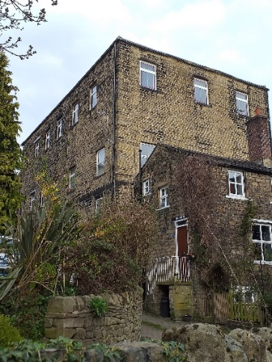
Bingley United Reformed Church is taking part in this year’s National Heritage Open Days – Creativity Unwrapped - over the weekend of 16th and 17th September. Besides their unique handmade pulpit falls, they will also be showcasing their stained glass light box, historic carved table and chair and embroidered church family trees. There will be refreshments and a family craft table.
On the Sunday the church will be celebrating their Harvest with a festival service as an integral part of the heritage weekend.

For more details about the weekend and about Bingley URC in general, please visit their website at Bingley United Reformed Church (bingleyurc.org)

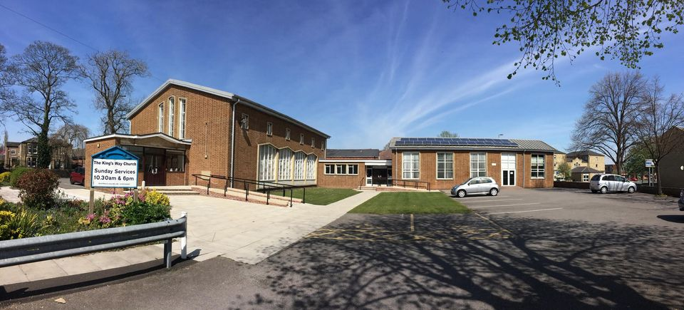
The Wednesday House Group who meet at The King’s Way Church, Ossett have organised their church’s Heritage Open Day based on celebrations for the church's 60th anniversary. Included over the weekend will be an Art and Photographic exhibition featuring local artists, the church’s Harvest Festival, together with a display of events over the 60 years of the life of the church.
The King’s Way church will be open on Friday 15th September through to Monday 18th September with light refreshments being served, the times being:
Friday 15 September: 18:00-20:00, Saturday 16 September: 10:00- 15:00 and Sunday 17 September: 13:00-17:00. No booking is required and all are welcome.
Check them out on social media at (4) The King's Way Church Ossett (official) | Facebook and also on the Heritage Open Day website at https://www.heritageopendays.org.uk/visiting/event/the-kings-way-church
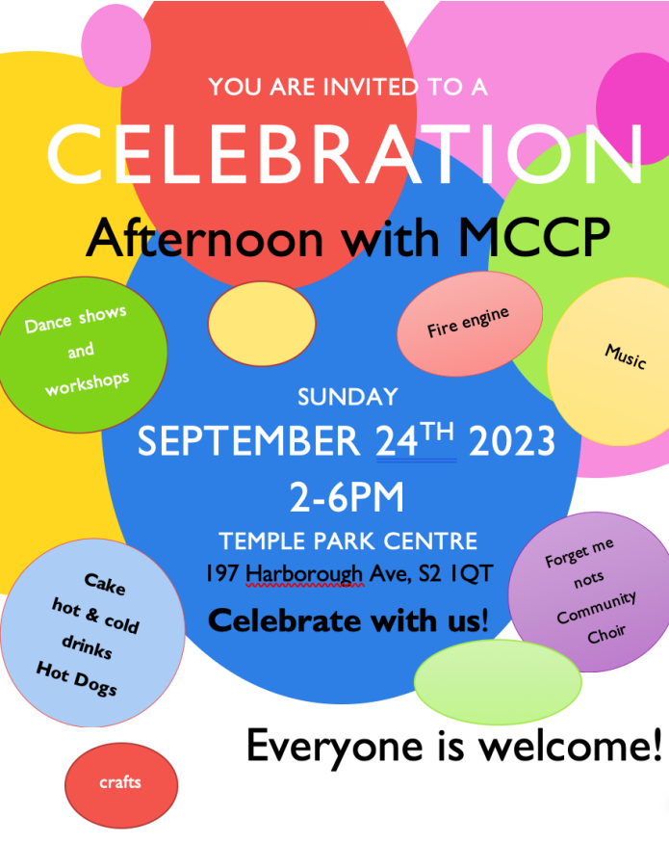
Manor Church and Community Project (MCCP) Celebration Afternoon on Sunday, 24th September from 2-6pm at Temple Park Centre.

St Mary’s in the Wood, Morley
The members of St Mary’s in the Wood Morley, established in 1650, have been working hard over the last 18 months to ensure a safe passage for our building in order that the people of Morley can still benefit from this cherished magnificent grade 2 listed building. The building on Commercial Street was erected in 1900 to help educate the youth of the town and was paid for by the Morley Congregationalists of St Mary’s. The building has been central to the people of the town and used by many in their time of need. The buildings future in the care of Leeds City College will replicate its original purpose all be it in modern day times.
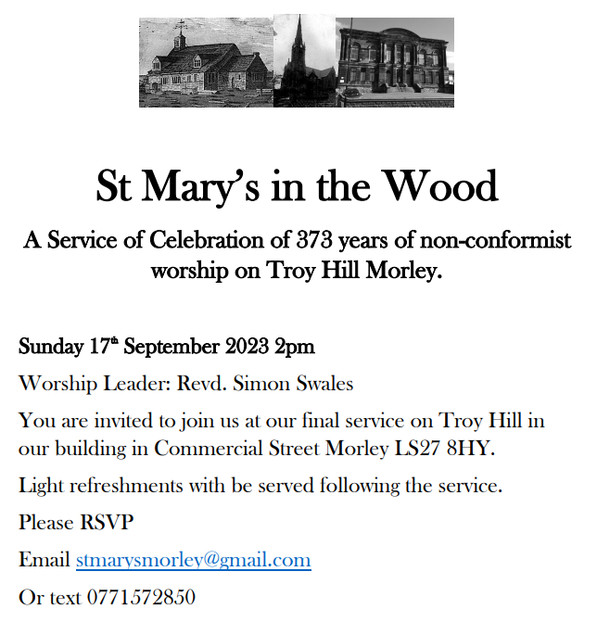
The church have therefore organised a service of celebration on Sunday 17th September at 2pm and this will be the last service on Troy Hill, to which everyone is invited. The members that remain will continue to worship in Morley as our friends at Central Methodist have offered us a room on Sunday in our time of need. When will have time and space to reflect on our mission.
If you could please RSVP to the church email address stmarysmorley@gmail.com if you intend to join us as we need to know numbers for the tea afterwards.
Journey of the Magi
This is quite an advanced notice from the team behind the Journey of the Magi touring show.
They currently still have dates available for Springs Dance Company's much loved Christmas production Journey of the Magi – a festive, light-hearted, joyful event with a moving and profound message.
Share the joy and wonder of Christmas with your church and local community through this exhilarating, critically acclaimed performance. The show offers a bridge between contemporary life and Jesus’s birth, comparing our own personal journey to Christmas day with the journey that the wise men took. With sparkle and songs to keep the children entertained and bags of good humour for the grown-ups, Journey of the Magi delights audiences of all ages and offer a chance to reflect and refocus.
“Absolutely fabulous show. Wonderful mix of fun, wit, and meaning. It made me laugh and it made me cry all in a couple of minutes. (Hope you'll come back)" - Richard, Poynton Methodist Church
Springs is inviting churches to host a performance of Journey of the Magi, which will be available nationally during Advent 2023.
Further information can be found on the Springs Dance Company website page https://springsdancecompany.org.uk/productions/journey-of-the-magi/, by emailing touring@springsdancecompany.org.uk or by calling 07775 628442.

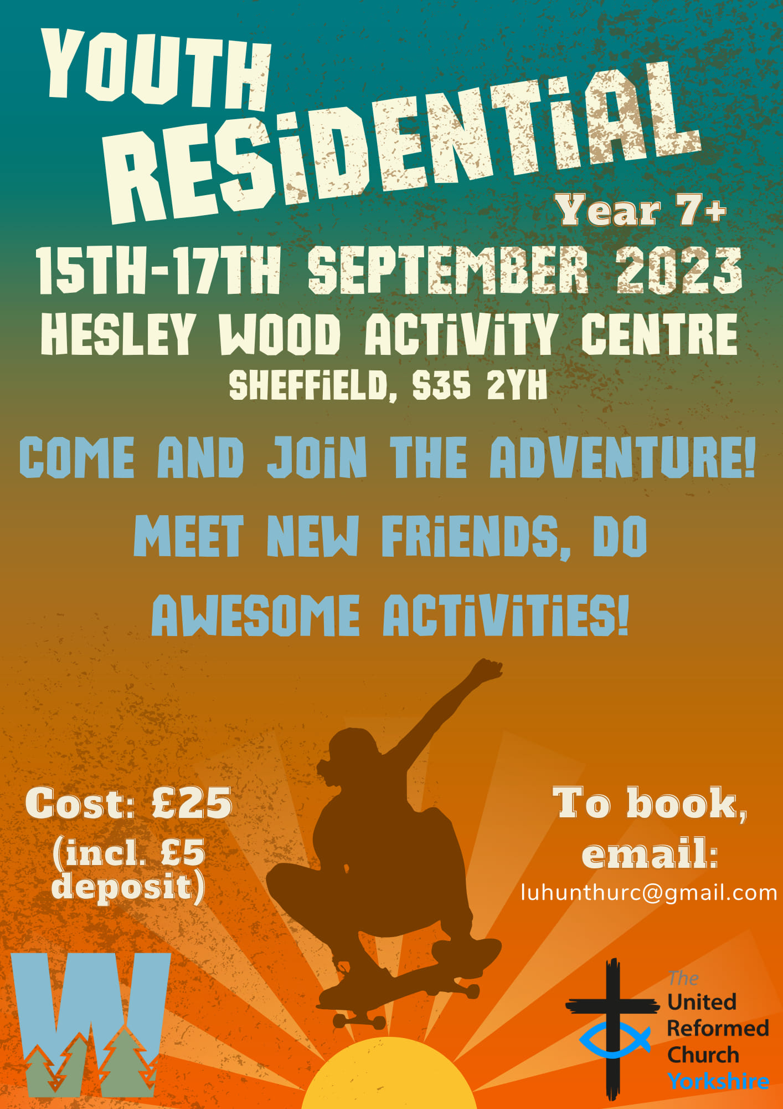
Contact luhunthurc@gmail.com to book!
Places are limited, don't delay, book today!

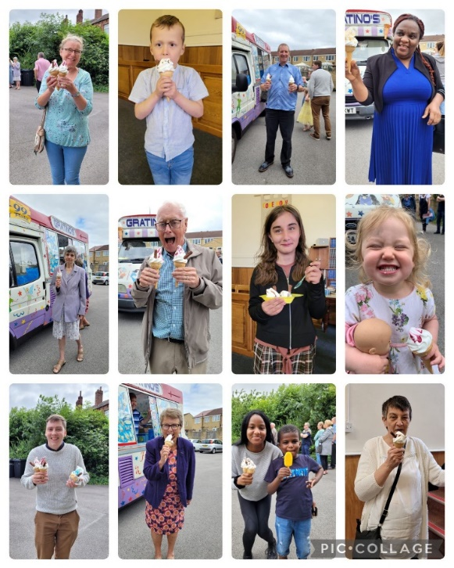
Heckmondwike URC held a service in July which was led by Junior Church staff, children and young people on the occasion of their Junior Church Anniversary.
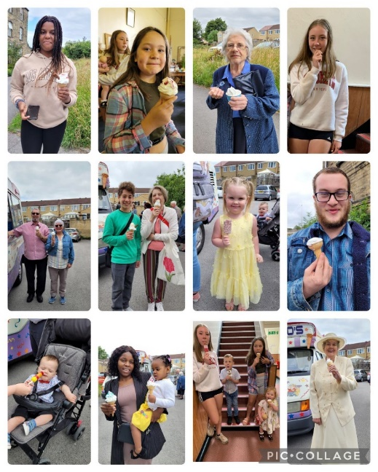
At the end of the service there was a belated celebration of Kieran’s Lundie Award, which was received during covid. The celebration involved the whole congregation having treats from a local ice-cream seller. As you can see from the faces this was very well received! Everyone thought it was a really cool idea and 99 times better than the usual tea and biscuits!

Celebrate God’s Gifts on Disability Awareness Sunday, 17 September 2023
Christian disability inclusion charity ‘Through the Roof’ is offering free resources for Disability Awareness Sunday on the 17th September 2023 (or a day of your choice). All churches are invited to celebrate the unique gifts God gives to each one of us – including disabled people. Follow this link to request a free resource pack: https://throughtheroof.org/forchurches/disability-awareness-sunday/.
Is your church or Christian community including disabled people in its ministry?

You can use Disability Awareness Sunday as a positive message to disabled people.

Access the free resources here, including free Disability Awareness postcards to order for your event.
Through the Roof is a Christian disability inclusion charity whose name is inspired by the Bible account in Luke 5. Our mission is to transform lives through Jesus with disabled people. For more information, visit www.throughtheroof.org or @TTRChangesLives.

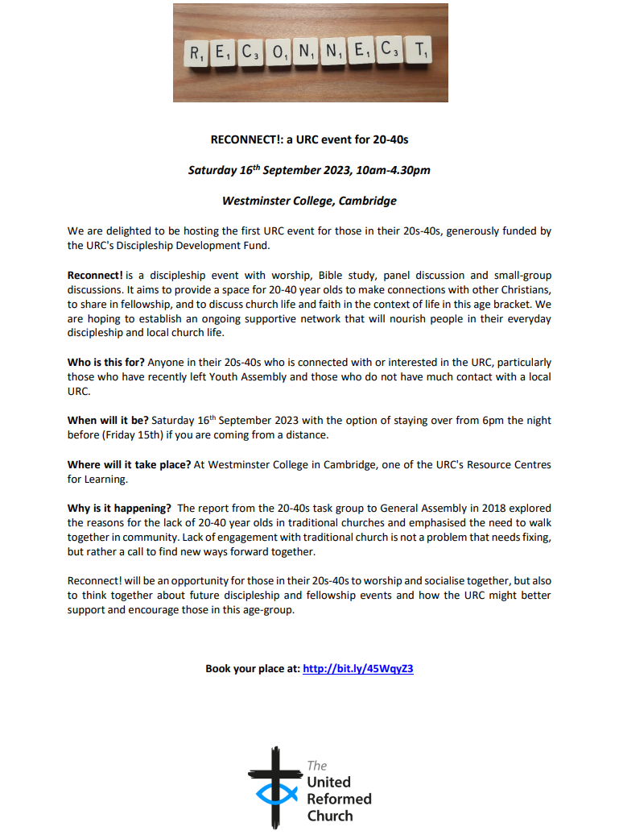
As mentioned, please book your place at: http://bit.ly/45WqyZ

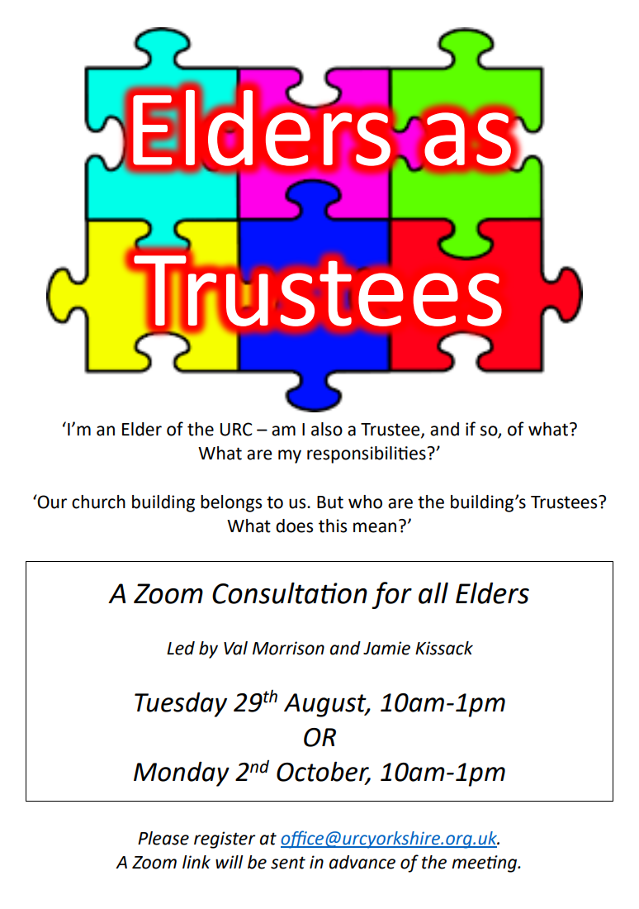
Three new Idle Church Members…………
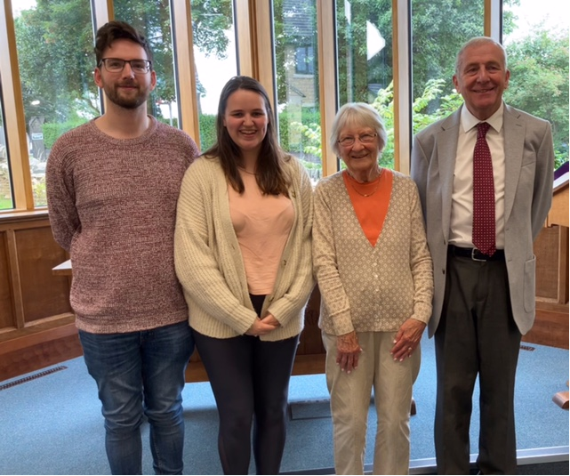
Many of you will know that I have a strange sense of humour, so when Graham Carter, the Church Secretary at Idle (Upper Chapel) United Reformed Church, got in touch with the great news that the church there had received three people into membership, the headline wrote itself.
Anyway, congratulations to the three new members seen here with Graham (on the right hand side). I hope you can join me in wishing them all the best as they continue their Christian journey at Upper Chapel in Idle.

Yorkshire Synod Discipleship Development
Grant funds 2023
The Discipleship Development Funds are intended to contribute to the development of lay people and therefore the purposes for which it can be used are as broad as can be generated by creativity and vocation, in line with the aims of the URC’s Discipleship Development Strategy (DDS), which are to equip the people of the United Reformed Church to:
- Create opportunities for everyone to encounter the living God, whether they
already identify themselves as followers of Christ or not.
- Encourage everyone in their prayer life and relationship with God to enable them
to live as disciples of Jesus.
- Encourage everyone to make the most of education opportunities that are relevant and appropriate for them in their discipleship journey.
The eligible costs would include, without being restricted to:
- National or denominational learning events, conferences or programmes developed in-house;
- Personnel costs;
- Courses (at any level) at any of the United Reformed Church Resource Centres for Learning or other suitable learning providers;
- Books, equipment and resources related to a particular topic or activity;
- Attendance at Synod learning events; and
- Travel costs for attending learning events.

There is a video for you to watch if you want at https://youtu.be/HQ8ODOW3rA0 and lots more information on the dedicated URC website page at Discipleship Development Fund - United Reformed Church

As ever though, if anyone wants to discuss any form of Discipleship Development project then look no further than our Convenor of the Synod’s Ministeries Committee, Kath Lonsdale at kathlonsdale@talktalk.net. And remember this is for any age to apply so please discuss with your young people as well as adults.

Legacies of Slavery

14th September 6.30pm to 8.30pm

with Rev Dr Rob Hoch
(Learning mentor for the NW URC Synod)

at St Andrews Church playgroup room
(at the rear of church hall on Newmarket Street, Skipton BD23 2 JE)

This event will explore the roots of racialised inequalities and injustices today which lie in part to the rhetoric, practice and fund raising of mission societies such as the Council for World Mission and others, which developed and perpetuated a racist colonial anthropology with which it recruited, made money and occupied White and Black minds, lands and bodies, dressing in in Christian vision. Find out more at https://www.cwmission.org/cwm-legacies-of-slavery-project-update/

All welcome – just turn up

For more information contact Judy touredrive432@btinternet.com

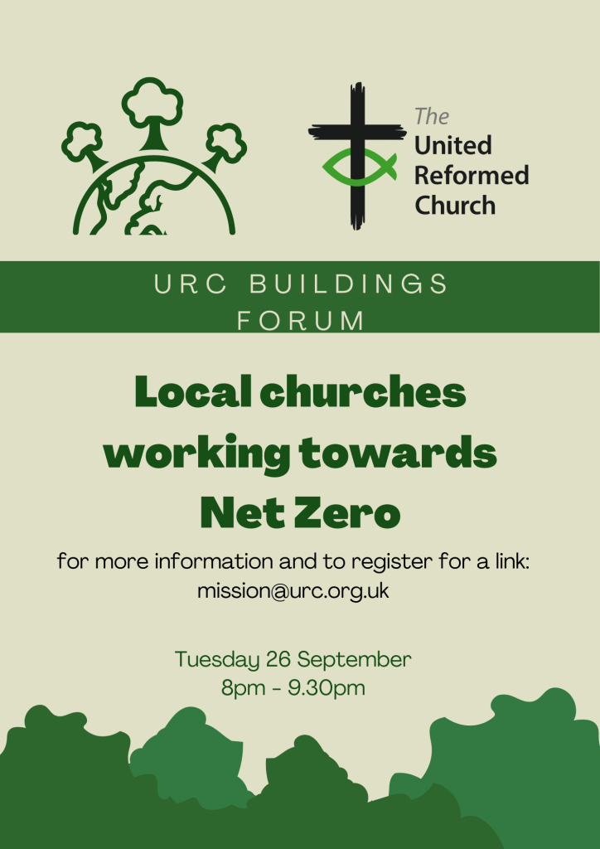
The next Buildings Forum Conference will be on 26 September 2023, 8pm - 9.30pm:
Working Towards Net Zero.
It will focus on environmental issues for church buildings, and we will be hearing from the URC’s Assembly appointed Net Zero Task Group and from churches who are on the journey.

For further information and to register your interest please email: mission@urc.org.uk including your name and email address and which church you belong to or are representing, if appropriate.

Information about the Buildings Forum and recordings of previous webinars can be found at: www.urcbuildingsforum.co.uk .
Safeguarding news

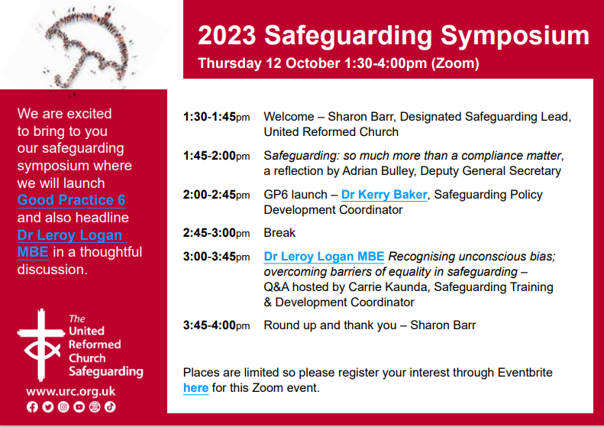
Places are limited so please register your interest through Eventbrite here for this Zoom event.
Safeguarding Intermediate Training via Zoom

We have two dates for a Zoom Safeguarding Intermediate Training course.
Please encourage your members who have completed the E-learning Foundation Course to take part if possible. The dates:-
20th September 2023 – 7pm to 9.30pm
26th September 2023 – 10am to 12.30pm

To book a place please email safeguarding1and4@urc.org.uk (Please note new e-mail address).

Don’t forget that there are National Safeguarding Courses are still running. The full list of courses can be found in previous Briefings, or you can contact emma.pearce@urc.org for more information

KELD RESOURCE CENTRE
IN PARTNERSHIP WITH LOW ROW WITH KELD URC
THE FINAL 2023 STUDY DAY
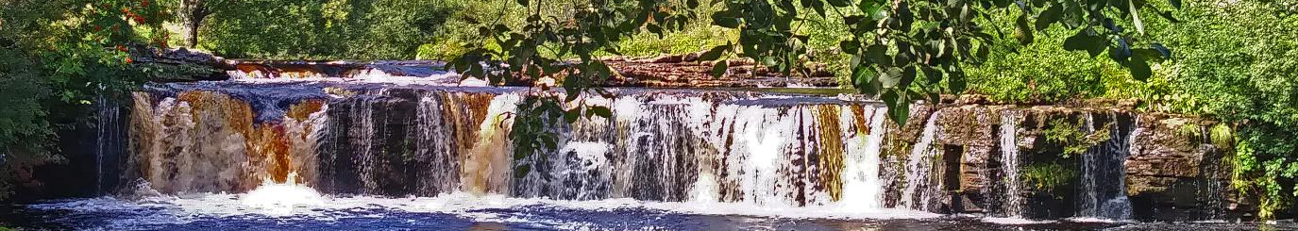
The Keld Resource Centre will be holding one more study day this summer.
Thursday September 28th:
Rivers of Living Water: Reading John’s Gospel in a Thirsty World.
Led by Rev. Jamie Kissack
The programme for the day will be as follows:

10.30: Arrivals and Coffee
11.00: Session One
12.30: Lunch
13.30: Session Two
15.00: Refreshments and Departure

There will be discussion, sharing, space to ponder …….
All participants are invited to bring a packed lunch. Drinks will be provided. The cost for the day will be £10 per person. To book, please contact Revd David Wood at david.wood4@btinternet.com.

Castleford URC
Church Photocopier: Free to good Home
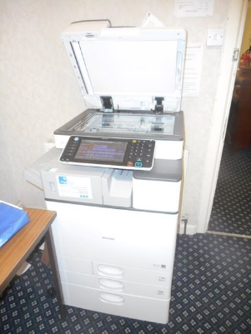
Castleford URC are sadly having to close and they are looking to offer certain items to fellow URCs in the Synod. One big piece of kit is their A3/A4 colour photocopier. It is a Ricoh MP C2003. The terms of the lease have now expired, so it now belongs to the church. It is in good working condition but due to Covid and closedown not serviced in the last couple of years.
Usage has been 21521 copies colour and 44057 black and white over its lifetime so in photocopier terms it has not had too hard a life. Also available are 4 toner unopened toner cartridges. Those currently in the machine are about 50 % used.
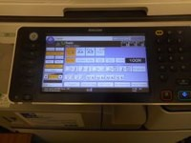
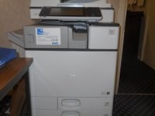
It would though have to be collected from the church.

To express an interest or find out more, please contact John Hoyle via the Synod Office at office@urcyorkshire.org.uk

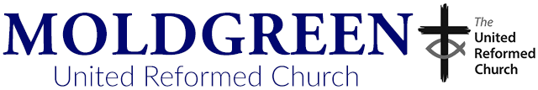
Community Worker
Moldgreen United Reformed Church is seeking to appoint a creative, experienced and knowledgeable Community Worker to support the “Unite – Respect – Connect” (URC) Project across three diverse local areas of Huddersfield (Moldgreen, Brackenhall and Oakes/Lindley).

The person appointed will work with individuals, families and communities, empowering them to:
- identify and articulate their challenges, needs and opportunities
- plan what they want to achieve and take appropriate action
- develop and run activities and events to generate, inclusion, aspiration and confidence
This is a new position that involves working alongside; a URC Minister, volunteers, local community groups, partner organisations and services (eg Kirklees Council, local schools, Neighbourhood Policing Team and Health Professionals). Whilst based at Moldgreen and reporting to a key member of the Unite – Respect – Connect Project Steering Committee the post holder will work across the Pastorate as necessary and determined by priorities and circumstances.

The post holder will work in partnership with others to develop, deliver and monitor a variety of community initiatives, activities and events (new and existing), which will support communities, help address inequalities and involve residents and young people, especially those living in more deprived situations. The post holder will also help to raise funding, monitor activity budgets and produce progress reports on the impact of the project and their work.
At least two years previous experience working and/or volunteering in diverse communities is essential. The successful candidate will be able to demonstrate excellent communication skills (written and verbal) and a ‘can do’ attitude. They must have the ability to relate to people of different ages and from diverse backgrounds, and build strong and effective relationships with stakeholders and partners. Good organisational and time management skills, and an ability to work as part of a team and independently, using their own initiative, are essential. The candidate will be able to work sensitively with people of all faiths and of no faith to ensure an inclusive approach to involving people in the URC Project and its related community activities and events.

The candidate will ideally have a related qualification in community development further to any GCSE and/or A Level qualifications (or equivalent). Good literacy, numeracy and IT skills are essential with the ability to compile emails, flyers and posters, and produce standard narrative and financial reports.

Initially the appointment is fixed term for a period of 12 months, with a six month probationary period but with a view, subject to funding, to continuing this role.

Hours of work are; 16 hours per week, normally undertaken in 4 or 5 blocks of time - this may well include working some evenings, bank holidays and weekends on occasions. The salary is £12,000 – £14,500 per annum depending on experience. The ability to travel around the communities of the Project is essential and therefore a car is desirable. Travel expenses will be reimbursed.

To request an application form and Job Description please email; office@moldgreenurc.org.uk
Closing date; 15th September
First round Interviews are expected to take place week commencing 25th September
Second round interviews will take place on Monday 2nd October

Finally, please let me have details of what YOUR church is doing. Let me know how the summer has been for you or tell me about what you plan for the autumn, drop me a line at clerk@urcyorkshire.org.uk and I’ll showcase it in the next edition, due out on 7th September with the deadline for submissions being on 5th September!!.

Tim Crossley

Tim Crossley
Synod Clerk

You can also keep an eye on all our social media platforms for news; on the website at Home - URC Yorkshire Synod, the Facebook pages at United Reformed Church in Yorkshire - Home | Facebook and Wilderness URC Yorkshire - Home | Facebook, the YouTube page at URC Yorkshire - YouTube and the Twitter page at URC in Yorkshire (@URCYorkshire) / Twitter.

