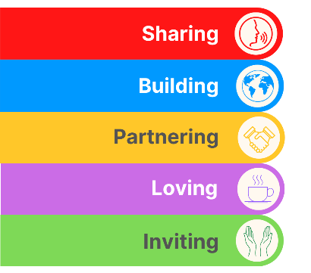
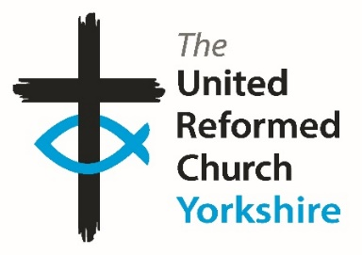
Yorkshire Synod Briefing
Number 116

5th October 2023

Synod Meeting Time
Much of the last few days has been spent getting the papers together for the forthcoming Autumn Synod meeting which will be held at Holme URC in Bradford. Holme is a church with a long history – according to the Synod Handbook it was established in 1835 – and moved to its present position 50 years ago. However, far from looking back the folk at Holme always look forward and especially in ways in which they can serve the community in which they find themselves. Over time they have adapted; from serving a community along the side of the main highway between Wakefield and Bradford to one serving a large post-war estate. The move to Madison Avenue in 1973 saw the start of their work with the Holmewood estate and if you chance upon their Facebook site at https://www.facebook.com/holmeurc/?locale=en_GB you may spot this logo. They are doing God’s work in their community and I hope that by supporting them at this Synod meeting we may all learn something to take back to our churches and communities.
The Synod Meeting will be a time to come together to worship, discern the will of God and learn of how our present Christian journey is progressing. We are fortunate to be able to welcome Roo Stewart, the Programme Officer for URC Church & Society whose emphasis at the moment is the URC and the Environment. With our growing Eco group, much of the day will be focused on how we can be better stewards of God’s creation. Not only that, we will be looking at extending the Synod Forums which were started this past summer as well as learning of the continuing commitment to Anti-Racism and the lessons being learnt as a result of the URC’s Legacies of Slavery journey. The Synod representatives will have received their mailings (or will have their packs dropping behind their letterboxes) and details of how to follow the proceedings will be published on the website in the days leading up to the meeting. Please hold those who attend, either in person or by digital means, in your prayers, and with God’s blessing we can move forward in the strength of Jesus Christ to bring his Kingdom closer.
Elsewhere in this Briefing there are other items to tie up your diary. Please take up the invitations being offered; celebrate the wide diversity of Christian Mission on show and let me know what you are doing in your churches and how you are furthering the work of the Lord in your area. Please let us know at Synod office and we will help you as best we can. Don’t forget, we are only a click or two away by e-mail at office@urcyorkshire.org.uk, or a call away at 0113 289 8490 or 07936 362673.

Thank you and God Bless,
Tim Crossley
Synod Clerk

PET BLESSING SERVICE
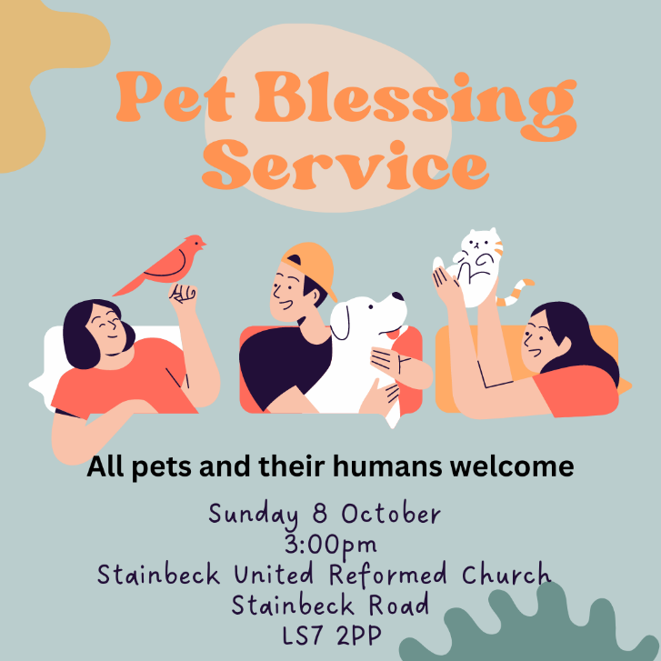
It seems to be that a welcoming paw is being extended around the Leeds Partnership churches this autumn. Stainbeck URC is hosting a Pet Blessing service at 3pm on Sunday 8th October, where you are invited to bring your four legged, furry, scaled or feathered friends and companions into the fellowship of our church.

Previously, on Saturday 23rd September, Headingley St Columba’s had hosted a Pet Blessing Service, so if you missed that, then the opportunity to celebrate is offered again.

The service is open to anyone and to any pet, large or small. If your pet is too shy or you are worried about bringing them, then bring along a photo and they can be part of the celebration as well.

Christchurch, Ilkley with the Beamsley Project

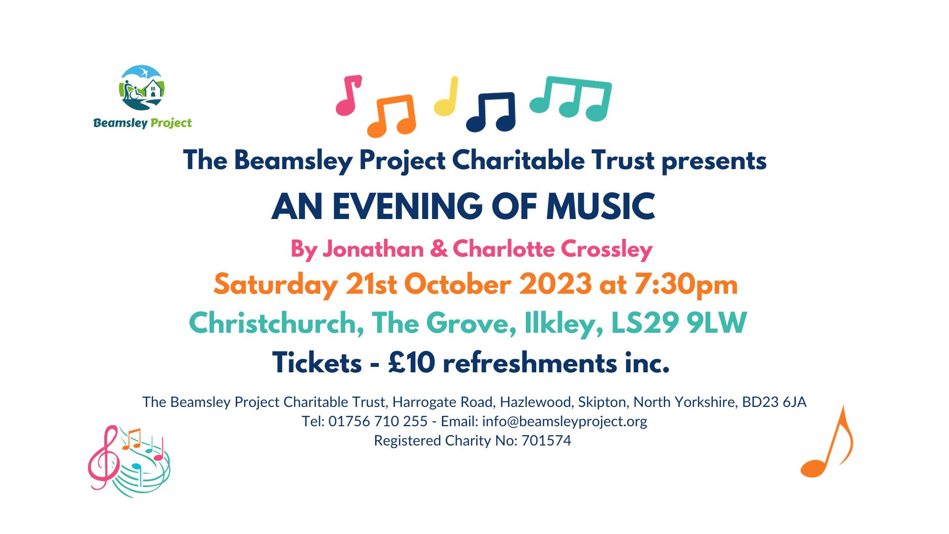

The Beamsley Project Charitable Trust presents an 'Evening of Music' at Christchurch, Ilkley on Saturday 21st October when the extremely talented Jonathan & Charlotte Crossley will entertain you with a variety of genres, including folk, blues, easy listening and classical, accompanied by a cornucopia of instruments.

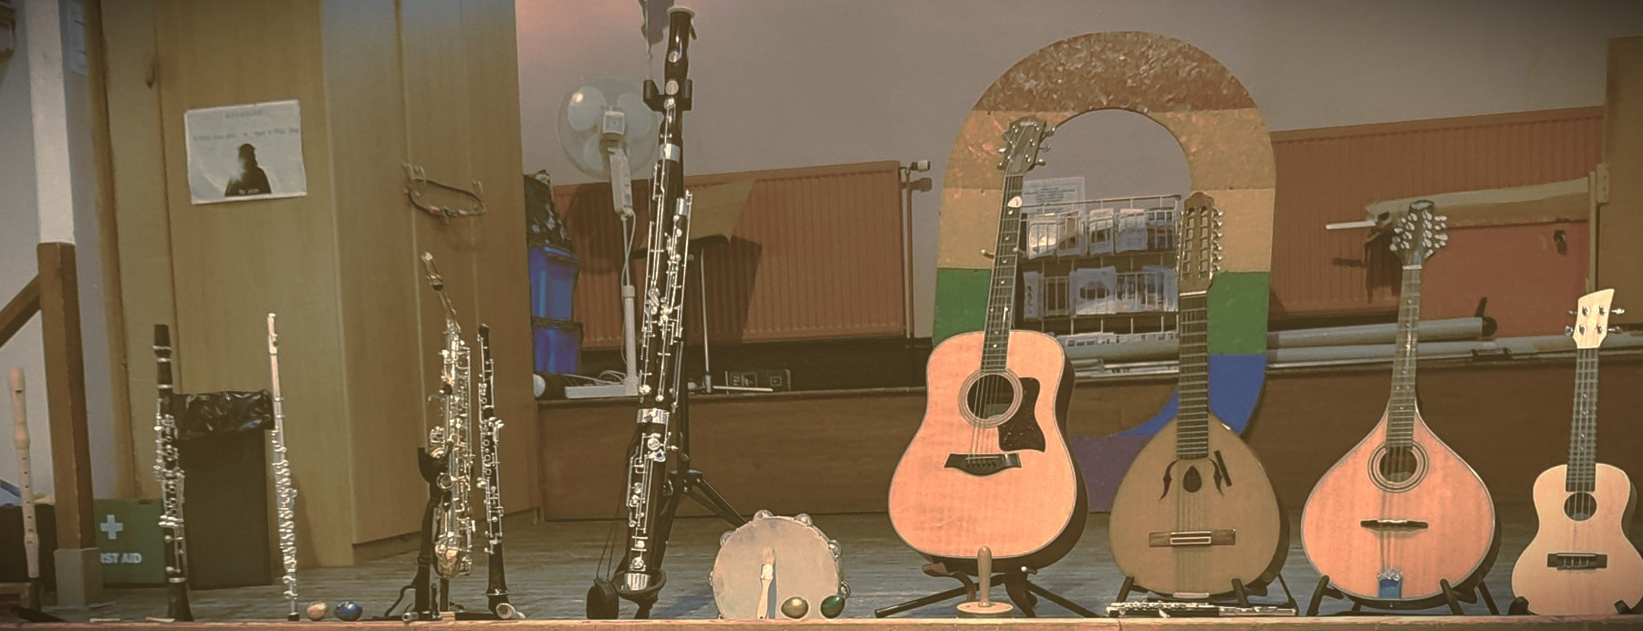
Tickets are available from the Beamsley Project Charitable Trust - Tel: 01756 710255 or info@beamsleyproject.org
Tickets are £10 per person and includes refreshments.
All proceeds will go towards the Beamsley Project’s bursary for 2024, the aim of which is to provide holiday accommodation for children with additional needs whose families are struggling financially.
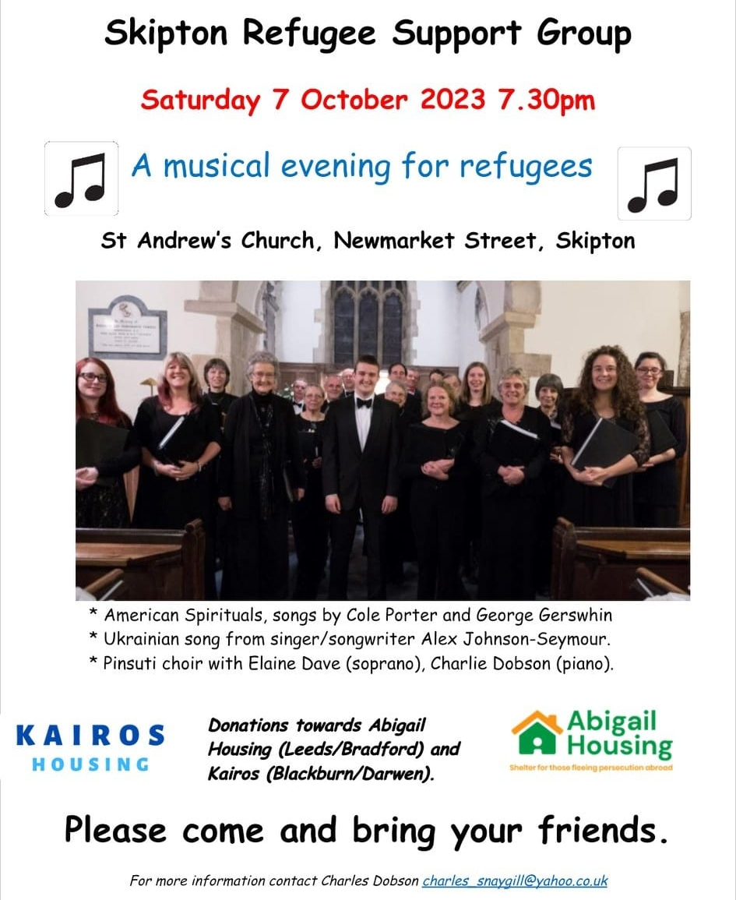
All are welcome to this concert and entry is free. However, donations of any size are welcome to enable Abigail Housing and Kairos help in their work with refugees and asylum seekers.
For more information contact Charles Dobson at charles_snaygill@yahoo.co.uk
Journey of the Magi
This is the last chance to look to get dates from the Springs Dance Company's much loved Christmas production Journey of the Magi – a festive, light-hearted, joyful event with a moving and profound message.
Share the joy and wonder of Christmas with your church and local community through this exhilarating, critically acclaimed performance. The show offers a bridge between contemporary life and Jesus’s birth, comparing our own personal journey to Christmas day with the journey that the wise men took. With sparkle and songs to keep the children entertained and bags of good humour for the grown-ups, Journey of the Magi delights audiences of all ages and offer a chance to reflect and refocus.
Further information can be found on the Springs Dance Company website page https://springsdancecompany.org.uk/productions/journey-of-the-magi/, by emailing touring@springsdancecompany.org.uk or by calling 07775 628442.

JOINED UP CONFERENCE 2023, YORK

FREE tickets available for anyone who would like to attend the Joined Up Conference in York.
Contributors include Parenting for Faith, Missional Generation, TLG, God Venture & more....
Contact Megan Tillbrook megancyp@urcyorkshire.org.uk to confirm your free ticket.

Lay Preachers and Worship Leaders lectionary planning zoom session

Following on from last month’s exploring of the October lectionary readings is this invitation for you to explore the November lectionary readings together on Wednesday 18th October.
Again, there will be two identical sessions, the first session being at 10.00am with a second repeated session at 7.30pm.
Facilitated by Rod Morrison in the morning and Anne Dale in the evening, this will be a time for participants to look together at the lectionary readings for 5th, 12th, 19th & 26th November in preparation for leading worship on those Sundays.
Please register your interest with Rod Morrison at rodmorrison1946@btinternet.com by Friday 13th October, indicating whether you will join in the morning or evening or if you are available for either, so if necessary we can balance the groups so both sessions are viable.
Both sessions will be held on Zoom and the link will be sent on Monday 16th October.

Please share these opportunities with anyone who leads worship in your church, whether on their own or part of a worship team, especially if they are new to this calling, to help us reach those who are not on our circulation list.
Yours in Christ’s service
Kath Lonsdale, Rod Morrison, Jill Fletcher and Anne Dale
Yorkshire Synod Lay Preachers and Worship Leaders Planning Group.

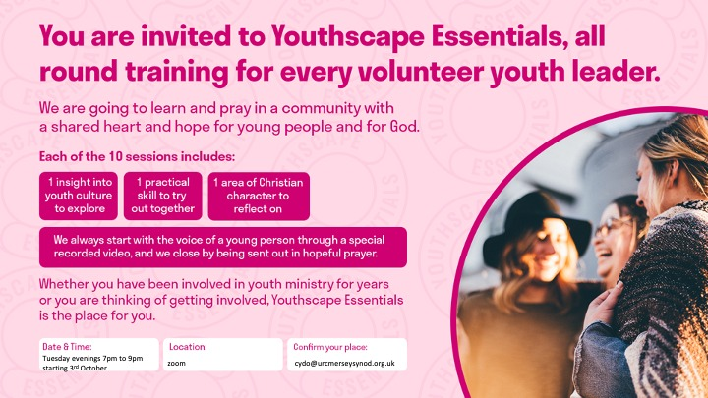
Youthscape Essentials is a ten week course to equip and strengthen anyone working with/ministering to young people in churches and community projects. Each week the course covers an insight into youth culture, a practical skill and an area of personal spiritual development. Each session is standalone so you can attend as many or a few as you would like.
The course will run every Tuesday night from 10th October to 12th December from 7pm to 9pm on zoom. The course is free to attend but we recommend buying the handbook from https://www.youthscape.co.uk/store/product/yse-handbook
Any participants from the Yorkshire Synod can claim back the cost of their handbook.
Roots resources for churches
New look, and brand-new Communion resources
Many URC churches already know and love Roots weekly resources - but have you seen their brand-new Communion material? 'Bread & Wine' is a new feature in the Adult & All Age resources, responding to a need for Communion prayers that are meaningful and accessible to all ages. In Roots Children & Youth, the new-look magazines include a captivating double-page 'story spread' every week, helping you engage children with the lectionary Bible readings.
View selected pages from the new magazines here - including resources for Halloween, Light Party ideas, and the full 'Bread & Wine' Communion resources for Sept-Oct:
https://www.flipsnack.com/rootsontheweb/sample-pages-from-roots-magazines-sept-oct-2023.html
Children and Youth Work
Advent Resources 2023– ‘God in the ordinary’.
The URC Advent resource for local churches to give away to families.
Following the success of the 2022 resource, the C&YW Team is producing an Advent pack with a huge poster, four mini-books, and things to make and do to help families find God in ordinary, everyday life. As previously, this will come in an unsealed envelope so churches can add an invitation to their Christmas services and events. Please pre-order by emailing the Children's and Youth Work Team children.youth@urc.org.uk with the quantity you would like to ensure you don’t miss out. Cost £2.50 per pack +p&p.

There is much more in the latest issue of the E&L Committee newsletter. It can be accessed here E&L News October Edition (urc-news.org.uk) and from there you can subscribe to receive it regularly.

RAAC in URC church buildings
Reinforced autoclaved aerated concrete (RAAC) is a reinforced version of autoclaved aerated concrete, commonly used in roofing and wall construction. It gained popularity from the 1950s as a cheaper and more lightweight alternative to conventional reinforced concrete. It is a 'bubbly' form of concrete predominantly found as precast panels in roofs, flat roofs, and occasionally in floors and walls (cladding). It has a bubbly appearance on the inside and looks a little bit like an Aero chocolate bar and unlike traditional concrete it does not contain aggregate and thus has a smooth appearance on the outside. The most common use of RAAC was for beams, used in flat roof and floor construction.
In the past few weeks, the term RAAC has been in the headlines due to a number of schools having to be closed, or partially closed, due to the presence of RAAC within them. It seems probable that other public buildings from the same period – like hospitals, prisons, libraries, theatres and leisure centres – may also contain various amounts of RAAC.

In terms of our church buildings the presence of RAAC is of little concern as most of our church buildings are considerably older than the 1950s. However, there are a few churches and church halls which were constructed in the post-war period and could contain it within a flat roof or occasionally a pitch roofed construction and the advice we are getting is to inspect those areas which may have manifested themselves in the following ways:
- Problems relating to the original construction, such as RAAC beams which were never adequately supported at each end.
- Problems relating to poor maintenance, including roofs where the overlaying waterproofing has failed, causing the concrete beneath it to have been wet for a long period, and to have deteriorated.
- Other issues which may be problematic, include flat roofs where extra weight has been added to address problems of water ingress. It will also be crucial to take into account the strength of RAAC when adding additional insulation to a building to improve its thermal performance.

The Government has produced a useful guide to identifying it which can be found here: https://assets.publishing.service.gov.uk/government/uploads/system/uploads/attachment_data/file/1182192/GUIDE-DFE-XX-XX-T-X-9002-Reinforced_Autoclaved_Aerated_Concrete_Identification_Guidance-A-C02.pdf
If you follow the guidance and find anything that potentially could be RAAC please contact your inspecting architect or surveyor and/or a structural engineer and arrange for a specialist inspection of the building, in consultation with myself.
If the building does contain RAAC it may not be necessary to cease using it. Your professional advisors will be able to inform you of the appropriate action to ensure that everyone is kept safe. If RAAC is present you should inform your insurers.
Any situation which might cause the sudden collapse of a building is clearly enormously concerning, and the safety of people must be the top priority. There is an urgent need to understand where RAAC was used, to examine whether or not it is now failing in each case, and then work out how best to repair or replace every building which requires urgent attention.
It is unknown if RAAC is present in URC owned buildings, although given many were constructed earlier than the 1950s this is unlikely, unless of course there were any additions to properties such as church halls.
Jane Bunyan
Property Officer, URC (Yorkshire) Inc.
Email: property@urcyorkshire.org.uk
3rd October 2023
Safeguarding news

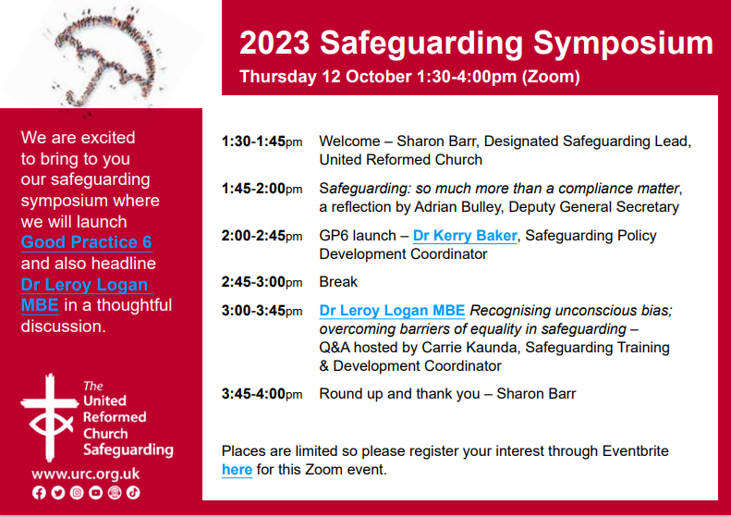
Places are limited for the 2023 Safeguarding Symposium and the launch of Good Practice 6, so please register your interest through Eventbrite here for this Zoom event as soon as you can.

Are You Called?
In the last few Briefings I have sent out this appeal and it is an appeal I will be putting out at the forthcoming Synod meeting. It is a call for those who feel that they can help the Synod to help our churches reach out to the communities in which they sit and for whom they serve. As this time of the year is such a great time for new things, I’m asking again to see whether you feel a call to help us out at Synod or whether you know of someone whose talents can be used to further the Kingdom through Synod.
Many of you who read this will have worked with the Synod team and may know that the functions of Synod are quite often left in the hands of the excellent staff based in and around the Synod office in Morley. However, behind this team, supporting them and guiding the way in which Synod looks to support all the churches in its care, are another group of people without whom the basis of what we do would falter. These are the people who sit on the various committees which are at the beating heart of Synod life. They prayerfully consider the way in which the Synod moves; through offering pastoral care to giving financial advice, from offering a broad range of theological training to giving technical or compliance support.
This group of people is sadly diminishing and at Synod next month we say goodbye to seven people who have served Synod in many capacities and who have yet to be replaced. So this call goes out to see whether you can fill any of the key roles Synod needs for it to function. At present there is a need for those with a financial acumen or interest to join the Financial Resources Committee as it plans how to best resource the Synod’s support for its churches. Similarly, those whose expertise in bricks and mortar are gladly welcomed on to the Property Committee which supports churches in how best to utilise their buildings. Not forgetting those who have a call to help the pastoral and missional side of our many churches. We welcome anyone who can offer their wisdom and if you do feel called, please get in touch with me at clerk@urcyorkshire.org.uk or call on 07936 362673.

Finally, please let me have details of what YOUR church is doing. Let me know how the summer has been for you or tell me about what you plan for the autumn, drop me a line at clerk@urcyorkshire.org.uk and I’ll showcase it in the next edition, due out on 19th October with the deadline for submissions being on 18th October!
Tim Crossley
Synod Clerk

You can also keep an eye on all our social media platforms for news; on the website at Home - URC Yorkshire Synod, the Facebook pages at United Reformed Church in Yorkshire - Home | Facebook and Wilderness URC Yorkshire - Home | Facebook, the YouTube page at URC Yorkshire - YouTube and the Twitter page at URC in Yorkshire (@URCYorkshire) / Twitter.

yes, they are relations – they are the Synod Clerk’s brother & sister!! (ed).

