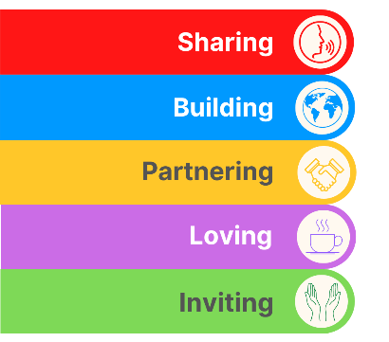
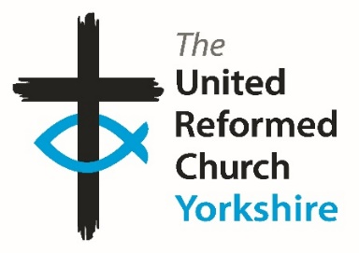
Yorkshire Synod Briefing
Number 117

19th October 2023

Synod Thank Yous
I’d like to take a little time here to say thank you. I’m not going to narrow my thanks down to any specific individual, mainly because there are so many people to thank at the moment, but to all those who help make The Briefing what it is. So, to those who read it, those who feature in it and to those who contribute to it, THANK YOU.
The reason for my expressions of thanks lies in the extremely generous welcome Synod received last Saturday at Holme URC, where the Autumn meeting was held. They are currently celebrating 50 years in that building, having moved from their original site off Tong Street in Bradford as a result of improvements to one of the main roads into (or out of) Bradford. Their move coincided with the construction of the huge estate over which the Holme church prays and to which it serves in so many different ways. If you were there on Saturday you will have seen that Christ given spirit of generosity at work and if not, check them out on their https://www.facebook.com/holmeurc/?locale=en_GB site.
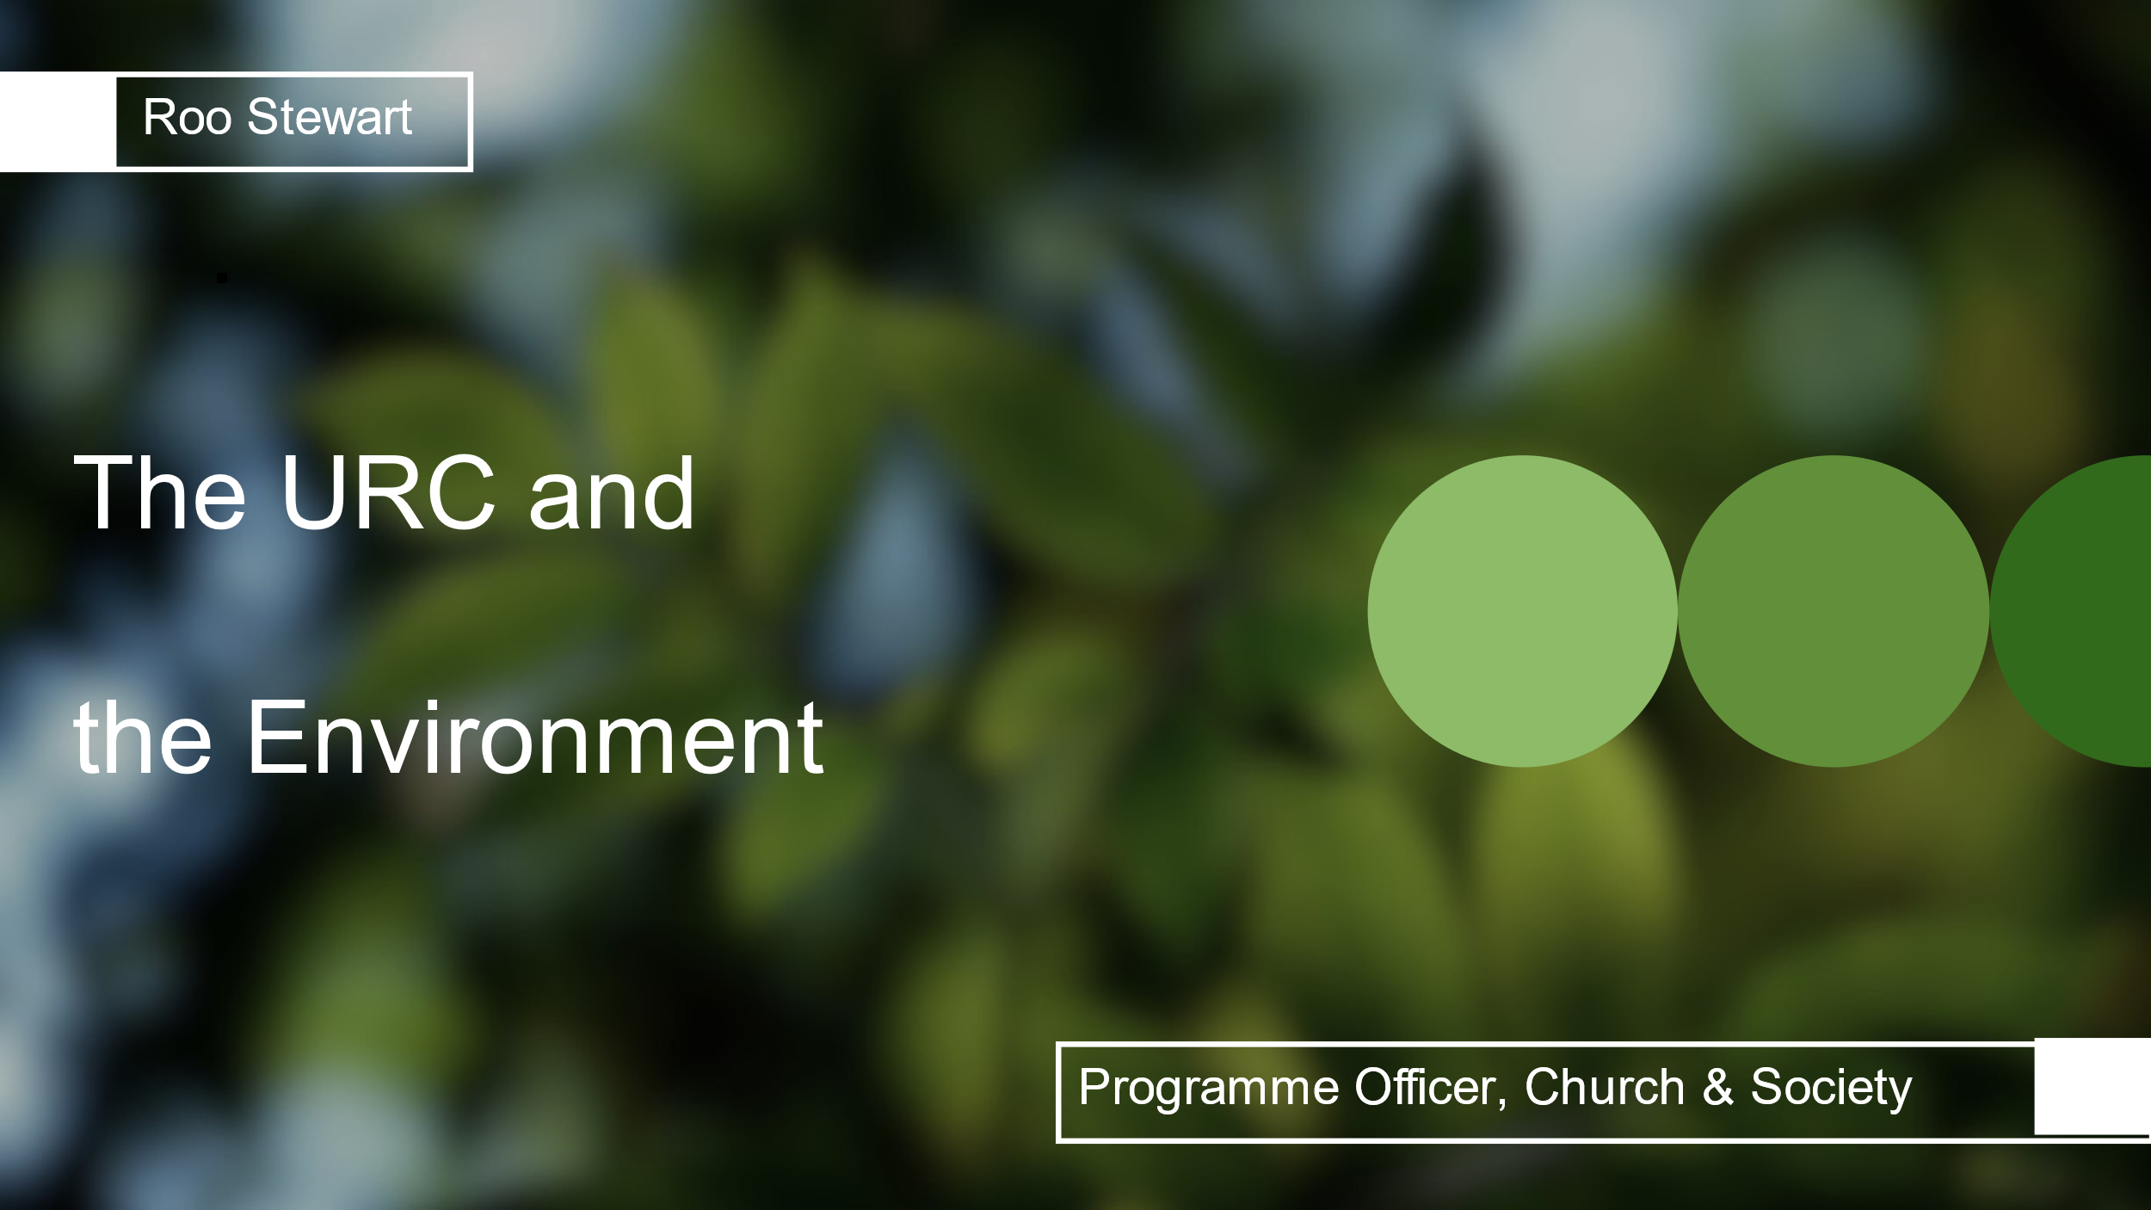
At that Synod meeting we were blessed to have Roo Stewart lead us in our morning worship and for him challenge us in our relationship with the environment. During the Synod meeting I offered to forward the slides, the Hymns, the Readings and the Prayers to those who asked for them. The links have been sent to the Synod representatives, but why limit this cracking resource to them, So with Roo’s blessing I’ve uploaded them to this https://www.dropbox.com/scl/fo/u6waxep1ec6uas1ep6azy/h?rlkey=8bgsi47ek9u697hfvc0w5f5s1&dl=0 file and as for the tunes for the hymns, Roo tells me that they were:
- Lobe Den Herren (the usual one) for “Praise to the Lord, The Almighty” (Rejoice & Sing tune 74)
- Roving Gambler (folk tune) for “Like the Weeping Willow” here with the lyrics in the correct order https://stlydias.org/blog/wp-content/uploads/2021/09/like-the-weeping-willow.pdf
- What a friend for “God, the maker of the heavens” (Rejoice & Sing tune 413)
In addition, I have also included the PowerPoint and script used to illustrate the Safer Recruitment presentation which I hope that these files will prove to be a rich resource for you to use in your own church or personal devotions.
During the day at the Synod meeting, with our growing Eco group, we were challenged as to how we can be better stewards of God’s creation. Not only that Synod committed itself to extending the Synod Forums to include four more events over the summer – full details to follow, and we also learnt of the continuing commitment to Anti-Racism and the lessons being learnt as a result of the URC’s Legacies of Slavery journey. Synod is always a conversation, so if you feel that you would like to contribute to the various conversations current in Yorkshire, please drop me a line and I can put you in contact with the relevant groups.
As usual, elsewhere in this Briefing there are other items to tie up your diary. Please take up the invitations being offered; celebrate the wide diversity of Christian Mission on show and let me know what you are doing in your churches and how you are furthering the work of the Lord in your area. Please let us know at Synod office and we will help you as best we can. Don’t forget, we are only a click or two away by e-mail at office@urcyorkshire.org.uk, or a call away at 0113 289 8490 or 07936 362673.
Thank you and God Bless,
Tim Crossley
Synod Clerk

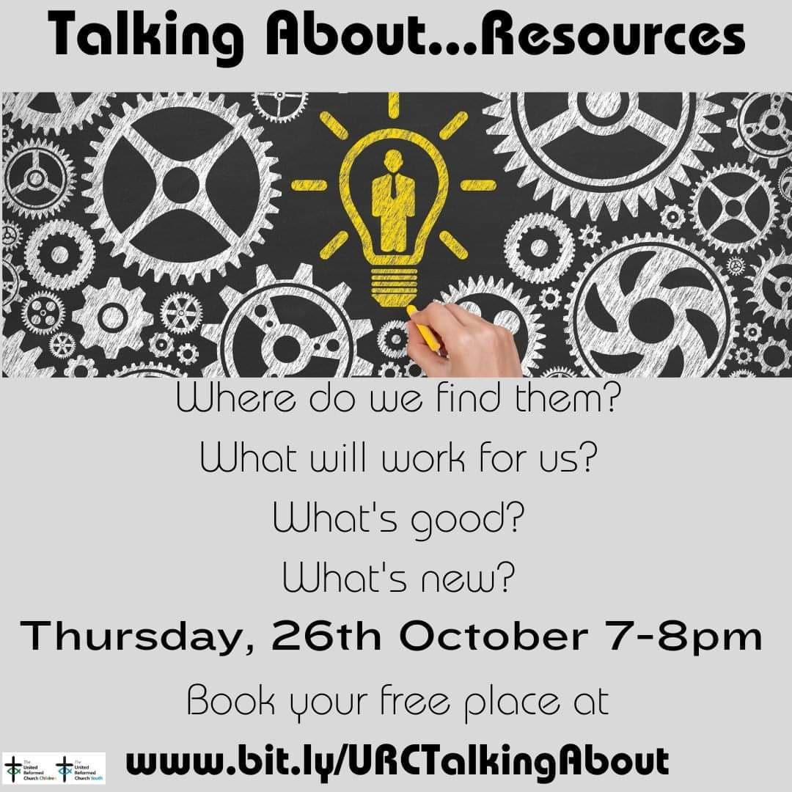
How do we find new ideas that will work with our group?
What are the latest resources in children’s and youth work?
Do we have to buy? Or can we borrow? Are there free resources that would work?
What should we be looking for in a good resource?

Join us on Thursday, 26th October, 7-8pm when Richard Knott, the Children and Youth Development Officer for East Midlands Synod and Lorraine Webb, the Children’s and Youth Work Programme Officer for the United Reformed Church, will share with us ideas on how to get hold of the best resources for our work with children and young people.
Book your free place at www.bit.ly/URCTalkingAbout
Christchurch, Ilkley with the Beamsley Project

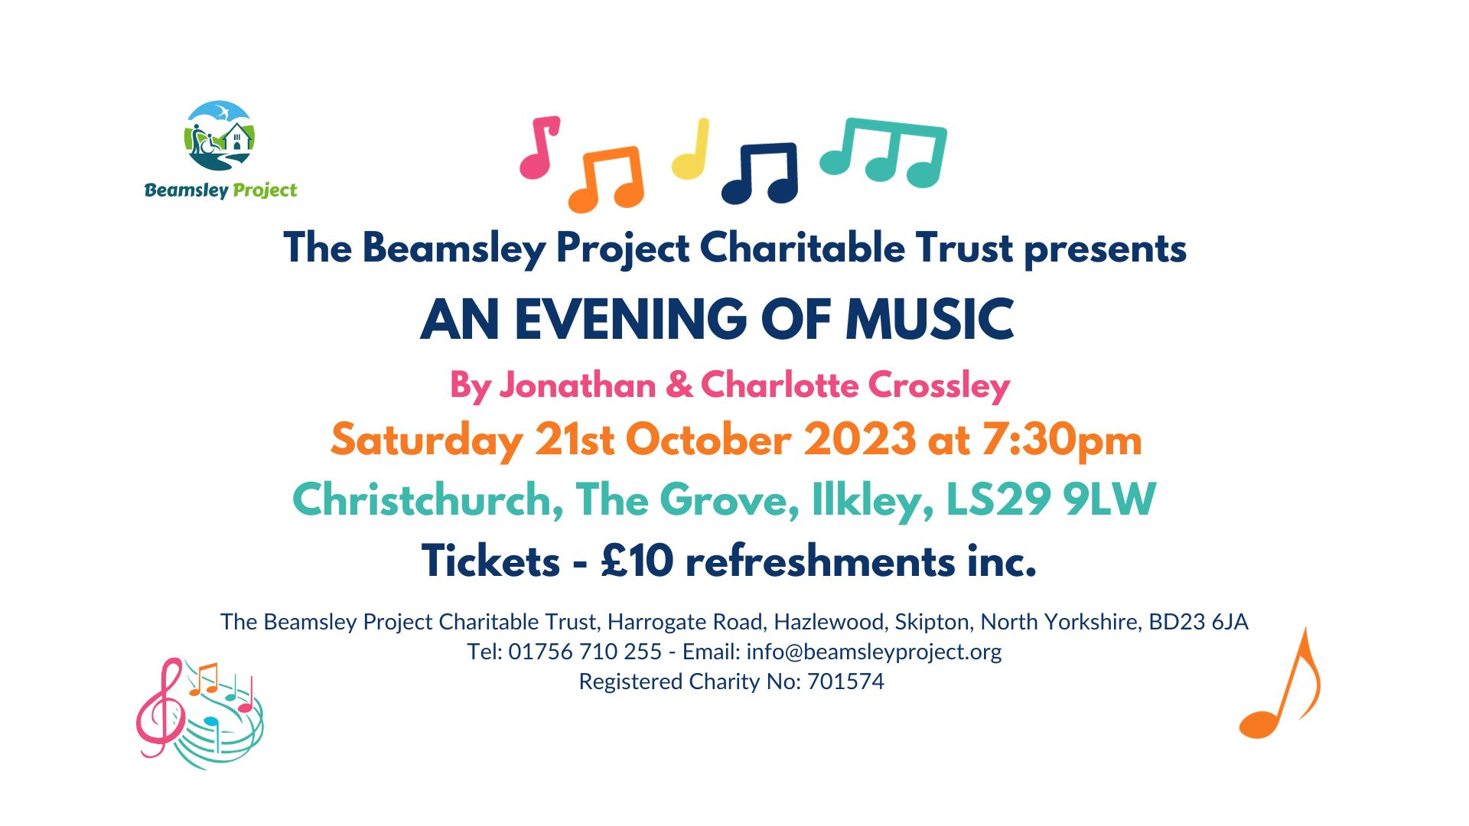

The Beamsley Project Charitable Trust presents an 'Evening of Music' at Christchurch, Ilkley on Saturday 21st October when the extremely talented Jonathan & Charlotte Crossley will entertain you with a variety of genres, including folk, blues, easy listening and classical, accompanied by a cornucopia of instruments.

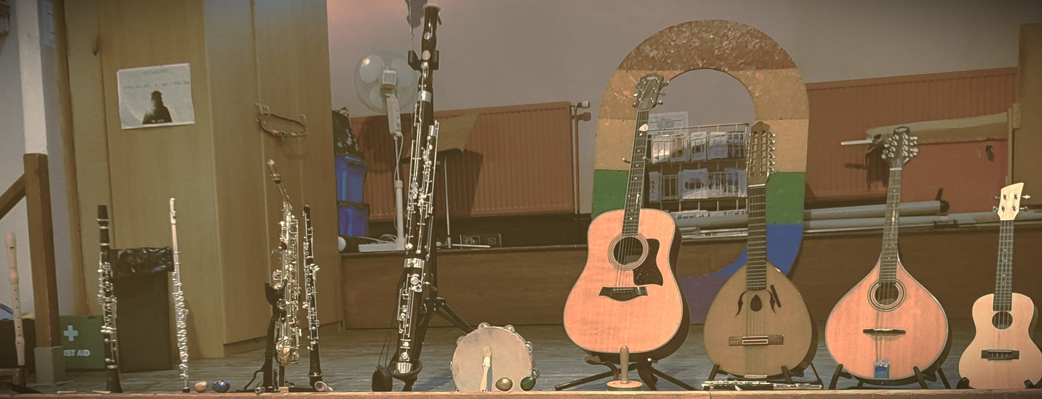
Tickets are available from the Beamsley Project Charitable Trust - Tel: 01756 710255 or info@beamsleyproject.org
Tickets are £10 per person and includes refreshments.
All proceeds will go towards the Beamsley Project’s bursary for 2024, the aim of which is to provide holiday accommodation for children with additional needs whose families are struggling financially.
SELBY ECO AWARD
At Portholme Church, Selby, Iain Nutt recently took on the baton for Eco Church and sought to get Portholme recognised officially for all the work they do at church to reduce their carbon footprint, much of which has been going on for several years.
Happily this work has paid off and Portholme has been awarded the bronze eco award. They are the first church in Selby to gain this award as well as being the first in Selby Methodist Circuit (not that there is a formal competition of course). Iain added “Caring for God’s creation is incredibly important to us all – and we are really pleased to receive this bronze award from the Eco Church scheme. It recognises the efforts we have made so far in raising awareness and adapting the way we operate to care for God’s creation. Onwards now to the Silver award!!!”
Keep an eye on their website and Facebook page for an event celebrating this award and the completion of the solar panels.

Inclusivity at the heart of Portholme Church
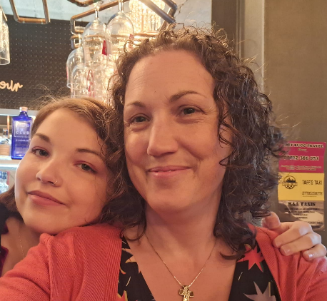
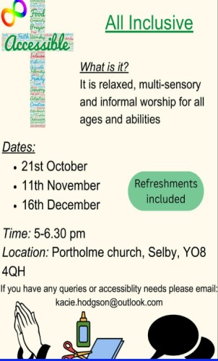
In other news from Selby, the church has recently featured in the The Methodist Blog as they are working hard to becoming as inclusive as possible, ranging from gluten allergies to physical access. The mother and daughter team of Claire and Kacie have been passionate about inclusivity and intergenerational activities for many years. They wanted to encourage people of all ages and conditions to attend church by making Portholme Church as safe and accessible a place as possible. You can read about it here Inclusivity at the heart of Portholme Church (methodist.org.uk) and keep up to date with Kacie and Claire’s endeavours on their (2) Facebook page. You can also attend one of the three All Inclusive Accessible services planned this autumn to see how Kacie and Claire’s plans are coming together.
Kacie Hodgson & Claire Nutt

JOINED UP CONFERENCE 2023, YORK
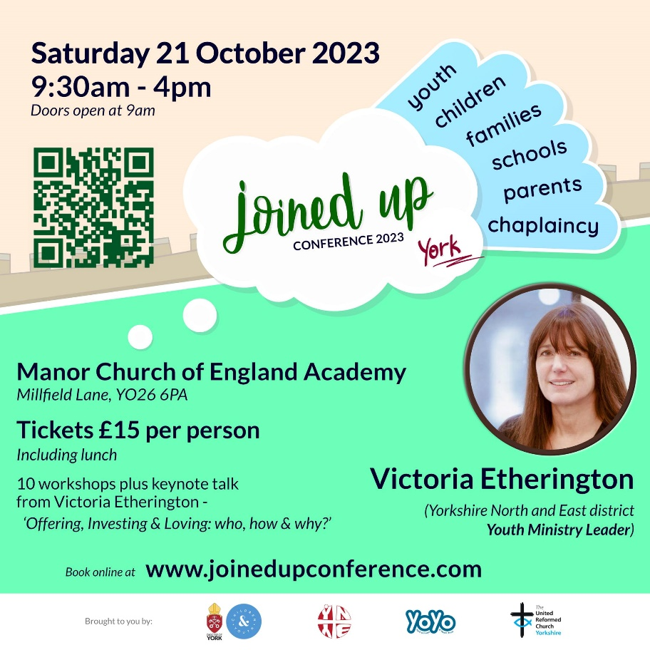
Contact Megan Tillbrook megancyp@urcyorkshire.org.uk to confirm your free ticket.

News Update, October 2023
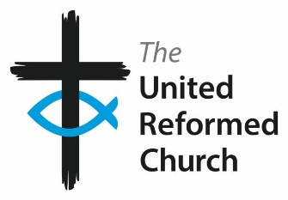
The latest edition of News Update as just hit the web. To keep an eye on the latest news from around the United Reformed Church all you need to do is click on this link, URC News Update October 2023 (urc-news.org.uk), read the October 2023 Update and then sign up to receive it directly into your in-box. There is much of interest this time – two new Moderator nominations, the reaffirming of Eco-Congregation in Scotland, and hot on the heels of Roo Stewart’s presentation at our own Synod this past Saturday, Simeon Mitchell, Secretary for Church and Society, shares what the URC’s Environmental Policy means for us all in this short video Play An introduction to the URC's environmental policy.
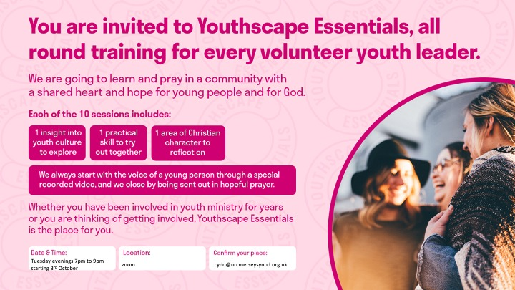
Youthscape Essentials is a ten week course to equip and strengthen anyone working with/ministering to young people in churches and community projects. Each week the course covers an insight into youth culture, a practical skill and an area of personal spiritual development. Each session is standalone so you can attend as many or a few as you would like.
The course will run every Tuesday night from 10th October to 12th December from 7pm to 9pm on zoom. The course is free to attend but we recommend buying the handbook from https://www.youthscape.co.uk/store/product/yse-handbook
Any participants from the Yorkshire Synod can claim back the cost of their handbook.

Children and Youth Work
Advent Resources 2023– ‘God in the ordinary’.
The URC Advent resource for local churches to give away to families.
Following the success of the 2022 resource, the C&YW Team has produced an Advent pack with a huge poster, four mini-books, and things to make and do to help families find God in ordinary, everyday life. As previously, this will come in an unsealed envelope so churches can add an invitation to their Christmas services and events. Please pre-order by emailing the Children's and Youth Work Team children.youth@urc.org.uk with the quantity you would like to ensure you don’t miss out. Cost £2.50 per pack +p&p.

RAAC in URC church buildings
Reinforced autoclaved aerated concrete (RAAC) is a reinforced version of autoclaved aerated concrete, commonly used in roofing and wall construction. It gained popularity from the 1950s as a cheaper and more lightweight alternative to conventional reinforced concrete. It is a 'bubbly' form of concrete found mainly as precast panels in roofs, flat roofs, and occasionally in floors and walls. It has a bubbly appearance on the inside and looks a little bit like an Aero chocolate bar. Unlike traditional concrete it does not contain aggregate and thus has a smooth appearance on the outside. The most common use of RAAC was for beams, used in flat roof and floor construction.
In the past few weeks, the term RAAC has been in the headlines due to a number of schools having to be closed, or partially closed, due to the presence of RAAC within them. It seems probable that other public buildings from the same period – like hospitals, prisons, libraries, theatres and leisure centres – may also contain various amounts of RAAC.

In terms of our church buildings the presence of RAAC is of little concern as most of our church buildings are considerably older than the 1950s. However, there are a few churches and church halls which were constructed in the post-war period and could contain it within a flat roof or occasionally a pitch roofed construction and the advice we are getting is to inspect those areas which may have manifested themselves in the following ways:
- Problems relating to the original construction, such as RAAC beams which were never adequately supported at each end.
- Problems relating to poor maintenance, including roofs where the overlaying waterproofing has failed, causing the concrete beneath it to have been wet for a long period, and to have deteriorated.
- Other issues which may be problematic, include flat roofs where extra weight has been added to address problems of water ingress.

The Government has produced a useful guide to identifying it which can be found here: https://assets.publishing.service.gov.uk/government/uploads/system/uploads/attachment_data/file/1182192/GUIDE-DFE-XX-XX-T-X-9002-Reinforced_Autoclaved_Aerated_Concrete_Identification_Guidance-A-C02.pdf
If you follow the guidance and find anything that potentially could be RAAC please contact your inspecting architect or surveyor and/or a structural engineer and arrange for a specialist inspection of the building, in consultation with myself.
If the building does contain RAAC it may not be necessary to cease using it. Your professional advisors will be able to inform you of the appropriate action to ensure that everyone is kept safe. If RAAC is present you should inform your insurers.
Any situation which might cause the sudden collapse of a building is clearly enormously concerning, and the safety of people must be the top priority. Work out how best to repair or replace every building which requires urgent attention.
Jane Bunyan
Property Officer, URC (Yorkshire) Inc.
Email: property@urcyorkshire.org.uk
3rd October 2023
There is much more in the latest issue of the E&L Committee newsletter. It can be accessed here E&L News October Edition (urc-news.org.uk) and from there you can subscribe to receive it regularly.

Roots resources for churches
New look, and brand-new Communion resources
Many URC churches already know and love Roots weekly resources - but have you seen their brand-new Communion material? 'Bread & Wine' is a new feature in the Adult & All Age resources, responding to a need for Communion prayers that are meaningful and accessible to all ages. In Roots Children & Youth, the new-look magazines include a captivating double-page 'story spread' every week, helping you engage children with the lectionary Bible readings.
View selected pages from the new magazines here - including resources for Halloween, Light Party ideas, and the full 'Bread & Wine' Communion resources for Sept-Oct:
https://www.flipsnack.com/rootsontheweb/sample-pages-from-roots-magazines-sept-oct-2023.html

Prayers In A Time of Conflict
As the URC has deep and strong connections with all people in this troubled part of the world, please take a moment to read this and to use the other Prayers In A Time of Conflict - United Reformed Church which have been uploaded.

For Peace and Justice

O Most High,
Your people rage over the Land,
war and terror engulf those who seek to follow You,
hundreds have died, thousands have been wounded,
and this is just the beginning.

Jesus, Incarnate Word,
give strength to those working for peace in the midst of war;
doctors, nurses, and medics tending the wounded,
fire fighters and rescue workers pulling people from the ruin of their lives,
regional leaders calling for calm.

Eternal Flame of Love,
teach us all the ways of peace;
bring to justice those:
who wage war, violence and terror,
who limit life, steal land, use law to oppress.

Eternal Trinity,
show us quickly how to turn away from violence,
pursue costly justice
and live in peace with each other and with the earth.

Amen.

To offer support please visit the URC’s website at Christian Aid Middle East Crisis Appeal - United Reformed Church. Which has links to the Christian Aid Appeal and includes supporting key facts and information, together with the opportunity to make donations direct to Christians Aid. You can also contribute through the URC’s own programme Commitment for Life at Israel and the occupied Palestinian territory – United Reformed Church.
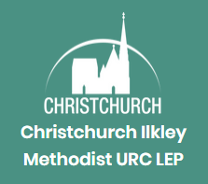

JOB VACANCY

OPERATIONS MANAGER

We are seeking to appoint a part-time
Operations Manager

Exciting opportunity for a highly capable and motivated person to play a central role in the effective operation of Christchurch Ilkley, an active, outwardly focused joint Methodist and United Reformed Church located in the heart of the town.

The post involves a wide range of tasks, focused on practical operations of the church’s work, finance, people management including line management of three members of staff and working closely with many volunteers. Excellent organisational and communication skills are essential.

The post is subject to obtaining a satisfactory enhanced DBS (Disclosure and Barring Service) disclosure.

NEXT STEPS & MAIN TERMS

Hours of work: 20 hours per week - normal working pattern can be flexible to suit (Monday to Friday) in agreement with the Line Manager. You will not be expected to work on more than four days in a calendar week.
Contract: Permanent
Salary: £29,250 pro rata (actual salary £15,600), with enrolment in the church’s workplace pension scheme
Location: Based at Christchurch, The Grove, Ilkley, LS29 9LW
Next steps: For an informal discussion, please contact the Minister, Revd Roberta Topham by email (rev.robertatopham@gmail.com) to arrange a telephone call.
For an application pack please contact Mike Fawcett, Church Administrator, via office@christchurchilkley.org.uk or 01943 603209.

Closing date: Monday 30th October 2023 at 12 noon
Interview date: Tuesday 7th November 2023
Start date: 2nd January 2024

To learn more about our church and the work that we do, please visit:
www.christchurchilkley.org.uk

Are You Called?
In the last few briefings I have sent out this appeal and it is an appeal that I put out at the recent Synod meeting. It is a call for those who feel that they can help the Synod to help our churches reach out to the communities in which they sit and for whom they serve. As this time of the year is such a great time for new things, I’m asking again to see whether you feel a call to help us out at Synod or whether you know of someone whose talents can be used to further the Kingdom through Synod.
Many of you who read this will have worked with the Synod team and may know that the functions of Synod are quite often left in the hands of the excellent staff based in and around the Synod office in Morley. However, behind this team, supporting them and guiding the way in which Synod looks to support all the churches in its care, are another group of people without whom the basis of what we do would falter. These are the people who sit on the various committees which are at the beating heart of Synod life. They prayerfully consider the way in which the Synod moves; through offering pastoral care to giving financial advice, from offering a broad range of theological training to giving technical or compliance support.
This group of people is sadly diminishing and at Synod we said goodbye to seven people who have served Synod in many capacities and who have yet to be replaced. So, this call goes out to see whether you can fill any of the key roles Synod needs for it to function. At present there is a need for those with a financial acumen or interest to join the Financial Resources Committee as it plans how to best resource the Synod’s support for its churches. Similarly, those whose expertise in bricks and mortar are gladly welcomed on to the Property Committee which supports churches in how best to utilise their buildings. Not forgetting those who have a call to help the pastoral and missional side of our many churches. We welcome anyone who can offer their wisdom and if you do feel called, please get in touch with me at clerk@urcyorkshire.org.uk or call on 07936 362673

Finally, please let me have details of what YOUR church is doing. Let me know how the summer has been for you or tell me about what you plan for the autumn, drop me a line at clerk@urcyorkshire.org.uk and I’ll showcase it in the next edition, due out on 9th November with the deadline for submissions being on 8th November (mainly as there is a half term holiday heading up and the Clerk will be away with his family for part of it).
Tim Crossley
Synod Clerk

You can also keep an eye on all our social media platforms for news; on the website at Home - URC Yorkshire Synod, the Facebook pages at United Reformed Church in Yorkshire - Home | Facebook and Wilderness URC Yorkshire - Home | Facebook, the YouTube page at URC Yorkshire - YouTube and the Twitter page at URC in Yorkshire (@URCYorkshire) / Twitter.

yes, they are relations – they are the Synod Clerk’s brother & sister!! (ed).

