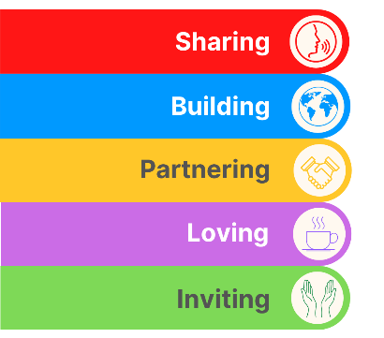
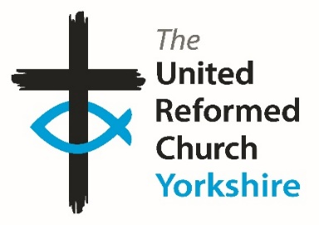
Yorkshire Synod Briefing
Number 118

9th November 2023

Where is Autumn Going?
I have got no idea where the last three weeks have gone since I sent out the last edition of The Briefing. It is as though I have misplaced them. I decided that due to me having a bit of time off over my children’s half term holiday it would be a bit of a rush to put a Briefing out last week. However, time seems to have rushed by and all of a sudden I find myself between Bonfire Night and Remembrance Sunday and franticly writing this and thinking on how to fit in all the stories and events that need to be shared. This feeling of time flying by is as a result of being busy, and thinking about it that has been the case here at the Synod office and by the look of it, amongst many of the churches in Yorkshire Synod. Not only that, there is lots of activity which you are invited to share beyond the boundaries of Synod and dare I say, there are invitations to prepare for Advent and ultimately Christmas.
Sadly though the world in general seems to be turning upside down and I offer again the resources that are open to all on the URC website at Home - United Reformed Church. As the URC has deep and strong connections with all people across God’s earth, and especially in Israel/Palestine, please take a moment to read this and to use the other Prayers In A Time of Conflict - United Reformed Church which have been uploaded.

For Peace and Justice

O Most High,
Your people rage over the Land,
war and terror engulf those who seek to follow You,
hundreds have died, thousands have been wounded,
and this is just the beginning.

Jesus, Incarnate Word,
give strength to those working for peace in the midst of war;
doctors, nurses, and medics tending the wounded,
fire fighters and rescue workers pulling people from the ruin of their lives,
regional leaders calling for calm.

Eternal Flame of Love,
teach us all the ways of peace;
bring to justice those:
who wage war, violence and terror,
who limit life, steal land, use law to oppress.

Eternal Trinity,
show us quickly how to turn away from violence,
pursue costly justice
and live in peace with each other and with the earth.

Amen.

To offer support please visit the URC’s website at Christian Aid Middle East Crisis Appeal - United Reformed Church. Also please visit the Christian Aid Appeal site which includes supporting key facts and information, together with the opportunity to make donations direct to Christians Aid. You can also contribute through the URC’s own programme Commitment for Life at Israel and the occupied Palestinian territory – United Reformed Church.

URC Rural Advocates
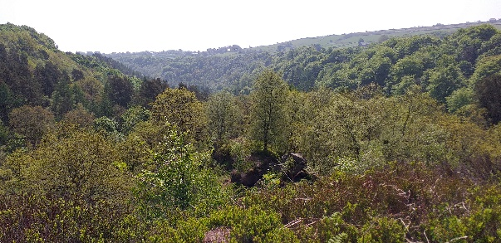
There will be an online gathering of URC Rural Advocates on Zoom on the 6th December at 2.00pm-3.00pm to which anyone who is interested is invited. The idea of this initial get-together is to talk about how such a gathering might look in the future. As you may be aware, there is already an ecumenical gathering based at the Arthur Rank Centre and after the last meeting a few people agreed that a URC specific one might be useful. The hope is that becomes an ideal place for sharing stories and ideas, for mutual support and perhaps occasionally including a speaker on a relevant topic.
To register an interest please contact Linda Rayner, the URC’s Coordinator for fresh expressions at linda.rayner@urc.org.uk and you’ll be sent the Zoom link.

Advent Activity at Ossett
The Kingsway Church in Ossett have been in touch to let us know that they will be hosting their annual “Advent Activity Afternoon’’ on Saturday 25th November. This highly popular event, which has run since 2007, was re-instated last year after the enforced cancellation for Covid. It is a free event for all the community and people can pop in for 10 minutes or stay for the full afternoon. There are 7 crafting tables, using different mediums, adaptable for either children or adults. Of course coffee and cake are available too for people to sit and have a breather! This is timed to finish as the Ossett Christmas Lights are switched on, so an exciting time for all! For more details check out their website at The Aire and Calder Methodist Circuit - The King's Way (aireandcaldercircuit.org.uk)

West Park Harrogate and the Harrogate War Memorial Centenary
In one of the final events of the 12 week commemoration programme marking Harrogate War Memorial’s cenentary. West Park URC, Harrogate is hosting three choirs to perform a unique, moving and final roof-raising event. Musical Director, Catherine Field-Leather, has assembled over 70 singers from the Harrogate Theatre Choir, Eurythmia Ensemble and The Collavoce Collective to perform in You Must Remember This.
Book soon so as not to be disappointed with Tickets £10 from trybooking.co.uk/CLQQ or email; eurythmiacoro@gmail.com (under 16s free). The evening will also support the British Red Cross.
For more information about the choirs visit:
https://harrogatetheatrechoir.co.uk/event/remembrance-concert/
https://www.facebook.com/eurythmiaensemble/?locale=en_GB
https://www.facebook.com/collavocecoro/?locale=en_GB
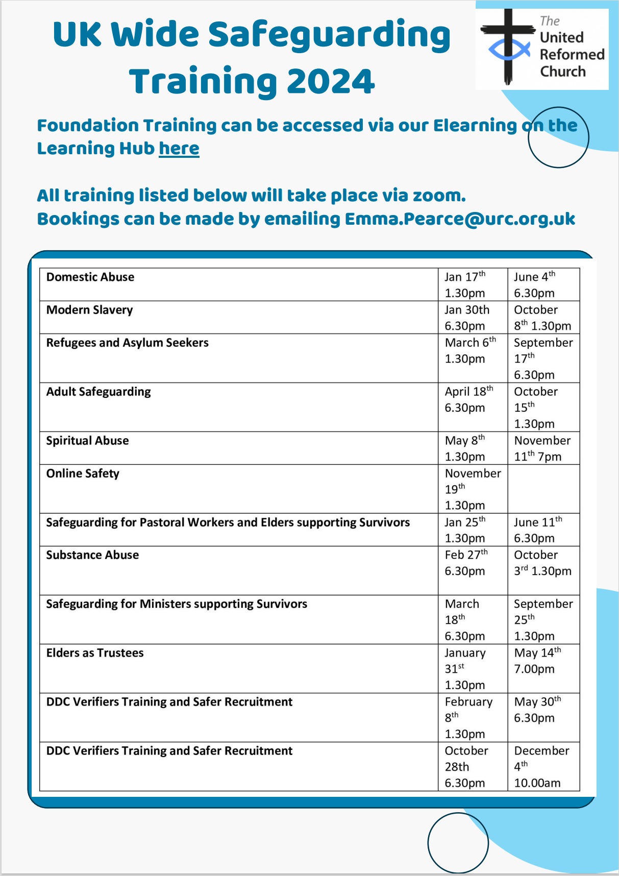
SELBY ECO AWARD
At Portholme Church, Selby, Iain Nutt recently took on the baton for Eco Church and sought to get Portholme recognised officially for all the work they do at church to reduce their carbon footprint, much of which has been going on for several years.
Happily this work has paid off and Portholme has been awarded the bronze eco award. They are the first church in Selby to gain this award as well as being the first in Selby Methodist Circuit (not that there is a formal competition of course) Iain added “Caring for God’s creation is incredibly important to us all – and we are really pleased to receive this bronze award from the Eco Church scheme. It recognises the efforts we have made so far in in raising awareness and adapting the way we operate to care for God’s creation. Onwards now to the Silver award!!!”
Keep an eye on their website and Facebook page for an event celebrating this award and the completion of the solar panels.

Inclusivity at the heart of Portholme Church
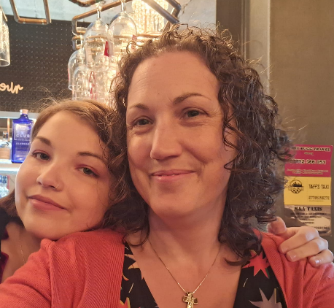
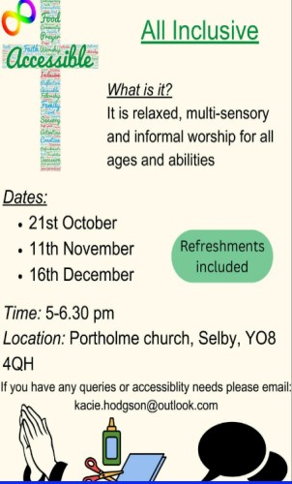
In other news from Selby, the church has recently featured in the The Methodist Blog as they are working hard to becoming as inclusive as possible, ranging from gluten allergies to physical access. The mother and daughter team of Claire and Kacie have been passionate about inclusivity and intergenerational activities for many years. They wanted to encourage people of all ages and conditions to attend church by making Portholme Church as safe and accessible a place as possible. You can read about it here Inclusivity at the heart of Portholme Church (methodist.org.uk) and keep up to date with Kacie and Claire’s endeavours on their (2) Facebook page. You can also attend one of the three All Inclusive Accessible services planned this autumn to see how Kacie and Claire’s plans are coming together.
Kacie Hodgson & Claire Nutt

MORAVIAN BISHOP LEADS WORSHIP AT RIDDLESDEN URC
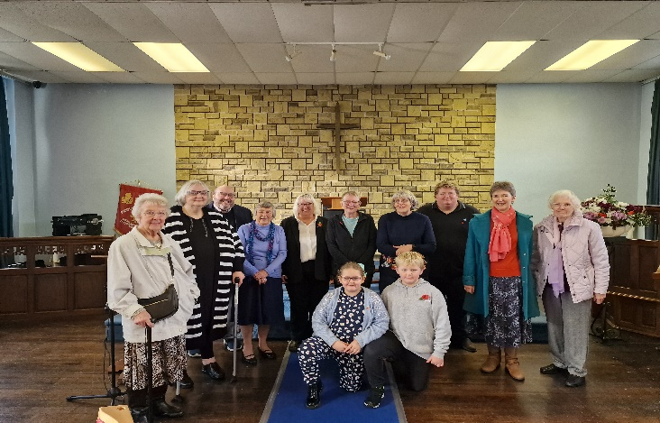
On Sunday 5th November Riddlesden URC’s act of worship was led by the Moravian Bishop of Ireland Rt. Rev Sarah Groves (pictured with some of the congregation).
During the service Sarah spoke of the close links between the Moravian Church and the United Reformed Church, not least in the Ministerial training at Northern College.
Sarah’s son and daughter-in-law Howard and Emma are leaders within the Scouting Group at the church.

URC Youth Assembly
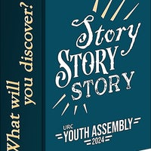
Each year the URC Youth Assembly brings together a diverse group of under-25s from across Scotland, England and Wales for a weekend of business and fun combined, exploring issues and topics relevant to Church, society and life through workshops, seminars, discussions and creative activities. It is a weekend to have your say, make friends and find fellowship.
In 2024 the Youth Assembly will be held at Whitemoor Lakes, Alrewas, Staffs from 26 to 28 January and is for all young people associated with the United Reformed Church in any way. The age range is from Year 10 (England and Wales)/S3 (Scotland) up to and including 25.
The cost on or before November 13 is £124, from November 14 it is £149. Talk to your church or synod about help with funding if needed. There is a creche available for children aged 0 to 5.
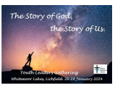
Book your place at linktr.ee/urcyouthassembly2024 by 2 January or contact children.youth@urc.org.uk for a booking form.
LEADERS’ GATHERING: Alongside Youth Assembly, by popular demand, we will be running the Youth Leaders Gathering. For all those who work with young people in URC settings, this will be a chance to meet with others to be encouraged, challenged, inspired and equipped through a mixture of input, worship, space to relax, prayer and social time. Contact children.youth@urc.org.uk for more details or book on http://www.linktr.ee/urcyouthassembly2024
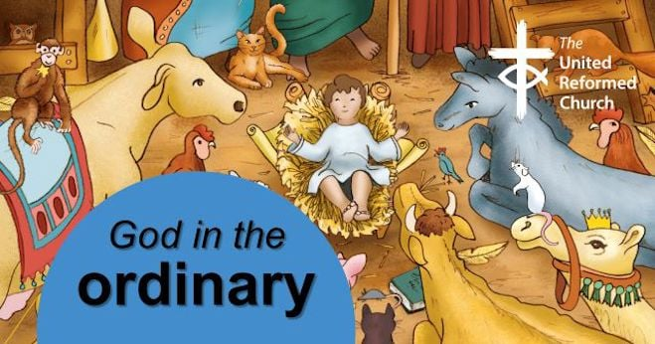
Advent Resources 2023– ‘God in the ordinary’.
The URC Advent resource for local churches to give away to families.
Following the success of the 2022 resource, the C&YW Team has produced an Advent pack with a huge poster, four mini-books, and things to make and do to help families find God in ordinary, everyday life. As previously, this will come in an unsealed envelope so churches can add an invitation to their Christmas services and events. Please pre-order by emailing the Children's and Youth Work Team children.youth@urc.org.uk with the quantity you would like to ensure you don’t miss out. Cost £2.50 per pack + p&p.

Roots resources for churches
New look, and brand-new Communion resources
Many URC churches already know and love Roots weekly resources - but have you seen their brand-new Communion material? 'Bread & Wine' is a new feature in the Adult & All Age resources, responding to a need for Communion prayers that are meaningful and accessible to all ages. In Roots Children & Youth, the new-look magazines include a captivating double-page 'story spread' every week, helping you engage children with the lectionary Bible readings.
View selected pages from the new magazines here - including resources for Halloween, Light Party ideas, and the full 'Bread & Wine' Communion resources for Sept-Oct:
https://www.flipsnack.com/rootsontheweb/sample-pages-from-roots-magazines-sept-oct-2023.html

Talking About … Children’s and Youth Work
Fourth Thursday in the month 7-8 pm.
A series of online gatherings, hosted by the URC Children’s and Youth Development Officers team. Join us to build networks and find out more about issues that concern you. These sessions are specific for all who work with children and young people.

Talking About… Lego™ Church
Thursday, 23rd November 7-8pm on Zoom
Have you heard of Lego™ Church?
Have you tried Lego™ Church with your group?
Would you like to know more, or are you able to share your experiences?
Book a place on Talking About…Lego Church to hear what it’s all about.
Our guest speakers are Judy Harris (CYDO for the National Synod of Wales) who will share the thinking around the faith and spirituality development opportunities offered by Lego ™ church and a practitioner from Desborough URC (East Midlands Synod) who will share the practicalities of starting a Lego ™ church and how it has engaged children, young people and families.
Book your place at www.bit.ly/URCTalkingAbout

Upcoming 'Talking About....' Sessions:
25 January - Youth Participation
22 February - Child Participation
28 March - 'Uniformed' Organisations
25 April - LGBTQ+
23 May - Sports Ministry

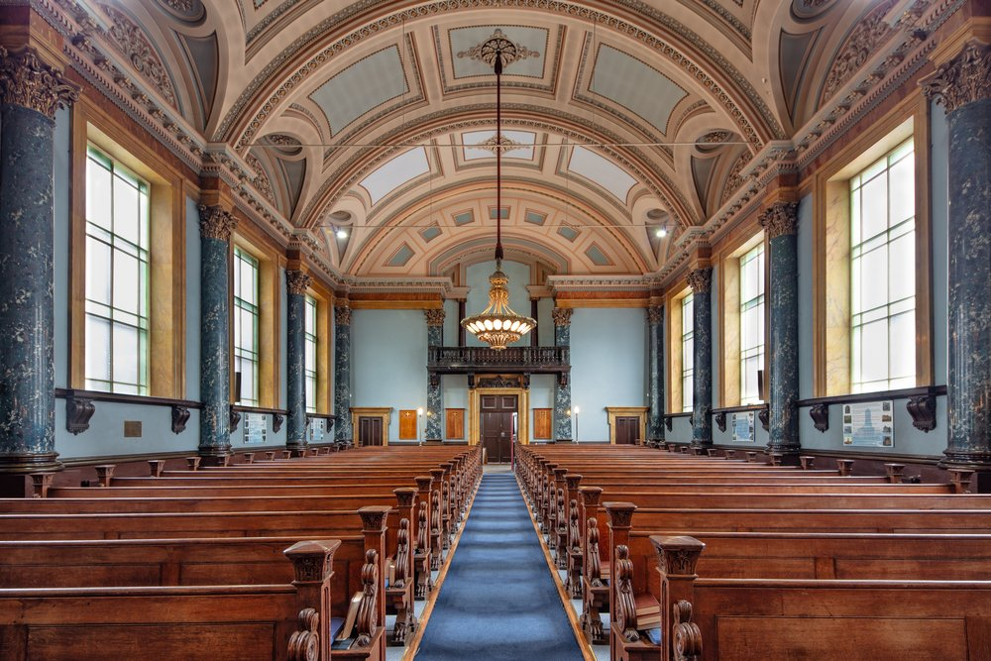
Saltaire URC Architects are Awards Winners

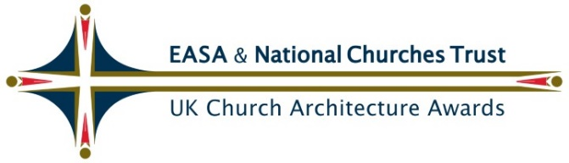
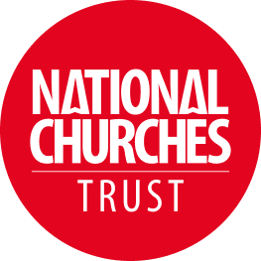
As many of you will know, the past few years at Saltaire URC have been dominated by the repairs done to the building in the aftermath of February 2020’s “Storm Dennis”. With the ceiling collapse and the lockdown immediately on its heels in March 2020, the future looked grim, but through the perseverance and faith of the church community and the technical excellence of the contractors, the building has been repaired. So, it was great to hear that the architect, Russell Trudgeon of Arctic Associates, not only had been nominated for the King of Prussia Gold Medal Award for the innovative, high quality church conservation or repair work at Saltaire, but that he won it. This prestigious award is open to the architect or chartered surveyor on any scheme of repair for a church or chapel of any Christian denomination in the UK, in use for regular worship and over one hundred years old and is presented by the National Churches Trust (NCT) and the Ecclesiastical Architects and Surveyors Association (EASA) at each of their ceremonies.
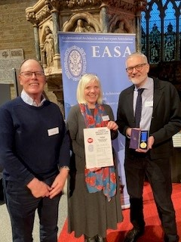
Joining Russell were Elaine and Tony Wilson of Saltaire URC who attended the EASA ceremony on the 2nd November, whilst our Property Officer Jane Bunyan attended the National Churches Trust event on the 6th November.
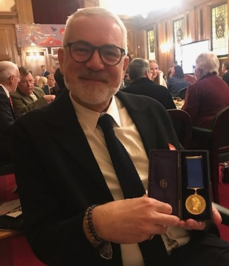

For more details about the awards, the other churches considered, and the project Russell led since 2020 visit the following sites:
2023 UK Church Architecture Awards
Saltaire United Reformed Church | National Churches Trust
Arctic Associates — Saltaire United Reformed Church (arctic-associates.co.uk)

Guided Retreats at Cliff College
Advent is a time of preparation for Christmas - and in addition to all the presents, decorations and cards, it's important to take time to prepare ourselves to receive Jesus into our lives again in this special season. Join Revd Carole Marsden and Dr Ali Mackenzie, at Cliff College, for an Advent guided retreat on Saturday 9 December and prepare yourself for an encounter with Jesus again this Christmas.
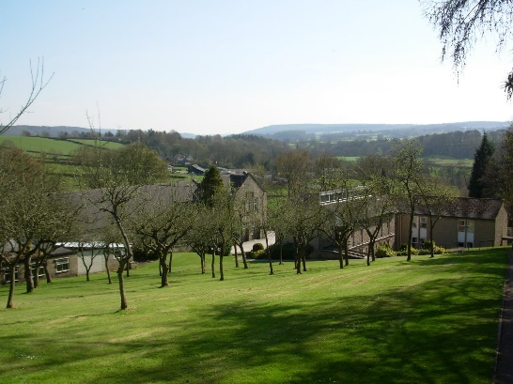
Whilst being a college routed within the Methodist tradition the retreat day will be accessible to all traditions. If you, your church or groups would like to arrange a bespoke guided retreat day please feel free to contact Carole Marsden at c.marsden@cliffcollege.ac.uk. In addition, they also have self-guided retreat material such as prayers, walks and our labyrinth which are available to all church bookings and individually booked retreat visits.
And looking into 2024, there will be a Lent retreat taking place on Saturday 10th February.
Book now: https://www.cliffcollege.ac.uk/shop/courses/advent-retreat-2023

Celebrations at Eccleshill
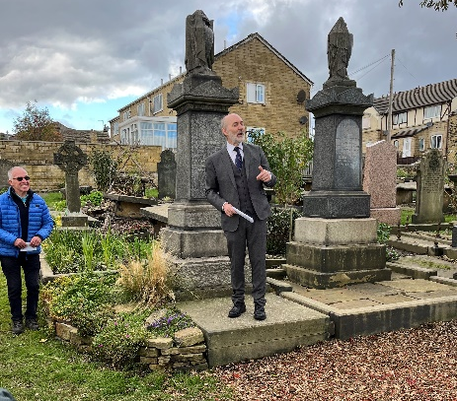
Back in 2021 Eccleshill URC made the difficult decision to close its doors for the last time after being in existence for 198 years. The building on Victoria Road was sold quite quickly, but the site of the older chapel, including the graveyard was left. Fortunately, in the Spring of 2020, during the “lockdown" but before the church closure, two residents of Chapel Street made a start in clearing the paths to gain access to the graves in the old graveyard. In July of that year more volunteers arrived to help and “Friends of Chapel Street Cemetery” was formed. When in the September 2021 the cemetery was placed on the open market the “Friends”, several residents and the community were concerned that a piece of social history possibly being lost forever. However, through discussions with the Synod team and others in the Eccleshill area this group were able to become a registered charity and soon it is hoped that the graveyard will be transferred into their care.

In the meantime, however, they realised that the 200th anniversary was too good to miss and invited Revd Jamie Kissack to help them celebrate this milestone, mark their becoming a charity and to bless a specially made sundial which will have pride of place in the cemetery.

Are You Called?

In the last few Briefings I have sent out this appeal and it is an appeal I put out at the recent Synod meeting. It is a call for those who feel that they can help the Synod to help our churches reach out to the communities in which they sit and for whom they serve. As we start to think about Advent and the great gift God gave us in Jesus, I’m asking again to see whether you feel a call to give your time to the Synod or whether you know of someone whose talents can be used to further the Kingdom through Synod.
Many of you who read this will have worked with the Synod team and may know that the functions of Synod are quite often left in the hands of the excellent staff based in and around the Synod office in Morley. However, behind this team, supporting them and guiding the way in which Synod looks to support all the churches in its care, are another group of people without whom the basis of what we do would falter. These are the people who sit on the various committees which are at the beating heart of Synod life. They prayerfully consider the way in which the Synod moves; through offering pastoral care to giving financial advice, from offering a broad range of theological training to giving technical or compliance support.
This group of people is sadly diminishing and at Synod last month we said goodbye to seven people who have served Synod in many capacities and who have yet to be replaced. So, this call goes out to see whether you can fill any of the key roles Synod needs for it to function. At present there is a need for those with a financial acumen or interest to join the Financial Resources Committee as it plans how to best resource the Synod’s support for its churches. Similarly, those whose expertise in bricks and mortar are gladly welcomed on to the Property Committee which supports churches in how best to utilise their buildings. Not forgetting those who have a call to help the pastoral and missional side of our many churches. We welcome anyone who can offer their wisdom and if you do feel called, please get in touch with me at clerk@urcyorkshire.org.uk or call on 07936 362673

Finally, please let me have details of what YOUR church is doing. Let me know what you plan for the rest of the autumn, what your plans are for Christmas, and even how you are organising your churches in 2024. Drop me a line at clerk@urcyorkshire.org.uk and I’ll showcase it in the next edition, due out on 23rd November with the deadline for submissions being on 22nd November.

Thank you and God Bless,
Tim Crossley
Synod Clerk

You can also keep an eye on all our social media platforms for news; on the website at Home - URC Yorkshire Synod, the Facebook pages at United Reformed Church in Yorkshire - Home | Facebook and Wilderness URC Yorkshire - Home | Facebook, the YouTube page at URC Yorkshire - YouTube and the Twitter page at URC in Yorkshire (@URCYorkshire) / Twitter.

