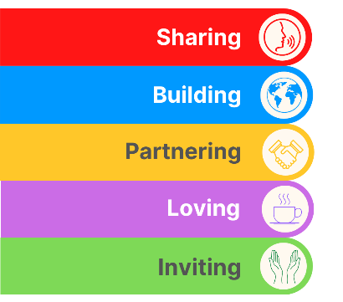
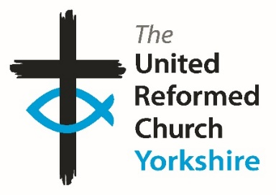
Yorkshire Synod Briefing
Number 119

23rd November 2023

To Christmas and Beyond!!!
No denying it, a month and a day to Christmas Eve and you will see that there are a few things happening over the next few weeks which will lead us into Christmas properly. Although we have yet to reach the season of Advent, this issue is the one which will try to set the tone in the run up to the big day. I know many churches host Christmas Tree festivals, Community Carol services, Christingle events and offer many other activities leading up to and over the Christmas period. So as there will be further Briefings in December, on the 6th and on the 20th, please let me know if you want anything advertised here as soon as you can – details of how to get in touch are at the bottom of page 12. The editor is also looking for the corniest jokes to outdo all those Christmas Cracker jokes we have to put up with. I thought it would be nice to be able to share something that always makes the eyes roll heavenwards at this time of year. Drop me a line with the best (or worst as the case may be) – they don’t always have to be seasonally relevant - and I’ll hopefully have you rolling in the aisles during December.
Not only is this Briefing looking forward to the run up to Christmas, it has its eye on things happening in 2024 and beyond. As you’ll see we are looking for a Communications and Digital lead to help Yorkshire Synod be more active in the way it interacts with individuals, churches and the wider community. Please circulate this among your own networks as we would love to be able to appoint this side of the New Year for a start during January. More information and application forms are available at https://urcyorkshire.org.uk/cadl or if you want an informal chat, please get in touch.

URC Youth Assembly
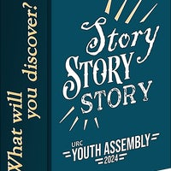
Each year the URC Youth Assembly brings together a diverse group of under-25s from across Scotland, England and Wales for a weekend of business and fun combined, exploring issues and topics relevant to Church, society and life through workshops, seminars, discussions and creative activities. It is a weekend to have your say, make friends and find fellowship.
In 2024 the Youth Assembly will be held at Whitemoor Lakes, Alrewas, Staffs from 26 to 28 January and is for all young people associated with the United Reformed Church in any way. The age range is from Year 10 (England and Wales)/S3 (Scotland) up to and including 25.
The cost on or before November 13 is £124, from November 14 it is £149. Talk to your church or synod about help with funding if needed. There is a creche available for children aged 0 to 5.
Book your place at linktr.ee/urcyouthassembly2024 by 2 January or contact children.youth@urc.org.uk for a booking form.
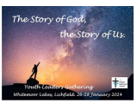
LEADERS’ GATHERING: Alongside Youth Assembly, by popular demand, we will be running the Youth Leaders’ Gathering. For all those who work with young people in URC settings, this will be a chance to meet with others to be encouraged, challenged, inspired and equipped through a mixture of input, worship, space to relax, prayer and social time. Contact children.youth@urc.org.uk for more details or book on http://www.linktr.ee/urcyouthassembly2024

URC Rural Advocates
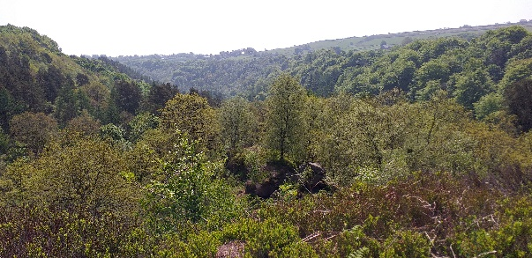
There will be an online gathering of URC Rural Advocates on Zoom on the 6th December at 2.00pm-3.00pm to which anyone who is interested is invited. The idea of this initial get-together is to talk about how such a gathering might look in the future. As you may be aware, there is already an ecumenical gathering based at the Arthur Rank Centre and after the last meeting a few people agreed that a URC specific one might be useful. The hope is that becomes an ideal place for sharing stories and ideas, for mutual support and perhaps occasionally including a speaker on a relevant topic.
To register an interest please contact Linda Rayner, the URC’s Coordinator for fresh expressions at linda.rayner@urc.org.uk and you’ll be sent the Zoom link.

Advent Activity at Ossett
The Kingsway Church in Ossett have been in touch to let us know that they will be hosting their annual “Advent Activity Afternoon’’ on Saturday 25th November. This highly popular event, which has run since 2007, was re-instated last year after the enforced cancellation for Covid. It is a free event for all the community and people can pop in for 10 minutes or stay for the full afternoon. There are 7 crafting tables, using different mediums, adaptable for either children or adults. Of course, coffee and cake are available too for people to sit and have a breather! This is timed to finish as the Ossett Christmas Lights are switched on, so an exciting time for all! For more details check out their website at The Aire and Calder Methodist Circuit - The King's Way (aireandcaldercircuit.org.uk)

Holiday Forum in a Day -
Saturday 24th February 2024
Save the date! Join us on Zoom next February 24th for HF in a Day and have a taste of what to expect at next year’s summer conference.
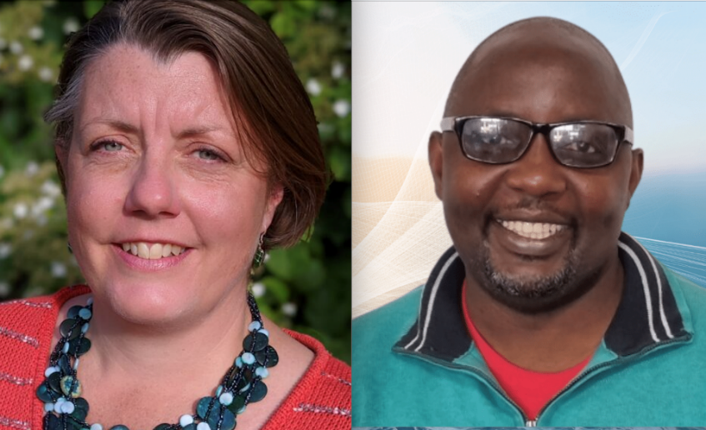
The Holiday Forum team will be joined by Rev Fiona Bennett who leads our theme and Rev Kuraone Mutimwii, our worship leader. They’ll give us a flavour of their sessions to whet your appetite and there’ll be other things to get stuck in to throughout the morning and later in the evening (full timetable TBC).
The day will run in two parts: from 9.30am-12.30pm and then from 7.30pm-9.30pm (with the option to join from 6.30pm to meet and share dinner virtually).
Don’t forget, places for the summer conference (Sunday 18th to Friday 23rd August 2024 at The Hayes & online) are limited to just 100 this year and lots have been filled already, so book early to avoid disappointment!

Online Winter Social
Saturday 25th November 2023, 7.30pm-9.30pm

And finally, don’t forget to join them for their online Winter Social this coming Saturday.
Pop in using this link to see Forum friends and catch up - there’ll be some break out rooms and a quiz round or two to keep you entertained!

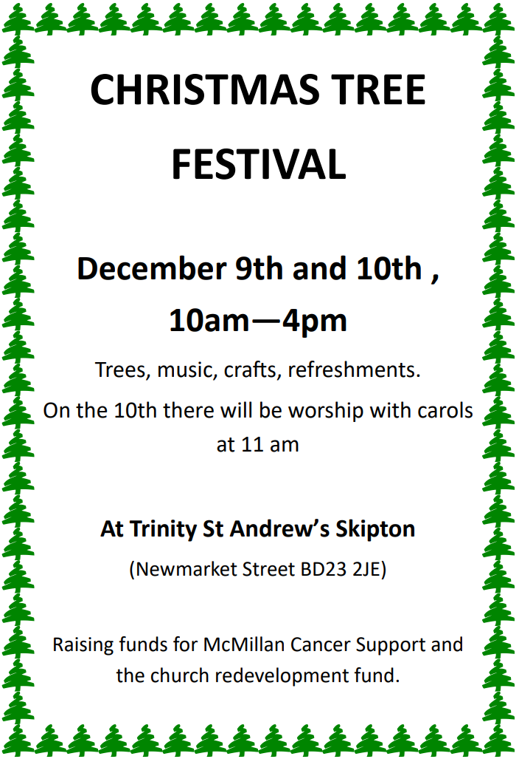

LADY HEWLEY’S CHARITY – Registered Charity number
The ALMSHOUSES at 14 St Saviourgate, York, YO1 8NW
Home - The Lady Hewley Trust
_____________________
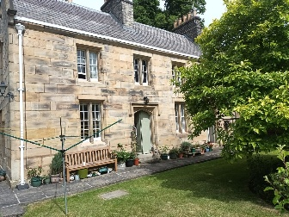
A residence is available for a person who is in need and aged over 55 years old. The charity is a Christian charity so that, in accordance with the trusts and the principles laid down by the founder of the Trust, those who are resident in the northern counties of England and are single women and are members of any of the Baptist, Congregational and United Reformed Churches will be considered first.
Application for appointment must be made in writing with a completed application form.

Application may be made EITHER
by visiting the Lady Hewley Trust website at the above address, downloading the application form for almshouse accommodation, completing and saving it, and sending it via email to clerk@theladyhewleytrust.org.uk or ravelston20@hotmail.co.uk. (Alternatively, you may print off the form and complete it and send it to Neil Mackenzie at his address mentioned in the next paragraph.)
OR
by asking Neil Mackenzie for an application form on 01704 531856 or 07866 484665; or via email ravelston20@hotmail.co.uk, or by post to 20 Scarisbrick New Road, Southport, PR8 6PY.

An applicant must be prepared to attend an interview with members of the Almshouse Committee in person. The applicant may be required to supply evidence of their qualification for appointment.

URC :: Spirituality
broadening and deepening prayer

Spirituality in the Reformed tradition covers a wide range: it includes people who are enriched by deep explorations of scripture, or sitting in silence, encountering God in the world, or exploring things in quiet days and retreats.
This new web site brings together some of these strands as a way of encouraging people to broaden and deepen their spirituality. There are ways of interacting with others, taking part in events, sharing something of the spirituality that takes place in private, and looking at spiritual direction.
Members of URC spirituality can join in discussion groups on this site and network with other members. Click here to join.

URC spirituality came into being as a result of a re-visioning of the United Reformed Church Retreat Group, which, earlier in its story, was called the URC Silence and Retreats Network. At the 2023 General Assembly it was agreed that the new Worship Faith & Order committee would have oversight of URC spirituality and that it would report to them on an annual basis. There is an ongoing process of reviewing and renewing this activity and gradually it will be moving out of online-only activity. For example, our website www.urc-spirituality.org.uk could be a place to advertise local retreats, quiet days and other events and place, which would be especially useful for folk on the edges of Synods.

At the moment this is a small group - some still around since the S&R Network days and others invited in and we need to broaden our constituency somewhat. If you or someone you know might be interested in joining us at this actually quite exciting time, then get in touch with Kathryn Price (revdrkmprice@gmail.com) or our secretary Ann Barton (ann.barton@hotmail.com) and an invitation and zoom link can be sent out.

You will then receive information about upcoming online events for Advent and Epiphany, which I hope you will be able to circulate in your own networks. These events are free join and currently the dates are -
- Carolling Advent - a week of evening reflections on a range of carols - 4th - 8th December at 7.30pm
- Living Wisely - a quiet day for Epiphany (three separate sessions: morning, lunch and early afternoon) - Saturday 6th January 2024

Do please get in touch - let the URC Spirituality group know what is happening where you are, so that they can develop a greater sense of community around the church.

Advent Resources 2023– ‘God in the ordinary’.
The URC Advent resource for local churches to give away to families.
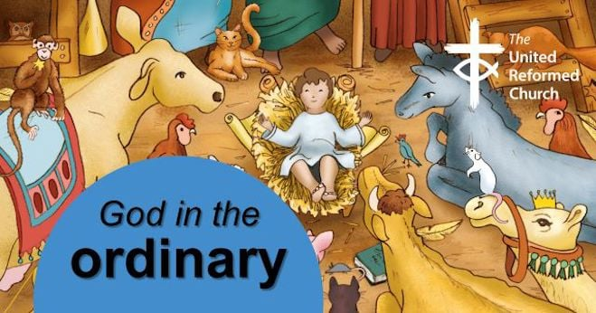
Following the success of the 2022 resource, the C&YW Team has produced an Advent pack with a huge poster, four mini-books, and things to make and do to help families find God in ordinary, everyday life. As previously, this will come in an unsealed envelope so churches can add an invitation to their Christmas services and events. Please pre-order by emailing the Children's and Youth Work Team children.youth@urc.org.uk with the quantity you would like to ensure you don’t miss out. Cost £2.50 per pack + p&p.

Roots resources for churches
New look, and brand-new Communion resources
Many URC churches already know and love Roots weekly resources - but have you seen their brand-new Communion material? 'Bread & Wine' is a new feature in the Adult & All Age resources, responding to a need for Communion prayers that are meaningful and accessible to all ages. In Roots Children & Youth, the new-look magazines include a captivating double-page 'story spread' every week, helping you engage children with the lectionary Bible readings.
View selected pages from the new magazines here - including resources for Halloween, Light Party ideas, and the full 'Bread & Wine' Communion resources for Sept-Oct:
https://www.flipsnack.com/rootsontheweb/sample-pages-from-roots-magazines-sept-oct-2023.html

Talking About … Children’s and Youth Work
Fourth Thursday in the month 7-8 pm.
A series of online gatherings, hosted by the URC Children’s and Youth Development Officers team. Join us to build networks and find out more about issues that concern you. These sessions are specific for all who work with children and young people.

Talking About… Lego™ Church
Thursday, 23rd November 7-8pm on Zoom
Have you heard of Lego™ Church?
Have you tried Lego™ Church with your group?
Would you like to know more, or are you able to share your experiences?
Book a place on Talking About…Lego Church to hear what it’s all about.
Our guest speakers are Judy Harris (CYDO for the National Synod of Wales) who will share the thinking around the faith and spirituality development opportunities offered by Lego ™ church and a practitioner from Desborough URC (East Midlands Synod) who will share the practicalities of starting a Lego ™ church and how it has engaged children, young people and families.
Book your place at www.bit.ly/URCTalkingAbout

Upcoming 'Talking About....' Sessions:

25 January - Youth Participation
22 February - Child Participation
28 March - 'Uniformed' Organisations
25 April - LGBTQ+
23 May - Sports Ministry

Manor Church Community Coffee Corner
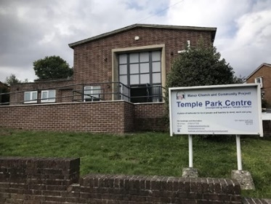
Manor Church and Community Project in Sheffield have been in touch to thank Yorkshire Synod for the Synod Mission Fund grant they received towards their initial work to engage with local community in the Manor and Temple Park areas of Sheffield. It marks a new start to their mission to love and serve their neighbours and to share Gods love for all.
They wanted their building to be an asset for local people, with a vision to grow a community within a community and become a hub where people can meet, learn, laugh, cry, grow and feel a true belonging.
Their new in post (January 2023) community worker has started work creating time and space for people to gather. A warm and comfortable place has been created offering hot drinks, breakfast sandwiches and more importantly fostering a welcoming place for all people.
They were able to purchase equipment which helped in them to develop this reinvigorated outreach. This included lightweight folding tables to enable all users to easily and safely set up and clear away, a trolley to ensure safe storage, a filter coffee machine which creates the rich aroma of coffee – always an inviting smell. They replaced their mismatched and aging mugs, purchased a Bain Marie for keeping food at temperature, and a large toaster. All of this has created a much more efficient and well-equipped kitchen.
Not only has this equipment helped their coffee mornings but it is also in use at their lunch club’s light lunches, at the regular craft group meetings, by their children’s groups and by all the other user groups and tenants.

Guided Retreats at Cliff College
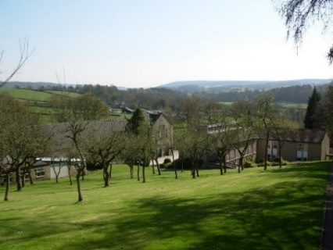
Advent is a time of preparation for Christmas and in addition to all the presents, decorations and cards, it's important to take time to prepare ourselves to receive Jesus into our lives again in this special season. Join Revd Carole Marsden and Dr Ali Mackenzie, at Cliff College, for an Advent guided retreat on Saturday 9 December and prepare yourself for an encounter with Jesus again this Christmas.
Whilst being a college rooted in the Methodist tradition, the retreat day will be accessible to all traditions. If you, your church or groups would like to arrange a bespoke guided retreat day please feel free to contact Carole Marsden at c.marsden@cliffcollege.ac.uk. In addition, they also have self-guided retreat material such as prayers, walks and our labyrinth which are available to all church bookings and individually booked retreat visits.
And looking into 2024, there will be a Lent retreat taking place on Saturday 10th February.
Book now: https://www.cliffcollege.ac.uk/shop/courses/advent-retreat-2023
SAFEGUARDING

URC launches new safeguarding guidance - Good Practice 6

On 23 October 2023 the URC launched Good Practice 6. You can read more from the URC national website by clicking here. A copy of Good Practice 6 will be posted to all church-based Safeguarding Coordinators, Synod Safeguarding Officers and Moderators. You can also read a free digital version of Good Practice 6 by clicking here.

Forthcoming Training Sessions

The following dates are available for Intermediate Safeguarding Training via Zoom with Matt Knowles.

Wednesday 10th January 2024, 7pm – 9.30pm
Tuesday 23rd January 2024, 10am – 12.30pm
Monday 5th February 2024, 1pm – 3.30pm
Saturday 17th February 2024, 9.30am – 12.00pm

If you are unsure as to whether you need to do the foundation (basic) training or the intermediate training Please click here to read Paper T5 which was adopted at last summer’s General Assembly. It details the roles and levels of training required. Members wishing to book a place should have completed the foundation e-learning package prior to the date of the Intermediate course. For more information or to book your course please email Paula Kitson as soon as you can as spaces are limited and are being taken up rapidly.

Additionally, the Safeguarding team are looking to do several face-to-face Intermediate training courses throughout the Northern and Yorkshire areas. If you wish to nominate your church to potentially hold one of these courses, could you let Paula or Matt know.
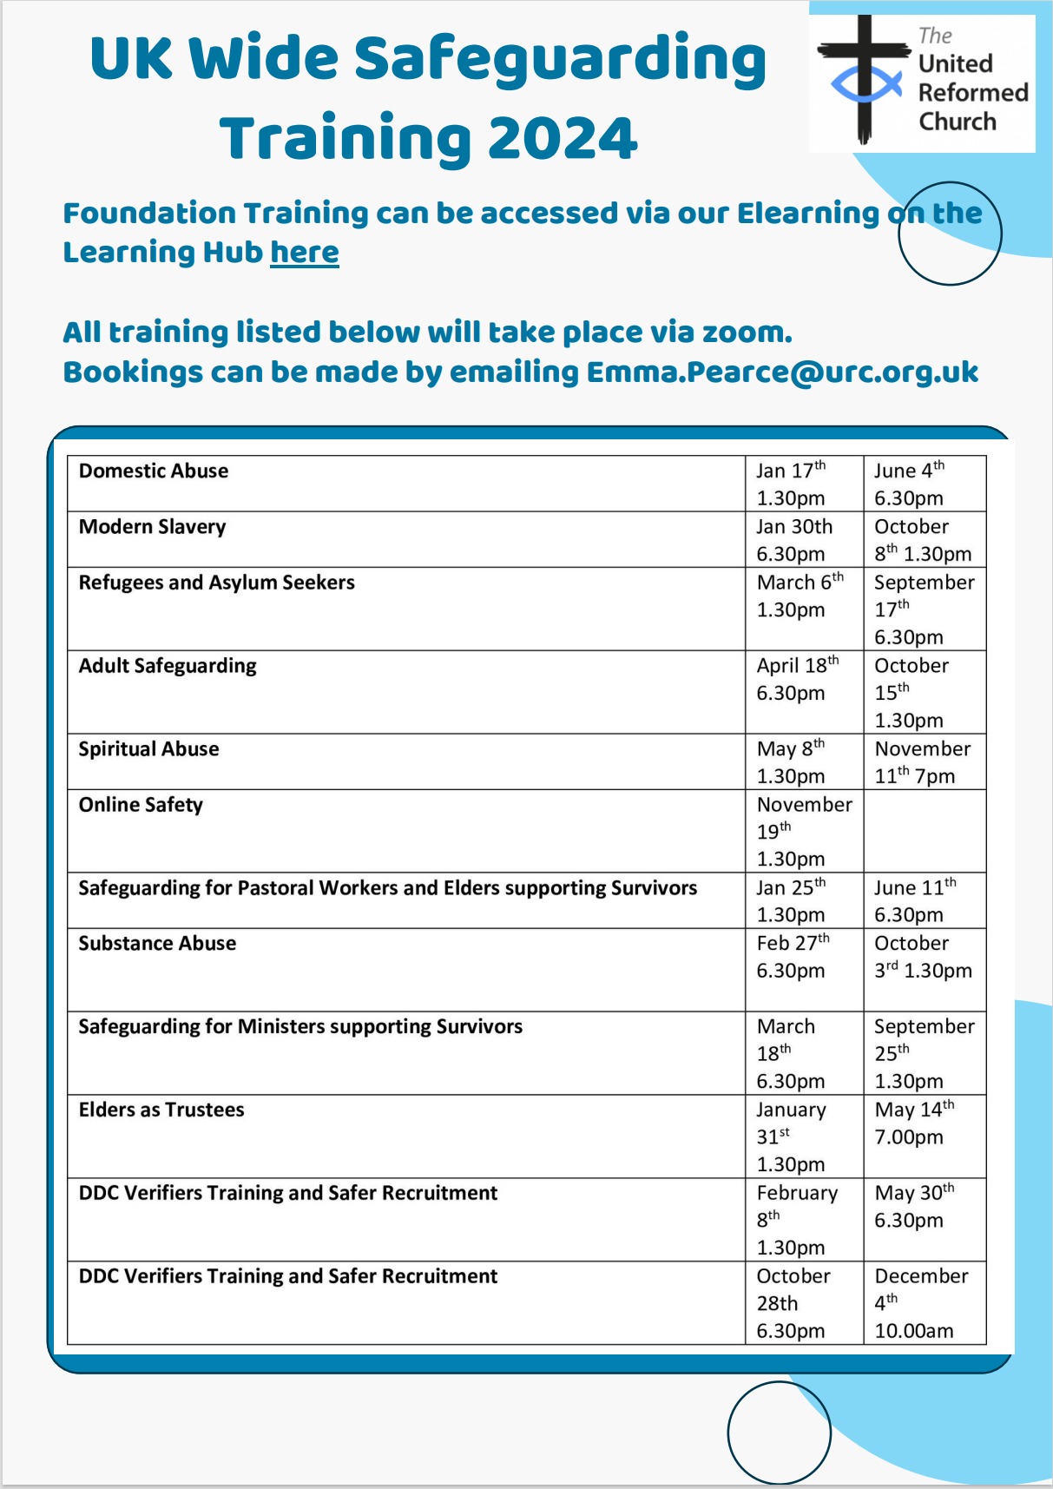

Sadly, the world in general seems to be turning upside down and I offer again the resources that are open to all on the URC website at Home - United Reformed Church. As the URC has deep and strong connections with all people across God’s earth, and especially in Israel/Palestine, please take a moment to read this and to use the other Prayers In A Time of Conflict - United Reformed Church which have been uploaded.

For Peace and Justice

O Most High,
Your people rage over the Land,
war and terror engulf those who seek to follow You,
hundreds have died, thousands have been wounded,
and this is just the beginning.

Jesus, Incarnate Word,
give strength to those working for peace in the midst of war;
doctors, nurses, and medics tending the wounded,
fire fighters and rescue workers pulling people from the ruin of their lives,
regional leaders calling for calm.

Eternal Flame of Love,
teach us all the ways of peace;
bring to justice those:
who wage war, violence and terror,
who limit life, steal land, use law to oppress.

Eternal Trinity,
show us quickly how to turn away from violence,
pursue costly justice
and live in peace with each other and with the earth.

Amen.

To offer support please visit the URC’s website at Christian Aid Middle East Crisis Appeal - United Reformed Church. Also please visit the Christian Aid Appeal site which includes supporting key facts and information, together with the opportunity to make donations direct to Christians Aid. You can also contribute through the URC’s own programme Commitment for Life at Israel and the occupied Palestinian territory – United Reformed Church.

Finally, please let me have details of what YOUR church is doing. Let me what you plan for the rest of the autumn, what your plans are for Christmas, and even how you are organising your churches in 2024. Drop me a line at clerk@urcyorkshire.org.uk and I’ll showcase it in the next edition, due out on 7th December with the deadline for submissions being on 6th December.
Thank you and God Bless,
Tim Crossley
Synod Clerk

And don’t forget to send me your Christmas Cracker jokes……..

You can also keep an eye on all our social media platforms for news; on the website at Home - URC Yorkshire Synod, the Facebook pages at United Reformed Church in Yorkshire - Home | Facebook and Wilderness URC Yorkshire - Home | Facebook, the YouTube page at URC Yorkshire - YouTube and the Twitter page at URC in Yorkshire (@URCYorkshire) / Twitter.

