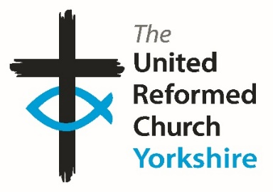**Yorkshire Synod Briefing**

**Number 122**

**18th January 2024**

|  |
| --- |
|  |

**Happy New Year – at last………..**

It seems ages ago since I inflicted a series of Christmas Cracker jokes on you all – last year if my memory serves – and if all it did was to raise an eyebrow or garnered a flicker of a smile, at least there was some reaction. The new year is here; a happy new year to you all, and first Briefing of 2024 is ready. Although it is a month since the last one the perception of time (for me at least) has it being that it is only very recently that issue 121 was published and I am aware that some of the things published in that last December issue may still be in this one. Added to this is a feeling on my part that it has been a rather odd start to the year – from a personal point of view I was fortunate enough to take my wife, Jenny, away for a special birthday holiday, and that has meant that the first half of January has been spent in temperatures akin to midsummer as well as experiencing some cold hard frosts.

However, now that I’m back I can happily say that the work of the Yorkshire Synod has carried on apace and there are lots of things happening, both in the final two weeks of this month, throughout February and into the spring. You will see a couple of Godly Play events, one in Beverley and one at the Synod Office in Morley. This initiative is something that all churches are invited to, to open up different kinds of engagement with the youngest end of our church family, as well as with the more long-in-the-tooth. Please contact either Susie or Megan and choose which of the two events (or both) you would like to attend.

In other news, there are plans afoot at Shiregreen for a new Childrens’ worker to build on the foundations that have already been laid there. Hopefully this new role will be able to bring together all that previous work, bring something new to encourage children, adults and their families into a wider understanding of what Jesus can do for us and to be an outward expression of God’s love.

The Lectionary planning sessions are resuming, with the late February and early March passages being considered; we have dates for planning Holiday Forums, for Walking Through the Bible, and for the latest Ministry Enquirers’ Event. Added to this there are the more practical events taking place, including the excellent in-house Line Management Training being offered by Church House as well as Resilience Training and all the essential Safeguarding Training the Synod and National teams are providing.

**Finally, the one thing I lack this time is what has been happening in your churches. Please let me have details of what is happening where you are. Tell me what you plan for 2024 so that I can help spread that news, especially what you are doing on the weeks leading up to Lent, during Lent itself and over Easter 2024. Drop me a line at** [**clerk@urcyorkshire.org.uk**](mailto:clerk@urcyorkshire.org.uk) **and I’ll showcase it in the next edition, due out on Thursday 1st February with a deadline of Wednesday 31st January 2024.**

**Thank you and God Bless,**

Tim Crossley

**Synod Clerk**

**Lay Preachers’ and Worship Leader’s lectionary planning zoom sessions**

The Lay Preachers’ and Worship Leaders’ Planning Group are pleased to let you know that we are facilitating another of these sessions in February.

**You are invited to Explore the lectionary readings together** on **Thursday 8th February.** There will be two identical sessions,the first session beingat **10.00am** with a second repeated session at **7.30pm.**

Facilitated by Anne Dale in the morning and Rod Morrison in the evening**,** this will be a time for participants to look together at the lectionary readings for 18th & 25th February and 3rd & 10th March in preparation for leading worship on those Sundays.

Please register your interest with Rod Morrison  [rodmorrison1946@btinternet.com](mailto:rodmorrison1946@btinternet.com)  by Friday 2nd February **,** indicating whether you will join in the morning or evening or if you are available for either**,** so if necessary we can balance the groups so both sessions are viable.

Both events will be held on Zoom and the link for the sessions will be sent on Monday 5th February to all who register.

**URC Line Management Training**

The Human Resources Department at Church House has now released the Line Management training dates for 2024. These sessions will be online on Zoom from 10 am to 11:15 am.

You can find the training dates and topics here: [**https://urc.org.uk/your-church/guidance-support-for-churches-synods/employment-guidance/training-events-and-courses/**](https://urc.org.uk/your-church/guidance-support-for-churches-synods/employment-guidance/training-events-and-courses/)

To reserve a place, please follow the details in the link where you will also find more details on what the training entails. Having done it, I do recommend it for any church official who acts in a line management capacity.

For more details contact click on the link above or contact **Deepti Upadhyaya, the HR Coordinator at The United Reformed Church,** 86 Tavistock Place, LondonWC1H 9RT, 020 7691 9871, [deepti.upadhyaya@urc.org.uk](mailto:deepti.upadhyaya@urc.org.uk) | [www.urc.org.uk](http://www.urc.org.uk/)

**To offer support for the Church’s humanitarian support for those affected by the ongoing crisis in Gaza please visit the URC’s website at** [**Christian Aid Middle East Crisis Appeal - United Reformed Church**](https://urc.org.uk/our-news-stories/christian-aid-middle-east-crisis-appeal/)**. Also please visit the**[**Christian Aid Appeal**](https://www.christianaid.org.uk/appeals/emergencies/middle-east-crisis-appeal)**site which includes supporting key facts and information, together with the opportunity to make donations direct to**[**Christians Aid**](https://give.christianaid.org.uk/donate/CAM-005943)**. You can also contribute through the URC’s own programme *Commitment for Life* at**[**Israel and the occupied Palestinian territory – United Reformed Church**](https://urc.org.uk/your-church/church-local-and-global/commitment-for-life/israel-and-the-occupied-palestinian-territory/)**.**



**Holiday Forum in a Day -**

**Saturday 24th February 2024**

Save the date! Join us on Zoom next February 24th for [***HF in a Day***](https://www.urcholidayforum.org.uk/wpsite/) and have a taste of what to expect at next year’s summer conference.

The Holiday Forum team will be joined by **Rev Fiona Bennett** who leads our theme and **Rev Kuraone Mutimwii**, our worship leader. They’ll give us a flavour of their sessions to whet your appetite and there’ll be other things to get stuck in to throughout the morning and later in the evening (full timetable TBC).

**The day will run in two parts:** from 9.30am-12.30pm and then from 7.30pm-9.30pm (with the option to join from 6.30pm to meet and share dinner virtually).

Don’t forget, places for the summer conference (Sunday 18th to Friday 23rd August 2024 at The Hayes & online) are limited to just 100 this year and lots have been filled already, so [**book early**](https://www.urcholidayforum.org.uk/wpsite/booking-form/)to avoid disappointment!

**SAVE THE DATE!**

**Join us for an inspiring walk through the New Testament**

“Relax and enjoy the journey as an experienced guide encourages you to see God’s Word through the ‘Big Picture’. Our FUN and MEMORABLE sessions will help you learn with such CLARITY you’ll be able to retell the whole STORYLINE to a friend.

We will also do our best to INSPIRE and EQUIP you to keep digging deeper.”

**One event over two days**

**Friday 12th April 2024 7 - 9.15pm AND Saturday 13th April 2024 9.30am - 1pm**

**at Bilton Grange URC, Harrogate**

**For further details and to book please contact Caroline Butler (Knaresborough URC)**

**Tel: 07904 509802 Email: butler.caroline@outlook.com**



**February is the month to find out more about Godly Play in Yorkshire!**

Godly Play is a unique approach to storytelling in a way that nurtures spirituality and creativity, and allows children to be curious about scripture and the stories of Jesus.

With two up and coming events across the synod, you are spoilt for choice!



Join Susie Steel at Toll Gavel in Beverley on **Saturday 10th February** to learn some of the Godly Play techniques.

*The day is from 10am-3pm and costs £15 per person. For booking and any questions, contact* [*tgchildrenfamilywork@gmail.com*](mailto:tgchildrenfamilywork@gmail.com)*)*

Richard Knott will be with us on **Saturday 24th February** at Somerset House for an opportunity for you to experience Godly Play for yourself. More details of this event below and flier attached.

*The day (24/02/2024) will allow you to participate in 2 complete Godly Play sessions, each exploring a different story genre. There will be opportunity to discuss key elements of the Godly Play approach and childhood spirituality.*

*This is a free event and open to anyone. It is especially designed for those who have little or no previous experience of Godly Play. This opportunity is suitable for children’s leaders, youth leaders, teachers, ministers, chaplains or anyone interested in childhood spirituality.*

*Hot drinks and lunch provided. You may like to bring a cushion to sit on, as wherever possible we like to sit on the floor for Godly Play.*

*If you have any questions, please get in touch. Places are limited. Please contact Megan to confirm your attendance.* [***Megancyp@urcyorkshire.org.uk***](mailto:Megancyp@urcyorkshire.org.uk) */ 07522 220213*

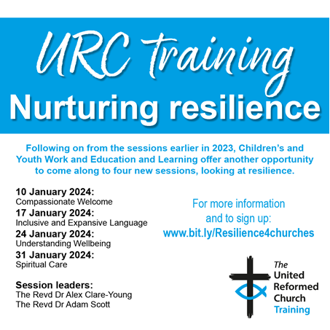

Following on from the success of the URC Training sessions in 2023, Children’s & Youth Work and Education & Learning are offering four new sessions on **RESILIENCE**, led by Alex Clare-Young and Adam Scott.

**Revd Dr Alex Clare-Young** (they/them or just their name) is a URC minister in Special Category Ministry developing a new faith-based community in Cambridge City Centre.  Alex is an Associate Tutor at Westminster College and is also a writer, facilitator and activist, creating content around LGBTQ+ identities, neurodiversity, compassionate/trauma awareness and DEI (diversity, equity and inclusion) more broadly. Alex enjoys using creativity - in words, music, craft and design - to express their commitment to social and eco justice and to bring people together.

**Revd Dr Adam Scott** is Principal of Northern College, a NSM URC minister and a chartered psychologist. He loves to explore where psychology and faith intersect and has a particular interest in wellbeing, mindfulness and human flourishing.

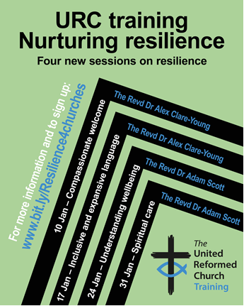**24 January 7.15-8.45pm: Understanding Wellbeing – with Adam Scott**

Wellbeing is about a broad understanding of health and relates to not only our physical or mental health, but also our happiness, pleasure and sense of meaning. This session will explore how people of faith can nurture their wellbeing in practical and enjoyable ways.

**31 January 7.15-8.45pm: Spiritual Care – with Adam Scott**

There is much talk about resilience in the church today, and the importance of self-care and community-care in the development of resilience. In this session we will specifically look at the role that spirituality and spiritual resources can play in enabling us to effectively care for ourselves and others.

To register for these sessions, please go to Eventbrite URC Training or click on this link: [**https://bit.ly/Resilience4churches**](https://bit.ly/Resilience4churches)

**Stop Press**

Rev’d Ashley Evans, the Yorkshire Synod Evangelist, has a new e-mail. From now on can you change your records for Ashley to [**evangelist@urcyorkshire.org.uk**](mailto:evangelist@urcyorkshire.org.uk)**.** Why not e-mail him to see what he can offer your church (and to make sure the new e-mail address works).

**SAFEGUARDING**

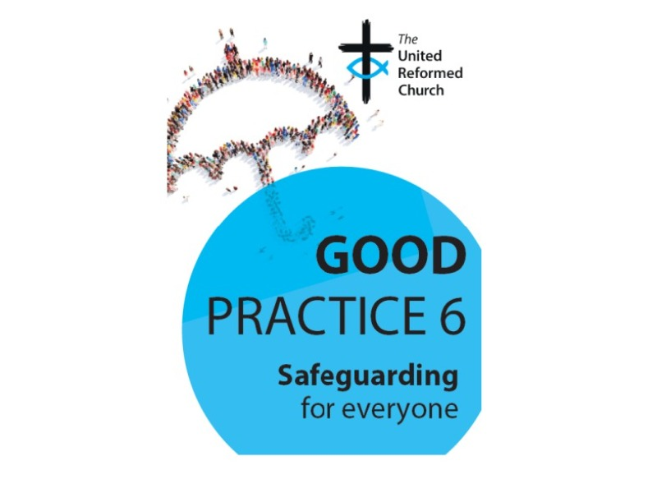

**URC launches new safeguarding guidance - Good Practice 6**

On 23 October 2023 the URC launched Good Practice 6.  You can read more from the URC national website by clicking [**here**](https://urc-northernsynod.us19.list-manage.com/track/click?u=4355102fbe037b2e7cd421cfb&id=979ddadcb2&e=c5cd7412e8).  A copy of Good Practice 6 will be posted to all church-based Safeguarding Coordinators, Synod Safeguarding Officers and Moderators. You can also read a free digital version of Good Practice 6 by clicking [**here**](https://urc-northernsynod.us19.list-manage.com/track/click?u=4355102fbe037b2e7cd421cfb&id=df3c97a954&e=c5cd7412e8).

**Forthcoming Training Sessions**

**The following dates in 2024 are still available for Intermediate Safeguarding Training via Zoom with Matt Knowles.**

**Tuesday 23rd January, 10am – 12.30pm**

**Monday 5th February, 1pm – 3.30pm**

**Saturday 17th February, 9.30am – 12.00pm**

If you are unsure as to whether you need to do the foundation (basic) training or the intermediate training Please click [**here**](https://urc-northernsynod.us19.list-manage.com/track/click?u=4355102fbe037b2e7cd421cfb&id=ec2bc9a85d&e=c5cd7412e8) to read Paper T5 which was adopted at last summer’s General Assembly. It details the roles and levels of training required.  Members wishing to book a place should have completed the foundation e-learning package prior to the date of the Intermediate course.  For more information or to book your course please [**email**](mailto:paulakitson.1and4@urc.org.uk) Paula Kitson as soon as you can as spaces are limited and are being taken up rapidly.

Additionally, the Safeguarding team are looking to do several face-to-face Intermediate training courses throughout the Northern and Yorkshire areas.  If you wish to nominate your church to potentially hold one of these courses, could you let Paula or Matt know.

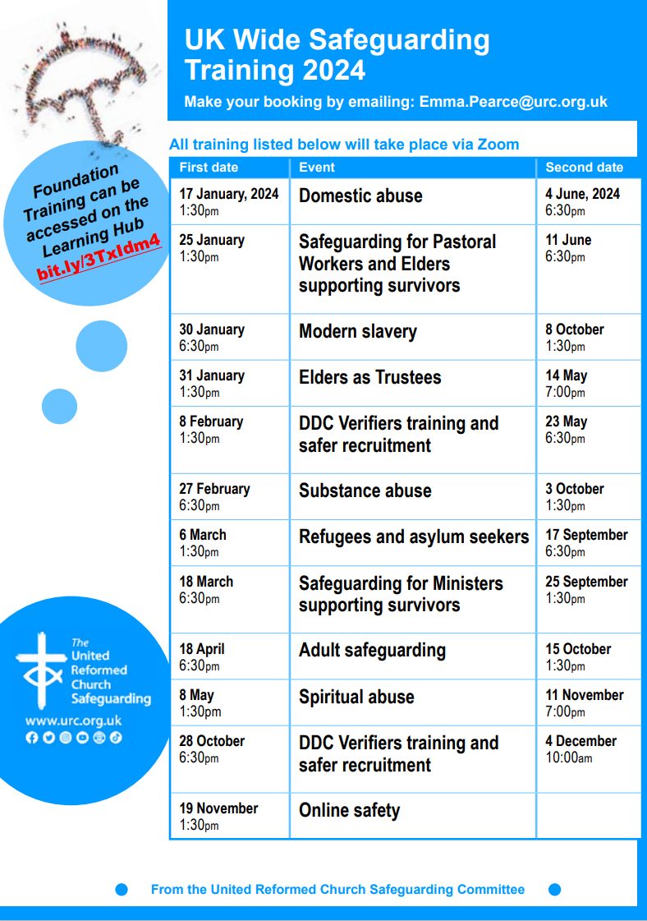

The Church Army in Sheffield is hosting a Comedy Night with Andy Kind at 7.30pm on Friday 20th January, at Wilson Carlile Centre, 50 Cavendish Street, Broomhall, Sheffield S3 7RZ.  Andy is a preacher and award-winning comedian (calling himself a ‘promedian’) and gets great reviews.

**Synod is in partnership with the Church Army at Darnall URC in the Attercliffe and Darnall Centre of Mission. You can see much of what is happening there in Briefing no 105 from April 2023 or at** [**Attercliffe And Darnall Centre of Mission - Church Army**](https://churcharmy.org/mission/attercliffe-darnall/)

Tickets for the event are £9 and all proceeds raised will be going to the frontline work of the Church Army, transforming lives through the love of God. Tickets can be purchased through the QR code on the poster attached or online at

[**https://www.eventbrite.co.uk/e/charity-comedy-night-with-andy-kind-tickets-764057044187**](https://www.eventbrite.co.uk/e/charity-comedy-night-with-andy-kind-tickets-764057044187)

If you have any questions, please contact Rachael at the Church Army by email: [**rachaelrookwilliams@churcharmy.org**](mailto:rachaelrookwilliams@churcharmy.org) or by telephone: 0114 551 2604

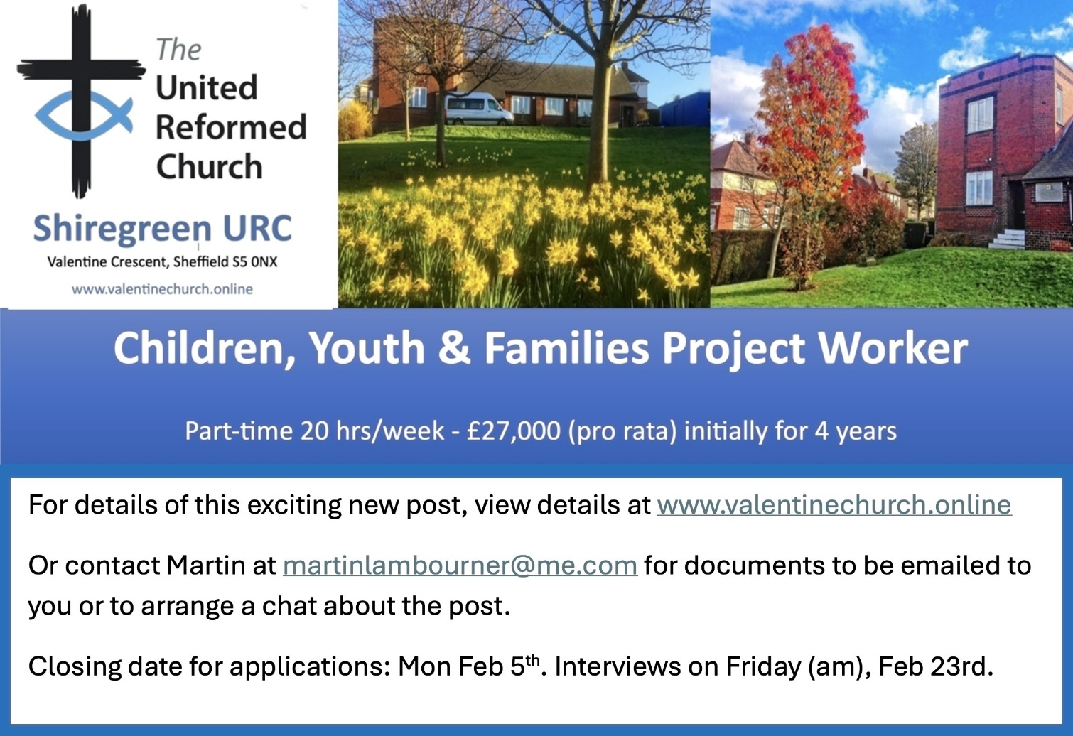

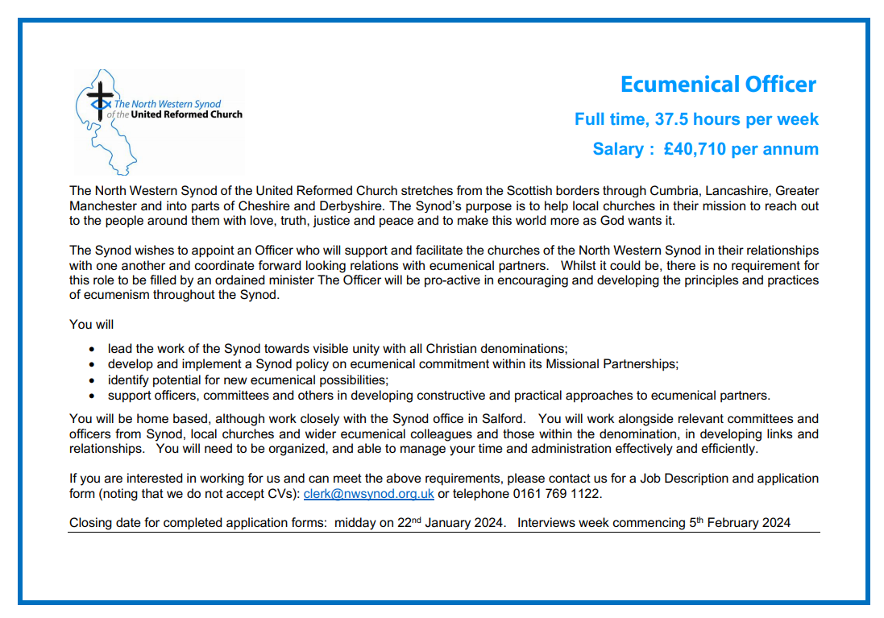

**And Finally**

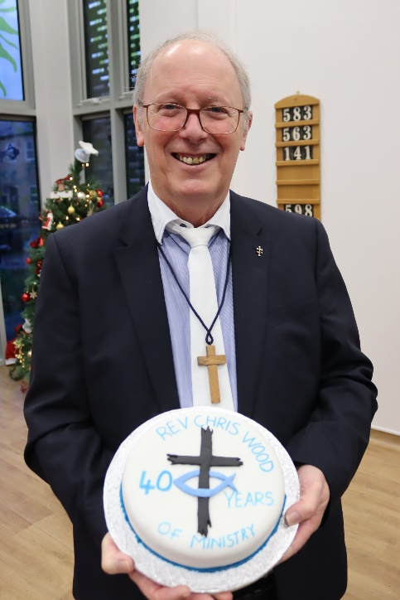Perhaps this is the place to put those nice, heartwarming stories, which if they were at the end of “News at Ten” and had the dulcet tones of Trevor MacDonald narrating it: so apologies to Chris for not getting this in the last issue of 2023, but here’s something to celebrate:

**40th Anniversary of Ordination**

The Rev’d Chris Wood celebrated his 40th Anniversary of Ordination by taking the service at Brackenhall URC, Huddersfield on Sunday December 10th. Chris was brought up at Lightcliffe URC, Halifax under the guidance of the Rev’ds Pat Smailes and Hugh Neems and was encouraged to undertake a course in Community & Youth Work at Westhill College, Birmingham to test out his calling to ministry. Four years were subsequently spent on Merseyside, at the Rock Church Centre in Everton and then at Charing Cross Methodist Church in Birkenhead, where he worshipped at Tranmere URC.

After successfully candidating through the Yorkshire Synod, Chris trained at Westminster College, Cambridge, before being Ordained at Brackenhall URC, Huddersfield on 10th December 1983, having been called to the Special Category position of Brackenhall and Sheepridge Community Ministry. This involved living on the estate – the only ‘professional’ that did – with oversight of the churches on the Brackenhall estate as well as Wiggan Lane Methodist Church situated in the village of Sheepridge. After 5 years, Chris moved to the South Leeds Team Ministry, whose Team Leader at the time was Rev David Marsden. Chris’s role was the oversight of Belle Isle United Reformed Church as well as the work of the two Day Centres and pastoral link to the Youth Hostel in Beeston. He was also the Team link to Cottingley LEP serving on their Management Committee and the taking of occasional services. It was while at Belle Isle that Chris met Jayne; they married at Dewsbury Road URC in November 1995 and were blessed with a son, Aaron Jowett in 1998.

In 1999, much to the amazement of family, friends and church members, Chris, Jayne and Aaron moved away from their beloved Yorkshire to the Eastern Synod. They spent 13 very happy years at Clacton-on-Sea and then 6 years in Central Suffolk where he had responsibilities for a URC within a market town, and four villages.

In retirement, Chris and Jayne have moved back to West Yorkshire and transferred their membership to Norristhorpe URC, Liversedge. He has also been appointed Yorkshire Synod Companion to Heywood URC, Northowram, a Chapel close to the area he grew up in, where he has had links since his childhood. Indeed, at Lightcliffe the children and young people were constantly reminded of the example of Oliver Heywood who lost his living in Coley, imprisoned and hounded by the authorities but who would eventually set up a non-conformist fellowship in Northowram in 1672 which still serves the village and community today.

Congratulations, Chris, on your 40 years as a Minister of Word & Sacraments and may God keep you busy with us for many more years to come.

You can also keep an eye on all our social media platforms for news; on the website at [**Home - URC Yorkshire Synod**](https://urcyorkshire.org.uk/), the Facebook pages at [**United Reformed Church in Yorkshire - Home | Facebook**](https://www.facebook.com/urcyorkshire) and [**Wilderness URC Yorkshire - Home | Facebook**](https://www.facebook.com/wildernessyorkshireurc/), the YouTube page at [**URC Yorkshire - YouTube**](https://www.youtube.com/channel/UCSAly5eC6tBlmY52dLxrylg) and the Twitter page at [**URC in Yorkshire (@URCYorkshire) / Twitter**](https://twitter.com/URCYorkshire).