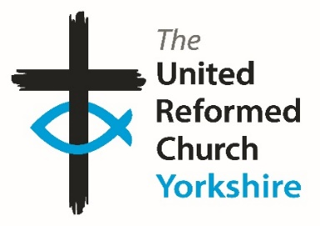**Yorkshire Synod Briefing**

**Number 124**

**22nd February 2024**

|  |
| --- |
|  |

**Keeping You in the Loop**

When the first issue of the Briefing was published, just short of four years ago, one of the things that we wanted to do was to keep churches informed as to what Synod (and the URC as a whole) was doing in response to the emerging Covid-19 pandemic. As that passed, the focus of the Briefing changed to help churches in the economic difficulties that we are still facing, and this is what we are still trying to do. We are still endeavouring to keep churches informed of what is happening in and around the Synod, as well as letting you know what other churches are doing to build the Kingdom in His own country. This issue there is no exception as there is lots to read about, many events to go to or pray about and in the spirit of those early Briefings, guidance on grants and how to source them.

However, to be able to continue we still need your input. Firstly, we do need your details to be up to date as possible, which is why Church secretaries and Safeguarding leads are being asked to fill in the Church returns accurately and fully. Without the latest details key messages can get lost, so if you do require any help, please get in touch with the office. Secondly, we do need your help in filling roles across the denomination, in particular relation to the ongoing Church Life Review. The deadline for those willing to volunteer for roles has been extended to March 4th, so please visit this link <https://urc.org.uk/church-life-review-task-group-opportunities/> so see whether you are called to a national role.

As well as the CLR request I am as ever looking for lots of volunteers to help in the smooth running of the Synod. There are several of our committees in urgent need of new faces. Without your help, the well-oiled machine that is Synod will grind to a halt. Currently the Financial Resources, the Property and the Children & Young People’s Committees are in desperate need of new people to help guide Synod. More will be said at the upcoming Synod meeting, but as with any appeal I make I am happy to talk through the role if you are called to serve and if you feel that you know somebody who may be interested, please let me know in the usual manner – via my e-mail or mobile or through the office in Morley.

**Yorkshire Synod Meeting**

We meet as Yorkshire Synod in just over two weeks on Saturday March 9th at 10.15am at Central URC in Sheffield. One of the things we try to do is to spread the location of our meetings around the county, so please make an effort and attend this one as it **will not** be hybrid and at the moment it is unlikely that it will be streamed. Perhaps it’s tag line should be “Going Back to the Future” as we will be discussing the future work of the Synod in the time-honoured tradition of being in one place discerning the way in which God has us move.

**Finally, please let me have details of what is happening where you are. Tell me what you plan for 2024 so that I can help spread that news, especially what you are doing in Lent and over Easter. Drop me a line at** [**clerk@urcyorkshire.org.uk**](mailto:clerk@urcyorkshire.org.uk) **and I’ll showcase it in the next edition, due out on Thursday 7th March with a deadline of Wednesday 6th March 2024.**

**Thank you and God Bless,**

Tim Crossley

**Synod Clerk**

**



**Holiday Forum in a Day -**

**Saturday 24th February 2024**

Save the date! Join us on Zoom next February 24th for [***HF in a Day***](https://www.urcholidayforum.org.uk/wpsite/) and have a taste of what to expect at next year’s summer conference.

The Holiday Forum team will be joined by **Rev Fiona Bennett** who leads our theme and **Rev Kuraone Mutimwii**, our worship leader. They’ll give us a flavour of their sessions to whet your appetite and there’ll be other things to get stuck in to throughout the morning and later in the evening (full timetable TBC).

**The day will run in two parts:** from 9.30am-12.30pm and then from 7.30pm-9.30pm (with the option to join from 6.30pm to meet and share dinner virtually). Feel free to drop in as you like throughout the day using this zoom link.

[**https://us06web.zoom.us/j/85672315058**](https://us06web.zoom.us/j/85672315058), Meeting ID: 856 7231 5058.

Don’t forget, places for the summer conference (Sunday 18th to Friday 23rd August 2024 at The Hayes & online) are limited to just 100 this year and lots have been filled already, so [**book early**](https://www.urcholidayforum.org.uk/wpsite/booking-form/)to avoid disappointment!

**SAVE THE DATE!**

**Join us for an inspiring walk through the New Testament**

“Relax and enjoy the journey as an experienced guide encourages you to see God’s Word through the ‘Big Picture’. Our FUN and MEMORABLE sessions will help you learn with such CLARITY you’ll be able to retell the whole STORYLINE to a friend.

We will also do our best to INSPIRE and EQUIP you to keep digging deeper.”

**One event over two days**

**Friday 12th April 2024 7 - 9.15pm AND Saturday 13th April 2024 9.30am - 1pm**

**at Bilton Grange URC, Harrogate**

**For further details and to book please contact Caroline Butler (Knaresborough URC)**

**Tel: 07904 509802 Email: butler.caroline@outlook.com**

**TURIN SHROUD EXHIBITION COMES TO THE BRIDGE CHURCH**

***An exhibition around one of the most famous religious artefacts in history is coming to the Bridge Church***

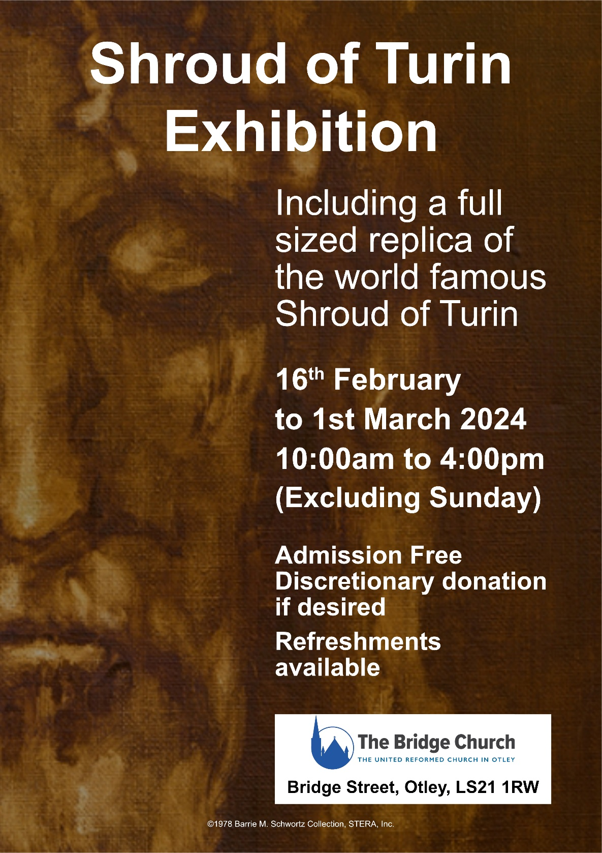Visitors to the Bridge Church, Otley, will be able to see a full-sized replica of the world-famous Shroud of Turin as part of a fascinating exhibition which will be on display in the sanctuary from Friday 16th February to Friday 1st March.

The actual Shroud is housed in the cathedral in the Italian city of Turin and is a length of linen cloth that bears a faint image of the front and back of a man.

It has been venerated for centuries, especially by members of the Catholic Church, as the actual burial shroud used to wrap the body of Jesus of Nazareth after his crucifixion, and upon which his bodily image is miraculously imprinted.

As well as a full-sized replica of the Shroud of Turin, the exhibition will also feature other fascinating displays and detailed information boards, which cover evidence revealed by historical and scientific research, explaining how the Shroud’s image and bloodstains align with Gospel accounts.

Minister at the Bridge Church, Rev Jason McCullagh, said ‘we are thrilled to be hosting this incredible exhibition in the Bridge Church, and we hope that it will be visited by many people over the fortnight.

For more information of other activities at the Bridge Church, please visit [**Otley Bridge Church**](https://www.otleybridgechurch.org.uk/)**.**

**February is the month to find out more about Godly Play in Yorkshire!**

Godly Play is a unique approach to storytelling in a way that nurtures spirituality and creativity, and allows children to be curious about scripture and the stories of Jesus.

Richard Knott will be with us on **Saturday 24th February** at Somerset House for an opportunity for you to experience Godly Play for yourself. More details of this event below and flier attached.

*The day (24/02/2024) will allow you to participate in 2 complete Godly Play sessions, each exploring a different story genre. There will be opportunity to discuss key elements of the Godly Play approach and childhood spirituality.*

*This is a free event and open to anyone. It is especially designed for those who have little or no previous experience of Godly Play. This opportunity is suitable for children’s leaders, youth leaders, teachers, ministers, chaplains or anyone interested in childhood spirituality.*

*Hot drinks and lunch provided. You may like to bring a cushion to sit on, as wherever possible we like to sit on the floor for Godly Play.*

*If you have any questions, please get in touch. Places are limited. Please contact Megan to confirm your attendance.* [***Megancyp@urcyorkshire.org.uk***](mailto:Megancyp@urcyorkshire.org.uk) */ 07522 220213*

**Peak Wesley Way**

Our friends in the Sheffield Methodist District have brought this invitation to small groups of all faiths and none to engage in the ancient practice of pilgrimage along a path connecting six rural chapels in the beautiful Peak District National Park.

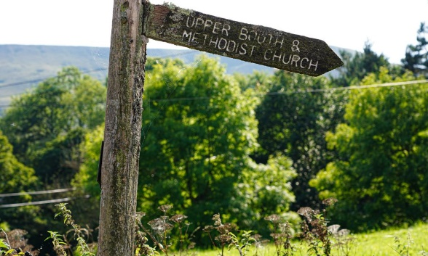The **Peak Wesley Way** is a contemporary opportunity to engage with the ancient spiritual practice of pilgrimage within the beauty of the Peak Park. It began as a vision of members of Peak Methodist Circuit to share their stories with small groups who are spiritually curious and intrigued by spending time in the ancient holy places, indoor and outdoor. The pilgrimage is for groups of friends or family with a shared quest for adventure, wanting to connect with a simpler greener lifestyle, or needing space to broaden life experiences. Thanks to support from many circuit members, people from beyond the circuit’s congregations and district officers they are now ready to invite you to book your pilgrimage. Please visit [**https://peakwesleyway.com/**](https://peakwesleyway.com/), follow us on [**Facebook**](http://facebook.com/peakwesleyway) or [**Instagram**](http://instagram.com/peak_wesley_way), and tell your friends! Is this the next step of your journey?

**Lay Preachers and Worship Leaders Weekend**

**“Lifting parables from the page: preaching for today’s Church”.**

at the Wydale Conference Centre, Brompton by Sawdon near Scarbrough

<https://www.wydale.org>

We are pleased to say that registration for our third **Lay Preachers and Worship Leaders weekend at Wydale Conference Centre** is **NOW OPEN**.

This will be **19th – 21st July 202424** (Friday teatime to Sunday lunch).

We are excited that Rev Dr Susan Durber will be our main speaker at the conference, and that once again we will be joined by our Moderator, Rev Jamie Kissack.

This weekend will again be paid for by synod and grants so you will only need to cover your travel costs.

**There are 30 places available** and you are now invited to register with the office at

[**office@urcyorkshire.org.uk**](mailto:office@urcyorkshire.org.uk)or 0113 289 8490.

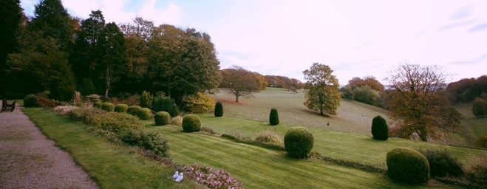

Yours in Christ’s service

Kath Lonsdale, Anne Dale, Jill Fletcher, Rod Morrison,

Lay Preachers and Worship Leaders Planning Group

For any queries, please contact Kath at [kathlonsdale@talktalk.net](mailto:kathlonsdale@talktalk.net)  01274 315203 or 07759525936.

**New Youth Building arrives at Stainbeck**

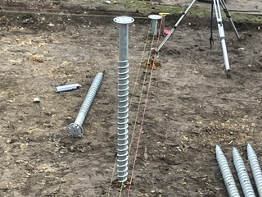This is building the Kingdom in more ways than one: the congregation at Stainbeck URC are super excited that their new youth building arrived on Monday 19th February. Usually, we think of buildings being built, brick by brick or stone by stone, but in this case it has been craned in, as you’ll see in the photo kindly supplied by Rev Angela Hughes.

The foundations were “screwed” into place at the back end of January and the ground was prepared to receive the new building earlier this month. Happily, the weather seems to have played its own part and the contractors were able to get the module in place.

It's a modular building that young people will be able to use as a safe space. This is a joint venture between Stainbeck URC, InterACT and THRIVE LEEDS, two local Leeds based organisations working in the Stainbeck area with young people. As well as being this safe space, the module will be available for use by others in the local community and Stainbeck tells us that they have a group of between 20 and 30 youngsters who are all ready to make it their own - watch this space!

It's taken a lot of work and time to get the building on site. So, with Stainbeck URC, please give thanks for it and pray for its good use going forward. To see what else Stainbeck URC are up to please pay their webpage a visit at <https://stainbeckurc.org.uk/> and in particular head to

<https://stainbeckurc.org.uk/ca-youth-project/> where you’ll find more information about the Thrive project.

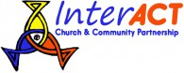

<https://interact.uk.net/> <http://thriveleeds.org.uk/>

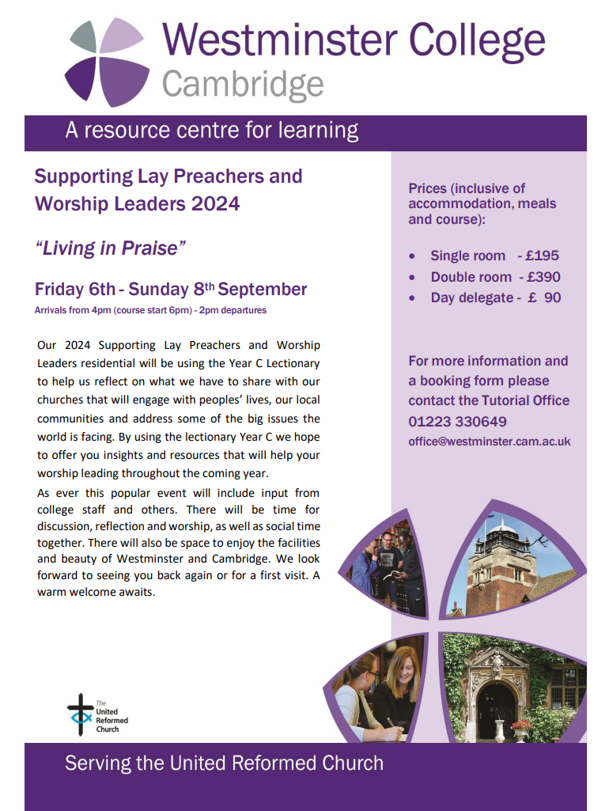More details as well as a booking form can be found on the Westminster College website at……

<https://www.westminster.cam.ac.uk/urc/events>

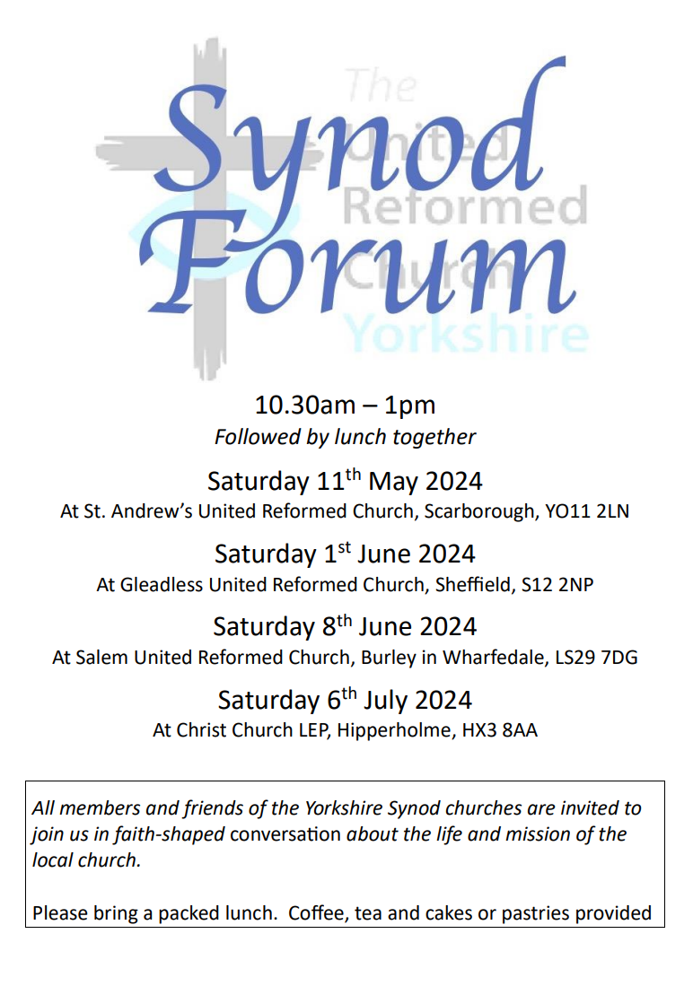Building on the success of last year’s Synod Forums as opportunities for fellowship and good conversation, we will be meeting again in four different locations around Yorkshire Synod in May, June and July. You are free to choose the date and venue that is best for you. All will run from 10.30am – 1pm. You are encouraged to stay to share a bring-your-own lunch.

As last year, the conversation will be based around Paul’s first letter to the Corinthians. It will be mostly in small group discussions, so you get chance to share with people from other churches. We will picking up on some of the themes in the URC’s Theos report ([**https://www.theosthinktank.co.uk/cmsfiles/URC-report-Final.pdf**](https://www.theosthinktank.co.uk/cmsfiles/URC-report-Final.pdf)), and will be asking Where do we see flourishing in Yorkshire Synod? (And what might be the barriers to flourishing?)

We hope that this will also be a chance for those with Synod roles to hear from the local church about your opportunities and challenges so that together we can find the best ways to support and encourage each other. The Synod Forum is your place to have your voice heard, and to help shape the priorities of the Synod.

[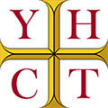](https://www.yhct.org.uk/)

[Helping Yorkshire's Historic Churches & Chapels](https://www.yhct.org.uk/)

**Good news! Funding available for Yorkshire’s Churches**

**The Yorkshire Historic Churches Trust is welcoming funding applications from places of worship across the county for repair, restoration and maintenance work. Due to the generous donations and legacies received last year, the Trust is actively encouraging churches to apply for the next round of funding.**

**The application deadlines for 2024 are Friday 8 March for consideration at the April grants committee and Friday 23 August for consideration at the October grants committee. For guidance and how to apply please go to: www.yhct.org.uk/grants.**

**In summary:**

**What you can apply for: Grants are available for repairs to the church fabric, the walls, roofs, floors, tower, bell frames, windows, stonework, repointing and rainwater goods. Grants are also available for the conservation of fixture and fittings, such as monuments, furniture and stained glass and repairs to bells, clocks and organs.**

**Applications are also welcome for investigatory work, e.g. where a cherry picker may be required to assess what repairs may be required. You can apply for this type of grant at any time of the year. Do contact Jonathan Stamp by email at grants@yhct.org.uk if you would like to discuss this.**

**The YHCT have no set funding amounts, but common grants range from £2000 - £10,000, depending on the size of the works. The Grant Committee looks at how much the total project is and how much effort has gone into fund raising locally, and which other funders have been approached or confirmed their grants. The YHCT ideally likes to be able to help a church or chapel who have neared the end of their fund raising and only have a shortfall of say £10 - £15,000 to be able to start their project.**

**It is also inviting individual churches and chapels to become 'Church Members' and to support the Trust by opening churches on Yorkshire Churches Day on 14 September 2024 or taking part in the Ride and Stride sponsored event. All this is found on the trust website** [**https://www.yhct.org.uk/yorkshire-churches-day/**](https://www.yhct.org.uk/yorkshire-churches-day/)

**We look forward to hearing from you.**

**Stop Press**

Rev’d Ashley Evans, the Yorkshire Synod Evangelist, has a new e-mail. From now on can you change your records for Ashley to [**evangelist@urcyorkshire.org.uk**](mailto:evangelist@urcyorkshire.org.uk)**.** Why not e-mail him to see what he can offer your church (and to make sure the new e-mail address works).

**SAFEGUARDING**

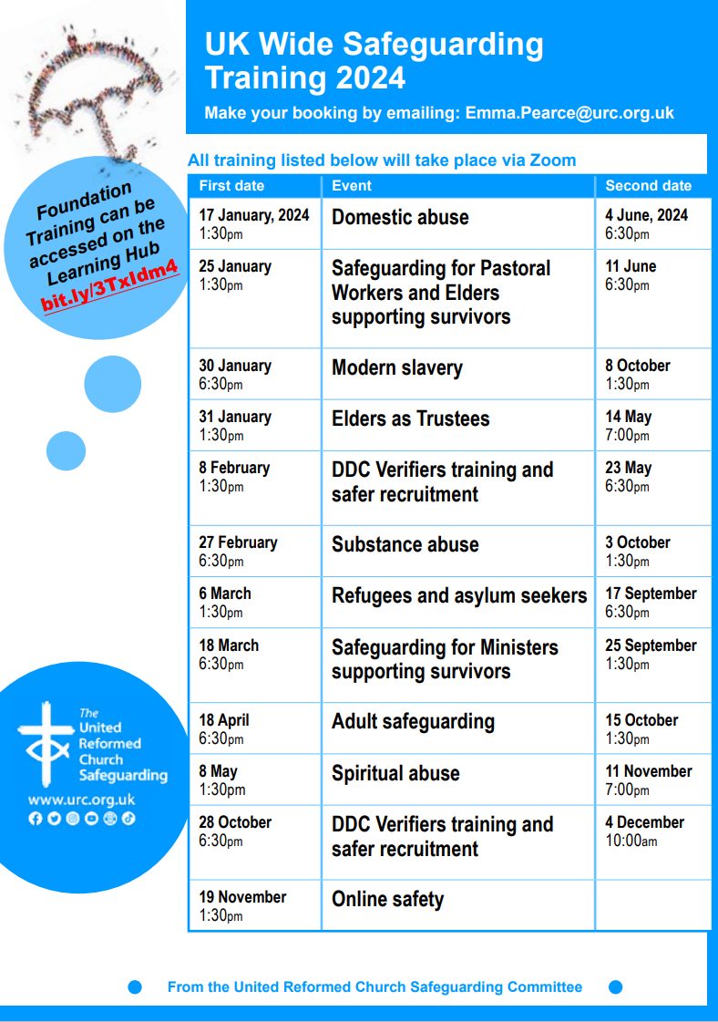

**Funding Resources - Winter 24**

Rev Simon Copley, our Treasurer, has circulated a fuller version of this to all our church treasurers this past week, but it useful to let you all know that there are plenty of resources available to Synod churches to help them through this winter as well as to help them build on any missional initiatives they plan to work on.

1. **Synod Funds**

The Synod has three sources of grant support that local congregations (including LEPs) can access:

***Synod Mission Fund*** - this is our go-to funding pot for any projects/posts that help your congregation carry out any aspect of mission in your local community. Both small and larger/multi-year grants are available.

***Mission Capacity Fund*** - this new fund will support any measure (including back-room, support, organisational changes and administration tasks) that will help release energy for your congregation to engage in mission.

***Vision and Opportunity Property Grants*** - these can be of any size and fund any alteration to church buildings that help congregations engage more effectively in mission.

We recommend a conversation with our Synod Clerk, Tim Crossley ([clerk@urcyorkshire.org.uk](mailto:clerk@urcyorkshire.org.uk)) about any prospective application to the Synod Mission and Mission Capacity Funds and with Val Morrison, Convenor of the Synod Property Committee ([valmorrison7@btinternet.com](mailto:valmorrison7@btinternet.com)), about Vision and Opportunity Grants.

Further details of how to apply to all these funds can be found on the Synod website at [Forms - URC Yorkshire Synod](https://urcyorkshire.org.uk/forms/)

1. **National URC Funds**

The United Reformed Church has national funding streams that any congregation can apply to. The two largest are:

***Church Buildings Fund*** - gives loans, and sometimes grants, towards any building cost. These are usually £25,000 maximum but larger loans and grants can be made. Please ask Simon Copley, the Synod Treasurer, about details of how to apply to these funds ([whiteknight_copley@hotmail.com](mailto:whiteknight_copley@hotmail.com)). Further information is also available at [Church Buildings Fund - United Reformed Church](https://urc.org.uk/your-church/guidance-support-for-churches-synods/church-finance/the-church-buildings-fund/)

***Legacy Fund***- gives grants normally with a limit of £50,000 per application for innovative and ground-breaking mission projects. Further information is available at [The Legacy Fund - United Reformed Church](https://urc.org.uk/your-church/guidance-support-for-churches-synods/church-finance/the-legacy-fund/) where you can download the application form.

There are a number of **other, smaller funds** and details of these can be found at: [Grants & funding opportunities - United Reformed Church](https://urc.org.uk/grants-funding-opportunities/). Please note that national URC funds tend to be undersubscribed so a well-thought application will have a good chance of success. Please contact Simon ([whiteknight_copley@hotmail.com](mailto:whiteknight_copley@hotmail.com)) for advice on how to put your bid together.

1. **Trust Funds, Landfill and Lottery Funding etc**

There are a large number of Trusts and Foundations (and other sources) that give grants for community, Christian and environmental causes.

Synod has access to the ***Directory of Social Change database*** with information about over 4,500 Trusts and Foundations giving grants for the widest possible range of causes.

The database can be accessed by any Congregation. Contact Simon, the Synod Treasurer ([whiteknight_copley@hotmail.com](mailto:whiteknight_copley@hotmail.com)), and he will be happy to guide you through the access procedure and to give any further advice on how to research the database.

**The URC History Society Conference**

**16-18 September 2024, University of Durham**

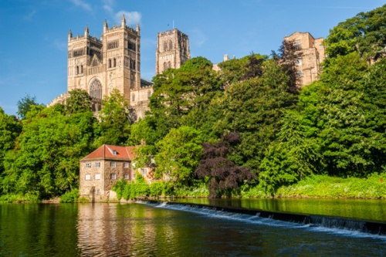***The Church on the margins:***

***learning from the past to shape the future***

Speakers include:

1. Dr Michael Hopkins – *“Durham and its Dissent”*
2. Nancy Graham - *“The trajectory of Erik Routley”*
3. Professor Alec Ryrie – *“A remarkable work of grace”: the first era of Presbyterian missions (c. 1740-70)*
4. Professor Peter Ackers - *“The Churches of Christ and the early twentieth century British labour movement”*
5. Dr Victoria Turner – *“Coming to terms with Coloniality: The Changed Mind of Bernard Thorogood as General Secretary of CWM”*
6. Professor Stephen Taylor – *“Episcopalian congregationalism: a neglected episode in the development of Anglicanism in the seventeenth and eighteenth centuries”*

This is an open and welcoming conference, for those with a general interest through to professional historians/theologians.  Independent scholars, practitioners, and those with no formal training are all equally welcome.  We welcome serving ministers, because the conference is about exploring where we have come from in order to know where we are going. ***£275 full board in single room, £250 per person sharing a double room.*** Payments to United Reformed Church History Society 40-52-40, 00032467

Ministers can access EM3 funding towards this and for others it comes within the scope of the small DDF grant application for lay folk in Synods. For more information on this contact Kath Lonsdale through the Synod office at [office@urcyorkshire.org.uk](mailto:office@urcyorkshire.org.uk).

**To offer support for the Church’s humanitarian support for those affected by the ongoing crisis in Gaza please visit the URC’s website at** [**Christian Aid Middle East Crisis Appeal - United Reformed Church**](https://urc.org.uk/our-news-stories/christian-aid-middle-east-crisis-appeal/)**. Also please visit the**[**Christian Aid Appeal**](https://www.christianaid.org.uk/appeals/emergencies/middle-east-crisis-appeal)**site which includes supporting key facts and information, together with the opportunity to make donations direct to**[**Christians Aid**](https://give.christianaid.org.uk/donate/CAM-005943)**. You can also contribute through the URC’s own programme *Commitment for Life* at**[**Israel and the occupied Palestinian territory – United Reformed Church**](https://urc.org.uk/your-church/church-local-and-global/commitment-for-life/israel-and-the-occupied-palestinian-territory/)**.**

**And Finally**

Your hard-working Synod Clerk was spotted at a Lectern on 8th February, but he wasn’t expounding on a deep theological point. He was in fact welcoming a class of 9 and 10 year olds from Beckfoot Priestthorpe Primary School in Bingley to Saltaire URC. The class (which included the Clerk’s younger son) have been studying the Industrial Revolution this term and on a trip to see Saltaire Village and the mill there, they popped into the church to see the wonders of Saltaire URC.

The Clerk offered them a brief history of the church and how the workers at the mill were expected to join Sir Titus Salt in worshipping in his specially built church. He pointed out to the class the recent repairs to the ceiling and was quite surprised to be asked by one child whether they could play the organ. A highlight for most of the children was to look into the Mausoleum and wonder at the huge angel carved from the beautiful white Italian marble.

Despite the very wintry weather the children and teachers received a very warm welcome and it is hoped that future classes will be able to do the same trip in future years.

You can also keep an eye on all our social media platforms for news; on the website at [**Home - URC Yorkshire Synod**](https://urcyorkshire.org.uk/), the Facebook pages at [**United Reformed Church in Yorkshire - Home | Facebook**](https://www.facebook.com/urcyorkshire) and [**Wilderness URC Yorkshire - Home | Facebook**](https://www.facebook.com/wildernessyorkshireurc/), the YouTube page at [**URC Yorkshire - YouTube**](https://www.youtube.com/channel/UCSAly5eC6tBlmY52dLxrylg) and the Twitter page at [**URC in Yorkshire (@URCYorkshire) / Twitter**](https://twitter.com/URCYorkshire).