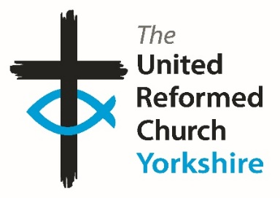**Yorkshire Synod Briefing**

**Number 125**

**7th March 2024**

|  |
| --- |
|  |

**Spring Synod Time**

Little did I think that I would be wondering where I may have to edit this time’s issue, but the amount of information I’ve received over the last fortnight has been incredible. The events that are being brought to your attention are a sign that there is a great deal of activity both within the Synod and around the denomination. This is the work of the Lord, and it really does those who are behind these events great credit that their outreach is touching the lives of so many people.

We won’t be resting on any laurels though, as there is always much work to be done and as ever the Briefing is here to help the Word and that work reach as wide an audience as possible. We always endeavour to keep churches informed of what is happening in and around the Synod, as well as letting you know what other churches are doing to build the Kingdom in His own country. As ever, we still need your input. Keep up the flow of information and let us know what is happening in the final weeks leading up to Easter and let us know your plans so we can let everyone know.

Again, I’m putting out an appeal for those who feel they have a call to help out the Synod and the Denomination in the roles we have vacant. There are still roles across the denomination that have yet to be filled, in particular relating to the ongoing Church Life Review. The deadline had been extended to March 4th, but this link is still open <https://urc.org.uk/church-life-review-task-group-opportunities/> so see whether you are called to a national role.

As well as the CLR request I am as ever looking for lots of volunteers to help in the smooth running of the Synod. There are several of our committees in urgent need of new faces. Without your help, the well-oiled machine that is Synod will grind to a halt. Currently the Financial Resources, the Property and the Children & Young People’s Committees are in desperate need of new people to help guide Synod. More will be said at the upcoming Synod meeting, but as with any appeal I make I am happy to talk through the role if you are called to serve and if you feel that you know somebody who may be interested, please let me know in the usual manner – via my e-mail or mobile or through the office in Morley.

**Yorkshire Synod Meeting**

We meet as Yorkshire Synod in just two days’ time **on Saturday March 9th** at 10.15am at Central URC in Sheffield. One of the things we try to do is to spread the location of our meetings around the county, so please make an effort and attend this one as it **will not** be hybrid and at the moment it is unlikely that it will be streamed. Perhaps it’s tag line should be “Going Back to the Future” as we will be discussing the future work of the Synod in the time-honoured tradition of being in one place discerning the way in which God has us move.

**Finally, please let me have details of what is happening where you are. Tell me what you plan for 2024 so that I can help spread that news, especially what you are doing in the run up to and over Easter. Drop me a line at** [**clerk@urcyorkshire.org.uk**](mailto:clerk@urcyorkshire.org.uk) **and I’ll showcase it in the next edition, due out on Thursday 21st March with a deadline of Wednesday 20th March 2024.**

**Thank you and God Bless,**

Tim Crossley

**Synod Clerk**

**

**SAVE THE DATE!**

**Join us for an inspiring walk through the New Testament**

“Relax and enjoy the journey as an experienced guide encourages you to see God’s Word through the ‘Big Picture’. Our FUN and MEMORABLE sessions will help you learn with such CLARITY you’ll be able to retell the whole STORYLINE to a friend.

We will also do our best to INSPIRE and EQUIP you to keep digging deeper.”

**One event over two days**

**Friday 12th April 2024 7 - 9.15pm AND Saturday 13th April 2024 9.30am - 1pm**

**at Bilton Grange URC, Harrogate**

**For further details and to book please contact Caroline Butler (Knaresborough URC)**

**Tel: 07904 509802 Email: butler.caroline@outlook.com**

**United Reformed Church Waldensian Fellowship**

Chairman – Revd. John S. Bremner

Gathering at Hinsley Hall, Leeds

**Celebrating 850 years of the Waldensian Movement**

Thursday 18 to Saturday 20 April 2024

*This year, the Waldensian Church celebrates the 850th anniversary of the movement started by Pietro Valdo, who sought to preach and live the simple Gospel message.*

*We shall explore something of the history of the Waldensian movement during our time together.*

*This will also be an opportunity for us to share our experiences of meeting the Waldensian people, both in Italy and here in Britain – so bring photographs and other memorabilia!*

Information about the Gathering, costs and timings, and a booking form, are available from:

George Morton, 4 St Annes Road, Manchester M21 8TD

email: [g.morton50@ntlworld.com](mailto:g.morton50@ntlworld.com); telephone: 0161 881 8195

**KELD RESOURCE CENTRE**

**IN PARTNERSHIP WITH LOW ROW WITH KELD URC**

**NEW FOR 2024 : STUDY DAYS**



We are delighted to announce a new series of study days for 2024 and issue a warm invitation to come to any or all of them! They are:

Thursday July 4th : Revd. Michael Pearson

**Five impossible Things to Believe before Christmas!**

Saturday August 17th : Revd. Peter Sinclair

**After Sunday : Being Church Seven Days a Week**

Thursday September 26th : Ms. Dorothy Thomson

**There’s a Sermon in There Somewhere!**

The programme will be as follows:

10.30 : Arrivals and Coffee

11.00 : Session One

12.30 : Lunch

13.30 : Session Two

15.00 : Refreshments and Departure

There will be discussion, sharing, space to ponder …….

All participants are invited to bring a packed lunch. Drinks will be provided. The cost for the day will be £10 per person.

To book your place, please contact Revd David Wood

Email address : [david.wood4@btinternet.com](mailto:david.wood4@btinternet.com)

**Lay Preachers and Worship Leaders Weekend**

**“Lifting parables from the page: preaching for today’s Church”.**

at the Wydale Conference Centre, Brompton by Sawdon near Scarbrough

<https://www.wydale.org>

We are pleased to say that registration for our third **Lay Preachers and Worship Leaders weekend at Wydale Conference Centre** is **NOW OPEN**.

This will be **19th – 21st July 202424** (Friday teatime to Sunday lunch).

We are excited that Rev Dr Susan Durber will be our main speaker at the conference, and that once again we will be joined by our Moderator, Rev Jamie Kissack.

This weekend will again be paid for by synod and grants so you will only need to cover your travel costs.

**There are 30 places available** and you are now invited to register with the office at

[**office@urcyorkshire.org.uk**](mailto:office@urcyorkshire.org.uk)or 0113 289 8490.



Yours in Christ’s service

Kath Lonsdale, Anne Dale, Jill Fletcher, Rod Morrison,

Lay Preachers and Worship Leaders Planning Group

For any queries, please contact Kath at [kathlonsdale@talktalk.net](mailto:kathlonsdale@talktalk.net)  01274 315203 or 07759525936.

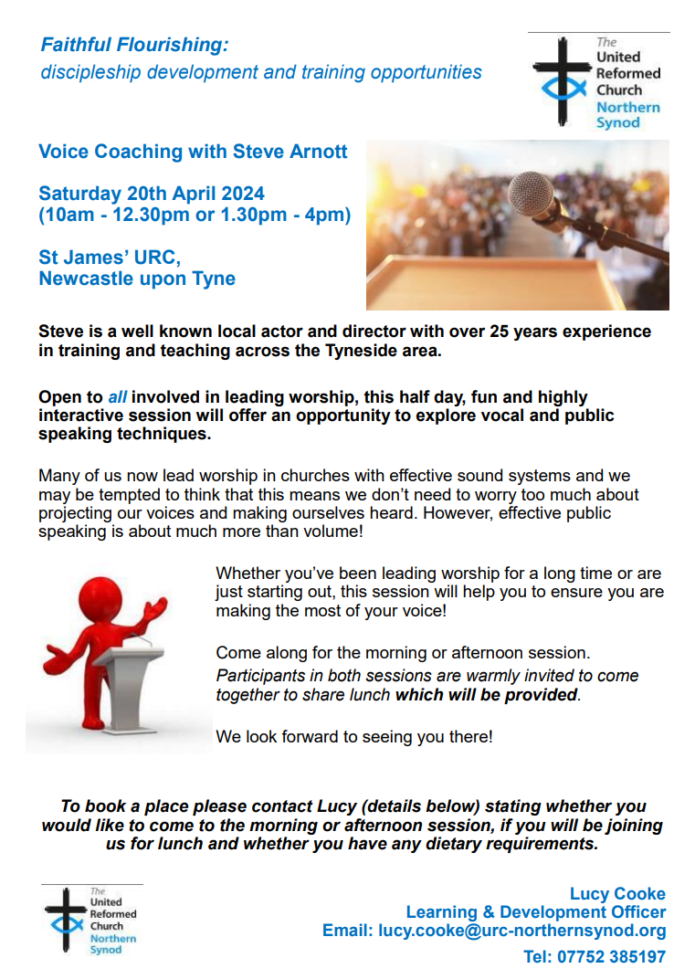

**New Youth Building arrives at Stainbeck**

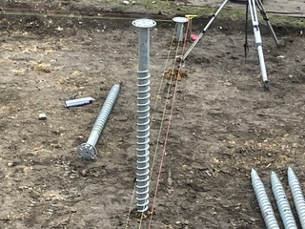This is building the Kingdom in more ways than one: the congregation at Stainbeck URC are super excited that their new youth building arrived on Monday 19th February. Usually, we think of buildings being built, brick by brick or stone by stone, but in this case it has been craned in, as you’ll see in the photo kindly supplied by Rev Angela Hughes.

The foundations were “screwed” into place at the back end of January and the ground was prepared to receive the new building earlier this month. Happily, the weather seems to have played its own part and the contractors were able to get the module in place.

It's a modular building that young people will be able to use as a safe space. This is a joint venture between Stainbeck URC, InterACT and THRIVE LEEDS, two local Leeds based organisations working in the Stainbeck area with young people. As well as being this safe space, the module will be available for use by others in the local community and Stainbeck tells us that they have a group of between 20 and 30 youngsters who are all ready to make it their own - watch this space!

It's taken a lot of work and time to get the building on site. So, with Stainbeck URC, please give thanks for it and pray for its good use going forward. To see what else Stainbeck URC are up to please pay their webpage a visit at <https://stainbeckurc.org.uk/> and in particular head to

<https://stainbeckurc.org.uk/ca-youth-project/> where you’ll find more information about the Thrive project.

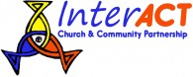

<https://interact.uk.net/> <http://thriveleeds.org.uk/>

**Making Disciples Day**

**Saturday 18th May 2024 – 10.00am to 3.30pm**

**Longcauseway Church, Dewsbury**

36, Longcauseway, The Princess of Wales Precinct, Dewsbury WF13 1NH

This is a day for all members and friends of our churches in the Yorkshire Synod. It will be led by Andrew Roberts, author of Holy Habits and Linda Rayner, URC co-ordinator for Fresh Expressions.

Andrew and Linda write, “*In response to the call and commission of Jesus to go and make disciples we will share and explore stories of initiatives in this area that have been fruitful and consider stories that have not been so fruitful and see what learning we can take from these.*

*We will also take time to consider how we can be bearers of good news and people of hope as we seek to make God known in difficult times and situations.*

*There will be plenty of time for both group conversations and personal reflection which will include the provision of prayer stations.”*

Please bring your own lunch – tea and coffee will be provided.

To book a place please email **valmorrison7@btinternet.com**

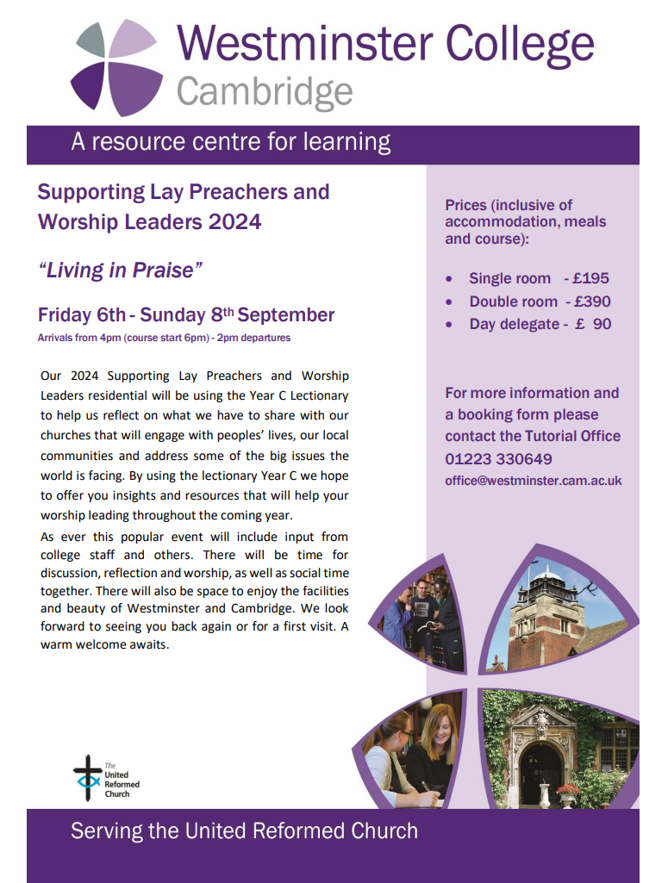More details as well as a booking form can be found on the Westminster College website at……

<https://www.westminster.cam.ac.uk/urc/events>

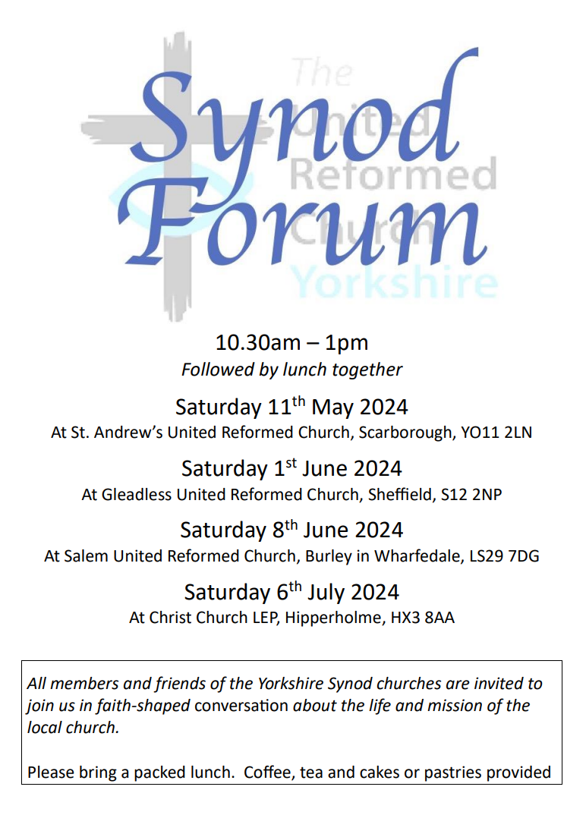Building on the success of last year’s Synod Forums as opportunities for fellowship and good conversation, we will be meeting again in four different locations around Yorkshire Synod in May, June and July. You are free to choose the date and venue that is best for you. All will run from 10.30am – 1pm. You are encouraged to stay to share a bring-your-own lunch.

As last year, the conversation will be based around Paul’s first letter to the Corinthians. It will be mostly in small group discussions, so you get chance to share with people from other churches. We will picking up on some of the themes in the URC’s Theos report ([**https://www.theosthinktank.co.uk/cmsfiles/URC-report-Final.pdf**](https://www.theosthinktank.co.uk/cmsfiles/URC-report-Final.pdf)), and will be asking Where do we see flourishing in Yorkshire Synod? (And what might be the barriers to flourishing?)

We hope that this will also be a chance for those with Synod roles to hear from the local church about your opportunities and challenges so that together we can find the best ways to support and encourage each other. The Synod Forum is your place to have your voice heard, and to help shape the priorities of the Synod.

[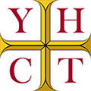Helping Yorkshire's Historic Churches & Chapels](https://www.yhct.org.uk/)  
**Good news! Funding available for Yorkshire’s Churches**

**The Yorkshire Historic Churches Trust is welcoming funding applications from places of worship across the county for repair, restoration and maintenance work. Due to the generous donations and legacies received last year, the Trust is actively encouraging churches to apply for the next round of funding.**

**The application deadlines for 2024 are 8th March for consideration in April and 23rd August for consideration in October grants committee. For guidance and how to apply please go to:** [**www.yhct.org.uk/grants**](http://www.yhct.org.uk/grants)**.**

**Grants are available for repairs to the church fabric, the walls, roofs, floors, tower, bell frames, windows, stonework, repointing and rainwater goods. Grants are also available for the conservation of fixture and fittings, such as monuments, furniture and stained glass and repairs to bells, clocks and organs. Applications are also welcome for investigatory work. You can apply for this type of grant at any time of the year. Do contact Jonathan Stamp by email at** [**grants@yhct.org.uk**](mailto:grants@yhct.org.uk) **if you would like to discuss this.**

**The YHCT have no set funding amounts, but common grants range from £2000 - £10,000, depending on the size of the works. The Grant Committee looks at how much the total project is and how much effort has gone into fund raising locally, and which other funders have been approached or confirmed their grants. The YHCT ideally likes to be able to help a church or chapel who have neared the end of their fund raising and only have a shortfall of say £10 - £15,000 to be able to start their project.**

**It is also inviting individual churches and chapels to become 'Church Members' and to support the Trust by opening churches on Yorkshire Churches Day on 14 September 2024 or taking part in the Ride and Stride sponsored event. All this is found on the trust website** [**https://www.yhct.org.uk/yorkshire-churches-day/**](https://www.yhct.org.uk/yorkshire-churches-day/)

**United Reformed Church Buildings Forum Webinar**

***‘Living stones for a living church: buildings for the ministry of Mission’***

**Part 1 – 21st May 7.30pm Part 2 – 4th June 7.30pm**

This is an open invitation to attend the **URC Church Buildings Forum webinar** on Zoom on 21 May 2024 7.30-9pm. Following the launch of these webinars just over three years ago, The Revd Dr John P. Bradbury will return as the keynote speaker to address how we may best use our building and assets for mission and ministry, particularly within the context of the **Church Life Review** and its outworking. As always with the webinars, you will have the opportunity for conversation in breakout rooms and, importantly, it will also be a listening exercise to hear the questions that you have, the challenges that churches face, and positive ideas, examples and news to be shared.

A complementary and more pragmatically focussed Part Two will take place on 4 June 2024 7.30-9pm.  There will be a presentation of North Western Synod’s strategy *‘A Church with People at the Margins: A Strategy for Mission and Ministry’* and examples of a number of local churches already on that journey, in order to stimulate debate and encourage other synods and local churches.

Coming along to one of the webinars will be more useful than not coming to either, but we do hope that you will be able to attend both.

**To register for either or both seminars please email** [**mission@urc.org.uk**](mailto:mission@urc.org.uk)**.**

**Volunteer with the United Reformed Church**

**at The Greenbelt Festival 2024!**

22 – 25 August 2024 at Boughton House, near Kettering

**yoURCafe venue team**

As well as being an exciting opportunity to be part of the URC team in the yoURCafe venue, now in its third year, offering food saved from landfill, crafts, talks, music and more, you will also get to enjoy the myriad activities the festival has to offer.  
You will receive a complimentary weekend pass, food vouchers and a car or caravan pass as a thank you.  
For more information on how to become a volunteer, what is involved, and how to apply, visit [https://urc.org.uk/greenbelt/](https://eur01.safelinks.protection.outlook.com/?url=https%3A%2F%2Furc.org.uk%2Fgreenbelt%2F&data=05%7C02%7Csamara.andrews%40urc.org.uk%7Cc34bfcdb4695467cefef08dc2d4b8bc0%7C3fd368e1f1d74a1e8e4045a843b55e89%7C0%7C0%7C638435049728785998%7CUnknown%7CTWFpbGZsb3d8eyJWIjoiMC4wLjAwMDAiLCJQIjoiV2luMzIiLCJBTiI6Ik1haWwiLCJXVCI6Mn0%3D%7C0%7C%7C%7C&sdata=8V6a9UfLSOIWNmo0JDurNcH1LC82fTd3FPxiLPt4Ai8%3D&reserved=0)

.

**Youth Engagement team**

Are you aged 18+?

Do you enjoy supporting 12–17 year-olds?

Have experience, gifts, skills to share?

Then volunteer on the URC Youth Engagement team.  
The opportunity comes with festival benefits, training and support.

Email [children.youth@urc.org.uk](mailto:children.youth@urc.org.uk)for more information.

The theme for this year’s festival is: **Dream On.** If you would like to know more about this theme and why it has been chosen, you can read a blog by Paul Northup’s, Greenbelt’s Creative Director, [here](https://www.greenbelt.org.uk/greenbelt-2024-dream-on/).

**The deadline for applications is** **Saturday 20 April** and the Volunteer Team will aim to inform applicants as to whether they have been successful (or not) by the **end of Thursday** **25 April.** Demand for spaces is high (as ever) and although we had an amazing team of volunteers last year, we always welcome and encourage new people to join.

**Peak Wesley Way**

Our friends in the Sheffield Methodist District have brought this invitation to small groups of all faiths and none to engage in the ancient practice of pilgrimage along a path connecting six rural chapels in the beautiful Peak District National Park.

The **Peak Wesley Way** is a contemporary opportunity to engage with the ancient spiritual practice of pilgrimage within the beauty of the Peak Park. It began as a vision of members of Peak Methodist Circuit to share their stories with small groups who are spiritually curious and intrigued by spending time in the ancient holy places, indoor and outdoor. The pilgrimage is for groups of friends or family with a shared quest for adventure, wanting to connect with a simpler greener lifestyle, or needing space to broaden life experiences. Thanks to support from many circuit members, people from beyond the circuit’s congregations and district officers they are now ready to invite you to book your pilgrimage. Please visit [**https://peakwesleyway.com/**](https://peakwesleyway.com/), follow us on [**Facebook**](http://facebook.com/peakwesleyway) or [**Instagram**](http://instagram.com/peak_wesley_way), and tell your friends! Is this the next step of your journey?

**SAFEGUARDING**

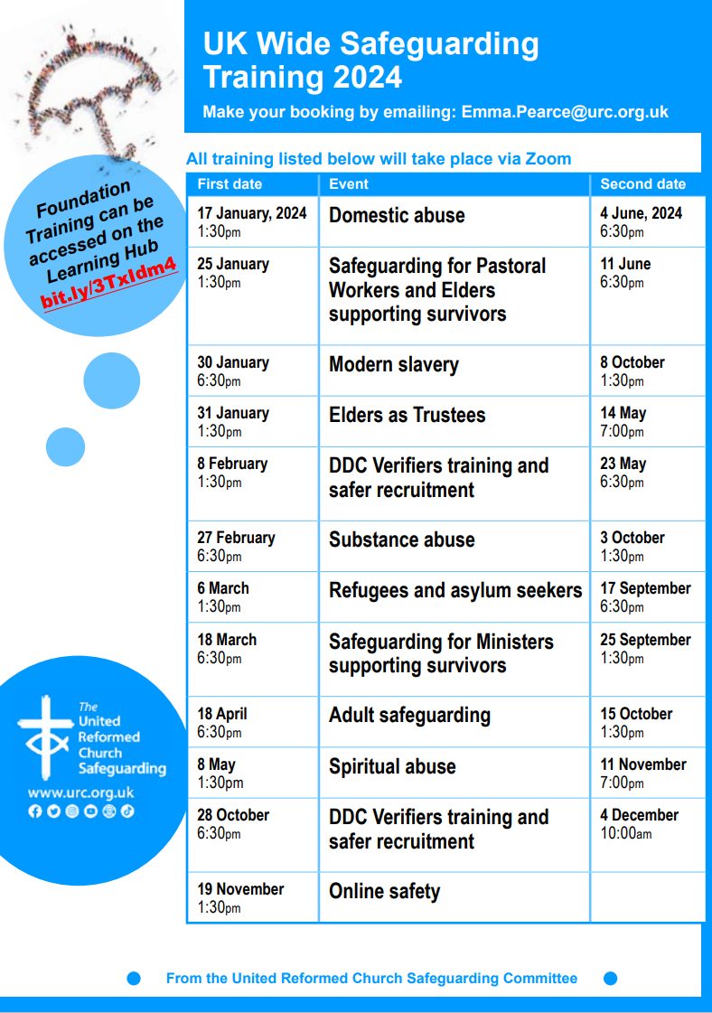

**Funding Resources - Winter 24**

Rev Simon Copley, our Treasurer, has circulated a fuller version of this to all our church treasurers this past week, but it’s useful to let you all know that there are plenty of resources available to Synod churches to help them through this winter as well as to help them build on any missional initiatives they plan to work on.

1. **Synod Funds**

The Synod has three sources of grant support that local congregations (including LEPs) can access:

***Synod Mission Fund*** - this is our go-to funding pot for any projects/posts that help your congregation carry out any aspect of mission in your local community. Both small and larger/multi-year grants are available.

***Mission Capacity Fund*** - this new fund will support any measure (including back-room, support, organisational changes and administration tasks) that will help release energy for your congregation to engage in mission.

***Vision and Opportunity Property Grants*** - these can be of any size and fund any alteration to church buildings that help congregations engage more effectively in mission.

We recommend a conversation with our Synod Clerk, Tim Crossley ([clerk@urcyorkshire.org.uk](mailto:clerk@urcyorkshire.org.uk)) about any prospective application to the Synod Mission and Mission Capacity Funds and with Val Morrison, Convenor of the Synod Property Committee ([valmorrison7@btinternet.com](mailto:valmorrison7@btinternet.com)), about Vision and Opportunity Grants.

Further details of how to apply to all these funds can be found on the Synod website at [Forms - URC Yorkshire Synod](https://urcyorkshire.org.uk/forms/)

1. **National URC Funds**

The United Reformed Church has national funding streams that any congregation can apply to. The two largest are:

***Church Buildings Fund*** - gives loans, and sometimes grants, towards any building cost. These are usually £25,000 maximum but larger loans and grants can be made. Please ask Simon Copley, the Synod Treasurer, about details of how to apply to these funds ([whiteknight_copley@hotmail.com](mailto:whiteknight_copley@hotmail.com)). Further information is also available at [Church Buildings Fund - United Reformed Church](https://urc.org.uk/your-church/guidance-support-for-churches-synods/church-finance/the-church-buildings-fund/)

***Legacy Fund***- gives grants normally with a limit of £50,000 per application for innovative and ground-breaking mission projects. Further information is available at [The Legacy Fund - United Reformed Church](https://urc.org.uk/your-church/guidance-support-for-churches-synods/church-finance/the-legacy-fund/) where you can download the application form.

There are a number of **other, smaller funds** and details of these can be found at: [Grants & funding opportunities - United Reformed Church](https://urc.org.uk/grants-funding-opportunities/). Please note that national URC funds tend to be undersubscribed so a well-thought application will have a good chance of success. Please contact Simon ([whiteknight_copley@hotmail.com](mailto:whiteknight_copley@hotmail.com)) for advice on how to put your bid together.

1. **Trust Funds, Landfill and Lottery Funding etc**

There are a large number of Trusts and Foundations (and other sources) that give grants for community, Christian and environmental causes.

Synod has access to the ***Directory of Social Change database*** with information about over 4,500 Trusts and Foundations giving grants for the widest possible range of causes.

The database can be accessed by any Congregation. Contact Simon, the Synod Treasurer ([whiteknight_copley@hotmail.com](mailto:whiteknight_copley@hotmail.com)), and he will be happy to guide you through the access procedure and to give any further advice on how to research the database.

Our attention has been drawn to this event, which we are told was so successful last year that it is being repeated this year. 21 funders are presenting how they may be able to help churches over 3 days – some which are nationally based organisations, and some which are Yorkshire specific. These are FREE events but if you fancy helping us with the costs you can donate the cost of a coffee. Use this link [paypal.me/communitymattersyork](https://community-matters.us14.list-manage.com/track/click?u=6fa1cb42e8b7198b5c1414c5a&id=7ea9435113&e=0db9e1fb5b) or you can donate when you book your tickets.

**Yorkshire Funders: Yorkshire & Humber day is Monday 18th March**

[Day 1- Session 1 9:00 – 10:00 : Sir George Martin Trust](https://community-matters.us14.list-manage.com/track/click?u=6fa1cb42e8b7198b5c1414c5a&id=990d9865a5&e=0db9e1fb5b)focuses on West Yorkshire registered charities and churches doing community outreach work which support vulnerable and disadvantaged local people.

[Day 1- Session 2 10:00 -11:00 : Seedlings Foundation](https://community-matters.us14.list-manage.com/track/click?u=6fa1cb42e8b7198b5c1414c5a&id=a805a01929&e=0db9e1fb5b)offers small grants of up to £1000 to organisations working with Children in West Yorkshire. The Peter Greenwood Memorial Trust offers cash grants (bursaries) to deaf and hearing-impaired students who are permanent residents of the United Kingdom

[Day 1- Session 3 11:00 – 12:00: WY Safer Communities Fund](https://community-matters.us14.list-manage.com/track/click?u=6fa1cb42e8b7198b5c1414c5a&id=a0ef8c3bd8&e=0db9e1fb5b) has been launched to help voluntary, community groups, charities and partners keep their communities safe and feeling safe across West Yorkshire.

[Day 1- Session 4 12:00 – 13:00 : Wharfedale](https://community-matters.us14.list-manage.com/track/click?u=6fa1cb42e8b7198b5c1414c5a&id=24a6c7db89&e=0db9e1fb5b)Foundation will provide grants of £500 – £25,000 over the next 2 years in 4 application rounds, to organisations operating in Yorkshire & Humber under 3 priority areas: breaking down barriers in society; integration of marginalised groups; tackling disadvantage.

[Day 1- Session 5 13:00 – 14:00 : Two Ridings Community Foundation](https://community-matters.us14.list-manage.com/track/click?u=6fa1cb42e8b7198b5c1414c5a&id=dfbf7f9e12&e=0db9e1fb5b)is a regional, independent charity committed to improving the quality of people’s lives and building stronger communities for future generations in North and East Yorkshire.

[Day 1- Session 6 14:00 – 15:00 : Hillard’s Trust](https://community-matters.us14.list-manage.com/track/click?u=6fa1cb42e8b7198b5c1414c5a&id=afee0da9e8&e=0db9e1fb5b)**s**upports independent, locally managed, non-profit, voluntary and community-based organisations that provide social support to the communities once served by Hillards stores. Normally makes grants on a one-off basis up to £1,000.

[Day 1- Session 7 15:00 – 16:00 : South Yorkshire Community Foundation](https://community-matters.us14.list-manage.com/track/click?u=6fa1cb42e8b7198b5c1414c5a&id=a15836f5ad&e=0db9e1fb5b)is the largest grant giving charity in South Yorkshire and are proud to have supported community groups in Barnsley, Doncaster, Rotherham, and Sheffield with grant funding and advice for more than 38 years.

**National Funders:National Funders days: Tuesday 19th March and Wednesday 20th March**

[﻿Tues 19th March Session1: 9:00am – 10:00am : Grantscape](https://community-matters.us14.list-manage.com/track/click?u=6fa1cb42e8b7198b5c1414c5a&id=5e70336444&e=0db9e1fb5b)  
Grantscape funds are very geographically specific please check that you are in the correct area: Please look at the [website.](https://community-matters.us14.list-manage.com/track/click?u=6fa1cb42e8b7198b5c1414c5a&id=627dea28de&e=0db9e1fb5b)to check which areas are eligible  
﻿[Tues 19th March Session2 10:00 – 11:00 : Lloyds Bank Foundation](https://community-matters.us14.list-manage.com/track/click?u=6fa1cb42e8b7198b5c1414c5a&id=bc1730f2dc&e=0db9e1fb5b)  
[Tues 19th March Session3 11:00 – 12:00 : Easyfundraising](https://community-matters.us14.list-manage.com/track/click?u=6fa1cb42e8b7198b5c1414c5a&id=b1dfdf495f&e=0db9e1fb5b).  
﻿[Tues 19th March Session4 12:00 – 13:00 : Good Things Foundation](https://community-matters.us14.list-manage.com/track/click?u=6fa1cb42e8b7198b5c1414c5a&id=37b2483a12&e=0db9e1fb5b)  
[Tues 19th March Session5 13:00 – 14:00: Groundwork](https://community-matters.us14.list-manage.com/track/click?u=6fa1cb42e8b7198b5c1414c5a&id=3381b493f8&e=0db9e1fb5b)

[Tues 19th March Session6 14:00 – 15:00: Heritage Lottery Fund](https://community-matters.us14.list-manage.com/track/click?u=6fa1cb42e8b7198b5c1414c5a&id=88455cbfbe&e=0db9e1fb5b)  
[Tues 19th March Session7 15:00 – 16:00 The People’s Postcode Lottery](https://community-matters.us14.list-manage.com/track/click?u=6fa1cb42e8b7198b5c1414c5a&id=2df01c42de&e=0db9e1fb5b)  
[Weds 20th March Session1 9:00 – 10:00 : Bernard Sunley Foundation](https://community-matters.us14.list-manage.com/track/click?u=6fa1cb42e8b7198b5c1414c5a&id=aeffecf1ab&e=0db9e1fb5b)  
[Weds 20th March Session2 10:00 – 11:00 : Clothworkers Foundation](https://community-matters.us14.list-manage.com/track/click?u=6fa1cb42e8b7198b5c1414c5a&id=94411fcad8&e=0db9e1fb5b)  
[Wed 20th March Session3 11:00 – 12:00: Co-op Local Community Fund](https://community-matters.us14.list-manage.com/track/click?u=6fa1cb42e8b7198b5c1414c5a&id=700bb758a2&e=0db9e1fb5b)  
[Weds 20th March Session4 12:00 – 13:00 : Key Fund](https://community-matters.us14.list-manage.com/track/click?u=6fa1cb42e8b7198b5c1414c5a&id=7c21ac0522&e=0db9e1fb5b)  
[Weds 20th March Session5 13:00 – 14:00 : National Lottery Community Fund](https://community-matters.us14.list-manage.com/track/click?u=6fa1cb42e8b7198b5c1414c5a&id=c1cecfa946&e=0db9e1fb5b)  
[Weds 20th March Session6 14:00 – 15:00 : People’s Health Trust](https://community-matters.us14.list-manage.com/track/click?u=6fa1cb42e8b7198b5c1414c5a&id=b5859fef18&e=0db9e1fb5b)  
[Day 3- Session 7 15:00 – 16:00 : Benefact Trust](https://community-matters.us14.list-manage.com/track/click?u=6fa1cb42e8b7198b5c1414c5a&id=f238c28ef8&e=0db9e1fb5b)

How this will work is each funder has been allocated a 30 minute session using Zoom to explain what funding they have and also how the application process works. There will also be an opportunity to ask questions. You will need to book separately for each session you wish to attend.

**The URC History Society Conference**

**16-18 September 2024, University of Durham**

***The Church on the margins:***

***learning from the past to shape the future***

Speakers include:

1. Dr Michael Hopkins – *“Durham and its Dissent”*
2. Nancy Graham - *“The trajectory of Erik Routley”*
3. Professor Alec Ryrie – *“A remarkable work of grace”: the first era of Presbyterian missions (c. 1740-70)*
4. Professor Peter Ackers - *“The Churches of Christ and the early twentieth century British labour movement”*
5. Dr Victoria Turner – *“Coming to terms with Coloniality: The Changed Mind of Bernard Thorogood as General Secretary of CWM”*
6. Professor Stephen Taylor – *“Episcopalian congregationalism: a neglected episode in the development of Anglicanism in the seventeenth and eighteenth centuries”*

This is an open and welcoming conference, for those with a general interest through to professional historians/theologians.  Independent scholars, practitioners, and those with no formal training are all equally welcome.  We welcome serving ministers, because the conference is about exploring where we have come from in order to know where we are going. ***£275 full board in single room, £250 per person sharing a double room.*** Payments to United Reformed Church History Society 40-52-40, 00032467

Ministers can access EM3 funding towards this and for others it comes within the scope of the small DDF grant application for lay folk in Synods. For more information on this contact Kath Lonsdale through the Synod office at [office@urcyorkshire.org.uk](mailto:office@urcyorkshire.org.uk).

**To offer support for the Church’s humanitarian support for those affected by the ongoing crisis in Gaza please visit the URC’s website at** [**Christian Aid Middle East Crisis Appeal - United Reformed Church**](https://urc.org.uk/our-news-stories/christian-aid-middle-east-crisis-appeal/)**. Also please visit the**[**Christian Aid Appeal**](https://www.christianaid.org.uk/appeals/emergencies/middle-east-crisis-appeal)**site which includes supporting key facts and information, together with the opportunity to make donations direct to**[**Christians Aid**](https://give.christianaid.org.uk/donate/CAM-005943)**. You can also contribute through the URC’s own programme *Commitment for Life* at**[**Israel and the occupied Palestinian territory – United Reformed Church**](https://urc.org.uk/your-church/church-local-and-global/commitment-for-life/israel-and-the-occupied-palestinian-territory/)**.**

**And Finally**

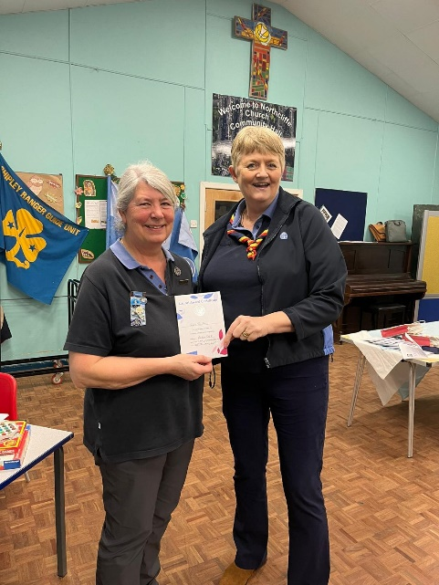Some folk may think that there is something happening in the BD18 part of the Synod or that I have a bit of a bias for things occurring in the Aire Valley, and you may be right as this story from Northcliffe Church in Shipley is only just up the road from where I was in the last issue of the Briefing.

On Tuesday 30th January Julie Smith from Eldwick Church but most importantly the Brownie Leader at Northcliffe received the highest award in GirlGuiding, The Laurel Award. This is for service and dedication to guiding and Julie has most definitely provided a lifetime of achievements. The award had been kept a secret from Julie since October and the folk at Northcliffe couldn't believe she didn't twig what was going on. Julie initially took over running 4th Shipley Guides then starting Shipley Ranger unit before setting up a Brownie pack which she continues to run at Northcliffe. Whilst doing this she has had appointments within the Shipley Division, the County and North East England where she handled all the safeguarding for guiding. Her continued commitment and love of guiding has shone through her Guiding life and she so thoroughly deserved this award.

Northcliffe also saw Helen, Louise, Carol and Charlotte our Brownie, Guide and Ranger leaders receiving their long service awards and Alice received her Adult leadership award too.

Our two supported leaders Molly and Ajeema also received their long service awards of which we were so proud.

It was a lovely night shared with the girls, families, friends and church members.

If you want to redress the balance, and you have a good news story from your part of the Synod, drop me a line at [**clerk@urcyorkshire.org.uk**](mailto:clerk@urcyorkshire.org.uk) and I’ll make sure it hits the back page!!

You can also keep an eye on all our social media platforms for news; on the website at [**Home - URC Yorkshire Synod**](https://urcyorkshire.org.uk/), the Facebook pages at [**United Reformed Church in Yorkshire - Home | Facebook**](https://www.facebook.com/urcyorkshire) and [**Wilderness URC Yorkshire - Home | Facebook**](https://www.facebook.com/wildernessyorkshireurc/), the YouTube page at [**URC Yorkshire - YouTube**](https://www.youtube.com/channel/UCSAly5eC6tBlmY52dLxrylg) and the Twitter page at [**URC in Yorkshire (@URCYorkshire) / Twitter**](https://twitter.com/URCYorkshire).