Making Disciples Day
Saturday 18th May 2024 – 10.00am to 3.30pm
Longcauseway Church, Dewsbury
36, Longcauseway, The Princess of Wales Precinct, Dewsbury WF13 1NH

This is a day for all members and friends of our churches in the Yorkshire Synod. It will be led by Andrew Roberts, author of Holy Habits and Linda Rayner, URC co-ordinator for Fresh Expressions.
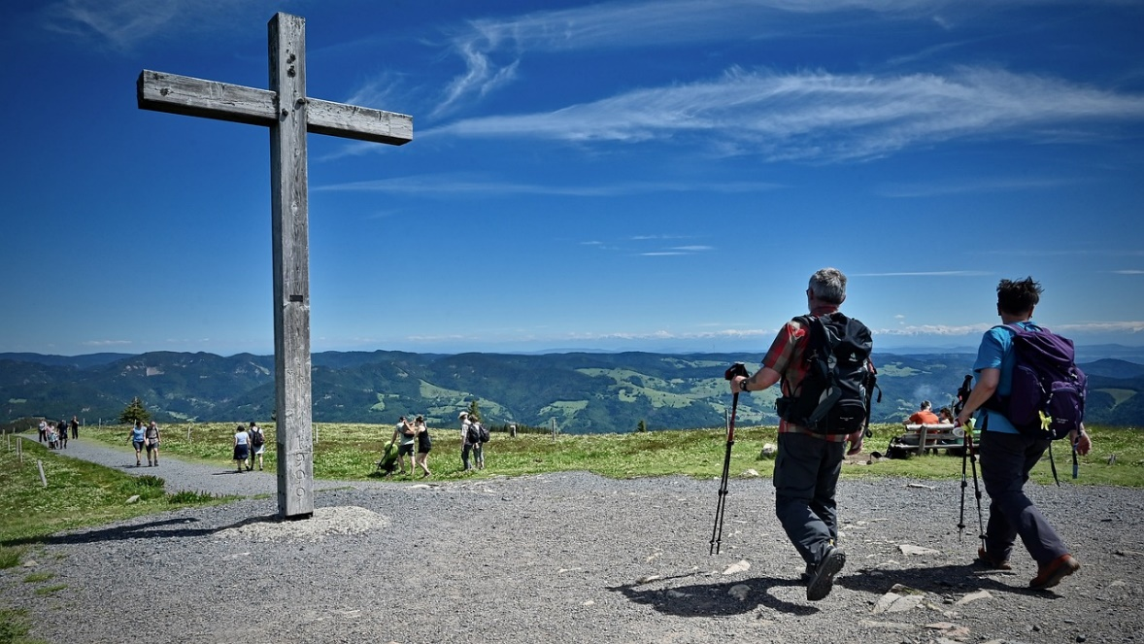

Andrew and Linda write, “In response to the call and commission of Jesus to go and make disciples we will share and explore stories of initiatives in this area that have been fruitful and consider stories that have not been so fruitful and see what learning we can take from these.
We will also take time to consider how we can be bearers of good news and people of hope as we seek to make God known in difficult times and situations.
There will be plenty of time for both group conversations and personal reflection which will include the provision of prayer stations.”
Please bring your own lunch – tea and coffee will be provided.
To book a place please email valmorrison7@btinternet.com

