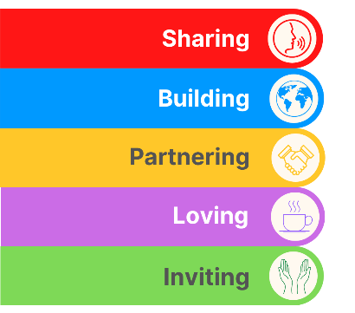
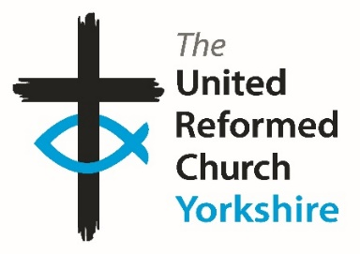
Yorkshire Synod Briefing
Number 132

27th June 2024

It’s Here; Sun, Sea (nearly) and The Spirit
There are some big things happening in the next fortnight (and beyond) and like in previous weeks we are being invited to lots of events and to make some important choices.

A week today we are being invited to choose those folk who want to represent us in Parliament. The JPIT team have some excellent resources to help us discern the choices we make, steeped in the Bible, in Justice and in Fairness. The URC (with other denominations) are supporting JPIT’s “LOVE, PRAY, VOTE” initiative and have uploaded a very useful resources page on their website at https://jpit.uk/elections. Please make use of it if you can.
There are plenty of other invitations to events across Synod which will explore our environment, our local communities and our faith. We are also three quarters of the way through the Synod Forums, with the final one being held at Christ Church, Hipperholme a week on Saturday (6th July). Once the team behind the Forums has brought together all that was discussed over the four events, I hope to be able to able to use The Briefing to bring you the feedback.
Other invitations are to the Summer Fun day in August at Herringthorpe and I would like to highlight two special invitations, one on Saturday 27th July when we welcome Joe Amoah into Harrogate St Paul's, and on the following Saturday, on 3rd August when we welcome Simon Cross to the Hull Churches at St Ninian’s & St Andrew’s. Full details can be found on the Synod Calendar at https://urcyorkshire.org.uk/calendar/
We also have invitations to a couple of key ‘Leading Your Church into Growth’ events. On the evening of Tuesday 23rd July there is an introductory session to the local LYCiG course and we are also invited to make our bookings for the three-day conference being held at The Hayes in Swanwick in November. Keep on reading the Briefing for further details.
Finally, 15 of us will be heading to the General Assembly of the URC at The Hayes in Swanwick between 12th and 15th July. This annual meeting of the whole denomination is the place where the direction and mission of the URC is determined. Please pray for the Yorkshire representatives, as well as for all those representing their own Synods around the country, as they discern God’s plan in the URC and beyond. More details will appear here General Assembly papers - United Reformed Church.

So, with this in mind, there’s no excuse not to ring the office up with all the details of what is happening where you are and where we can find it. Tell me what you plan for the summer so that I can help spread that news. Drop me a line at clerk@urcyorkshire.org.uk and I’ll showcase it in the next edition, due out on Thursday 11th July.
Thank you and God Bless,
Tim Crossley
Synod Clerk

 The LYCiG local course
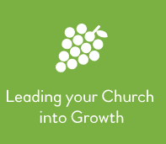
Over the last few years, Synods have been helping to resource our churches in all sorts of ways.
One of those ways to attend a LYCiG (Leading Your Church into Growth) conference, and to use the materials. However as a starter Ashley Evans, our Synod Evangelist will be leading an Introductory training session on the 23rd July at 7pm which will cover how to run the Leading Your Church Into Growth Local course at your church or group of churches.
If you are interested please let Ashley know by contacting him at Evangelist@urcyorkshire.org.uk so that he can send you the zoom link.
With this we are able to help your church family to go on a journey of discovery and excitement.
----------------------------------------------------------------------------------------------------------

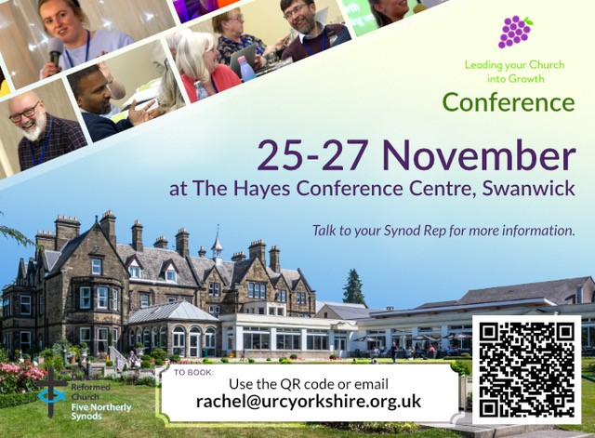
And then it is with great excitement that the LYCiG team is able to offer our Six Synods (Scotland, Northern, North Western, Mersey, Yorkshire and now West Midlands) 12 places each on this year’s ‘Leading Your Church into Growth’ conference.
This is a great opportunity to meet with URC folk from various places to learn together about how much God loves us and wants us to share that love in practical, doable and life affirming ways.
If you would like to know more, please do not hesitate to contact Ashley Evans. Tickets are on a first come, first served basis and you can book directly through the QR code, by emailing rachel@urcyorkshire.org.uk, or by following this link https://buytickets.at/theunitedreformedchurchyorkshireprovincetrustltd/1245607

Rev Ashley Evans, Evangelist@urcyorkshire.org.uk, lycig@urcwestmidlands.org.uk

https://www.facebook.com/ashleymtevans
Mobile---07403423082, Landline-01274241234,
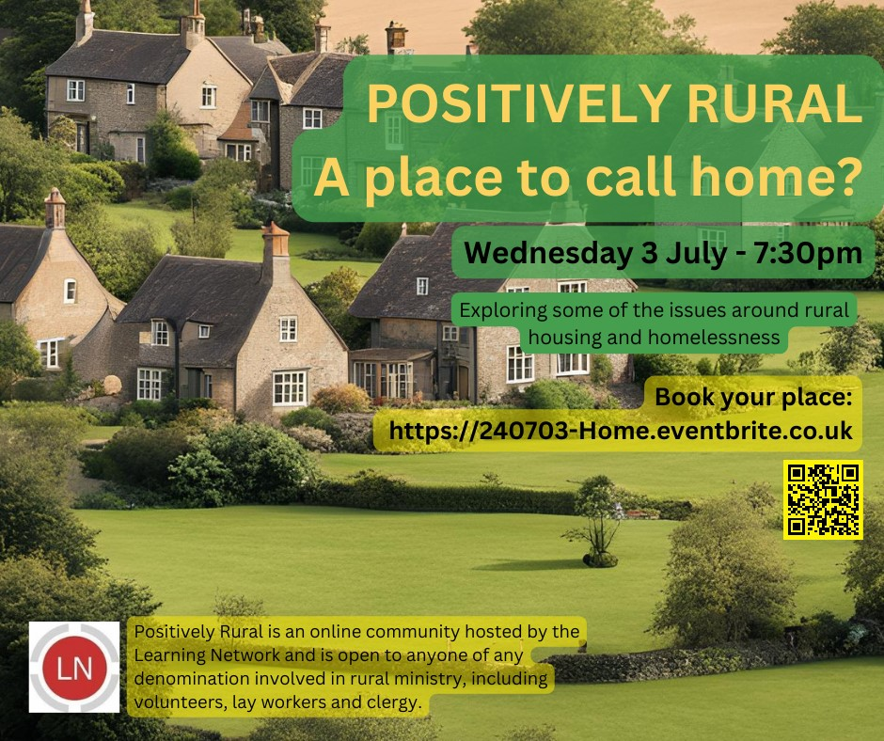


Calling Appreciative Inquiry practitioners in Northern England!

On Monday 8th July there will be an “Appreciating Church” gathering being held here at the Synod Office at 12.30pm and led by Rev Fiona Thomas.

“The event will be a time and space to eat together, worship together, learn together, deepen the sense of being a community of practice, and exercise our appreciative muscle.

An on-site opportunity for conversation with Appreciative Inquiry practitioners working with churches or from church backgrounds. Facilitated by Fiona Thomas, Developmentalist for Appreciating Church….”

More information can be found on the attachments and for booking, please click the link below
https://appreciating.church/events/appreciating-church-regional-gathering-in-leeds/



After such a wet spring and it feels like the summer is still so far away
However, here is an event to give you that summer feeling!

THURSDAY 15 AUGUST at
Herringthorpe United Reformed Church
Get your young people together and come and join in with an afternoon of fun and friendship.
We will have inflatables available, a nerf war, summer craft activities, food and drink, and short faith seminars.
Bookings now open!
For more information contact wilderness@urc.org.uk.

Short Courses at Trinity College Glasgow

The good folk at URC Education and Learning have asked that you be made aware of these short courses being run by Trinity College Glasgow in the coming academic year, 2024-25. These courses are a mixture of online, in-person and hybrid formats (specified on each course poster, banner and website page), and so will be suitable for a range of people.
Comprehensive information for all of our courses is available at our website: https://www.trinitycollegeglasgow.co.uk/

Please don't hesitate to get in touch directly if you would like specific sizing of the promotional material or have any questions. The primary contact is Heather O'Connor whose e-mail is TrinityCollegeGlasgow@gmail.com .

1. History and Theology of Worship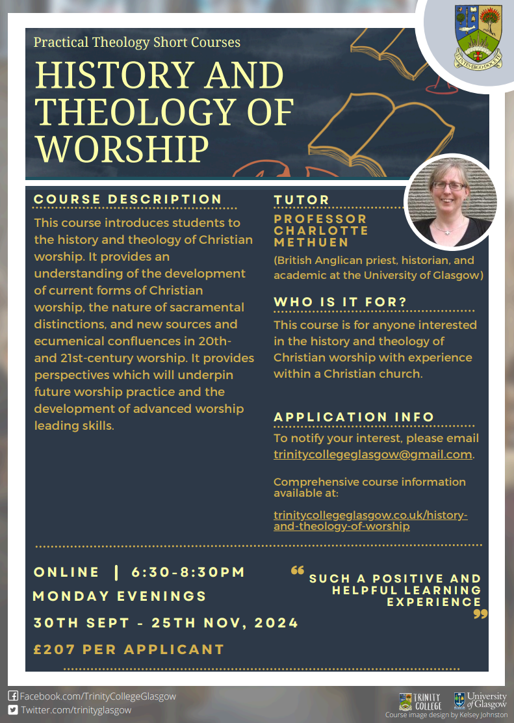
2. Preaching in Church Contexts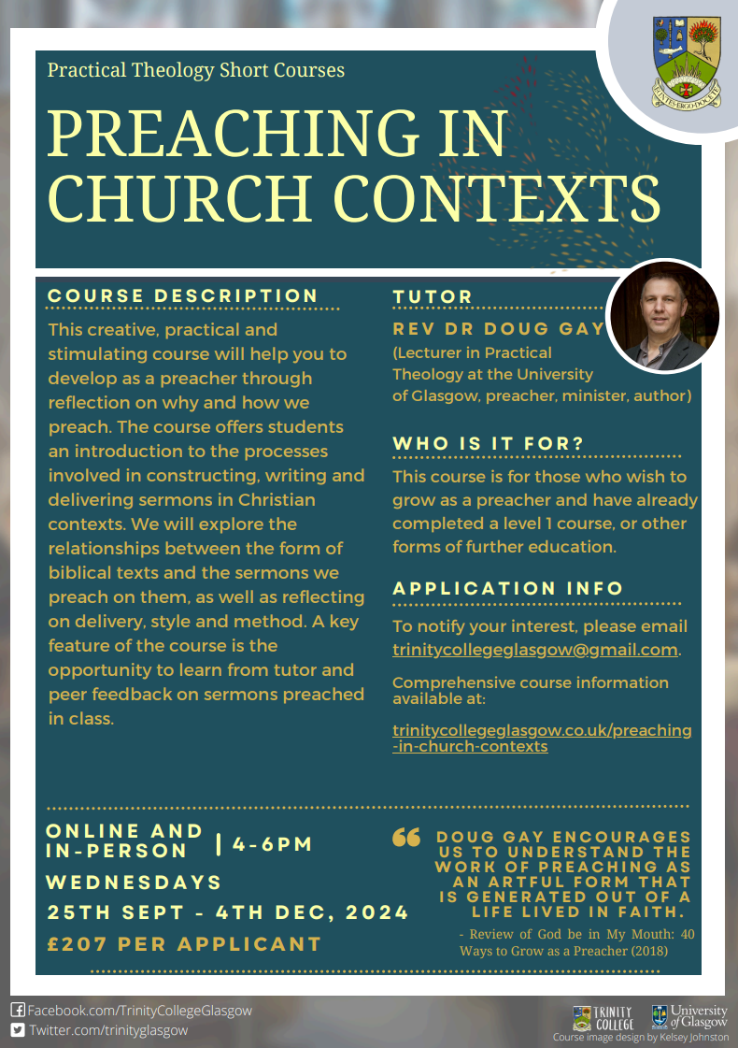
3. Contemporary Art and Visual Worship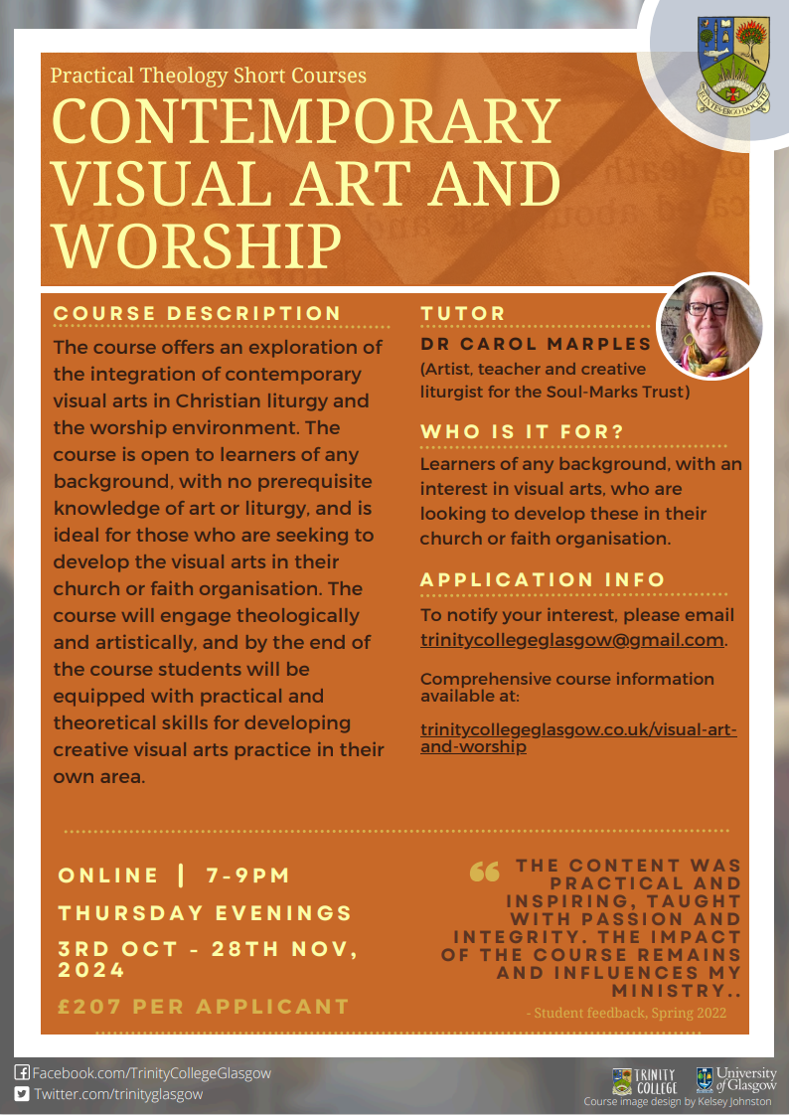
4. Creative Writing as Spiritual Reflection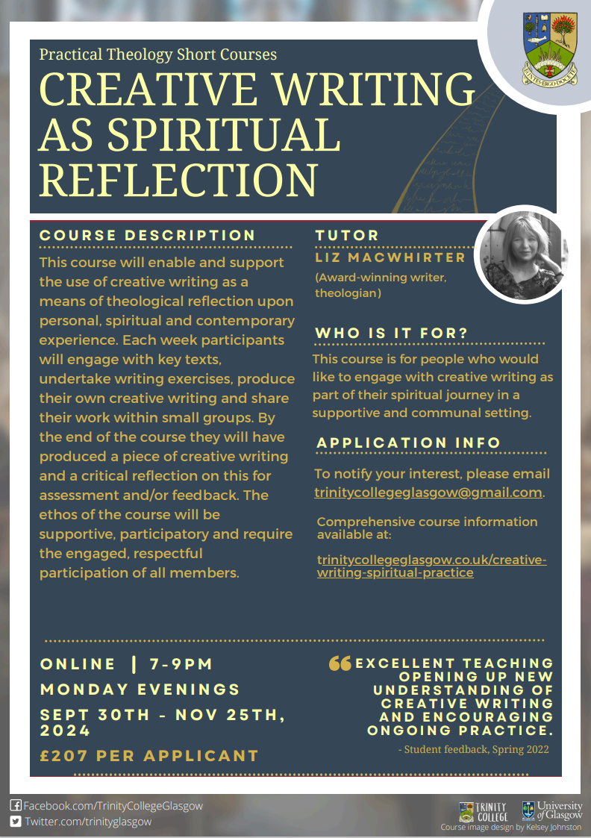
5. Designing and Leading Worship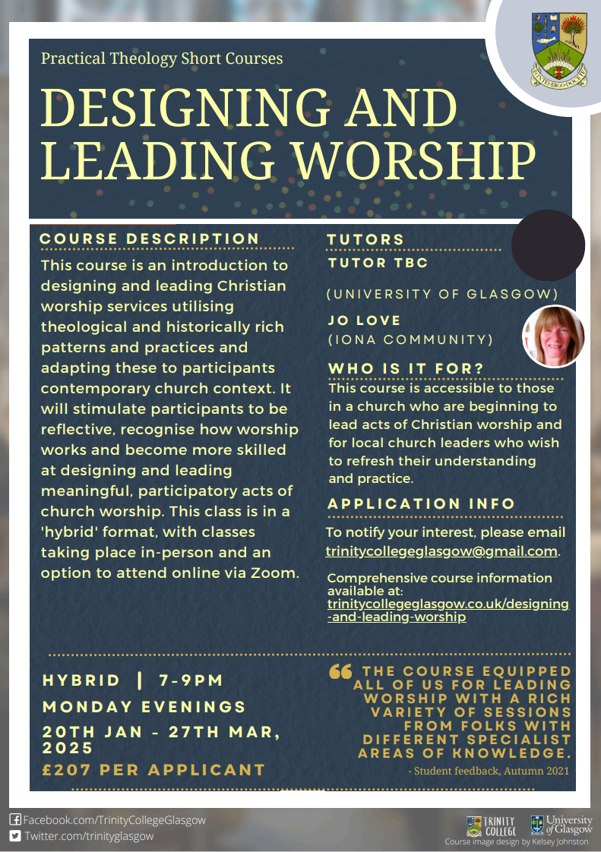
6. Listening in Mission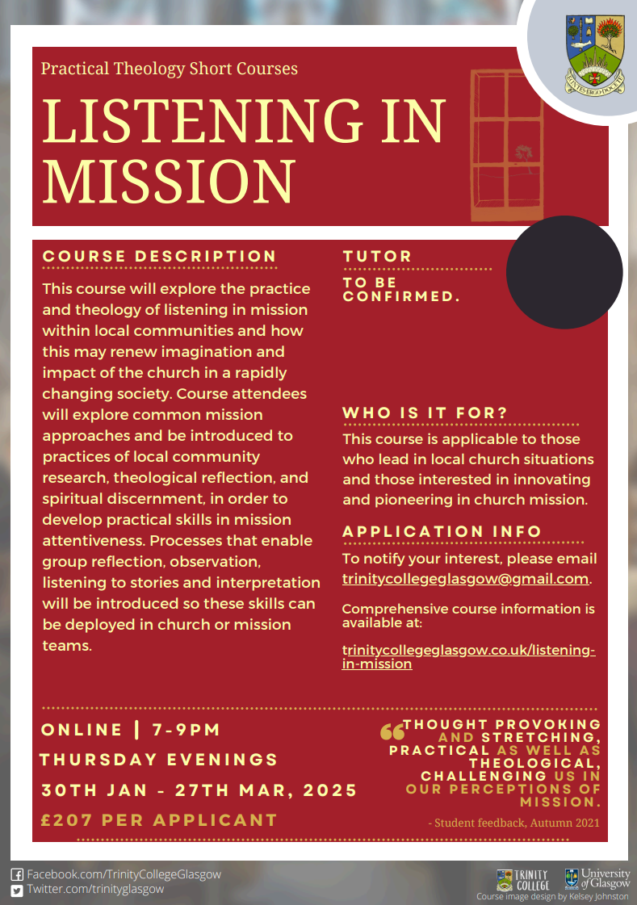
7. Liturgy and Prayer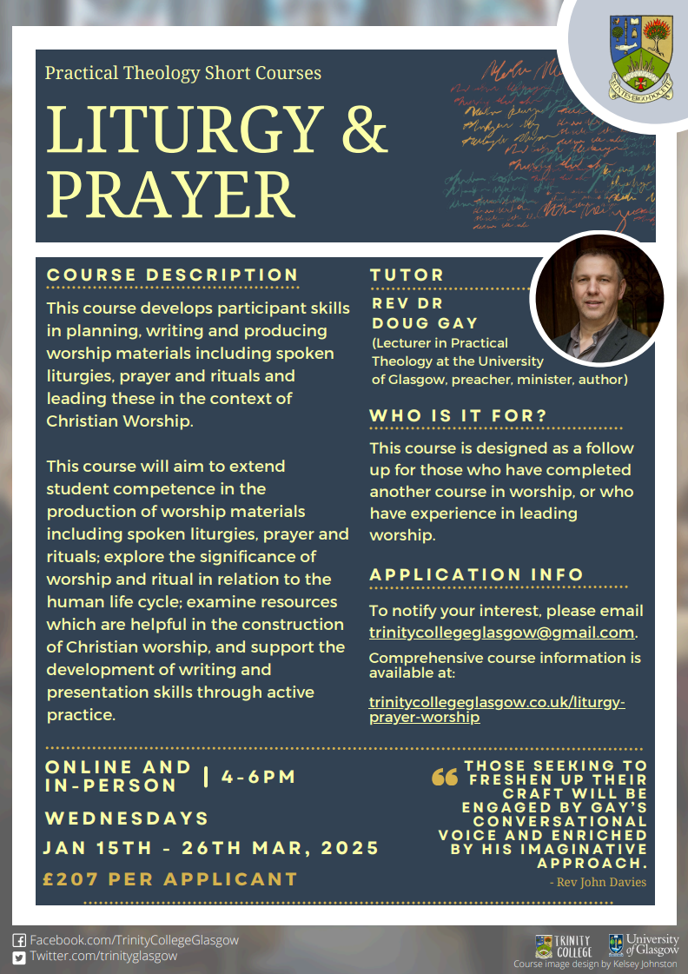

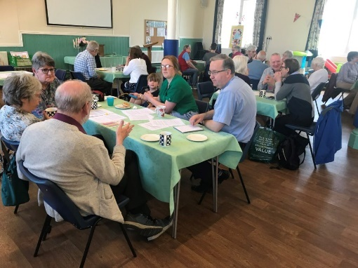
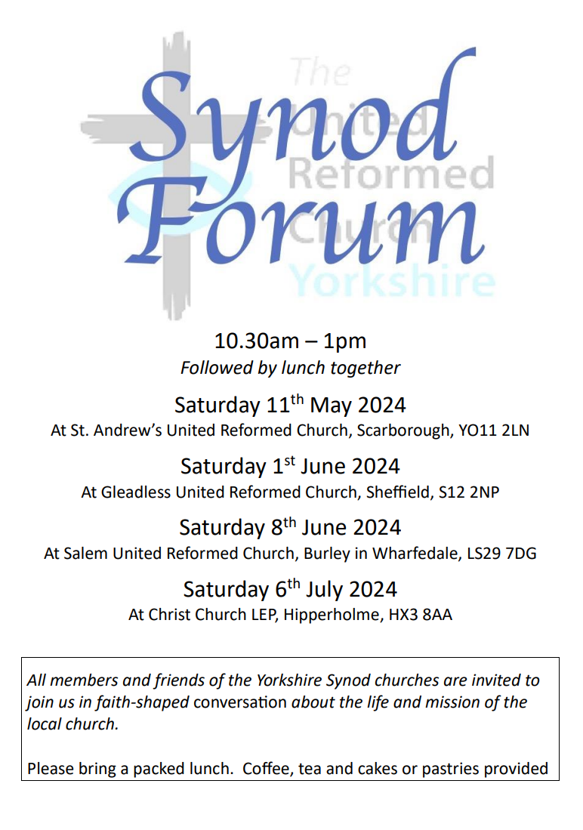
Building on the success of last year’s Synod Forums, this year’s sessions have nearly finished. The last of this year’s Forums will be taking place at Christ Church, Hipperholme on Saturday 6th July. It is this summer’s final opportunity for fellowship and good conversation and it is really too good to miss. As with the previous Forums, the Hipperholme one will run from 10.30am – 1pm and you are encouraged to stay to share a bring-your-own lunch.

As last year, the conversation will be based around Paul’s first letter to the Corinthians. It will be mostly in small group discussions, so you get chance to share with people from other churches. We will picking up on some of the themes in the URC’s Theos report (https://www.theosthinktank.co.uk/cmsfiles/URC-report-Final.pdf), and will be asking Where do we see flourishing in Yorkshire Synod? (And what might be the barriers to flourishing?)

We hope that this will also be a chance for those with Synod roles to hear from the local church about your opportunities and challenges so that together we can find the best ways to support and encourage each other. The Synod Forum is your place to have your voice heard, and to help shape the priorities of the Synod.


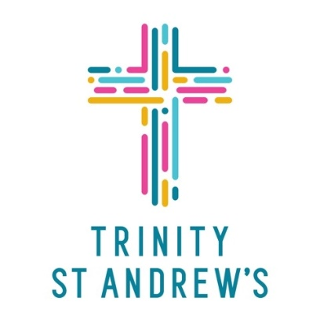


Trinity St Andrews Church celebrated Refugee Week this year by inviting friends from the Darwen Asylum and Refugee Enterprise to visit Skipton on 16th June, for the day.
Members of the DARE group took part in the service. The preacher was Rev Gilbert Esambe, a minister of the Lancashire East Missional Partnership, who is very involved in the work of Central URC in Darwen that runs the DARE project.
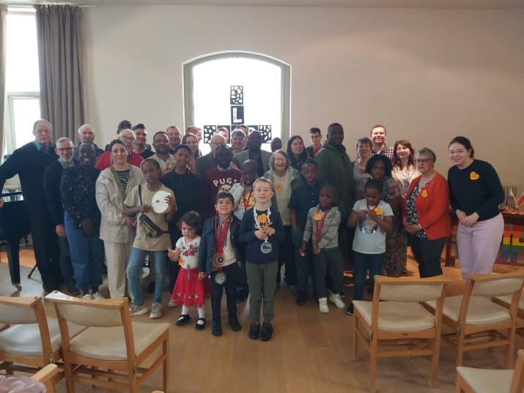

Two members of the group read lessons and the congregation were told a little of their stories, whilst the children made Refugee Week suncatchers and orange heart badges which were given out to the congregation as they left the service. This was a truly memorable service, alive with singing and praying for our refugee friends.
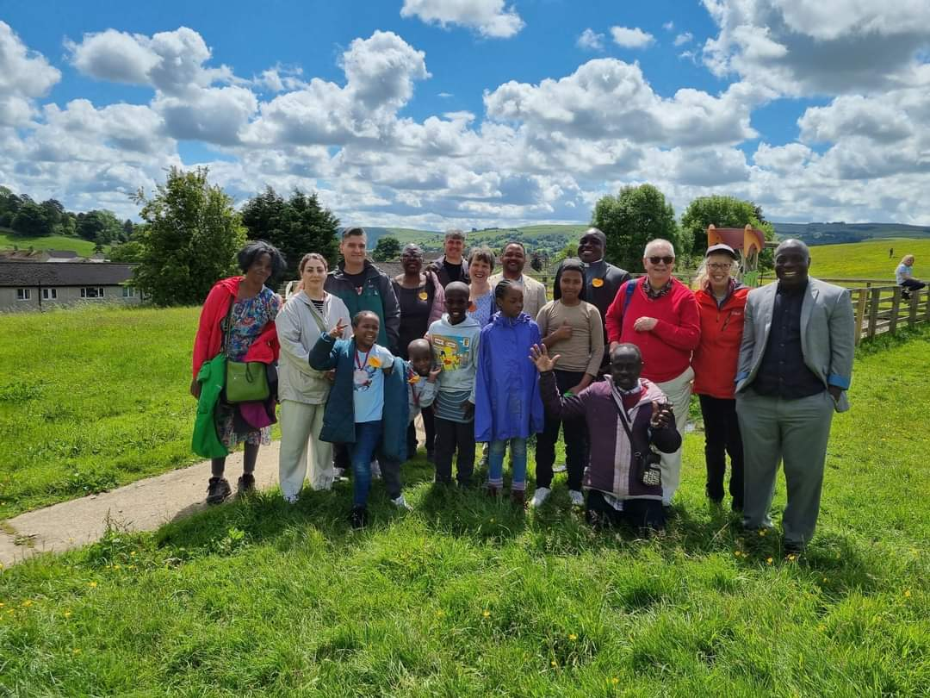
After the service visitors were treated to a wonderful hot meal provide by members of the congregation, followed by a walk up to a nearby open space with magnificent views over Skipton and a playground for the children.
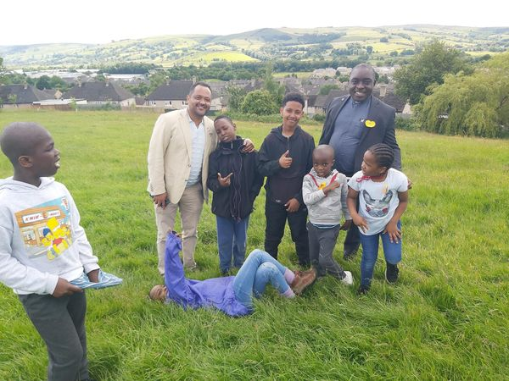
Events such as these bring together diverse communities and say more than words can do alone. They are literally faith in action. The theme of this year’s Refugee Week was ‘Our Home’ and we hope that our friends from DARE found a home away from home in Skipton.

KELD RESOURCE CENTRE
IN PARTNERSHIP WITH LOW ROW WITH KELD URC
NEW FOR 2024 : STUDY DAYS

We are delighted to announce a new series of study days for 2024 and issue a warm invitation to come to any or all of them! They are:
Thursday July 4th - Revd. Michael Pearson: Five impossible Things to Believe before Christmas!
Saturday August 17th - Revd. Peter Sinclair: After Sunday : Being Church Seven Days a Week
Thursday September 26th - Ms. Dorothy Thomson: There’s a Sermon in There Somewhere!
The programme will be as follows:

10.30 : Arrivals and Coffee
11.00 : Session One
12.30 : Lunch
13.30 : Session Two

15.00 : Refreshments and Departure
There will be discussion, sharing, space to ponder …….
All participants are invited to bring a packed lunch. Drinks will be provided. The cost for the day will be £10 per person.
To book your place, please contact Revd David Wood at david.wood4@btinternet.com
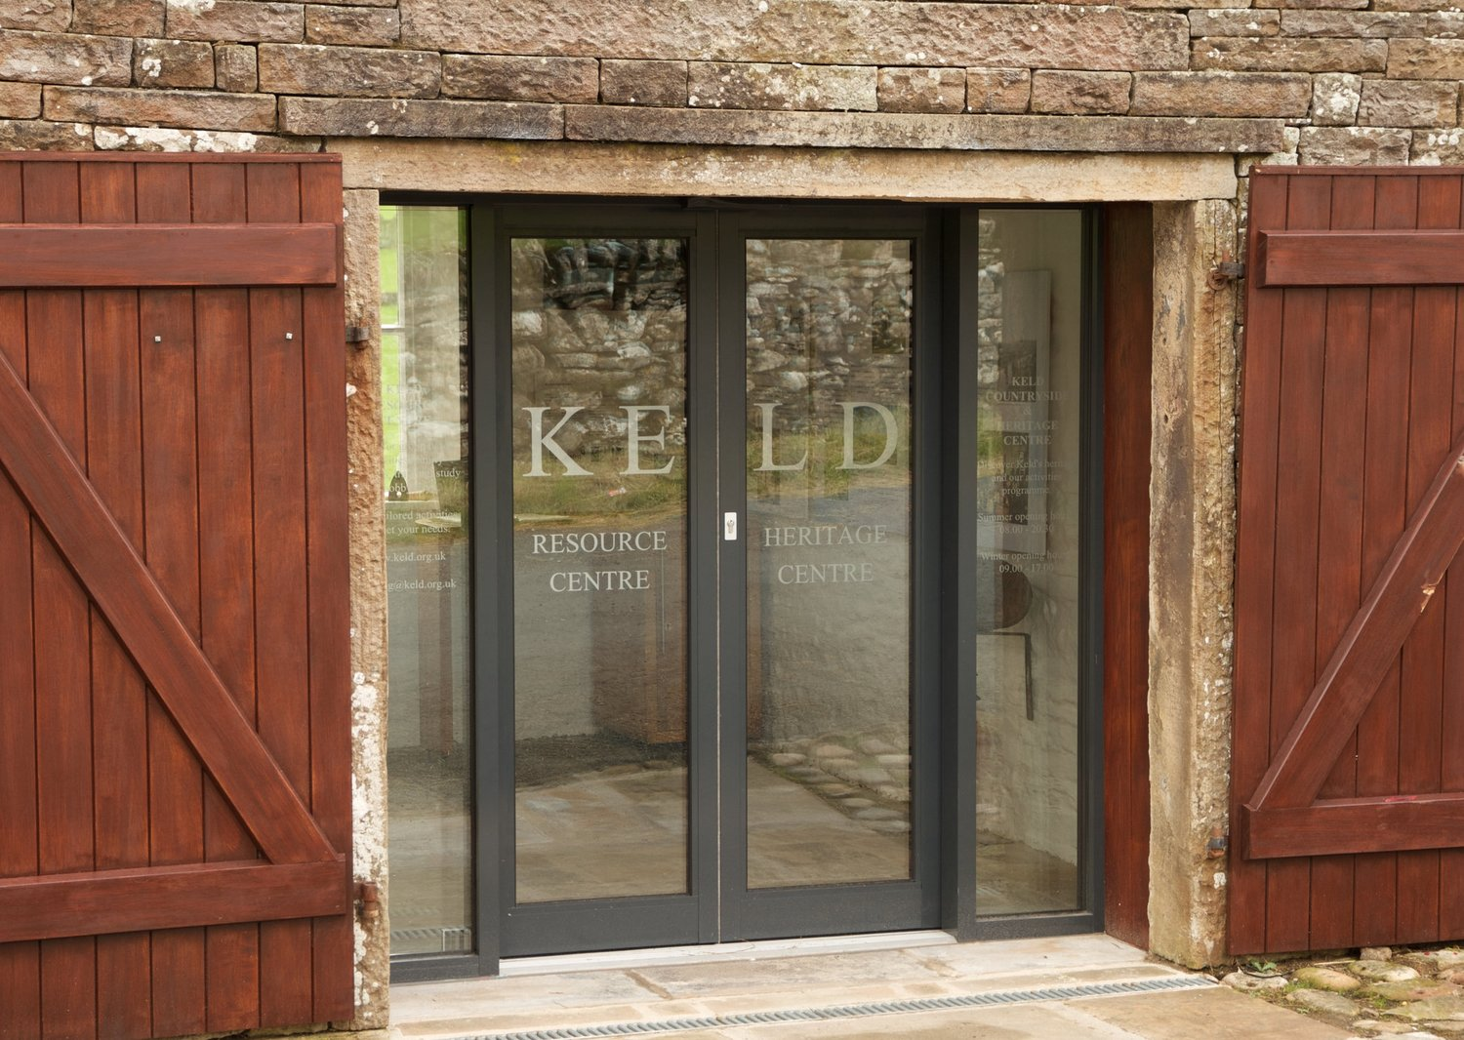

Steps along the Way

An event to remember and celebrate:
the lives of loved ones now died, the occasion of our baptism, wedding days – our own and those of friends and family
Keld Chapel Sunday July 7 at 2.00pm
Led by the Revd Peter Poulter
Please feel free to bring a photograph, memento or toy to help focus on the special people and occasions that we are celebrating

TAIZE PILGRIMAGE
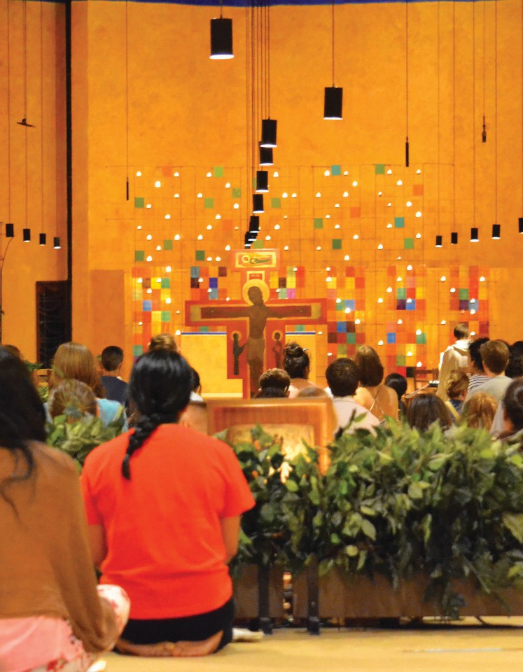

We have been contacted by our friend, Rt Revd Smitha Prasadam, the Bishop of Huddersfield. She is leading a pilgimage to Taize during August 2024 and it is hoped the Archbishop of York will also join it for part of that time. The pilgrimage is open to young people, families and church leaders so that we can better connect faith and daily life through the rhythms of prayer that community life affords and in the company of fellow pilgrims from all over the world – in a place which a former Pope called a “little springtime for the church.”

17 – 26 August 2024

17 – 26 August 2024
You need to have a British passport or other passport with Schengen visa and the cost will be £300 per person. This includes a contribution for the stay in Taizé and return travel to Huddersfield (other stops negotiable).
There is a leaflet available which I can send out (e-mail me at clerk@urcyorkshire.org.uk) but for more information please contact Bishop Smitha at bishop.smitha@leeds.anglican.org or taize@holynativity.co.uk and we are told that bookings and full payments are due by 5th July.

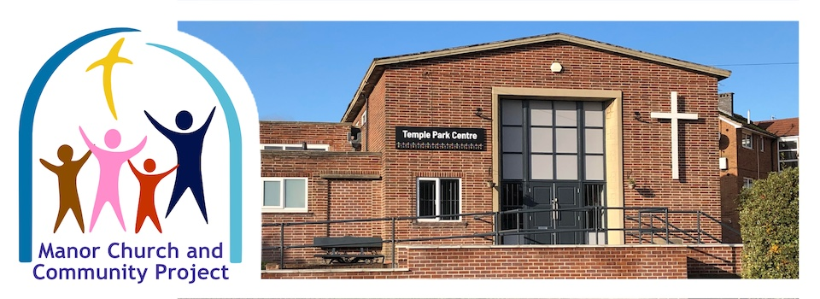
The Temple Park Centre in Sheffield is at the heart of what we know in Yorkshire as the Manor Project. Up to a couple of years ago Simon Loveitt was in post as a CRCW there, and although he has now headed south to help them level up with the north, we still have close links. They recently held a Celebration Day, and you can see that celebration, and how they are moving forward by clicking here https://youtu.be/V2okMxjV2_0 to watch a video of the day on YouTube. For more information visit the Celebration day page on their website at https://templeparkcentre.org/2024/05/29/temple-park-centre-celebration-day/ or go directly to the main site at https://templeparkcentre.org/

Hitting the high notes at Heckmondwike
The afternoon of Sunday 23rd June saw the fabulous Cafe Jam worship group at a gathering of the churches in SPACE (SPen And Calder Enterprise).
Congregations from Heckmondwike URC, Longcauseway church, Norristhorpe URC and Ravensthorpe with Hopton URC were spiritually uplifted with both familiar and new worship songs during the all age worship.
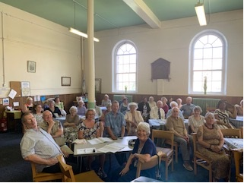
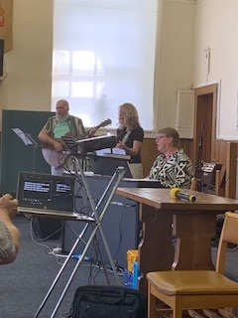
The proceedings began with an ‘afternoon tea’ style lunch prepared by people of the Heckmondwike church, followed by the quality live music as performed by Malcolm, Rita and Helen, expertly coordinated by Richard. The group, Cafe Jam, had travelled from areas of the Mersey Synod and were warmly received as praise, prayer and reflections enhanced the whole worship experience. Truly inspirational!

SAFEGUARDING
The Safeguarding team have asked that you are reminded that they are available 24 hours a day, seven days a week and 365 days a year (and even 366 days in Leap Years!!). Details can be found on the Yorkshire website at https://urcyorkshire.org.uk/safeguarding/ and any query, either by phone or by e-mail will be answered within 24 hours.

Safeguarding Training
The Safeguarding team have put together some fresh dates for Intermediate and Advanced Safeguarding Training as well as a few dates offering Refresher Training.
As ever, to book a place, please let Paula Kitson know which course and the date you wish to attend – her e-mail address is paulakitson.1and4@urc.org.uk – and a zoom link will be sent to you shortly before the event where appropriate.

Intermediate Training – via zoom

Thursday 27th June 2024 @ 7pm
Monday 16th September @10am
Wednesday 20th November 2024 @1pm

Refresher Training – via zoom
Thursday 25th July 2024 @ 10am
Tuesday 13th August 2024 @ 1pm
Wednesday 25th September 2024 @ 7pm
Saturday 16th November 2024 @10am

Advanced Training – via zoom, both parts must be completed.
Monday 25th November 2024 @ 1pm
Monday 2nd December 2024 @ 1pm
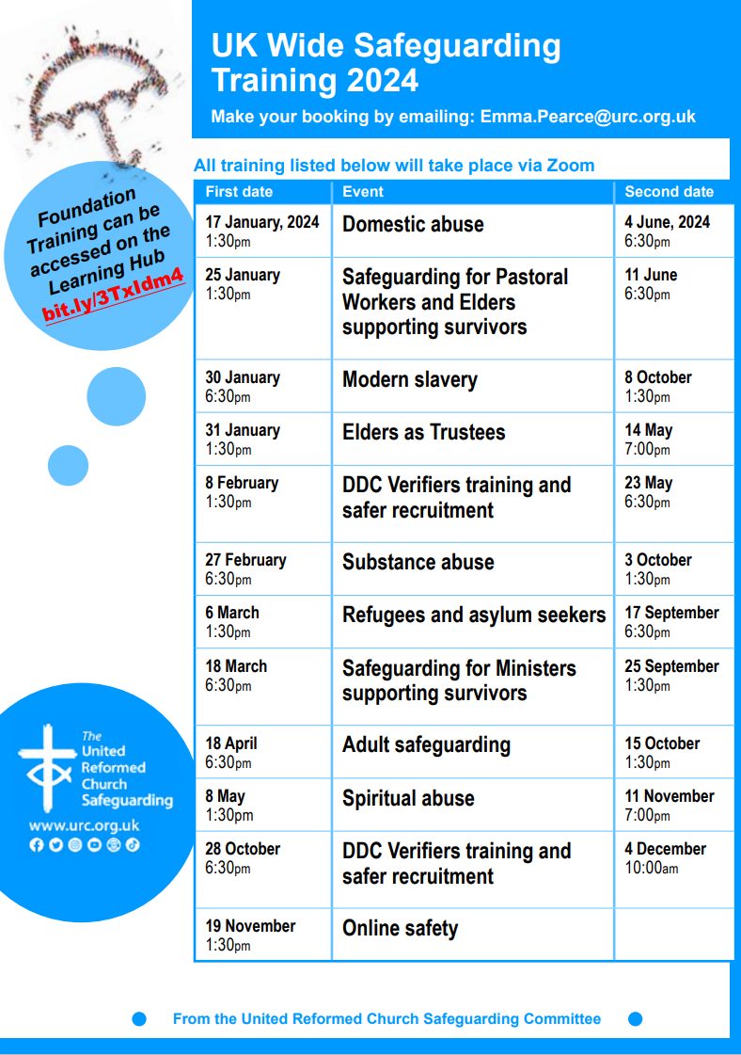


The Joint Public Issues Team has launched a range of General Election resources for congregations and we have received this from Roo Stewart, the URC’s Programme Officer for Church and Society.

These are intended to help churches and their neighbourhoods to consider the issues that will come up during the election, to engage with their local candidates and to ensure that the voices of members of each community are heard.



The URC has joined the national ‘Voter Registration Ambassador’ scheme, which encourages those who are eligible to vote to ensure they are registered to vote and have appropriate photo ID (or have applied for a postal vote) in time for the general election on 4 July. All congregations are invited to become a Voter Registration Champion, also means thinking of those who are less likely to vote in a general election. For church buildings which serve as a community hub for a broad range of people during the week, this is an ideal opportunity to encourage many more people to engage in the democratic system by choosing who will speak for them in the UK Parliament.
The General Election on 4 July is an opportunity to help your congregation consider the big issues that affect our society. So the Joint Public Issues Team has produced some resources that might help you:
How to hold a hustings event for your community
- Issues briefings and key questions for candidates on issues of immigration and asylum seekers, the environment, the economy, peace-making, poverty and engagement in a politics characterised by listening, kindness and truthfulness
- A poster explaining appropriate photo ID
- How to encourage fruitful conversation between people with different viewpoints, see jpit.uk/election.

As always, we encourage churches to be courageous in speaking out about the issues that affect your neighbourhood and our world. During an election, any communications made on behalf of a church (regulated in the UK by the Charity Commission) must not be party political – i.e. endorsing or criticising a key policy of a particular party. This might seem tough to do, but you are at liberty to share your church’s values as long as they cannot be perceived as partisan. E.g. ‘We believe that poverty can be ended in the UK if there is the political will. We are urging all our election candidates to put this high on their political agenda for the next government’, or ‘We are praying for all our local candidates, for safety during their campaigns, that they would hear the voices of the marginalised in our communities, and they would take seriously our commitment to care for our planet’s creatures and climate.’ We have practical advice on preaching and praying during the election period in our blog.
If you need more advice or support, or have further ideas or suggestions, please email: roo.stewart@urc.org.uk or phone: 020 7916 8632. However in the meantime, here’s something that may be useful for your Church Magazines:
The General Election will be held on 4 July.
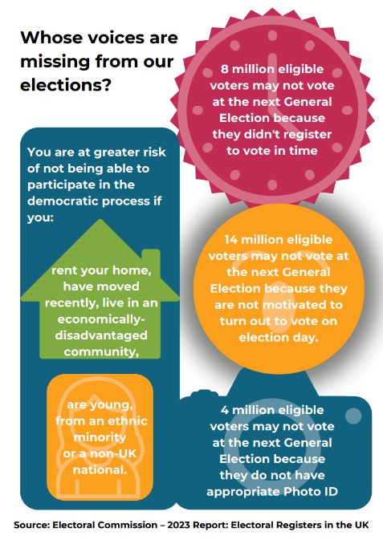
You might already be tired by the media coverage, but this is an important opportunity to choose who will speak up for our community.
- If you’re eligible to vote, are you 100% sure you are registered?
- Do you know what photo ID you need to take to the Polling Station?
- Which issues do you care about most?
- Are there voices in our neighbourhood that are not being heard?
- Could you help a neighbour get out to vote on election day?
The Joint Public Issues Team has created resources to help you engage in the general election.
jpit.uk/election

Church and Outreach Worker
for Altrincham United Reformed Church
Cecil Road, Hale, Altrincham, Cheshire WA15 9NT
We are a friendly and welcoming church family seeking a person who will help us in
developing relationships with the wider community through innovative projects. Why not
come and join us on the church’s journey in the Altrincham area? You will also play a full
and active part in the life of our church.
This is an exciting post with the full support of a small management team. There is an office base although some homeworking will be an option.
The position is full-time (37.5 hours per week) but we will be willing to consider applicants who wish to work fewer hours. Flexibility on hours worked will be required with some work on evenings and weekends.
Salary will be between £27k and £30k (full time) depending on experience. The post is budget limited but is expected to last for three years initially and will be subject to review after a probationary period of three months.

A job description is available from the Church Secretary Sue Jesson:
Contact jessonsusan@gmail.com.

To apply, please send a covering letter detailing your reasons for applying together with a copy of your CV to Sue Jesson, Church Secretary at the above address.

Closing date for applications is 31st July 2024
Date of interview to be advised.
If you wish to have an informal discussion about this role please contact Sue Jesson on 07973 391154.
And Finally
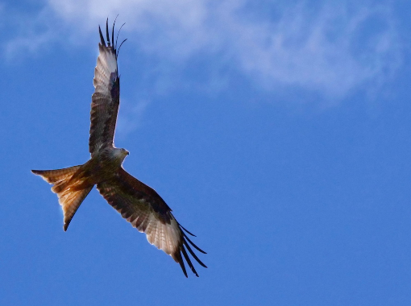
Last time we had a food orientated “And Finally”, so I thought I would continue the theme with a “Bake Off” version. This is from our friends at St Andrew’s Roundhay where they had a great evening of church groups coming together to create something. So, when The Red Kite Explorers Red Kite ESU | North Leeds Scouts (nlscouts.org.uk) asked the church catering team for help with a “technical style baking challenge” required for a badge, the culinary experts at St Andrew’s were delighted to help. On 23rd May they brought ingredients, tins, pans and expertise along to the “Bake off–Lemon Meringue Pie Challenge”. The first challenge was that many of the young people had never heard of lemon meringue pie and didn’t know what it should look like!! The generation gap has never felt wider!!

Anyway, the teams got themselves ready and the baking began. First they made the pastry which they would take home with them to turn into tarts as we did not have time to let it chill. This was messy and the results were mixed but everyone gave it their best shot. Then we moved onto the pastry cases we had prepared earlier (very Blue Peter) and, while they were blind baking, we made the lemon filling. We had lots of fun and laughter zesting and juicing lemons and oranges and all fillings were successfully completed.
Cases filled, we turned to the meringue topping and the associated challenge of separating egg whites and yolks. “Be prepared” they taught us in brownies and guides, and thankfully we had been, as we needed a few of the extra eggs we had brought along! Toppings were splodged, swirled and piped and finally the meringue was popped in the oven. Technical challenge achieved! Great results from them all!

If you have a good news story from your part of the Synod, drop me a line at clerk@urcyorkshire.org.uk and I’ll make sure it hits the back page!!

You can also keep an eye on all our social media platforms for news; on the website at Home - URC Yorkshire Synod, the Facebook pages at United Reformed Church in Yorkshire - Home | Facebook and Wilderness URC Yorkshire - Home | Facebook, the YouTube page at URC Yorkshire - YouTube and the Twitter page at URC in Yorkshire (@URCYorkshire) / Twitter.

