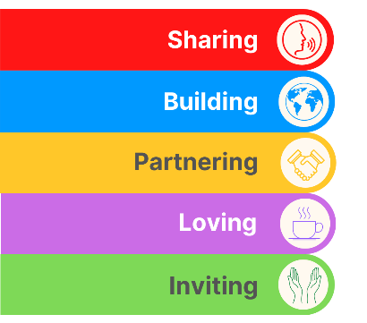
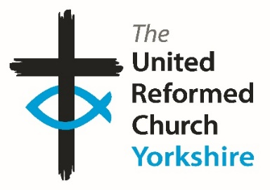
Yorkshire Synod Briefing
Number 133

11th July 2024

Spirit of Summer
You can tell that we have reached the height of summer when the Clerk starts to think about digging about at the back of his wardrobe for his swimming trunks and The Briefing starts to mention Advent and Christmas. This year is no different to any other year; there will be one more Briefing before I head off to the sun and you will find details below on how to get a discount on the URC’s 2024 Advent packs. Not only that but the Springs Dance Company are offering their services to churches with their acclaimed Journey of the Magi presentation, which has been well received by all those churches who have hosted them. There is nothing like forward planning, so please contact the Wilderness team to order the Advent Packs and consider whether your church can be on the tour list for the Journey of the Magi.
However, summer isn’t over. Some may say it hasn’t even started, but nevertheless we still have invitations are still being offered for the Summer Fun Day in August at Herringthorpe and I would like to highlight two very special invitations, one on Saturday 27th July when we welcome Joe Amoah into Harrogate St Pauls, and on the following Saturday, on 3rd August when we welcome Simon Cross to the Hull Churches at St Ninian’s & St Andrew’s. Full details can be found on the Synod Calendar at https://urcyorkshire.org.uk/calendar/
We also have invitations to a couple of key Leading Your Church into Growth events. On the evening of Tuesday 23rd July there is an introductory session to the local LYCiG course and we are also invited to make our bookings for the three-day conference being held at The Hayes in Swanwick in November. Keep on reading the Briefing for further details.
Finally, 15 of us will be heading to the General Assembly of the URC at The Hayes in Swanwick between 12th and 15th July. This annual meeting of the whole denomination is the place where the direction and mission of the URC is determined. Please pray for the Yorkshire representatives, as well as for all those representing their own Synods around the country, as they discern God’s plan in the URC and beyond. More details will appear here General Assembly papers - United Reformed Church.

So, with this in mind, there’s no excuse not to ring the office up with all the details of what is happening where you are and where we can find it. Tell me what you plan for the summer so that I can help spread that news. Drop me a line at clerk@urcyorkshire.org.uk and I’ll showcase it in the next edition, due out on Thursday 25th July.
Thank you and God Bless,
Tim Crossley
Synod Clerk

The LYCiG local course
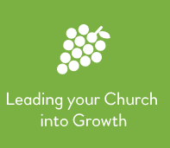
Over the last few years, Synods have been helping to resource our churches in all sorts of ways.
One of those ways to attend a LYCiG (Leading Your Church into Growth) conference, and to use the materials. However as a starter Ashley Evans, our Synod Evangelist will be leading an Introductory training session on the 23rd July at 7pm which will cover how to run the Leading Your Church Into Growth Local course at your church or group of churches.
If you are interested please let Ashley know by contacting him at Evangelist@urcyorkshire.org.uk so that he can send you the zoom link.
With this we are able to help your church family to go on a journey of discovery and excitement.
----------------------------------------------------------------------------------------------------------

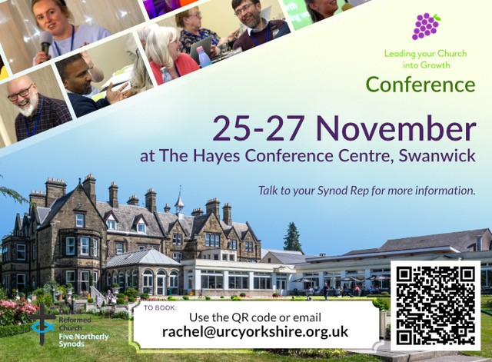
And then it is with great excitement that the LYCiG team is able to offer our Six Synods (Scotland, Northern, North Western, Mersey, Yorkshire and now West Midlands) 12 places each on this year’s ‘Leading Your Church into Growth’ conference.
This is a great opportunity to meet with URC folk from various places to learn together about how much God loves us and wants us to share that love in practical, doable and life affirming ways.
If you would like to know more, please do not hesitate to contact Ashley Evans. Tickets are on a first come, first served basis and you can book directly through the QR code, by emailing rachel@urcyorkshire.org.uk, or by following this link https://buytickets.at/theunitedreformedchurchyorkshireprovincetrustltd/1245607

Rev Ashley Evans, Evangelist@urcyorkshire.org.uk, lycig@urcwestmidlands.org.uk
https://www.facebook.com/ashleymtevans
Mobile---07403423082, Landline-01274241234,

After such a wet spring and it feels like the summer is still so far away
However, here is an event to give you that summer feeling!

THURSDAY 15 AUGUST at
Herringthorpe United Reformed Church
Get your young people together and come and join in with an afternoon of fun and friendship.
We will have inflatables available, a nerf war, summer craft activities, food and drink, and short faith seminars.
Bookings now open!
For more information contact wilderness@urc.org.uk.

Short Courses at Trinity College Glasgow

The good folk at URC Education and Learning have asked that you be made aware of these short courses being run by Trinity College Glasgow in the coming academic year, 2024-25. These courses are a mixture of online, in-person and hybrid formats (specified on each course poster, banner and website page), and so will be suitable for a range of people.
Comprehensive information for all of our courses is available at our website: https://www.trinitycollegeglasgow.co.uk/

Please don't hesitate to get in touch directly if you would like specific sizing of the promotional material or have any questions. The primary contact is Heather O'Connor whose e-mail is TrinityCollegeGlasgow@gmail.com .

1. History and Theology of Worship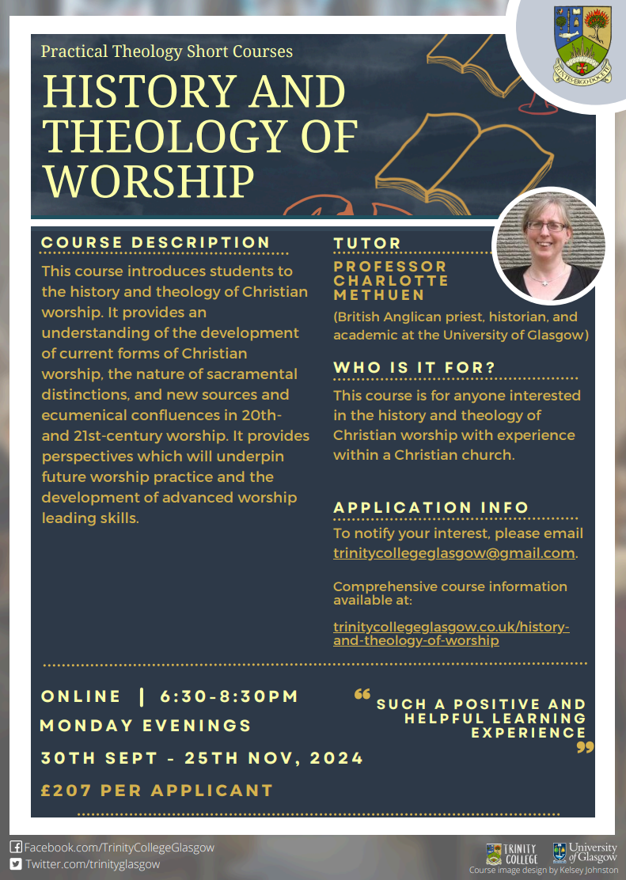
2. Preaching in Church Contexts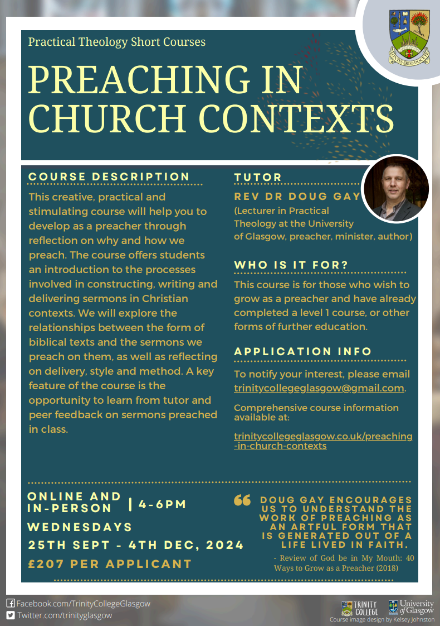
3. Contemporary Art and Visual Worship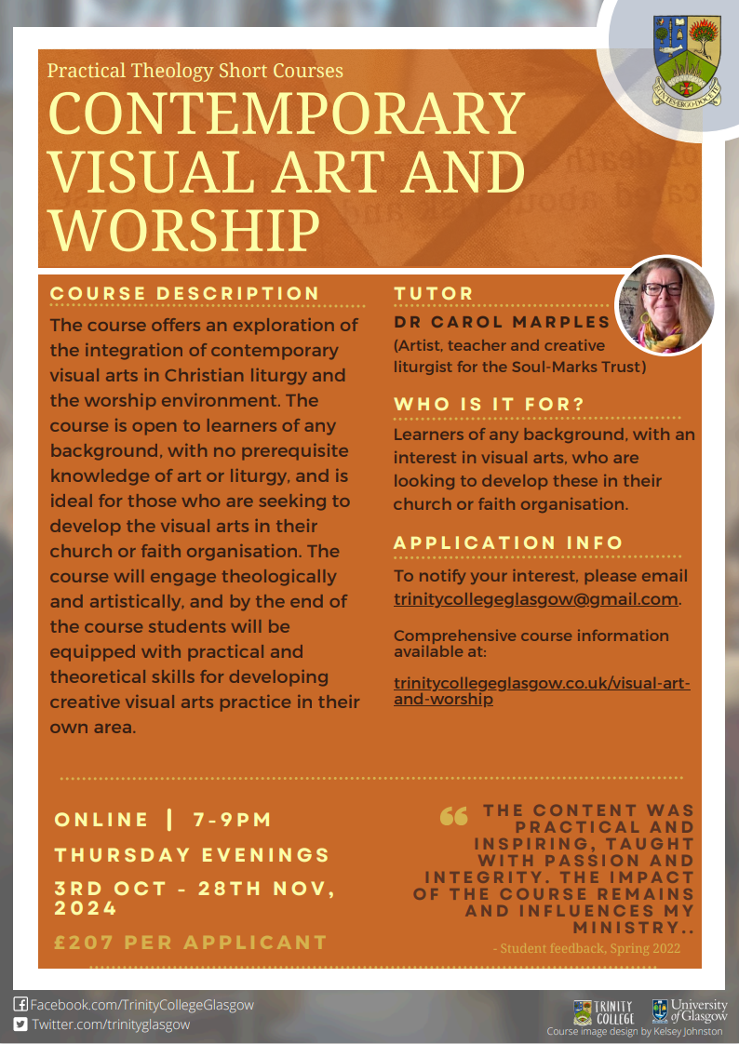
4. Creative Writing as Spiritual Reflection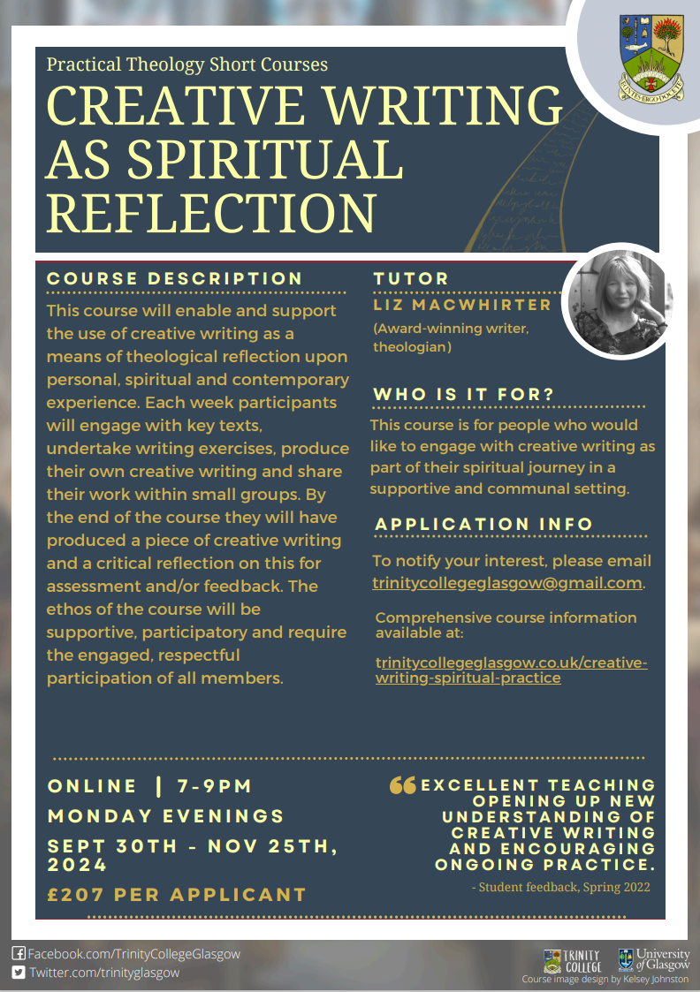
5. Designing and Leading Worship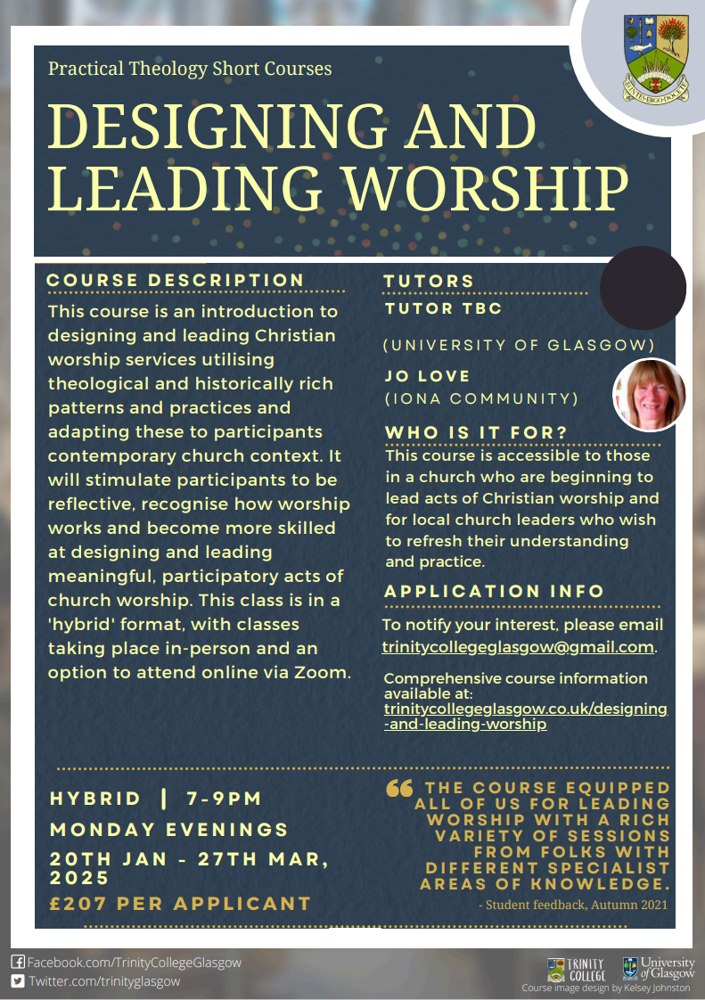
6. Listening in Mission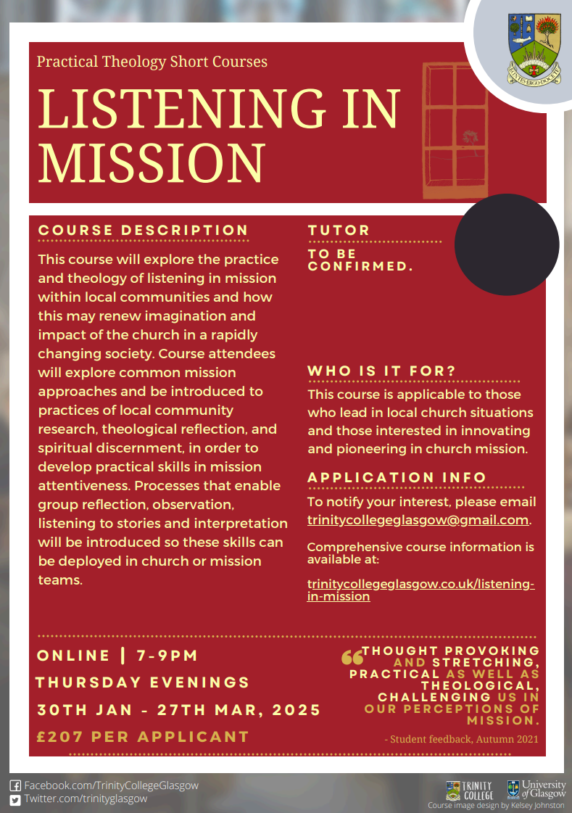
7. Liturgy and Prayer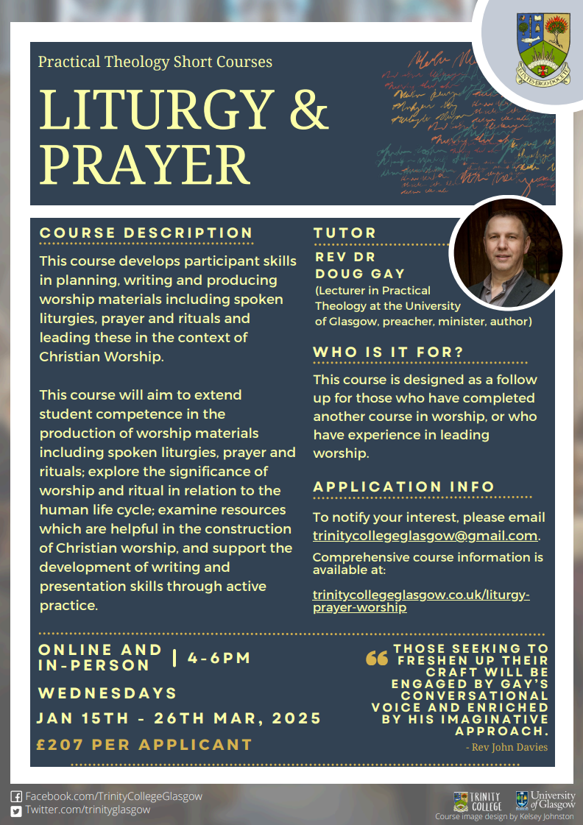

KELD RESOURCE CENTRE
IN PARTNERSHIP WITH LOW ROW WITH KELD URC
NEW FOR 2024 : STUDY DAYS

We are delighted to announce that this year’s study days has already begun and we issue a warm invitation to come to any or all of them! We have already welcomed Rev Michael Pearson who led on Five impossible Things to Believe before Christmas! Still to come there is:
Saturday August 17th - Revd. Peter Sinclair: After Sunday : Being Church Seven Days a Week
Thursday September 26th - Ms. Dorothy Thomson: There’s a Sermon in There Somewhere!

The programme will be as follows:

10.30 : Arrivals and Coffee
11.00 : Session One
12.30 : Lunch
13.30 : Session Two

15.00 : Refreshments and Departure

There will be discussion, sharing, space to ponder …….
All participants are invited to bring a packed lunch. Drinks will be provided. The cost for the day will be £10 per person.
To book your place, please contact Revd David Wood at david.wood4@btinternet.com

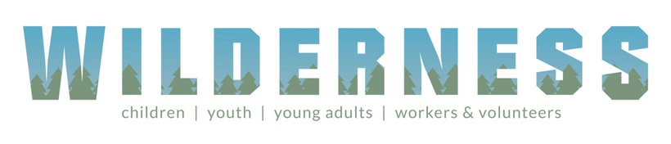
URC Advent Pack: Step into the Story
PRE-ORDER NOW
This year’s Advent Packs from the URC Children’s and Youth Work team invite people to ‘step into the story’ and focus on Christmas as everyone’s story with traditions, crafts and recipes from around the world to enrich the celebration.
The Advent Packs are a great gift to give to families. They arrive in unsealed, A5 envelopes for churches to add their own material and invitations.
Each pack will contain:
- A giant poster with a ‘countdown to Christmas’, featuring lots of suggestions for things to do, QR codes to the Faith Adventures: Children Together take-home postcards with the Bible story, prayer and activity for the four weeks of Advent
- Four mini-books (which look like presents) with ribbon to hang them up as decorations – each telling part of the Christmas story with playful photo illustrations and a simple prayer
- Four stained-glass windows to colour (linked to the four books)
Once again, the United Reformed Church in Yorkshire is offering 50% these Advent gifts: Just £15 for 10 packs or £32.50 for 25 packs.
Email wilderness@urcyorkshire.org.uk to put in your order TODAY.

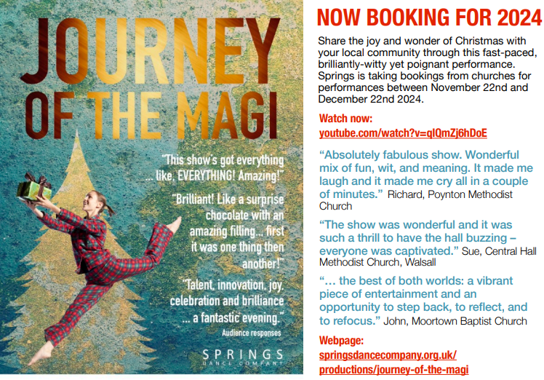
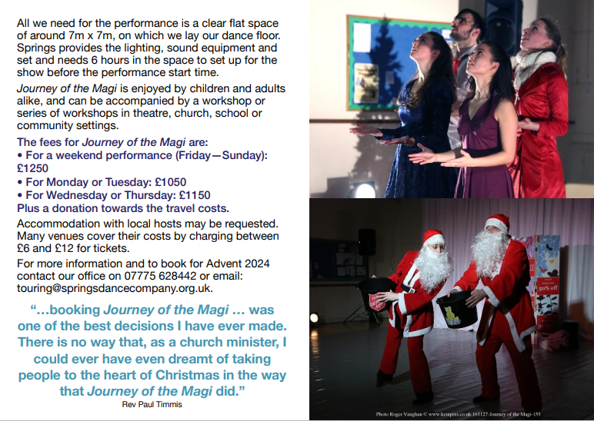
SAFEGUARDING
The Safeguarding team have asked that you are reminded that they are available 24 hours a day, seven days a week and 365 days a year (and even 366 days in Leap Years!!). Details can be found on the Yorkshire website at https://urcyorkshire.org.uk/safeguarding/ and any query, either by phone or by e-mail will be answered within 24 hours.

Safeguarding Training
The Safeguarding team have put together some fresh dates for Intermediate and Advanced Safeguarding Training as well as a few dates offering Refresher Training.
As ever, to book a place, please let Paula Kitson know which course and the date you wish to attend – her e-mail address is paulakitson.1and4@urc.org.uk – and a zoom link will be sent to you shortly before the event where appropriate.

Refresher Training – via zoom

Thursday 25th July 2024 @ 10am
Tuesday 13th August 2024 @ 1pm
Wednesday 25th September 2024 @ 7pm
Saturday 16th November 2024 @10am

Intermediate Training – via zoom
Monday 16th September @10am
Wednesday 20th November 2024 @1pm

Advanced Training – via zoom, both parts must be completed.
Monday 25th November 2024 @ 1pm
Monday 2nd December 2024 @ 1pm

Finally, there are two more UK wide Safeguarding training sessions left this year, both in the Autumn:
For more information and to book onto these courses, please contact emma.pearce@urc.org.uk

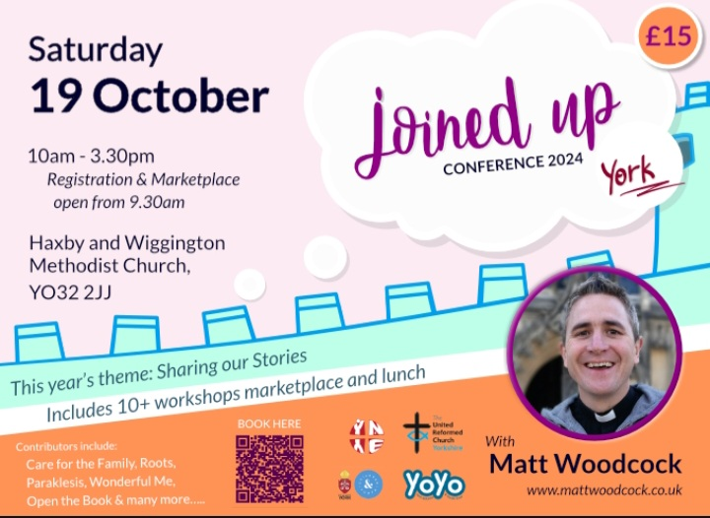
Joined Up Conference, York 2024
Hot off the e-mail is advanced notice of the Joined Up Conference being held in York in October. More details will be following, but we have a little more information through Megan Tillbrook via
megancyp@urcyorkshire.org.uk

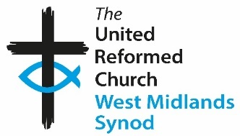
The West Midlands Synod of the United Reformed Church
is seeking to appoint a
Children and Youth Development Officer (Ref CYDO)

This is a full-time post for 35 hours per week, including evening and weekends on an open-ended contract. This post is subject to an Enhanced DBS Disclosure.
Salary: £40,000 depending on experience and qualifications
This post offers a challenging opportunity for an experienced and professionally qualified Children’s and Youth Worker with training (or development) skills. We are looking for an enterprising Christian to serve the churches of the Synod in offering advice and support to those working with children and young people and to build up a Synod Youth Executive.
The Officer appointed will be a member of a professional Assembly team and a large lay Synod team; good team working skills are essential.
If you share our passion for children and young people playing
their part in the mission of God, please download the job description, person specification and application form from our website:

Click to download the Job Description
Click to download the Person Specification
Click to download the Application Form
Alternatively, request an information pack from Lindsay Peniston,
West Midlands Synod Office, on 0121 783 1177
E-mail: moderatorspa@urcwestmidlands.org.uk

Closing date for applications: noon on Thursday 15 August 2024
Shortlisting: Monday 19 August 2024
Interview date: Monday 2 September 2024
In accordance with the Equality Act 2010: Part 1, Schedule 9, there is an occupational
requirement for the post holder to be a practising Christian.
We are committed to diversity and equality of opportunity. We especially welcome applications from women and Black and Minority Ethnic Groups who are currently under-represented in this area of work in the Church.
Church and Outreach Worker
for Altrincham United Reformed Church
Cecil Road, Hale, Altrincham, Cheshire WA15 9NT
We are a friendly and welcoming church family seeking a person who will help us in developing relationships with the wider community through innovative projects. Why not come and join us on the church’s journey in the Altrincham area? You will also play a full and active part in the life of our church.
This is an exciting post with the full support of a small management team. There is an office base although some homeworking will be an option.
The position is full-time (37.5 hours per week) but we will be willing to consider applicants who wish to work fewer hours. Flexibility on hours worked will be required with some work on evenings and weekends.
Salary will be between £27k and £30k (full time) depending on experience. The post is budget limited but is expected to last for three years initially and will be subject to review after a probationary period of three months.
A job description is available from the Church Secretary Sue Jesson: Contact jessonsusan@gmail.com.

To apply, please send a covering letter detailing your reasons for applying together with a copy of your CV to Sue Jesson, Church Secretary at the above address.

Closing date for applications is 31st July 2024
Date of interview to be advised. If you wish to have an informal discussion about this role please contact Sue Jesson on 07973 391154.
And Finally
Celebrations in South Leeds
The food and hospitality theme that seems to have developed in this slot over the past few issues seems to be continuing as I’m please to bring you a link to the South Leeds Life newspaper article about Trinity Network, the URC in South Leeds day centre's 50th anniversary. By clicking on
https://southleedslife.com/trinity-network-celebrates-half-a-century-of-service/ you’ll see that the URC in South Leeds has a thriving missional outreach project and that the 50th anniversary was well attended on Friday 14th June.
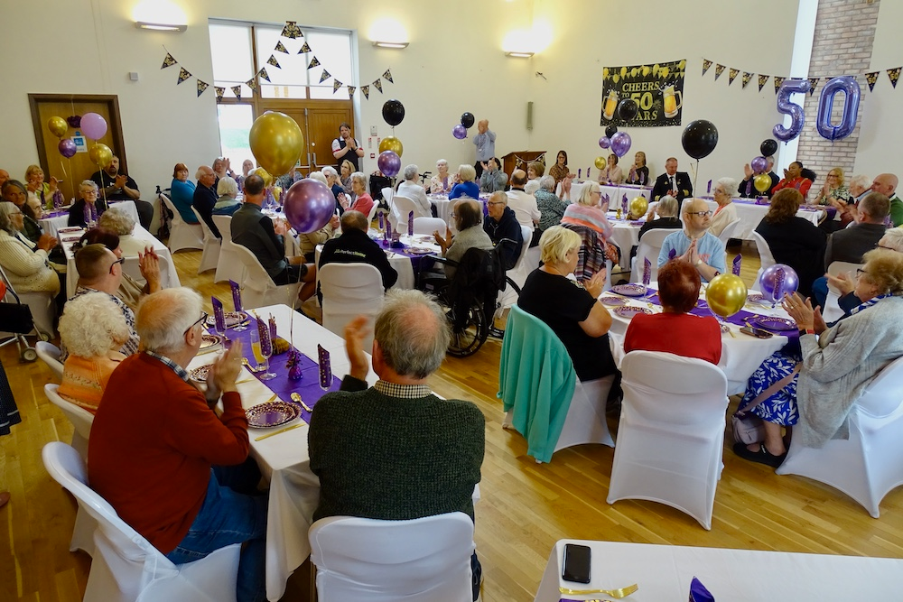
For those who don’t know, Trinity Network provides a range of day facilities for older people in South Leeds including hot lunches, a wide range of activities, trips and holidays. It provides opportunities for friendship, social interaction and making people safe, stay healthy and independent. Manager Trevor Heylings gave a potted history explaining how Trinity Network started out as an ‘Over 55s Club’ based at Dewsbury Road URC church. It developed opening in Belle Isle in 1982 and it changed its name in 2011. Unfortunately, the Dewsbury Road site had to close in 2020 due to Covid, but a minibus provides transport to allow members from Beeston to access the services.
Alex Walker the Chair of Trinity Network also spoke, thanking all the staff and volunteers who have served and also remembering those members have passed away over the years. He recalled asking a member how they had got involved with Trinity Network. She explained that her mother had used the service twenty years previously and had told her it was “too good not to go.”
The centre and the church were decked out with balloons and bunting as well as hundreds of photos displaying the work, the members and the volunteers over the decades. The chat was lively as old friends caught up and talked about old times and new developments with other guests including the Lord Mayor of Leeds, Cllr Abigail Marshall Katung, Hilary Benn MP and Tom Riordan, Chief Executive of Leeds City Council.

If you have a good news story from your part of the Synod, drop me a line at clerk@urcyorkshire.org.uk and I’ll make sure it hits the back page!!

You can also keep an eye on all our social media platforms for news; on the website at Home - URC Yorkshire Synod, the Facebook pages at United Reformed Church in Yorkshire - Home | Facebook and Wilderness URC Yorkshire - Home | Facebook, the YouTube page at URC Yorkshire - YouTube and the Twitter page at URC in Yorkshire (@URCYorkshire) / Twitter.

