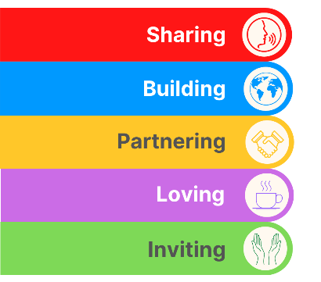
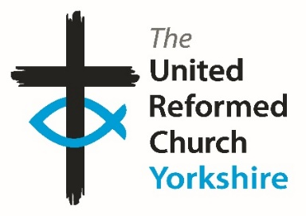
Yorkshire Synod Briefing
Number 134

25th July 2024

Summer Invitations
Two weeks ago, this coming Friday saw the start of the 2024 General Assembly and in the end fourteen of us travelled to the Hayes in Derbyshire to be your representatives. It was an uplifting, exciting, challenging and spiritually rewarding experience for all of us. The dry details have appeared online here General Assembly papers - United Reformed Church, and those who attended will expand upon the weekend further at our next Synod meeting in October. I’ll be sending out more details about that in due course, but one of the highlights was to welcome Rev Tim Meadows, seen here, as the new Moderator of General Assembly. Now I hear that we in Yorkshire have an opportunity to welcome him to God’s own County as he will be leading worship at Heckmondwike URC on Sunday 18th August at 10.30am. Although it’s not a SPen And Calder Enterprise church service, the good folk at Heckmondwike do extend a wide invitation to listen to Rev Tim and to show him how we in Yorkshire can work to increase the Kingdom here. I’m also told that it is also a chance too for Heckmondwike to show off their new AV equipment, the purchase and installation of which was supported by the Synod Mission Fund (applications always welcome – contact the Clerk for details). So, if you want to join Heckmondwike in their service, pop WF16 0DY into the Sat Nav and enjoy the worship and fellowship on offer.
We have now reached the height of summer and the Clerk has dug about at the back of his wardrobe and has found his swimming trunks (as he heads off for his hols) and The Briefing carries on mentioning Advent and Christmas. You will find details below on how to get a discount on the URC’s 2024 Advent packs. Not only that but the Springs Dance Company are still offering their services to churches with their acclaimed Journey of the Magi presentation. There is nothing like forward planning, so please contact the Wilderness team to order the Advent Packs and consider whether your church can be on the tour list for the Journey of the Magi.
The Invitation is still open from Herringthorpe URC to join them at their Summer Fun Day on August 15^{th,} and I would like to highlight two very special invitations, one this coming Saturday 27th July when we welcome Joe Amoah into Harrogate St Paul’s, and on the following Saturday, on 3rd August when we welcome Simon Cross to the Hull Churches at St Ninian’s & St Andrew’s. Full details can be found on the Synod Calendar at https://urcyorkshire.org.uk/calendar/
Finally, please let me know what you have been up to in your churches and the plans you have for the latter end of the summer and early autumn by dropping me a line at clerk@urcyorkshire.org.uk and I’ll showcase it in the next edition, due out on Thursday 15th August.
Thank you and God Bless,
Tim Crossley
Synod Clerk

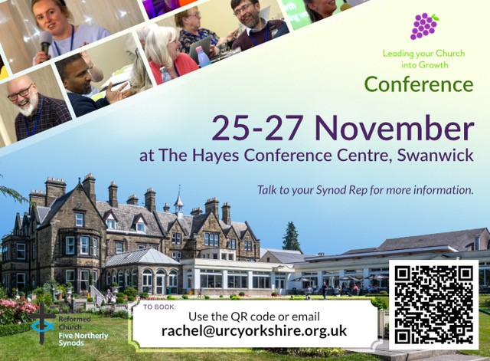
It is with great excitement that the LYCiG team is able to offer our Six Synods (Scotland, Northern, North Western, Mersey, Yorkshire and now West Midlands) 12 places each on this year’s ‘Leading Your Church into Growth’ conference.
This is a great opportunity to meet with URC folk from various places to learn together about how much God loves us and wants us to share that love in practical, doable and life affirming ways.
If you would like to know more, please do not hesitate to contact Ashley Evans. Tickets are on a first come, first served basis and you can book directly through the QR code, by emailing rachel@urcyorkshire.org.uk, or by following this link https://buytickets.at/theunitedreformedchurchyorkshireprovincetrustltd/1245607

Rev Ashley Evans, Evangelist@urcyorkshire.org.uk, lycig@urcwestmidlands.org.uk
https://www.facebook.com/ashleymtevans
Mobile---07403423082, Landline-01274241234,

New small grant available to build links with uniformed groups

This is something that was hidden in the corner of the regular URC News update. I know that many of you have used the Discipleship Development Fund to help with individual Christian journeys and learning, but this snippet has widened the fund’s remit.
In a nutshell, new small grants of £50 or £100 are available for URC local churches from the Discipleship Development Fund to support churches building links with uniformed groups Boys’ Brigade, Girls’ Brigade, Guiding or Scouting. Apply for the new small grant.

After such a wet spring and it feels like the summer is still so far away
However, here is an event to give you that summer feeling!

THURSDAY 15 AUGUST at
Herringthorpe United Reformed Church
Get your young people together and come and join in with an afternoon of fun and friendship.
We will have inflatables available, a nerf war, summer craft activities, food and drink, and short faith seminars.
Bookings now open!
For more information contact wilderness@urc.org.uk.

Short Courses at Trinity College Glasgow

The good folk at URC Education and Learning have asked that you be made aware of these short courses being run by Trinity College Glasgow in the coming academic year, 2024-25. These courses are a mixture of online, in-person and hybrid formats (specified on each course poster, banner and website page), and so will be suitable for a range of people.
Comprehensive information for all of our courses is available at our website: https://www.trinitycollegeglasgow.co.uk/

Please don't hesitate to get in touch directly if you would like specific sizing of the promotional material or have any questions. The primary contact is Heather O'Connor whose e-mail is TrinityCollegeGlasgow@gmail.com .

1. History and Theology of Worship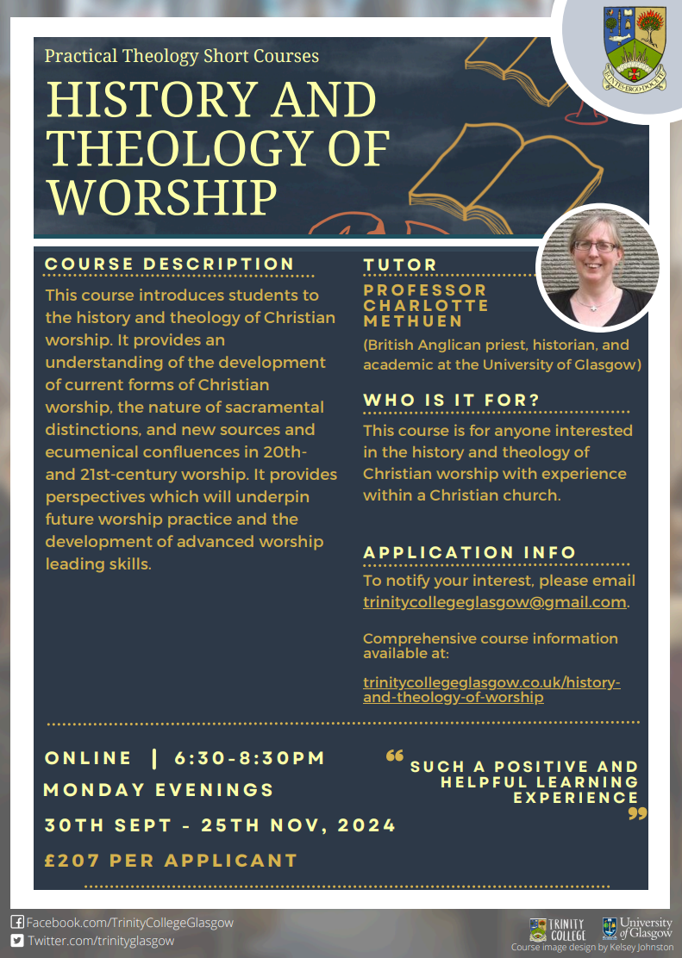
2. Preaching in Church Contexts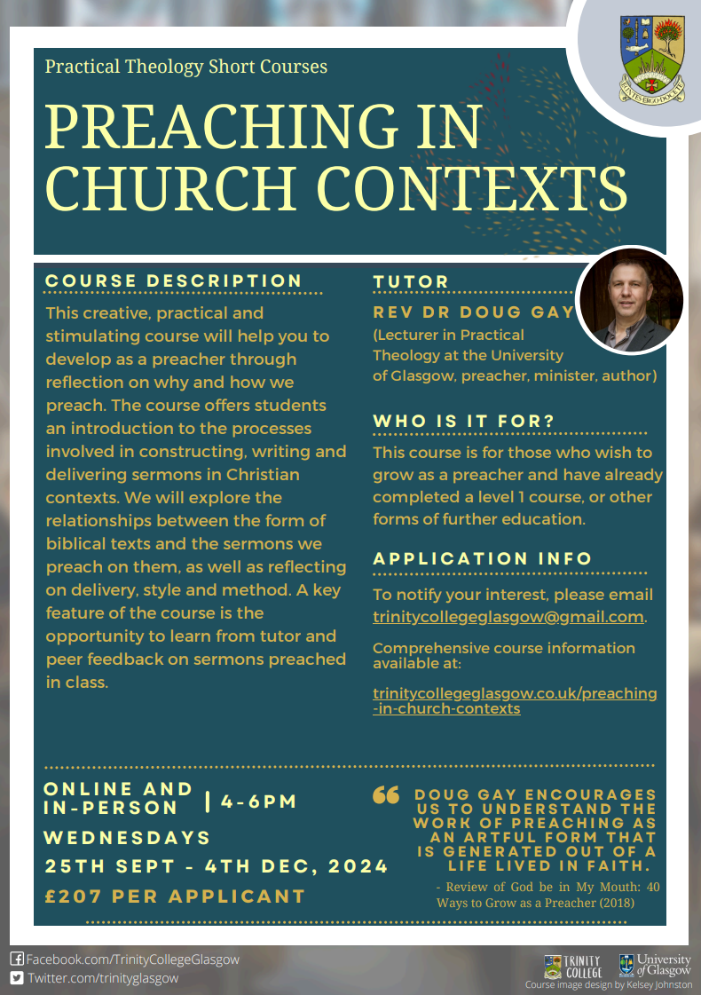
3. Contemporary Art and Visual Worship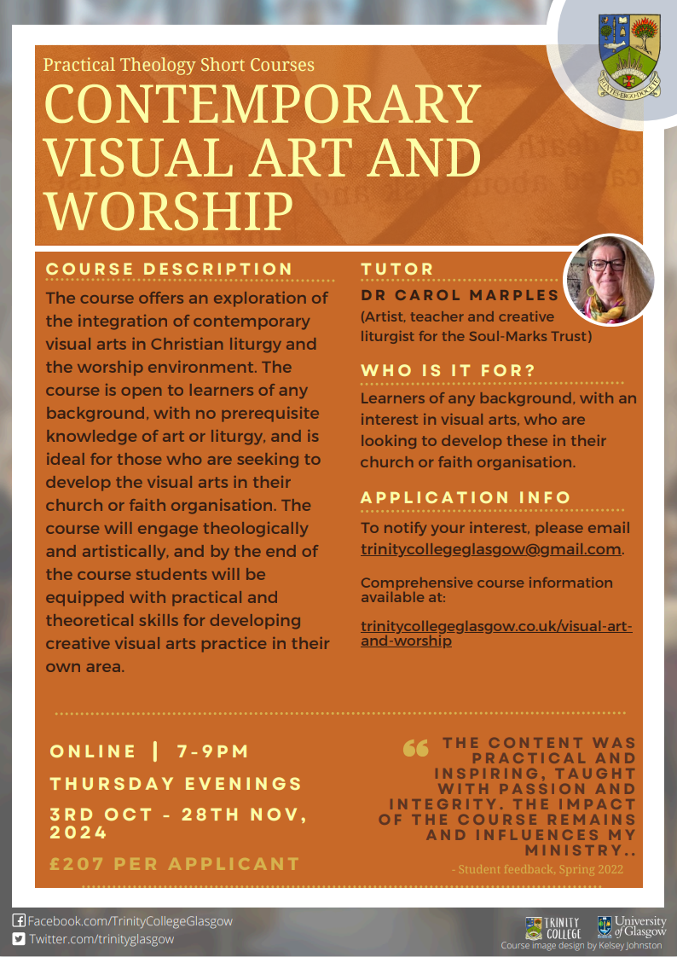
4. Creative Writing as Spiritual Reflection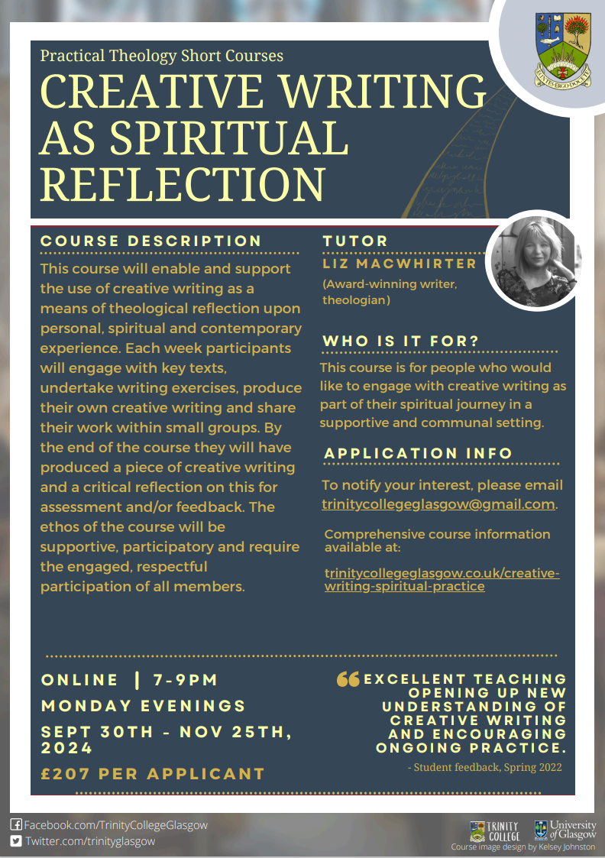
5. Designing and Leading Worship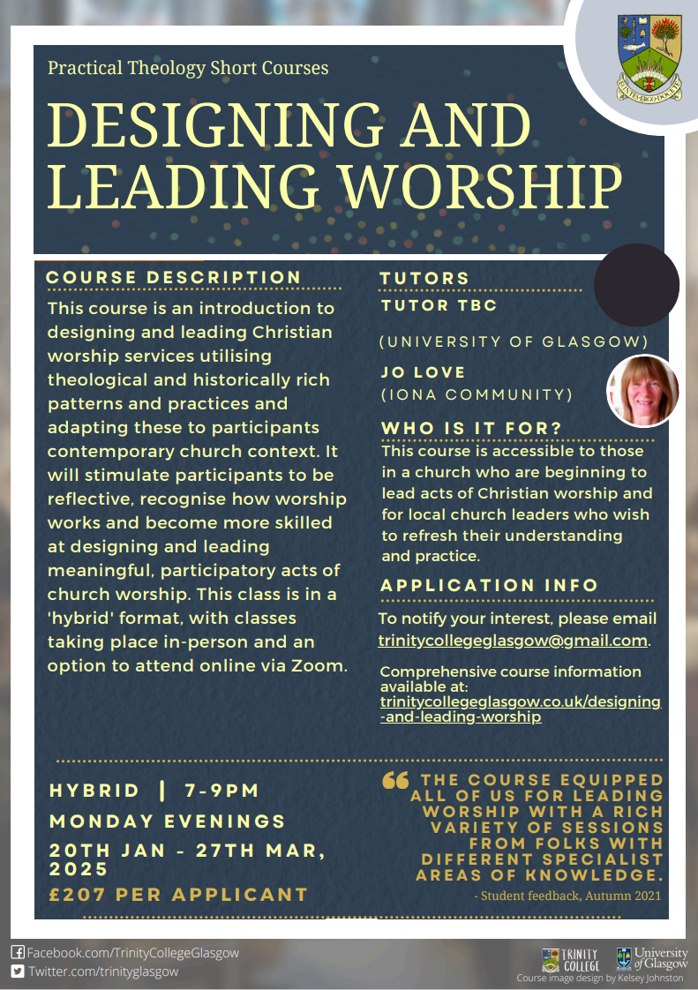
6. Listening in Mission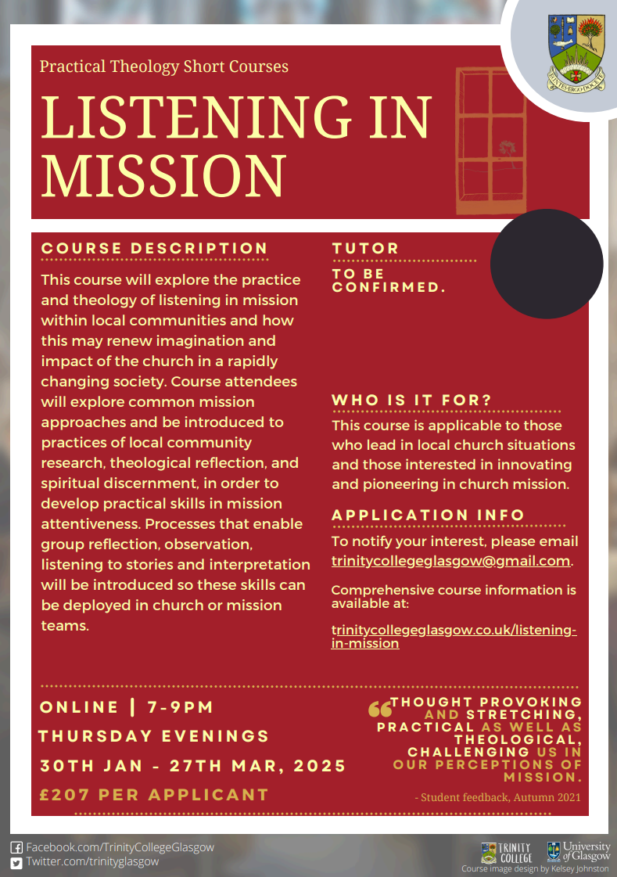
7. Liturgy and Prayer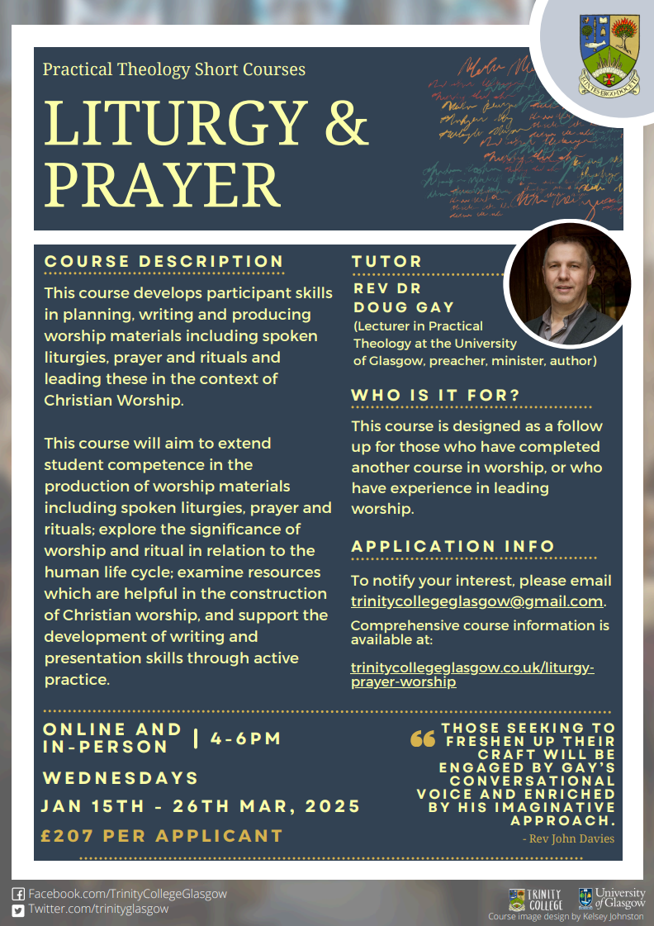

KELD RESOURCE CENTRE
IN PARTNERSHIP WITH LOW ROW WITH KELD URC
NEW FOR 2024: STUDY DAYS

We are delighted to announce that this year’s study days has already begun and we issue a warm invitation to come to any or all of them! We have already welcomed Rev Michael Pearson who led on Five impossible Things to Believe before Christmas! Still to come there is:
Saturday August 17th - Revd. Peter Sinclair: After Sunday: Being Church Seven Days a Week
Thursday September 26th - Ms. Dorothy Thomson: There’s a Sermon in There Somewhere!

The programme will be as follows:

10.30: Arrivals and Coffee
11.00: Session One
12.30: Lunch
13.30: Session Two

15.00: Refreshments and Departure

There will be discussion, sharing, space to ponder …….
All participants are invited to bring a packed lunch. Drinks will be provided. The cost for the day will be £10 per person.
To book your place, please contact Revd David Wood at david.wood4@btinternet.com

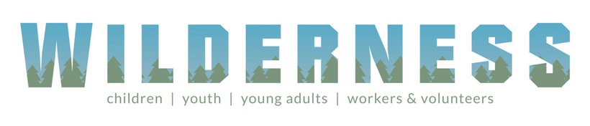
URC Advent Pack: Step into the Story
PRE-ORDER NOW
This year’s Advent Packs from the URC Children’s and Youth Work team invite people to ‘step into the story’ and focus on Christmas as everyone’s story with traditions, crafts and recipes from around the world to enrich the celebration.
The Advent Packs are a great gift to give to families. They arrive in unsealed, A5 envelopes for churches to add their own material and invitations.
Each pack will contain:
- A giant poster with a ‘countdown to Christmas’, featuring lots of suggestions for things to do, QR codes to the Faith Adventures: Children Together take-home postcards with the Bible story, prayer and activity for the four weeks of Advent
- Four mini-books (which look like presents) with ribbon to hang them up as decorations – each telling part of the Christmas story with playful photo illustrations and a simple prayer
- Four stained-glass windows to colour (linked to the four books)
Once again, the United Reformed Church in Yorkshire is offering 50% these Advent gifts: Just £15 for 10 packs or £32.50 for 25 packs.
Email wilderness@urcyorkshire.org.uk to put in your order TODAY.

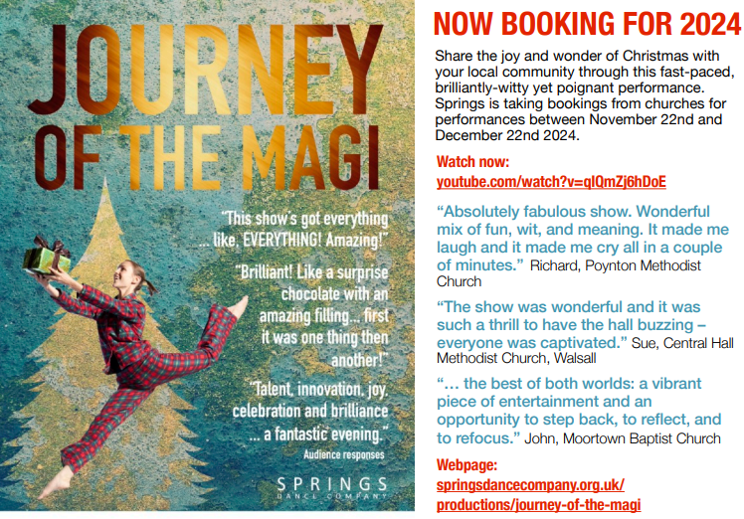
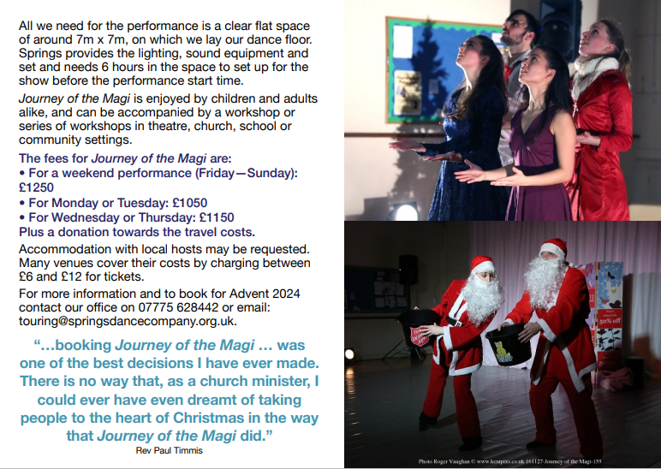
SAFEGUARDING
The Safeguarding team have asked that you are reminded that they are available 24 hours a day, seven days a week and 365 days a year (and even 366 days in Leap Years!!). Details can be found on the Yorkshire website at https://urcyorkshire.org.uk/safeguarding/ and any query, either by phone or by e-mail will be answered within 24 hours.

Safeguarding Training
The Safeguarding team have put together some fresh dates for Intermediate and Advanced Safeguarding Training as well as a few dates offering Refresher Training.
As ever, to book a place, please let Paula Kitson know which course and the date you wish to attend – her e-mail address is paulakitson.1and4@urc.org.uk – and a zoom link will be sent to you shortly before the event where appropriate.

Refresher Training – via zoom

Thursday 25th July 2024 @ 10am
Tuesday 13th August 2024 @ 1pm
Wednesday 25th September 2024 @ 7pm
Saturday 16th November 2024 @10am

Intermediate Training – via zoom
Monday 16th September @10am
Wednesday 20th November 2024 @1pm

Advanced Training – via zoom, both parts must be completed.
Monday 25th November 2024 @ 1pm
Monday 2nd December 2024 @ 1pm

Finally, there are two more UK wide Safeguarding training sessions left this year, both in the Autumn:
For more information and to book onto these courses, please contact emma.pearce@urc.org.uk

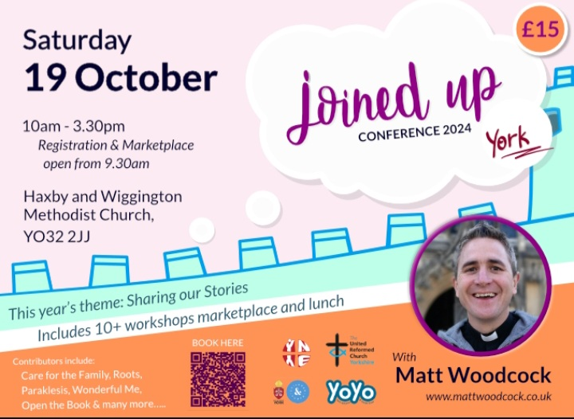
Joined Up Conference, York 2024
Hot off the e-mail is advanced notice of the Joined Up Conference being held in York in October. More details will be following, but we have a little more information through Megan Tillbrook via
megancyp@urcyorkshire.org.uk

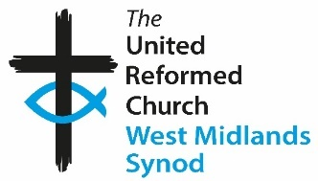
Church and Outreach Worker
for Altrincham United Reformed Church
Cecil Road, Hale, Altrincham, Cheshire WA15 9NT
We are a friendly and welcoming church family seeking a person who will help us in developing relationships with the wider community through innovative projects. Why not come and join us on the church’s journey in the Altrincham area? You will also play a full and active part in the life of our church.
This is an exciting post with the full support of a small management team. There is an office base although some homeworking will be an option.
The position is full-time (37.5 hours per week), but we will be willing to consider applicants who wish to work fewer hours. Flexibility on hours worked will be required with some work on evenings and weekends.
Salary will be between £27k and £30k (full time) depending on experience. The post is budget limited but is expected to last for three years initially and will be subject to review after a probationary period of three months.
A job description is available from the Church Secretary Sue Jesson: Contact jessonsusan@gmail.com.

To apply, please send a covering letter detailing your reasons for applying together with a copy of your CV to Sue Jesson, Church Secretary at the above address.

Closing date for applications is 31st July 2024
Date of interview to be advised. If you wish to have an informal discussion about this role, please contact Sue Jesson on 07973 391154.
The West Midlands Synod of the United Reformed Church
is seeking to appoint a
Children and Youth Development Officer (Ref CYDO)

This is a full-time post for 35 hours per week, including evening and weekends on an open-ended contract. This post is subject to an Enhanced DBS Disclosure.
Salary: £40,000 depending on experience and qualifications
This post offers a challenging opportunity for an experienced and professionally qualified Children’s and Youth Worker with training (or development) skills. We are looking for an enterprising Christian to serve the churches of the Synod in offering advice and support to those working with children and young people and to build up a Synod Youth Executive. The Officer appointed will be a member of a professional Assembly team and a large lay Synod team; good team working skills are essential.
If you share our passion for children and young people playing
their part in the mission of God, please download the job description, person specification and application form from our website:

Click to download the Job Description
Click to download the Person Specification
Click to download the Application Form
Alternatively, request an information pack from Lindsay Peniston,
West Midlands Synod Office, on 0121 783 1177
E-mail: moderatorspa@urcwestmidlands.org.uk

Closing date for applications: noon on Thursday 15 August 2024
Shortlisting: Monday 19 August 2024
Interview date: Monday 2 September 2024
In accordance with the Equality Act 2010: Part 1, Schedule 9, there is an occupational requirement for the post holder to be a practising Christian.
We are committed to diversity and equality of opportunity. We especially welcome applications from women and Black and Minority Ethnic Groups who are currently under-represented in this area of work in the Church.

We are currently looking for a member of the URC’s Pensions Committee - I have attached the role description and further information can be found here: Jobs - United Reformed Church We would be most grateful if you could circulate this around your network or to people you know who may have the expertise needed.

And Finally
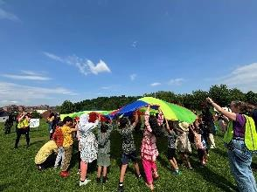
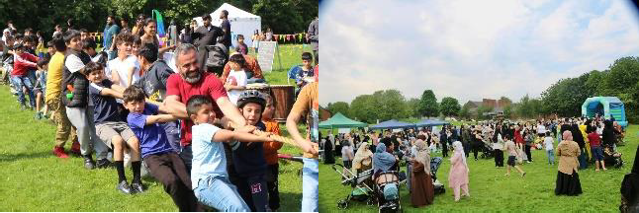
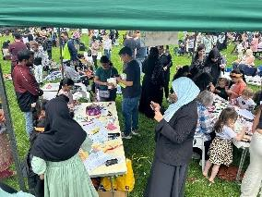
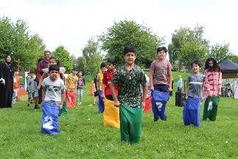
Although it may seem a little late to bring this, but the Create team working through the Darnall and Attercliffe project which is part supported by the Synod Mission Fund celebrated Pentecost by learning about Christianity around the world. They were blessed to have videos about a church in Kenya and two of the mums from Create also shared their home-made food from Poland (including learning the language) and from South Africa. It was a powerful time, especially when people were listening to testimony. Foods were tried from different countries and spent time thinking about how our faith makes a difference.
On the Saturday before Pentecost, the local churches blessed the local area with a free Funday on the local park. Each church contributed generously to the costs and we are grateful to Together for Sheffield who also supported it financially. After lots of planning, and with trepidation – would the weather be ok? Who would come and would families come along? How would it all work? - we set up and waited for people to come along.
The weather was fantastic – in fact possibly the sunniest day of the year so far! And we needn’t have worried about people coming. We had over 500 people come along and join in with the fun. There was a bouncy castle, face glitter, circus skills, craft activities, a poetry wall, bubbles, table tennis and games. The clothing bank offered clothes, and we had an organisation giving free books, and were grateful to all those who donated cakes. There was a prayer tent that was supported by Christians from churches outside Darnall and they were able to pray with a number of people. Alongside all the activities, there was interactive drumming, Bollywood dancing, storytelling (including the story of Pentecost) and singing old school bangers.
It was a wonderful day, and as the event finished, people were already asking about another one. Watching families and friends come together, hearing people phoning friends and telling them to come along and watching people from lots of different nationalities, cultures and faiths, coming together was wonderful. There was something so powerful in the way the churches all came together in unity, and served the community, on the day before Pentecost.

If you have a good news story from your part of the Synod, drop me a line at clerk@urcyorkshire.org.uk and I’ll make sure it hits the back page!!
If not, then I may have to fill The Briefing with Dad Jokes like this:
“Our local minister’s eyesight is so bad that he has to do baptisms in a massive font…………”

You can also keep an eye on all our social media platforms for news; on the website at Home - URC Yorkshire Synod, the Facebook pages at United Reformed Church in Yorkshire - Home | Facebook and Wilderness URC Yorkshire - Home | Facebook, the YouTube page at URC Yorkshire - YouTube and the Twitter page at URC in Yorkshire (@URCYorkshire) / Twitter.

