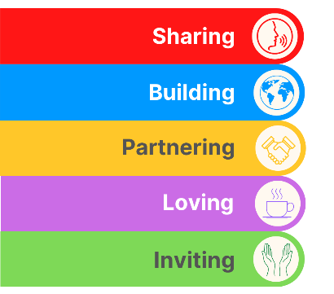
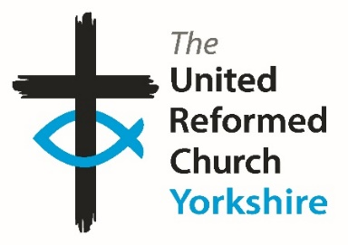
Yorkshire Synod Briefing
Number 135

15th August 2024

A Quiet Summer? Hardly……
It doesn’t seem like three weeks since I was dusting off the knotted hankie, looking for the factor 50 and heading off on holiday and I’m sure that the last three weeks have flown by for many of you as there has been so much going on in the Synod to keep us occupied over the “quiet” summer months. As you will see, we have had ordinations, inductions, return visits and collective gatherings. Not only that, preparations are being made for events in the late summer, through autumn, dare I say Christmas and even into 2025. All this shows the depth and breadth of activity within the churches in the Yorkshire Synod and it is really good to hear about it.
God of all life,

We ask for peace in a time of strife.
We ask for healing in a time of trouble.
We pray for the end of violence and intimidation,
expressed in our towns and on our streets in recent days.
You call us to care for the vulnerable in our society without prejudice.
Help us to respond to hatred and violence
with love and support for the victims,
with solidarity and kindness towards those who are afraid.
We know that living in harmony is not easy.
We know we often fall short.
But we know that, with your help and inspiration,
we can be a people known
for their strong compassion and deep welcome.
God of peace, bring peace.
Amen
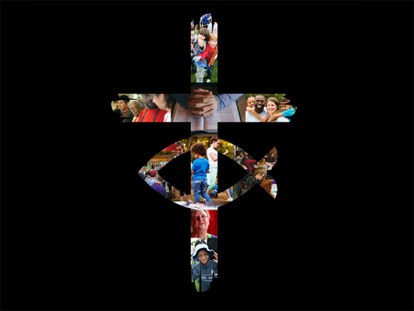
As you will see below in the article celebrating Rev Simon Cross’s Ordination and Induction into the Hull Pastorate, the Synod’s goal of bringing the Gospel to one and all faced a major challenge as a result of public disturbances. Yorkshire Synod stands firmly with the whole of the United Reformed Church in standing against hate in all its forms.
No-one should suffer intimidation and violence because of their religious beliefs or ethnic background. People fleeing from threat and persecution in other places should be able to find a safe place in the UK.
British values of mutual respect and tolerance of different faiths and beliefs underpin our society. As Christians, we are called to care for vulnerable people and speak up for those who suffer.
The moderators of the United Reformed Church and its synods are united in their deep concern for those who have been targeted in recent civil unrest. The hallmarks of racial prejudice have been on display. An initial solemn response to a terrible attack in Southport has been subverted into further violence. No good will come of it.
We stand with Black and Asian friends and neighbours, and with asylum seekers and refugees. We stand against hate in all its forms, including islamophobia and antisemitism, and call for all Christians to offer friendship and support to all those who are frightened or in need today.

Finally, please let me know what you have been up to in your churches and the plans you have for the next few weeks by dropping me a line at clerk@urcyorkshire.org.uk and I’ll showcase it in the next edition, due out on Thursday 29th August.
Thank you and God Bless,
Tim Crossley
Synod Clerk
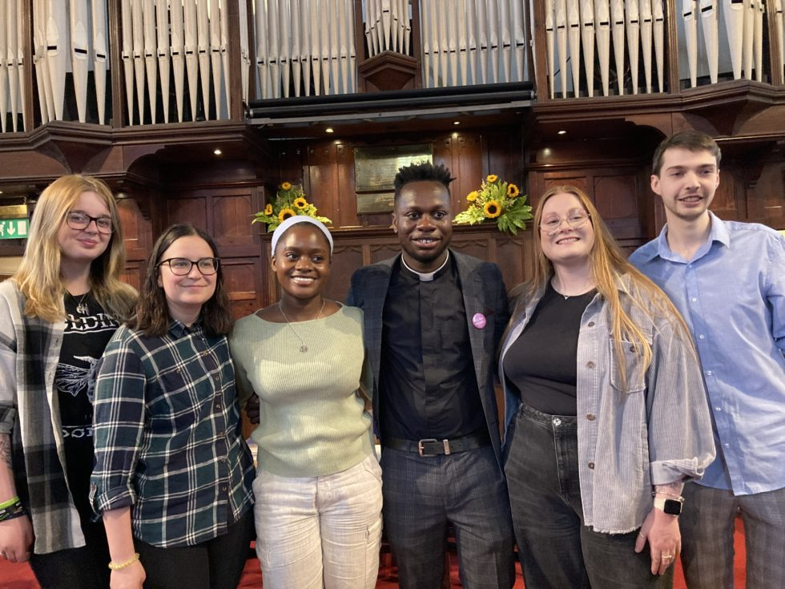
A Yorkshire Welcome to Revd Joseph Amoah!
From L to R: URC Youth Reps Japan Tuner, Heather Moore URC Youth Moderator), Philippa Osei, Revd Joseph Amoah, Megan Westgarth & Daniel Raddings
On Saturday 27th July Joseph Amoah, was welcomed, ordained and inducted as minister of St Paul’s URC, Harrogate. The service was a wonderful celebration for the church, family and all those who came along to support him, including some United Reformed Church Youth representatives, as Joe had been their chaplain for the last year.

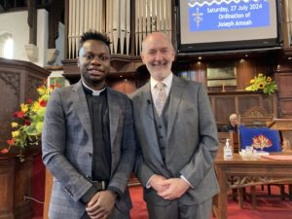
Revd Jamie Kissack, Yorkshire Synod Moderator, said: “There was a real sense of excitement as St Paul’s Harrogate hosted the Ordination and Induction service for Joe Amoah – the first time in its history that it had hosted an Ordination service. The St Paul’s congregation was joined by a large contingent from Joe’s home church in Thames North, and from his various placement churches. After a long vacancy, there was a strong sense of God’s timing in calling Joe to Harrogate and to his Synod-directed ministry.”

We welcome Joe to Yorkshire Synod and pray God’s blessings on his ministry!

Hope, Peace and Compassion at Simon Cross’s
Ordination and Induction
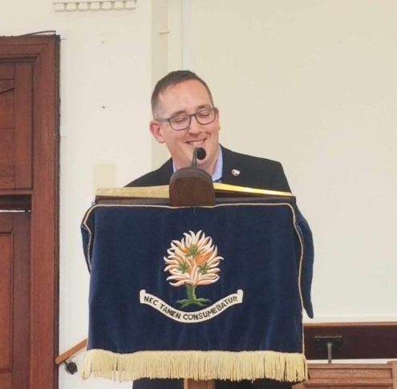
On Saturday 3rd August, Simon Cross was welcomed, Ordained and Inducted to the Hull Team of Churches and Peter’s House. The service took place at St Ninian’s and St Andrew’s United Reformed Church at the same time as rioters did their best to cause mayhem only a short distance away.

A number of people who attended the service found themselves confronted by, or directly affected by the aftermath of, the violent clashes between anti-immigrant gangs and the police.

“I was really struck by the difference,” one person said, “between what I witnessed at the riot, and what I witnessed in the church.”
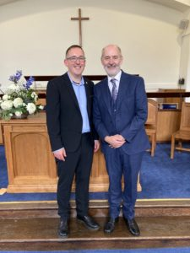
The congregation included people from Japan, Congo, Iran, South Africa, Pakistan, India and beyond, many of whom represented different faiths and traditions – from Baha’i and Buddhists to Muslims and Sikhs, from an Irish druid to a Jewish atheist – together they were a beautiful testament to the way that people from all different cultures and world views can live peacefully together.
In the same way URC folk were joined at the service by Catholics, Unitarians, Anglicans, Methodists, Anabaptists and Pentecostals, conservatives and liberals among them. The breadth of Christian traditions present in the room was a clear depiction of the church’s unity in catholicity.
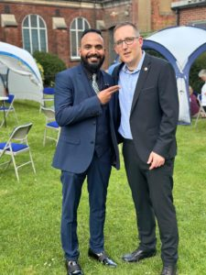
The service concluded with a blessing which included the following words:
It only takes a whisper to break the silence
It only takes a glimmer to illumine the darkness
It only takes a trickle to wear down the solid stone…
In the face of great challenges small things seem absurdly weak.
But there is a curious strength in fragility,
a strange, subversive, power in frailty.
So into the silence of domination and injustice
let’s take the whisper of hope.
Into the darkness of conflict and polarisation
let’s take the glimmer of peace.
And into the solidity of suffering and oppression
let’s take the trickle of compassion.
Simon with friend Azeem Bahsh, student minister & ordinand

“It was a beautiful afternoon,” Simon said, “there was so much love and kindness in the room – which fills me full of hope.”

For more information on the Hull Team Churches visit: https://www.hullurcchurches.org.uk/welcome.htm
All of the churches meet every Sunday for worship, you will always be welcome to join them, and meet Simon too.
IDLE “OLD BOY” RETURNS
On Sunday 4th August Idle Upper Chapel were pleased to welcome an “old boy” to lead their worship.
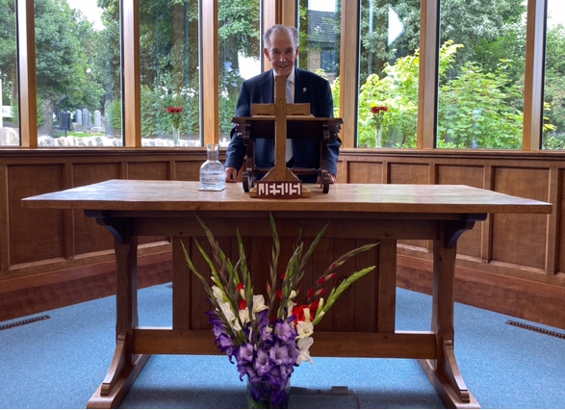
Rev Stephen Thornton, as he is now known, was born in Idle and was a regular attendee at Upper Chapel. During this time, he had a calling to become a Minister, and this came to fruition. He recently celebrated 60 years of service in the United Reformed Church and whilst having ‘retired’ from being a Minister at Fleet in Hampshire, regularly leads services around the south coast area. Stephen was instrumental in writing the URC’s Children’s Charter and the setting up of the Windermere Centre, a residential training centre and retreat. Stephen has kept in touch over the years and in recent years we have been receiving regular phone calls enquiring how the new church was coming on in the planning and construction stages, then as to how it is progressing and growing since the new building opened. Having been part of the 3rd and 4th Upper Chapels, Stephen was very keen to come to preach and meet the people of the 5th Upper Chapel.

Moldgreen Matters
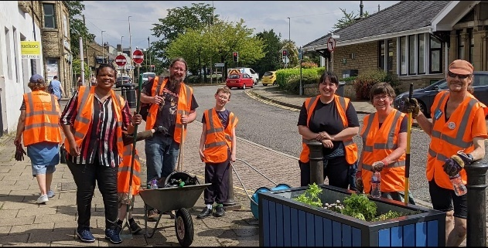
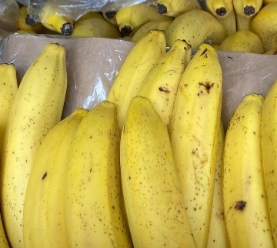
The Summer has been a great time for Moldgreen URC in Huddersfield to connect with their local community. As part of many activities they have restored and taken on the upkeep of the village planters, learned about bees, gone bananas with their community food cupboard supplies, set up school uniform provision and hosted a well-being through art session.
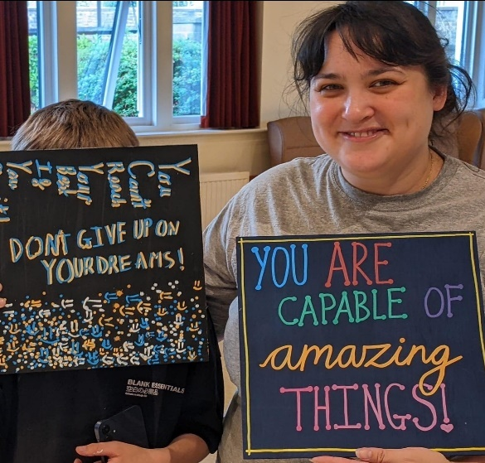
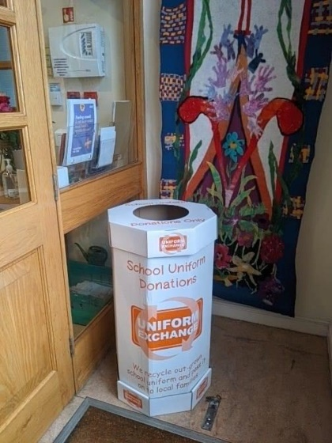
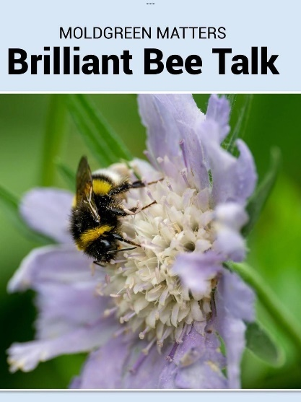
It has been busy both inside and outside our church and we feel that our fellowship and those who live around our church have enjoyed, faith in action, throughout the Summer and not just on a Sunday!

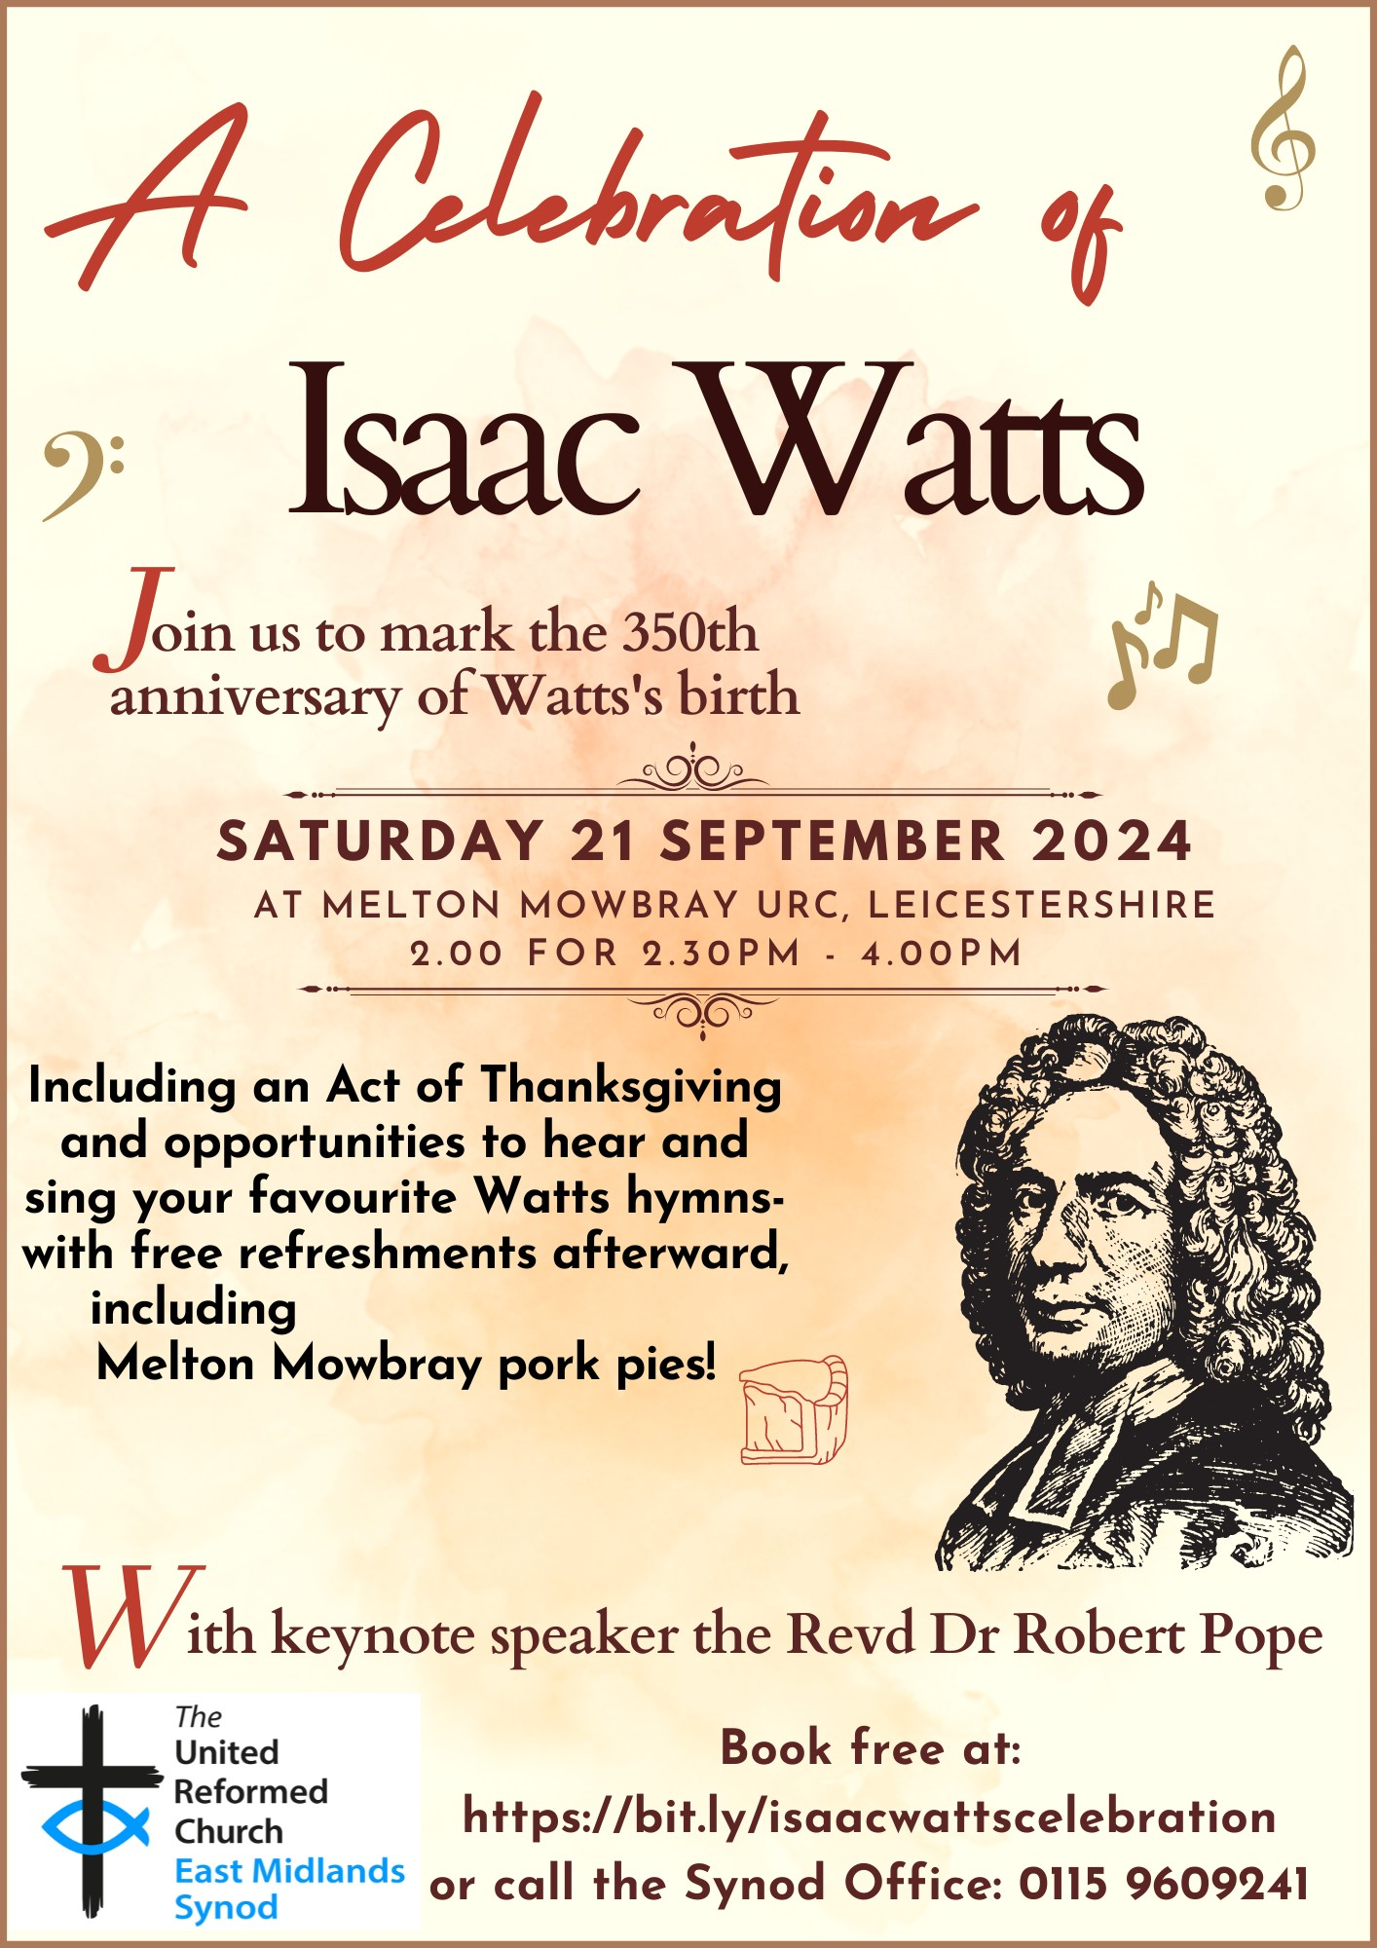

BIG DAY OUT 2025
Following the recent announcement that the next BIG DAY OUT will be on Saturday 17th May 2025 at the Yorkshire Sculpture Park - https://ysp.org.uk/, those who are arranging the event are asking for some willing volunteers to help out on the day.

To help the day run smoothly, they would really appreciate volunteers to greet people as they arrive, give them a programme, a map, let them know where things are happening and to be the happy , welcoming faces of the BIG DAY OUT.

Also, volunteers will be needed to help in the craft room. There will be no preparation necessary, just a willingness to be involved. The team are anticipating that the craft room will be a children and family area and will run from 10.30am - 12noon and 1pm - 2pm.
More information about the day will be circulated in due course, but in the meantime if you could help out on the day, please do get in touch as soon as possible and let us know via the Synod Office by email at office@urcyorkshire.org.uk or telephone on 0113 289 8490. We look forward to hearing from you soon.
With thanks and best wishes
The BIG DAY OUT team

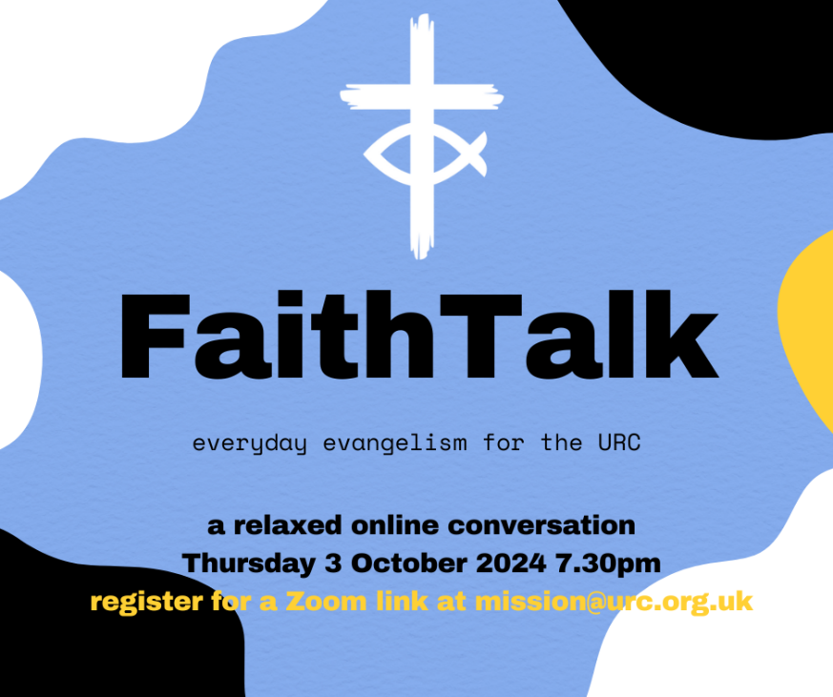
Do you ever wonder how you can be comfortable sharing your faith with others? Are you worried you might be laughed at or dismissed or considered strange? Are you concerned you wouldn’t know what to say if someone did want to know more? Join us for the second FaithTalk, a light-hearted conversation exploring how we talk about our faith.

Thursday 3 October at 7.30pm

To register or to find out more, email mission@urc.org.uk.

Lindsey Brown
Evangelism and Ecumenical Officer | United Reformed Church
86 Tavistock Place, London WC1H 9RT
lindsey.brown@urc.org.uk | 0207 871 7872 | 07494 761894 | www.urc.org.uk

KELD RESOURCE CENTRE
IN PARTNERSHIP WITH LOW ROW WITH KELD URC
NEW FOR 2024: STUDY DAYS

We are delighted to announce that this year’s study days has already begun and we issue a warm invitation to come to any or all of them! We have already welcomed Rev Michael Pearson who led on Five impossible Things to Believe before Christmas! Still to come there is:
Saturday August 17th - Revd. Peter Sinclair: After Sunday: Being Church Seven Days a Week
Thursday September 26th - Ms. Dorothy Thomson: There’s a Sermon in There Somewhere!

The programme will be as follows:

10.30: Arrivals and Coffee
11.00: Session One
12.30: Lunch
13.30: Session Two

15.00: Refreshments and Departure

There will be discussion, sharing, space to ponder …….
All participants are invited to bring a packed lunch. Drinks will be provided. The cost for the day will be £10 per person.
To book your place, please contact Revd David Wood at david.wood4@btinternet.com

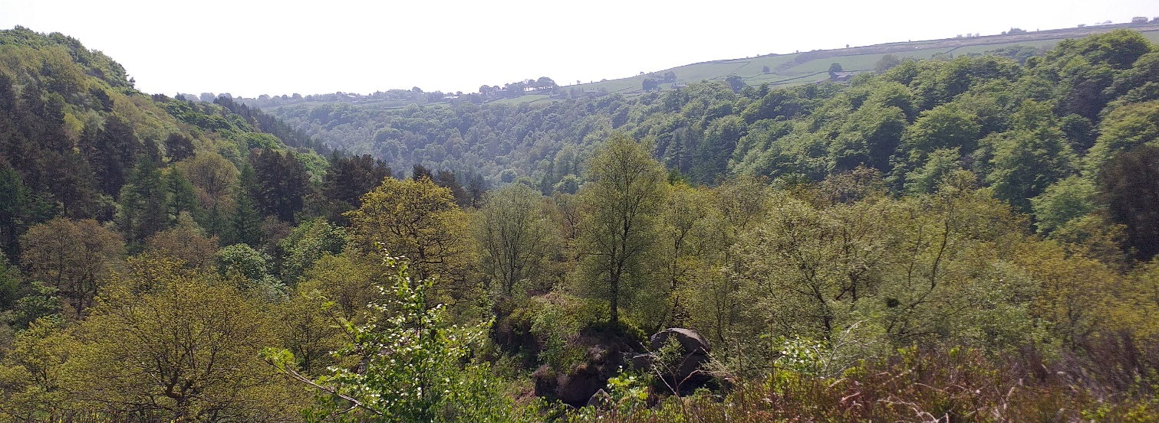
RURAL MISSION
The URC nationally are looking for someone in each Synod to be part of a Rural regional network. Ideally that person should be:
- well connected & able to network locally (lay or ordained)
- involved in rural mission & ministry (not necessarily in an agricultural chaplaincy role)
- keen to support, encourage & resource local rural congregations (eg pass on the summary info notes 4 x per year) as well as represent them at national level
We meet as an ecumenical group for an hour four times per year (Thursdays daytime) online to share encouragement, resources, pray together & also engage with input on a topical rural issue or subject. Emails in between times are kept to a minimum.

Early notice diary dates for 2024-2025: All Thursdays, 11.30am - 12.30pm (zoom link reminder & agenda emailed out one week in advance)

- 10 Oct 24
- 23 Jan 25
- 20 Mar 25
- 12 June 25
- 18 Sept 25
- 20 Nov 25

I know that few of the URC Yorkshire Synod churches are truly rural, but there are many on the urban/rural fringe, so you are interested in being involved in this work please drop me a line at clerk@urcyorkshire.org.uk and I’ll put you in touch with the national URC team.

New small grant available to build links with uniformed groups

This is something that was hidden in the corner of the regular URC News update. I know that many of you have used the Discipleship Development Fund to help with individual Christian journeys and learning, but this snippet has widened the fund’s remit.
In a nutshell, new small grants of £50 or £100 are available for URC local churches from the Discipleship Development Fund to support churches building links with uniformed groups Boys’ Brigade, Girls’ Brigade, Guiding or Scouting. Apply for the new small grant.

URC Advent Pack: Step into the Story
PRE-ORDER NOW
This year’s Advent Packs from the URC Children’s and Youth Work team invite people to ‘step into the story’ and focus on Christmas as everyone’s story with traditions, crafts and recipes from around the world to enrich the celebration.
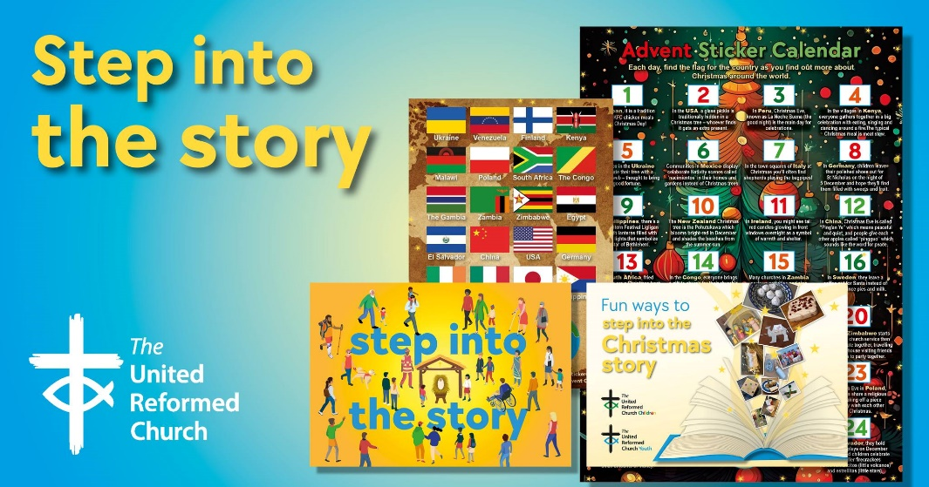
The Advent Packs are a great gift to give to families. They arrive in unsealed, A5 envelopes for churches to add their own material and invitations.
Each pack will contain:
- A giant poster with a ‘countdown to Christmas’, featuring lots of suggestions for things to do, QR codes to the Faith Adventures: Children Together take-home postcards with the Bible story, prayer and activity for the four weeks of Advent
- Four mini-books (which look like presents) with ribbon to hang them up as decorations – each telling part of the Christmas story with playful photo illustrations and a simple prayer
- Four stained-glass windows to colour (linked to the four books)
Once again, the United Reformed Church in Yorkshire is offering 50% these Advent gifts: Just £15 for 10 packs or £32.50 for 25 packs.
Email wilderness@urcyorkshire.org.uk to put in your order TODAY.
Dore & Totley Lunch Club celebrates 50 years
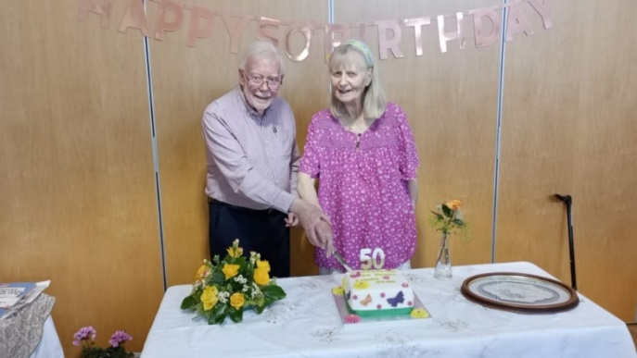
On Thursday, 18th July, present and past friends of Dore & Totley Lunch Club got together to celebrate this great achievement. They were delighted to have Vivien Filleul with them as she was the inspiration behind setting up the club. The formation of the club in 1974 was supported by Sheffield Family and Community Services and volunteers through the local Council of Churches. Also with them was Rev Duncan Wilson, minister of the United Reformed Church at the time, who offered accommodation for the club where it continues today at the church on Totley Brook Road. Duncan can also be credited, along with the former Rev Alan Jockel, for the establishment of Transport 17 community transport which helps so much in getting guests to the club.
Revd Duncan Wilson & Vivien Filleul
A short service of celebration led by Rev Zaidie Orr was followed by drinks and delicious cakes. The Club really appreciates all the support they get, including donations of food from the Co-op and an additional donation from Dore Village Society which helps them provide a Christmas meal.

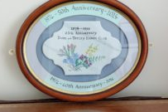
The Club looks forward to a long future serving the elderly, isolated people of S17 but, as ever, they rely on volunteers. Those who already help will say what a pleasure it is when you see people arrive looking forward to meeting together with LOTS to talk about and they leave having thoroughly enjoyed their meal and friendship.
If you think you may be interested in volunteering, please drop in and see us on a Tuesday morning. Alternatively, you can contact Voluntary Action Sheffield.

Roots for Churches
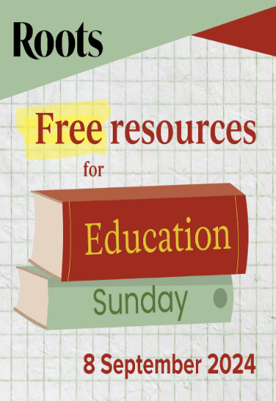
Roots has always offered a wide range of seasonal resources to help churches celebrate special events throughout the year. Until recently many of these have only been available to Roots subscribers, but now selected resources are available as PDF downloads that everyone can access - either free or at low cost. Resources currently available at rootsforchurches.com/seasonal include materials for Education Sunday on 8th September, Harvest, and a space-themed Light Party.
If you already subscribe to Roots, please spread the word to others who may find these resources useful. If you don't already use Roots resources, this is an excellent way to get a feel for their seasonal materials. You can view the latest seasonal downloads here:
https://www.rootsontheweb.com/seasonal
And Roots have an increasing range of podcasts which can be found here: The Roots for Churches podcast | Roots for Churches (podbean.com)
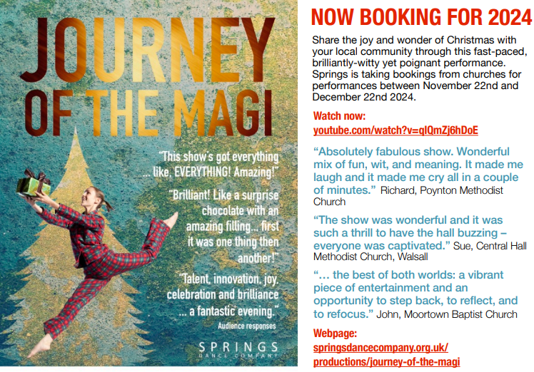

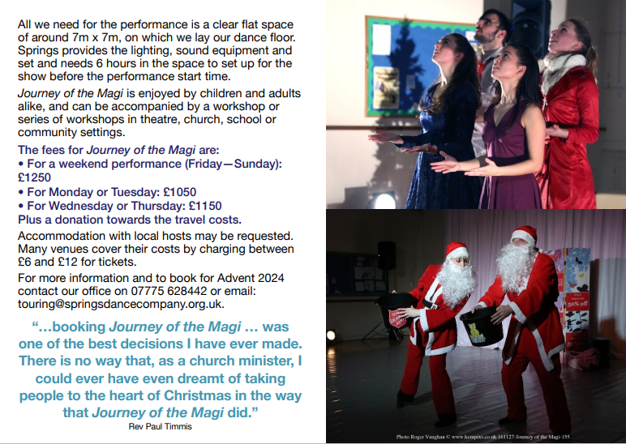
SAFEGUARDING
The Safeguarding team have asked that you are reminded that they are available 24 hours a day, seven days a week and 365 days a year (and even 366 days in Leap Years!!). Details can be found on the Yorkshire website at https://urcyorkshire.org.uk/safeguarding/ and any query, either by phone or by e-mail will be answered within 24 hours.

Safeguarding Training
The Safeguarding team have put together some dates for Intermediate and Advanced Safeguarding Training as well as a few dates offering Refresher Training.
As ever, to book a place, please let Paula Kitson know which course and the date you wish to attend – her e-mail address is paulakitson.1and4@urc.org.uk – and a zoom link will be sent to you shortly before the event where appropriate.

Refresher Training – via zoom
Wednesday 25th September 2024 @ 7pm
Saturday 16th November 2024 @10am
Intermediate Training – via zoom
Monday 16th September @10am
Wednesday 20th November 2024 @1pm

Advanced Training –via zoom, both parts must be completed.
Monday 25th November 2024 @ 1pm
Monday 2nd December 2024 @ 1pm

Finally, there are two more UK wide Safeguarding training sessions left this year, both in the Autumn:

For more information and to book onto these courses, please contact emma.pearce@urc.org.uk

Staying safe in church buildings
The Synod Safeguarding Team is reaching out to all churches across the Synod to signpost you to the following website: https://www.protectuk.police.uk/marauding-terrorist-attack-mta-run-hide-tell
This part of the government website gives specific guidance on what to do if you or your local churches are faced with any instances of threat from people who may wish to cause harm to anyone associated with your church. Whilst we do appreciate that some of the content may look disturbing, please don’t let it frighten you, it is just there to ensure your safety and to know what to do if anything should occur.
We have no information to suggest that anyone or any of our churches are at risk at the moment, but with the instances of civil unrest and public disorder which have occurred in our Synod recently, we wanted you all to be aware of what to do if needed.
If there is any further information that any church may need, please contact Carrie Kaunda, the Yorkshire Safeguarding Officer straight away who will advise and assist you with any issue.
In addition, as there has been an increase in local churches seeking support on building and people safety and in response, some guidance has been added to the URC website. Please feel free to share with your networks in local churches/synods.
https://urc.org.uk/your-church/guidance-support-for-churches-synods/staying-safe-in-church-buildings/

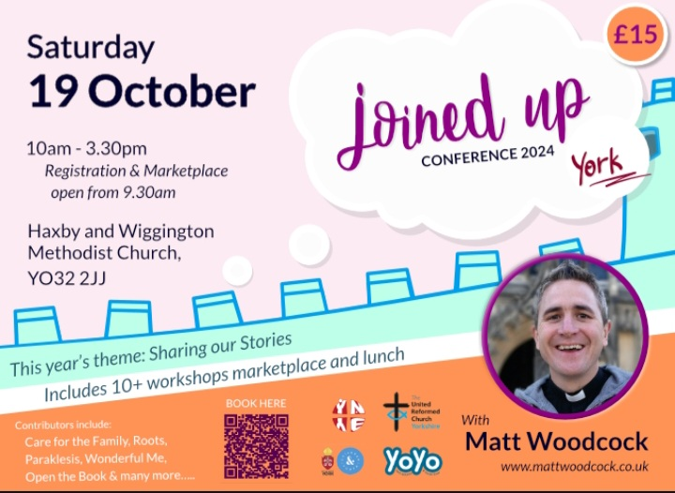
Joined Up Conference, York 2024
Hot off the e-mail is advanced notice of the Joined Up Conference being held in York in October. More details will be following, but we have a little more information through Megan Tillbrook via
megancyp@urcyorkshire.org.uk

We are currently looking for a member of the URC’s Pensions Committee - I have attached the role description and further information can be found here: Jobs - United Reformed Church We would be most grateful if you could circulate this around your network or to people you know who may have the expertise needed.
Not only that, but the Synod is still in need of people to offer their time to various Synod Committees. If you have a call to serve the Synod, please contact either myself at clerk@urcyorkshire.org.uk or our Moderator, Revd Jamie Kissack at moderator@urcyorkshire.org.uk

And Finally
Lay preachers and worship leaders annual conference 19th -21st July 2024
Lifting parables from the page: preaching for today’s Church

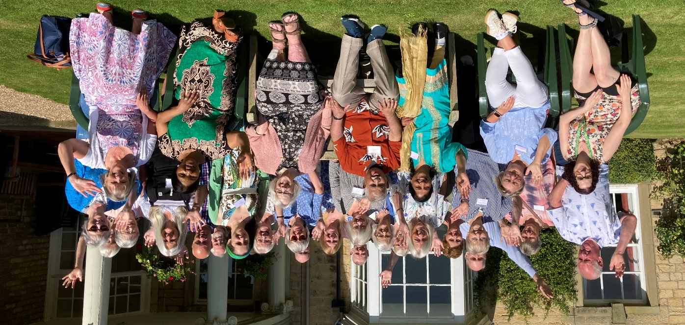
From 19th – 21st July, the Yorkshire Synod’s Lay Preachers and Worship Leaders returned to Wydale Hall for their annual conference, entitled “Lifting Parables from the Page: preaching for today’s church” and it was really valued by all who attended. The lead speaker was Rev Dr Susan Durber and their time there passed all too quickly.
Kath Lonsdale, Ministries Committee Convener, summed up their time together:
“This conference was valued by all who attended. Our speaker, Rev Dr Susan Durber, fed us well spiritually and her sessions were engaging and thought-provoking. It was a time to worship, pray, learn and relax together before returning to our own fellowships with fresh ideas to share the parables in new ways.”

If you want to attend next year’s Fourth Yorkshire Lay Preachers and Worship Leaders Conference at Wydale Hall, the dates will be from the 25th to the 27th July 2025 and bookings will be taken early next year.

If you have a good news story from your part of the Synod, drop me a line at clerk@urcyorkshire.org.uk and I’ll make sure it hits the back page!!

You can also keep an eye on all our social media platforms for news; on the website at Home - URC Yorkshire Synod, the Facebook pages at United Reformed Church in Yorkshire - Home | Facebook and Wilderness URC Yorkshire - Home | Facebook, the YouTube page at URC Yorkshire - YouTube and the Twitter page at URC in Yorkshire (@URCYorkshire) / Twitter.

