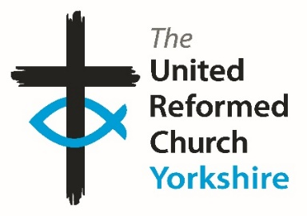**Yorkshire Synod Briefing**

**Number 136**

**29th August 2024**

|  |
| --- |
|  |

**Autumn plans**

Well that was the summer. The seasons change and this coming season sees lots of changes in the Synod. As you will have seen in the last issue, we we have welcomed Revs Joe Amoah and Simon Cross into the Synod and we will be welcoming Helen Snashall into the Huddersfield CRCW role in September. The start of September also brings new ministers into some of our URC/Methodist Local Ecumenical Partnerships, and I hope to be able to bring you news of who begins in those roles in the next issue. The Synod also marked the work of Alan and Janet Kendall who have stepped down as Pilots officers for Yorkshire, as well as celebrating the artwork being created at St James’ in Sheffield.

This Autumn seems to be gearing itself up to being another busy one. I know that many church’s calendars begin to fill with events and meetings from the start of September, and the Synod is no different as you’ll see below and on the website. The autumn is also a time for the Synod to come together in fellowship at one of its two biannual meetings; the next one being on 12th October at Christchurch Ilkley. More details will be in the next couple of issues, and it goes without saying that they offer a very warm welcome to those who will be attending.

Not only that, preparations are being made across the Synod for events throughout Autumn, dare I say Christmas and even into 2025. All this shows the depth and breadth of activity within the churches in the Yorkshire Synod and it is really good to hear about it. What would be even better is to be able to get the word out about all your events – either those that have happened or those that are planned. All you need to do is get in touch with me at the Synod office. It really is good to share your stories around Synod and beyond.

**So, please let me know what you have been up to in your churches and the plans you have for the next few weeks by dropping me a line at** [**clerk@urcyorkshire.org.uk**](mailto:clerk@urcyorkshire.org.uk) **and I’ll showcase it in the next edition, due out on Thursday 12th September.**

**Thank you and God Bless,**

Tim Crossley

**Synod Clerk**

**A Yorkshire Thank You!**

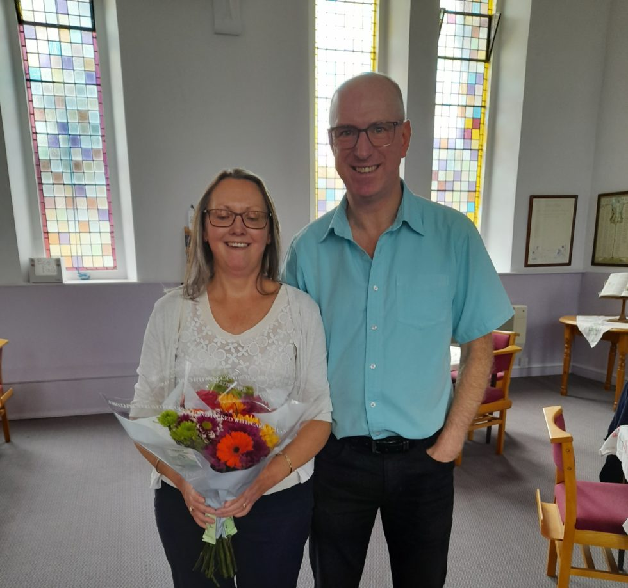Earlier this year, Alan and Janet Kendall stepped down as the Pilots officers for the Yorkshire Synod, and Alan also stepped down from the Yorkshire Children & Youth Work Committee. Their service to the children and young people of the synod has spanned across 10 years (and more…)! At the end of July, Megan Tillbrook, the Synod’s Children & Young People Development Practitioner, attended Heath URC to present the committed couple to a gift from the synod to thank them for their dedication and efforts over the years. During the service, Megan and Karen Bridge (former PILOTS captain at Lightcliffe LEP), shared some stories of their ministry with Alan and Janet. For more stories and memories of Alan and Janet’s time working with the young people of Yorkshire Synod as well as in the national framework see <https://urcyorkshire.org.uk/thank-you-to-alan-janet-kendall/> on the Yorkshire website.

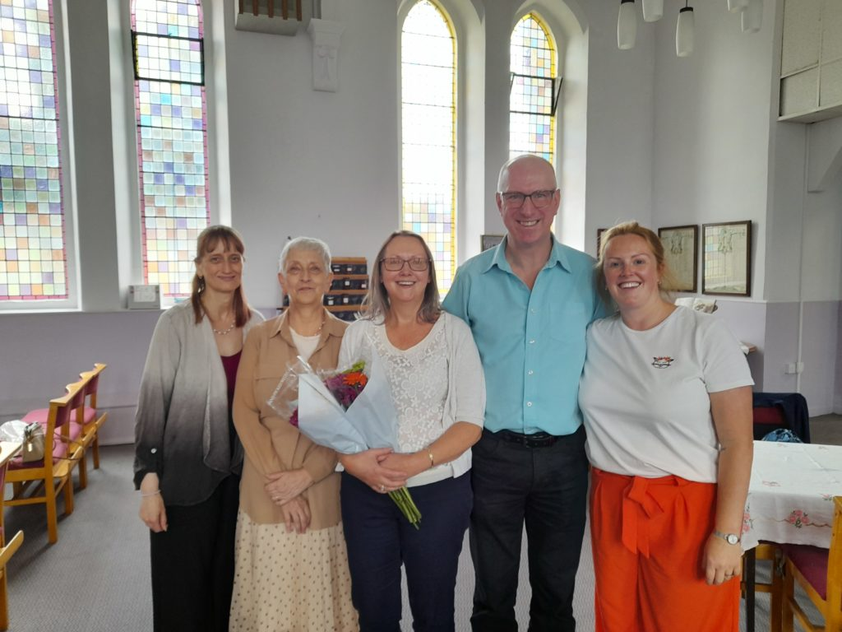

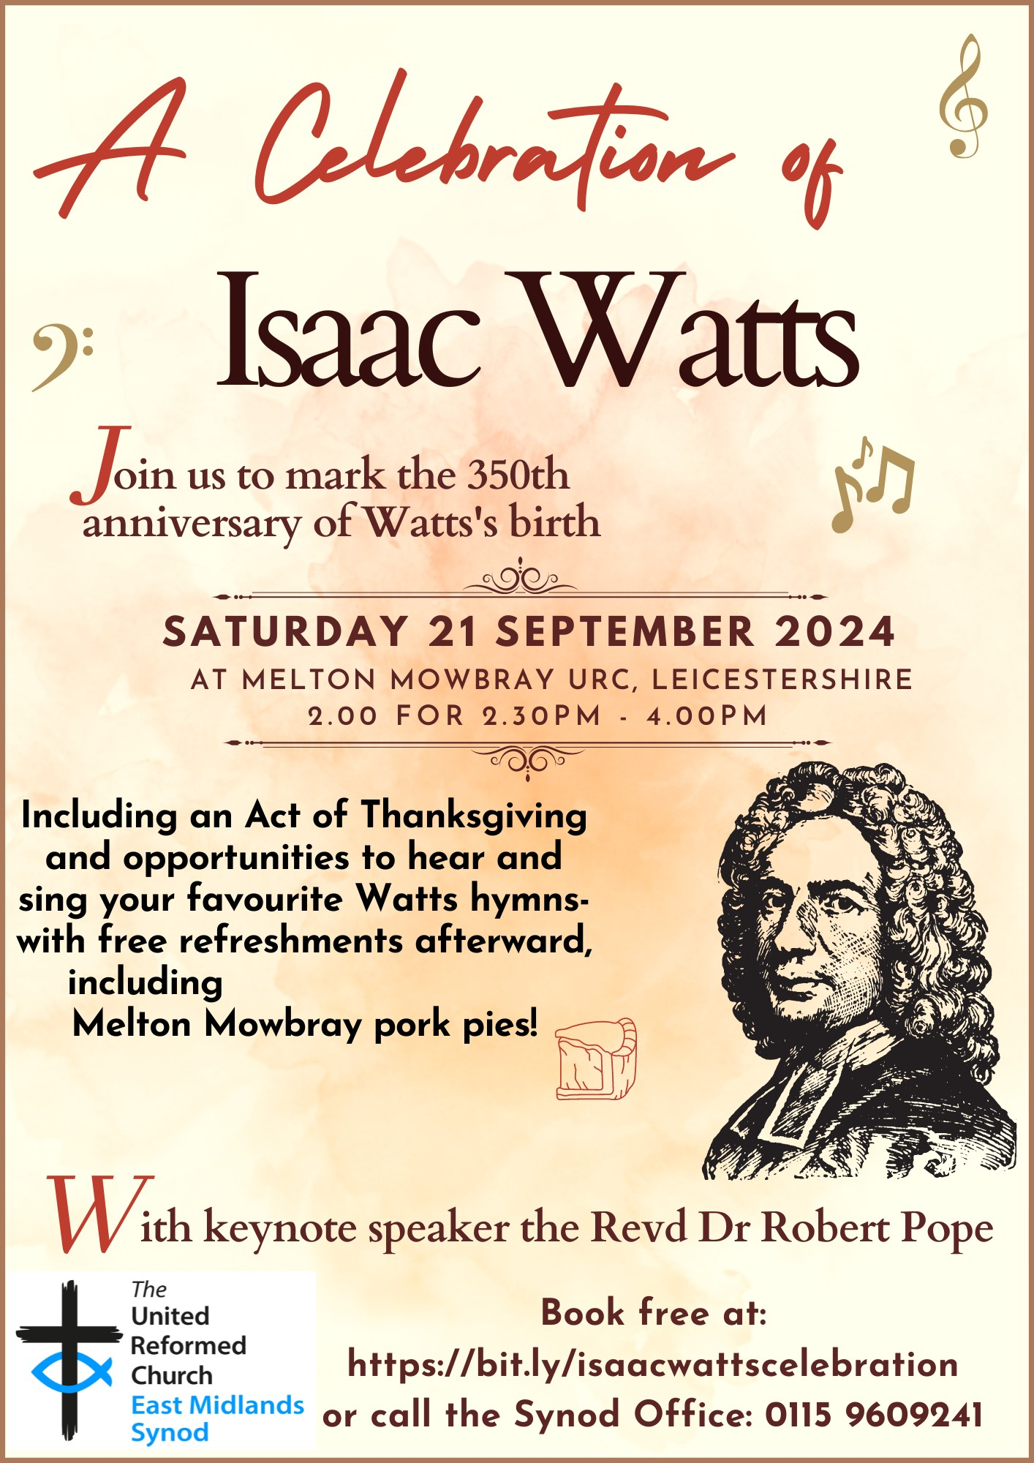

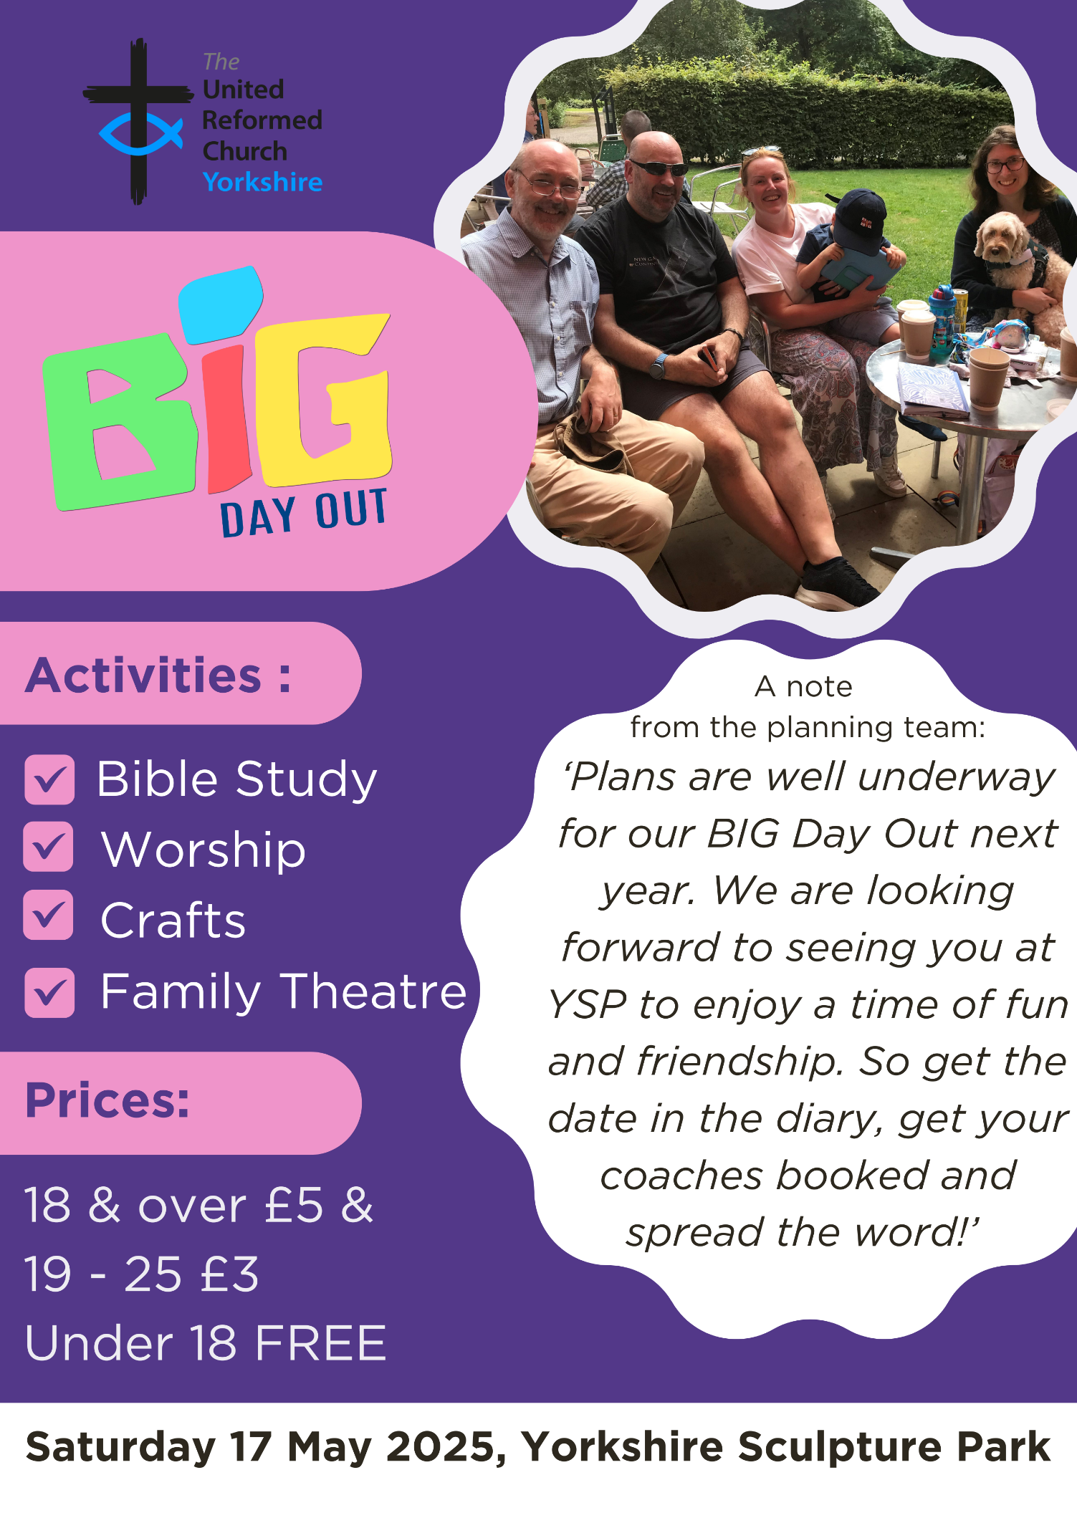**BIG DAY OUT 2025**

Following the recent announcement that the next **BIG DAY OUT** will be on **Saturday 17th May 2025 at the Yorkshire Sculpture Park** - <https://ysp.org.uk/>**,** those who are arranging the event are asking for some willing volunteers to help out on the day.

To help the day run smoothly, they would really appreciate volunteers to greet people as they arrive, give them a programme, a map, let them know where things are happening and to be the happy, welcoming faces of the **BIG DAY OUT**.

Also, volunteers will be needed to help in the craft room. There will be no preparation necessary, just a willingness to be involved. The team are anticipating that the craft room will be a children and family area and will run from 10.30am - 12noon and 1pm - 2pm.

More information about the day will be circulated in due course, but in the meantime if you could help out on the day, please do get in touch as soon as possible and let us know via the Synod Office by email at [office@urcyorkshire.org.uk](mailto:office@urcyorkshire.org.uk) or telephone on 0113 289 8490. We look forward to hearing from you soon.

With thanks and best wishes

The **BIG DAY OUT** team

Do you ever wonder how you can be comfortable sharing your faith with others?  Are you worried you might be laughed at or dismissed or considered strange?  Are you concerned you wouldn’t know what to say if someone did want to know more? Join us for the second FaithTalk, a light-hearted conversation exploring how we talk about our faith.

**Thursday 3 October at 7.30pm**

**To register or to find out more, email** [**mission@urc.org.uk**](mailto:mission@urc.org.uk).

**Lindsey Brown**

**Evangelism and Ecumenical Officer | United Reformed Church**

86 Tavistock Place, London WC1H 9RT

[lindsey.brown@urc.org.uk](mailto:lindsey.brown@urc.org.uk) | 0207 871 7872 |  07494 761894 | [www.urc.org.uk](http://www.urc.org.uk/)

**KELD RESOURCE CENTRE**

**IN PARTNERSHIP WITH LOW ROW WITH KELD URC**

**NEW FOR 2024: STUDY DAYS**



We are delighted to announce that this year’s study days has already begun and we issue a warm invitation to come to any or all of them! We have already welcomed Rev Michael Pearson who led on **Five impossible Things to Believe before Christmas!** and Revd. Peter Sinclair on **After Sunday: Being Church Seven Days a Week.** The final study day is to be held on Thursday September 26th when Ms. Dorothy Thomson will lead on **There’s a Sermon in There Somewhere!**

The programme will be as follows:

10.30: Arrivals and Coffee

11.00: Session One

12.30: Lunch

13.30: Session Two

15.00: Refreshments and Departure

There will be discussion, sharing, space to ponder …….

All participants are invited to bring a packed lunch. Drinks will be provided. The cost for the day will be £10 per person.

To book your place, please contact Revd David Wood at [**david.wood4@btinternet.com**](mailto:david.wood4@btinternet.com)

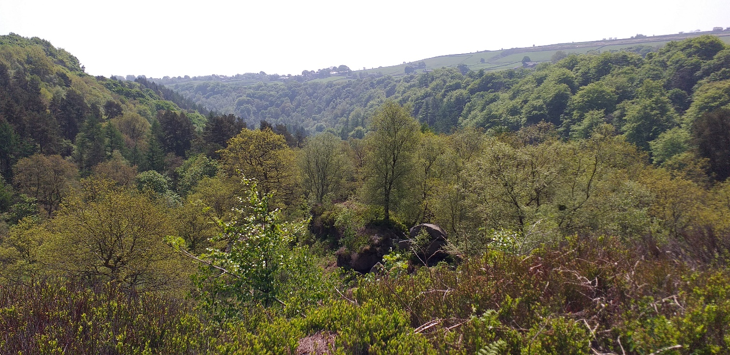**RURAL MISSION**

The URC nationally are looking for someone in each Synod to be part of a **Rural regional network.** Ideally that person should be:

* well connected & able to network locally (lay or ordained)
* involved in rural mission & ministry (not necessarily in an agricultural chaplaincy role)
* keen to support, encourage & resource local rural congregations (eg pass on the summary info notes 4 x per year) as well as represent them at national level

We meet as an ecumenical group for an hour four times per year (Thursdays daytime) online to share encouragement, resources, pray together & also engage with input on a topical rural issue or subject. Emails in between times are kept to a minimum.

**Early notice diary dates for 2024-2025:** All Thursdays, 11.30am - 12.30pm (zoom link reminder & agenda emailed out one week in advance)

* 10 Oct 24
* 23 Jan 25
* 20 Mar 25
* 12 June 25
* 18 Sept 25
* 20 Nov 25

I know that few of the URC Yorkshire Synod churches are truly rural, but there are many on the urban/rural fringe, so you are interested in being involved in this work please drop me a line at [clerk@urcyorkshire.org.uk](mailto:clerk@urcyorkshire.org.uk) and I’ll put you in touch with the national URC team.

|  |
| --- |
| **New small grant available to build links with uniformed groups** |

|  |
| --- |
| This is something that was hidden in the corner of the regular URC News update. I know that many of you have used the Discipleship Development Fund to help with individual Christian journeys and learning, but this snippet has widened the fund’s remit.  In a nutshell, new small grants of £50 or £100 are available for URC local churches from the Discipleship Development Fund to support churches building links with uniformed groups Boys’ Brigade, Girls’ Brigade, Guiding or Scouting. [**Apply for the new small grant**](https://urc-news.org.uk/c/AQi9nAcQ_LvOARjcs9GXASD-k9EnDbaVfdErVYuuo7UmxkoopNcQj3YhT5BB09zi9kygfCE). |

**URC Advent Pack: Step into the Story**

**PRE-ORDER NOW**

This year’s Advent Packs from the URC Children’s and Youth Work team invite people to ‘step into the story’ and focus on Christmas as everyone’s story with traditions, crafts and recipes from around the world to enrich the celebration.

The Advent Packs are a great gift to give to families. They arrive in unsealed, A5 envelopes for churches to add their own material and invitations.

Each pack will contain:

* A giant poster with a ‘countdown to Christmas’, featuring lots of suggestions for things to do, QR codes to the Faith Adventures: Children Together take-home postcards with the Bible story, prayer and activity for the four weeks of Advent
* Four mini-books (which look like presents) with ribbon to hang them up as decorations – each telling part of the Christmas story with playful photo illustrations and a simple prayer
* Four stained-glass windows to colour (linked to the four books)

Once again, the [United Reformed Church in Yorkshire](https://www.facebook.com/urcyorkshire?__cft__%5b0%5d=AZXu9_tc5idvH9kuQqyagS5qHt1U_3PMPQvEs_a1XCkqjz634WKYuL3FhmJdmryXmys1DGSScbzdTpCHBCCpFIuYEkdo5tsPfAqqCtkqEU_RtcvLHY2v3oMfoTeHqU9W2ICBoMWXnQfazpbb-rhU2sSImipF_cD2Ce_q0bV8qsGA8xbtu8mXDGEsXj0xQe7fdtxFL7bp4soPRlDq6SlsnfBj&__tn__=-%5dK-R) is offering 50% these Advent gifts: Just £15 for 10 packs or £32.50 for 25 packs.

Email [wilderness@urcyorkshire.org.uk](mailto:wilderness@urcyorkshire.org.uk) to put in your order TODAY.

**SAFEGUARDING**

**The Safeguarding team have asked that you are reminded that they are available 24 hours a day, seven days a week and 365 days a year (and even 366 days in Leap Years!!). Details can be found on the Yorkshire website at** [**https://urcyorkshire.org.uk/safeguarding/**](https://urcyorkshire.org.uk/safeguarding/) **and any query, either by phone or by e-mail will be answered within 24 hours.**

**Safeguarding Training**

The Safeguarding team have put together some dates for Intermediate and Advanced Safeguarding Training as well as a few dates offering Refresher Training.

As ever, to **book a place, please let Paula Kitson know which course and the date you wish to attend – her e-mail address is** [**paulakitson.1and4@urc.org.uk**](mailto:paulakitson.1and4@urc.org.uk) **– and a zoom link will be sent to you shortly before the event where appropriate.**

**Refresher Training – via zoom**

**Wednesday 25th September 2024 @ 7pm**

**Saturday 16th November 2024 @10am**

**Intermediate Training – via zoom**

**Monday 16th September @10am**

**Wednesday 20th November 2024 @1pm**

**Advanced Training –via zoom, both parts must be completed.**

**Monday 25th November 2024 @ 1pm**

**Monday 2nd December 2024 @ 1pm**

Finally, there are two more UK wide Safeguarding training sessions left this year, both in the Autumn:

For more information and to book onto these courses, please contact [emma.pearce@urc.org.uk](mailto:emma.pearce@urc.org.uk)

**Staying safe in church buildings**

The Synod Safeguarding Team is reaching out to all churches across the Synod to signpost you to the following website: [**https://www.protectuk.police.uk/marauding-terrorist-attack-mta-run-hide-tell**](https://www.protectuk.police.uk/marauding-terrorist-attack-mta-run-hide-tell)

This part of the government website gives specific guidance on what to do if you or your local churches are faced with any instances of threat from people who may wish to cause harm to anyone associated with your church. Whilst we do appreciate that some of the content may look disturbing, please don’t let it frighten you, it is just there to ensure your safety and to know what to do if anything should occur.

We have no information to suggest that anyone or any of our churches are at risk at the moment, but with the instances of civil unrest and public disorder which have occurred in our Synod recently, we wanted you all to be aware of what to do if needed.

If there is any further information that any church may need, please contact your Carrie Kaunda, the Yorkshire Safeguarding Officer straight away who will advise and assist you with any issue.

In addition, as there has been an increase in local churches seeking support on building and people safety and in response, some guidance has been added to the URC website. Please feel free to share with your networks in local churches/synods.

[**https://urc.org.uk/your-church/guidance-support-for-churches-synods/staying-safe-in-church-buildings/**](https://urc.org.uk/your-church/guidance-support-for-churches-synods/staying-safe-in-church-buildings/)

**Joined Up Conference, York 2024**

Hot off the e-mail is advanced notice of the **Joined Up** Conference being held in York in October. More details will be following, but we have a little more information through Megan Tillbrook via

[megancyp@urcyorkshire.org.uk](mailto:megancyp@urcyorkshire.org.uk)

We are currently looking for a member of the URC’s Pensions Committee - I have attached the role description and further information can be found here: [Jobs - United Reformed Church](https://urc.org.uk/jobs/#urcvol) We would be most grateful if you could circulate this around your network or to people you know who may have the expertise needed.

Not only that, but the Synod is still in need of people to offer their time to various Synod Committees. If you have a call to serve the Synod, please contact either myself at [clerk@urcyorkshire.org.uk](mailto:clerk@urcyorkshire.org.uk) or our Moderator, Revd Jamie Kissack at [moderator@urcyorkshire.org.uk](mailto:moderator@urcyorkshire.org.uk)

**And Finally**

**Creating artwork together at St James URC, Sheffield**

Rev Zaidie Orr, Minister in the Sheffield Team, tells of the Friendship Group at St James URC and how they have worked together, to make something beautiful in memory of loved ones…..

*“We meet at St James United Reformed Church, in Pitsmoor for our Friendship Group every Tuesday, sometimes we bring our knitting or crochet work, sometimes we do a little gentle exercise or chairobics sometimes we swap books, sometimes we dance and sing but we ALWAYS EAT.*

*The Team Ministry had set up a project where each church within the Team was encouraged to choose a parable and then design a piece of art / craft to reflect the story of the parable. Whenever, we gather to eat, our spread always reminded us of the Great Banquet in the Gospel of Luke –‘Blessed is the one who will eat at the feast in the kingdom of God.’*

*We have friends in our group who are in their mid 50’s to almost 90’s, so we needed something that we could all join together. As we are so bad at threading needles, that meant that we could not do a patchwork or collage, as we have done in the past. We wanted to do something that could be displayed in the church and an activity where we could gather around and chat as we worked. The idea of constructing a Mosaic came up.*

*We wanted to make the food which we shared on Tuesdays. We do not usually have pizza and cake every week, but sometimes, someone will bring them to share for a birthday and special occasions. We started by making a list of the food which we usually share as the basis of the design. None of us had done mosaic work before, so it was a learning curve for us all. We each worked in different ways and we enjoyed working and watching the project come together. We have kept a scrapbook as a record of how we completed the task. We did not make the deadline which the Team Ministry had set for the display of the projects. However, we continued to work and we have now completed the project and we share it in memory of our dear Sisters Mary, Josie and Selem. God bless – Zaidie”*

**If you have a good news story from your part of the Synod, drop me a line at** [**clerk@urcyorkshire.org.uk**](mailto:clerk@urcyorkshire.org.uk) **and I’ll make sure it hits the back page!!**

You can also keep an eye on all our social media platforms for news; on the website at [**Home - URC Yorkshire Synod**](https://urcyorkshire.org.uk/), the Facebook pages at [**United Reformed Church in Yorkshire - Home | Facebook**](https://www.facebook.com/urcyorkshire) and [**Wilderness URC Yorkshire - Home | Facebook**](https://www.facebook.com/wildernessyorkshireurc/), the YouTube page at [**URC Yorkshire - YouTube**](https://www.youtube.com/channel/UCSAly5eC6tBlmY52dLxrylg) and the Twitter page at [**URC in Yorkshire (@URCYorkshire) / Twitter**](https://twitter.com/URCYorkshire).