**Yorkshire Synod Briefing**

**Number 144**

**19th December 2024**

|  |
| --- |
|  |

**A VERY HAPPY CHRISTMAS TO YOU ALL FROM US AT THE SYNOD OFFICE**

This is the final Briefing of the year and finds us all preparing to celebrate the coming of our Lord and Saviour into this world in our own special way. Over the next three or four days the work of 2024 will draw to a close and on Monday afternoon the Synod Office will close until Thursday 2nd January. The phones will be monitored, as will the e-mails, but the Synod staff will be doing what many of us will be doing as we see our families and friends over the Christmas period. I hope that we will thoroughly enjoy all that these social activities bring, be it in our churches, or in our local communities, at home or where we elect to spend the holiday, but please say a prayer and spend some time thinking about those who have loved lost ones, recently or otherwise, who may not have that family and friendship support many of us take for granted or whose occupations mean that they are working at those times we are relaxing and celebrating.

This past fortnight I have been encouraged by the number of responses to my request for feedback on the briefing, and you will also see that I have received details of what some of our churches are doing over Christmas. Please keep that feedback coming in and please send in stories of how your churches celebrated Christmas and the New Year.

**If you have any news of welcoming people into Church, stories of celebration and hope or even notices of future events, especially during the Advent, Christmas and New Year periods, please let me know by dropping me a line at** [**clerk@urcyorkshire.org.uk**](mailto:clerk@urcyorkshire.org.uk) **and I’ll showcase it in the next edition, due out on Thursday 9th January 2025.**

**Thank you, God Bless and I hope to see you all in 2025,**

Tim Crossley

**If Food Be the Gift of Love…Serve On!**

‘Wayfarer is an initiative of **Emmanuel St John’s** church in **Scarborough**, aimed at taking the church out into the community. After starting small as a winter Warm Space, it has grown into an important part of the church’s – and the community’s – life’

After a brief Warm Space venture during the first ‘Covid’ period back in 2020-21 and its lack of presence, Sharon and Ian Hall were called in prayer to Jesus’ instruction to ‘Feed my sheep’. They knew that this was God nudging them, so they sought and obtained Emmanuel St John’s agreement to start it up again, and this time with meals provided, not tea/coffee and biccies!

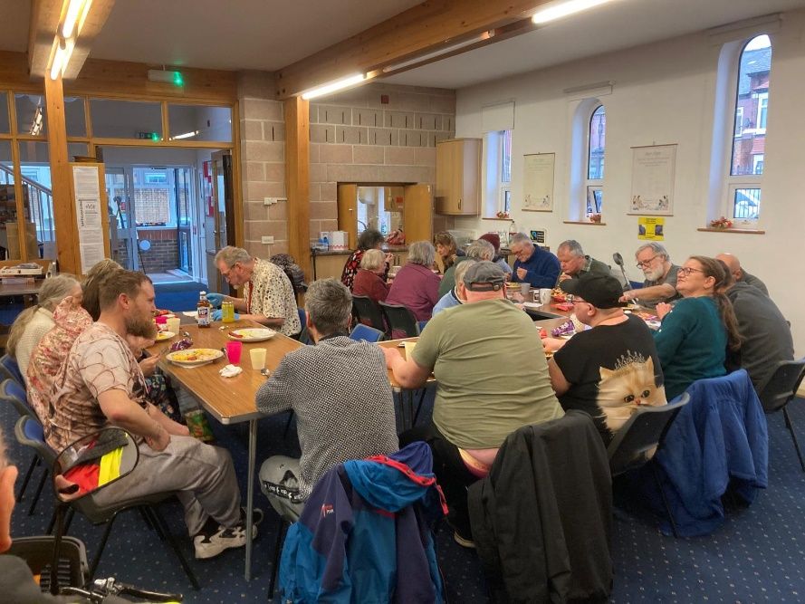For over three months they have had at least twenty present (sometimes those include our congregation’s support at ESJ). Entirely on faith they have provided food and drinks, and a donations dish left out has in the main financed the following week’s shopping for WAYFARER! They never cease to be ‘wowed’ by the windows of heaven’s blessings making this venture possible.

By joining three long tables they often make a ‘family meal’ of it! Smaller tables round the room have newspapers and activities (of which people have their favourites): some were provided by the members of our neighbouring church, St Saviour’s. A member of our own congregation has provided rhubarb crumble from their allotment, plus biscuits from her son’s employment. An initial stranger, now familiar, has weekly provided cutlery from her hunts in charity shops!

Table and chair lifting, washing up, and my sister’s skills with food all come together and have become a recognisable support framework for the work being done through WAYFARER. A member of church has provided (ad hoc) a surprise pudding of strawberries and cream, so the dessert we’d prepared went in the freezer for the following week!

Homeless people (two with their dogs at times), all are welcome, and there is no US and THEM, we are all God’s sheep! Some have hard circumstances, but a listening ear and a sandwich to take home at the end brings them a brief respite. A gentleman who had attended recently said as he was being given a lift home “I’ve got a really warm feeling in the bottom of my stomach – thank you for all your hospitality”.

Sharon has shared this prayer and invites us to join with her: “God, we pray you will fan that ‘feeling’ into a flame for that gent, and may each visitor find you present at Wayfarer, in each empty chair!

Fill the room and all hearts, Father… AMEN.”

**STAINBECK URC: A STORY FROM 2024**

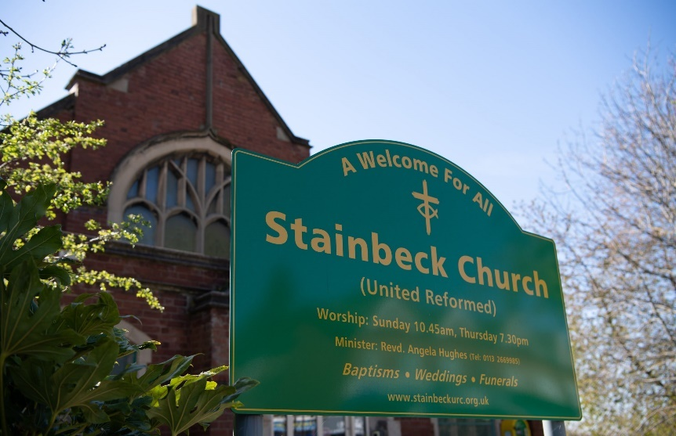Revd Angela Hughes has been in touch with an incredible tale of mission, partnership and invitation from the church at Stainbeck. Although Stainbeck URC is not the biggest of our churches, it has one of the biggest hearts in Synod, so have a read and be inspired by Stainbeck’s story.

“The land at the edge of Stainbeck’s car park and round the back of the church buildings has been unused for years and for quite a while some of us had a dream that we could use this land and re-order it to be an asset for the church. But sadly, resources of money and people held us back and as a consequence it remained overgrown, a prime spot for fly tipping and a blot on the landscape.

**But no longer! This is a good story – and good stories need to be shared!**

The change began before Covid with **Team Beckhills,** the residents**’** group from our local estate. This group, with the support of **Leeds Citizens** and **Stainbeck Church**, successfully secured support from the Council for new steps and lighting for the estate. It was a great job and well done. [**https://www.citizensuk.org**](https://www.citizensuk.org)

What next? Well following the pandemic *‘litter’* was the main cry and clean ups began (yet again!) … and Team Beckhills morphed into **My Community United,** a new broader group of residents wanting to tidy up the area.

Alongside this, **InterACT Church and Community Partnership (**[**https://interact.uk.net/**](https://interact.uk.net/)**)** obtained an **ABCD (Asset Based Community Development) Grant. InterACT** is a CIO (Charitable Incorporated Organisation), a partnership of four local churches.

These two things came together when one of the Beckhill residents became increasingly involved with a local **Incredible Edible** Group [**https://www.incredibleedible.org.uk**](https://www.incredibleedible.org.uk) based in Meanwood.

**Incredible Edible’s** vision is to create kind, confident and connected communities through the power of food, with an amazing strapline line ***“If you eat, you’re in!”***

As we talked about community assets, about what resources we already had in the area, this resident, now backed by others, was pleased to talk more positively about what is POSSIBLE and not what’s wrong.

And so, in no time at all, many local residents have been the driving force behind setting up the garden, using their knowledge and skills and enthusiasm to get things going. Amazing!

This group has used funding that we hold as part of our ABCD work that residents can *“apply*” for, as well as funding from other sources. They have bought the various planters, seeds and soil. We’ve received lots of freebies (InterACT has many partnership connections), mostly in the form of labour and wood chippings, but more importantly, the activity has connected with other people on and off the estate who want to be part of this initiative. As they work, people walk by, strike up conversations, harvest food and share stories.

The latest additions are a Vegetable Cupboard donated by **‘Feed Leeds’**. ( [**https://feedleeds.org**](https://feedleeds.org) ) and some solid digging and hard physical work from the **‘Goodgym’** Group in Leeds. [**https://www.goodgym.org/**](https://www.goodgym.org/)

**It’s not a forgotten patch any more!**

Work on the garden continues almost daily – different people taking on different tasks such as watering on a regular basis. Also, **community action days** have been a great way to bring larger groups of people together. These have been held in school holidays to allow children to get involved. There are lots of budding gardeners and diggers out there!

But that is not all as **Litter Free Leeds** have been involved too. They describe themselves in this way: ***Litter Free Leeds*** *brings communities, groups and individuals together to be good role models of what can be achieved when we all work together* **(**[**https://litterfreeleeds.co.uk**](https://litterfreeleeds.co.uk)**).**

So, whilst some dig and plant, some walk the estate and pick litter. As a church **Stainbeck,** with its local partner churches **(InterACT),** thank, chat, encourage, share and invite. And I reflect that as churches, here for the long-term, knowing our area, good at listening, we are in an ideal situation to spot where the energy lies and link people together.”

**“We can do so much more together. May we be open to it.”**

*Angela: December 2024*

**Dementia Champions**

As a small, mostly elderly, congregation, dementia is a real topic of concern for **Bingley URC** and they felt that they might benefit from some up-to-date knowledge on the subject.

They approached Dementia Friendly Keighley (who have a unit in the main shopping centre) and found out that they have ‘Dementia Champions’ who will go out and give talks to groups, including churches. One of these champions is coming to **Bingley URC** on Thursday 9th January at 10.30am. It is an open meeting and we have asked people to bring friends. We have also told the other churches about it and invited them to join us. For directions to Bingley URC, visit their website at <https://bingleyurc.org/> where you will also find what this friendly and vibrant church is doing over Christmas and into 2025.



**Line Management Training 2025**

The HR department at URC Church House are once again running their Line Management course. Having done this course, I heartily recommend that those of you who are either line managing or are thinking about employing people in your churches sign up to do the course. As well as the hour-long sessions you will be able to link into other churches who are doing just what your church is doing as well as drawing on the vast experience of the Church House staff. Although this course is for anyone working within the URC with direct line management responsibility its scope is a bit wider, so first read the URC’s [Essential line management](https://urc.org.uk/your-church/guidance-support-for-churches-synods/employment-guidance/essential-line-management/) on the website then sign up for the course.

Each session is from 10.00am to 11:15am on the dates below and covers the several topics

*Date Topic*

*Thursday 27 February The Basics*

*Thursday 27 March Managing Performance*

*Thursday 24 April Appraisals*

*Thursday 15 May Managing Attendance*

*Thursday 26 June Flexible Working*

*Thursday 24 July Recruitment*

*Thursday 25 September Equalities*

*Thursday 16 October Policies – Capability*

*Thursday 20 November Policies – Disciplinary and Grievance*

To reserve a place on our training sessions, please email [deepti.upadhyaya@urc.org.uk](mailto:deepti.upadhyaya@urc.org.uk) with your full name, Email, Synod/Church name and Role/job title.

It costs nothing, apart from your time each month, but it’s value is beyond measure.

For more information visit: <https://urc.org.uk/your-church/guidance-support-for-churches-synods/employment-guidance/training-events-and-courses/>

**Envisioning Worship Conference**

For everyone interested in how worship affects mission

**Theme: What if God is Child?**

**Dates:** 11am on 8th March – 3.30pm on 9th March 2025

**Venue:** Luther King Centre, Manchester

**Costs:** Residential : £200, Non-residential : £120

**Who is it for?** Anyone intrigued by the idea of the childlikeness of God – in the midst of the smallest experiences; apparently weak but disruptive; curious, playful and imaginative; raging and dancing – and what this might mean for worship and mission. Anyone drawn to Bible explorations, creative workshops and more – and who is interested in imagining things differently.

**For more information** and to register, visit –

[**https://northerncollege.co.uk/ewc-march-2025/**](https://northerncollege.co.uk/ewc-march-2025/)

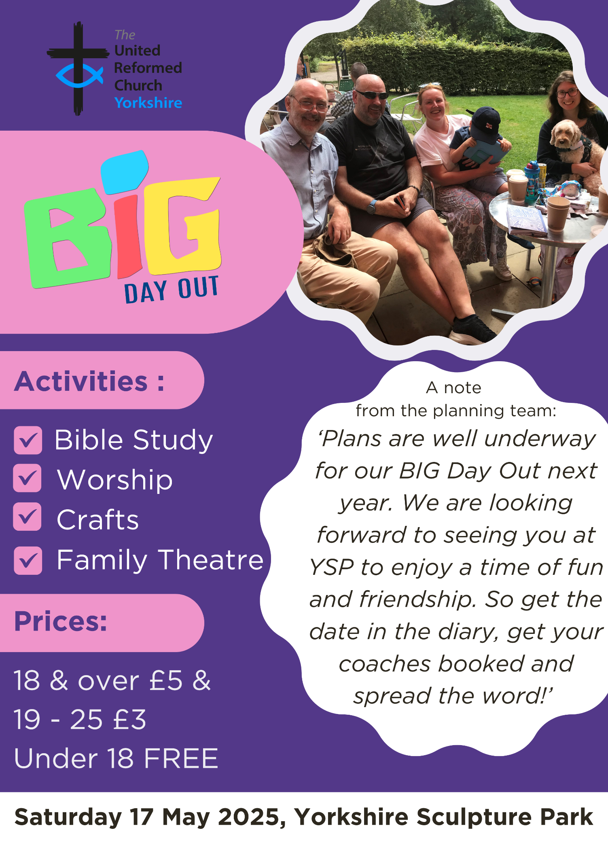**BIG DAY OUT 2025**

**Denholme Trees**

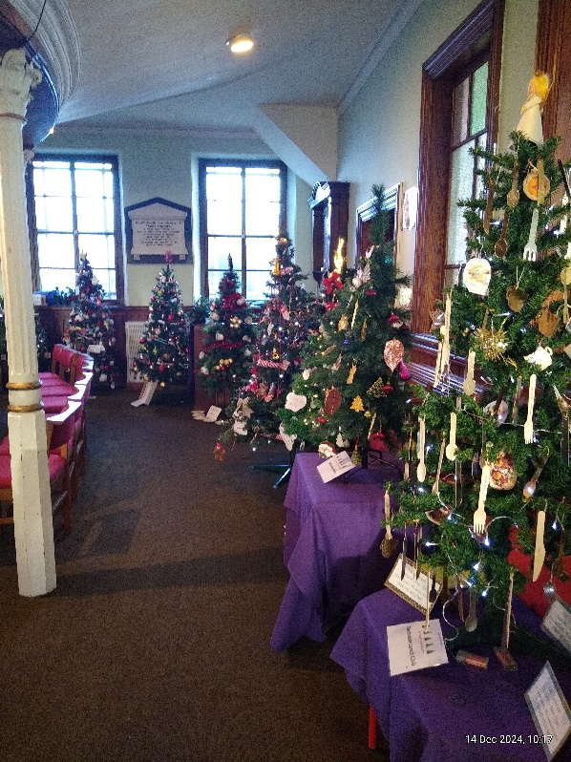Denholme Shared Church held its annual Christmas Tree Festival this past weekend (14th & 15th December). The picture shows just a few of the 22 Christmas trees created by local groups from the village. It was a really enjoyable weekend with lots of visitors and was aimed at bringing many of groups, such as the Scouts, the Crafting Group, the local Primary School and the various church organisations which meet in Denholme together in one place at the same time.

I’m told that the trees will be there for a while yet and if you want to join the congregation at Denholme and enjoy the displays their services in the next week are on Sunday 22nd December at 10:30am for Morning Worship, Tuesday 24th December at 4:00pm for a Christingle Service and again on Christmas Eve at 9:30pm for a Bethlehem Midnight Communion.

For more details of Denholme Shared Church’s actoivities please visit <https://www.denholmechurch.org.uk/>

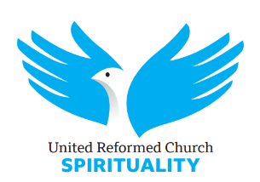 **Reflecting on Epiphany**

**6th January 2025 to 10th January 2025**

**Venue: Online – free of charge**

**Book via the URC Spirituality website -** [**https://urc-spirituality.org.uk/urcsp_event/reflecting-on-epiphany/**](https://urc-spirituality.org.uk/urcsp_event/reflecting-on-epiphany/)

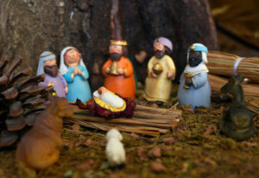

A series of personal reflections on Epiphany, each evening from 7.30pm until 8.45pm. from across the URC and beyond:

**Revd Geoffrey Clarke – East Midlands Moderator – 6 January**

**Revd Dr Susan Durber – European President of the World Council of Churches – 7 January**

**Revd Andrew Brown – Unitarian Minister from central Cambridge – 8 January**

**Revd Sheila Maxey – retired minister and regular *Reform* contributor – 9 January**

**Revd Timothy Meadows – GA Moderator 2024-25 on 10 January**

There will be an opportunity for those who have booked, to interact with the above speakers.

Please book before 9.00pm on 5 January. A Zoom link will be sent to those who have booked shortly after that.

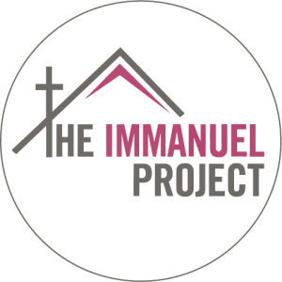

The Immanuel Project is a Christian charity dedicated to serving the homeless and vulnerable individuals of Bradford. At their Hub, they provide essential support services, a welcoming environment, and a sense of belonging to those in need.

They are currently looking for a full-time Guest Engagement & Volunteer Coordinator based at their head office and have asked that we circulate this around our churches. For more details and how to apply please look at this link:  <https://snicket.org/jobs/guest-engagement-volunteer-co-ordinator/>

**SAFEGUARDING**

**The Safeguarding team have asked that you are reminded that they are available 24 hours a day, seven days a week and 365 days a year (and even 366 days in Leap Years!!).** **Details can be found on the Yorkshire website at** [**https://urcyorkshire.org.uk/safeguarding/**](https://urcyorkshire.org.uk/safeguarding/) **and any query, either by phone or by e-mail at** [**safeguarding.1and4@urc.org.uk**](mailto:safeguarding.1and4@urc.org.uk) **will be answered within 24 hours.**

**Staying safe in church buildings**

The Synod Safeguarding Team is reaching out to all churches across the Synod to signpost you to the following website: [**https://www.protectuk.police.uk/marauding-terrorist-attack-mta-run-hide-tell**](https://www.protectuk.police.uk/marauding-terrorist-attack-mta-run-hide-tell)

This website gives specific guidance on what to do if you or your local churches are faced with any instances of threat. If there is any further information that any church may need, please contact your Carrie Kaunda, the Yorkshire Safeguarding Officer straight away or visit [**https://urc.org.uk/your-church/guidance-support-for-churches-synods/staying-safe-in-church-buildings/**](https://urc.org.uk/your-church/guidance-support-for-churches-synods/staying-safe-in-church-buildings/)

**And Finally**

**From all the Synod Team, we send you prayers and blessings for a**

**Christmas full of Love, Joy and Peace and also for the coming New Year.**



Jamie, Tim, Jane, Alastair, Simon, Ashley,

Megan, Matt, Paula, Carrie, Anne, Hayley, Rachel and Sally

**If you have a good news story from your part of the Synod, drop me a line at** [**clerk@urcyorkshire.org.uk**](mailto:clerk@urcyorkshire.org.uk) **and I’ll make sure it hits the back page!!**

You can also keep an eye on all our social media platforms for news; on the website at [**Home - URC Yorkshire Synod**](https://urcyorkshire.org.uk/), the Facebook pages at [**United Reformed Church in Yorkshire - Home | Facebook**](https://www.facebook.com/urcyorkshire) and [**Wilderness URC Yorkshire - Home | Facebook**](https://www.facebook.com/wildernessyorkshireurc/), the YouTube page at [**URC Yorkshire - YouTube**](https://www.youtube.com/channel/UCSAly5eC6tBlmY52dLxrylg) and the Twitter page at [**URC in Yorkshire (@URCYorkshire) / Twitter**](https://twitter.com/URCYorkshire).