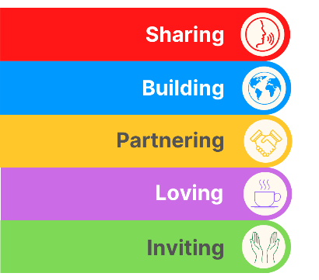
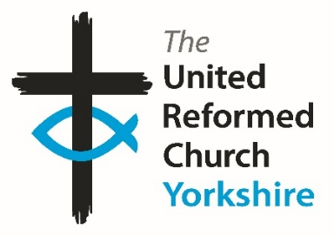
Yorkshire Synod Briefing
Number 147

13th February 2025

HOW, WOW and news from N.O.W.
You may have noticed that there has been a three week gap since the last Briefing, and this was down to your Clerk attending the General Assembly Executive and other meetings last week. When that decision was made, and knowing that the last issue was quite a light one your Clerk thought that this issue would also be relatively light. But boy, was he wrong.
This is a bumper issue, and one which includes great news stories which have been sent in from across the Synod, advance notice of lots of events happening in the Synod over the spring and summer and the promised a mini profile of our new starter, Tony Harris, who has taken up the role of Wilderness Youth worker in the “N.O.W.” group of churches. This group of churches in the Nidd, Ouse and Wharfe group have come together with the Synod’s Children & Youth Work committee and have appointed Tony as their new Youth, Children and Family Enabler. He started on Monday 27th January and I’m hearing that the foundations for his work are already being laid. And talking of foundations, one of our two “And Finally” stories continues in that theme of foundations, begun last time through our friends in Idle.
Mid-February also sees us rushing headlong into Synod meeting season. On Saturday 8th March Synod will be meeting at Heckmondwike URC. I am not aware that they have hosted one of our twice yearly meetings before (although I am happy to be educated) and I know that the church are looking forward to welcoming Synod with open arms. However the meeting won’t be streamed out to a wider audience this time, which makes it all the more important for your church representatives to head into the heart of the Synod to join in fellowship and be part of that decision making body which supports and resources the URC in our part of the world. I hope to be able to send all the papers out (both digitally and real paper copies to those who request) before the next issue of The Briefing and I’ll give a report of the meeting in the issue due out on 13th March.
Finally, my usual further call for folk to help in the running of Synod. We are always looking for people to help in the mission and direction of Synod and the URC in general. If you know of anyone who you feel could help, or if you feel as though you have a gift to offer, please follow that call and get in touch with either myself at clerk@urcyorkshire.org.uk or our Moderator Rev Jamie Kissack at moderator@urcyorkshire.org.uk. If you time it right, I may even ask Synod to appoint you on March 8th!!!

If you have any news of welcoming people into Church, stories of celebration and hope or even notices of future events, please let me know by dropping me a line at clerk@urcyorkshire.org.uk and I’ll showcase it in the next edition, due out on Thursday 27th February 2025.
Thank you
Tim Crossley

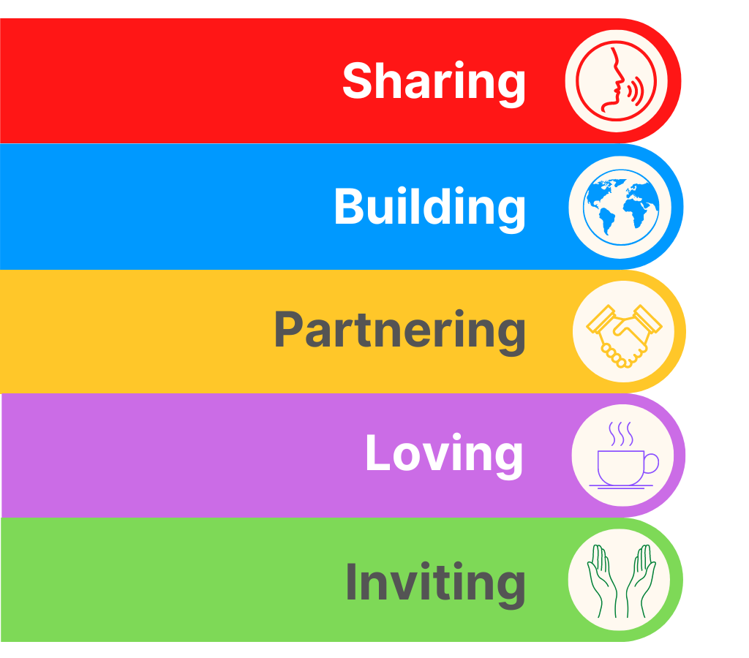

INTRODUCING TONY HARRIS
Wilderness Hub Enabler for the N.O.W. Churches
The Wilderness Team are really happy to be able to introduce Tony Harris (seen here with his family) as the new Wilderness Hub Enabler for the N.O.W. group of churches based in the Nidd, Ouse and Wharfe group of churches. Tony started at the back end of January and here’s a little message from him to us, and I pray that his welcome in Yorkshire is a warm and Christlike one.
Hi everyone, I'm Tony.
I'm a born and bred midlander who now lives in God's own County. I'm a dad of 4 boys Euan 16, Nate 12, Cody 10 and Oscar 5 and a husband to my beautiful wife Sarah (I'm not allowed to add her age).
I Love Jesus, my family and Rugby League and Union and follow Coventry City FC in that order. I have been working with secular and Christian kids for nearly 20 years, and my midlife crisis was getting a theology degree to embark on my journey of making my passion a reality and privilege of helping kids and families find the Lord. I am really looking forward to this chapter of my testimony and can't wait to meet as many of you as I can.
God blessings over you all
Tony

Yorkshire Synod Discipleship Development Small Grant Fund 2025
The Ministries Committee have so far approved 20 applications to this fund since 2022 and are pleased to say that there is another £2000 available for new applications in 2025. There is a new application form as the amount which you can ask for has increased to up to £300. So if anyone wants to discuss an application before submitting it or to ask for a new application form to be sent across please contact the Convenor of the Yorkshire Ministries Committee, Kath Lonsdale at kathlonsdale@talktalk.net.
Remember this is for any age of lay person to apply for so please discuss with your young people as well as adults.

COMMITMENT FOR LIFE: LAY PREACHERS TRAINING EVENT
Suzanne Pearson of the Commitment for Life programme, https://urc.org.uk/your-church/church-local-and-global/commitment-for-life/, has been in touch to highlight this training event being held shortly at Luther King House in Manchester. Over the past year or so there has been a high demand from churches requesting someone to visit and lead a Commitment For Life services. While it is critical for the sustainability of CFL that the programme engages with congregations on a Sunday morning, this is quite a challenge from such a small team! Therefore, a special training event has been put together at Luther King House in Manchester for Assembly or Synod Accredited Lay Preachers to help us in this task. The event will equip and resource preachers in each of the Regions we support, to assist us in leading these services. Costs involving travel, accommodation and meals will be covered by Commitment For Life.

As places are limited, please can you send responses to Suzanne.pearson@urc.org.uk by Friday, 14th February 2025 at the very latest (and apologies for the short notice).


Thirty years of Racial Justice Sunday
This year's theme for Racial Justice Sunday is the 'Coat of many Colours' and the resources have been produced by the Churches Together in Britain and Ireland. This year is a landmark one for racial justice as it marks the 30th Anniversary of Racial Justice Sunday. The Coat of Many Colours reflects the increasing diversity that exists in our churches today. Yet despite of this, the reality is one where inequality still exists in our churches and it is an affliction which continues to damage our relationship and the experience of many people of a Global Majority heritage.
So, this message comes with a thank you if you included Racial Justice in your worship on the 9th February and a request that if your preaching plan was already full, then chose another Sunday to mark this fundamental part of our ministry and mission to the world today. Please see below a prayer which can be used in worship.
Thirty years of Racial Justice Sunday – 9 February 2025 – Churches Together in England

Prayer
God, You have told us what is good. You have made clear what You require of us.
We pray that You remind us of our shared responsibility to work with You to build a better world for all.
As we seek to do what is just, help us to recognise injustice, to notice those who are oppressed or alienated.
As we sow love throughout this world, in Your mercy, guide us to the ones who feel unloved.
May we bring Your light and love into places where fear and hatred have cast their shadow.
May we walk in humility and solidarity with all around us.
Help us not to trespass or misstep on the journey towards equality and justice for all.
Amen
Racial Justice is everyone's business
With blessings,
Zaidie Orr.
More news from the Children and Young People’s Synod team
There is a lot happening around Synod this spring, and these events need to be shared around Synod so that you can be promoting and encouraging in your own churches and groups.
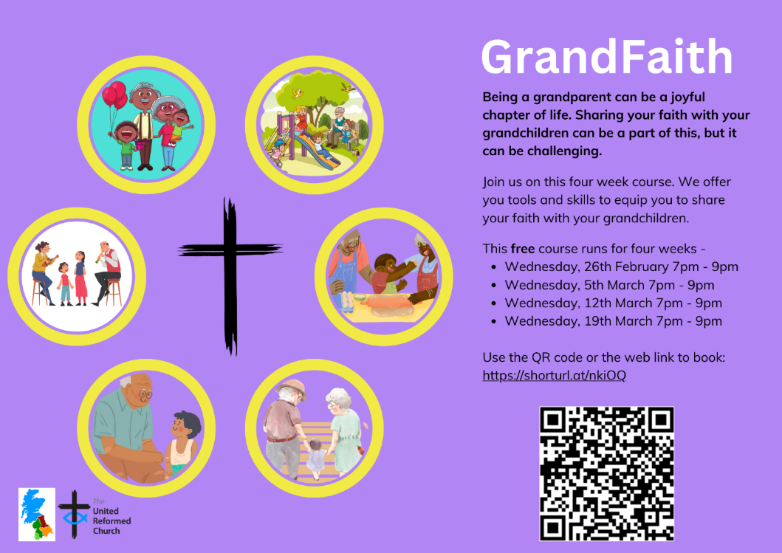
GrandFaith.
The material is largely based on the ‘Grandparenting for Faith’ material by BRF and is a 4-week course for grandparents who would like to feel encouraged and equipped to share their faith with their grandparents. Our churches are full of grandparents so please do share with those you feel might be interested!

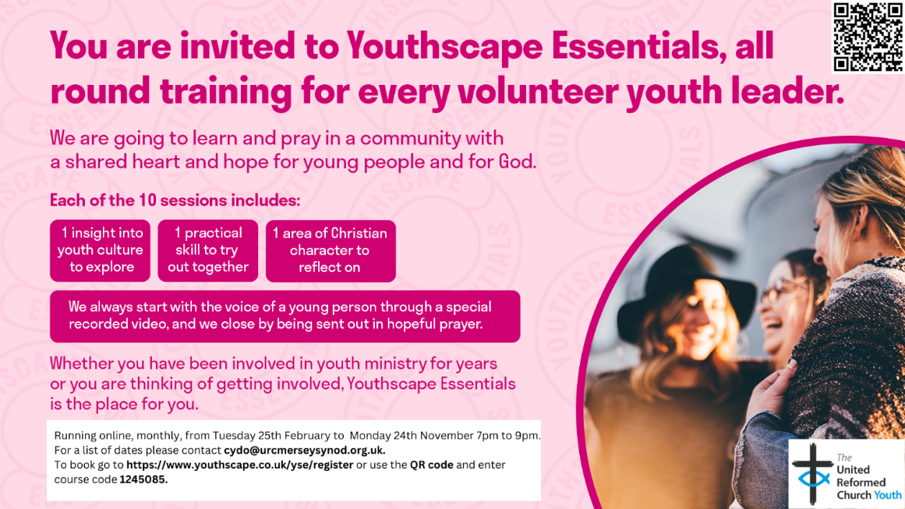
Youthscape Essentials Course
This is a 10 month course (one session per month) which has been put together for all those who already do, or who would like to work with young people. Each session of this course offers an insight into contemporary culture or research into young people’s lives, a practical skill to learn and develop and a personal characteristic which can be applied to building effective relationships with young people. It really is an insightful and useful course. This course and the GrandFaith course are being delivered by me and my Five Northerly CYDO+ colleagues.
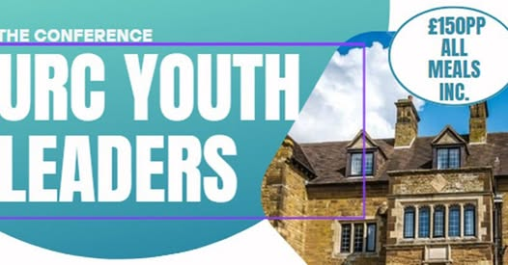
There are still a few more days to book onto the Youth Leaders Gathering in March. This is a unique opportunity to gather with other youth leaders in URC’s in the UK, and to share the company and knowledge of Ali Campbell, who will be delivering part of the weekend’s program. If you know anyone who may be interested, please pass it on and let them know that the synod will contribute to their costs.

Youth FORUM 2025
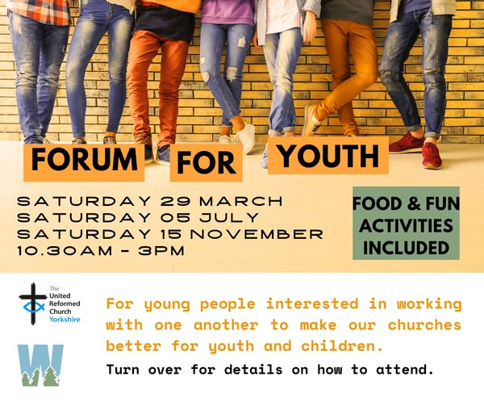
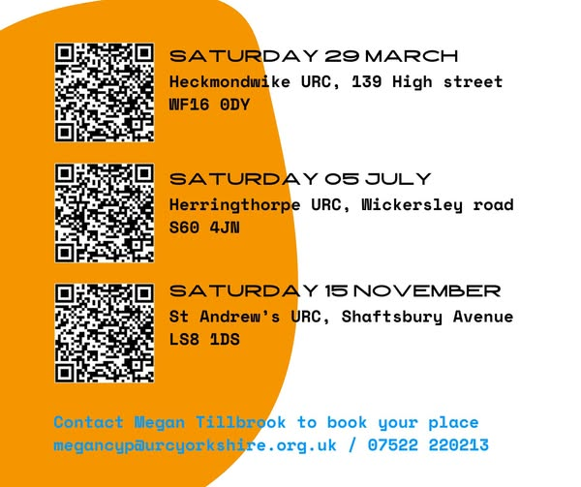
Three forums so far have been planned for 2025. The first gathering is on 29th March at Heckmondwike URC. As part of the day we will be going to a local Pottery Barn for a pottery wheel lesson and some pot painting. Other sessions include gathering at the Stag Community Church – Herringthorpe URC on Saturday 5th July, then on November 15th at St Andrew’s Roundhay.
Use the QR code or the following link to book: https://buytickets.at/theunitedreformedchurchyork.../1546359


Joined up Conference
is for all who have a role in ministering and working with children and young people. It would be great if we could increase the URC presence at this conference, which is in Sheffield next door to Central URC. This year is the 10th anniversary of the conference and they are thrilled to have Nick & Becki Drake keynoting and leading the worship. Please do consider attending and sharing with those in leadership and working with children and young people.
Finally, some of you may be aware that the URC is part of the Intergenerate UK network and that there is a series of webinars being produced over 2025 about intergenerational worship. The webinar in February is around preaching. Information can be found here: https://padlet.com/URCCYW/training-events-and-opportunities-pb0xf9hbk6xawrq8

Line Management Training 2025
The HR department at URC Church House are once again running their Line Management course. Having done this course, I heartily recommend that those of you who are either line managing or are thinking about employing people in your churches sign up to do the course. As well as the hour-long sessions you will be able to link into other churches who are doing just what your church is doing as well as drawing on the vast experience of the Church House staff. Although this course is for anyone working within the URC with direct line management responsibility its scope is a bit wider, so first read the URC’s Essential line management on the website then sign up for the course.
Each session is from 10.00am to 11:15am on the dates below and covers the several topics.
Date Topic
Thursday 27 February The Basics
Thursday 27 March Managing Performance
Thursday 24 April Appraisals
Thursday 15 May Managing Attendance
Thursday 26 June Flexible Working
Thursday 24 July Recruitment
Thursday 25 September Equalities
Thursday 16 October Policies – Capability
Thursday 20 November Policies – Disciplinary and Grievance
This is the final call to reserve a place on the training sessions, so please email deepti.upadhyaya@urc.org.uk with your full name, Email, Synod/Church name and Role/job title. It costs nothing, apart from your time each month, but its value is beyond measure. For more information visit: https://urc.org.uk/your-church/guidance-support-for-churches-synods/employment-guidance/training-events-and-courses/

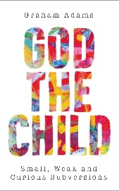

Envisioning Worship Conference

For everyone interested in how worship affects mission
Theme: What if God is Child?
Dates: 11am on 8th March – 3.30pm on 9th March 2025
Venue: Luther King Centre, Manchester
Costs: Residential: £200, Non-residential: £120
Who is it for? Anyone intrigued by the idea of the childlikeness of God – in the midst of the smallest experiences; apparently weak but disruptive; curious, playful and imaginative; raging and dancing – and what this might mean for worship and mission. Anyone drawn to Bible explorations, creative workshops and more – and who is interested in imagining things differently.
For more information and to register, visit –
https://northerncollege.co.uk/ewc-march-2025/

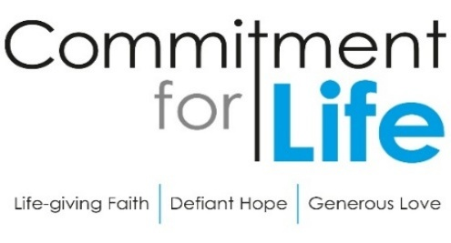
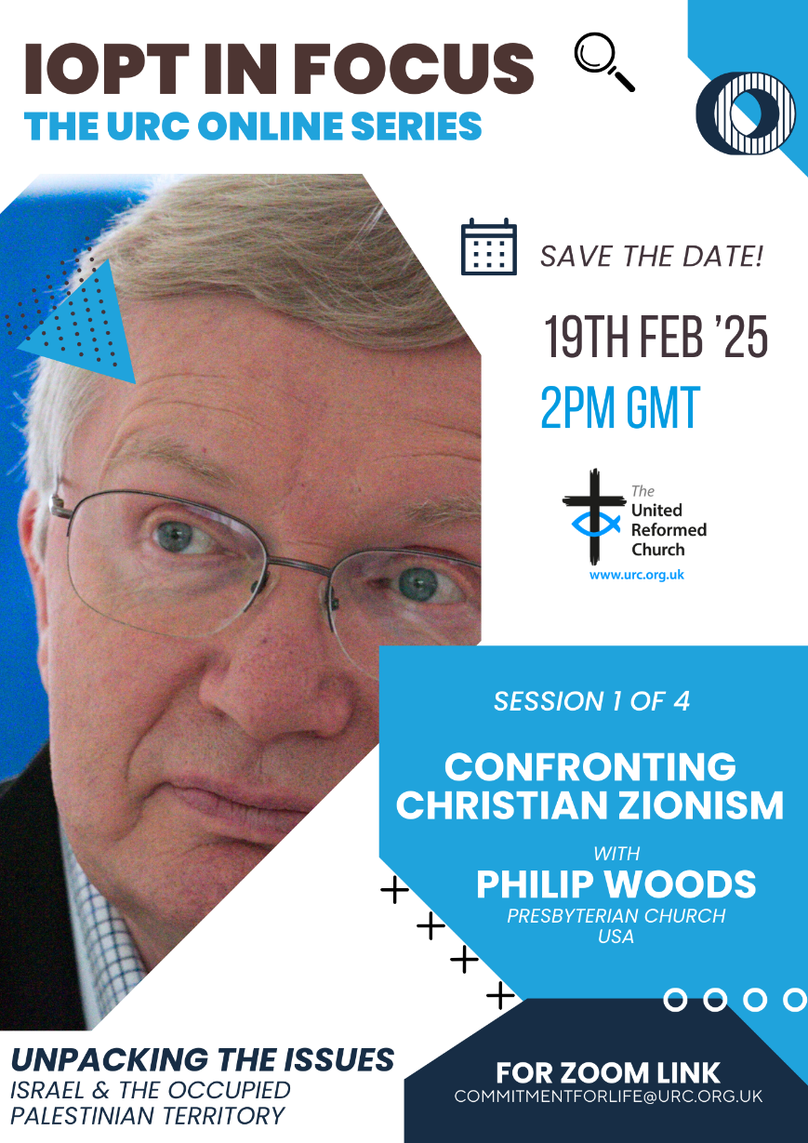
The General Assembly has recommended that URC members and groups widen/deepen their understanding of some of the fundamental issues as to why the conflict in Israel and the occupied Palestinian territory seems so intractable.

The inter faith enabling group together with Commitment for Life are hosting a series of online events beginning on 19 February 2025 with Revd Philip Woods who will be looking at Christian Zionism's role in the questions (see below). Please do try to attend and to circulate where you think it might best be received.
___________________________
Revd Dr Kevin Snyman
Programme Officer, Global Justice, Partnerships, & Inter Faith Relations

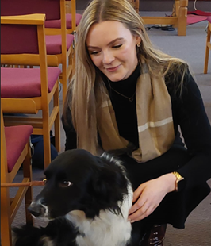

Last week Heath United Reformed Church Halifax invited their MP Kate Dearden along to their church service. They had a short sermon on Jesus being political before handing the mic over to Kate who shared her motivations and story as well as hopes to continue a relationship with the church.
Thank you to Jane Simmons sharing these photos of Kate meeting church members.

Feeling inspired? The Joint Public Issues Team have asked that you Read our guide on inviting your MP to church.
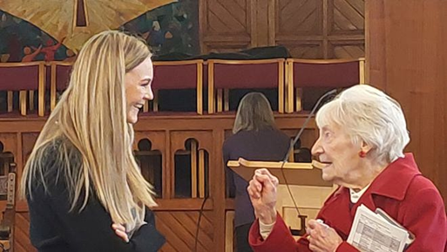
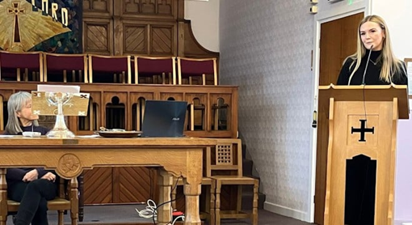
Lay Preachers’ and Worship Leaders’ Weekend

“Hope in a Troubled World"

25th – 27th July 2025
(Friday teatime to Sunday lunch)

at Wydale Conference Centre, Brompton by Sawdon near Scarborough www.wydale.org



We are excited that Hannah Fytche, Associate New Testament Tutor at Westminster College, will be our main speaker at the conference, and that we will be joined by our Moderator, Rev Jamie Kissack.

This weekend will again be paid for by Synod and grants so you will only need to cover your travel costs.

To register your place, contact:
office@urcyorkshire.org.uk or 0113 289 8490.

For any queries, contact Kath at:
kathlonsdale@talktalk.net
01274 315203 or 07759525936

For an opportunity to chat about the post contact Martin Lambourne on 07708946093 or martinlambourne@me.com. Closing date for applications is Monday 17th February with interviews late February/early March.
Please visit the Shiregreen website at https://www.valentinechurch.online/about-1 to download the fill job description and application form.
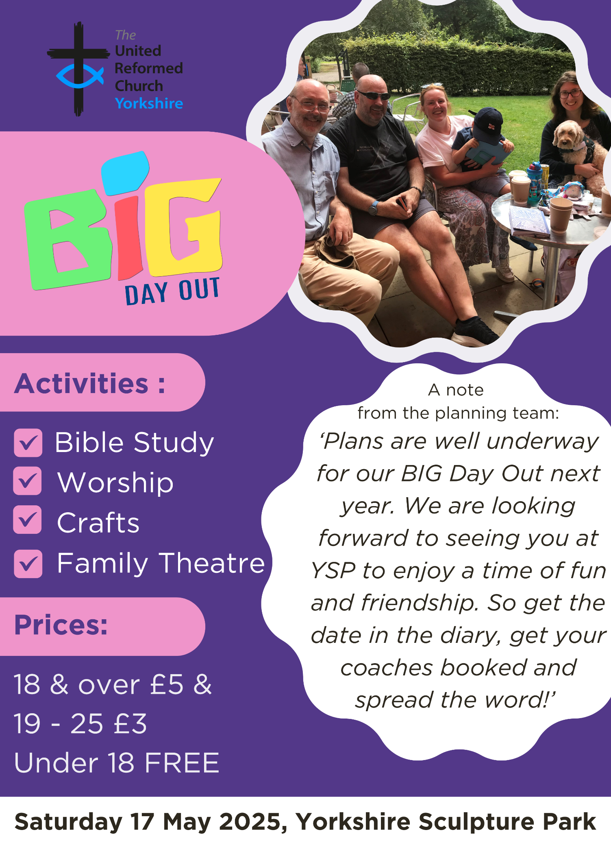
BIG DAY OUT 2025

Enter your prayer for the 2026 Prayer Handbook
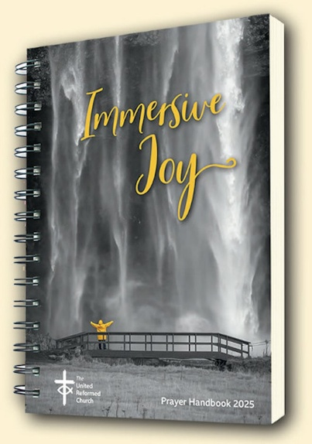
The deadline for submissions for the 2026 URC Prayer Handbook – Touching God is fast approaching.
Under the new editorship of the Revd Dr Susan Durber and the Revd Jonnie Hill, prayers are invited which express gratitude for, or a yearning to experience, the touch of God in our lives — moments when the sacred mystery of God breaks into the everyday, filling it with awe and wonder.
Prayers that celebrate the sacramental nature of all life, affirming the presence of the divine throughout the world we share.
Please make your submission by the deadline of 21 February. You can email your prayers for the 2026 Prayer Handbook to phb@urc.org.uk.

GOOD NEWS AT KNOTTINGLEY
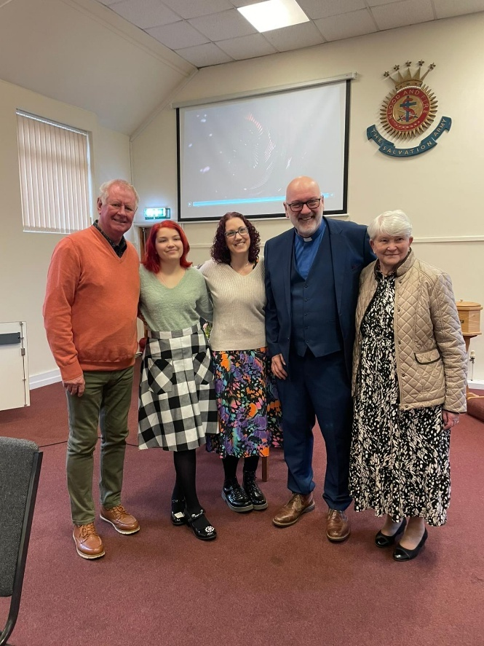
On Sunday 9th February at the service at Knottingley URC (who now meet in the Salvation Army bulding on Weeland Road) the congregation were joined by the Synod Evangelist, Revd Ashley Evans. Not only that, but he presided over the transfer into membership at Knottingley of three people, Claire Nutt, her husband Iain and Kacie Hodgson and inducted into membership Margaret Lyons who has been very active in the life of Knottingley URC for many years, but had never become a member. Claire, who is the Synod Pastoral Elder for that part of the world, was also inducted as an Elder at Knottingley and will be working closely with them as they embark on a new chapter in the life of the church there.
Knottingley had been a church on the edge, with a building that was too much for the congregation, but the agreement with the Salvation Army to share their building has brought a breath of fresh air and I hope you can join me in praying that the green shoots reappearing in Knottingley thrive and grow in the years to come.

SAFEGUARDING
The Safeguarding team have asked that you are reminded that they are available 24 hours a day, seven days a week and 365 days a year (and even 366 days in Leap Years!!). Details can be found on the Yorkshire website at https://urcyorkshire.org.uk/safeguarding/ and any query, either by phone or by e-mail at safeguarding.1and4@urc.org.uk will be answered within 24 hours.

SAFEGUARDING TRAINING COURSES
The following Safeguarding Training courses are now available for 2025.
All these courses are to be held via zoom and to book a place please contact Paula Kitson – paulakitson.1and4@urc.org.uk
Monday 17th February 2025 – 10am - Intermediate training
Wednesday 19th March 2025 - 10am – Refresher training
Friday 11th April 2025 – 10am – Intermediate training
Wednesday 7th May 2025 – 2pm – Refresher training
Thursday 5th June 2025 – 7pm – Refresher training

Staying safe in church buildings
The Synod Safeguarding Team is reaching out to all churches across the Synod to signpost you to the following website: https://www.protectuk.police.uk/marauding-terrorist-attack-mta-run-hide-tell
This website gives specific guidance on what to do if you or your local churches are faced with any instances of threat. If there is any further information that any church may need, please contact your Carrie Kaunda, the Yorkshire Safeguarding Officer straight away or visit https://urc.org.uk/your-church/guidance-support-for-churches-synods/staying-safe-in-church-buildings/
And Finally
An Evening with Harry at West Park United Reformed Church, Harrogate
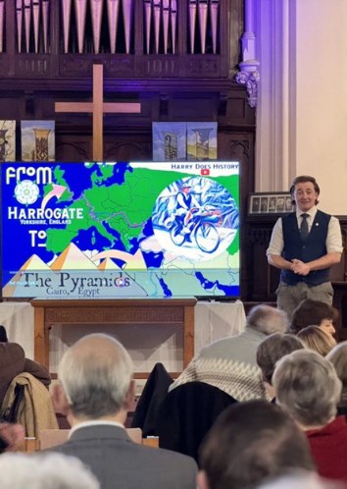
Harry Satloka of Harry Does History entertained a sold-out crowd at West Park United Reformed Church on 1st February with tales from his bicycle ride to the pyramids.
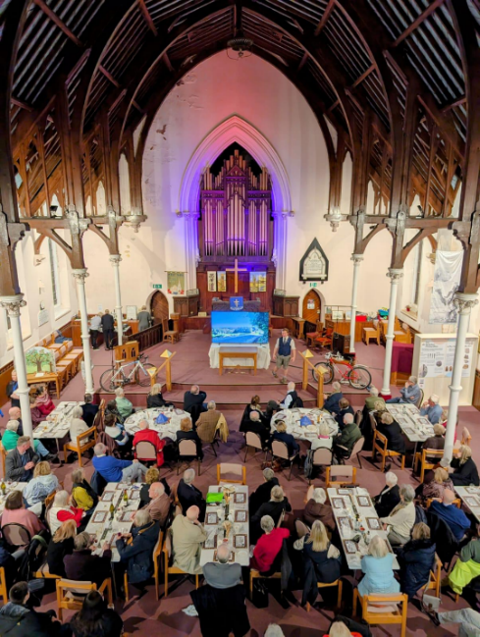
Harry began the evening talking of the passion for history and desire for adventure that inspired him to undertake the journey. The audience was treated to a series of videos which accompanied his stories about his adventures on Rudolph, his trusty bicycle from Resurrection Bikes. Videos included guides on how to open a bottle of wine with a shoe, cross a road in Egypt, start a fire, and set up a hammock. They also demonstrated his ‘top of the hill’ dance, performed to the tune of Wallace and Gromit (even after climbing 2300m in Switzerland!) Most importantly, Harry paid tribute to those who helped in along the way: good friends, new friends, complete strangers, and even a handful of dogs. Throughout the talk, the audience were enthralled, and treated to Harry’s signature jokes (familiar to many!).

The evening was made possible by team of dedicated volunteers, working together for the first time. The audience were served a delightful meal, and Artizan Café provided delicious chocolate cake to cap it off.
Funds raised during the event will go to support the West Park Church project and Artizan International.
And as Harry remarks in one of the clips: ‘The uphills are still tough. But I know in a day, a week, a month, a year, I’ll only remember the good bits’.

The West Park Project aims to restore the beautiful church overlooking The Stray, whilst retaining it as a place of worsip but transforming it into a vibrant community space for performance, meetings and use by local groups. It will also host a semi-permanent exhibition on the history of Harrogate, the first display for which was unveiled on the evening (rather appropriately on Harrogate’s connections with Egypt).

Artizan International enables, empowers and supports people with disabilities to meet their full potential, through therapeutic craft activities and social enterprise, in the UK and the developing world.

Harry’s videos from the trip will soon be available on his YouTube channel, Harry Does History. His Free Walking Tour of Harrogate will return in March, all via https://www.harrydoeshistory.com/

Due to the success of the evening, and a long waiting list of names, it is proposed to repeat the event in a few weeks time. Provisional bookings can be made at enquiries@westparkcentre.org.uk

More Mallets and Foundations
Following on from last time’s story about the foundation mallet celebrating the construction of Idle Upper Chapel’s 1950’s building found in Scotland, I’ve received this letter from Mrs Gillian Figures, a long-standing member at St Andrew’s Roundhay, with the accompanying pictures. As you will read, the challenge that our buildings present is nothing new and the way in which this was overcome at Roundhay over 100 years ago is something that we may learn from today.

Dear Tim,
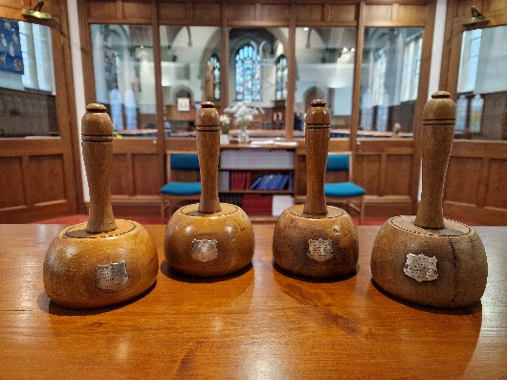
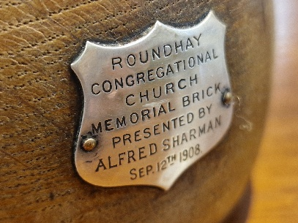
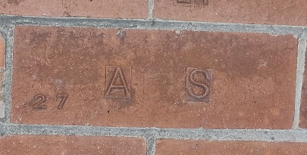
I was very interested to read the article about the ‘hammer’, connected with the church at Idle, being rescued from a charity shop in Scotland. At St Andrew’s Roundhay, we have several beautifully made mallets, each with a silver shield bearing the name of one of the children of the church. In January 1908, during the construction of the main sanctuary of what was then Roundhay Congregational Church, in order for the children of the Sunday School to feel part of the project, one of the senior teachers suggested that they should be challenged to each raise one guinea towards the Building Fund.
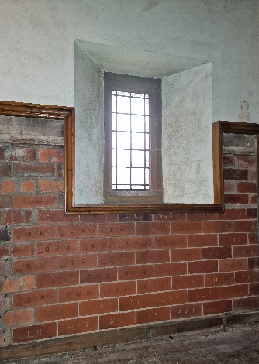
They were given collecting boxes for home use ‘for the pennies of the children themselves and the friends who come to visit them.’ No begging from neighbours! At a special ceremony on Saturday 12 September 1908, called The Children’s Demonstration, the successful forty eight children presented their purses and were given a specially made mallet with which to ceremonially lay a brick with their initials baked into it. They had to repeat the words, ‘This brick is well and truly laid.’ The mallets were treasured by the owners and some have been presented to the church many years later. It is poignant to identify the initials on the bricks when reading the names on the War Memorials. Many of the bricks can still be seen when doors in the vestibule panelling are opened, although some are obscured. I wonder if other churches have similar items of historic interest?
Gillian Figures

If you have a good news story from your part of the Synod or something that you feel would enhance the work of Synod in 2025, drop me a line at clerk@urcyorkshire.org.uk and I’ll make sure it hits the back page!!

You can also keep an eye on all our social media platforms for news; on the website at Home - URC Yorkshire Synod, at United Reformed Church in Yorkshire - Home | Facebook and Wilderness URC Yorkshire - Home | Facebook, the YouTube page at URC Yorkshire - YouTube and the Twitter (X) page at URC in Yorkshire (@URCYorkshire) / Twitter.

