
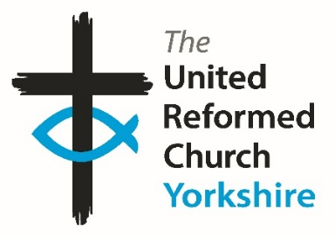
Yorkshire Synod Briefing
Number 153

15th May 2025

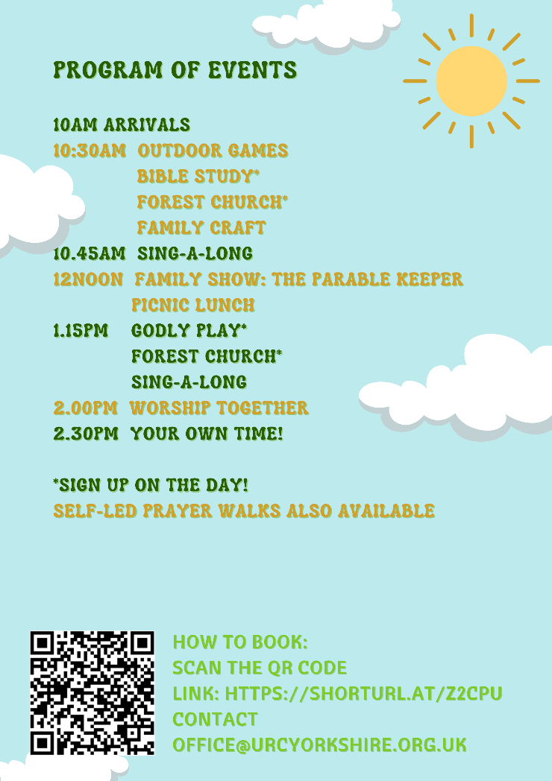

BIG DAY OUT 2025
Hello All
Although bookings are now officially closed, you are still welcome to come along to the Yorkshire Sculpture Park this coming Saturday (17th May) and join in the fun and fellowship of our BIG DAY OUT, by paying on the day. If you pay on the day, you will need to use the main car park and entrance and then walk to the Learning Centre to sign in and be given a wrist band.
Our team has been so busy organising events that everyone can join in with. Here are some of what you can expect to find on the day:
Godly Play
Join in with a calm, yet playful retelling of “The Parable of the Mustard Seed”, with the opportunity to wonder and explore together about the meaning of the story. As part of the session, participants will be encouraged to continue their own private ‘wondering’ about the parable, using a variety of creative materials. All ages are welcome.

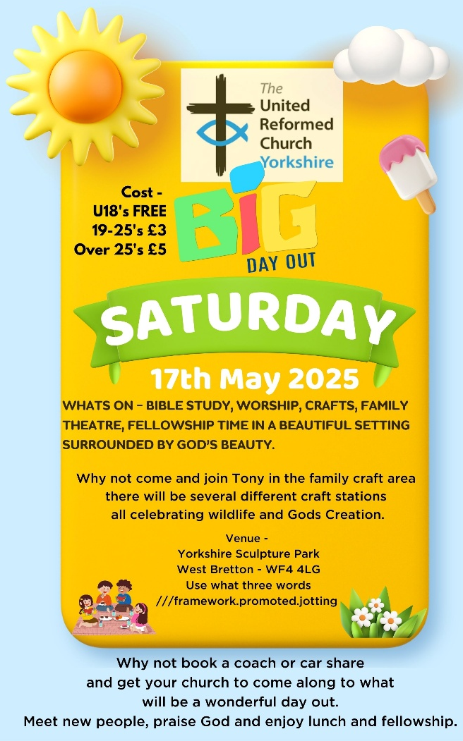
Guided Prayer Walk
Around the beautiful grounds.

Crafts
Crafts being run by Tony Harris celebrating wildlife and God’s creation.

Bible Study
Led by Rev Joe Amoah: “The Parable of the Talents” (Matthew 25:14–30)
“Ever wonder how your unique gifts can make an impact? Let’s gather for an energetic session where we explore how God’s gifts can empower you to live boldly and purposefully”.

Forest Church
An opportunity to seek God through His amazing creation in outdoor spaces, including forests, parks and countryside, through Bible stories, worship, nature walks, games, crafts, etc. This expression of church is for all ages and may be more accessible for those who don’t feel comfortable in a traditional church setting. All are welcome.

The Parable Keeper
4Front Theatre are excited to be bringing their family musical The Parable Keeper to your Big Day Out. Join the enigmatic Mr. K and his assistants in the Parabularium, an enchanting musical filled with weird and wonderful curios and knick-knacks and a whole lot of stories! The Parable Keeper brings the parables of Jesus to life like never before, with a host of toe-tapping musical numbers, magical storytelling and a whole lot of laughs. Suitable for the entire family, the show runs for roughly an hour and has plenty of audience interaction and moments to shout and sing along. We are thrilled to be bringing this to your Big Day Out – 4Front Theatre.
Here are some links to 4front (a small Christian theatre company) to whet your appetite
https://www.4front-theatre.com/about
https://www.youtube.com/watch?v=CDUEyqazh2k

Lunch will be picnicking together (bring your own or buy something on site), bring a chair and picnic blanket and pray for good weather!

For detailed information including fliers, letter to churches, directions and Under 18 consent form please contact the Synod Office at office@uecyorkshire.org.uk or clerk@urcyorkshire.org.uk and we’ll send them through. We look forward to seeing there!

Four Forums and a Singathon!

Returning for a third year are the Synod Forums (or should it be Fora? – I’ll leave that to any Latin scholars out there, and if anyone should let me know if a funny thing happened on the way to one of them, I will publish it here!!). The Forums are opportunities for fellowship and good conversation, and they will be meeting again in four different locations around Yorkshire Synod in May, June and July this year. The conversations will be faith-shaped around vocation and leadership and everyone is welcome. You are free to choose the date and venue that is best for you, with each running from 10.30am – 1pm. Please do stay and share a ‘bring-your-own lunch’ and continue the conversations.
See the advert further in the Briefing, but the first one is on Saturday 24th May at St Ninian’s and St Andrew’s URC, Hull, with the second one on Saturday 31st May at West Park URC, Harrogate
We hope these events will be a chance for those with Synod roles to hear from local churches so that we can support and encourage one another. The Synod Forum is your place to have your voice heard, and to help shape the priorities of the Synod.

It would be remiss of me though not to mention a celebration of the Ecumenical aspect of being United Reformed Church, and that is THE BIG SINGATHON taking place on Saturday 24th May at Trinity St Andrew’s in Skipton. This year sees the Golden Jubilee of the coming together of two Methodist churches and the United Reformed Church in Skipton and to mark this, as well as raising money for Christian Aid, two of the leading musical lights there are going to sing and play the whole of Singing the Faith from no1 to no790. More details below, but you are welcome to join them and if you time it right, you may get to sing your favourite hymn there.

It has been great to hear of the activities from around the Synod this time, and I hope to be able to keep on celebrating all that you do to spread the Word in the Yorkshire area. In this issue we have news from Bingley, the Leeds Partnership, Roundhay URC and Saltaire URC. Keep the stories coming in and I’ll add them to the next issue due out on 5th June (later than normal as I’m away for a week).

We are always looking for people to help in the mission and direction of Synod and the URC in general. In particular we are also looking for people to populate our Listed Buildings Advisory, Financial Resources and Property Committees. If you feel as though you can offer experience to the Synod please follow that call or if you know of someone who you feel has those gifts to offer, then please contact the Clerk at clerk@urcyorkshire.org.uk or our Moderator Rev Jamie Kissack at moderator@urcyorkshire.org.uk.

If you have any news of welcoming people into Church, stories of celebration and hope or even notices of future events, please let me know by dropping me a line at clerk@urcyorkshire.org.uk and I’ll showcase it in the next edition, due out on Thursday 5th June 2025.
Thank you

Tim Crossley





For more information and to send in your designs, contact wilderness@urcyorkshire.org.uk
Trinity St Andrew’s “THE BIG SINGATHON

To celebrate the 50th anniversary of the creation of the Local Ecumenical Partnership between Skipton United Reformed Church, Broughton Road Methodist Church and Gargrave Road Methodist Church on Whit Sunday in 1975 (and later to be joined by Trinity Methodist Church in 2023) the Music Group at Trinity St Andrew’s in Skipton is holding The Big Church Singathon.

This marathon session on Saturday 24th May, in aid of Christian Aid, will go through the whole of “Singing The Faith”, with at least every first verse being sung and if there is more than one tune for a hymn, then each tune will be rolled out as well.
The plan is to start at 8.00am with breaks every 5 minutes or so per hour with a Communion Service to take place at around 6pm when they get to Hymn no 568. The hope is that The Big Church Singathon will finish with no 790 at around 10pm.

A ‘Just Giving’ page has been set up at www.justgiving.com/page/jon-crossley-1 so save the date and help Trinity St Andrew’s raise the roof for Christian Aid.

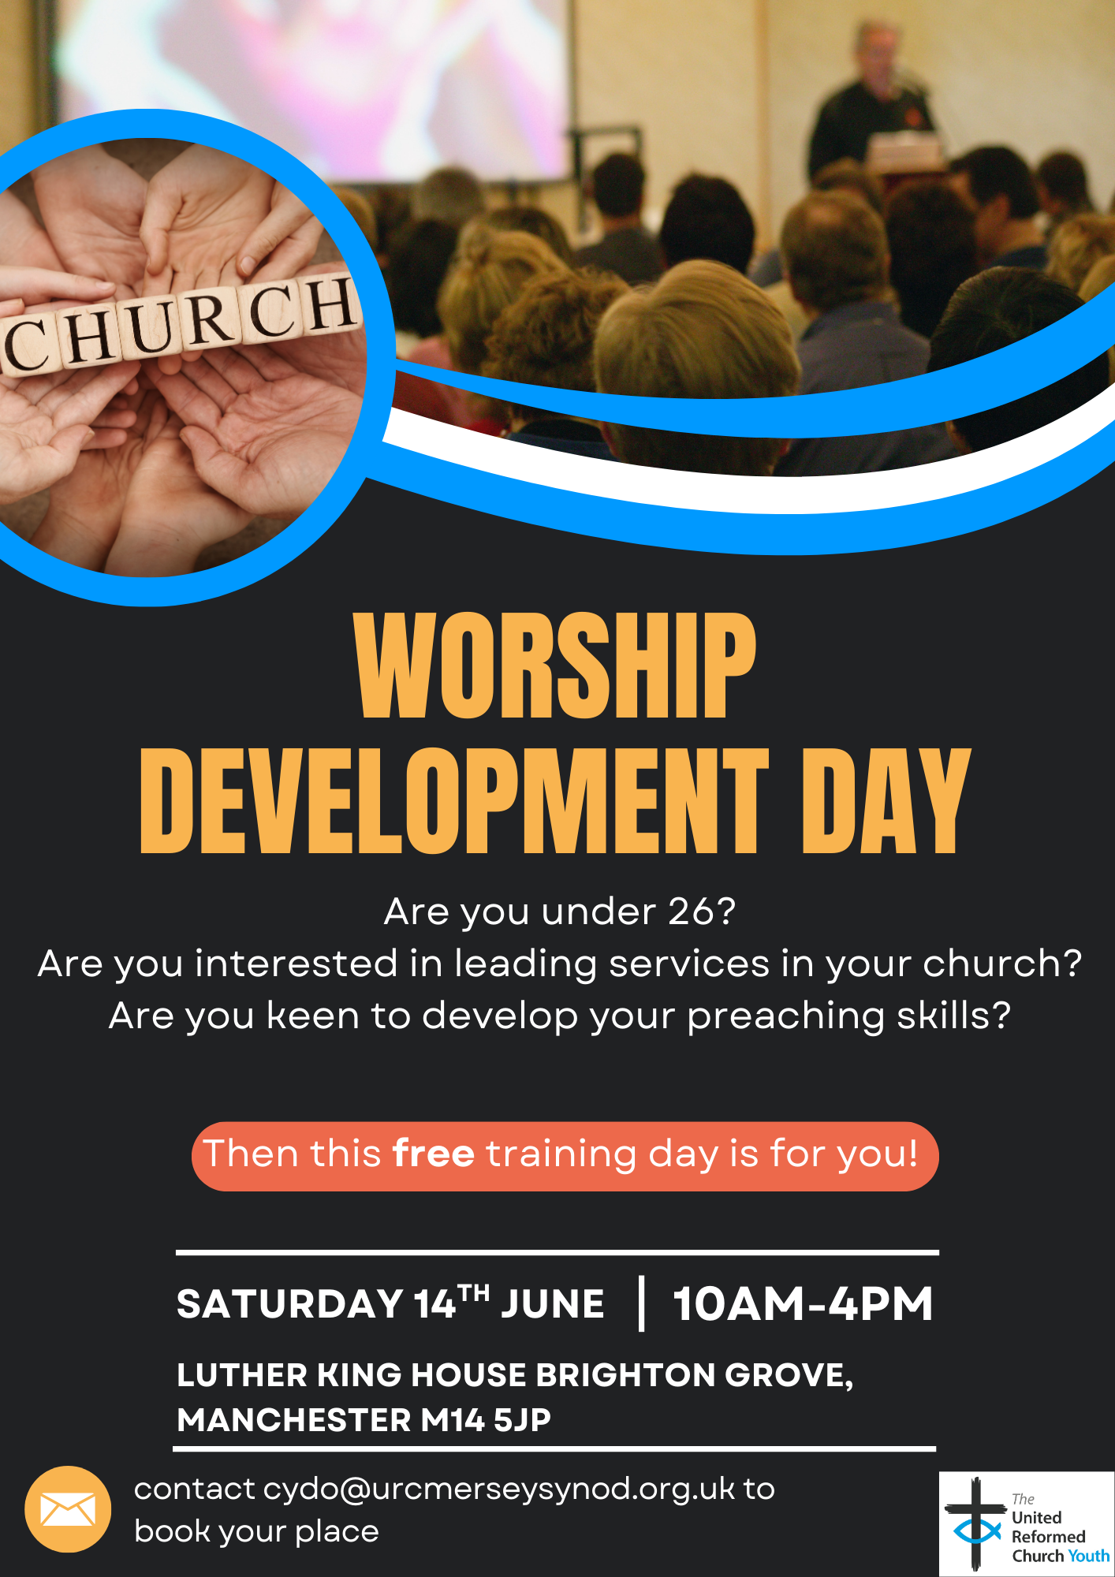For more information and the relevant consent forms, please contact Meghan Tillbrook at megancyp@urcyorkshire.org.uk or via the Synod Office at office@urcyorkshire.org.uk

Forming a new “Community of Pioneering”
On Thursday 26 June at 6:30pm there is an Online Taster Evening for the 2025-26 Newbigin Pioneering Hub for any potential candidates for the next cohort to ask any questions, and it will be led by Ash Barker.
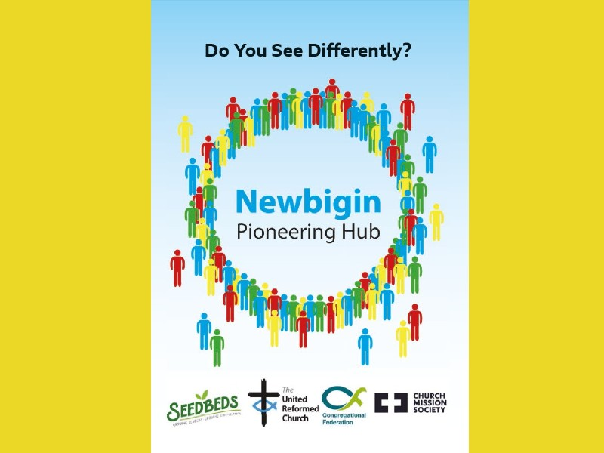
The Newbigin Pioneering Hub aims to discover, nurture, empower and release a new generation of Pioneers. This will include helping Pioneers connect with new mission contexts, pathways, retreats and coaching. We believe we can go further and deeper in our calling as Pioneers if we connect together well. We will form this ‘Community of Pioneers’ out of those who currently identify as Pioneers as well as those coming through the ‘Certificate in Pioneer Mission.’
This Online Taster Event is an opportunity to connect, find out more and ask questions about the ‘Community of Pioneers’ and the ‘Certificate in Pioneer Mission’ programme that is run by the ‘Newbigin Pioneering Hub’.
The next online taster event will take place on Thursday 26 June 2025 at 6:30pm, with the opportunity to ask any questions about the pioneering programme on zoom with Rev Dr Ash Barker. Log in on zoom at https://us02web.zoom.us/j/2844925967.
For more information on the Newbigin Pioneering Hub’s September 2025 - July 2026 programme click here https://seedbeds.org/newbigin-pioneering-hub-2/ and to apply, click here https://seedbeds.org/newbigin-pioneering-hub/ .

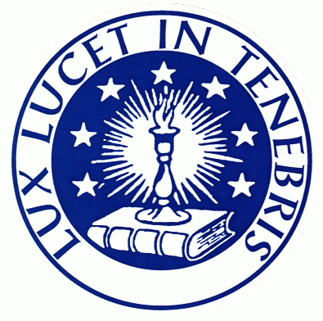
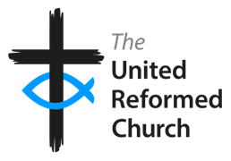
The URC Waldensian Fellowship On-Line
Tuesday, 20th May at 7.30 pm
The Story of the English-speaking Church in Turin
with Pastor Jo Chirone,
whose church is based in the Waldensian Church in the centre of Turin

Do join us on Zoom. All are welcome!

https://us02web.zoom.us/j/84476125567?pwd=MFFTR3F5c0REU2lOYkVLa2x1cU5qdz09
Meeting ID: 844 7612 5567 Passcode: 326951

Leading Your Church into Growth
2025 Yorkshire Synod Programme
The Synod is pleased to announce that our Synod Evangelist, Rev Ashley Evans, is running ‘Leading Your Church into Growth (LYCiG) Vision Days’ being held at various churches within our Synod over the coming months. The day is to seek God’s vision for your church and to help you implement it. We hope your church will be able to take part in one of them.
The first two have happened but if you missed it there are two others over the summer.
Saturday 28th June at The Bridge URC, Otley
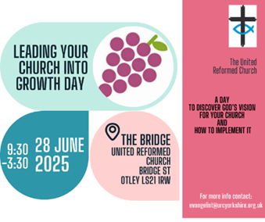
Saturday 5th July at Gleadless URC, Sheffield
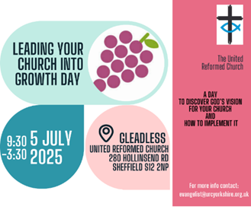

Both from 9.30am – 3.30pm
For more information and booking, please contact Ashley at evangelist@urcyorkshire.org.uk

Yorkshire Synod Discipleship Development Small Grant Fund 2025
The Ministries Committee have so far approved 21 applications to this fund since 2022 and we encourage all lay church members to consider applying in 2025. Please use the new application form available through the Synod Office as the amount which you can ask for resources or has increased to up to £300. This fund exists to help you on your Christian journey including the costs of attending a course or to offset the costs of buying resources for personal development or sharing with others. If anyone wants to discuss an application before submitting it please contact the Convenor of the Yorkshire Ministries Committee, Kath Lonsdale at kathlonsdale@talktalk.net.
Remember this is for any age of lay person in our churches to apply for so please discuss with your young people as well as adults.
Lay Preachers’ and Worship Leaders’ Weekend

“Hope in a Troubled World"

25th – 27th July 2025
(Friday teatime to Sunday lunch)

at Wydale Conference Centre, Brompton by Sawdon near Scarborough www.wydale.org



We are excited that Hannah Fytche, Associate New Testament Tutor at Westminster College, will be our main speaker at the conference, and that we will be joined by our Moderator, Rev Jamie Kissack.

This weekend will again be paid for by Synod and grants so you will only need to cover your travel costs.

To register your place, contact:
office@urcyorkshire.org.uk or 0113 289 8490.

For any queries, contact Kath at:
kathlonsdale@talktalk.net
01274 315203 or 07759525936
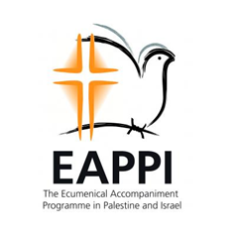
Recently Rev Jamie Kissack met up with Mr Neil Irving, who has recently spent 3 months in the West Bank serving with the Ecumenical Accompaniment Programme in Palestine and Israel (EAPPI). Neil would be very happy to visit churches and talk about his experiences there and how churches can help advocate for an end to the military occupation.

Eyewitness stories from Israel and Palestine
• What is daily life under occupation really like?
• What can be done to promote a just peace in Israeli-occupied Palestine?

www.eyewitnessblogs.com. The programme was established following an appeal from church leaders in Jerusalem for an international presence, accompanying local people and communities, offering protective presence and witnessing their daily struggles and hopes.

He was based in the Jordan Valley and witnessed many violations of human rights. His blogs www.eyewitnessblogs.com/i-am-frightened-and-have-to-treat-the-flags-like-i-treat-my-own-children and www.eyewitnessblogs.com/education-under-attack describe examples of harassment designed to intimidate and force innocent people to flee their homes.

Neil is seeking opportunities to talk to churches and groups about daily life for Palestinians living under military occupation in the West Bank and to tell the stories of some of the people he met. For further information email him at neilirving2024@outlook.com.

Bingley’s Easter Garden Competition
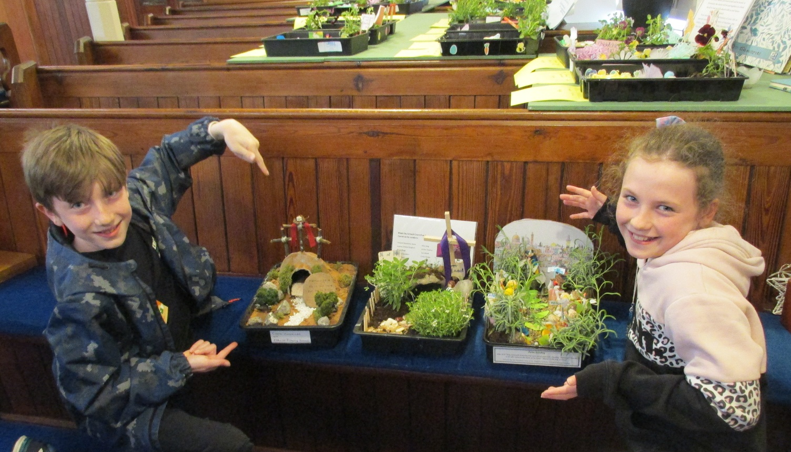
This year Bingley URC reached out to their local Primary/Junior schools by holding an Easter Garden Competition with cash prizes from their mission Budget and were rewarded by 28 entries from 5 schools.
They opted out of judging them themselves but handed that task over to Sophie and Harry, the visiting 10yr old twin grandchildren of Elders, as they appreciate the standard reached by their peers without being influenced by local knowledge.
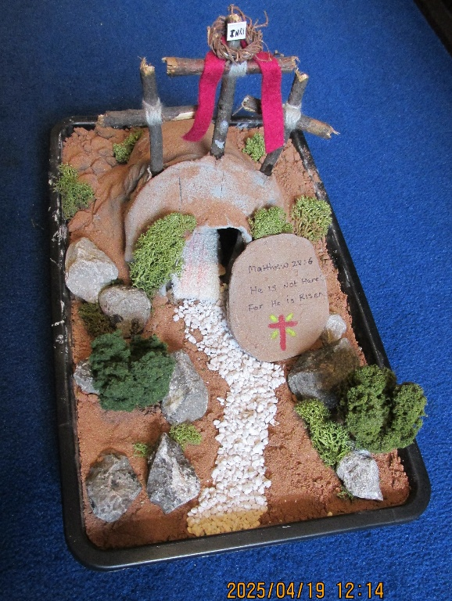
The twins took their role very seriously, writing thoughtful comments supporting their decisions. Harry said of the winning garden "Lots of detail and perfect presentation. It looks like I am actually there!" whilst Sophie added "Love the Bible verse and the detail for the cross".
Gardens featuring Holy Week included the Garden of Gethsemane (with, alongside Jesus and Judas, were sleeping disciples, Roman soldiers and pieces of silver), Palm Sunday where every child from a Reception class dressed a palm waving person and then several of the Empty Tomb - but not forgetting the Turin Shroud in that made by the winner!
Elders have attended assemblies in the schools of the winners which has been a rewarding finale to the event. There have been well over 100 visits to the church website to look at the entries/winning designs and the schools are already talking about next year's competition, which is a very positive sign.
Leeds URC Partnership Away Day
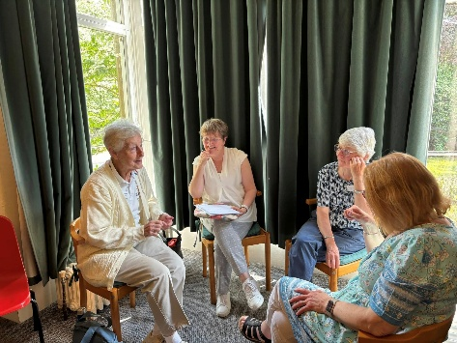
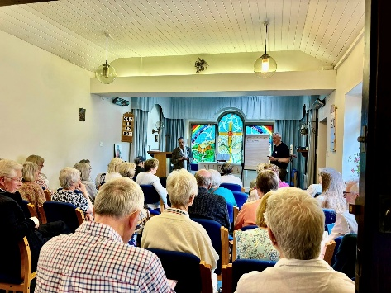
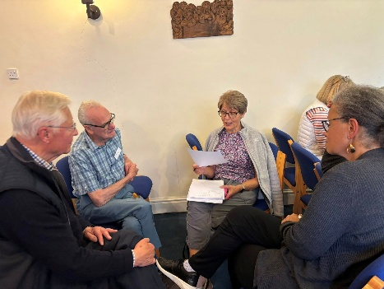
On Saturday the 10th of May, churches across the Leeds URC Partnership came together to talk about the Partnership. We looked at what’s going well and how the partnership could be better. It was a glorious day with prayer and honest conversations. I’m sure there will be many more meetings and much more to come to ensure the Partnership thrives but here are a few photos for now.

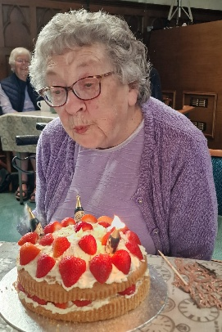
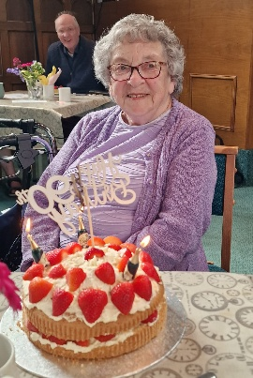
Roundhay URC celebrates Brenda Casey’s 90th Birthday
Normally (a good URC word…..) we don’t mention individual birthdays in The Briefing, but I’m told by the good folk at Roundhay URC that Brenda is a very special lady. She was a founding member of our Pastoral Care Group and is still a willing and valued member of our Forget-me-Not Community Café for people living with Dementia. She was ordained an Elder in 1980 and was involved in the Toddlers Group for many years. Brenda was even willing to undertake her Intermediate Safeguarding to ensure she was fully compliant to help. Brenda talks to people and understands their need. She is an amazing support for many – Ministers, Elders and friends.
Happy Brithday Brenda from all of us in and around the Synod!!

NEWS FROM THE DENOMINATION
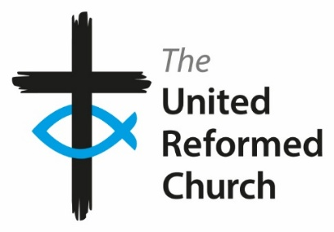
Andy Jackson, URC Head of Communications has sent the following, with links to several of the new videos available to download from the URC’s YouTube channel. Hopefully those who lead services or who are organising supporting events can download them so that they can be shown to a wider audience. You can find the following new videos on the URC’s YouTube channel, www.youtube.com/URCUK

Legacies of Slavery
A video about the trip to Jamaica where the Revd Tessa Henry-Robinson delivered the confessions and apology from the URC for the role played by its forebears in transatlantic slavery, and the failure to dismantle the continuing legacies which blight our world today. Part of an ecumenical pilgrimage to learn more about the legacies of slavery, the trip included Karen Campbell, the URC's Secretary for Global & Intercultural Ministries: https://youtu.be/vYGfPh1za1c. Watch an interview with Tessa about the purpose and meaning of the trip: https://youtu.be/AQmiJ-XDqis, and watch an edited version of the video followed by an interview by Dr Steve Tomkins and the Revd Geoff Felton, Moderator of the URC’s Mersey Synod, who spent his sabbatical learning more about the impact of slavery around the world. https://youtu.be/O9iTASkQ2_s
Read more about this work on the URC website: https://urc.org.uk/who-we-are/what-we-do/legacies-of-slavery/
Supporting Ukrainian Refugees
The conflict in Ukraine is three years old, and it is estimated that up to a million people have been killed or wounded. After the devastation of the Second World War across the UK, communities belonging to the Reformed Church in Transcarpathia collected funds and sent them over to the Reformed churches that now makes up the United Reformed Church. The URC is now helping out the church family in western Ukraine: https://youtu.be/grZ3zCfhicU

What is a Synod?
An introduction to the 13 Synods in Wales, Scotland and England: https://youtu.be/zpiEJbPdsO4. This accompanies the What is the URC? video: https://youtu.be/cee0NbrYtvE

An introduction to the Nominations Committee
Members of the new URC Nominations Committee introduce themselves and how the drive to safer recruitment is having a positive impact on the committees and volunteers that help the church in its life and mission: https://youtu.be/m8wSrjCxJEs?si=hvIN9GCtnaacyZie

150th Anniversary of the World Council of Reformed Churches
With roots in the 16th-century Reformation, and particularly in the theology of John Calvin, the World Communion of Reformed Churches (WCRC) dates its organisational history to London in 1875, and has been unifying churches over the course of its existence. It now represents 100m Christians from 230+ member churches in 109 countries around the world. A service to mark its 150th anniversary will be held on July 12 at the American International Church, Tottenham Court Road.
Free tickets can be reserved here: https://www.eventbrite.co.uk/e/1257520550819?aff=oddtdtcreator

Copyright booklet

Copyright is complicated! The Communications team have updated the copyright booklet but they’ve been told that older versions are lurking on various websites as downloads. If so, can you point to the download link at https://urc.org.uk/your-church/church-guides/getting-to-grips-with-copyright/ so that we cancel out any out of date versions?
This revised booklet sets out to do two things: to take you through some of these licences and agencies, explaining how and when each should be used; and to look at a variety of common copyright scenarios that churches may find themselves in – such as using sheet music, showing TV programmes or photocopying from magazines.

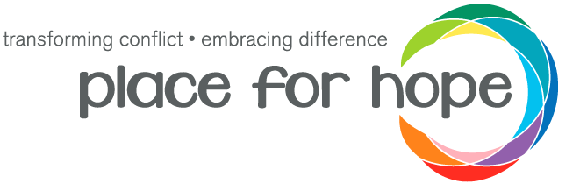
As part of the ongoing strategy and development of the Place for Hope and United Reformed Church partnership which was begun at the URC’s Assembly Executive meeting back in February 2024 (https://urc.org.uk/your-church/place-for-hope-partnership/), Place for Hope are conducting a needs assessment to better understand what is needed to help us reach their goals of creating transformation within our United Reformed churches and equipping our communities to navigate change, difference, and conflict well.

This form, the link to which is below, gives you an opportunity for your voice and opinion to be heard, and to shape the future of the project. All the responses will be used to help form an accurate and deeper understanding of conflict within the URC and will be used to shape the ongoing development of the project. This will help ensure that the programme we are building meets the needs of the wider community and that the roll out is sustainable.

Please follow this link to fill in the form https://forms.gle/1zgeykMcpxm7QSjZ9

The form is a mixture of multiple choice and longer form questions and should take between 15-30 minutes to complete, depending on how detailed the answers you give are! All your responses will be anonymous. Please send this onto anyone you feel may be interested in having a say - I would love as many people as possible to contribute.

If you have any questions, please contact the programme lead, Martha Hunt, on martha.hunt@placeforhope.org.uk.

Delegated Hiring Authority
This is a brief note of advice to all you Church secretaries out there. Some time ago, in 2017, the Yorkshire Congregational Union (Inc) were advised that legally they are responsible for any hiring of church premises to third parties. Accordingly, churches were invited to accept delegated authority from the Trust for temporary, occasional or intermittent third party hiring.
For those who accepted, this means that the authority for hiring your premises has been delegated to your Elders, and the YCU requires a six-monthly return of hirings (to June 30th and December 31st each year).
We are quite short on returns at present, so if your church has not already completed its return, I hope that it can be completed and returned to us at the earliest convenience. If you require a reminder of how to do it and the forms that are used, please contact our Trust officer at trust@urcyorkshire.org.uk.

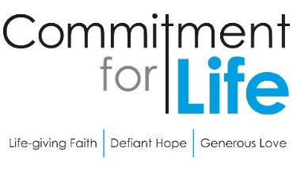
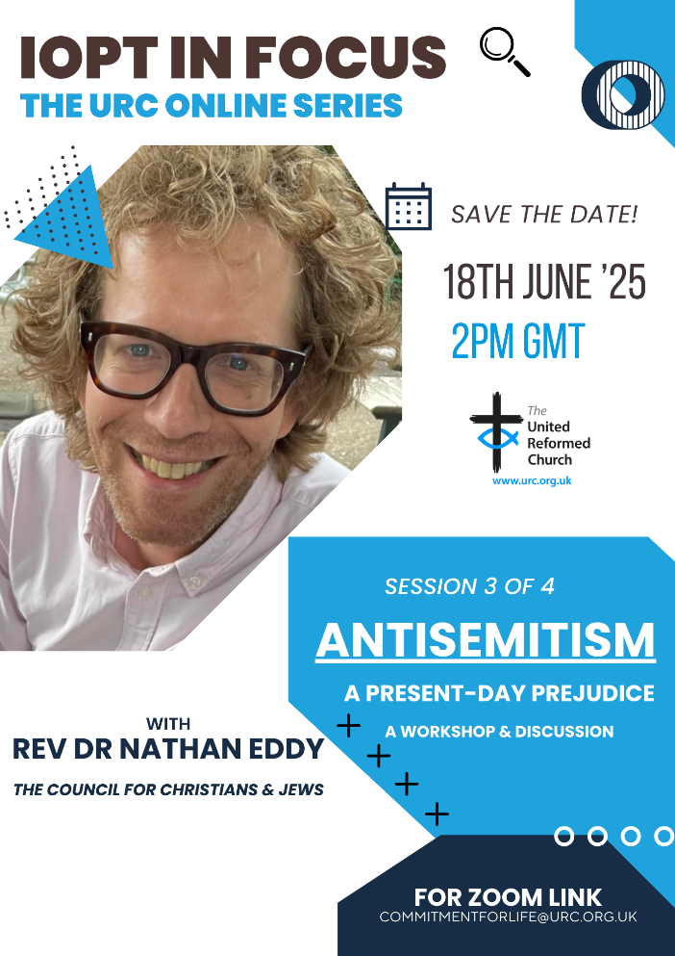
The General Assembly has recommended that URC members and groups widen/deepen their understanding of some of the fundamental issues as to why the conflict in Israel and the occupied Palestinian territory seems so intractable.

The Interfaith Enabling Group together with Commitment for Life are hosting a series of online events, continuing with:

18 June - ANTISEMITISM with Nathan Eddy, Co-Director, Council of Christians and Jews

For more information and a link to the webinars please contact commitmentforlife@urc.org.uk.
_______________________________________
Revd Dr Kevin Snyman
Programme Officer, Global Justice, Partnerships, & Inter Faith Relations

To learn more about what Commitment for Life is all about, and how your church can get involved, please visit the https://urc.org.uk/your-church/church-local-and-global/commitment-for-life/ page on the URC website. Here you will see that Commitment for Life is the URC’s global justice programme. Our goal is to enable you, the local congregation, to make global justice a core foundation of your mission. We offer resources to facilitate prayer, advocacy, and effective action for the most vulnerable people in the world.

SAFEGUARDING
The Safeguarding team have asked that you are reminded that they are available 24 hours a day, seven days a week and 365 days a year (and even 366 days in Leap Years!!). Details can be found on the Yorkshire website at https://urcyorkshire.org.uk/safeguarding/ and any query, either by phone or by e-mail at safeguarding.1and4@urc.org.uk will be answered within 24 hours.

SAFEGUARDING TRAINING COURSES
The following Safeguarding Training courses are now available for 2025.
All these courses are to be held via zoom and to book a place please contact Paula Kitson – paulakitson.1and4@urc.org.uk
Thursday 5th June 2025 – 7pm – Refresher training
Tuesday 24th June – Advanced Training at Bilton Grange URC

National Churches Trust
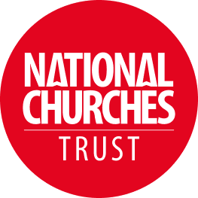
The House of Good: Local
Capture and showcase the social and economic value your church brings to its community using our free online tool in under 30 minutes.
Take me to the calculator or follow this link:
https://www.nationalchurchestrust.org/houseofgood-local

Our Property officer, Jane Bunyan, has asked that churches make use of this digital tool from the National Churches Trust. By using this tool, you can highlight the crucial role your church plays in supporting local people as well as strengthening your case for fundraising, the motivation volunteers, and be able to contribute to the future planning of your church's mission.

The calculator works out the social, economic and wellbeing value of your church by using information taken from nine questions about activities at your building. Once you have the data, you should be able to complete The House of Good: Local calculator in under 30 minutes.

If you have any questions or need any help with the calculator, get in touch with us at houseofgood@nationalchurchestrust.org

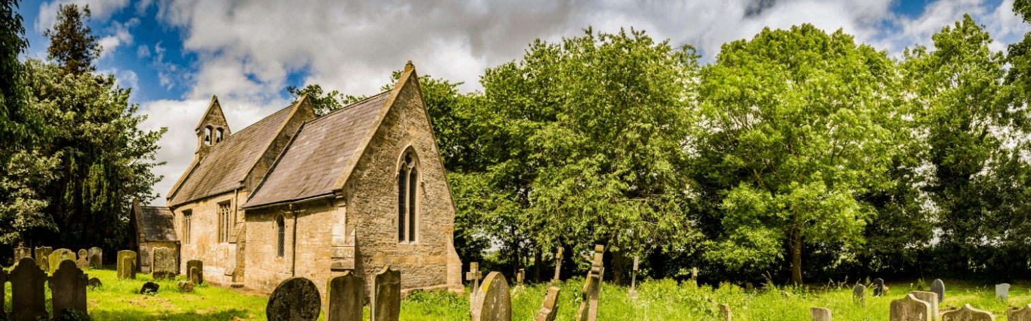
And Finally
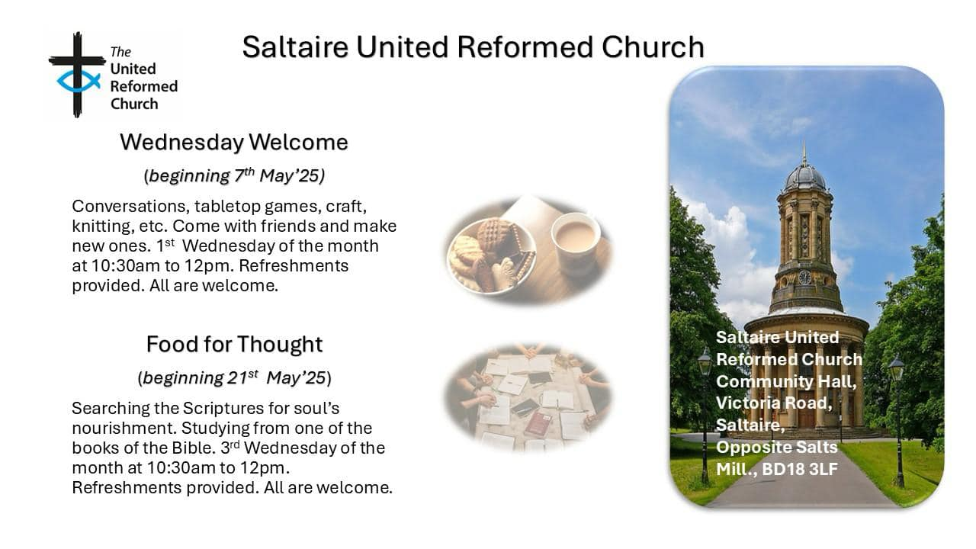
Welcomes and Food at Saltaire
This summer sees Saltaire URC reaching out into the World Heritage site in which it sits to invite people into join them in crafting or in studying. Already started is the Wednesday Welcome which offers conversation, games, crafts and refreshments. Coming soon will be the Food For Thought monthly Bible studies, again with refreshments. The invitation is open to all, so if you are in the Saltaire area on either the first or third Wednesdays in the month you will be assured of a very warm welcome.

If you have a good news story from your part of the Synod or something that you feel would enhance the work of Synod in 2025, drop me a line at clerk@urcyorkshire.org.uk and I’ll make sure it hits the back page!!

You can also keep an eye on all our social media platforms for news; on the website at Home - URC Yorkshire Synod, at United Reformed Church in Yorkshire - Home | Facebook and Wilderness URC Yorkshire - Home | Facebook, the YouTube page at URC Yorkshire - YouTube and the Twitter (X) page at URC in Yorkshire (@URCYorkshire) / Twitter.

