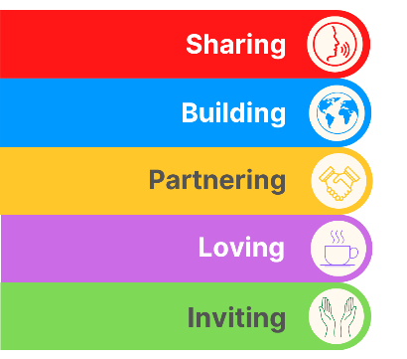
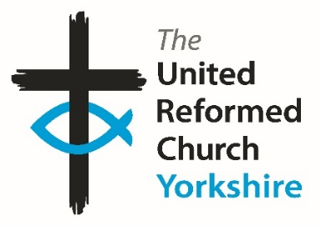
Yorkshire Synod Briefing
Number 154

5th June 2025

HERE COMES THE SUMMER!!
As we approach the start of Summer it is well worth noting that we are now halfway through the Forums season. Two successful gatherings have already taken place at St Ninian’s & St Andrew’s in Hull and at West Park in Harrogate. This Saturday sees the forum meeting at Ravensthorpe with Hopton URC and then again at West Melton on 12th July. Please do try to attend and join in the faith-shaped conversations about “Vocation and Leadership” and later next month I hope to bring some stories from all four of the forums. However a snippet of what happened at West Park URC last week has been uploaded to the Synod’s website at https://urcyorkshire.org.uk/a-buzz-around-the-room-at-synod-forum/
You’ll see below that there are some pictures from last month’s Big Day Out. I gather that there will be some feedback e-mails being sent out. So if you attended, please let us know what you thought about the day, and in the meantime you can read one of our new Children and Youth Co-ordinator Tony Harris’s thoughts on his first visit to a Yorkshire Synod Big Day Out below.
After the Big Singathon at Trinity St Andrew’s, which celebrated 50 years as a Local Ecumenical Partnership and supported Christian Aid, there were a few sore piano playing fingers and hoarse voices after playing every hymn in “Singing The Faith on 24th May. Happily they are still smiling in Skipton and have been able to send us a report which is below.
With there being a three week gap since the last Briefing there is a great deal of activity this time, with advance notices of lots of events over the summer and, dare I say, into the autumn. Summer tends to be a bit quiet in terms of events and activities, but I’m happy to say that Yorkshire Synod seems to be bucking that particular trend. So have a look through what is on offer, what you are being invited to - there’s no excuse not to participate - and bring these events to the attention of those you meet in church, at home or elsewhere.
As ever we are always looking for people to help in the mission and direction of Synod and the URC in general. In Yorkshire we are still looking for people to populate our Listed Buildings Advisory, Financial Resources and Property Committees, whilst around the country there are several Synod and National roles that are needing to be filled. If you feel as though you can offer experience to the Synod please follow that call or if you know of someone who you feel has those gifts to offer, then please contact the Clerk at clerk@urcyorkshire.org.uk or our Moderator Rev Jamie Kissack at moderator@urcyorkshire.org.uk.

If you have any news of welcoming people into Church, stories of celebration and hope or even notices of future events, please let me know by dropping me a line at clerk@urcyorkshire.org.uk and I’ll showcase it in the next edition, due out on Thursday 19th June 2025.
Thank you
Tim Crossley
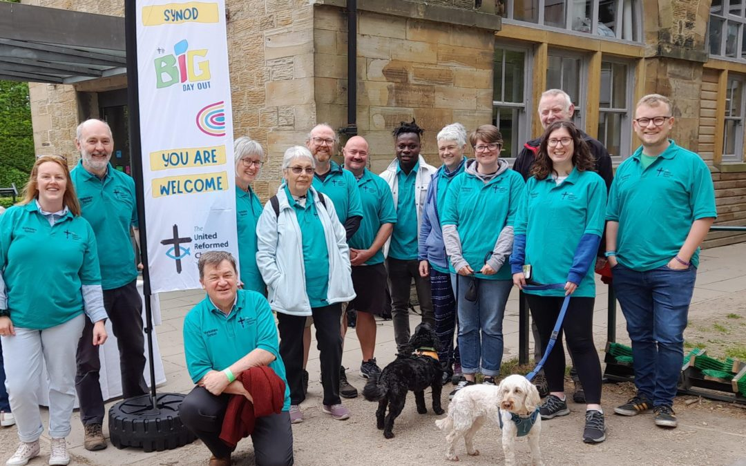
BIG DAY OUT 2025
Yorkshire Synod’s BIG Day Out happened on Saturday 17th May at The Yorkshire Sculpture Park. All our churches were invited and the sun shone for this special occasion. Over 100 people attended and the feedback has so far been extremely positive.
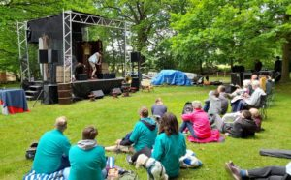
Read what Tony Harris, our Children, Youth and Family Enabler for the ‘NOW’ Mission and Care Group had to say about the day:- “What a wonderful Big Day Out we all had (we, being myself and my 4 boys, wife and dog). Lovely weather, great venue, new friends and lots to do.
I had the privilege of being in the craft area and shared some fun stories and even invented some mascots, hopefully everyone who entered enjoyed the free craft that were provided including bug making, magnifying glasses and bracelets.
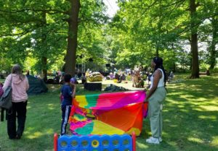
This was mine and my family’s first event with Yorkshire Synod and we all left buzzing (my 5 year old actually fell asleep on the way home) and had stories to share from enjoying dancing, badminton, the amazing 4Front Theatre Company and the Forest church.
Something for everyone and everyone was involved. THAT is church!
What really made it special was the fact that we all met someone new, made friends and plan to meet.
This is what I believe sets the URC apart from others.”
https://urcyorkshire.org.uk/the-big-day-out-a-wonderful-day/



For more information and to send in your designs, contact wilderness@urcyorkshire.org.uk
and don’t forget THE CLOSING DATE IS FRIDAY 20th JUNE!!
Trinity St Andrew’s “THE BIG SINGATHON”
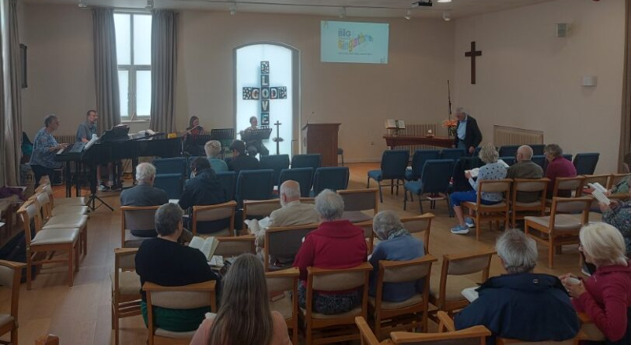
To celebrate the 50th anniversary of the creation of the Local Ecumenical Partnership between Skipton United Reformed Church, Broughton Road Methodist Church and Gargrave Road Methodist Church on Whit Sunday in 1975 (and later to be joined by Trinity Methodist Church in 2023) the Music Group at Trinity St Andrew’s in Skipton held the The Big Church Singathon on Saturday 24th May and it was a Big Success.
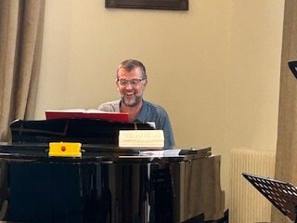
The Music Group played and sang for 14 hours - from 8am to 10pm - singing the first verse of every single one of the 790 hymns in the Singing the Faith hymnbook.
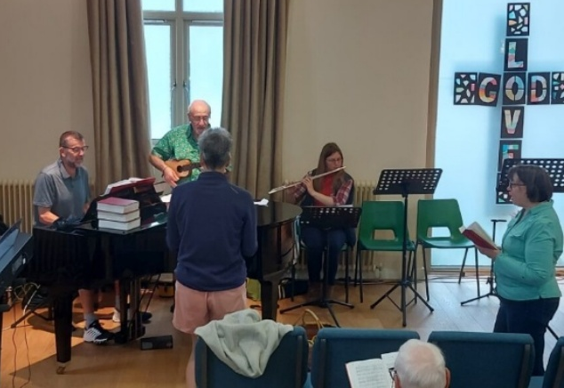
Jonathan Crossley, seen here still smiling on the left, played piano throughout the day, together with Susannah Morrish on flute. They were assisted by members of the Music Group – Chris on guitar, Rachel on another flute as well as by the Trinity St Andrews congregation.
People came and went throughout the day – joining in with the singing and enjoying a range of refreshments.
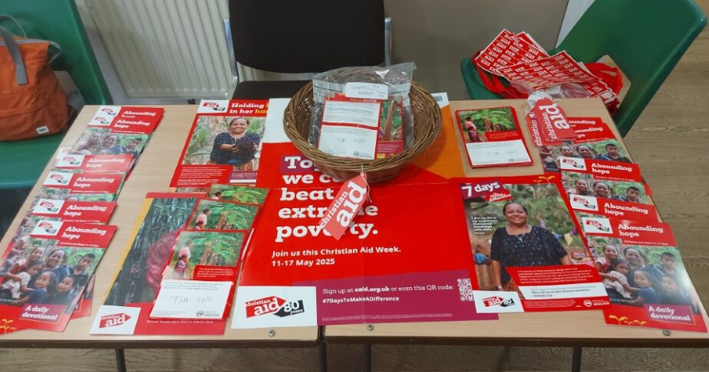

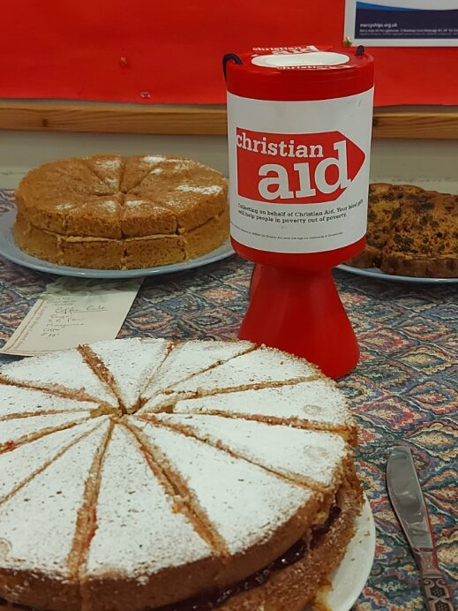

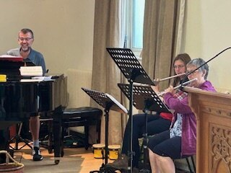
The performance raised and incredible £1631 for Christian Aid and it may be that the JustGiving page is still open for further contributions at www.justgiving.com/page/jon-crossley-1

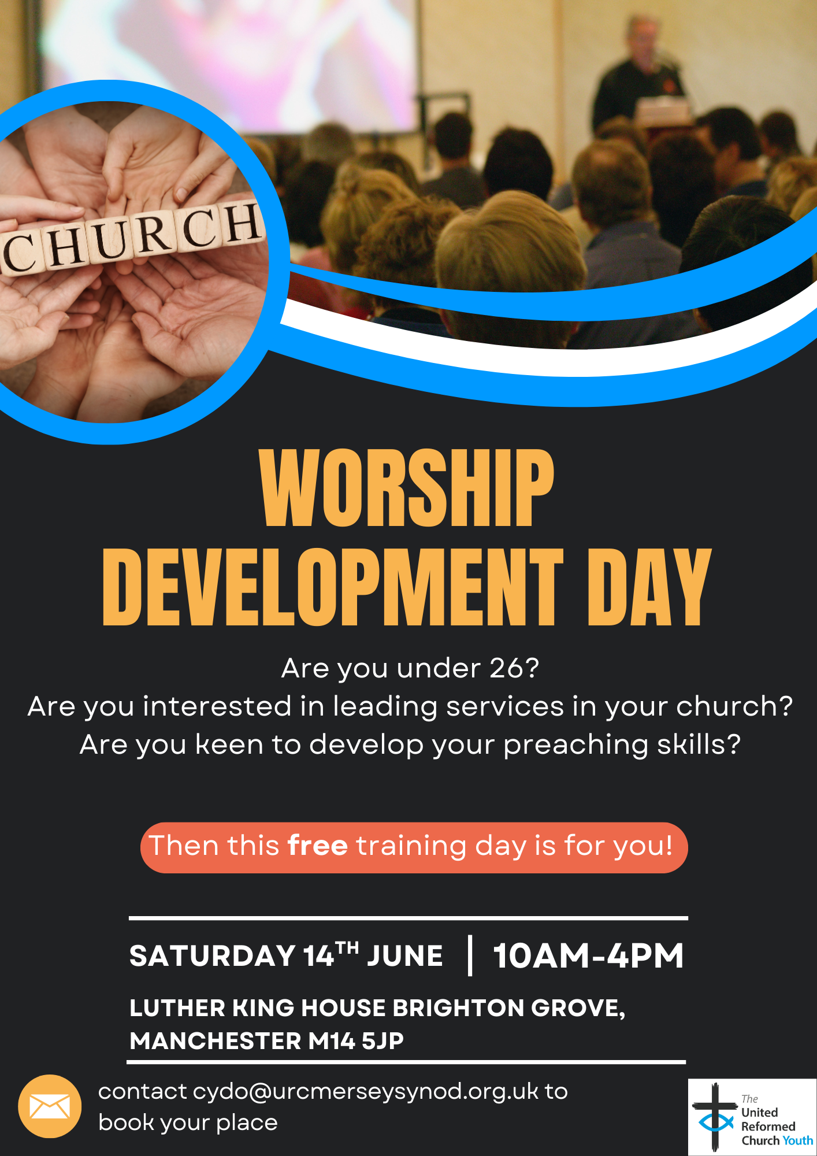For more information and the relevant consent forms, please contact Meghan Tillbrook at megancyp@urcyorkshire.org.uk or via the Synod Office at office@urcyorkshire.org.uk

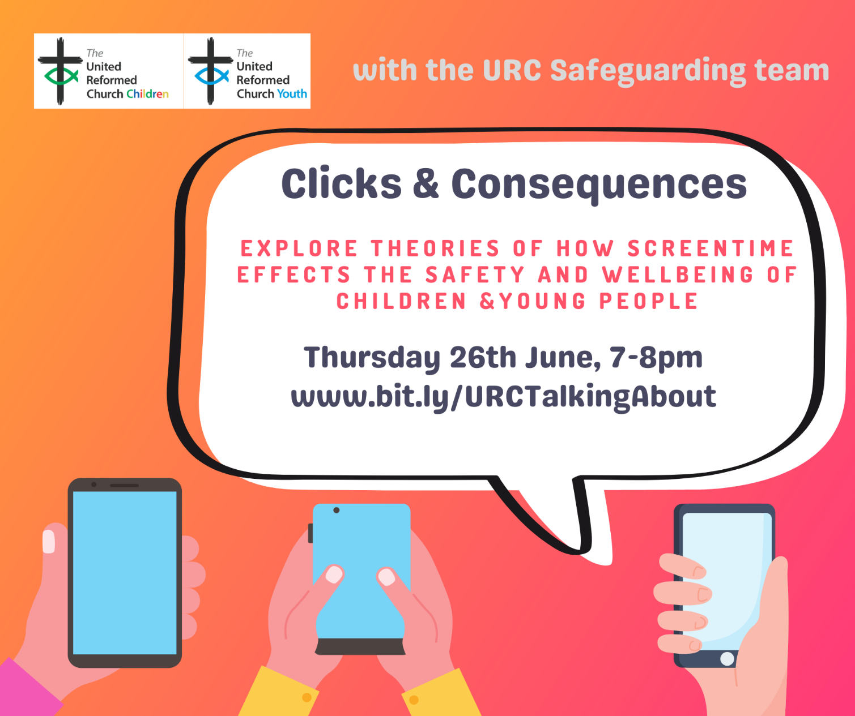

Forming a new “Community of Pioneering”
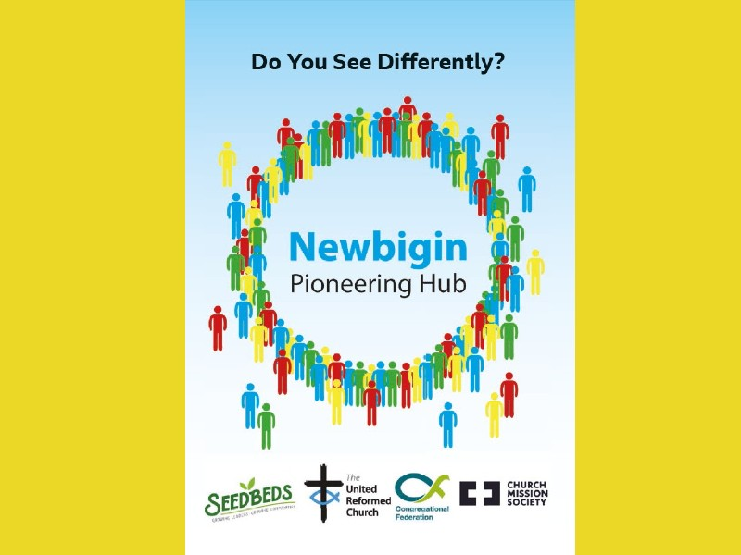
Also on Thursday 26 June at 6:30pm is an Online Taster Evening for the 2025-26 Newbigin Pioneering Hub for any potential candidates for the next cohort to ask any questions, being led by Ash Barker.
The Newbigin Pioneering Hub aims to discover, nurture, empower and release a new generation of Pioneers. This will include helping Pioneers connect with new mission contexts, pathways, retreats and coaching.
This Online Taster Event is an opportunity to connect, find out more and ask questions about the ‘Community of Pioneers’ and the ‘Certificate in Pioneer Mission’ programme that is run by the ‘Newbigin Pioneering Hub’.
The next online taster event will take place on Thursday 26 June 2025 at 6:30pm, with the opportunity to ask any questions about the pioneering programme on zoom with Rev Dr Ash Barker. Log in on zoom at https://us02web.zoom.us/j/2844925967.
For more information on the Newbigin Pioneering Hub’s September 2025 - July 2026 programme click here https://seedbeds.org/newbigin-pioneering-hub-2/ and to apply, click here https://seedbeds.org/newbigin-pioneering-hub/ .
FORUM FOR YOUTH
FORUM FOR YOUTH is back. After the successful event at Heckmondwike back in March, FORUM FOR YOUTH meet again on Saturday 5th July at The Stag Community Church (Herringthorpe URC) on Wickersley Road in Rotherham.
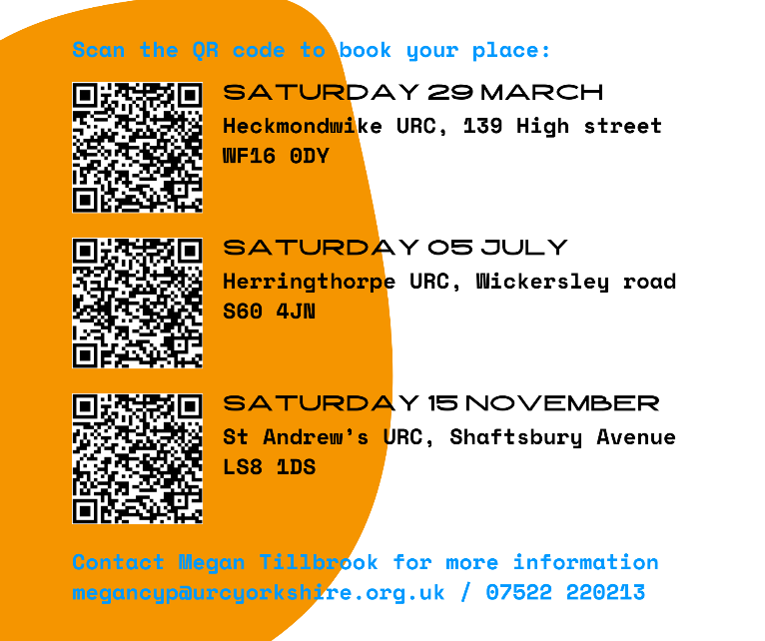
The voice of young people is important in the Yorkshire synod, so this is a time to come together with other young people from across the synod to read the Bible, share conversation and develop friendships.
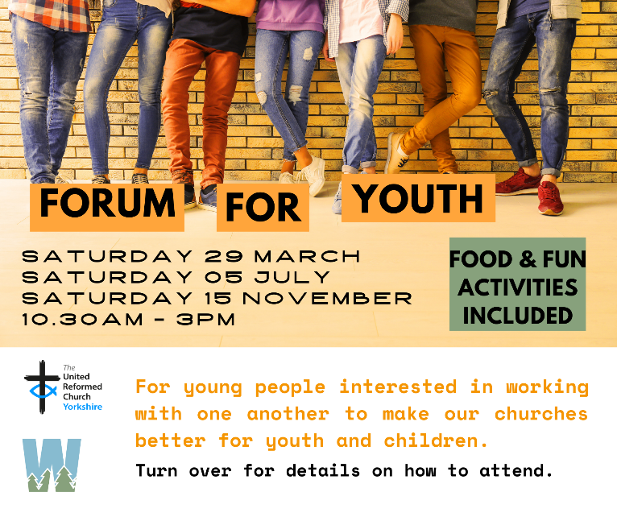
We will spend some time considering the issues of accessibility and inclusion and community (and any other issues you feel called to share) and shape what we want to say to local churches in engaging with these issues. There will be various fun, summer activities to do together including a colour run, and lunch will be provided. For more information and to book, either scan the QR code above or contact Megan at megancyp@urcyorkshire.org.uk.

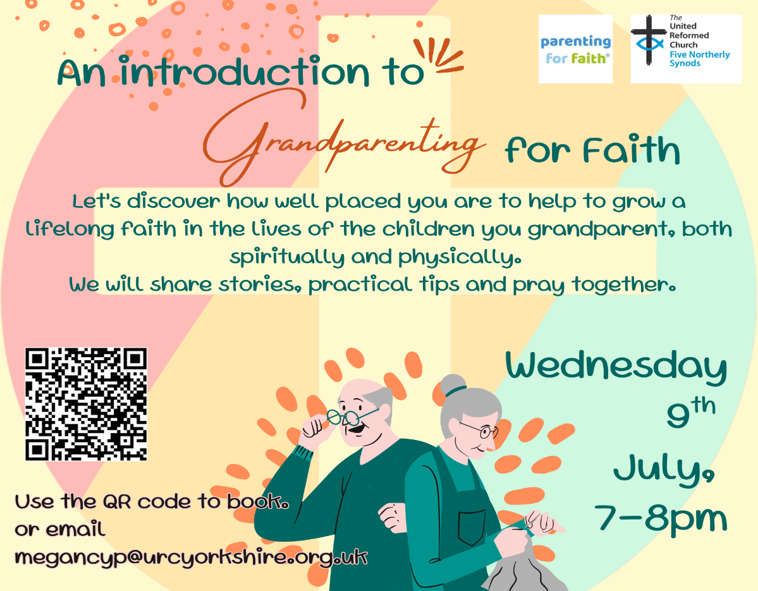

Leading Your Church into Growth
2025 Yorkshire Synod Programme
The Synod is pleased to announce that our recently retired Synod Evangelist, Rev Ashley Evans, is running a couple of ‘Leading Your Church into Growth (LYCiG) Vision Days’ being held at various churches within our Synod over the coming months. The day is to seek God’s vision for your church and to help you implement it. We hope your church will be able to take part in one of them.
The first two have happened but if you missed it there are two others over the summer.

Saturday 28th June at The Bridge URC, Otley
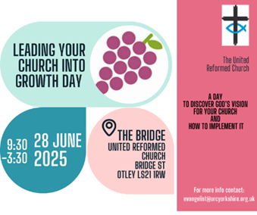
Saturday 5th July at Gleadless URC, Sheffield
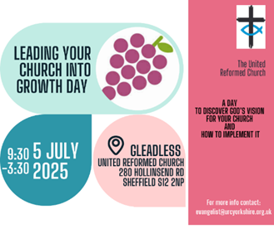

Both from 9.30am – 3.30pm
For more information and booking, please contact the office team at office@urcyorkshire.org.uk

Yorkshire Synod Discipleship Development Small Grant Fund 2025
The Ministries Committee have so far approved 21 applications to this fund since 2022 and we encourage all lay church members to consider applying in 2025. Please use the new application form available through the Synod Office as the amount which you can ask for resources or has increased to up to £300. This fund exists to help you on your Christian journey including the costs of attending a course or to offset the costs of buying resources for personal development or sharing with others. If anyone wants to discuss an application before submitting it please contact the Convener of the Yorkshire Ministries Committee, Kath Lonsdale at kathlonsdale@talktalk.net.
Remember this is for any age of lay person in our churches to apply for so please discuss with your young people as well as adults.

Discipleship Development Fund Large Grants
Up to £5,000 per award per year is available to recognised groups within the URC which can apply for the Discipleship Development Fund Large Grant. Grants can be put towards any purpose that will contribute to the discipleship development of lay people in or connected with the URC. Multi-year projects can be supported for up to three years and a tapered approach to funding is encouraged. Applications for grants that only partially fund a project are acceptable, but the application will need to identify the source of the other funds. Any recognised group can apply, but if the group applying is not an Assembly Committee or a Synod, they will need approval from their Assembly Committee or Synod. In Yorkshire’s case, then applications need to be sent via our Ministries Committee Convener, Kath Lonsdale at kathlonsdale@talktalk.net. Applicants will need to clearly demonstrate how the grant will be used to develop discipleship and lifelong learning within the URC. More information can be found at: https://urc.org.uk/your-faith/developing-your-faith/discipleship-development-fund/
The latest deadline for applications is 30th June, so for you to meet that deadline, please get any applications into Kath as soon as you can.

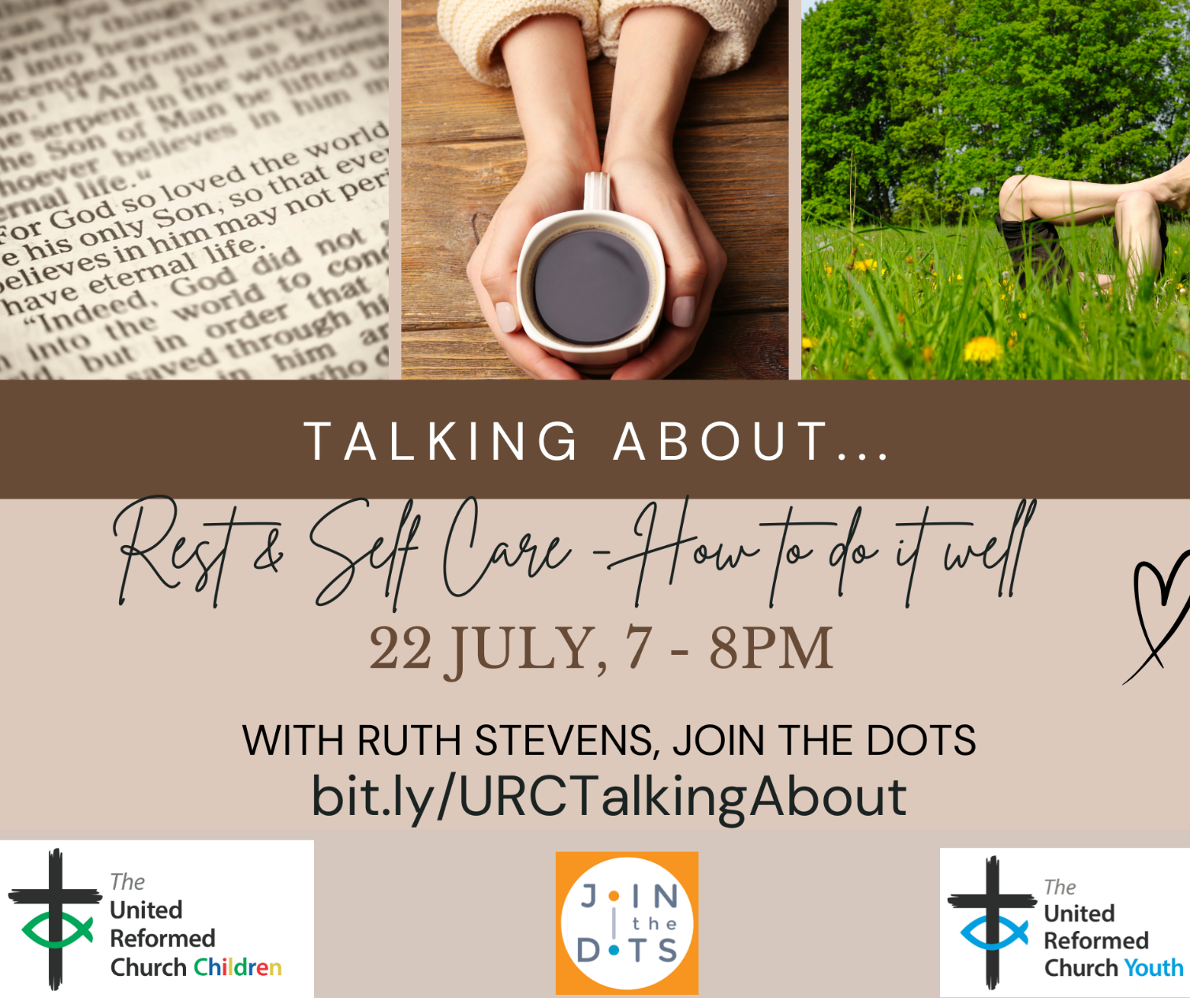

Yorkshire Speak Their Name



During the recent Saltaire Arts Trail over the May Bank Holiday Weekend, Saltaire URC hosted a section of the Baton of Hope Tour. https://batonofhopeuk.org/the-tour/
This was part of ‘Yorkshire Speak their Name’, the UK memorial site remembering loved ones lost to suicide https://speaktheirname.org/
Individuals who have experienced suicide by a loved one, made some amazing squares which were made into banners. This was an incredibly moving and powerful exhibition which was beautifully displayed in the sanctuary of Saltaire URC.
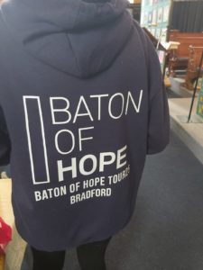
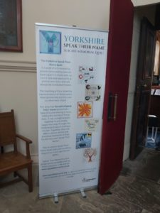
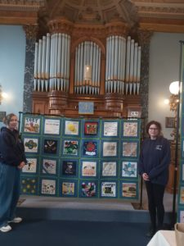

Lay Preachers’ and Worship Leaders’ Weekend

“Hope in a Troubled World"

25th – 27th July 2025
(Friday teatime to Sunday lunch)

at Wydale Conference Centre, Brompton by Sawdon near Scarborough www.wydale.org



We are excited that Hannah Fytche, Associate New Testament Tutor at Westminster College, will be our main speaker at the conference, and that we will be joined by our Moderator, Rev Jamie Kissack.

This weekend will again be paid for by Synod and grants so you will only need to cover your travel costs.

To register your place, contact:
office@urcyorkshire.org.uk or 0113 289 8490.

For any queries, contact Kath at:
kathlonsdale@talktalk.net
01274 315203 or 07759525936

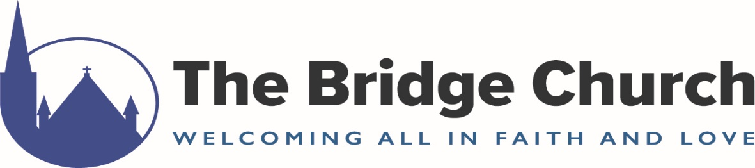

The Bridge Church, The United Reformed Church in Otley, Bridge St., Otley, West Yorks, LS21 1RW
CHILDREN & FAMILIES WORKER
A three year post to develop both church-based and community work with children and families.
• Full time (37.5 hours per week) Fixed Term Contract
• £27,711 - £30,060 (depending on experience)
The Bridge Church is a United Reformed Church accredited Children and Youth Friendly Church, and has extensive children’s work
We are seeking an enthusiastic worker, who will work with our volunteers to develop and expand this work further and make links with local schools and community groups.
An information pack, together with application form can be downloaded from the church website – www.otleybridgechurch.org.uk
Completed application forms must be returned to our Safeguarding Co-ordinator, Colin Whitaker at colin@otleybridgechurch.org.uk by Monday 30th June 2025.
Interview, for those shortlisted, will take place on Tuesday 5th August 2025.

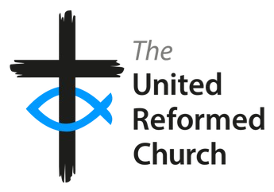
Church Family Support & Outreach Worker
(18 hours pw)
F/T Salary circa £29k P/T Pro Rata

Are you a people person who enjoys making connections?

Apply for full details to St Andrew’s URC Chesterfield
Revd Don Nichols standrewschesterfieldjob@gmail.com

by 23rd June.

NEWS FROM THE DENOMINATION
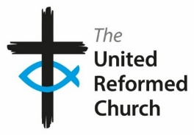
Andy Jackson, URC Head of Communications has sent the following, with links to several of the new videos available to download from the URC’s YouTube channel. Hopefully those who lead services or who are organising supporting events can download them so that they can be shown to a wider audience. You can find the following new videos on the URC’s YouTube channel, www.youtube.com/URCUK

Legacies of Slavery
A video about the trip to Jamaica where the Revd Tessa Henry-Robinson delivered the confessions and apology from the URC for the role played by its forebears in transatlantic slavery, and the failure to dismantle the continuing legacies which blight our world today: https://youtu.be/vYGfPh1za1c. Watch an interview with Tessa about the purpose and meaning of the trip: https://youtu.be/AQmiJ-XDqis, and watch an edited version of the video followed by an interview by Dr Steve Tomkins and the Revd Geoff Felton, Moderator of the URC’s Mersey Synod, who spent his sabbatical learning more about the impact of slavery around the world. https://youtu.be/O9iTASkQ2_s
Read more about this work on the URC website: https://urc.org.uk/who-we-are/what-we-do/legacies-of-slavery/
What is a Synod?
An introduction to the 13 Synods in Wales, Scotland and England: https://youtu.be/zpiEJbPdsO4. This accompanies the What is the URC? video: https://youtu.be/cee0NbrYtvE

An introduction to the Nominations Committee
Members of the new URC Nominations Committee introduce themselves and how the drive to safer recruitment is having a positive impact on the committees and volunteers that help the church in its life and mission: https://youtu.be/m8wSrjCxJEs?si=hvIN9GCtnaacyZie

150th Anniversary of the World Council of Reformed Churches
With roots in the 16th-century Reformation, and particularly in the theology of John Calvin, the World Communion of Reformed Churches (WCRC) dates its organisational history to London in 1875, and has been unifying churches over the course of its existence. It now represents 100m Christians from 230+ member churches in 109 countries around the world. A service to mark its 150th anniversary will be held on July 12 at the American International Church, Tottenham Court Road.
Free tickets can be reserved here: https://www.eventbrite.co.uk/e/1257520550819?aff=oddtdtcreator

Copyright booklet

Copyright is complicated! The Communications team have updated the copyright booklet but they’ve been told that older versions are lurking on various websites as downloads. If so, can you point to the download link at https://urc.org.uk/your-church/church-guides/getting-to-grips-with-copyright/ so that we cancel out any out of date versions?
This revised booklet sets out to do two things: to take you through some of these licences and agencies, explaining how and when each should be used; and to look at a variety of common copyright scenarios that churches may find themselves in – such as using sheet music, showing TV programmes or photocopying from magazines.

Accreditations Sub-Committee Convener
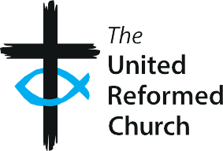
Do you have a passion to support people who release the church in its local community to flourish in faith, hope and love? Then this could be the opportunity for you!
Ministries Committee is looking for a convener for its Accreditations Sub-Committee to replace its current convenor who will complete their term at the July 2025 General Assembly. The convener will need to have working knowledge of the formal ministries of the United Reformed Church.
The Accreditations Sub-committee plays a vital role in supporting and creating new opportunities in shaping posts to be recognised as Church Related Community Work projects or Pioneering posts including current Special Category ministries, in approving certificates for ministers from partner churches both at home and abroad to serve with us, and in analysing trends in the Rolls of Ministers of the Word and Sacraments and Church Related Community Workers, Elders, Assembly Accredited Lay Preachers and Assembly Accredited Lay Pioneers.
Please click the link for the full role description and if interested in making an application or nomination, please email ministries@urc.org.uk for an application form.
https://urc.org.uk/wp-content/uploads/2025/05/ASC-Convener.pdf
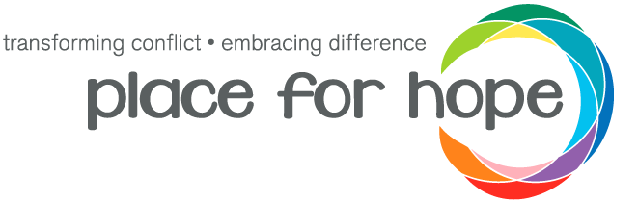
As part of the ongoing strategy and development of the Place for Hope and United Reformed Church partnership which was begun at the URC’s Assembly Executive meeting back in February 2024 (https://urc.org.uk/your-church/place-for-hope-partnership/), Place for Hope are conducting a needs assessment to better understand what is needed to help us reach their goals of creating transformation within our United Reformed churches and equipping our communities to navigate change, difference, and conflict well.

This form, the link to which is below, gives you an opportunity for your voice and opinion to be heard, and to shape the future of the project. All the responses will be used to help form an accurate and deeper understanding of conflict within the URC, and will be used to shape the ongoing development of the project. This will help ensure that the programme we are building meets the needs of the wider community and that the roll out is sustainable.

Please follow this link to fill in the form https://forms.gle/1zgeykMcpxm7QSjZ9

The form is a mixture of multiple choice and longer form questions and should take between 15-30 minutes to complete, depending on how detailed the answers you give are! All your responses will be anonymous. Please send this onto anyone you feel may be interested in having a say - I would love as many people as possible to contribute.

If you have any questions, please contact the programme lead, Martha Hunt , on martha.hunt@placeforhope.org.uk.

Delegated Hiring Authority
This is a brief note of advice to all you Church Secretaries out there. Some time ago, in 2017, the Yorkshire Congregational Union (Inc) were advised that legally they are responsible for any hiring of church premises to third parties. Accordingly, churches were invited to accept delegated authority from the Trust for temporary, occasional or intermittent third party hiring.
For those who accepted, this means that the authority for hiring your premises has been delegated to your Elders, and the YCU requires a six-monthly return of hirings (to June 30th and December 31st each year).
We are quite short on returns at present, so if your church has not already completed its return, I hope that it can be completed and returned to us at the earliest convenience. If you require a reminder of how to do it and the forms that are used, please contact our Trust officer at trust@urcyorkshire.org.uk.

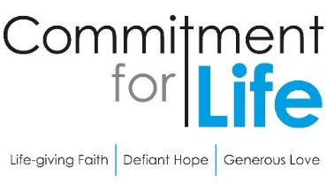
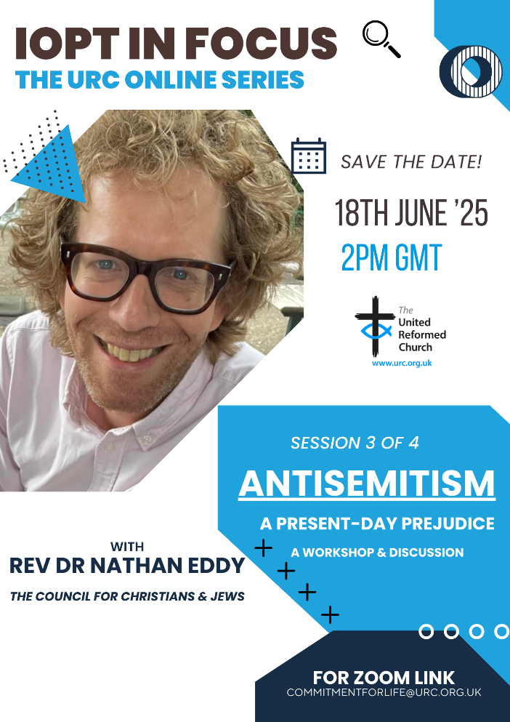
The General Assembly has recommended that URC members and groups widen/deepen their understanding of some of the fundamental issues as to why the conflict in Israel and the occupied Palestinian territory seems so intractable.

The Interfaith Enabling Group together with Commitment for Life are hosting a series of online events, continuing with:

18 June - ANTISEMITISM with Nathan Eddy, Co-Director, Council of Christians and Jews

For more information and a link to the webinars please contact commitmentforlife@urc.org.uk.
_______________________________________
Revd Dr Kevin Snyman
Programme Officer, Global Justice, Partnerships, & Inter Faith Relations

To learn more about what Commitment for Life is all about, and how your church can get involved, please visit the https://urc.org.uk/your-church/church-local-and-global/commitment-for-life/ page on the URC website. Here you will see that Commitment for Life is the URC’s global justice programme. Our goal is to enable you, the local congregation, to make global justice a core foundation of your mission. We offer resources to facilitate prayer, advocacy, and effective action for the most vulnerable people in the world.

Church Action on Poverty
I do not know if you have heard already but the next Poverty Sunday has been brought forward to Sunday 19 October 2025 to tie in with Challenge Poverty Week. What do you think the Church (plural) should do on this occasion to join up and pray about the issue and how it affects many of God's people and what we can do more to help those in need. If you feel called to this work, please contact the Church Action on Poverty team through the details below.

SAFEGUARDING
The Safeguarding team have asked that you are reminded that they are available 24 hours a day, seven days a week and 365 days a year (and even 366 days in Leap Years!!). Details can be found on the Yorkshire website at https://urcyorkshire.org.uk/safeguarding/ and any query, either by phone or by e-mail at safeguarding.1and4@urc.org.uk will be answered within 24 hours.

SAFEGUARDING TRAINING COURSES
The following Safeguarding Training courses are now available for 2025.
All these courses are to be held via zoom and to book a place please contact Paula Kitson – paulakitson.1and4@urc.org.uk
Tuesday 24th June – Advanced Training at Bilton Grange URC

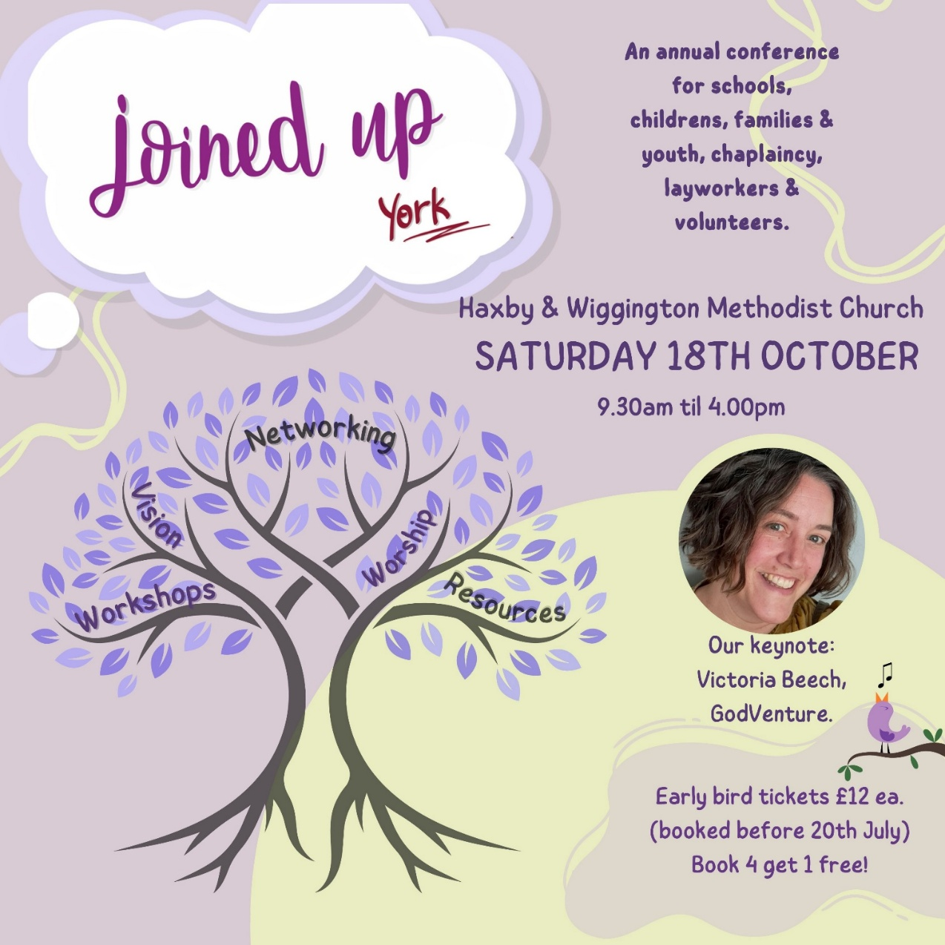
For more information and to get your Early Bird tickets follow this link https://joinedupconferencecom.wordpress.com/york/

Ministers wishing to transfer to the United Reformed Church
Ministers of other churches wishing to transfer to the United Reformed Church can seek a Certificate of Eligibility to come on to the Roll of Ministers of the United Reformed Church. Applications should be received by 31st July 2025, with initial interviews via Zoom in August. Successful candidates will be invited to attend an in-person Assessment Conference from 30th October – 1st November 2025 in Cambridge, UK.
Applications are welcome from ministers who are members of churches that are either a member of Churches Together in Britain and Ireland, the Council for World Mission, or the World Communion of Reformed Churches. Your application should evidence experience in local pastorate ministry (minimum 5 years) in a leadership role; intercultural competence; understanding/experience of working in multi-church pastorates/settings and a readiness and willingness to serve in any part of the UK. Those interested should contact the Ministries Office (ministries@urc.org.uk 020 7916 8649) for an application pack.

And Finally
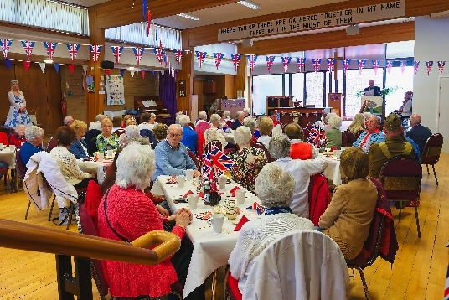
Wigton Moor URC Commemorates VE Day
Wigton Moor Church Leeds held a big event for the local community to commemorate VE Day 80.
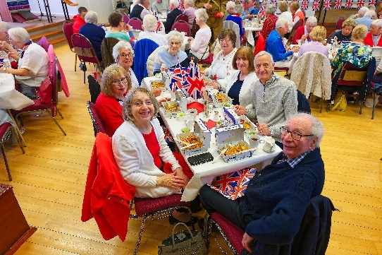
The event began with an act of remembrance followed by a church member delivering Winston Churchill’s VE day speech. This was followed by a lunch of fish and chips with a dessert of sticky toffee pudding and custard.

An order for 95 portions of fish and chips was required from the local fish and chip shop! A sing song took place in the afternoon and a good time was had by all.

There are more photographs on the Wigton Moor URC website at https://www.wigtonmoorchurch.co.uk/news-and-events and even better you can follow their embedded link to photographer Malcolm Poole’s own site at https://photos.google.com/share/AF1QipNYTur1-Gk709b0Y1AATO2rlHC5tcbTnHC6TETuMiiEzcJ65veKzT31SrXwtElxQg?pli=1&key=MFVDZXpabVNBMnN0eFVkZHhvVzlieS04SW96RGdB

If you have a good news story from your part of the Synod or something that you feel would enhance the work of Synod in 2025, drop me a line at clerk@urcyorkshire.org.uk and I’ll make sure it hits the back page!!

You can also keep an eye on all our social media platforms for news; on the website at Home - URC Yorkshire Synod, at United Reformed Church in Yorkshire - Home | Facebook and Wilderness URC Yorkshire - Home | Facebook, the YouTube page at URC Yorkshire - YouTube and the Twitter (X) page at URC in Yorkshire (@URCYorkshire) / Twitter.

