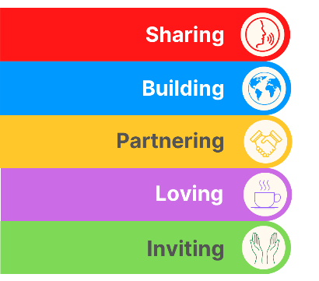
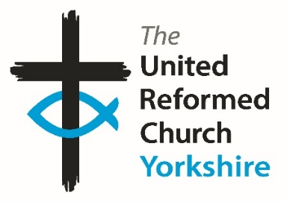
Yorkshire Synod Briefing
Number 157

24th July 2025

MISSIONAL SUMMER
It was brought to my attention this week that our “Mission” page on the Yorkshire Synod website at https://urcyorkshire.org.uk/mission/ is woefully out of date and short of stories. Much of what you will read in this Briefing (as well as in past ones, and no doubt in future ones) are invitations to events within and around the Synod. One thing that I have always been short of are stories of Mission. Fortunately in the last issue we got to know that two pieces of mission had received Highly Commended 2025 Community Project Awards, namely the Forget-Me-Not Café at St Andrews Roundhay and Soupermums at Wilsden Trinity Church and as a reminder you can still see the videos on the URC denominational website at https://urc.org.uk/2025-community-project-awards-winners-announced/ .
So this is a plea to all of you out there who are doing missional work in your community to share it around the Synod. I can report on it here and we can add it to the website, as testiment to what you can do to bring Jesus into the hearts of those who we meet both within and without the four walls of our buildings.
It doesn’t matter what you do as I’m sure it will fall in our 5 Threads and I’m sure that we can all learn from and celebrate with those churches who are working hard to bring God’s Kingdom closer.
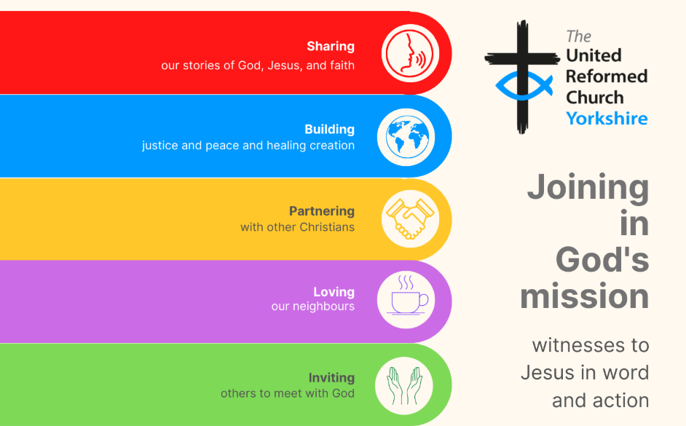
https://urcyorkshire.org.uk/wp-content/uploads/2024/05/5-threads-flyer-Joining-in-Gods-Mission-FINAL.pdf
If you have any news of welcoming people into Church, stories of celebration and hope or even notices of future events, please let me know by dropping me a line at clerk@urcyorkshire.org.uk and I’ll showcase it in the next edition, due out on Thursday 7th August 2025.
Thank you
Tim Crossley
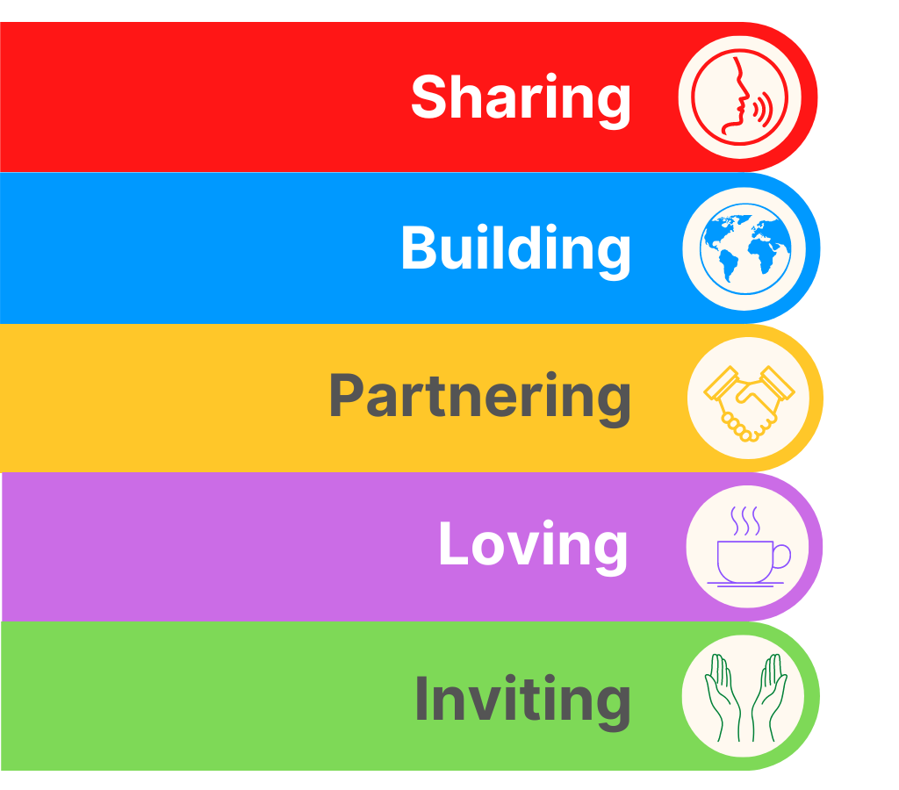

Bolton Villas to Celebrate 125 Years
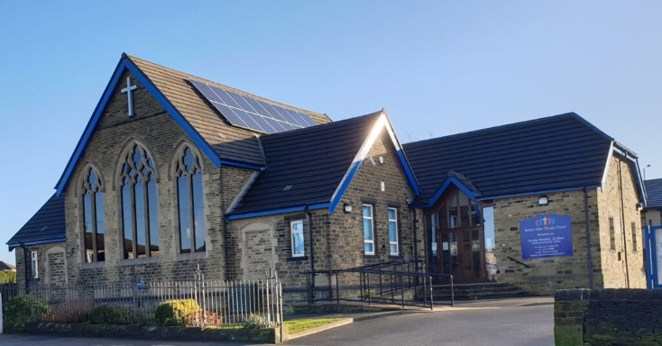
2025 is a very big year for Bolton Villas Family Church, as it's their 125th Anniversary year having been set-up in 1900 (see https://boltonvillasfamily.church/ for a brief potted history of our church).
They are delighted to annouce details of how they will be celebrating this momentus occasion over their anniversary weekend which is Saturday 13th and Sunday 14th September.

Kingdom Wrestling returns on Saturday 13th September and will see our main hall transformed into a wrestling arena as we welcome back Gareth Angel and other stars from Kingdom Wrestling for an epic night out for the whole family. Tickets available at https://www.skiddle.com/.../Kingdom-Wrestling.../41004595/ Following our Sunday morning worship service on 14th September, we'll be transforming yet again for a Victorian Afternoon Tea, running from 2-4pm. The cost for this event is just £5 per head. Tickets for this event can be purchased from Refreshed, our cafe and charity shop during opening hours or by e-mailing info@bvurc.org.uk

We will then be rounding off a full weekend of activities with a Festival of Praise worship evening, which will run from 6-8pm to which everyone is welcome (tickets are not needed).

Everyone is welcome, so please make an effort to join Bolton Villas in making this weekend a really special one.
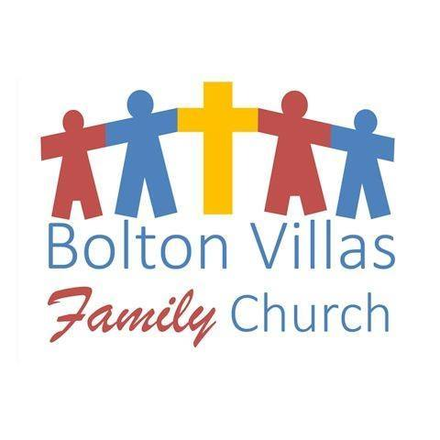
Lay Preachers’ and Worship Leaders’ Weekend

“Hope in a Troubled World"

25th – 27th July 2025
(Friday teatime to Sunday lunch)

at Wydale Conference Centre, Brompton by Sawdon near Scarborough www.wydale.org



We are excited that Hannah Fytche, Associate New Testament Tutor at Westminster College, will be our main speaker at the conference, and that we will be joined by our Moderator, Rev Jamie Kissack.

This weekend will again be paid for by Synod and grants so you will only need to cover your travel costs.

To register your place, contact:
office@urcyorkshire.org.uk or 0113 289 8490.

For any queries, contact Kath at:
kathlonsdale@talktalk.net
01274 315203 or 07759525936
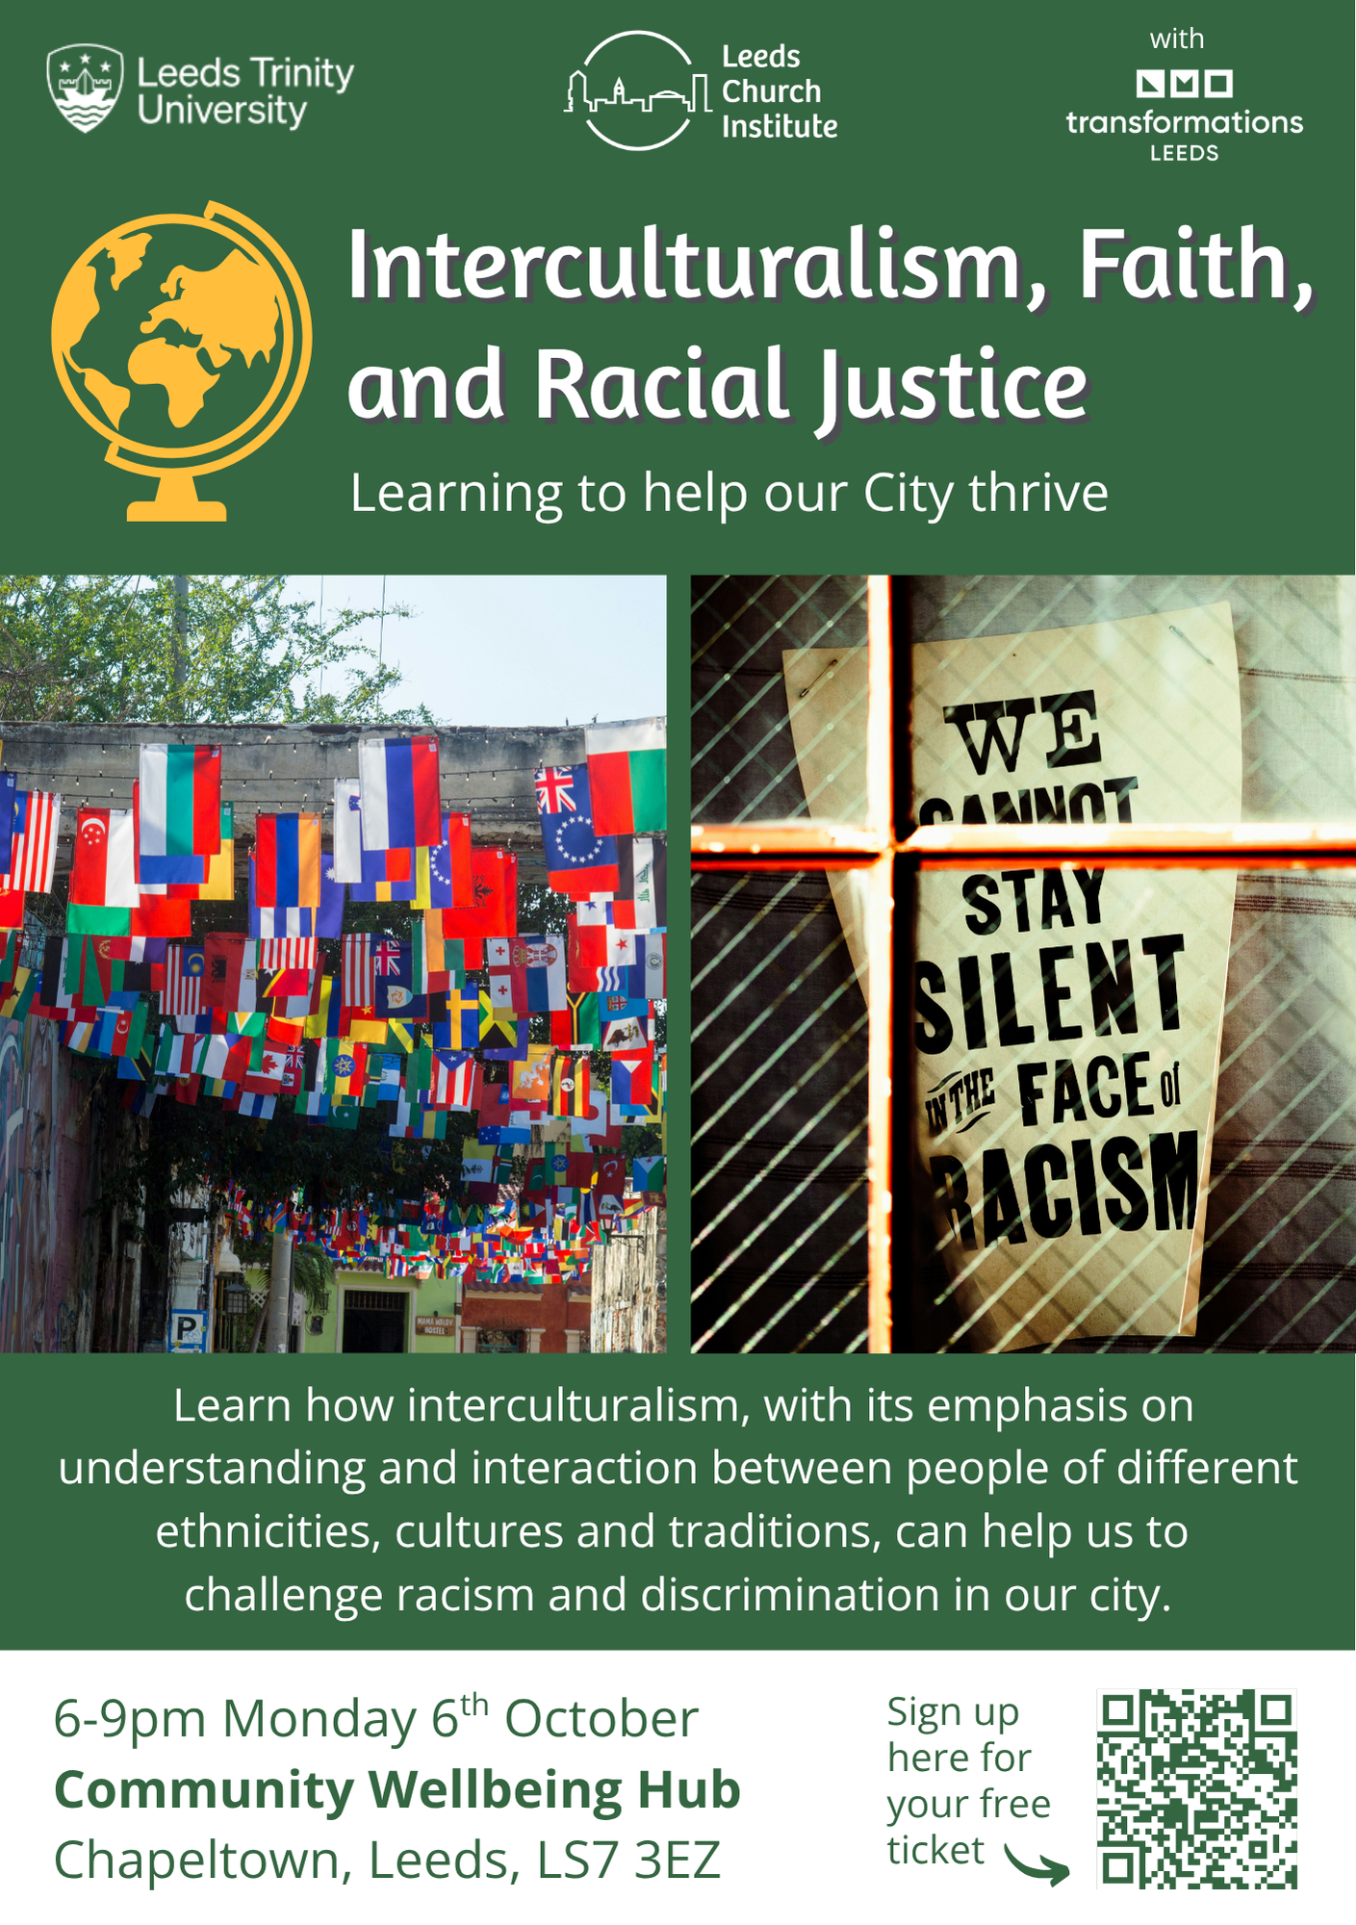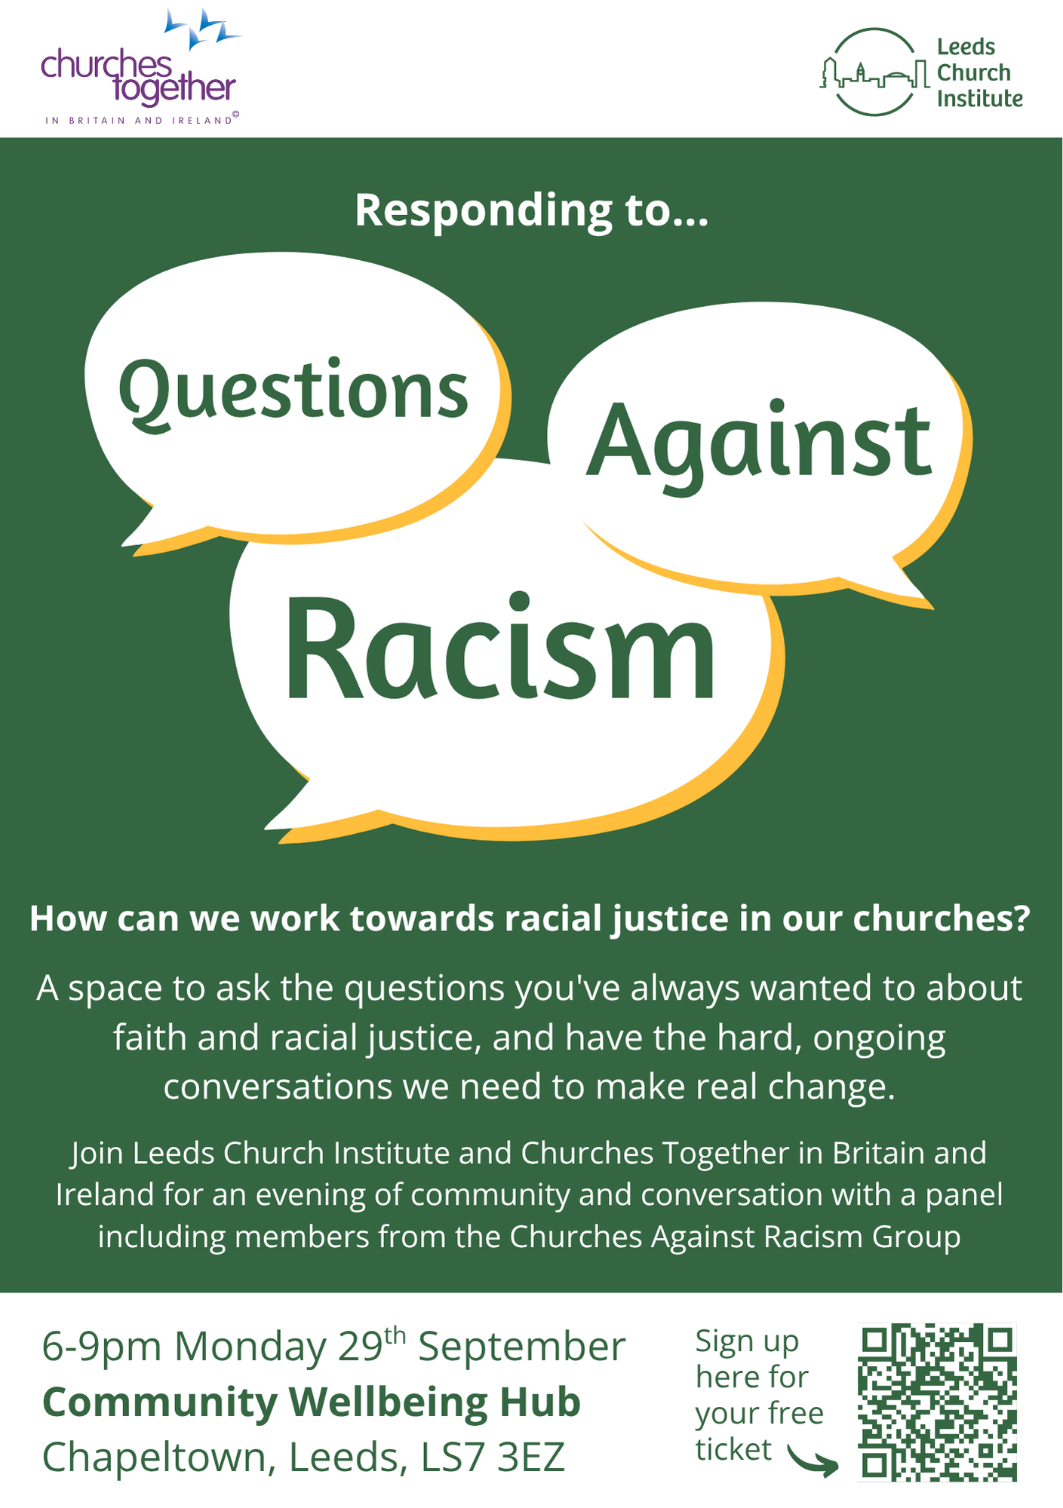
If you have any questions or you would like to book, please contact the Synod Office (office@urcyorkshire.org.uk or moderatorpa@urcyorkshire.org.uk) to inform us, who will be coming from your church, so we can advise West Park URC of numbers expected.



Yorkshire Synod Discipleship Development Small Grant Fund 2025
The Ministries Committee have so far approved 21 applications to this fund since 2022 and we encourage all lay church members to consider applying in 2025. Please use the new application form available through the Synod Office as the amount which you can ask for resources or has increased to up to £300. This fund exists to help you on your Christian journey including the costs of attending a course or to offset the costs of buying resources for personal development or sharing with others. If anyone wants to discuss an application before submitting it please contact the Convenor of the Yorkshire Ministries Committee, Kath Lonsdale at kathlonsdale@talktalk.net.
Remember this is for any age of lay person in our churches to apply for so please discuss with your young people as well as adults.

PARTNERSHIP PRAYERS
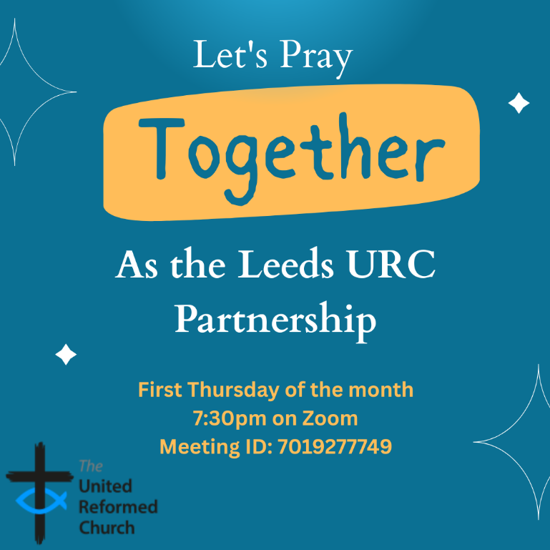
Although this is primarily aimed at those of us who are linked with the churches of the Leeds URC Partnership, this invitation is open to everyone from around the Synod and beyond.
It will be happening on the first Thursday of the month on Zoom at 7:30pm. The next one will be on Thursday 7th August and the link is here: https://us02web.zoom.us/j/7019277749

There will be a time to pray together, a time to share in reading the Bible and a time to share the joys and challenges in our lives, churches, communities and world.

Looking forward to seeing you there.


Disability Awareness Sunday

Janet Eardley, the Mission Programmes Manager for Through the Roof, a charity partner of the UFC has been in touch about Disability Awareness Sunday, which this year is on Sunday 28th September. Through the Roof are offering a short video of disabled Christian author Emily Owen that can be played in churches, and Emily has also written the materials for use in services too on the theme of 'Made in the image of God'. All the resources are free and include suggested hymns and songs, prayers, etc, as well as Emily's video and ideas for the talk. The material, though made for Disability Awareness Sunday, can be used on any Sunday: the important thing is to spread the message of welcome and inclusion for disabled people in our churches. Here's the link for people to request the pack:
Disability Awareness Sunday - Through the Roof or https://throughtheroof.org/forchurches/disability-awareness-sunday/

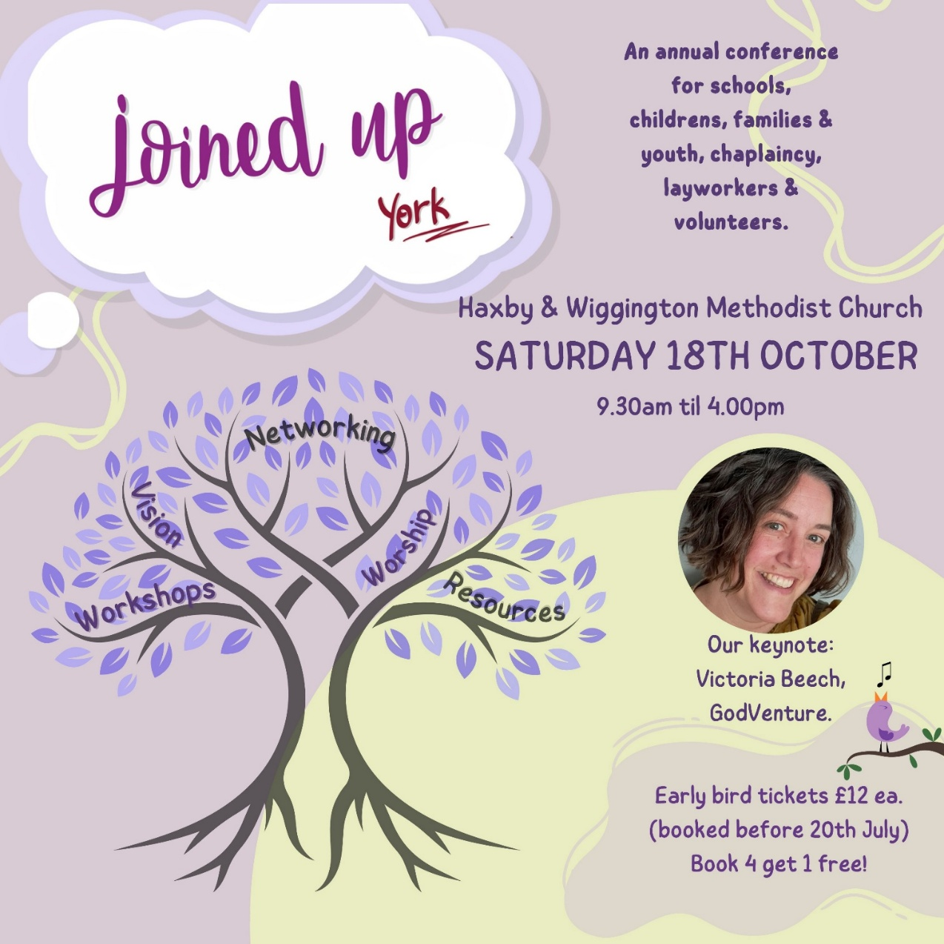
For more information and to get your Early Bird tickets follow this link https://joinedupconferencecom.wordpress.com/york/

Celebrating the Secret Services……
During the early 18th century, when non-conformist religious practices were illegal, secret Baptist services were held in the shelter of Buckstone Rock near Rawdon. These clandestine gatherings took place on the Sabbath, despite the risk of persecution.
Each year the congregation at Trinity Church, Rawdon meet at Buckstone Rock to honour those who 300 or so years ago faithfully worshipped God in this Place.
This remarkable stone has stood as a silent witness to faith, perseverance, and community and was historically used by John Wesley, the founder of Methodism, on numerous occasions as a place to preach and gather followers.
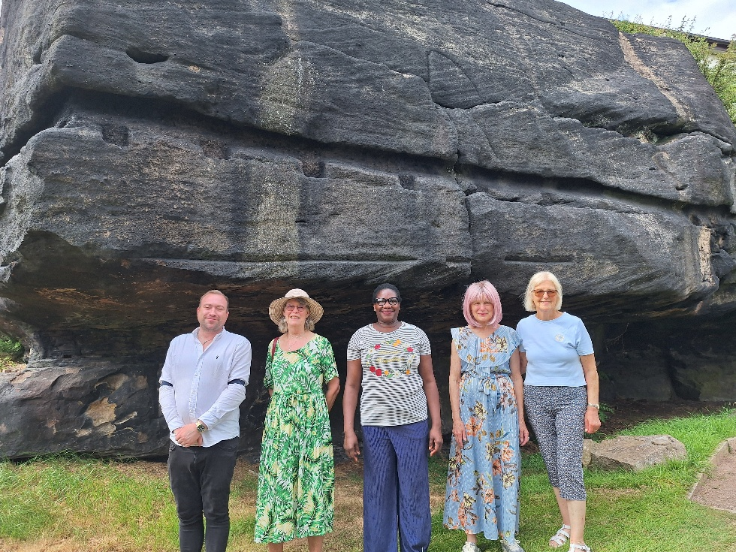
Members of Trinity Church, Rawdon (a Baptist/URC LEP) met to follow their example and to continue this tradition to celebrate their own religious liberty and maybe most poignantly they meet to remember those Christians in other parts of the world who are not yet free to worship God, and to pray for them.

We need to remember the sacrifices made by many Christians in this country to win for us the freedom to worship as we see fit.

This year, with grateful thanks to Rawdon Golf, Lawn Tennis and Padel Club (who now own the land where the rock is situated), Trinity Rawdon held their annual pilgrimage on Sunday 13th July and pictured (from Left to right) are Matt Chew who led the service, Margaret Grange, Pauline Whyte, Kate Woolley and Val Bruce.

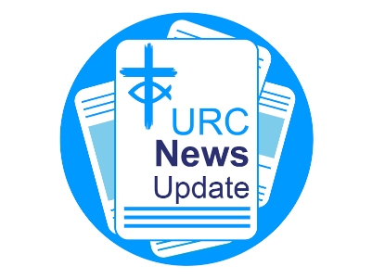
NEWS FROM THE DENOMINATION
The URC’s News Update is a monthly e-newsletter that keeps you informed about the latest news and events.
To receive this popular newsletter, please visit the https://urc.org.uk/news-updates-sign-up-form/ page on the URC website and follow the links. If you just want to dip in and catch up on what is going one, that’s fine and you can
read and print recent editions of our e-newsletter by visiting the URC News Update page at https://urc.org.uk/urc-news-update/ .

The NEW Church Leadership Programme (CLP)
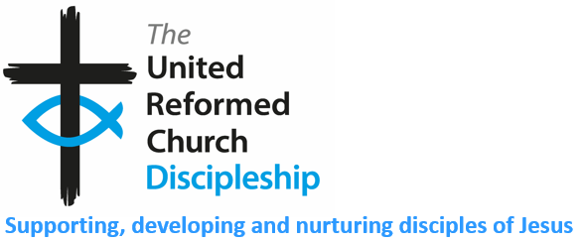
The Church Leadership Programme (CLP) is a year-long learning journey designed for lay and ordained leaders in URC churches and community contexts. It is delivered through a blend of online learning and three residential weekends held in Manchester.
The URC’s Ministries team are delighted to be able to share that the CLP course has been revised and updated and is now being offered, through Northern College, from September 2025. More details can be found here: https://northerncollege.co.uk/learning/training-for-lay-people/church-leadership/


Taster Session
Join Northern College for a taster session on Wednesday 13th August from 19:00-20:00 on Zoom. You will get a flavour of what you can expect from the course and the opportunity to ask questions. Please email Christine Hufton to register your interest at christine.hufton@lutherking.ac.uk

CLP encourages you to explore reflective practice as a foundation for sustaining healthy leadership in ministry. It aims to deepen your theoretical and practical understandings of reflective practice, by engaging with a range of perspectives including theological, biblical, and psychological approaches.

Experiential learning is central to this programme and will be fostered in several ways:
- A regular reflective space led by your tutor, creating an environment for shared reflection and discussion.
- Self-reflective tasks designed to help you personalise your engagement with the material.
- A reflective journal, maintained throughout the programme, which will form a key part of allowing you to integrate your learning into the heart of your ongoing ministerial practice.
By the end of the programme, participants will be able to:
- Demonstrate a critical understanding of reflective practice and its application to leadership in your context.
- Apply reflective practices to bring insight, transformation, and growth into your leadership and ministry.
- Gain a clearer understanding of your strengths, vulnerabilities, and development needs as a leader.

CLP is beginning in September 2025. To register your interest and for more information, please contact christine.hufton@lutherking.ac.uk.
If you would like to register for the course, please download the form at https://view.officeapps.live.com/op/view.aspx?src=https%3A%2F%2Fnortherncollege.co.uk%2Fwp-content%2Fuploads%2F2025%2F07%2F2025-CLP-Registration-Form.docx&wdOrigin=BROWSELINK
Fees and funding options can be found in Section 8 of the form.
To submit your registration form, or to discuss tuition and/or funding further, please email ministries@urc.org.uk – registration close at 12pm on Saturday 30th August 2025.

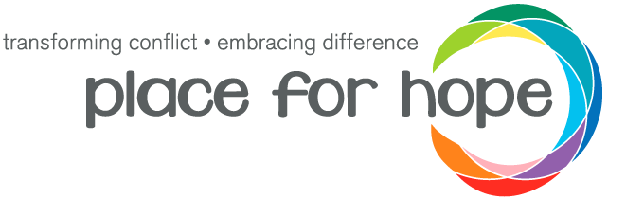
As part of the ongoing strategy and development of the Place for Hope and United Reformed Church partnership which was begun at the URC’s Assembly Executive meeting back in February 2024 (https://urc.org.uk/your-church/place-for-hope-partnership/), Place for Hope are conducting a needs assessment to better understand what is needed to help us reach their goals of creating transformation within our United Reformed churches and equipping our communities to navigate change, difference, and conflict well.

This form, the link to which is below, gives you an opportunity for your voice and opinion to be heard, and to shape the future of the project. All the responses will be used to help form an accurate and deeper understanding of conflict within the URC and will be used to shape the ongoing development of the project. This will help ensure that the programme we are building meets the needs of the wider community and that the roll out is sustainable.

Please follow this link to fill in the form https://forms.gle/1zgeykMcpxm7QSjZ9

The form is a mixture of multiple choice and longer form questions and should take between 15-30 minutes to complete, depending on how detailed the answers you give are! All your responses will be anonymous. Please send this onto anyone you feel may be interested in having a say - I would love as many people as possible to contribute.

If you have any questions, please contact the programme lead, Martha Hunt , on martha.hunt@placeforhope.org.uk.

SAFEGUARDING
The Safeguarding team have asked that you are reminded that they are available 24 hours a day, seven days a week and 365 days a year (and even 366 days in Leap Years!!). Details can be found on the Yorkshire website at https://urcyorkshire.org.uk/safeguarding/ and any query, either by phone or by e-mail at safeguarding.1and4@urc.org.uk will be answered within 24 hours.

FIRE SAFETY
Jane Bunyan, our Synod Property Officer property@urcyorkshire.org.uk has asked that I remind churches that fire regulations for small non-domestic premises have changed in light of the Grenfell Tower Enquiry outcomes. The advice Synod is giving is that all churches should make themselves aware of the new regulations and advice updated in 2024 at Making your small non-domestic premises safe from fire - GOV.UK or https://www.gov.uk/government/publications/making-your-small-non-domestic-premises-safe-from-fire but if you would like a pdf copy then please email Jane at the above e-mail address.

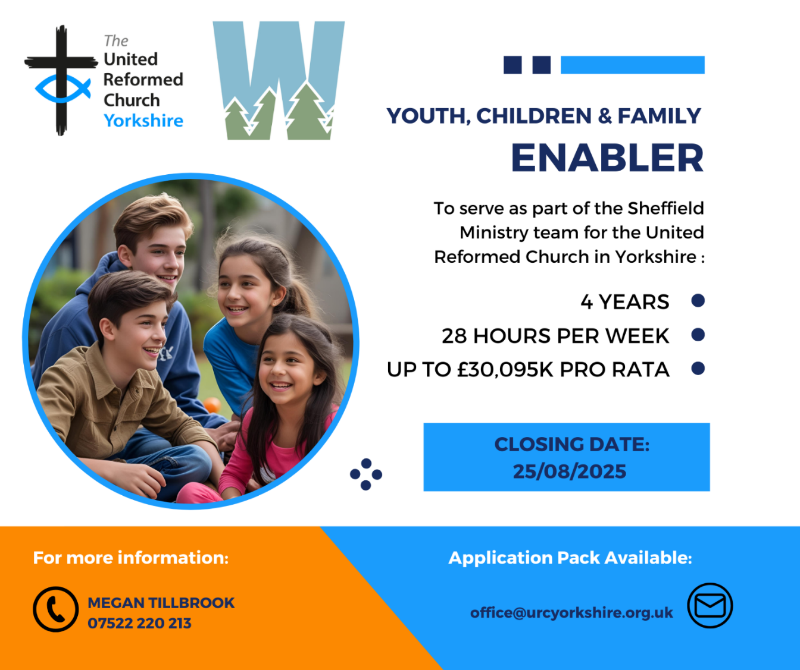

Church Action on Poverty
I do not know if you have heard already but the next Poverty Sunday has been brought forward to Sunday 19 October 2025 to tie in with Challenge Poverty Week. If you feel called to this work, please contact the Church Action on Poverty team through their website at https://www.church-poverty.org.uk/

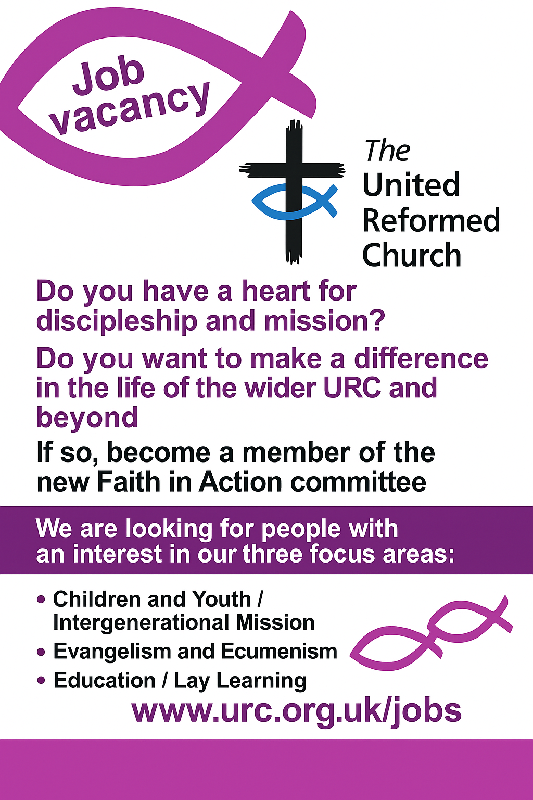
And Finally
A New Assembly Accredited Lay Preacher
On Sunday 13th July, Saltaire URC hosted the commissioning service of Roland Clark as an Assembly Accredited Lay Preacher. The special Holy Communion service, led by Caroline Pathak, marked a special moment in Roland’s Christian journey. Mrs Kath Lonsdale, representing the Synod, inducted Roland into his new role and welcomed him into this wider URC calling. Roland previously had been an Anglican Lay Reader (the role now being called a Licenced Lay Minister) and he said in his statement concerning his faith that the move to worshipping at Saltaire and the call to Lay Preaching was a combination of God both pushing him and pulling him into the role.
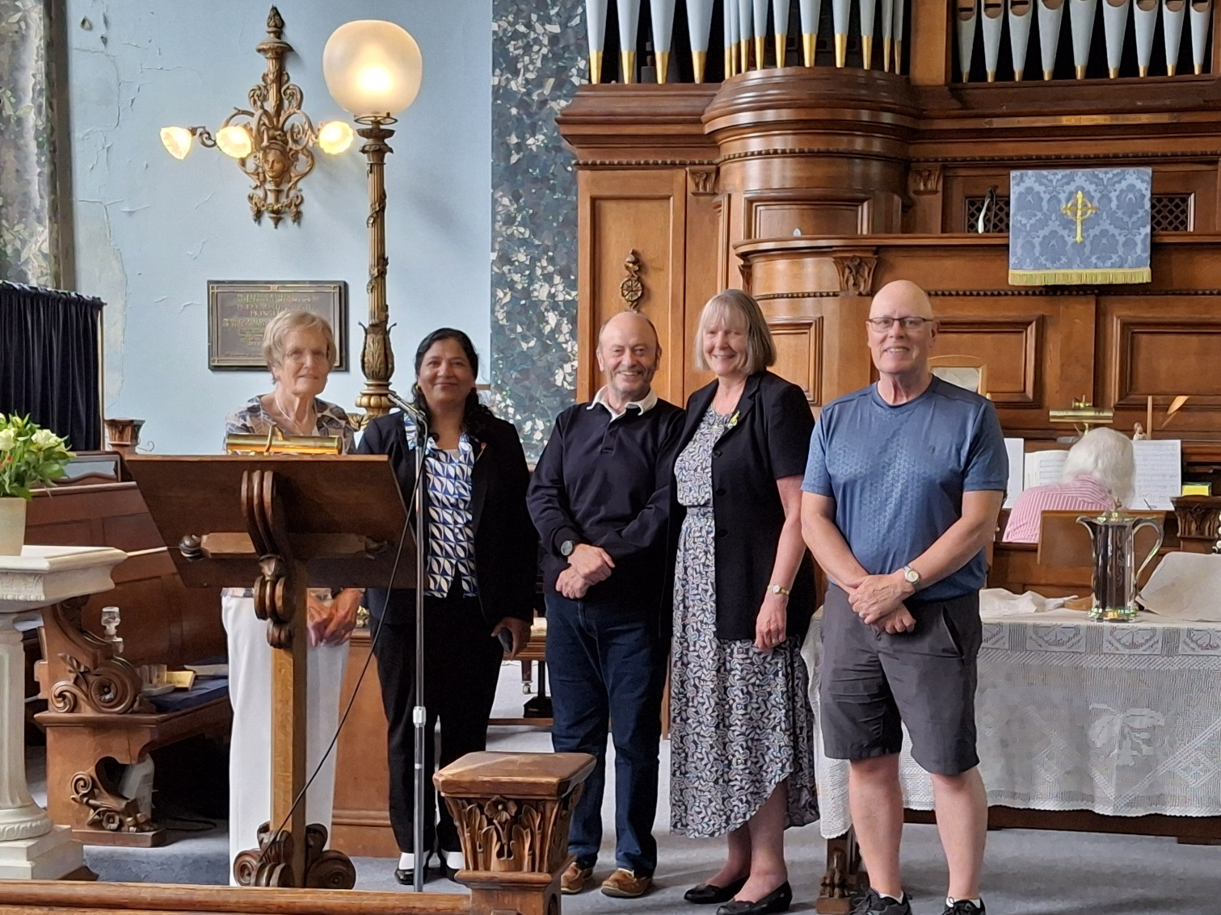
Roland Clark (centre) seen here with (from Left to Right) Janet Clark (Elder), Caroline Pathak, Kath Lonsdale (Ministries Committee Convenor) and Tony Wilson (Elder)

If you have a good news story from your part of the Synod or something that you feel would enhance the work of Synod in 2025, drop me a line at clerk@urcyorkshire.org.uk and I’ll make sure it hits the back page!!

You can also keep an eye on all our social media platforms for news; on the website at Home - URC Yorkshire Synod, at United Reformed Church in Yorkshire - Home | Facebook and Wilderness URC Yorkshire - Home | Facebook, the YouTube page at URC Yorkshire - YouTube and the Twitter (X) page at URC in Yorkshire (@URCYorkshire) / Twitter.

