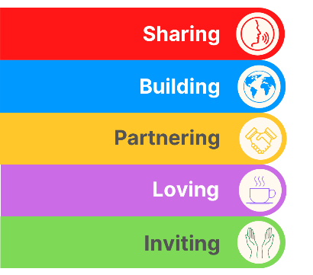
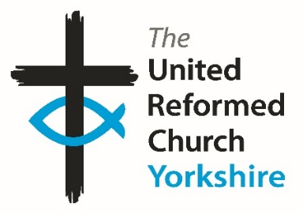
Yorkshire Synod Briefing
Number 159

4th September

FESTIVAL SEASON
I’m sure that many of you will know folk in your churches who attended the recent Greenbelt Festival or even have seen the reports of the URC website at https://urc.org.uk/hope-thrives-at-the-2025-greenbelt-festival/ and https://urc.org.uk/hospitality-hope-and-community-shine-through-at-greenbelt/, but we have one of our churches being central to another festival this month. From Saturday 13th September through to Sunday 21st September Saltaire URC will be at the heart of the annual Saltaire Festival https://saltairefestival.co.uk/. The church is delighted to welcome back Aire Valley Arts for their exhibition throughout the duration of the Saltaire Festival and it is anticipated that the exhibition will be open daily from 10am to 4pm, except both Sundays, when it will open at 12 noon, following worship. The downstairs church café will be open both weekends, 10am to 4pm, and you will be assured of a very warm welcome.
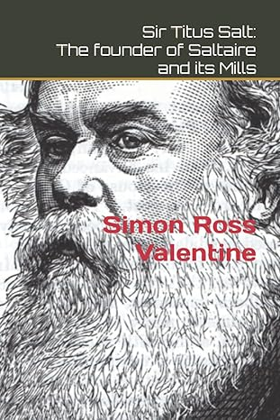
Not only that, the church is benefitting from a simple request to take some internal photographs of our church. Back in 2024, Dr. Simon Ross Valentine visited the church to take photographs for a book he was writing on the churches of Bradford. During a conversation with one of the Elders it emerged that Simon is also a Methodist Lay Preacher. Not one to miss an opportunity, he was invited to lead worship — an invitation he gladly accepted, and he has since returned to lead services on several occasions.
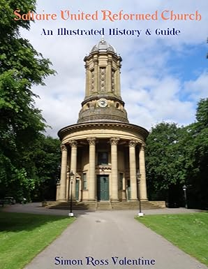
At the time of his first visit to lead worship, Simon brought along some copies of a book he had already written and published, titled Sir Titus Salt: Founder of Saltaire and its Mills. Keen to support the church, Simon keeps them supplied with copies of this book and kindly donates all proceeds from the books they sell towards the maintenance of the church. This book can be purchased from the church or Amazon, priced at £4.99.
The story didn’t end there! Earlier this year, Simon kindly offered to write and publish a guidebook at no cost to the church. The church gratefully accepted, and Saltaire United Reformed Church: An Illustrated History & Guide (A4 size, with colour photographs) is now available from the church, Waterstones, or via Amazon, priced at £8.99.
The church is deeply grateful to Simon for his generosity, encouragement, and ongoing support of our church.

If you have any news of welcoming people into Church, stories of celebration and hope or even notices of future events, please let me know by dropping me a line at clerk@urcyorkshire.org.uk and I’ll showcase it in the next edition, due out on Wednesday 17th September 2025.
Thank you
Tim Crossley
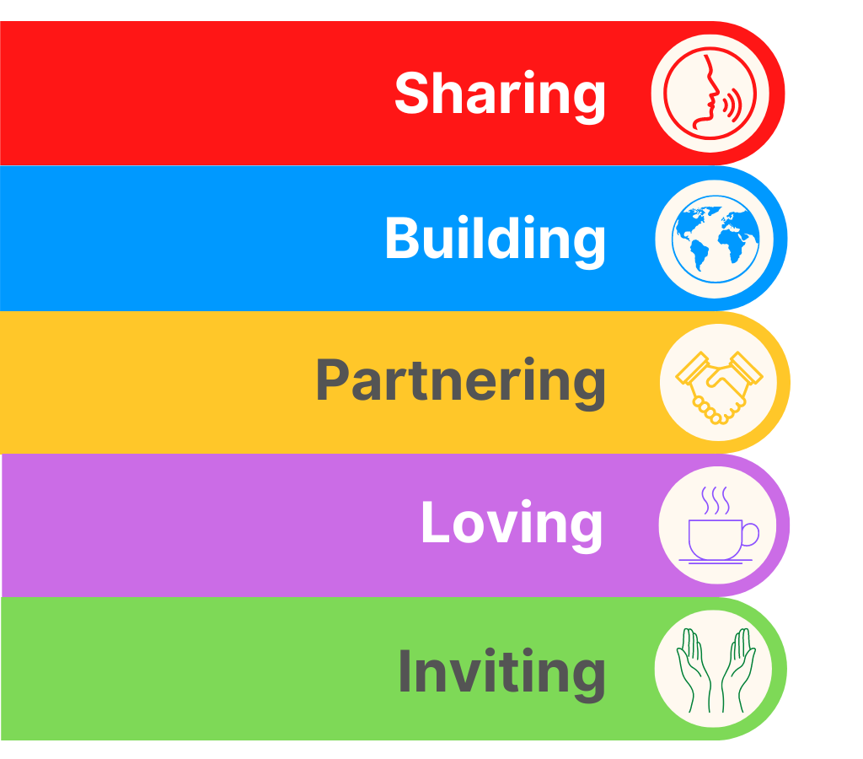
!!!!!!!!!!!!!!!PLEASE NOTE THE NEW DATE!!!!!!!!!!!!!!!
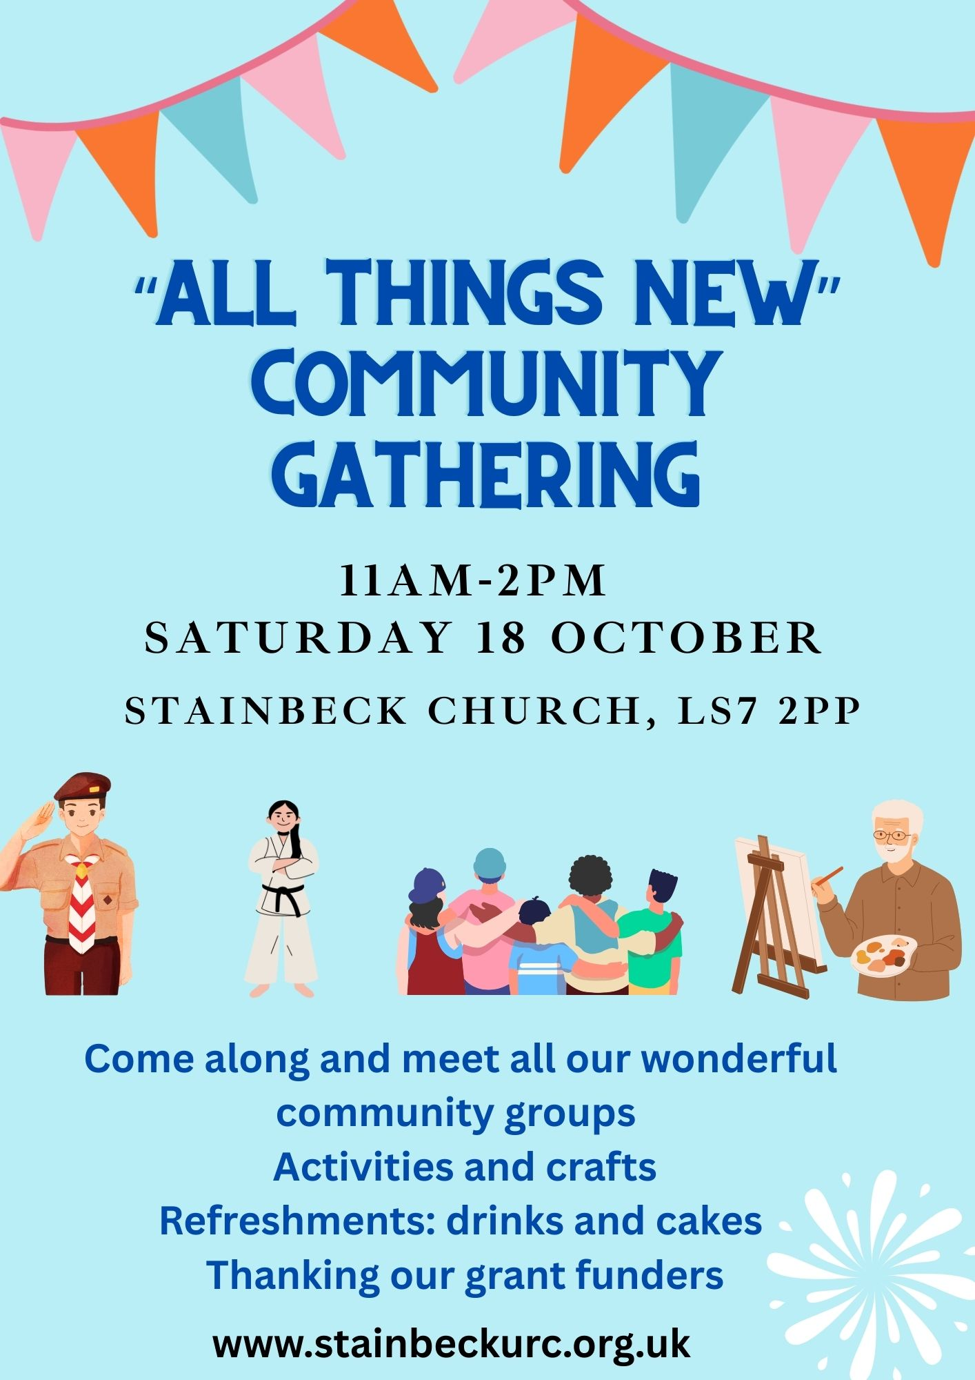
Due to essential car park resurfacing and repairs, Stainbeck’s community groups’/thanking grant funders' event has been moved from 13th September to Saturday 18 October.
Bolton Villas to Celebrate 125 Years
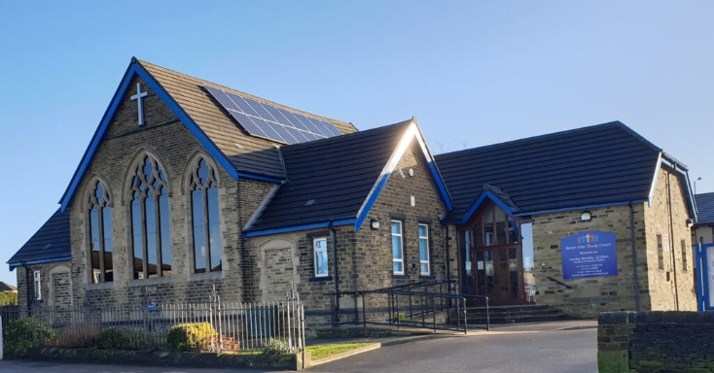
2025 is a very big year for Bolton Villas Family Church, as it's their 125th Anniversary year having been set-up in 1900 (see https://boltonvillasfamily.church/ for a brief potted history of the church).
They are delighted to annouce details of how they will be celebrating this momentus occasion over their anniversary weekend which is Saturday 13th and Sunday 14th September.

Kingdom Wrestling returns on Saturday 13th September and will see the main hall transformed into a wrestling arena as they welcome back Gareth Angel and other stars from Kingdom Wrestling for an epic night out for the whole family. Tickets available at https://www.skiddle.com/.../Kingdom-Wrestling.../41004595/. Following the Sunday morning worship service on 14th September, they will be transforming yet again for a Victorian Afternoon Tea, running from 2-4pm. The cost for this event is just £5 per head. Tickets for this event can be purchased from Refreshed, their cafe and charity shop during opening hours or by e-mailing info@bvurc.org.uk

Bolton Villas Family Church will then be rounding off a full weekend of activities with a Festival of Praise worship evening, which will run from 6-8pm to which everyone is welcome (tickets are not needed).

Everyone is welcome, so please make an effort to join Bolton Villas in making this weekend a really special one.
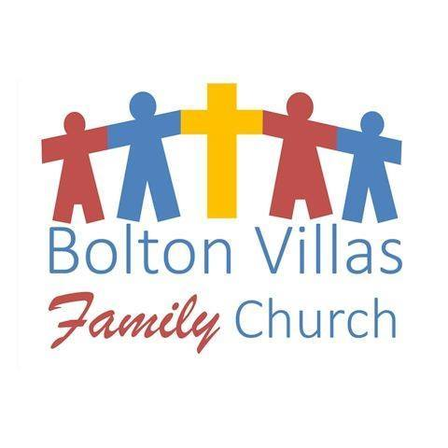


Online Quiet Day: Playing with God
27 September 2025 10:30am to 4:00pm
Venue: Online, Ticket: Free

Led by Leslie Bailey -(opening prayers),
Mark Argent and Ann Barton, and Jane Weedon (closing prayers).
The day draws its theme from part of the gospel for 27 September, which records Jesus predicting his death (again) and saying to the disciples: “Whoever welcomes this little child in my name welcomes me; and whoever welcomes me welcomes the one who sent me. For it is the one who is least among you all who is the greatest.”
For some that carries an invitation to come to God “like a child” — which could be heard as “praying with one’s inner child”. For others that can feel like a more difficult space — particularly if there are uncomfortable memories or associations to childhood.
In biblical times those words could have been heard quite differently — perhaps as a challenge to the idea that power gets someone closer to God (or God is on the side of the powerful).
The invitation of the day is to spend some time in prayer away from our screens, and in discussion with others, to attend to what God may be saying to us.The readings for the day are Psalm 91:1-6, 14-16; Jeremiah 24:1-10 and Luke 9:43b-48. For this quiet day we’ll focus on the gospel:
43b And they were all amazed at the greatness of God. While everyone was marvelling at all that Jesus did, he said to his disciples, 44 “Listen carefully to what I am about to tell you: The Son of Man is going to be delivered into the hands of men.” 45 But they did not understand what this meant. It was hidden from them, so that they did not grasp it, and they were afraid to ask him about it. 46 An argument started among the disciples as to which of them would be the greatest. 47 Jesus, knowing their thoughts, took a little child and had him stand beside him. 48 Then he said to them, “Whoever welcomes this little child in my name welcomes me; and whoever welcomes me welcomes the one who sent me. For it is the one who is least among you all who is the greatest.”
Book by clicking on this link: https://urc-spirituality.org.uk/urcsp_event/quiet-day-4/
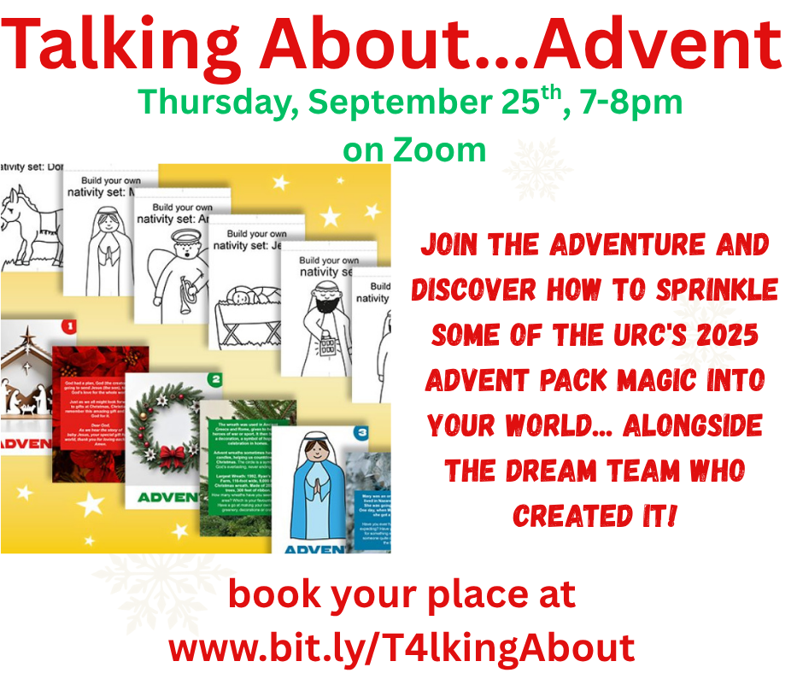
You may have heard that the 2025 Advent Pack from the URC’s Children and Youth Work Team is an alternative Advent calendar, a beautiful box of postcard-sized cards — one for each day in Advent – and that the final call for orders has gone out. Alternating images of things associated with Christmas and characters from the Christmas story, there are fun facts and activity ideas on the reverse.
Designed to be reusable, displayed like bunting or in other ways, the box even includes a DIY nativity set.
You may have heard that Advent Unpacked! is a gift for local URC churches to give to families, produced by the URC Children’s and Youth Work and Communications teams.
You may have heard that the price has been reduced (and, if you didn’t, get in touch with your CYDO+!)
And you may have pre-ordered your Advent Packs at https://urcshop.co.uk/2025-urc-advent-kit-preorder/ Brilliant!

Now what to do with them?
This session is an opportunity to meet with some of the writers of this year’s material, find out how “they” think the packs could be used in different contexts and with different groups.
Come with your questions – and your ideas – and get prepared to share the joy and excitement of Advent this year. Talking About…Advent
September 25th, 7-8pm, on Zoom
Book your place: www.bit.ly/URCTalkingAbout
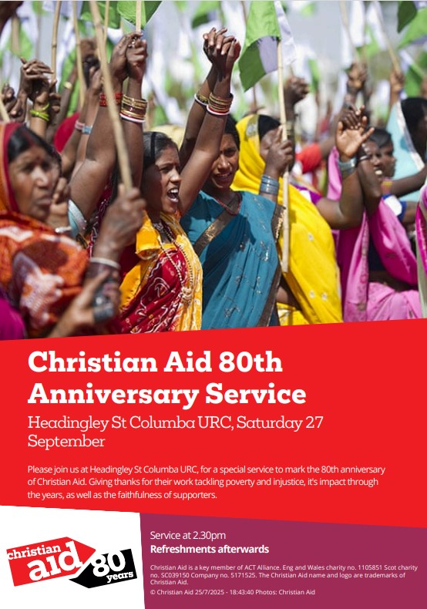

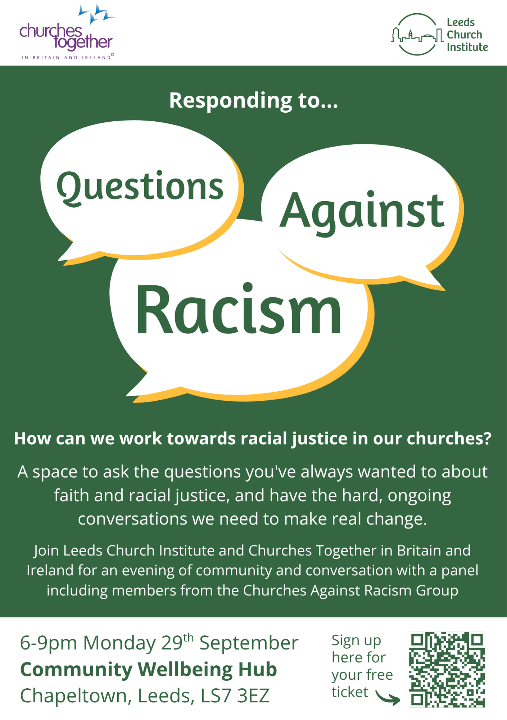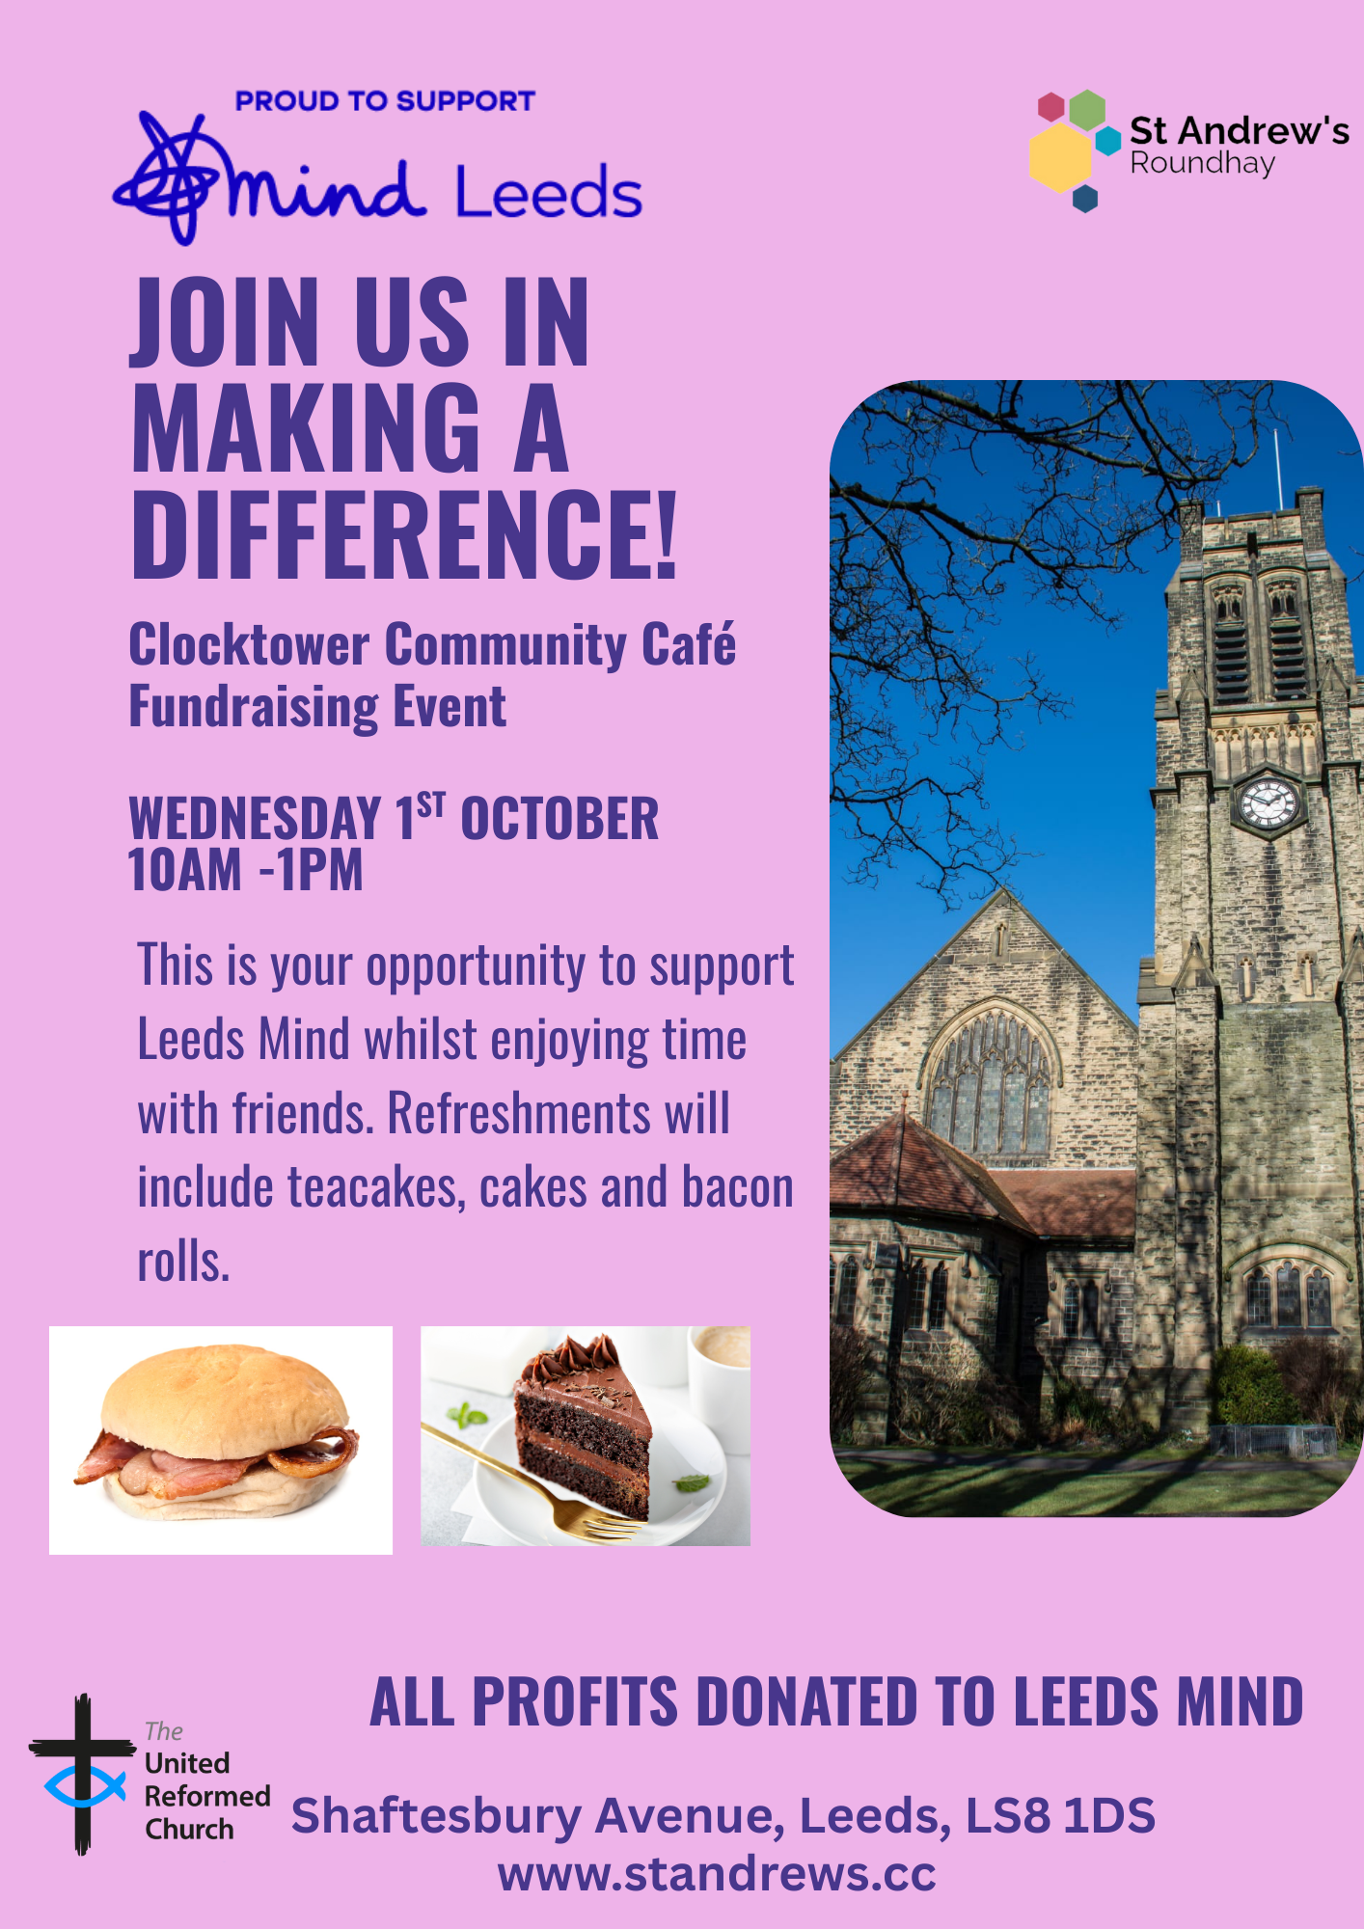
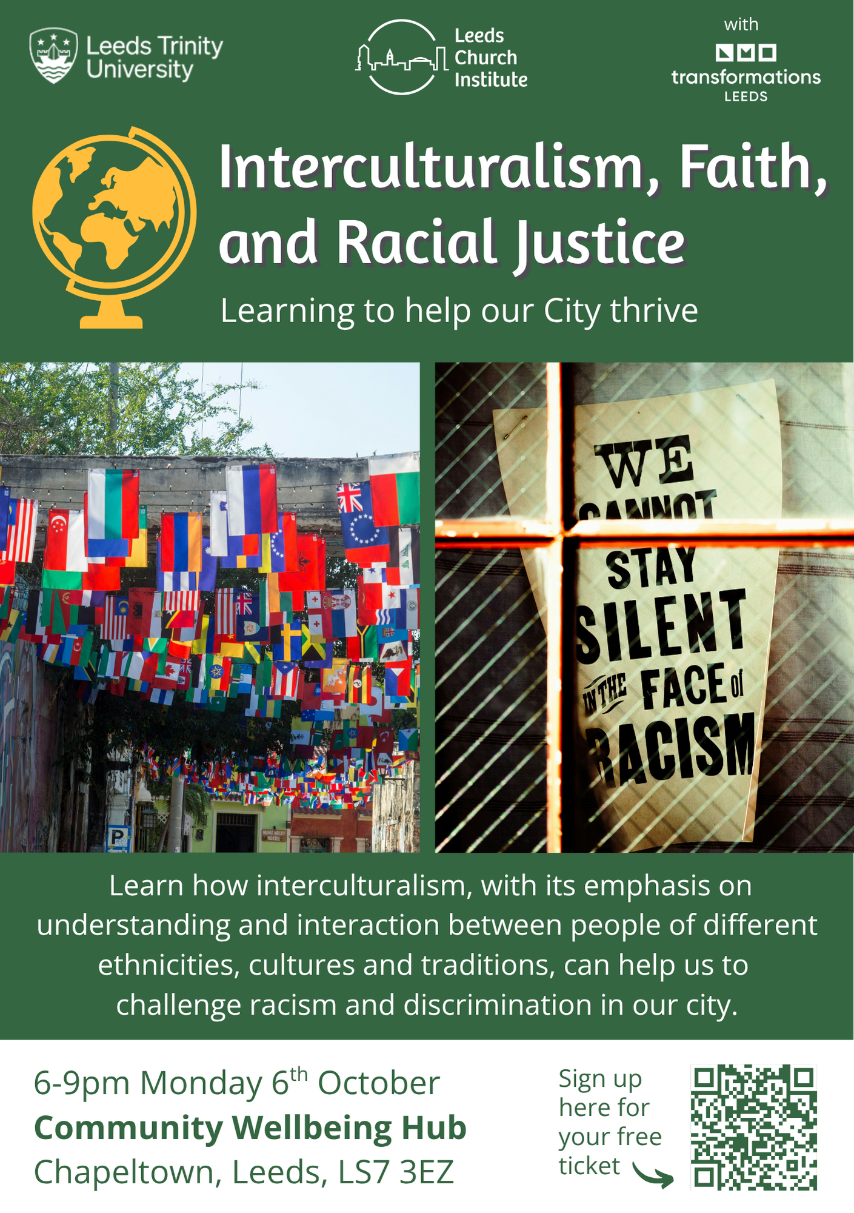

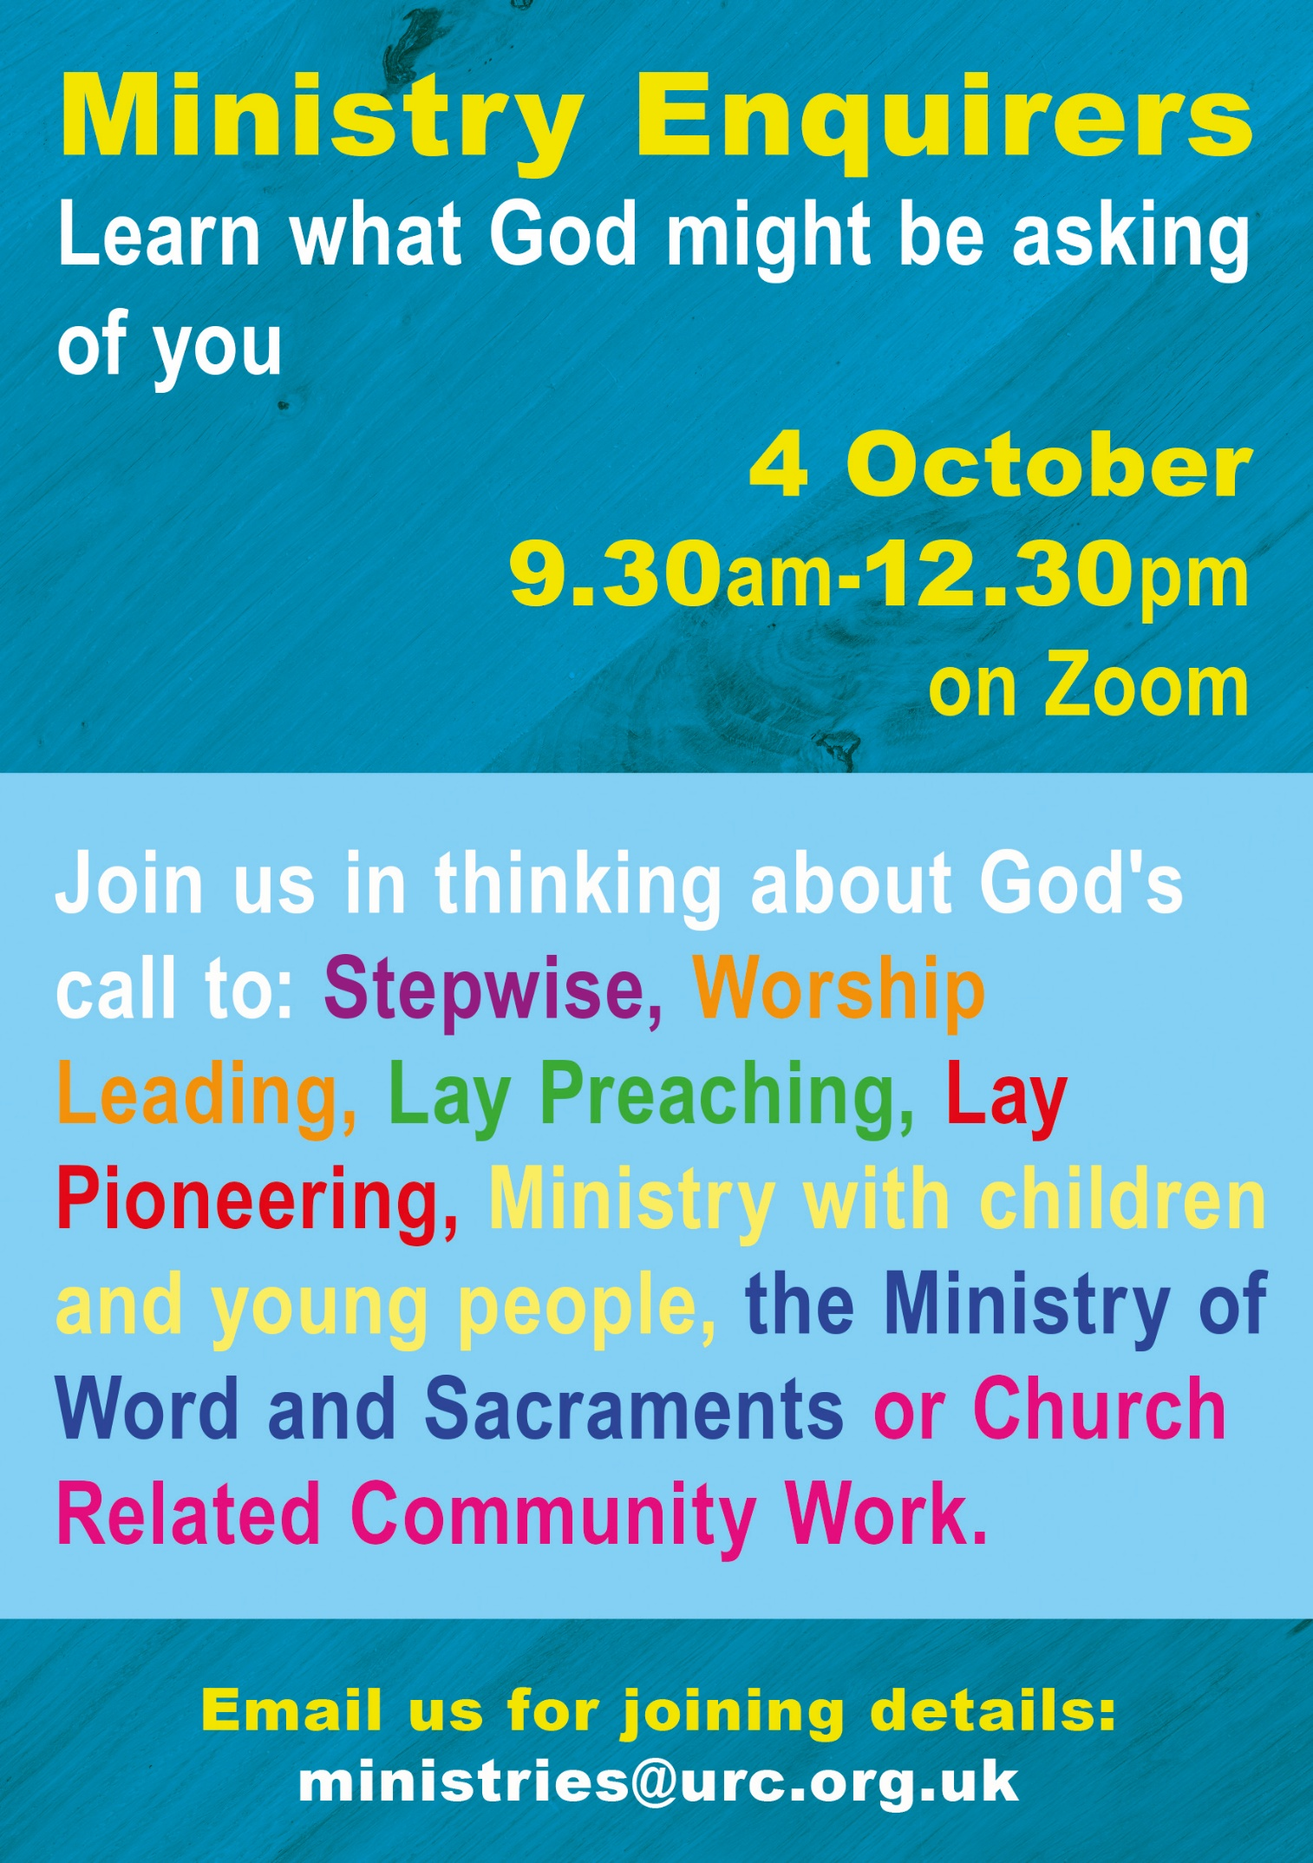

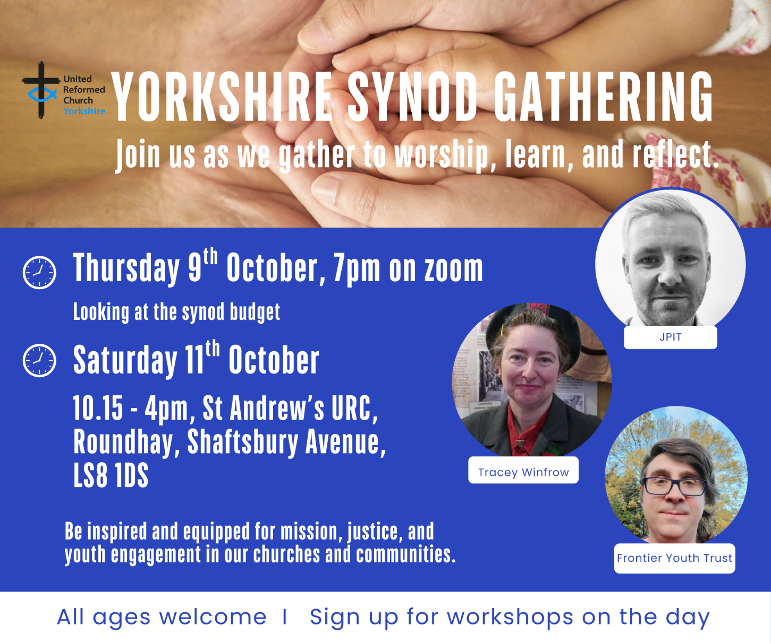

This Autumn’s Synod has a different feel about it as we are doing it in two parts. On the evening of Thursday 9th October we will be discussing the financial aspect of Synod life via Zoom, then on Saturday 11th October at St Andrew’s, Roundhay we look at the missional, justice and youth engagement aspect of our Synod’s life.

There are three workshops available and we invite Synod Representatives to join two of them during the day. They are:

Exploring Life, Love and Faith with Gen Z – Matthew Willmott, Frontier Youth Trust
Each generation understands the world slightly differently than the one before. How are Gen Z understanding life stages and in particular, what it means to be in a relationship? How can the church support, challenge and walk alongside young people as they make their way in the world? This is just the starting point of a conversation that we need to be open to having.

Discipleship in Divided Times - Joint Public Issues Team (JPIT)
How might Christians engage in a political and social mainstream that is shifting into more populist and openly far-right views and expression? How can our conversations with friends and family reflect a sensitivity to these influences, build trust across difference yet challenge extreme-right policies that undermine democracy and Christian values? The Joint Public Issues Team will lead a workshop highlighting current trends in society, the impact these have on the most vulnerable, and how Christians can engage effectively in changing times.
The Gift of Presence: How children and young people can transform church life – Tony Harris and Tracey Winfrow
What difference does it make when children and young people are truly part of the life of the church—not just present, but participating, shaping, and belonging? This workshop invites you to explore how the presence of young people can breathe new life, perspective, and purpose into your church community. Through stories, reflection, and discussion, we’ll uncover the theological, relational, and missional impact of engaging younger generations. Whether your church is growing with young people or longing for their return, this session will challenge and encourage you to see them not as the church of tomorrow, but as vital members of the church today.

Everyone will be able to attend 2 of the 3 on offer and choices can be made on the day, but we hope that by providing this information in advance, churches and synod representatives can share, discuss and consider their options. Those who are not synod representatives, but with an interest in the topics may also wish to attend. Everyone is welcome to come along and there will be creche facilities (unsupervised, in the main meeting hall) for babies and small children.

YOUTH ASSEMBLY 2026
Bookings have opened for next year’s URC Youth Assembly which will be happening between 27th February and 1st March 2026. Visit www.bit.ly/3TkqSfn for more details or contact Megan at the Synod Office at megancyp@urcyorkshire.org.uk. Megan will also be at the Synod meeting on 11th October, so if you get chance, have a word with her there.

If you have any questions or you would like to book, please contact the Synod Office (office@urcyorkshire.org.uk or moderatorpa@urcyorkshire.org.uk) to inform us, who will be coming from your church, so we can advise West Park URC of numbers expected.


Yorkshire Synod Discipleship Development Small Grant Fund 2025
The Ministries Committee have so far approved 21 applications to this fund since 2022 and we encourage all lay church members to consider applying in 2025. Please use the new application form available through the Synod Office as the amount which you can ask for resources or has increased to up to £300. This fund exists to help you on your Christian journey including the costs of attending a course or to offset the costs of buying resources for personal development or sharing with others. If anyone wants to discuss an application before submitting it please contact the Convenor of the Yorkshire Ministries Committee, Kath Lonsdale at kathlonsdale@talktalk.net.
Remember this is for any age of lay person in our churches to apply for so please discuss with your young people as well as adults.

LEEDS PARTNERSHIP PRAYERS
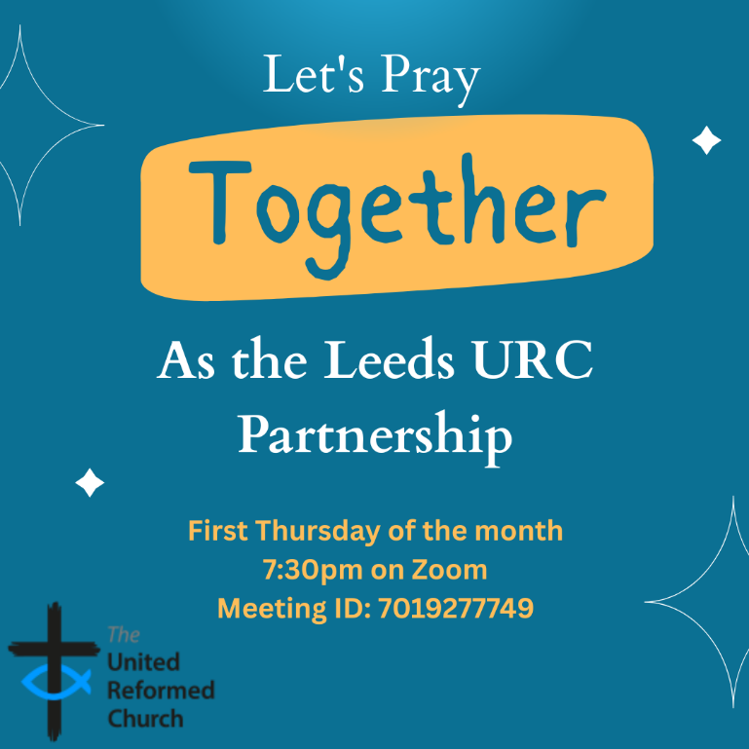
Although this is primarily aimed at those of us who are linked with the churches of the Leeds URC Partnership, this invitation is open to everyone from around the Synod and beyond.
It will be happening on the first Thursday of the month on Zoom at 7:30pm. The next one will be tonight, Thursday 4th September and the link is here: https://us02web.zoom.us/j/7019277749

There will be a time to pray together, a time to share in reading the Bible and a time to share the joys and challenges in our lives, churches, communities and world.

Looking forward to seeing you there.


Disability Awareness Sunday

Janet Eardley, the Mission Programmes Manager for Through the Roof, a charity partner of the UFC has been in touch about Disability Awareness Sunday, which this year is on Sunday 28th September. Through the Roof are offering a short video of disabled Christian author Emily Owen that can be played in churches, and Emily has also written the materials for use in services too on the theme of 'Made in the image of God'. All the resources are free and include suggested hymns and songs, prayers, etc, as well as Emily's video and ideas for the talk. The material, though made for Disability Awareness Sunday, can be used on any Sunday: the important thing is to spread the message of welcome and inclusion for disabled people in our churches. Here's the link for people to request the pack:
Disability Awareness Sunday - Through the Roof or https://throughtheroof.org/forchurches/disability-awareness-sunday/

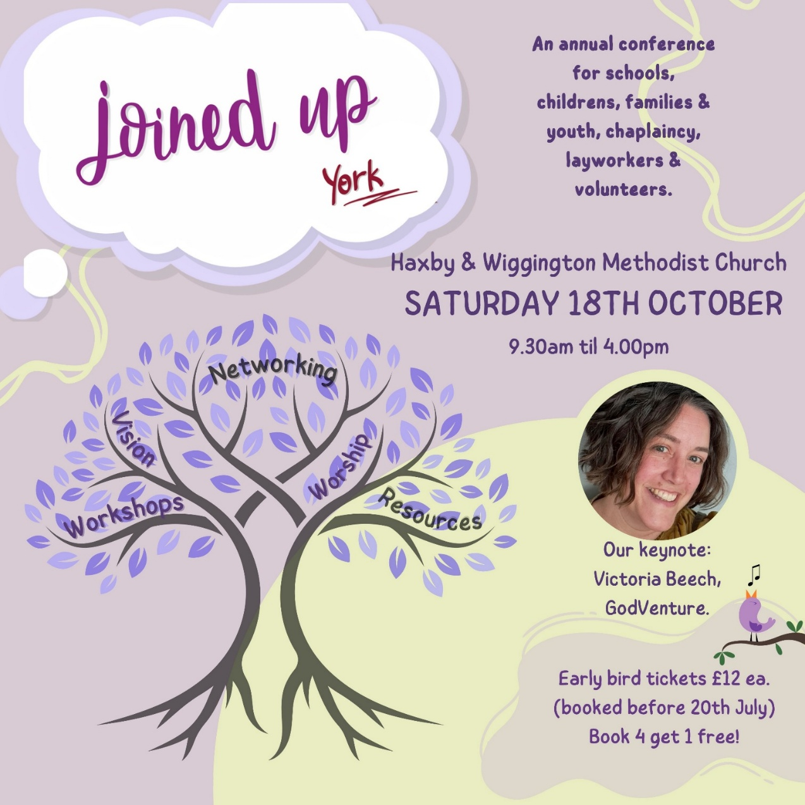
For more information and to get your Early Bird tickets follow this link https://joinedupconferencecom.wordpress.com/york/
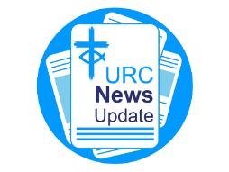
NEWS FROM THE DENOMINATION
The URC’s News Update is a monthly e-newsletter that keeps you informed about the latest news and events.
To receive this popular newsletter, please visit the https://urc.org.uk/news-updates-sign-up-form/ page on the URC website and follow the links. If you just want to dip in and catch up on what is going one, that’s fine and you can
read and print recent editions of our e-newsletter by visiting the URC News Update page at https://urc.org.uk/urc-news-update/ .

Church Action on Poverty Sunday
The next Poverty Sunday has been brought forward to Sunday 19 October 2025 to tie in with Challenge Poverty Week. The theme is Sharing Our Dreams and it is a conscious effort to share dreams of a better world. If you or your church feel called to this work, please contact the Church Action on Poverty team at https://www.church-poverty.org.uk/ where you will be able to
- Use the powerful ‘Dreams and Realities’ portrait exhibition to challenge and inspire your congregation
- Use our free worship resources to reflect and pray for change.
- Celebrate what your church is already doing – and explore how you could do more in partnership with Church Action on Poverty.
- Raise funds to support people working together to reclaim dignity, agency and power across the UK.

SAFEGUARDING
The Safeguarding team have asked that you are reminded that they are available 24 hours a day, seven days a week and 365 days a year (and even 366 days in Leap Years!!). Details can be found on the Yorkshire website at https://urcyorkshire.org.uk/safeguarding/ and any query, either by phone or by e-mail at safeguarding.1and4@urc.org.uk will be answered within 24 hours.

FIRE SAFETY
Jane Bunyan, our Synod Property Officer property@urcyorkshire.org.uk has asked that I remind churches that fire regulations for small non-domestic premises have changed in light of the Grenfell Tower Enquiry outcomes. The advice Synod is giving is that all churches should make themselves aware of the new regulations and advice updated in 2024 at Making your small non-domestic premises safe from fire - GOV.UK or https://www.gov.uk/government/publications/making-your-small-non-domestic-premises-safe-from-fire but if you would like a pdf copy then please email Jane at the above e-mail address.

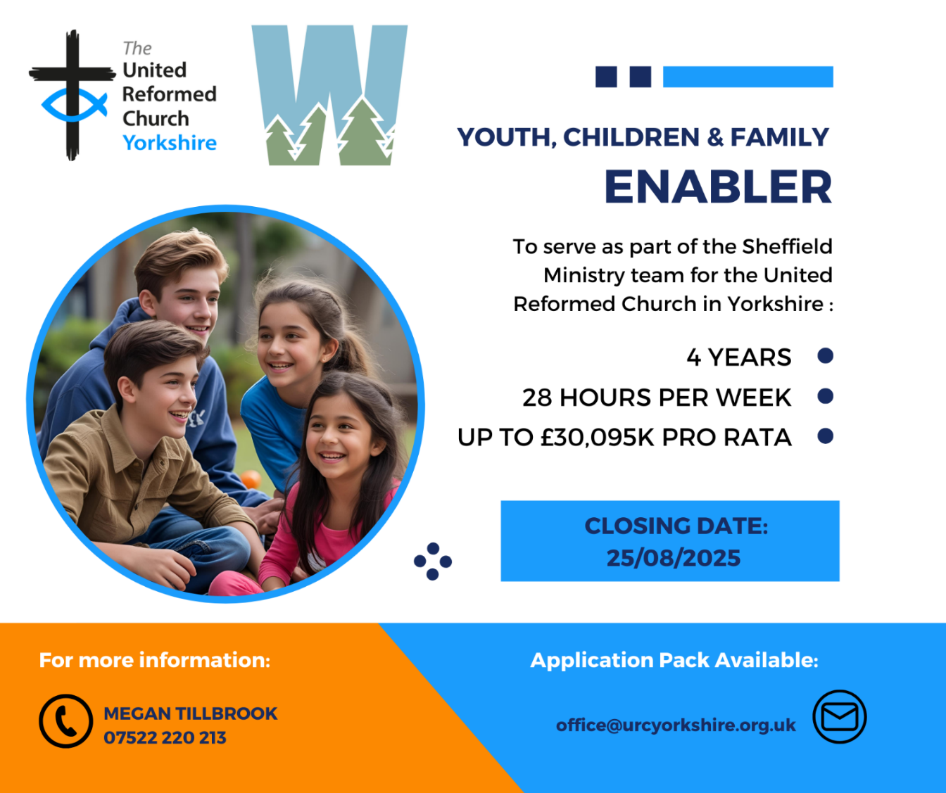
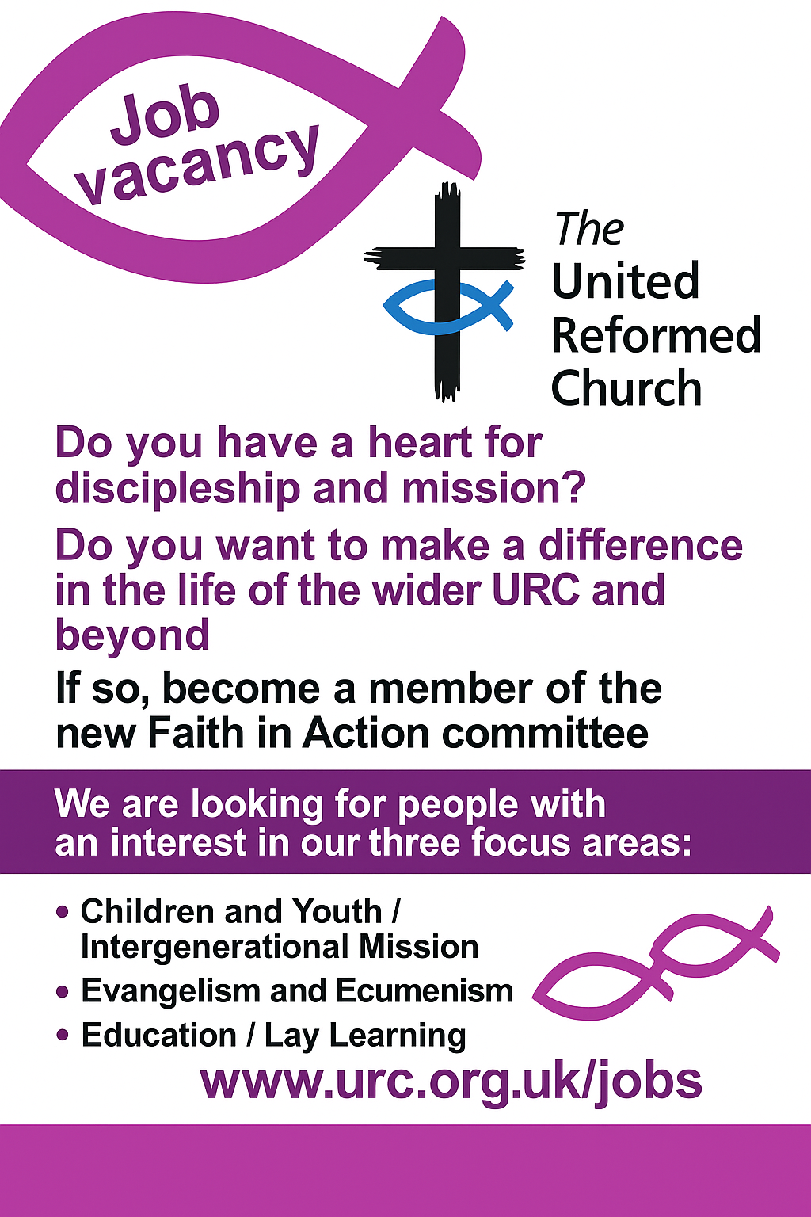
To see more available roles in the denomination, please visit https://urc.org.uk/jobs/#urcvol
And Finally
Messy Mondays and New Places for New People in Beverley

One of the joys about being Synod Clerk is that I get to see so much good work being done through our churches, from the Pennines to the North Sea, from the Dales to the seven hills of Sheffield. One example of a project being part funded by the Synod Mission Fund is the Messy Monday project at Toll Gavel church in Beverley.
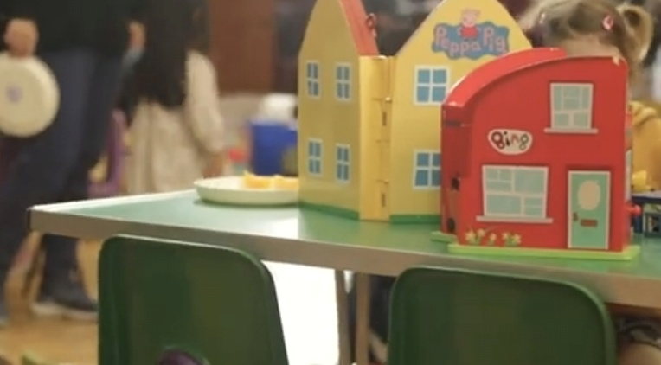
Messy Mondays is a weekly playgroup run in term time for babies and pre-school children. It is an outreach group supported by Church volunteers and staff for the benefit of the community. It is well established having been running for 40 plus years. The aim of the group is to connect local families to the Church, by providing an inviting playgroup in the Church building. Their welcoming group gives families a sense of belonging and connection with Church as they enjoy the play group facilities and supportive relationships with the play group staff and volunteers.

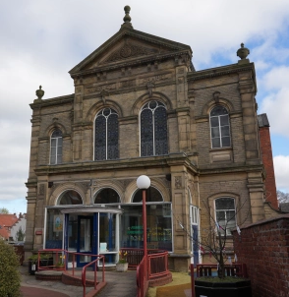
Toll Gavel Church also runs New Places for New People, which happens in parallel with Messy Mondays and they successfully appointed a Pioneer Pastor in August 2025. The vision to form a new worshipping community is being developed with a focus on young families within the Beverley & Hull Mission Area, evolving from a strong base of parents, carers, and families involved in thriving toddler and youth groups across four local churches. The shape and structure of this new Christian community are intentionally being kept flexible, allowing the community and a future pioneer lay pastor to co-create its direction. Their current children and family worker and playworker welcome children and caregivers to this new missional initiative.

There is even a video on YouTube at https://www.youtube.com/watch?v=4M6wJk8_I6Y, so if you want to see whether you can follow Toll Gavel’s example, have a look and contact us at Synod to see what support we can give you as well.

If you have a good news story from your part of the Synod or something that you feel would enhance the work of Synod in 2025, drop me a line at clerk@urcyorkshire.org.uk and I’ll make sure it hits the back page!!

You can also keep an eye on all our social media platforms for news; on the website at Home - URC Yorkshire Synod, at United Reformed Church in Yorkshire - Home | Facebook and Wilderness URC Yorkshire - Home | Facebook, the YouTube page at URC Yorkshire - YouTube and the Twitter (X) page at URC in Yorkshire (@URCYorkshire) / Twitter.

