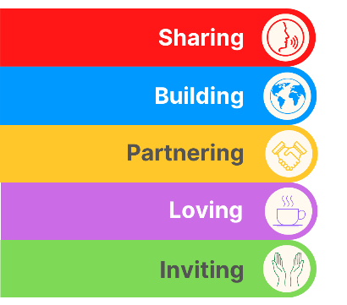
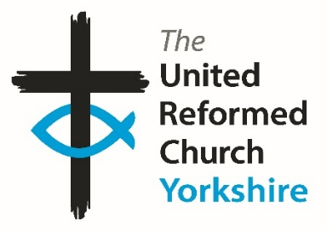
Yorkshire Synod Briefing
Number 161

2nd October 2025

Synod Specials
Before my next Briefing (due out on 23rd October) Synod will be preparing itself for a series of gatherings which encompasses all that Synod represents; from welcoming new ministers, to formal meetings to new experiences.
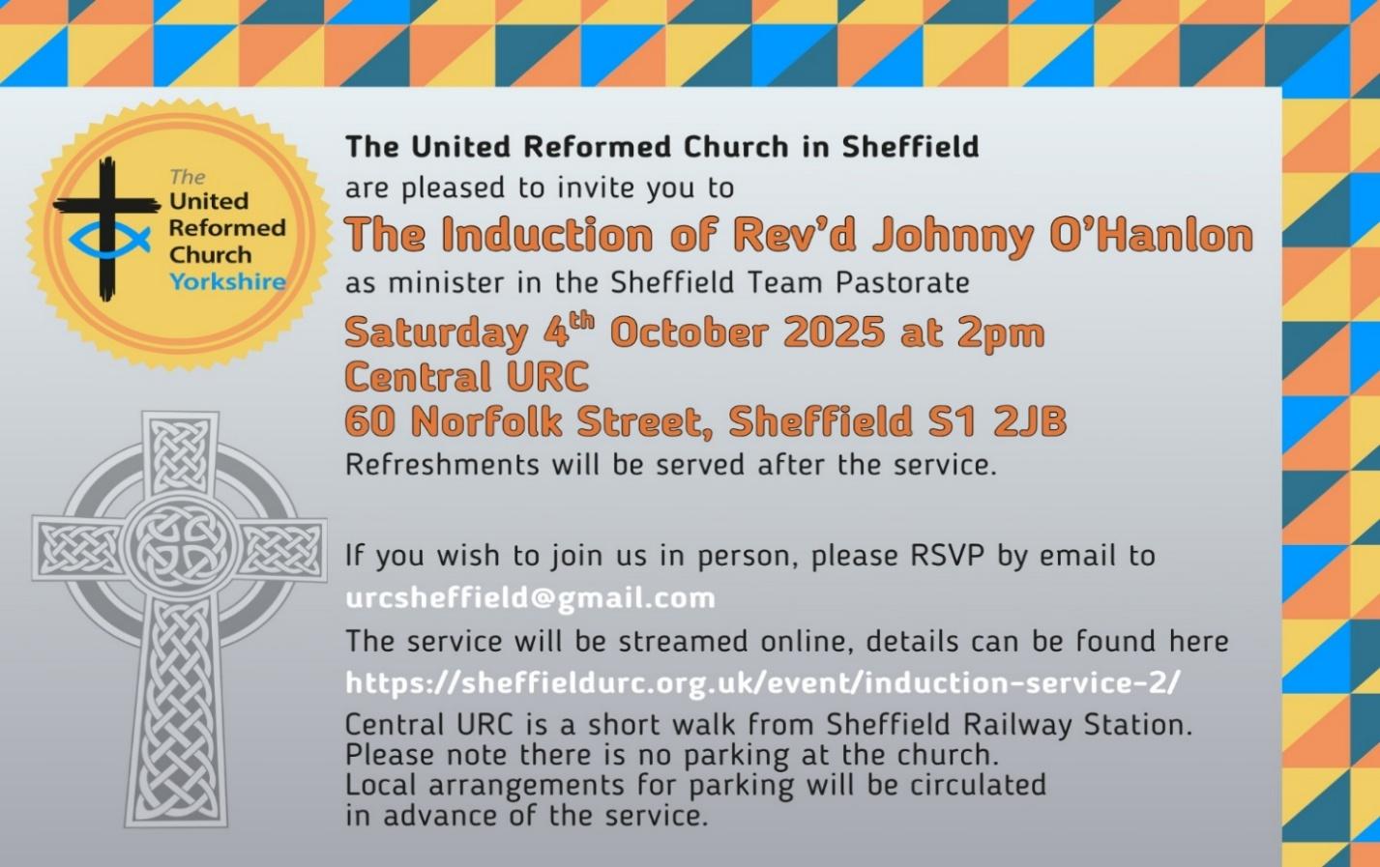
This coming Saturday 4th October, Synod will be joining the Sheffield Partnership in welcoming Revd Johnny O’Hanlon at his induction service at Central URC. The invitation is here for you all to come along to welcome Johnny into his new role and to join with the Sheffield fellowship in celebrating their witness in that part of the Synod, and I hope to be able to see as many of you as possible at Central URC as we mark this special moment.
Following on from that is the more formal side of Synod as we gather for a two part Autumnal Synod meeting. In these meetings we will listen for God’s guidance as we decide on Synod’s path over the next few years. First of all is the finance part of our agenda on the evening of Thursday 9th October where budgets and financial policies will take shape. Although seemingly a dry subject, this part of Synod’s work is central to how we may become a more effective missional Synod, and which links in seamlessly with the agenda set out for the full day’s Synod meeting at St Andrew’s URC in Roundhay on Saturday 11th October. Here we will be engaging collaboratively on the missional, justice and youth engagement aspect of our Synod’s life.

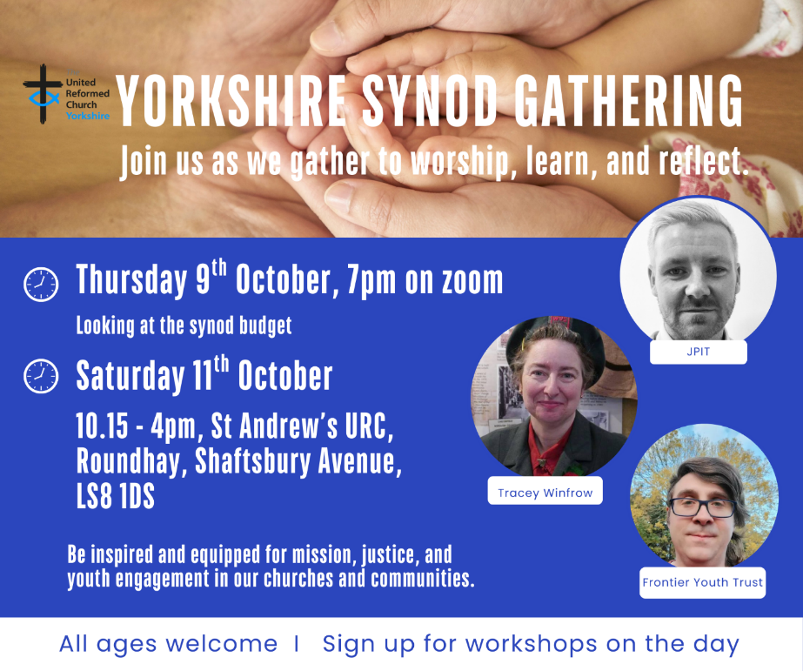
As I mentioned last time there are three workshops available and we invite Synod Representatives to join two of them during the day. They are:

Exploring Life, Love and Faith with Gen Z – Matthew Willmott, Frontier Youth Trust
Each generation understands the world slightly differently than the one before. How are Gen Z understanding life stages and in particular, what it means to be in a relationship? How can the church support, challenge and walk alongside young people as they make their way in the world? This is just the starting point of a conversation that we need to be open to having.

Discipleship in Divided Times - Joint Public Issues Team (JPIT)
How might Christians engage in a political and social mainstream that is shifting into more populist and openly far-right views and expression? How can our conversations with friends and family reflect a sensitivity to these influences, build trust across difference yet challenge extreme-right policies that undermine democracy and Christian values? The Joint Public Issues Team will lead a workshop highlighting current trends in society, the impact these have on the most vulnerable, and how Christians can engage effectively in changing times.

The Gift of Presence: How children and young people can transform church life – Tony Harris and Tracey Winfrow
What difference does it make when children and young people are truly part of the life of the church—not just present, but participating, shaping, and belonging? This workshop invites you to explore how the presence of young people can breathe new life, perspective, and purpose into your church community. Through stories, reflection, and discussion, we’ll uncover the theological, relational, and missional impact of engaging younger generations. Whether your church is growing with young people or longing for their return, this session will challenge and encourage you to see them not as the church of tomorrow, but as vital members of the church today.

Everyone will be able to attend 2 of the 3 on offer and choices can be made on the day, but we hope that by providing this information in advance, churches and synod representatives can share, discuss and consider their options. Those who are not synod representatives, but with an interest in the topics may also wish to attend. Everyone is welcome to come along and there will be creche facilities (unsupervised, in the main meeting hall) for babies and small children.

If you have any news of welcoming people into Church, stories of celebration and hope or even notices of future events, please let me know by dropping me a line at clerk@urcyorkshire.org.uk and I’ll showcase it in the next edition, due out on Thursday 23rd October 2025.
Thank you
Tim Crossley
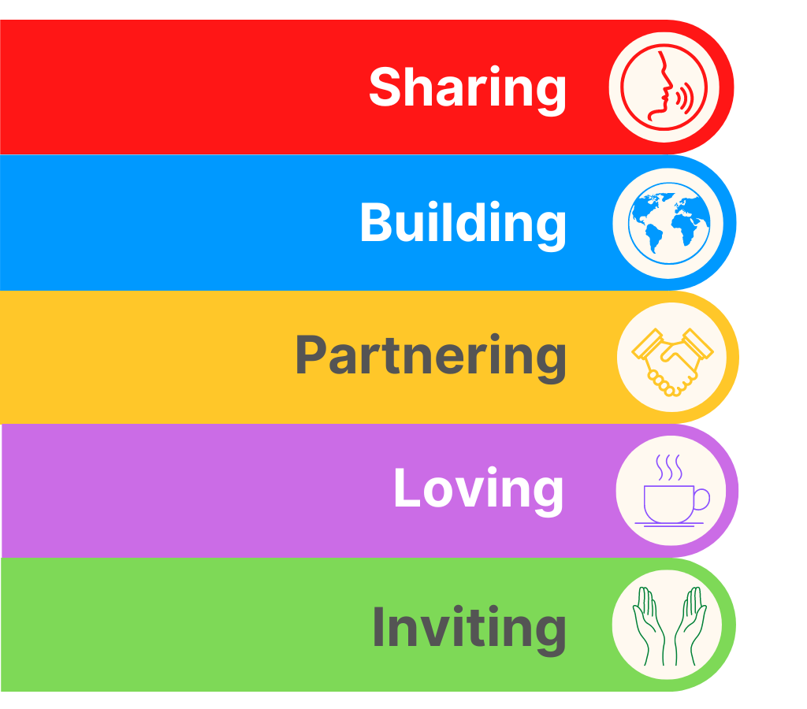
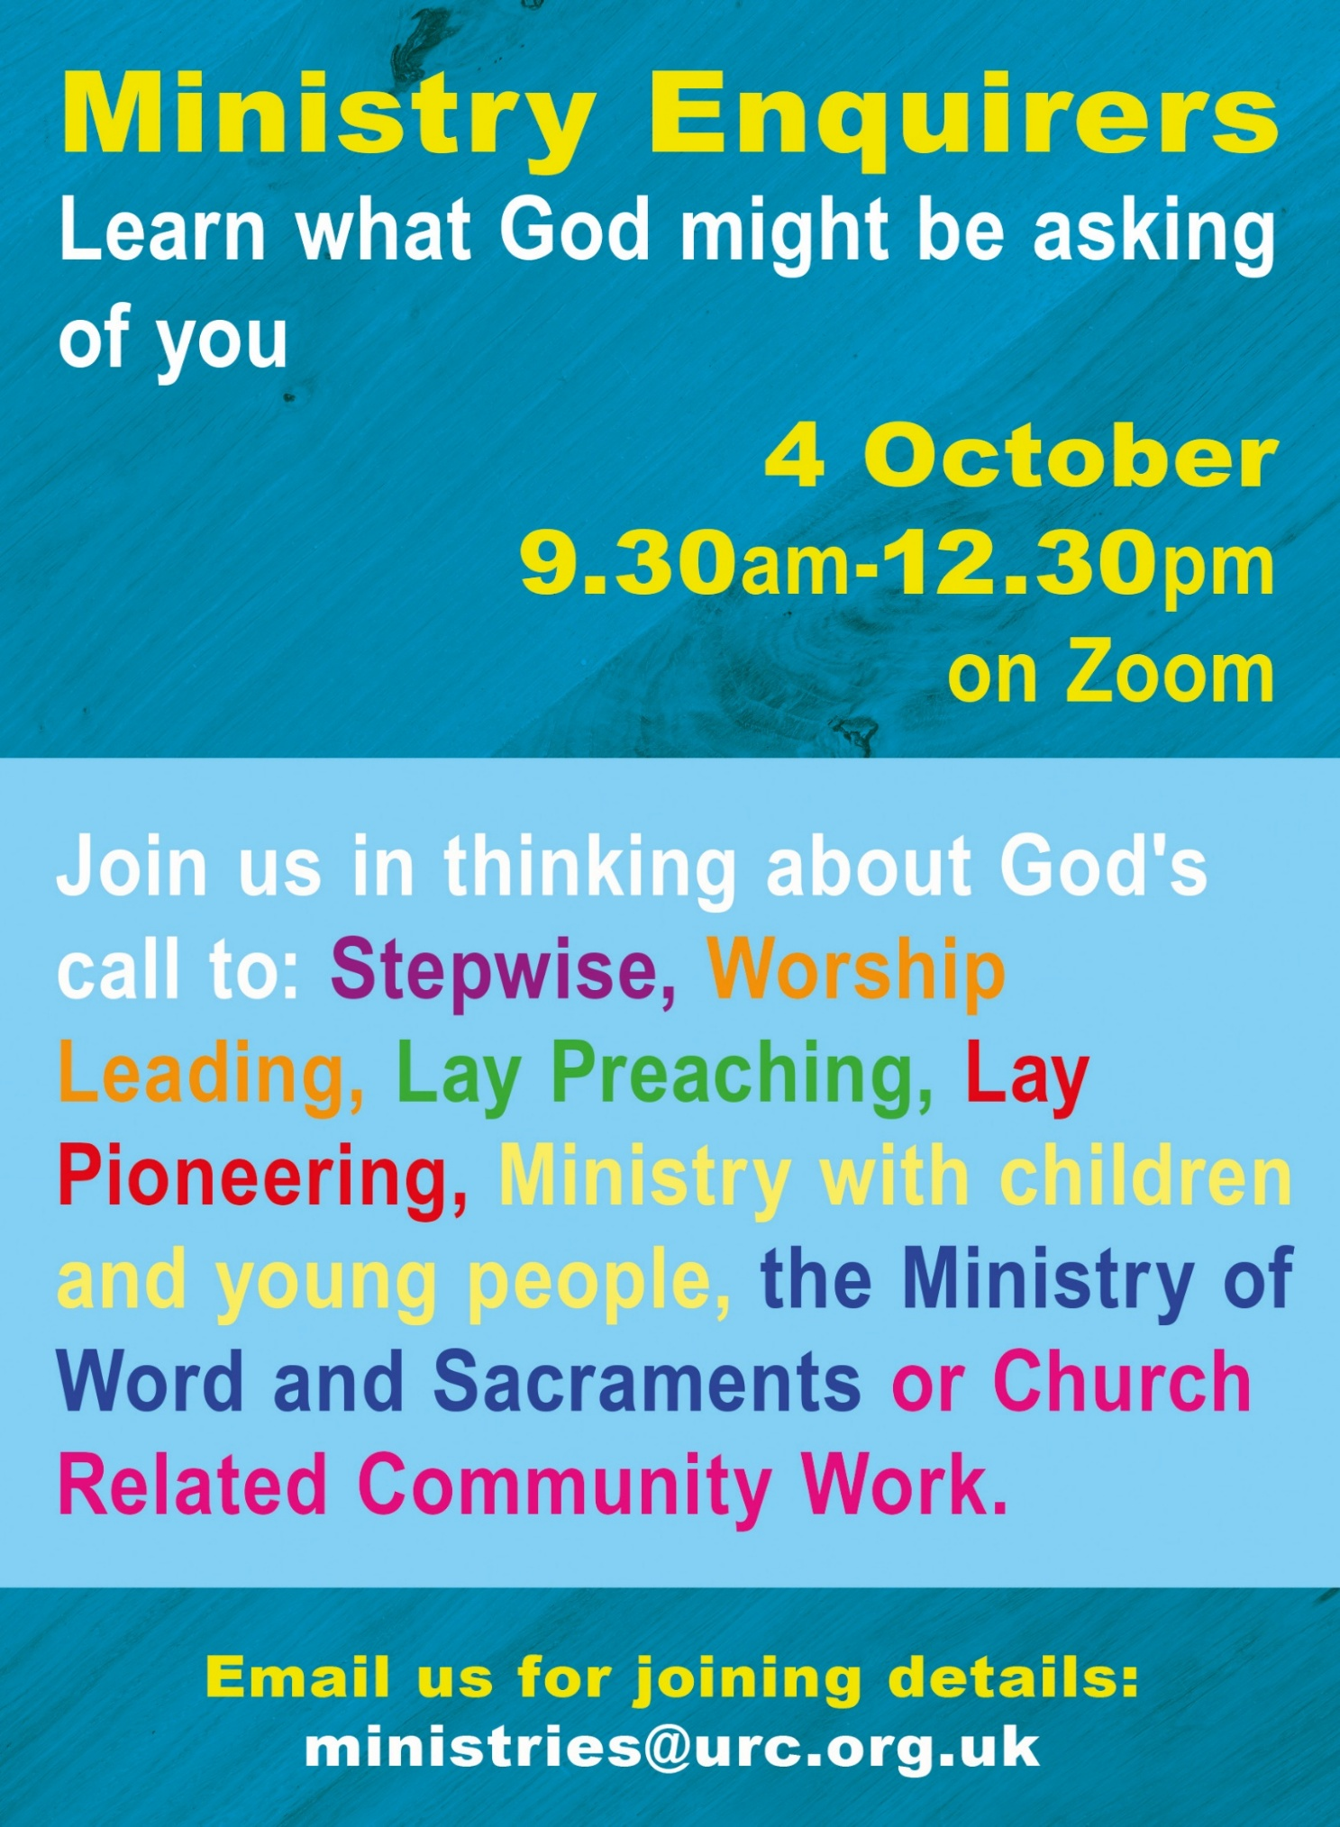
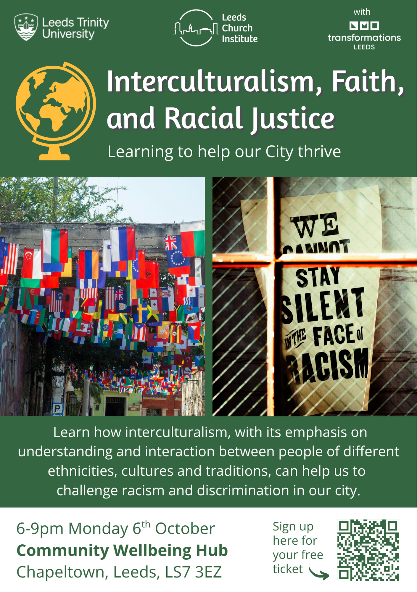
YOUTH ASSEMBLY 2026
Bookings have opened for next year’s URC Youth Assembly which will be happening between 27th February and 1st March 2026. Visit www.bit.ly/3TkqSfn for more details or contact Megan at the Synod Office at megancyp@urcyorkshire.org.uk. Megan will also be at the Synod meeting on 11th October, so if you get chance, have a word with her there.

!!!!!!!!!!!!!!!PLEASE NOTE THE NEW DATE!!!!!!!!!!!!!!!
Due to essential car park resurfacing and repairs, Stainbeck’s community groups’/thanking grant funders' event has been moved from 13th September to Saturday 18 October.
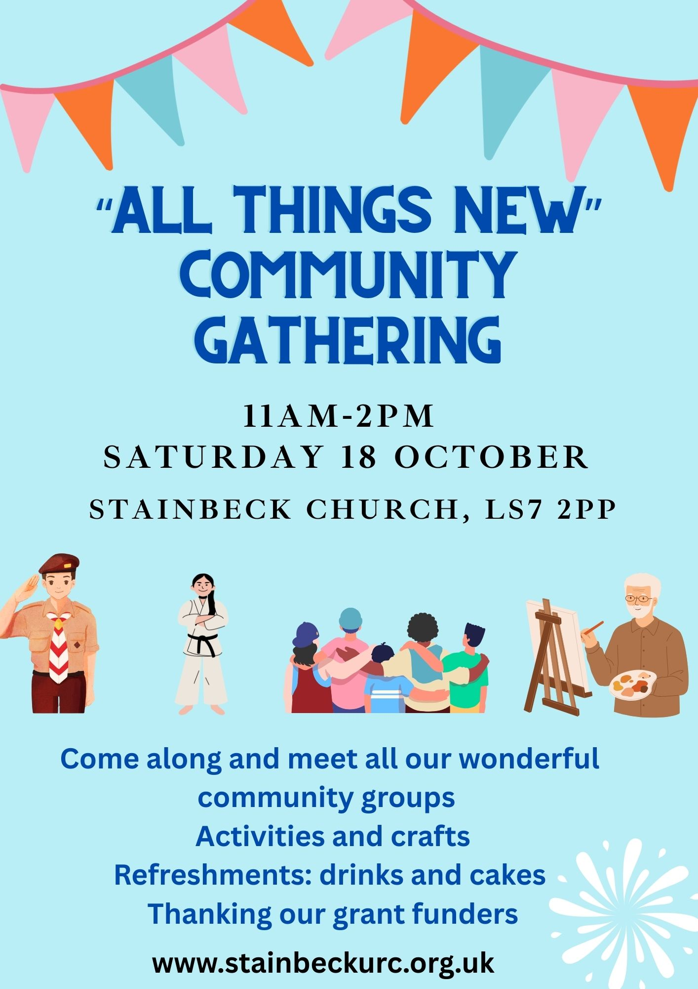
If you have any questions or you would like to book, please contact the Synod Office (office@urcyorkshire.org.uk or moderatorpa@urcyorkshire.org.uk) to inform us, who will be coming from your church, so we can advise West Park URC of numbers expected.


Yorkshire Synod Discipleship Development Small Grant Fund 2025
The Ministries Committee have so far approved 21 applications to this fund since 2022 and we encourage all lay church members to consider applying in 2025. Please use the new application form available through the Synod Office as the amount which you can ask for resources or has increased to up to £300. This fund exists to help you on your Christian journey including the costs of attending a course or to offset the costs of buying resources for personal development or sharing with others. If anyone wants to discuss an application before submitting it please contact the Convenor of the Yorkshire Ministries Committee, Kath Lonsdale at kathlonsdale@talktalk.net.
Remember this is for any age of lay person in our churches to apply for so please discuss with your young people as well as adults.

LEEDS PARTNERSHIP PRAYERS
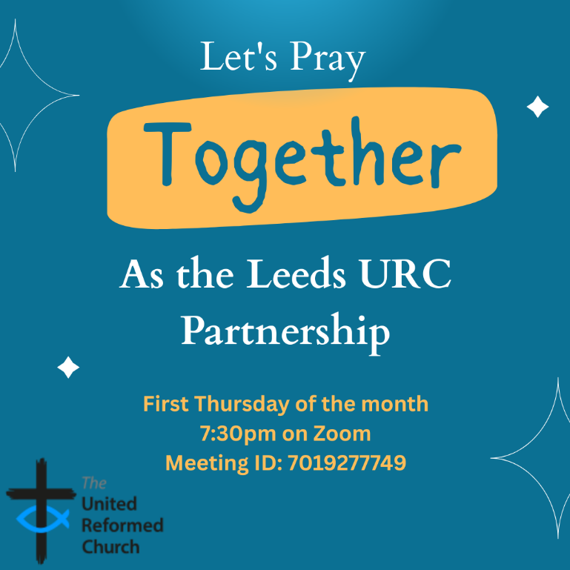
Although this is primarily aimed at those of us who are linked with the churches of the Leeds URC Partnership, this invitation is open to everyone from around the Synod and beyond.
It will be happening on the first Thursday of the month on Zoom at 7:30pm. The next one will be tonight, Thursday 2nd October and the link is here: https://us02web.zoom.us/j/7019277749

There will be a time to pray together, a time to share in reading the Bible and a time to share the joys and challenges in our lives, churches, communities and world.

Looking forward to seeing you there.

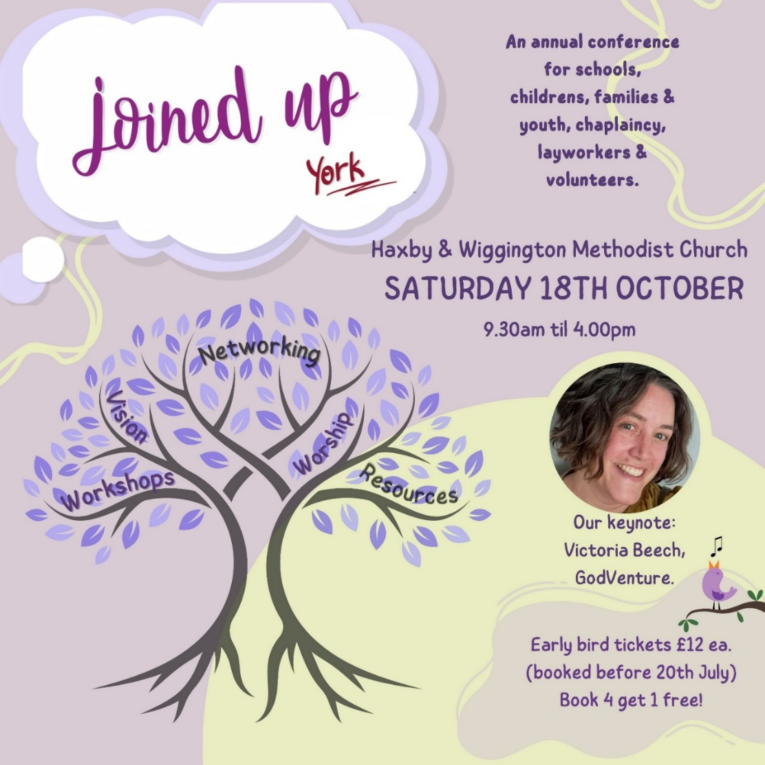
For more information and to get your Early Bird tickets follow this link https://joinedupconferencecom.wordpress.com/york/

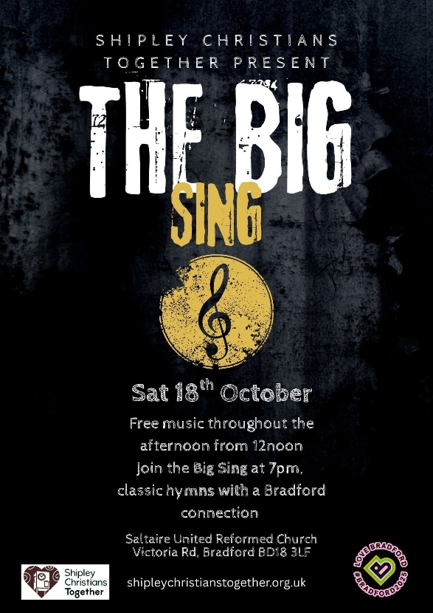
Saltaire URC to Host
“THE BIG SING”
The https://shipleychristianstogether.org.uk/ group are presenting THE BIG SING on Saturday 18th October and Saltaire URC is the venue. It is an afternoon and evening of free music, starting at 12 noon cumulating with THE BIG SING at 7pm when classic hymns with a Bradford connection will be sung.

All are welcome to join the celebration throughout the day – Saturday 18th October – as part of the 2025 Bradford City of Culture, or more importantly as a Christian with an opportunity to share your faith in music.





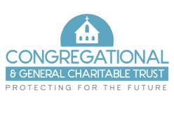
Are you interested in joining our team of trustees?
The Congregational & General Charitable Trust currently has 3 volunteer vacancies on our board of trustees and would love to hear from you if you feel you could add value to our aims and objectives.
Meeting 4 x per annum in Leeds (March, June, September and December), we ensure that the trust is run effectively as well as reviewing and determining grant applications to support Christian faith churches, particularly URC and Congregational, in their congregational development. All grant applications received during each quarter are distributed amongst the trustees prior to each meeting to review and recommend appropriate action to guide and support the final collective decision making process during the meetings.
We are particularly keen to hear from you if you have a financial and/or business background. For more information or how to apply please email us at admin@candgtrust.org.uk

Do you need financial support for your church building project or significant repairs?

The Congregational & General Charitable Trust may be able to help

The C&G Trust is an independent grant-making charity which aims to support churches, particularly those of the United Reformed and Congregational denominations, in the provision and repair of suitable buildings. They make grants towards the overall care, upkeep and extension of churches and also offer grant funding toward the capital cost of church community projects.
The trust began as the charitable arm of the Congregational & General Insurance Company but became a separate charity and now is completely independent of the insurance company and distributes grants from the investment of the proceeds of the sale of that company in 2016.

What grants are available?
The level of grants available to churches range from £1,000 to a maximum of £25,000. Grants are usually capped at 25% of the total project cost. Grants are awarded for church or related community capital projects involving building work, repairs, improvements or extensions. Any project costing less than £1m in total will be considered. Consideration will also be given to smaller clearly defined and discrete project phases. There are a few exclusions including organ or bell restoration, stand-alone environmental projects such as solar panels or heat source pumps, manse works, conservation/restoration of works of art, graveyard or garden maintenance, parking provision and the running costs of the church.

How do I apply?
Applications should be made in advance of starting any work (apart from obtaining professional design and project planning advice) and be submitted when planning has proceeded to the point where clear details of the planned works and their expected cost can be provided.
Applications are considered quarterly (March, June, September and December of each calendar year) The upcoming application date for each quarter is published on the website at https://www.candgtrust.org.uk/how-to-apply-funding-church-projects/ with further details and an application form available to download. The website also has a useful Q & A section as well as a sample completed application form for you to view. If you are unable to find all the answers to your questions, please contact us at admin@candgtrust.org.uk.
Applications must be supported by copies of your church accounts and documentation supporting the estimated cost of the project, such as Contractor quotes. There is an expectation that the church will contribute, so far as it is practicable, to the project from its own funds and from local fundraising.

The charity exists to help churches like yours – so please do not hesitate to apply if you feel we can be of help.
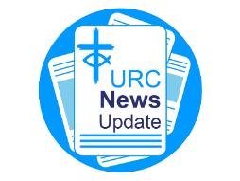
NEWS FROM THE DENOMINATION
The URC’s News Update is a monthly e-newsletter that keeps you informed about the latest news and events.
To receive this popular newsletter, please visit the https://urc.org.uk/news-updates-sign-up-form/ page on the URC website and follow the links. If you just want to dip in and catch up on what is going one, that’s fine and you can
read and print recent editions of our e-newsletter by visiting the URC News Update page at https://urc.org.uk/urc-news-update/ .

Church Action on Poverty Sunday
The next Poverty Sunday has been brought forward to Sunday 19 October 2025 to tie in with Challenge Poverty Week. The theme is Sharing Our Dreams and it is a conscious effort to share dreams of a better world. If you or your church feel called to this work, please contact the Church Action on Poverty team at https://www.church-poverty.org.uk/ where you will be able to
- Use the powerful ‘Dreams and Realities’ portrait exhibition to challenge and inspire your congregation
- Use our free worship resources to reflect and pray for change.
- Celebrate what your church is already doing – and explore how you could do more in partnership with Church Action on Poverty.
- Raise funds to support people working together to reclaim dignity, agency and power across the UK.


Put the date in your diary – Monday 24th November 2025.

Rod Morrison, of the Synod’s Eco Group asks “Do you remember the old days, when your mum darned your socks, or put patches on the elbows of your school blazer? When you took your shoes to the cobblers to be re-heeled, or unravelled that now-too-small jumper to knit a new one in a bigger size? It was repair, reuse, share, and upcycle – practices that we need to return to as we face the consequences of global warming; practices which we now call “circular consumption” - keeping resources in use and preventing waste. That’s what “Circular Monday” is all about. Forget Black Friday, and celebrate Circular Monday instead, when we focus on keeping resources in use and preventing waste. Of course, we should be keeping resources in use and preventing waste all the time. But Monday 24th November is when there is a main event to promote “circular consumption””.

So why not join the Main Event for this year – on Circular Monday 24th November
It’s just one hour – with big impact. It’s online, and showcases how circular solutions are reshaping the world. Expect inspiration, global perspectives, and engaging voices leading the way towards a more sustainable future. If you want to take part, simply post a photo of yourself or your group on social media with #CircularMonday, showing something linked to reuse, repair, or renting.

For more information use this link : https://www.eventbrite.com/e/circularmonday-2025-official-main-event-tickets-1607228065409?aff=oddtdtcreator

But “Circular Monday” is more than just one day in a year.
Circular Monday began in 2017 in Malmö, Sweden, as a counter-movement to Black Friday. It is now an on-line campaigning community which highlights and celebrates businesses, organisations, and individuals that keep resources in use and prevent waste, making it easier for people everywhere to choose circular solutions. (see www.circularmonday.com )

The Circular Monday community aims to promote circular consumption by:
- ‍Hosting an annual global action day (the main event - Circular Monday - the Monday before Black Friday)
- Building the world’s largest database of circular businesses and changemakers
- Inspiring people to repair, reuse, rent, share, and upcycle instead of buying new.
At their main event, always the Monday before Black Friday, the year’s campaign results are revealed. The goal is to make circular solutions visible, accessible, and the new normal.

As a guide, the Circular Monday community use the 12R strategies, including: Refuse, Reduce, Rethink, Redesign, Reuse, Repair, Refurbish, Remanufacture, Repurpose, Recycle, Re-earth, and (as a last resort) Recover. Recycling is considered baseline, not leadership so we encourage higher-value practices like reuse, repair, and redesign.

Anyone can join the Circular Monday community, both online and through local in-person activities or digital events. You can explore the Circular Monday database of circular businesses, or join as a volunteer. For ideas, check out @circularmonday on Instagram.

Why not join the online community yourself and start to consume circular – or at least think about which of the 12 Rs you can put into practice?

And an after-thought : If you want to calculate your carbon footprint so that you can monitor your progress towards zero carbon, go to https://climate-calculator.climatehero.org/?source=MicrosoftKeywords&msclkid=e14c76185f8b1f0a5a4c1ec4154a8c61 It takes just 5 minutes!
Important information from the Synod Safeguarding Team
Due to changes in the insurance industry, insurers are now adding a new safeguarding endorsement for churches to complete when their insurance is due for renewal. What this means is that insurance companies will now place conditions on all policies, that it these conditions must be adhered to for the policies to be valid.
What this means is that you will need to answer yes to the following questions –
- Have you a complete and comprehensive written safeguarding policy that is reviewed at least annually?
- Do you have a church safeguarding coordinator for your church?
- Do you as a church, provide safeguarding training to everyone who needs it due to their role within the church?
- Do you know how to respond to a safeguarding incident, know who to report it to and how to deal with it correctly?
- Has everyone who needs them, due to their role, had the correct level of DBS checks and has this been completed in the past three years?
- Have you and do you have a system to securely retain records of any abuse allegations and the action you took in relation to these allegations?
You would also need to make the insurance company aware if there have been any allegations of abuse which have been reported at your church.
The above relates to anybody involved in the church who works unsupervised with children or vulnerable adults or has unsupervised access to children or vulnerable adults. This means that everybody who falls under the guidance of Good Practice 6, which includes Elders etc need to make sure everything is up to date and in order, to be able to confirm this with the insurance company when the renewal is submitted.
If the answer is no, or the disclosure is incorrectly completed, insurance may be withheld or be made void in any claims. If this is the case and a claim is made it will be made against the church itself and the Trustees.
Many of you may already be able to answer yes to all the questions posed.
However, many of you may not be able to answer yes to all the questions and this is where action needs to be taken at the church.
The Elders/Trustees are responsible for ensuring that the church is a safe place for everyone and therefore responsible for making sure that you can answer all the questions posed by an insurance company to provide insurance cover for the church and everyone who attends.
If you need help making sure your church can answer yes to all the questions you will be asked please contact the Synod Safeguarding Team by email (click here) and we will assist you in making sure your church can be insured correctly.

The Safeguarding team are available 24 hours a day, seven days a week and 365 days a year (and even 366 days in Leap Years!!). Details can be found on the Yorkshire website at https://urcyorkshire.org.uk/safeguarding/ and any query, either by phone or by e-mail at safeguarding.1and4@urc.org.uk will be answered within 24 hours.
FIRE SAFETY
Jane Bunyan, our Synod Property Officer property@urcyorkshire.org.uk has asked that I remind churches that fire regulations for small non-domestic premises have changed in light of the Grenfell Tower Enquiry outcomes. The advice Synod is giving is that all churches should make themselves aware of the new regulations and advice updated in 2024 at Making your small non-domestic premises safe from fire - GOV.UK or https://www.gov.uk/government/publications/making-your-small-non-domestic-premises-safe-from-fire but if you would like a pdf copy then please email Jane at the above e-mail address.
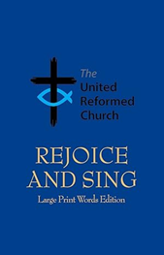

WANTED
The Synod Clerk has been contacted by the good folk at Bingley URC. They are in need of some large print Rejoice and Sing hymn books. At the moment they are saving up to repair their roof and rather than having to buy new, are asking that if any churches in the Synod have any spare they could pass them on.
If there are any, please contact the Clerk at the Synod office via clerk@urcyorkshire.org.uk so that a transfer can be arranged.

Saltaire Arts
The last two weekends of September saw Saltaire URC host the Bingley Arts Group as part of the Saltaire Festival. The church was open throughout and was able to offer another local group the space and facilities to showcase both the talented artists exhibiting and the church’s care and love for the community in which it sits.
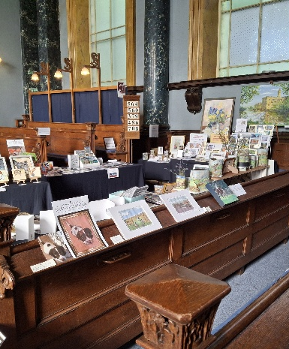
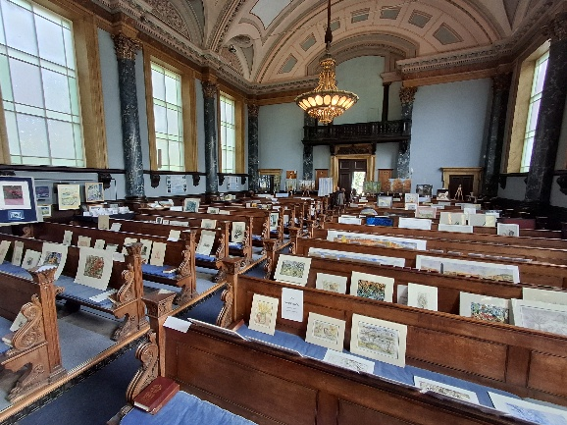
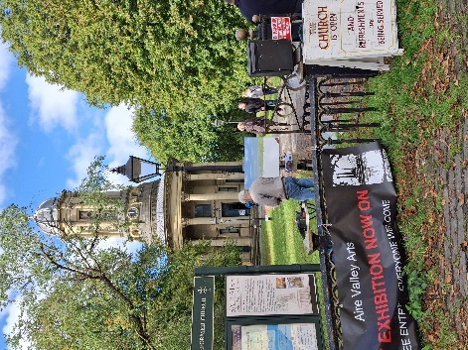


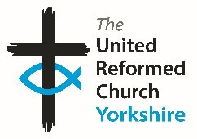

Somebody is missing
Is it you?

Synod is looking for volunteers to fill
several posts across it’s committees.
Please contact the Synod Moderator or
Clerk if you, or someone you know,
would like more information
on how to help.

clerk@urcyorkshire.org.uk moderator@urcyorkshire.org.uk
And Finally
SPACE welcomes a new Minister

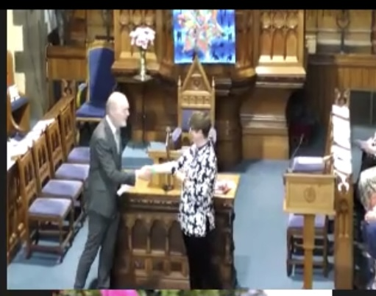
The SPACE group of churches (Longcauseway Dewsbury, Heckmondwike and Norristhorpe) warmly welcomed Rev Samantha Sheehan, her family and friends, as well as members of Synod, local clergy, and the Mayor of Kirklees at her induction service on 30th August. The celebratory service was followed by afternoon tea, lovingly provided and prepared by members of all three churches.
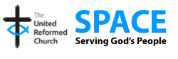
When asked, Samantha said, "It was a wonderful service, with an inspirational charge from Revd Jenny Mills to both myself and the churches - God has called us to be disciples. To follow Jesus, to walk in his footsteps and to find ways to share the love of God with those alongside whom we live, work and have our being here in our locality and as widely as possible. Remember throughout it all, you are not alone - you have fellow travellers in your churches, the Synod and the wider denomination and you have the love of God that is within, before, behind, beside and with you always; and to help us remember she gifted a mini Jesus to carry with us. It was a wonderful time of blessing for us all and I hope the start of a strong foundation as we grow together as minister and churches seeking God in all we do."

https://spaceurc.org.uk/

If you have a good news story from your part of the Synod or something that you feel would enhance the work of Synod in 2025 and into 2026, drop me a line at clerk@urcyorkshire.org.uk and I’ll make sure it hits the back page!!

You can also keep an eye on all our social media platforms for news; on the website at Home - URC Yorkshire Synod, at United Reformed Church in Yorkshire - Home | Facebook and Wilderness URC Yorkshire - Home | Facebook, the YouTube page at URC Yorkshire - YouTube and the Twitter (X) page at URC in Yorkshire (@URCYorkshire) / Twitter.

